Supplementary Figure Legend
Supplementary Figure 1. Adjusted dose-response association between body mass index (BMI) and the incidences of (a) total breast cancer, (b) breast cancer with hormonal drug administration, (c) breast cancer with trastuzumab administration, and (d) breast cancer by age ≤45 years according to multivariable Cox regression analysis using a restricted cubic spline with four knots (18.5, 22.0, 25.0, and 30.0 kg/m²). The Y-axis represents the hazard ratio for the outcomes with adjustment for age category, smoking history, alcohol consumption, and physical activity (Model 4), comparing individuals with a BMI of 22 kg/m² and those with any other BMI. The estimates are shown with 95% confidence intervals (CI). The points of intersection of the lines on the X-axis and the restricted cubic spline represent the four knots (18.5, 22.0, 25.0, and 30.0 kg/m²).
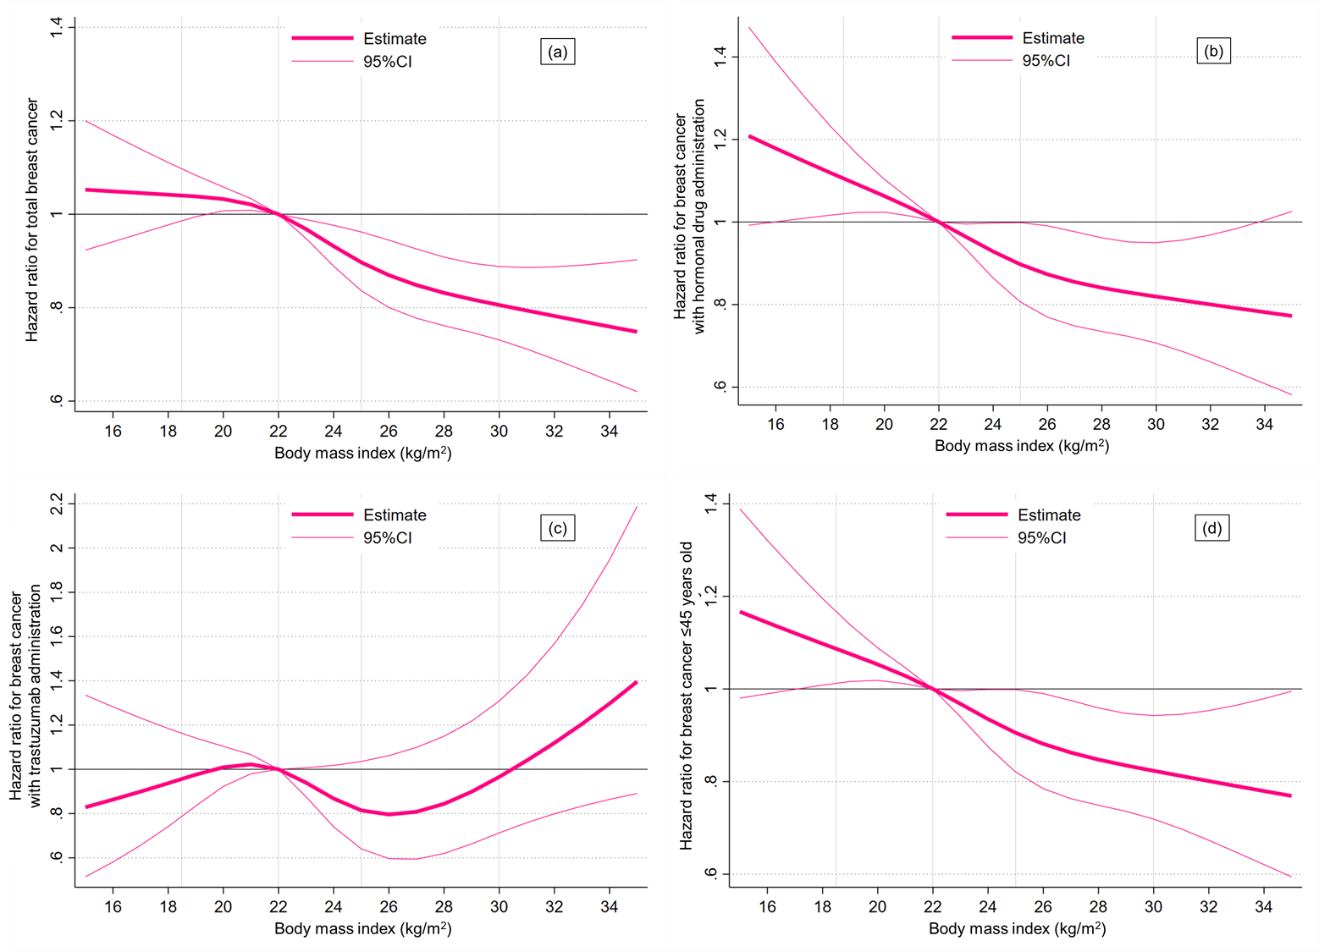

Supplementary Table 1. Cox regression analyses for the incidences of breast cancer in each body mass index category with reference to the combined normal group (body mass index of 18.5–24.9 kg/m²)
 | Body mass index category (kg/m²)
 | Underweight |  |  |  | Overweight |  |  |  | Obese
 | (<18.5) |  |  |  | (25.0–29.9) |  |  |  | (≥30.0)
 | Hazard ratio (95% CI) |  | P-value |  | Hazard ratio (95% CI) |  | P-value |  | Hazard ratio (95% CI) |  | P-value
Total breast cancer
Unadjusted model | 0.91 | (0.85–0.98) | .01* |  | 0.91 | (0.83–1.01) | .06 |  | 0.87 | (0.74–1.03) | .10
Model 1 | 1.01 | (0.94–1.08) | .74 |  | 0.82 | (0.75–0.91) | <.001** |  | 0.79 | (0.67–0.93) | .005**
Model 2 | 1.01 | (0.94–1.08) | .78 |  | 0.82 | (0.75–0.91) | <.001** |  | 0.79 | (0.67–0.93) | .005**
Model 3 | 1.02 | (0.95–1.09) | .65 |  | 0.83 | (0.76–0.91) | <.001** |  | 0.80 | (0.68–0.95) | .009**
Model 4 | 1.02 | (0.95–1.09) | .65 |  | 0.83 | (0.75–0.91) | <.001** |  | 0.80 | (0.68–0.95) | .008**
Breast cancer with hormonal drug administration
Unadjusted model | 0.97 | (0.88–1.08) | .62 |  | 0.90 | (0.78–1.04) | .14 |  | 0.84 | (0.65–1.09) | .19
Model 1 | 1.10 | (0.99–1.21) | .08 |  | 0.80 | (0.69–0.92) | .002** |  | 0.75 | (0.58–0.97) | .03*
Model 2 | 1.10 | (0.99–1.21) | .08 |  | 0.80 | (0.69–0.92) | .002** |  | 0.75 | (0.58–0.97) | .03*
Model 3 | 1.10 | (1.00–1.22) | .06 |  | 0.80 | (0.69–0.93) | .003** |  | 0.77 | (0.59–0.99) | .04*
Model 4 | 1.10 | (1.00–1.22) | .06 |  | 0.80 | (0.69–0.93) | .003** |  | 0.77 | (0.59–0.99) | .04*
Breast cancer with trastuzumab administration
Unadjusted model | 0.85 | (0.67–1.10) | .22 |  | 0.80 | (0.56–1.14) | .21 |  | 1.81 | (1.19–2.74) | .005**
Model 1 | 0.93 | (0.72–1.19) | .55 |  | 0.73 | (0.51–1.05) | .09 |  | 1.66 | (1.10–2.52) | .02*
Model 2 | 0.92 | (0.72–1.18) | .53 |  | 0.73 | (0.51–1.04) | .09 |  | 1.66 | (1.09–2.51) | .02*
Model 3 | 0.93 | (0.72–1.19) | .54 |  | 0.73 | (0.51–1.05) | .09 |  | 1.68 | (1.11–2.54) | .02*
Model 4 | 0.93 | (0.72–1.19) | .55 |  | 0.73 | (0.51–1.05) | .09 |  | 1.67 | (1.10–2.53) | .02*
Breast cancer by age ≤45 years
Unadjusted model | 0.97 | (0.88–1.05) | .41 |  | 0.88 | (0.76–1.00) | .06 |  | 0.88 | (0.70–1.10) | .27
Model 1 | 1.05 | (0.96–1.14) | .34 |  | 0.78 | (0.68–0.89) | <.001** |  | 0.77 | (0.62–0.98) | .03*
Model 2 | 1.04 | (0.95–1.14) | .35 |  | 0.78 | (0.68–0.89) | <.001** |  | 0.77 | (0.61–0.97) | .03*
Model 3 | 1.05 | (0.96–1.15) | .28 |  | 0.78 | (0.68–0.90) | .001** |  | 0.78 | (0.62–0.99) | .04*
Model 4 | 1.05 | (0.96–1.15) | .28 |  | 0.78 | (0.68–0.90) | <.001** |  | 0.78 | (0.62–0.98) | .04*
Hazard ratio was calculated with reference to the combined normal group (body mass index of 18.5–24.9 kg/m²). Model 1 was adjusted for age category. Model 2 was adjusted for age category and smoking history. Model 3 was adjusted for age category, smoking history, and alcohol consumption. Model 4 was adjusted for age category, smoking history, alcohol consumption, and physical activity.
* indicates <0.05 and ** indicates < 0.01. CI: confidence interval.

