Supplementary Figures
Genome-wide identification, evolution and expression analysis of LBD transcription factors family in wheat (Triticum aestivum. L)
Zhenyu Wang¹, Ying Gao¹, Fulin Huo¹, Yijun Shi¹, Wenqiu Pan¹, Pengzheng Lei¹, Weining Song^{1,2*}, Xiaojun Nie^{1*}
¹State Key Laboratory of Crop Stress Biology in Arid Areas, College of Agronomy and Yangling Branch of China Wheat Improvement Center, Northwest A&F University, Yangling712100, Shaanxi, China;
²Australia-China Joint Research Centre for Abiotic and Biotic Stress Management in Agriculture, Horticulture and Forestry, Yangling712100, Shaanxi, China
*Corresponding authors:
Weining Song: songweining@nwsuaf.edu.cn
Xiaojun Nie: small@nwsuaf.edu.cn
Tel.: +86-29- 87082984
Fax: +86-29- 87082203
Address: 3 Taicheng Road, Yangling712100, Shaanxi, China

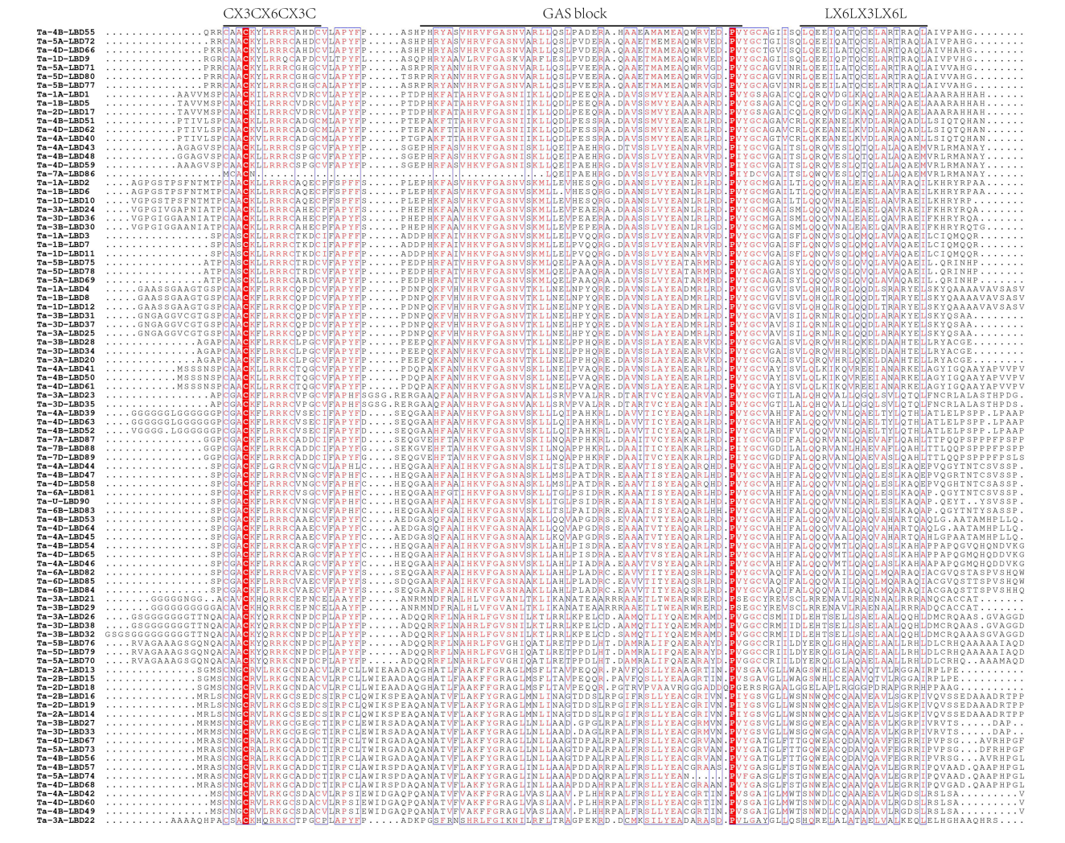Figure S1. Protein sequence alignment of TaLBD genes by DNAMAN. The highlighted blue dots showed the conserved signature motif..

Figure S1. Protein sequence alignment of TaLBD genes by DNAMAN. The highlighted blue dots showed the conserved signature motif.

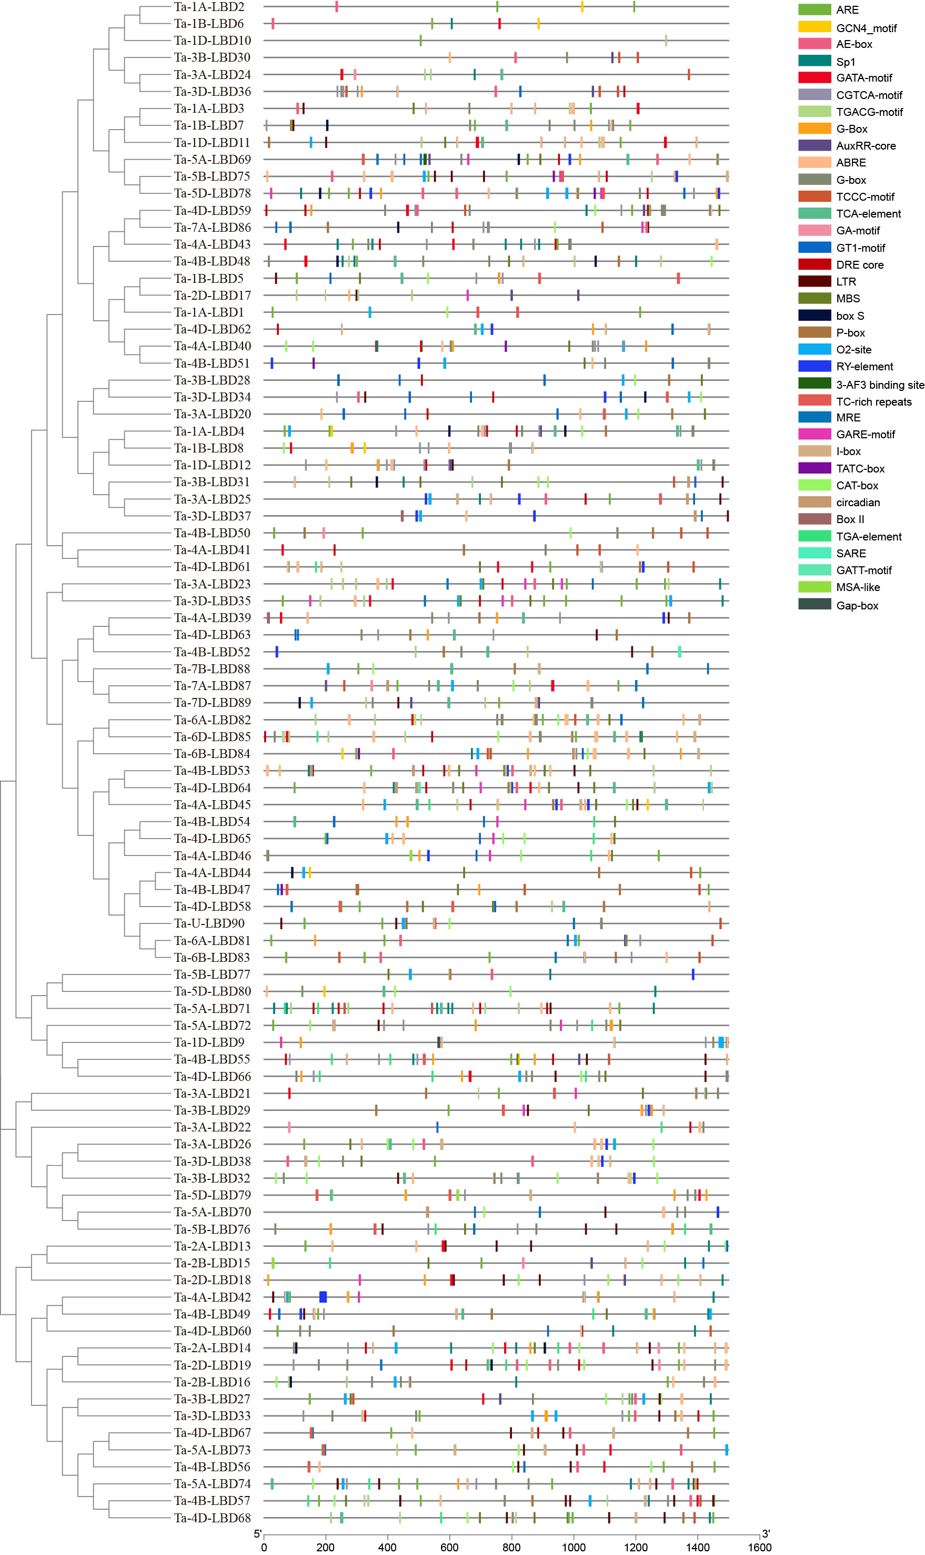
Figure S2. The distribution of cis-elements in 90 TaLBDs promoter regions.

