Supplementary Fig 1
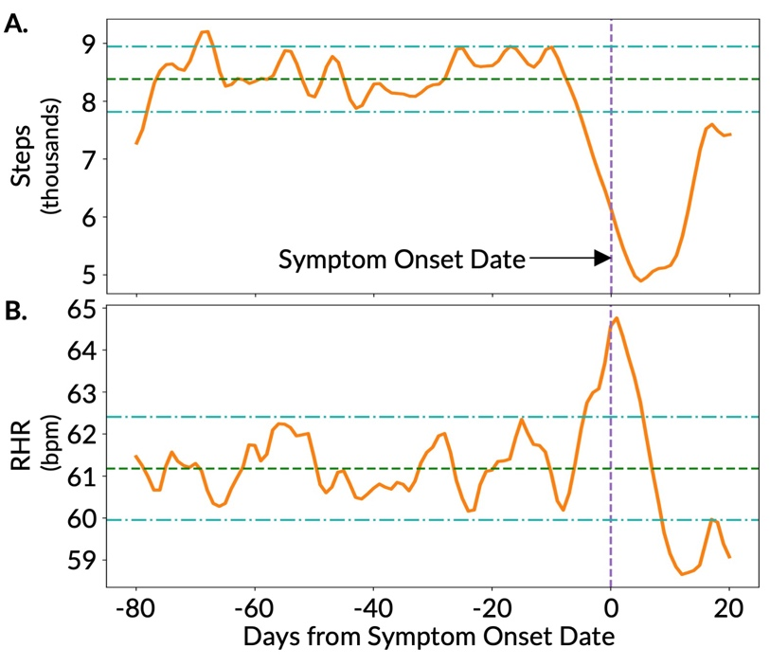

Supplementary Fig. 1. Time-series plot of digital biomarkers with respect to symptom onset date. (A) Time-averaged step count and (B) time-averaged resting heart rate (RHR) of the subset of participants (N=33) in the training set with available symptom onset date who tested positive for COVID-19. The horizontal green dashed lines and the horizontal light green dash-dotted lines show the baseline period mean and ± 2 standard deviations from the baseline mean respectively.

Supplementary Fig 2

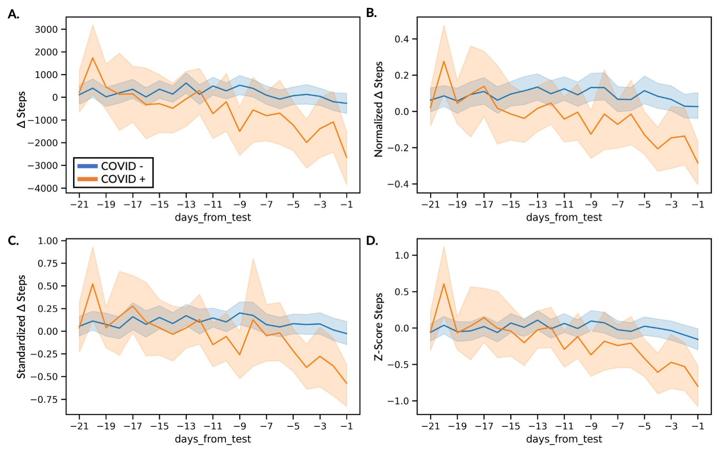
Supplementary Fig. 2. Time-series plot of four deviation metrics from the steps digital biomarker for the AF cohort. (A) deviation in step count from baseline median (detection – baseline median), ΔSteps, (B) normalized ΔSteps, (C) standardized ΔSteps, and (D) z-score ((detection – baseline mean) / baseline standard deviation) of Steps between the participants diagnosed as COVID-19 positive and negative. Confidence bands show the 95% confidence intervals.

Supplementary Fig 3

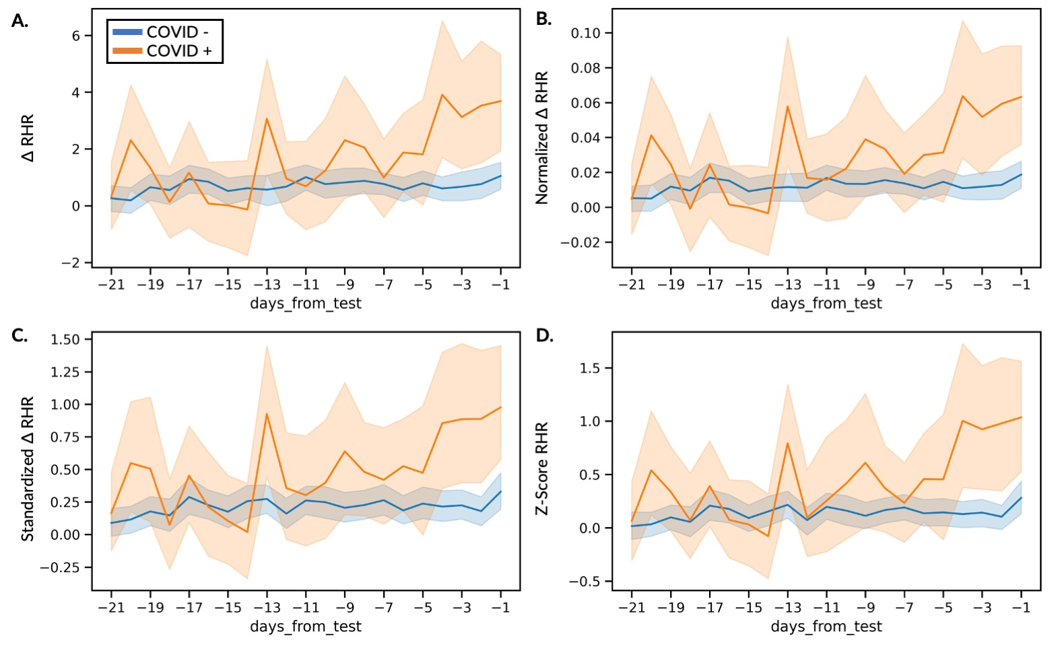
Supplementary Fig. 3. Time-series plot of four deviation metrics from the RHR digital biomarker for the AF cohort. (A) deviation in RHR from baseline median (detection – baseline median), ΔRHR, (B) normalized ΔRHR, (C) standardized ΔRHR, and (D) z-score ((detection − baseline mean) / baseline standard deviation) of RHR between the participants diagnosed as COVID-19 positive and negative. Confidence bands are showing the 95% confidence intervals.

Supplementary Fig 4
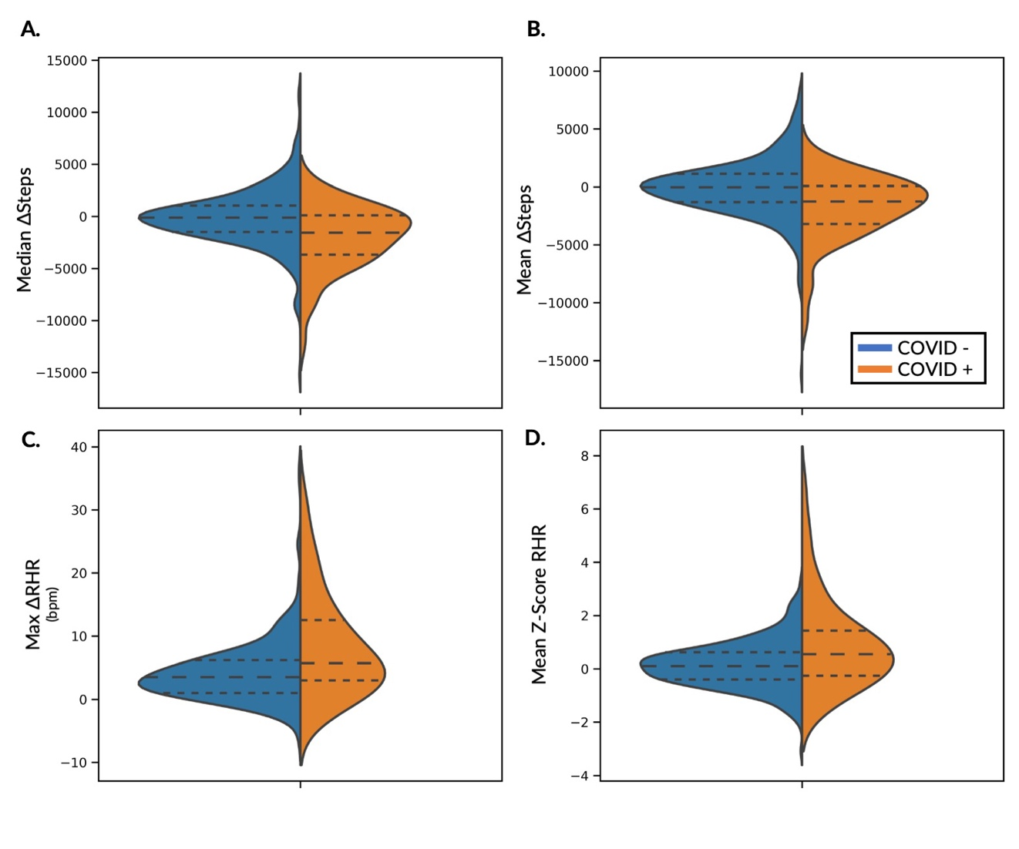

Supplementary Fig. 4. Distribution of the top two steps and RHR features across COVID-19 positive and negative groups in the AF cohort. Violin plots of two steps (A, B) and RHR (C, D) features with the lowest p-values, showing the distribution of the features between the participants diagnosed as COVID-19 positive (orange) and negative (blue). The outer dashed lines represent the first and third quartiles and the inner dashed line represents the median.

Supplementary Fig 5

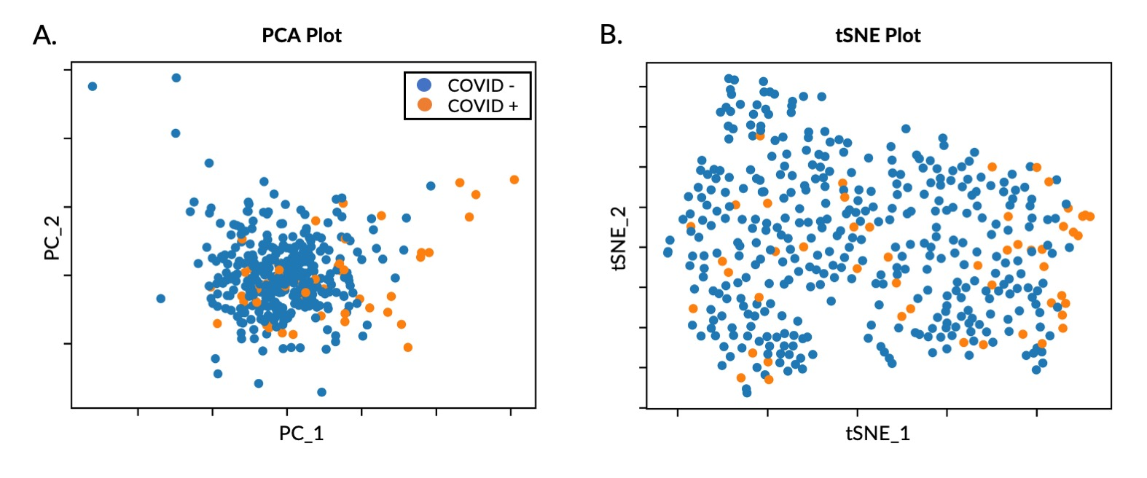
Supplementary Fig. 5. Low dimensional representation of input variables for the ITA model using the AF cohort. (A) Principal component analysis (PCA) and (B) t-stochastic neighborhood embedding (tSNE) plots for the input variables (significant steps and RHR features).

Supplementary Table 1: Demographic information for participants in the CovIdentify study
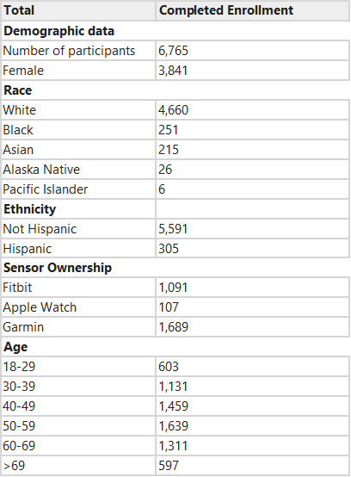

Supplementary Table 2: Significant features across three cohorts ordered in an ascending order based on significance (p-value).
AF Cohort | AHF Cohort | FHF Cohort
Mean Z-score RHR | Median Z-score RHR | Max ΔRHR
Max ΔRHR | Mean Z-score RHR | Max Normalized ΔRHR
Max Normalized ΔRHR | Max Z-score RHR | Range ΔRHR
Median Z-score RHR | Median Standardized ΔRHR | Range Normalized ΔRHR
Max Z-score RHR | Mean Standardized ΔRHR | Max Z-score RHR
Mean Normalized ΔRHR | Max Normalized ΔRHR | Mean Normalized ΔRHR
Mean Standardized ΔRHR | Max ΔRHR | Mean ΔRHR
Median Normalized ΔRHR | Mean ΔSteps | Max Standardized ΔRHR
Mean Standardized ΔRHR | Median ΔSteps | Mean Z-score RHR
Median ΔSteps | Mean Normalized ΔRHR | Mean ΔSteps
Mean ΔRHR | Median Normalized ΔRHR | Median ΔSteps
Max Standardized ΔRHR | Mean ΔRHR | Median Normalized ΔRHR
Median ΔRHR | Max Standardized ΔRHR | Median ΔRHR
Mean ΔSteps | Median ΔRHR | Median Z-score Steps
Mean Z-score Steps | Mean Z-score Steps | Mean Z-score Steps
Median Z-score Steps | Median Z-score Steps | Median Z-score RHR
Mean Normalized ΔSteps | Max Z-score Steps | Mean Standardized ΔRHR
Mean Standardized ΔSteps | Mean Normalized ΔSteps | Range Z-score RHR
Median Standardized ΔSteps | Median Standardized ΔSteps | Median Standardized ΔSteps
Max Z-score Steps | Mean Standardized ΔSteps | Mean Standardized ΔSteps
Median Normalized ΔSteps | Max ΔSteps | Median Standardized ΔRHR
Min ΔSteps | Min ΔSteps | Min ΔSteps
Max Standardized ΔSteps | Median Normalized ΔSteps | Max Z-score Steps
Max Normalized ΔSteps | Max Normalized ΔSteps | Mean Normalized ΔSteps
Min Normalized ΔSteps | Max Standardized ΔSteps | Max ΔSteps
Max ΔSteps | Min Z-score RHR | Max Standardized ΔSteps
Min Z-score RHR | Min Standardized ΔRHR | Median Normalized ΔSteps
Min Standardized ΔRHR | Min Normalized ΔSteps | Min Normalized ΔSteps
Min Z-score Steps |  | Max Normalized ΔSteps
 |  | Min Z-score Steps
 |  | Min Z-score RHR

Max, Maximum; Min, Minimum.

