Extended Data Fig 1

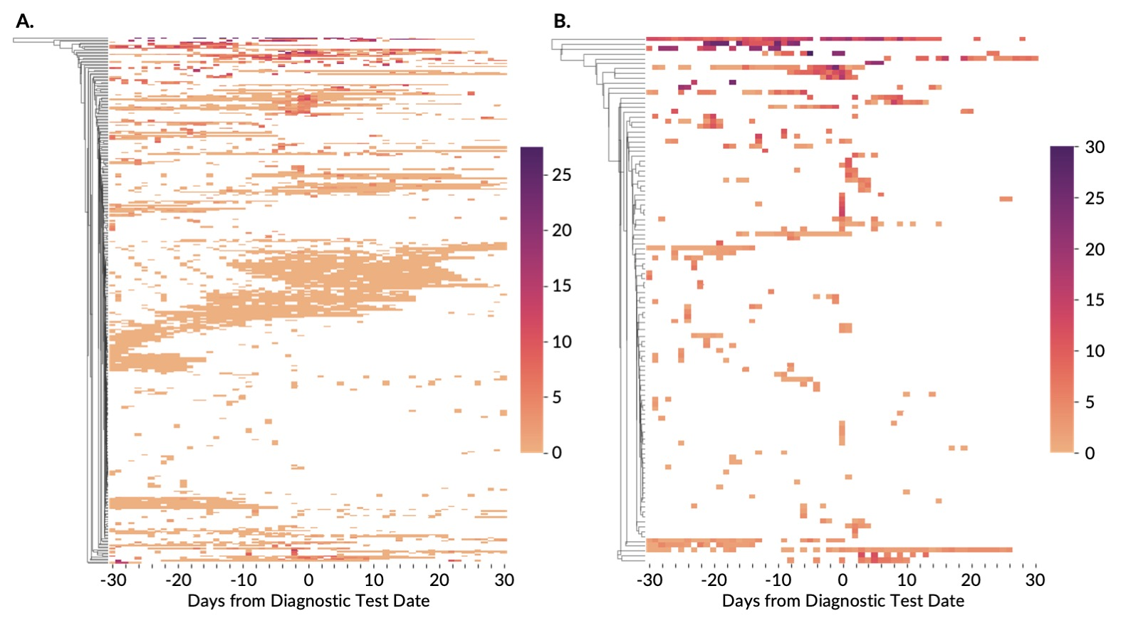

Extended Data Fig. 1. Hierarchical clustering of COVID-19 negative participants.
A. CovIdentify participants (n = 348) B. MyPHD participants (n =108). Each participant is represented by a row on the heatmap to the right of the dendrogram. The color scale demonstrates the daily sum of the symptom ratings, where each symptom ranged on a scale from 1 to 5 (purple = most symptomatic and peach = least symptomatic). Areas in white show where no symptoms were reported.

Extended Data Fig 2

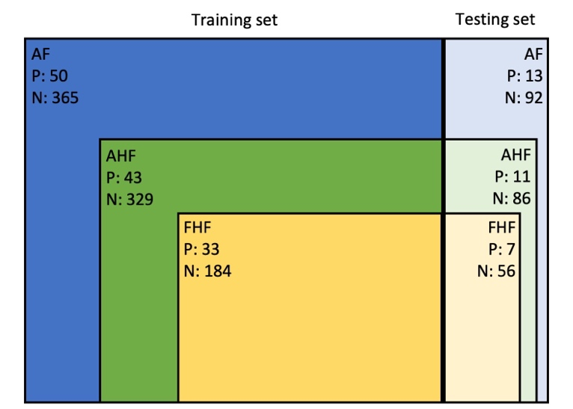
Extended Data Fig. 2. Cohort definitions. All three cohorts (All Frequency, AF (blue), All-High-Frequency, AHF (green), and Fitbit-High-Frequency, FHF (yellow)) were divided into an 80% train and 20% test split, with FHF as a subgroup of AHF, which itself is a subset of AF to ensure that no observations in the training set of one cohort existed in the test set of another.

Extended Data Fig 3
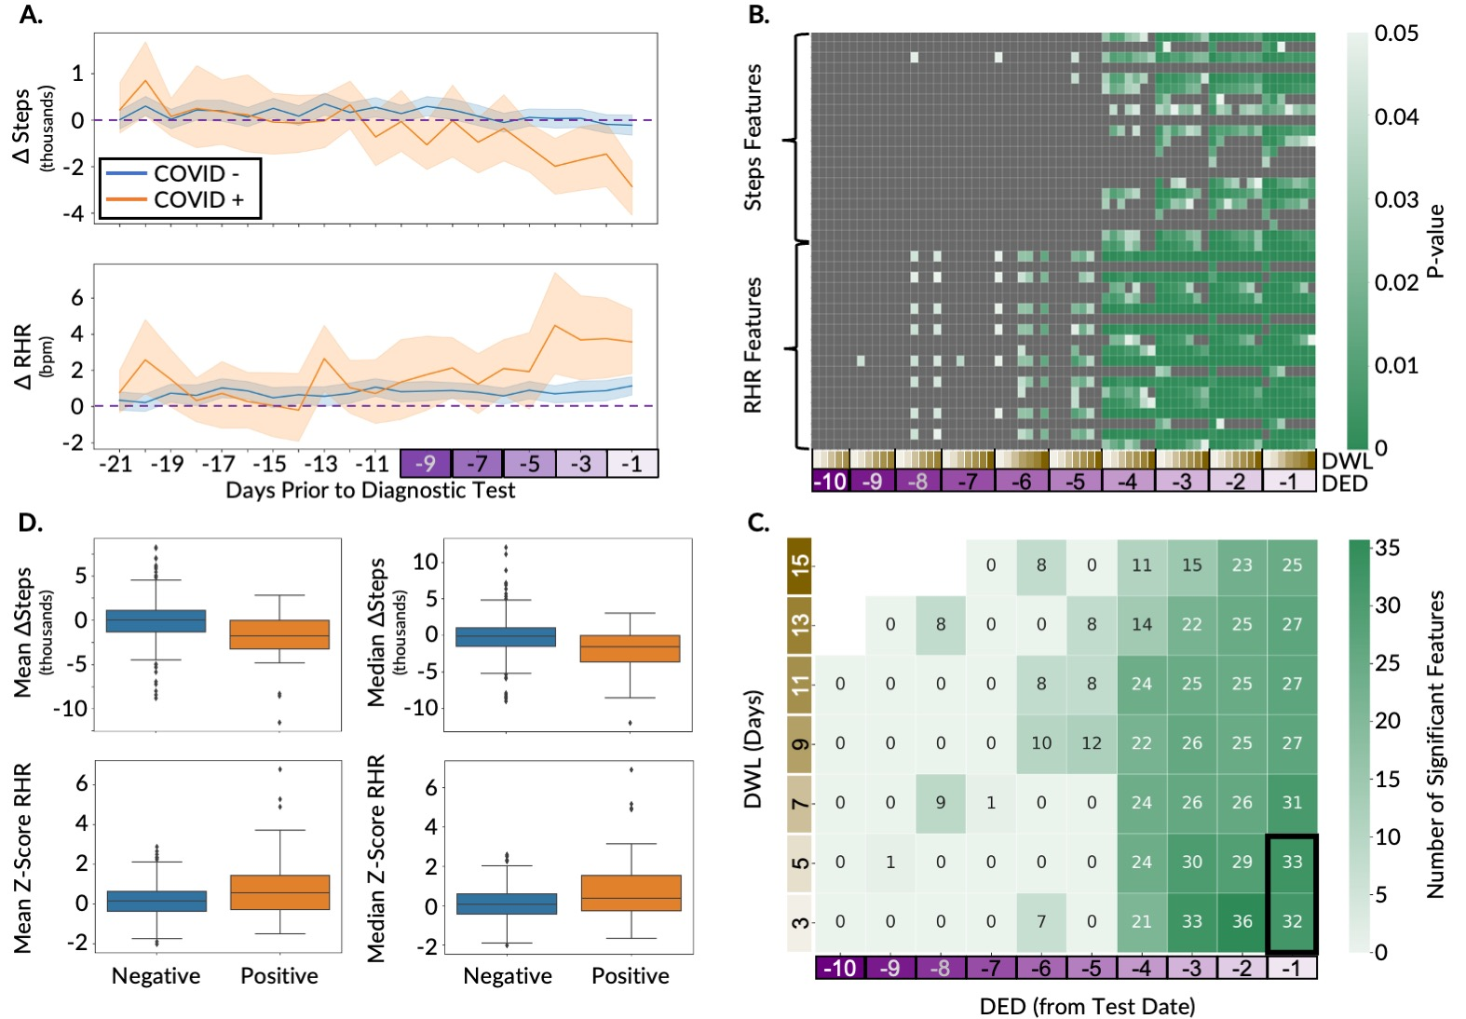

Extended Data Fig. 3. Overview of the feature exploration and extraction for the ITA model development on the AHF cohort. A. Time-series plot of the deviation in digital biomarkers (ΔSteps and ΔRHR) in the detection window compared to baseline periods, between the participants diagnosed as COVID-19 positive and negative. The horizontal dashed line displays the baseline median and the confidence bounds show the 95% confidence intervals. B. Heatmaps of steps and RHR features that are statistically significantly different (p-value < 0.05) in a grid search with different DED and DWL combinations, with green boxes showing p-values < 0.05 and gray boxes showing p-values ≥ 0.05. The p-values are adjusted with the Benjamini-Hochberg method for multiple hypothesis correction. C. Summary of the significant features (p-value < 0.05) from B, with each box showing the number of statistically significant features for the different combinations of DED and DWL. The intersection of the significant features across DWL of 3 and 5 days with a common DED of 1 day prior to the test date (as shown using the black rectangle) were used for the ITA model development. D. Box plots comparing the distribution of the two most significant steps and RHR features between the participants diagnosed as COVID-19 positive and negative.

Extended Data Fig 4
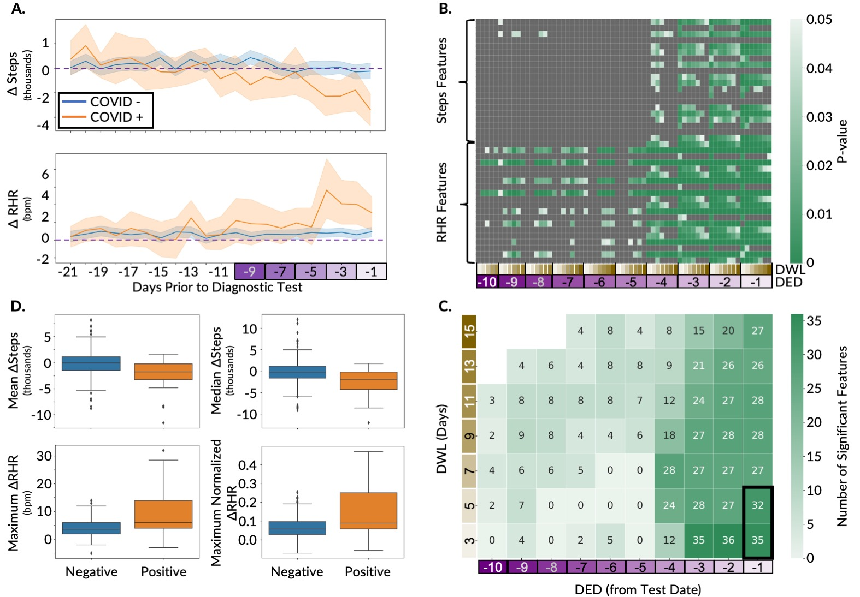

Extended Data Fig. 4. Overview of the feature exploration and extraction for the ITA model development on the FHF cohort. A. Time-series plot of the deviation in digital biomarkers (ΔSteps and ΔRHR) in the detection window compared to baseline periods, between the participants diagnosed as COVID-19 positive and negative. The horizontal dashed line displays the baseline median and the confidence bounds show the 95% confidence intervals. B. Heatmaps of steps and RHR features that are statistically significantly different (p-value < 0.05) in a grid search with different DED and DWL combinations, with green boxes showing p-values < 0.05 and gray boxes showing p-values ≥ 0.05. The p-values are adjusted with the Benjamini-Hochberg method for multiple hypothesis correction. C. Summary of the significant features (p-value < 0.05) from B, with each box showing the number of statistically significant features for the different combinations of DED and DWL. The intersection of the significant features across DWL of 3 and 5 days with a common DED of 1 day prior to the test date (as shown using the black rectangle) were used for the ITA model development. D. Box plots comparing the distribution of the two most significant steps and RHR features between the participants diagnosed as COVID-19 positive and negative.

Extended Data Fig 5

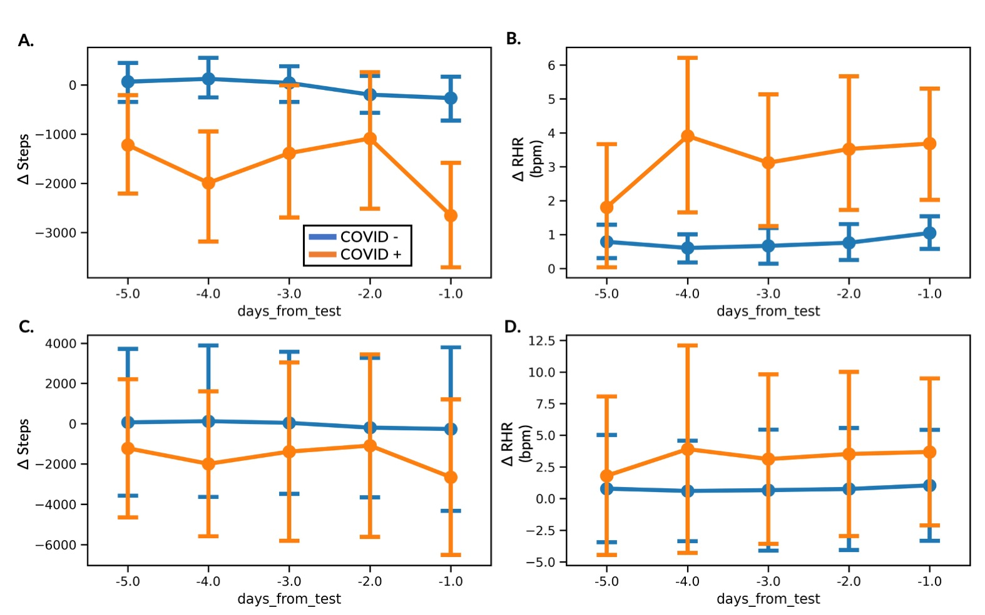
Extended Data Fig. 5. Overview of the digital biomarkers in the detection period showing different representations of error bars. Time-series plot of Δ Steps (A, C), and Δ RHR (B, D) between the participants diagnosed as COVID-19 positive (orange) and negative (blue). Error bars in A and B show the 95% confidence intervals, whereas error bars in C and D show the one standard deviation.

Extended Data Fig 6

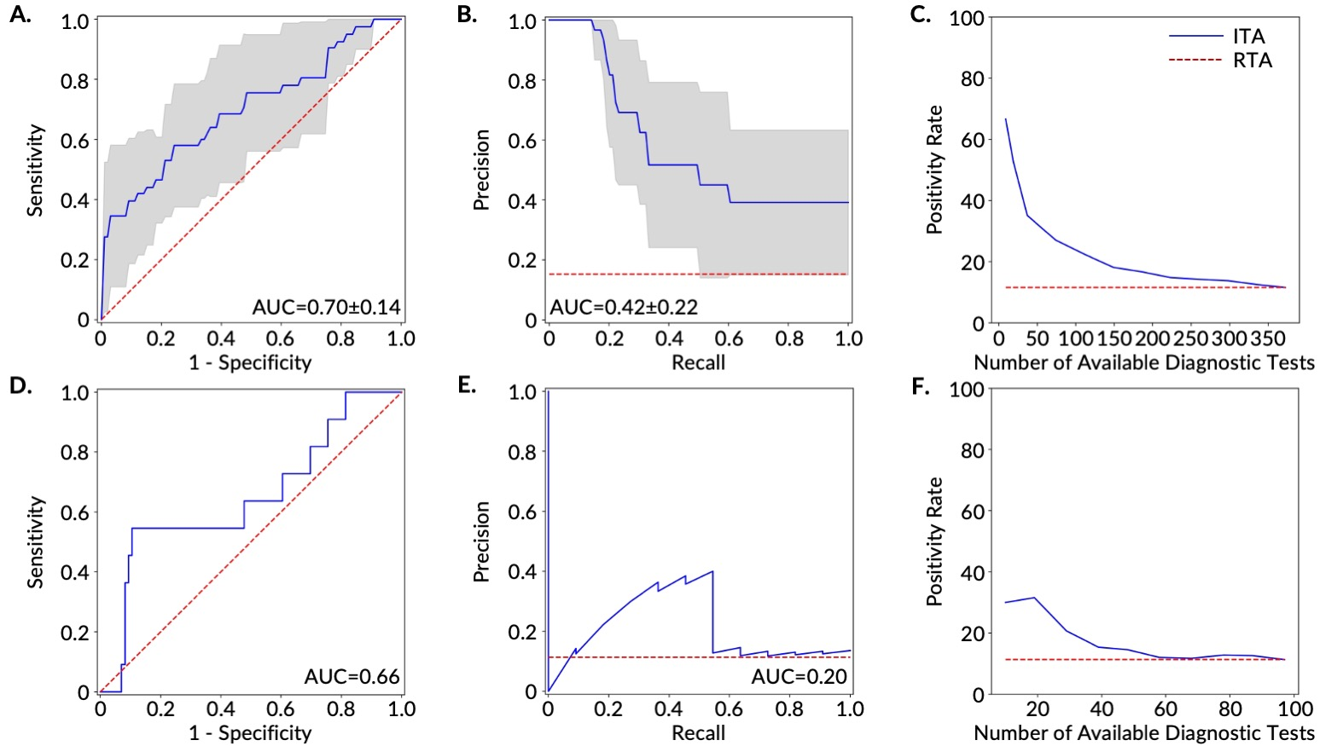
Extended Data Fig. 6. Prediction and ranking results of the ITA models on both the training (A-C) and testing sets (D-F) for the AHF Cohort. A. Receiver operating characteristics curves (ROCs) and B. precision-recall curves (PRCs) for the discrimination between COVID-19 positive participants (n=43) and negative participants (n=329) in the training set. The gray area shows one standard deviation from the mean of the ROCs/PRCs generated from 10-fold nested cross-validation on the training set and the red dashed line shows the results based on a Random Testing Allocation (RTA) model (the null model). C. The positivity rate of the diagnostic testing subpopulation as determined by ITA given a specific number of available diagnostic tests. The red dashed line displays the positivity rate/pre-test probability of an RTA (null) model. D. ROC and E. PRC for the discrimination between Covid-19 positive participants (n=11) and negative participants (n=86) in the test set. The red dashed line shows the results based on an RTA model. F. Positivity rate of the diagnostic testing subpopulation as determined by ITA given a specific number of available diagnostic tests. The red dashed line shows the positivity rate of an RTA (null) model.

Extended Data Fig 7

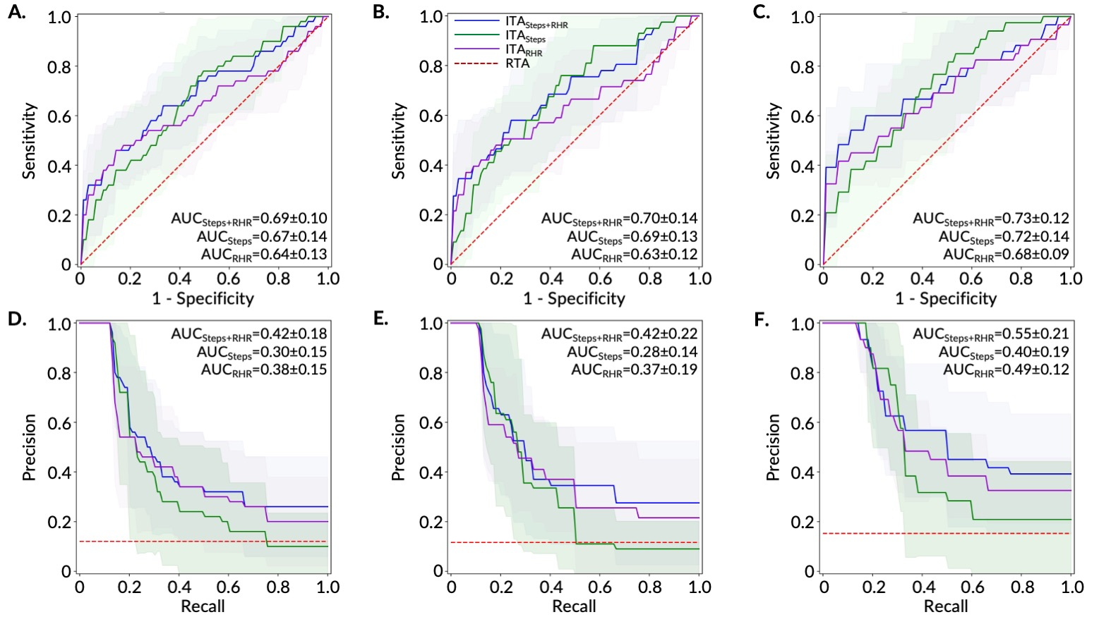
Extended Data Fig. 7. Comparison of model performance on all three cohorts using features from combination of Steps and RHR, Steps and RHR digital biomarkers. (A, B, C) ROC curves and (D, E, F) PR curves generated from the model built on the training set of the three cohorts (AF, AHF, and FHF) and evaluated with 10-fold nested cross-validation. The light blue, light green, and light violet area show one standard deviation from the mean of the ROCs/PRs generated from 10-fold nested cross-validation on the training set for the models with Steps+RHR, Steps, and RHR features, respectively. The red dashed line shows the results based on a random testing allocation (RTA), or null model.

Extended Data Fig 8
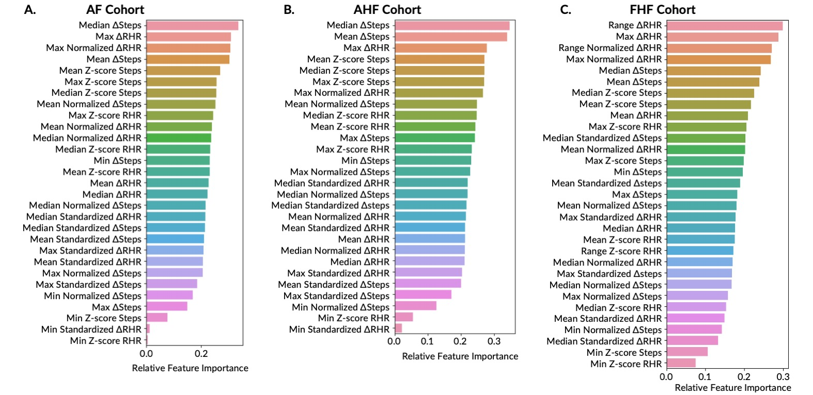
Extended Data Fig. 8. Feature importance ranking for the logistic regression models. Feature importance ranking based on the absolute value of coefficients of each feature used in the logistic regression model using training data from the (A) AF (B) AHF, and (C) FHF cohorts. Max, maximum; Min, minimum.

Extended Data Table 1: Performance of the five machine learning algorithms tested for the ITA model.

Cohort | AF |  | AHF |  | FHF
Model | AUC-ROC | AUC-PR | AUC-ROC | AUC-PR | AUC-ROC | AUC-PR
Logistic Regression | 0.69±0.10 | 0.42±0.18 | 0.70±0.14 | 0.42±0.22 | 0.73±0.12 | 0.55±0.21
KNN | 0.61±0.11 | 0.32±0.17 | 0.61±0.11 | 0.32±0.18 | 0.67±0.12 | 0.48±0.21
SVM | 0.63±0.12 | 0.27±0.17 | 0.64±0.13 | 0.32±0.20 | 0.64±0.16 | 0.45±0.16
Random Forest | 0.67±0.13 | 0.38±0.17 | 0.68±0.15 | 0.41±0.20 | 0.71±0.14 | 0.5±0.16
XGBoost | 0.67±0.14 | 0.35±0.19 | 0.71±0.12 | 0.4±0.20 | 0.71±0.13 | 0.45±0.20
Results reported in this table are generated from the model developed on the training set of the three cohorts using 10-fold nested cross-validation. The cross-validation results are calculated based on the validation on the left-out-fold in each iteration of the outer loop of the nested cross-validation and are reported in the mean (± SD) format.

Extended Data Table 2: ITA model performance for symptomatic and asymptomatic individuals.

Cohorts | Total Dataset |  |  |  | ITA Determined Subpopulation  (30% Testing Capacity)
Cohorts | Total N | Total COVID+ | Total COVID+  Symptomatic | Total  COVID+  Asymptomatic | Total N | Total COVID+ | Total COVID+  Symptomatic | Total  COVID+  Asymptomatic
Training Set
AF | 415 | 50 | 29 | 21 | 124 | 26 | 19 | 7
AHF | 372 | 43 | 29 | 14 | 112 | 25 | 20 | 5
FHF | 217 | 33 | 21 | 12 | 65 | 20 | 16 | 4
Test Set
AF | 105 | 13 | 8 | 5 | 32 | 6 | 5 | 1
AHF | 97 | 11 | 8 | 3 | 29 | 6 | 5 | 1
FHF | 63 | 7 | 6 | 1 | 19 | 5 | 4 | 1

