Extended Data Figures and Tables

Extended Data Fig. 1.

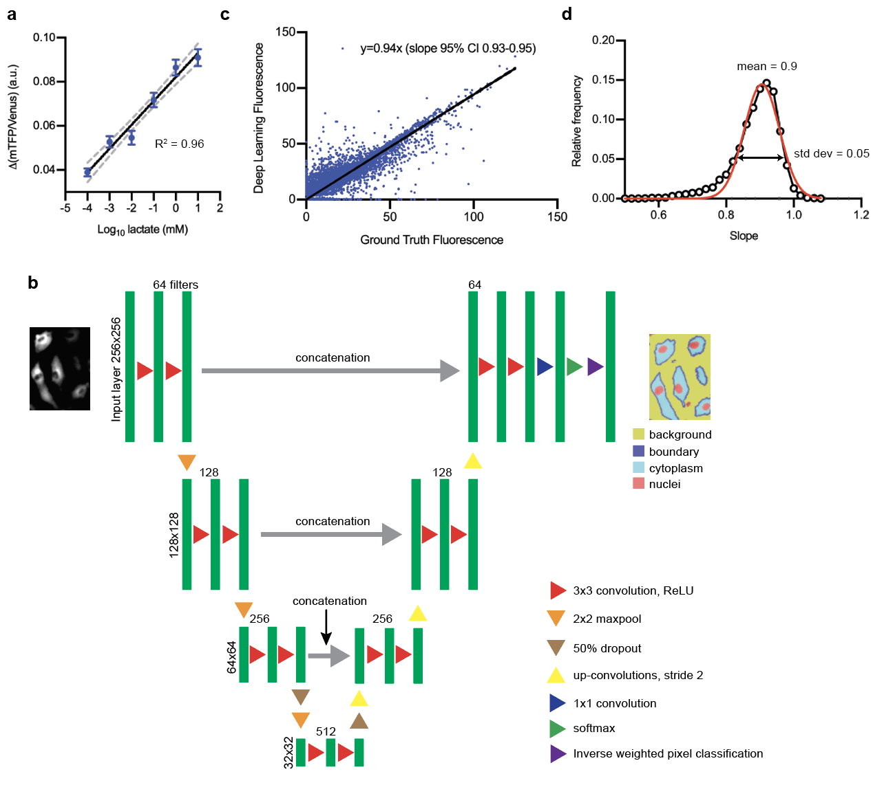
Extended Data Fig. 1: Single-cell metabolic assay utilizes deep learning-enabled segmentation. a, mTFP/Venus (or 1/FRET) change was linearly correlated over 6 orders of magnitude of log lactate (n = 287 cells; black line is semilog fit with R² = 0.96, gray dotted lines are 95% confidence interval). Standard deviation of regression coefficients for R² for (a) is 0.049. b, Deep learning architecture for semantic segmentation. The ground truth containing images and class labels were randomized into training (70%), validation (15%), and testing (15%) datasets. Random extraction of 128 × 128 patches was augmented by random reflection, rotation, and shear up to 10 degrees for input into the U-net shown. The U-net consisted of 3 sequential sets of 2 convolutional/ReLU layers followed by maxpooling for a final image size of 32 × 32. After 2 more convolutional/ReLU layers, the process was repeated in reverse with upconvolutions. When the tile size was up-sampled, the tiles were concatenated with images of the down-sampling path in order to localize learning in the image. The final layer consisted of pixel classification with inverse class weighting (based on normalized class frequency). c, Ground Truth Fluorescence vs. Deep Learning Fluorescence evaluation of deep-learning-enabled semantic segmentation. (n ~ 20,000 cells) Ground truth fluorescence was defined as signal inside the cell boundary. d, Frequency distribution of fluorescence slopes. Data from (c) or are randomly sampled 100 times and fitted to a line. This process is repeated 10,00 times and the distribution of fitted slopes was plotted (open black circles). The red line is a Gaussian fit with mean 0.9 and standard deviation of 0.05. Thus, the error in estimating slopes of fluorescence is approximately 0.05/0.9, or approximately 5%.

Extended Data Fig. 2
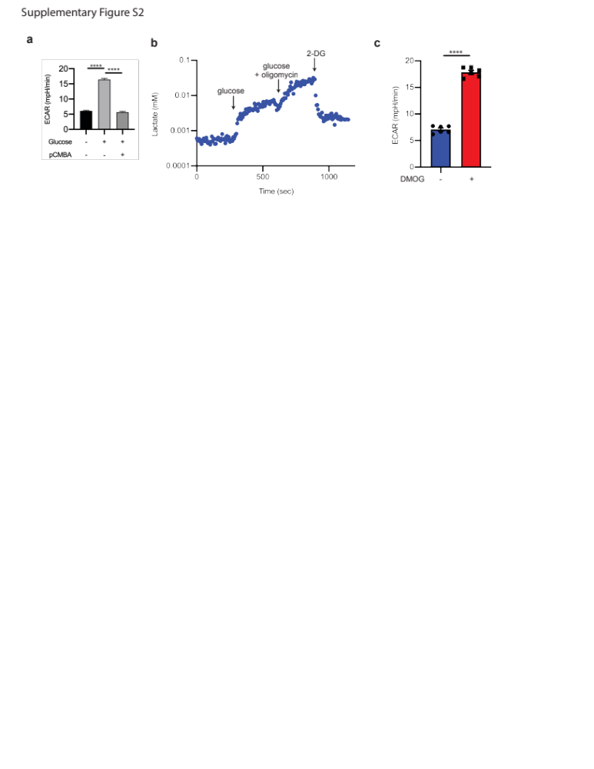
Extended Data Fig. 2: Single-cell laconic accurately mimics bioenergetics assays. a, Extracellular flux assay of HAECs treated with glucose then pCMBA (n = 5) using Seahorse. b, A single-cell glycolytic stress test using lactate FRET sensor. Cells were first starved in zero glucose buffer for 1 hour. Glucose addition increased intracellular lactate, which was further increased by adding oligomycin and glucose. Addition of 2-deoxyglucose (2-DG) blocked all glycolysis, causing intracellular lactate to drop. c, Overnight treatment of endothelial cells with 500 μM DMOG increases ECAR measured by extracellular flux relative to DMSO-treated cells using Seahorse. (n = 11 combined biological and technical replicates for each condition; error bars are SEM). ****p < 0.00005. Statistical significance determined by one-way ANOVA followed by Bonferroni test (a) or by Welch’s t-test (c).

Extended Data Fig. 3
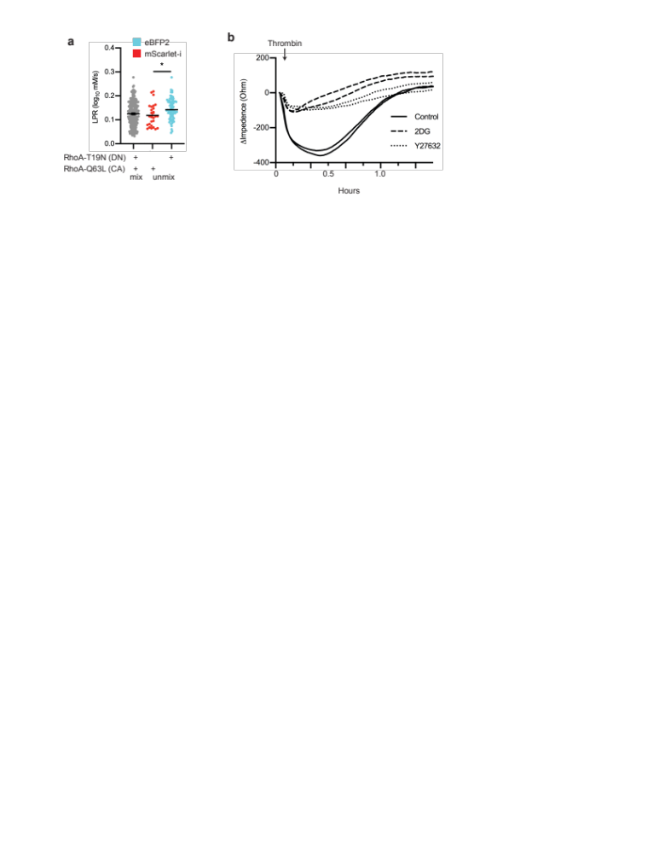
Extended Data Fig. 3: RhoA activity induces contraction using glycolysis. a, LPR of HAECs transfected with either RhoA-T19N-eBFP2 (dominant negative form, cyan) or RhoA-Q63L-mScarlet-i (constitutively active form, red), mixed, then deconvoluted by color (n = 174 “cyan” and 52 “red”, respectively). b, TEER measurement of HAECs after thrombin treatment, either pre-treated with Y27632 or 2DG compared to control (no Y27632 or 2DG). *p < 0.05. Statistical significance determined by Welch’s t-test.

Extended Data Fig. 4.
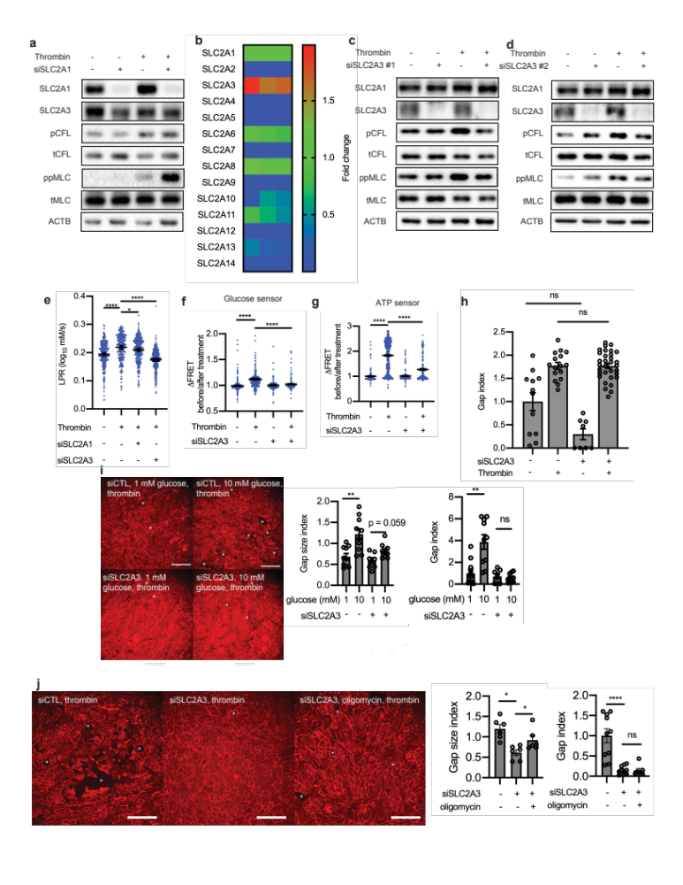
Extended Data Fig. 4: SLC2A3 but not SLC2A1 knockdown mitigates thrombin-induced phosphorylation of CFL and MLC and glycolysis. a, Western blot of SLC2A1, SLC2A3, phospho-cofilin and phospho-MLC in the presence or absence of siRNA targeted towards SLC2A1 and thrombin treatment. b, Heatmap of glucose transporter expression relative to SLC2A1 in HAECs captured by qRT-PCR (n = 3 biological replicates) c-d, Western blot of SLC2A1, SLC2A3, phospho-cofilin and phospho-MLC in the presence or absence of two distinct siRNA (separate from the one used in Figure 5a) (#1 in c and #2 in d) targeted towards SLC2A3 and thrombin treatment. e, Single-cell LPR of HAECs treated with thrombin in the presence of siSLC2A1 or siSLC2A3. f-g, Glucose (f) and ATP levels (g) in single-cells in the presence or absence of SLC2A3 knockdown and thrombin treatment (n = 190, 598, 150, 287 from left to right). h, Gap index of cells treated with or without thrombin in the presence or absence of SLC2A3 knockdown (n= 12, 16, 8, 32 from left to right). i-j, Representative images of HAECs treated with siSLC2A3 or control with varying concentrations of glucose (i) or with oligomycin (j) in the presence of thrombin. Red color is CDH5. Gap size index and gap index quantification of images (h, n = 10, 10, 7, 8 from left to right; i, n = 10, 10, 7, 100 from left to right; j, n = 6 for gap size index and n = 10, 11, 7 from left to right for gap index). White stars highlight gaps in the monolayer. Scale bars = 250 μm. *p < 0.05, **p < 0.005, ****p < 0.00005. Statistical significance determined by one-way ANOVA followed by Bonferroni test (e-g) or by Welch’s t-test (h-j).

Extended Data Fig. 5
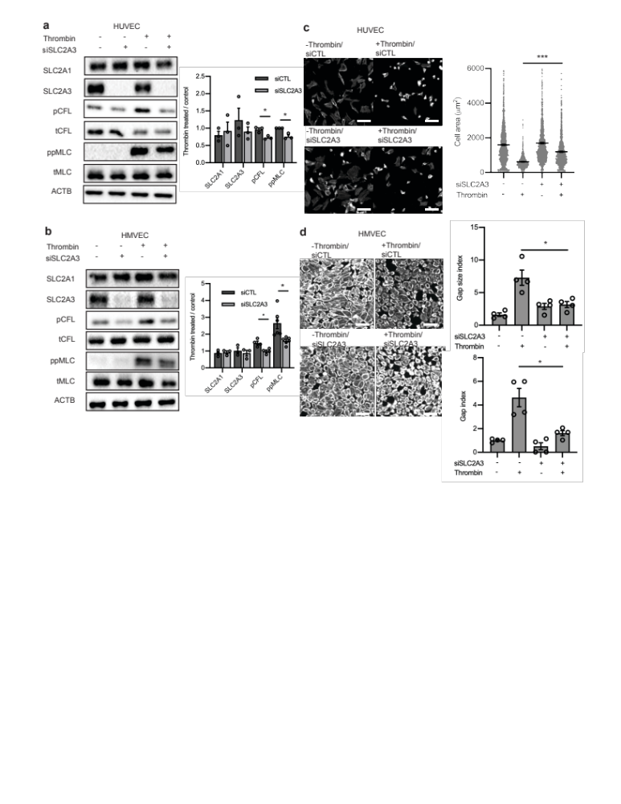
Extended Data Fig. 5: SLC2A3 inhibition abrogates thrombin-induced phosphorylation of CFL and MLC and contraction across multiple endothelial cell types. a-b, Western blot analysis of glucose transporter expression, phosphorylated CFL, and phosphorylated MLC, in human umbilical vein endothelial cells (HUVEC, a, n = 3) and human microvascular endothelial cells (HMVEC, b, n = 3-5). c, Representative images and cell size of contractile HUVECs subjected to thrombin stimulation in the absence or presence of SLC2A3 knockdown. (n = 1375, 1279, 760, 1162 from left to right) d, Representative images, gap size index, and gap index of contractile HMVECs subjected to thrombin stimulation in the absence or presence of SLC2A3 knockdown. Representative images are phalloidin. (n = 4 biological replicates) *p < 0.05, ***p < 0.0005. Statistical significance determined by Welch’s t-test.

Extended Data Fig. 6
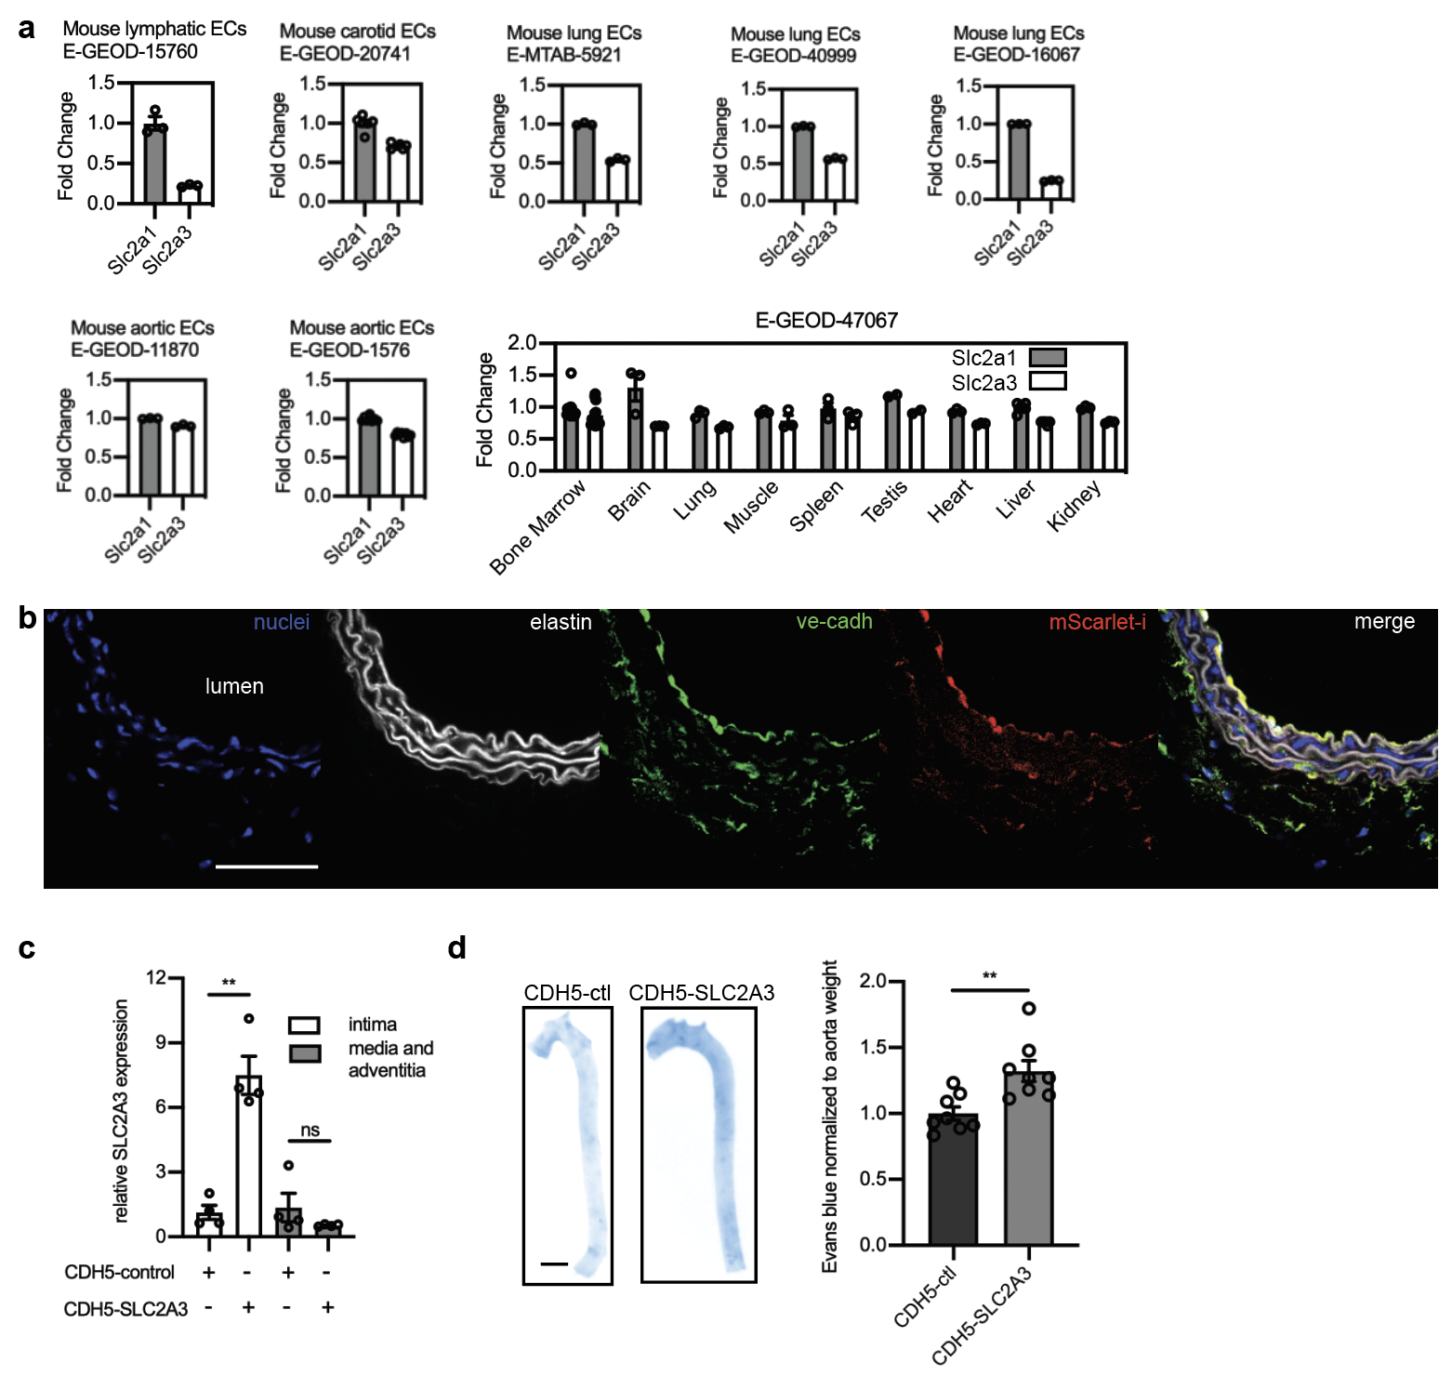
Extended Data Fig. 6: In vivo overexpression of SLC2A3 increased vascular leak. a, GEO datasets of primary endothelial mouse cells comparing Slc2a1 and Slc2a3 from different organs. Fold change indicates that data are normalized to Slc2a1 except for E-GEOD-47067 which was normalized to average of Slc2a1 in all tissues. Only controls of experiments in the GEO datasets were used in these analyses. b, Immunofluorescence of an arterial section demonstrating enhanced mScarlet-i fluorescence (red) colocalized with ve-cadh (green) which marks the endothelium next to the lumen (yellow, merge) (Scale bar, 500 μm). c, SLC2A3 expressing plasmid uses an endothelial specific CDH5 promoter. SLC2A3 is detected by qRT-PCR of the intima of the mouse aorta, and far less than in the media and adventitia. (n = 4 each condition) d, Evans blue (OD 620 nm) quantification of mouse aortas, normalized by weight. (n = 8 each condition). **p < 0.005 Statistical significance was determined by Welch’s t-test.

Extended Data Fig. 7.
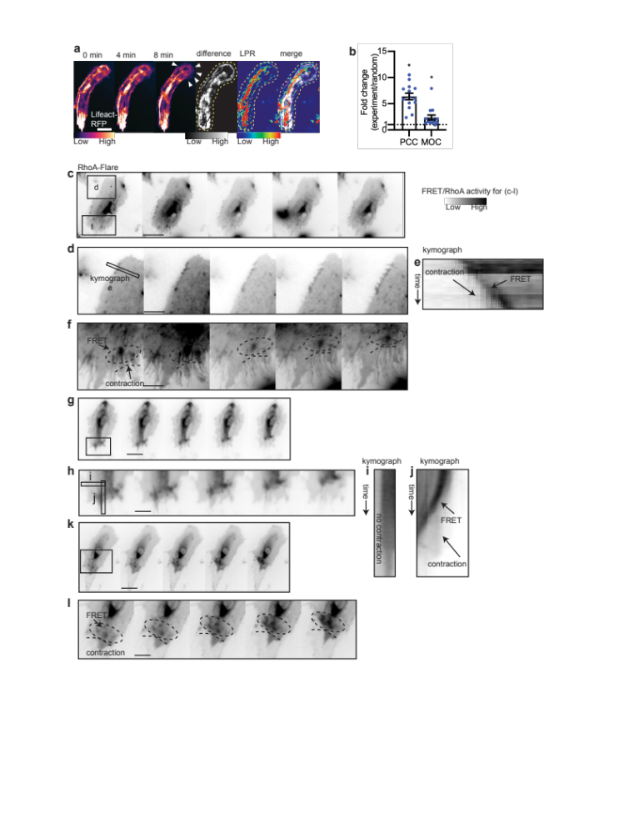
Extended Data Fig. 7: Subcellular RhoA activity, actin turnover, and LPR distribution in single motile endothelial cells. a, Montage of actin timelapse in a migratory endothelial cell; maximum projection of change in actin structure (Lifeact difference image, obtained by sequential subtraction of preceding 10 images, taken 1 minute apart, followed by maximum intensity projection of the absolute value of the differences), per pixel LPR map (LPR), Lifeact difference and LPR overlap (“difference+LPR”, merge), scale bar = 20 µm. White arrows in montage indicate cell spreading. Note how there was enhanced LPR near the regions of cell spreading. b, Pearson’s correlation coefficient (PCC) and Manders’ overlap coefficient (MOC) of Lifeact difference and LPR, compared to random. The random PCC/MOC is calculated by randomizing the LPR image and computing with the Lifeact difference image. Fold change of experimental PCC/MOC over randomized is shown. (n = 14). c-l, RhoA activity measured by RhoA-FLARE in contractile endothelial cells. (Scale bar = 16 μm in c, g, k. Scale bar = 7 μm in d, f, h, l). d,f, regions of contractile cell from (c) showing RhoA membrane activity. Circle in (f) notes moving RhoA activity. e, kymograph showing contractile edge from (d) and increasing RhoA activity over time. h, region of contractile cell from (g) showing increased RhoA membrane activity. i-j, kymograph showing non-contractile edge (i) without RhoA increase and contractile edge (j) from (g) and increasing RhoA activity over time. l, region of contractile cell from (k) showing RhoA membrane activity. Dotted ellipses notes highlight increasing RhoA activity along with active contraction. *p < 0.05. Statistical significance determined by Welch’s t-test.

Extended Data Table 1: Deep learning semantic segmentation metrics
Matthew’s Correlation Coefficient | 0.85
Global accuracy | 0.84
Class | Background | Cytoplasm | Nuclei | Cell boundary
Class specific accuracy | 0.85 | 0.83 | 0.45 | 0.78
Standard deviation of accuracy | 0.083 | 0.079 | 0.086 | 0.055
Boundary F1 score | 0.96 | 0.95 | 0.75 | 0.94
Standard deviation of Boundary F1 score | 0.05 | 0.047 | 0.079 | 0.071
Precision | 0.85 | 0.83 | 0.45 | 0.78
Recall | 0.97 | 0.84 | 0.31 | 0.38
Dice score | 0.9 | 0.82 | 0.38 | 0.53
Standard Deviation of Dice Score | 0.074 | 0.0659 | 0.064 | 0.064

