Supplementary FigureS1. BDNF and NGF Flow cytometry analysis of cortical neuron treated with 10, 25 and 50 µg/ml of LLT without H₂O₂ exposure. a) Representative dot plots graphs showing BDNF expression. b) Quantification of BDNF-positive cells at the single cell level. c) Representative dot plots graphs showing NGF expression. d) Quantification of NGF-positive cells at the single cell level. Data represent mean ± SEM of six independent experiments. Statistically significant differences compared with blank group by one-way ANOVA with Tukey’s post-hoc test. (*p < 0.05; **p < 0.01; ***p < 0.001).
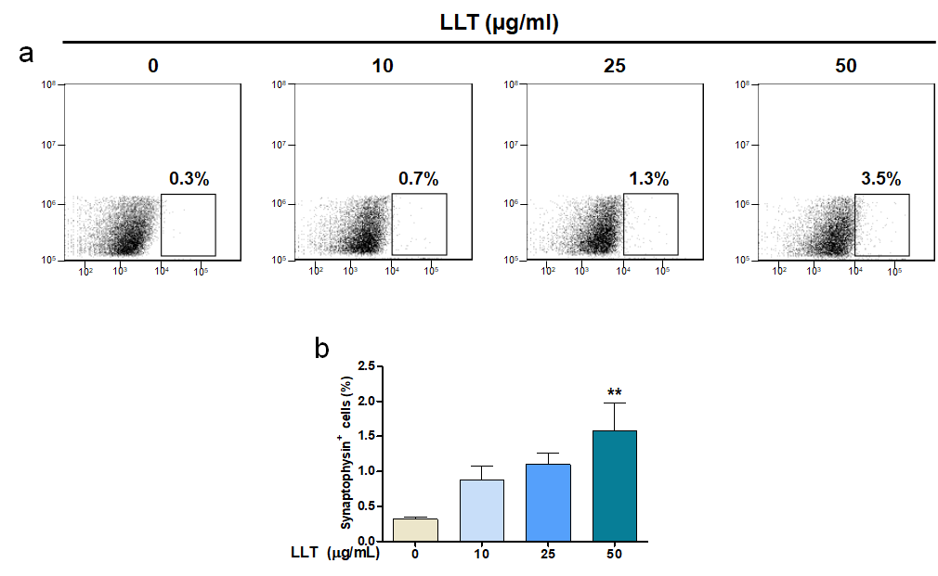
Supplementary FigureS2. Synaptophysin Flow cytometry analysis of cortical neuron treated with 10, 25 and 50 µg/ml of LLT without H₂O₂ exposure. a) Representative dot plots graphs showing Synaptophysin expression. b) Quantification of Synaptophysin-positive cells at the single cell level. Data represent mean ± SEM of six independent experiments. Statistically significant differences compared with blank group by one-way ANOVA with Tukey’s post-hoc test. (*p < 0.05; **p < 0.01; ***p < 0.001).

