Supplementary Material

Supplementary Figures and Tables

Supplementary Figures
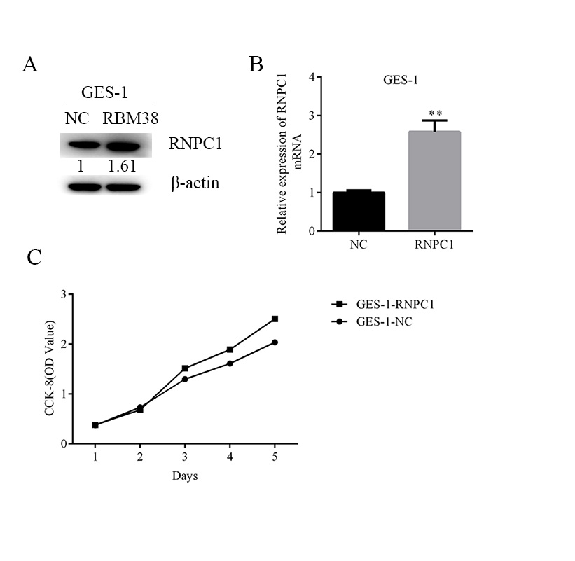
Supplementary Figure 1: RNPC1 overexpressed increased the viability of GES-1 cells.(A,B) Western blot and qRT-PCR were used to verify the efficiency of RNPC1 overexpressed in GES-1 cells. (C)The viability of gastric cancer cells were measured by CCK-8 assays, RNPC1 increased the viability of GES-1 cells.
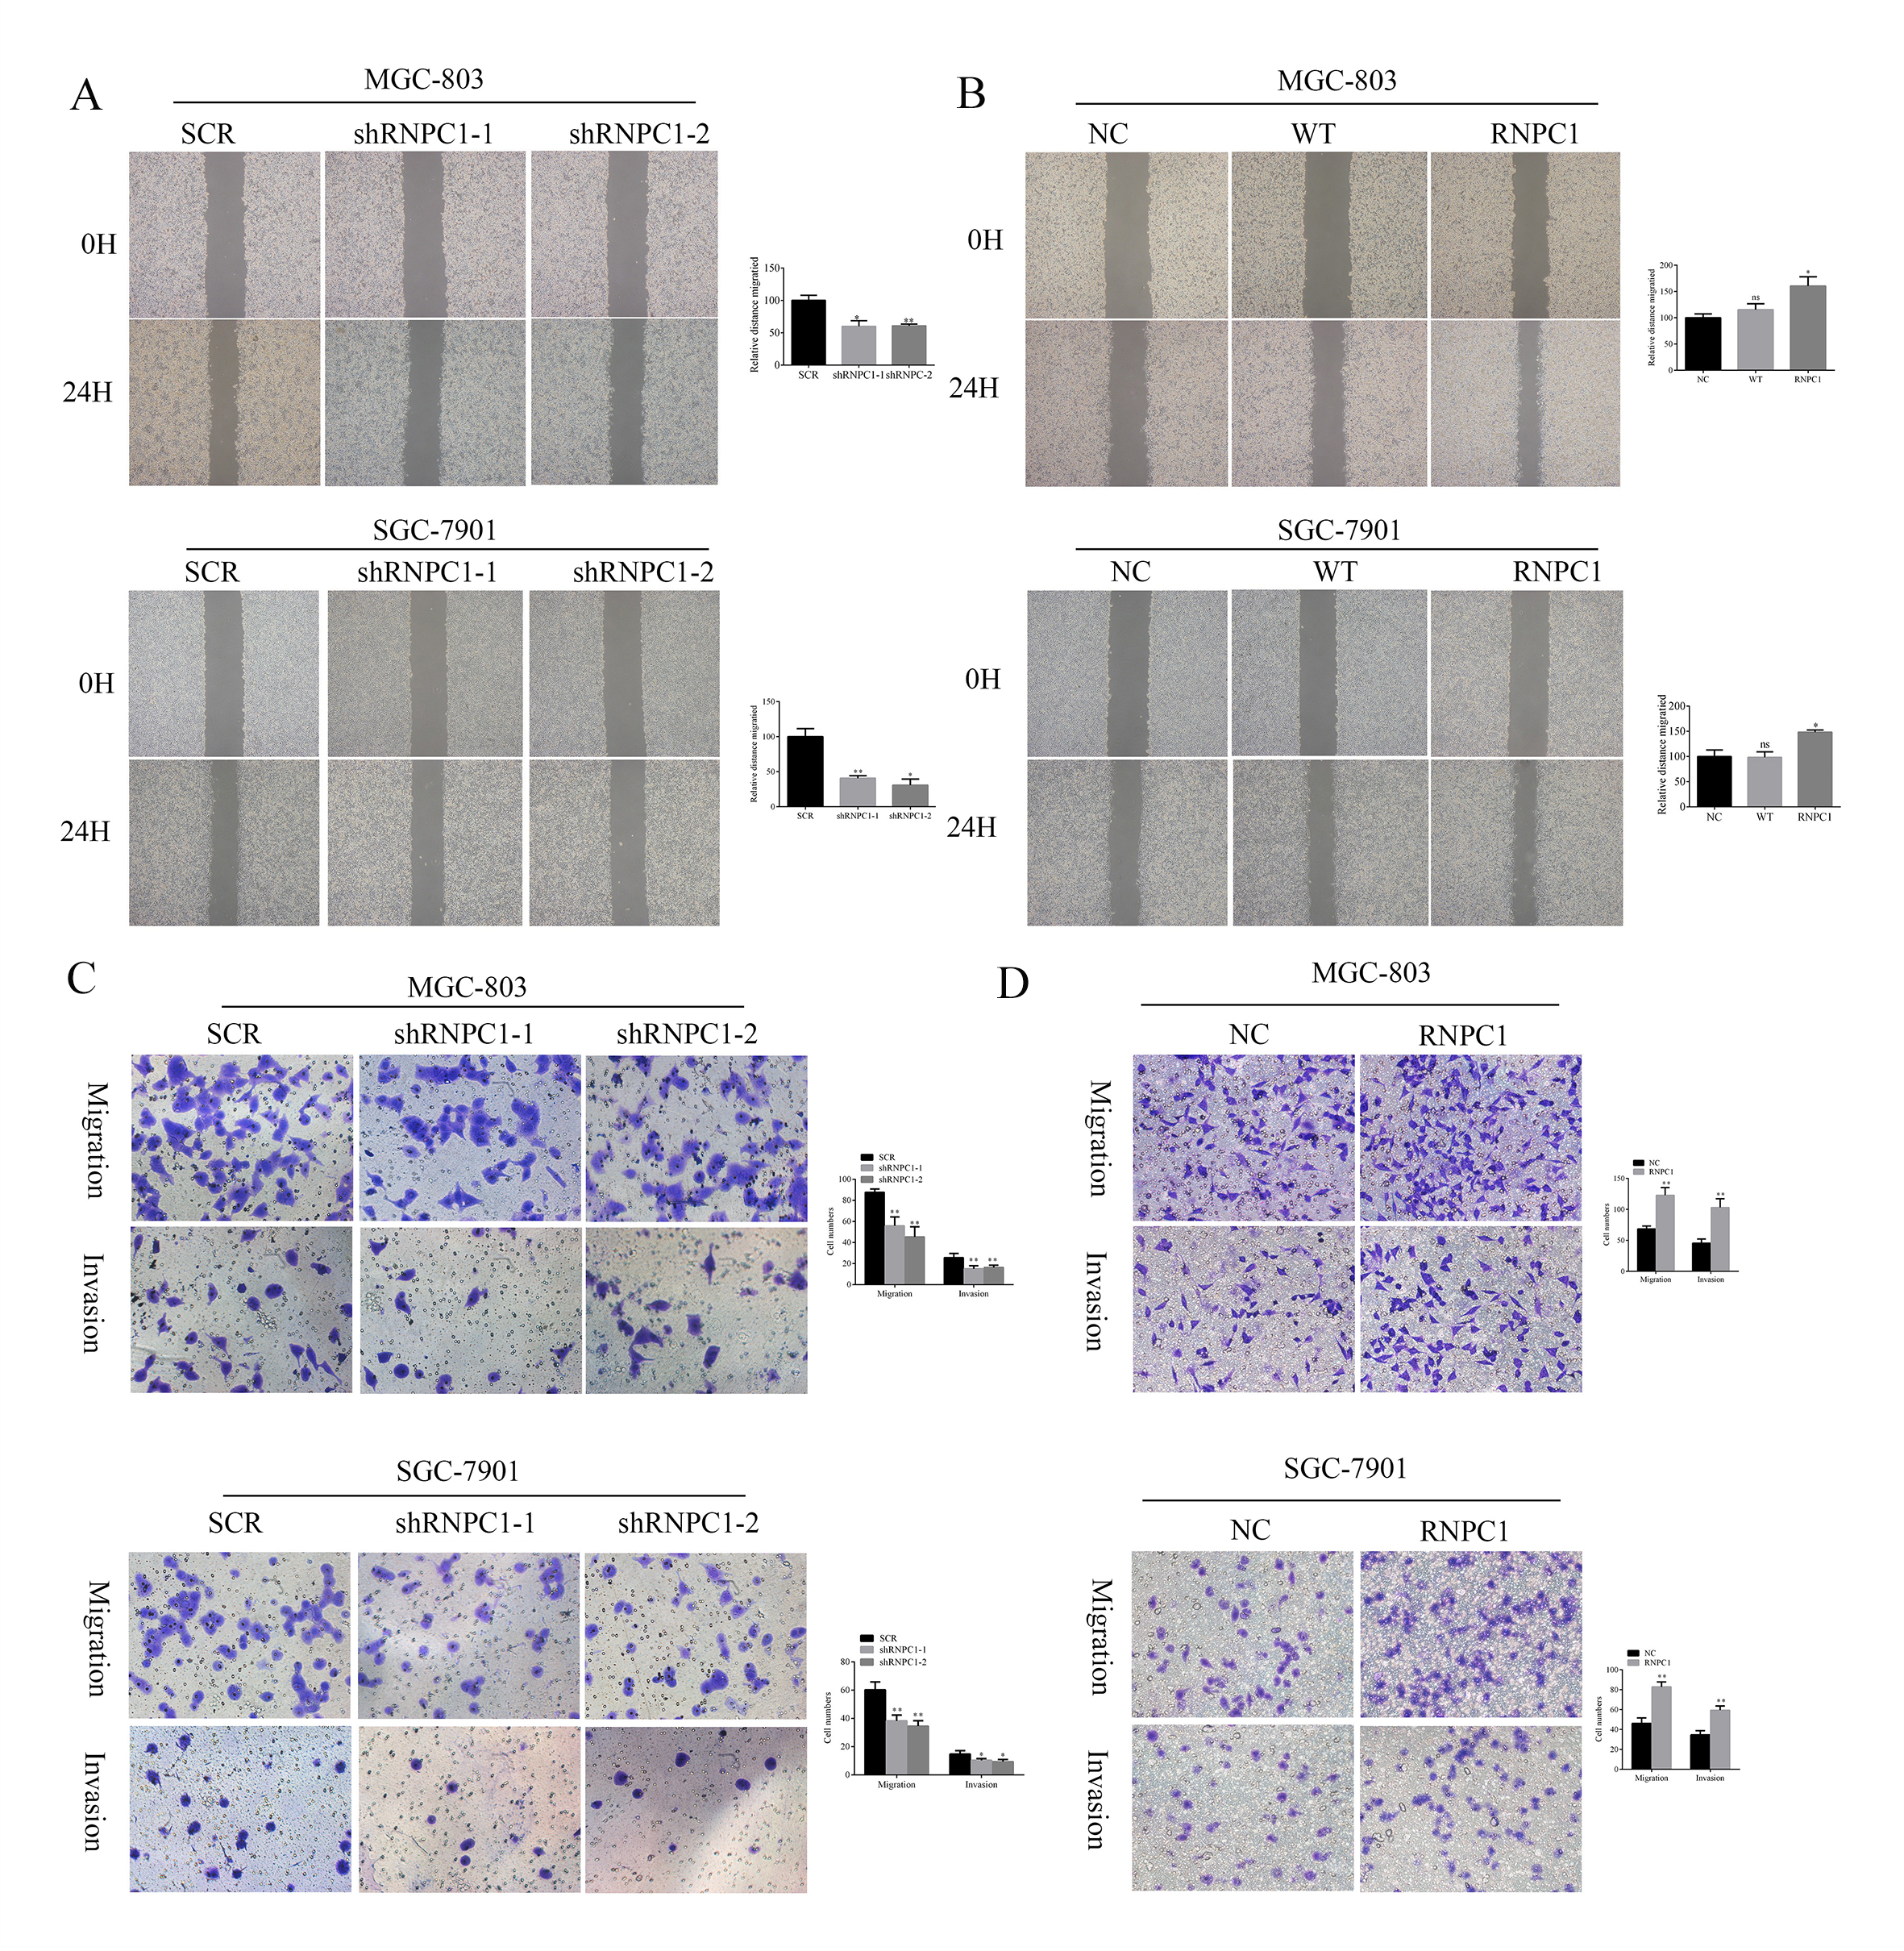
Supplementary Figure 2: RNPC1 promoted the migration and invasionability of gastric cancer cells.(A)Wound healing assay showed that the distance migrated of RNPC1 knockdown(shRNPC1-1,shRNPC1-2) decreased compared with the control(SCR) group in gastric cancer cell lines MGC-803 and SGC-7901. (B) RNPC1 overexpression (RNPC1) resulted in a significant increase in the migratory capabilities of gastric cancer cells compared with the control (NC) and empty vector(WT) cells. Representative photographs (left) and quantification (right) were shown. (C) Knockdown of RNPC1 resulted in a significant decrease in the migratory and invasive capabilities of MGC-803 and SGC-7901 cells compared with the control(SCR) cells.( D) On the contrary, the RNPC1 overexpression increased the migration and invasion ability. The representative photographs (left) and quantification (right) of transwell migration assay and matrigel invasion assay were shown, (*P<0.05, **P<0.01).
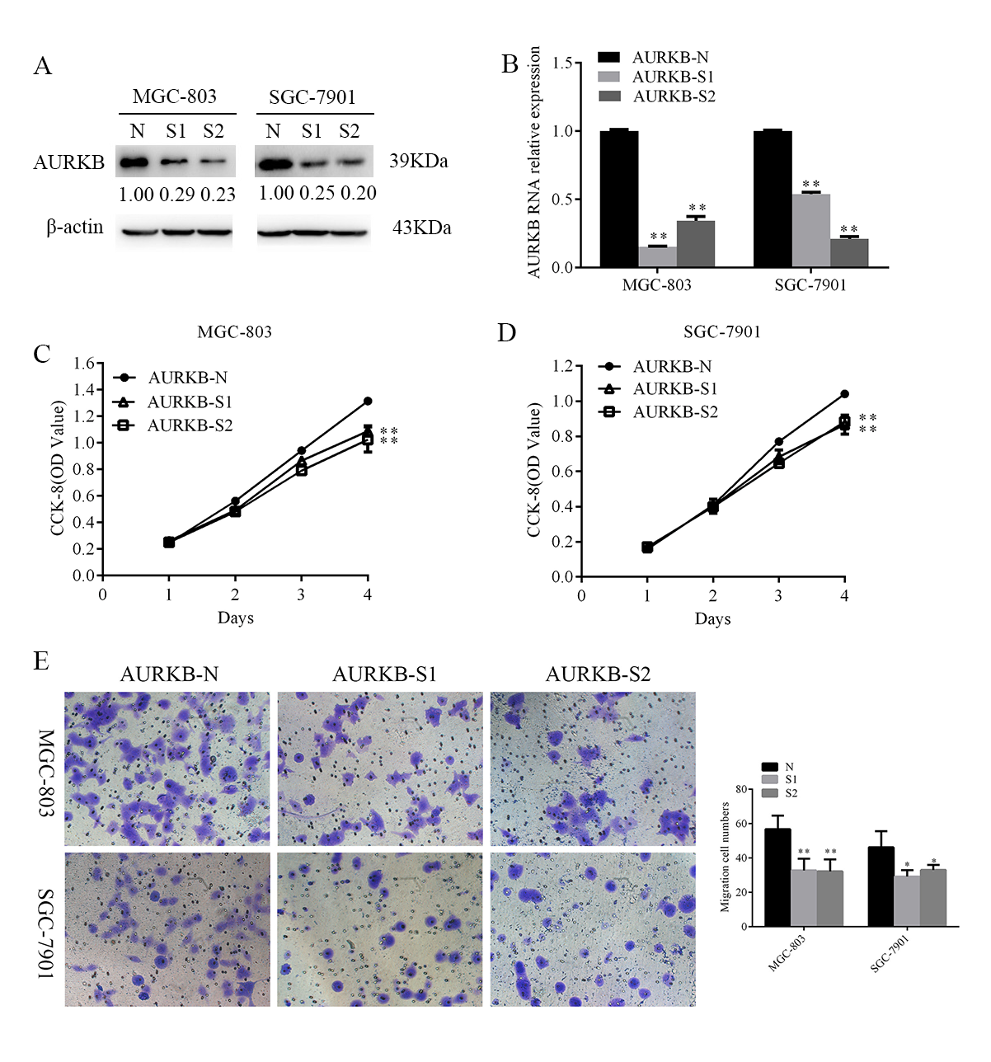
Supplementary Figure 3: AURKB acted as an oncogene in gastric cancer cell. (A) Western blot and qRT-PCR were used to confirm the efficiency of AURKB knockdown (AURKB-S1,AURKB-S2). (B)The growth ability of cells was measured with CCK-8. AURKB knockdown inhibited the growth ability of gastric cancer cells. (C)AURKB knockdown inhibited the invasion ability of gastric cancer cells, Representative photographs (left) and quantification (right) were shown. (*P<0.05, **P<0.01).

Supplementary Table
Supplementary Table 1: The association of AURKB expression and clinicopathological characteristics of gastric cancer.

Clinicopathological  characteristics | No. of case | AURKB expression |  | P
Clinicopathological  characteristics | No. of case | Low(%) | High(%)
gender
Male | 44 | 18(40.10) | 26(59.09)
Female | 41 | 16(39.02) | 25(60.98) | 1.000
Pathological grade
I | 6 | 3(50.00) | 3(50.00)
II | 49 | 22(44.90) | 27(55.10)
III | 30 | 9(30.00) | 21(70.00) | 0.370
Age
<=60 | 41 | 14(34.15) | 27(65.85)
>60 | 44 | 20(45.45) | 24(54.55) | 0.376
TNM stage
I+ II | 51 | 25(49.02) | 26(50.98)
Ⅲ+Ⅳ | 34 | 9(26.47) | 25(73.52) | 0.038
Lymph node metastasis
- | 27 | 17(62.96) | 10(37.04)
+ | 48 | 17(35.42) | 31(64.58) | 0.021
Cancer type
Gastric cancer tissues | 85 | 34(40.00) | 51(60.00)
tumor-adjacent normal tissues | 26 | 22(84.62) | 4(15.38) | 0.000

Supplementary Table 2: The sequences used in this article.

Name | Sequences
siRNA suqences
siAURKB-1 | 5'-GCAGAGAGAUCGAAAUCCAGGTT-3'
siAURKB-2 | 5'-GCAGAAGAGCUGCACAUUUGATT-3'
siRNPC1-1 | 5'-CCACGUUCACCAAGAUCUUTT-3'
siRNPC1-2 | 5'-GGAAGUACUUCGAGGGCUUTT-3
PCR primers
RNPC1 forward | 5′-ACGCCTCGCTCAGGAAGTA-3′
RNPC1 reverse | 5′-GTCTTTGCAAGCCCTCTCAG-3′
β-actin forward | 5′-GCTGTGCTATCCCTGTACGC-3′
β-actin reverse | 5′-TGCCTCAGGGCAGCGGAACC-3′
AURKB forward | 5′- CAGTGGGACACCCGACATC-3′
AURKB reverse | 5′- GTACACGTTTCCAAACTTGCC -3′
Primers for AURKB probes
AURKB 3′-UTR | 5′-UGGUCCCUGUCAUUCACUCGGGUGCGU  GUGUUUGUAUGUCUGUGUAUGUAUAGGG  GAAAGAAGGGAUCCCUAACUGUUCCCUUA  UCUGUUUUCUACCUCCUCCUUUGUUUAAU  AAAGGCUGAAGCUUUUUGUACUCAUG-3′

