Analysis of field-grown Panax ginseng rhizosphere microbiome provides clues for preventing red skin root syndrome
Xingbo Bian^{ab}, Ling Dong^{ab}, Yan Zhao^{b}, He Yang^{ab}, Yonghua Xu^{ab*}, Yongzhong Han^{c} and Lianxue Zhang^{ab*}
- National& Local Joint Engineering Research Center for Ginseng Breeding and Development, Changchun, China
- College of Chinese Medicinal Materials, Jilin Agricultural University, Changchun, China
- Jilin Provincial Ginseng and Pilose Antler Office, Changchun, China
* Corresponding author at: College of Chinese Medicinal Materials, Jilin Agricultural University, Changchun 130118, Jilin Province, China. Tel/Fax: +86 431 84533358, E-Mail address: xuyonghua777@yeah.net (Y. Xu), zlx863@163.com (LX. Zhang).

Sample Name | Raw PE | Raw Tags | Clean Tags | Effective Tags | Q20% | Q30% | GC% | Effective%
HGa | 85,615 | 81,029 | 78,710 | 62,579 | 98.25 | 94.35 | 56.36 | 73.09
HGb | 96,265 | 85,042 | 80,998 | 63,751 | 97.86 | 93.24 | 55.89 | 66.22
HGc | 80,408 | 65,779 | 61,796 | 47,380 | 97.78 | 93.04 | 55.65 | 58.92
HGd | 98,106 | 90,807 | 87,457 | 61,730 | 98.08 | 93.79 | 56.17 | 62.92
HGe | 79,888 | 65,536 | 61,563 | 48,228 | 97.76 | 93 | 55.73 | 60.37
HGf | 94,140 | 78,934 | 74,625 | 58,806 | 97.9 | 93.29 | 55.92 | 62.47
GRS1a | 92,042 | 87,960 | 86,029 | 63,497 | 98.47 | 94.84 | 55.85 | 68.99
GRS1b | 92,500 | 79,467 | 75,747 | 59,329 | 97.98 | 93.52 | 55.81 | 64.14
GRS1c | 94,033 | 80,050 | 76,054 | 60,210 | 97.88 | 93.28 | 55.6 | 64.03
GRS1d | 85,364 | 72,908 | 69,087 | 53,312 | 97.69 | 92.7 | 55.45 | 62.45
GRS1e | 93,471 | 79,651 | 75,922 | 59,793 | 97.83 | 93.01 | 55.72 | 63.97
GRS1f | 74,375 | 63,201 | 60,130 | 46,846 | 97.8 | 93.05 | 55.48 | 62.99
GRS2a | 90,189 | 85,752 | 83,177 | 64,929 | 98.25 | 94.32 | 55.89 | 71.99
GRS2b | 84,354 | 71,589 | 67,421 | 52,960 | 97.73 | 92.89 | 55.7 | 62.78
GRS2c | 97,021 | 85,077 | 81,859 | 66,295 | 98.24 | 94.11 | 55.12 | 68.33
GRS2d | 89,102 | 77,359 | 73,646 | 56,845 | 97.82 | 93.2 | 55.55 | 63.8
GRS2e | 91,689 | 75,792 | 71,497 | 56,277 | 97.79 | 92.97 | 55.33 | 61.38
GRS2f | 91,961 | 80,366 | 76,214 | 58,618 | 97.8 | 93.08 | 55.69 | 63.74
GRS3a | 83,697 | 80,775 | 78,922 | 63,764 | 98.56 | 95.15 | 55.48 | 76.18
GRS3b | 98,751 | 83,136 | 78,603 | 63,378 | 97.99 | 93.58 | 55.1 | 64.18
GRS3c | 85,830 | 72,948 | 69,249 | 54,929 | 97.89 | 93.25 | 55 | 64
GRS3d | 93,352 | 79,788 | 75,556 | 58,799 | 97.91 | 93.37 | 55.16 | 62.99
GRS3e | 92,548 | 78,912 | 74,609 | 58,995 | 97.93 | 93.36 | 55.09 | 63.75
GRS3f | 81,304 | 68,987 | 65,648 | 51,682 | 97.97 | 93.39 | 54.23 | 63.57
GRS4a | 80,847 | 77,470 | 75,693 | 59,487 | 98.46 | 94.83 | 55.6 | 73.58
GRS4b | 89,386 | 75,687 | 71,890 | 57,109 | 97.88 | 93.29 | 55.39 | 63.89
GRS4c | 88,601 | 73,639 | 69,639 | 53,881 | 97.93 | 93.39 | 55.49 | 60.81
GRS4d | 87,799 | 76,669 | 73,273 | 58,853 | 98.14 | 93.82 | 54.87 | 67.03
GRS4e | 90,104 | 76,512 | 72,220 | 56,546 | 97.8 | 93.07 | 55.68 | 62.76
GRS4f | 87,081 | 76,750 | 73,711 | 59,349 | 98.18 | 94.01 | 54.47 | 68.15
Table S1. Statistical results of bacterial sequencing data processing. Raw PE represents original PE reads; Raw Tags refers to the sequence of Tags that have been stitched together; Clean Tags refers to the sequence of Tags after filtering out low quality and short lengths; Effective Tags refer to the sequence of Tags filtered through chimeras and eventually used for subsequent analysis.Q20 and Q30 are the percentage of the Effective Tags with base quality values greater than 20(sequencing error rate less than 1%) and 30(sequencing error rate less than 0.1%).GC (%) represents the amount of GC bases in Effective Tags; Effective (%) indicates the percentage of the number of Effective Tags and the number of Raw PE.
Sample Name | Raw PE | Raw Tags | Clean Tags | Effective Tags | Q20% | Q30% | GC% | Effective%
HGa | 85,588 | 84,256 | 83,598 | 66,365 | 98.5 | 95.73 | 48.01 | 77.54
HGb | 99,861 | 96,247 | 94,317 | 66,230 | 98.48 | 95.91 | 46.92 | 66.32
HGc | 88,507 | 86,344 | 84,406 | 66,519 | 98.52 | 96.03 | 46.48 | 75.16
HGd | 91,708 | 88,589 | 86,730 | 64,808 | 98.54 | 96.1 | 46.76 | 70.67
HGe | 97,422 | 95,019 | 93,557 | 65,882 | 98.64 | 96.31 | 46.55 | 67.63
HGf | 81,911 | 79,550 | 77,903 | 65,961 | 98.48 | 95.9 | 46.33 | 80.53
GRS1a | 87,394 | 86,206 | 85,590 | 62,195 | 98.54 | 95.81 | 45.87 | 71.17
GRS1b | 96,387 | 93,800 | 92,038 | 66,847 | 98.58 | 96.21 | 46.59 | 69.35
GRS1c | 87,016 | 83,677 | 82,073 | 69,512 | 98.6 | 96.21 | 45.08 | 79.88
GRS1d | 92,379 | 89,030 | 87,239 | 63,725 | 98.59 | 96.19 | 44.78 | 68.98
GRS1e | 87,657 | 85,047 | 83,652 | 62,388 | 98.66 | 96.37 | 45.41 | 71.17
GRS1f | 80,173 | 76,862 | 74,893 | 62,828 | 98.5 | 95.94 | 45.89 | 78.37
GRS2a | 90,994 | 89,787 | 89,284 | 64,704 | 98.67 | 96.08 | 46.13 | 71.11
GRS2b | 92,755 | 90,133 | 87,717 | 62,793 | 98.46 | 95.9 | 45.75 | 67.7
GRS2c | 87,390 | 84,680 | 82,680 | 65,294 | 98.5 | 95.97 | 45.78 | 74.72
GRS2d | 99,856 | 96,210 | 94,492 | 63,276 | 98.56 | 96.07 | 47.26 | 63.37
GRS2e | 90,427 | 88,354 | 86,468 | 65,837 | 98.61 | 96.3 | 47.24 | 72.81
GRS2f | 91,310 | 88,178 | 86,752 | 60,319 | 98.58 | 96.14 | 46.75 | 66.06
GRS3a | 93,008 | 91,856 | 91,234 | 61,251 | 98.73 | 96.17 | 46.26 | 65.86
GRS3b | 98,092 | 96,009 | 94,382 | 66,927 | 98.61 | 96.2 | 47.7 | 68.23
GRS3c | 80,456 | 78,219 | 76,725 | 65,990 | 98.64 | 96.22 | 48.04 | 82.02
GRS3d | 85,283 | 82,485 | 80,804 | 68,095 | 98.64 | 96.31 | 48 | 79.85
GRS3e | 89,533 | 86,615 | 85,178 | 62,403 | 98.7 | 96.36 | 48.03 | 69.7
GRS3f | 78,007 | 75,630 | 74,537 | 67,623 | 98.8 | 96.54 | 47.88 | 86.69
GRS4a | 92,888 | 91,875 | 91,267 | 62,682 | 98.78 | 96.38 | 46.73 | 67.48
GRS4b | 90,815 | 88,296 | 86,888 | 61,518 | 98.72 | 96.51 | 47.56 | 67.74
GRS4c | 80,076 | 77,631 | 75,862 | 68,017 | 98.59 | 96.13 | 47.93 | 84.94
GRS4d | 94,494 | 91,729 | 89,907 | 61,778 | 98.67 | 96.39 | 46.87 | 65.38
GRS4e | 85,089 | 81,690 | 80,047 | 68,647 | 98.36 | 95.53 | 47.92 | 80.68
GRS4f | 88,486 | 87,507 | 85,527 | 66,565 | 98.67 | 96.45 | 46.11 | 75.23
Table S2. Statistical results of fungal sequencing data processing. Raw PE represents original PE reads; Raw Tags refers to the sequence of Tags that have been stitched together; Clean Tags refers to the sequence of Tags after filtering out low quality and short lengths; Effective Tags refer to the sequence of Tags filtered through chimeras and eventually used for subsequent analysis. Q20 and Q30 are the percentage of the Effective Tags with base quality values greater than 20(sequencing error rate less than 1%) and 30(sequencing error rate less than 0.1%). GC (%) represents the amount of GC bases in Effective Tags; Effective (%) indicates the percentage of the number of Effective Tags and the number of Raw PE.

 | Nodes | Total link | Positive links (percentage) | Negative links (percentage) | Modularity | Clustering coefficient | Average degree | Average path length
bacteria
HG | 289 | 3248 | 2073 (63.8%) | 1175 (36.2%) | 0.5663422 | 0.4992137 | 18.76125 | 4.941463
GRS1 | 284 | 2839 | 1659 (58.4%) | 1180 (41.6%) | 0.5335726 | 0.4705993 | 17.99296 | 4.910784
GRS2 | 292 | 3227 | 1790 (55.5%) | 1437 (44.5%) | 0.5140345 | 0.5030765 | 20.11644 | 4.806641
GRS3 | 284 | 2789 | 1695 (60.8%) | 1094 (39.2%) | 0.5446874 | 0.4699048 | 17.64789 | 5.045968
GRS4 | 290 | 3600 | 2136 (59.3%) | 1464 (40.7%) | 0.4940495 | 0.5276348 | 22.82759 | 4.14866
Fungi
HG | 88 | 363 | 234 (64.5%) | 129 (35.5%) | 0.6109209 | 0.5060241 | 6.227273 | 3.195169
GRS1 | 86 | 333 | 278 (83.5%) | 55 (16.5%) | 0.5981724 | 0.4609375 | 5.72093 | 2.63789
GRS2 | 88 | 347 | 233 (67.1%) | 114 (32.9%) | 0.5863755 | 0.4710425 | 5.863636 | 4.156273
GRS3 | 88 | 368 | 265 (72.0%) | 103 (28.0%) | 0.5654925 | 0.5232068 | 6.340909 | 3.437685
GRS4 | 87 | 438 | 312 (71.2%) | 126 (28.8%) | 0.4983225 | 0.5516857 | 8.045977 | 2.816084
Table S3. Network topological characteristics of microbial communities. HG (healthy ginseng), GRS1 (red skin area 0 to 25%), GRS2 (red skin area 25 to 50%), GRS3 (red skin area 50 to 75%) and GRS4 (red skin area 75 to 100%).

HG |  |  | GRS4
 |  | SCC |  |  | SCC
Ilyonectria | Pleotrichocladium | 0.828571429 | Fusarium | Chrysosporium | 0.828571429
Ilyonectria | Pseudallescheria | -0.81167945 | Fusarium | Pseudogymnoascus | 0.898645105
Ilyonectria | Zasmidium | 0.81167945 | Fusarium | Aspergillus | 0.885714286
Ilyonectria | Colletotrichum | 0.898645105 | Fusarium | Paraglomus | -0.885714286
Cylindrocarpon | Minimedusa | -0.828571429 | Fusarium | Arizonaphlyctis | -0.845154255
Cylindrocarpon | Microdochium | 0.828571429 | Fusarium | Coniochaeta | -0.828571429
 |  |  | Fusarium | Pseudosigmoidea | 0.81167945
 |  |  | Fusarium | Cylindrocarpon | 0.840668002
 |  |  | Ilyonectria | Byssonectria | 0.828078671
 |  |  | Ilyonectria | Simplicillium | -0.927633657
 |  |  | Ilyonectria | Musicillium | -0.927633657
 |  |  | Ilyonectria | Pochonia | -0.880406274
 |  |  | Ilyonectria | Arachnotheca | -0.985610761
 |  |  | Ilyonectria | Sagenomella | -0.869656553
 |  |  | Ilyonectria | Corallomycetella | -0.885714286
 |  |  | Ilyonectria | Trichoderma | -0.828571429
 |  |  | Ilyonectria | Penicillium | -0.942857143
Table S4 Fungus in interaction networks that may be associated with diseases. SCC (Spearman correlation coefficient). HG (healthy ginseng) and GRS4 (red skin area 75 to 100%).

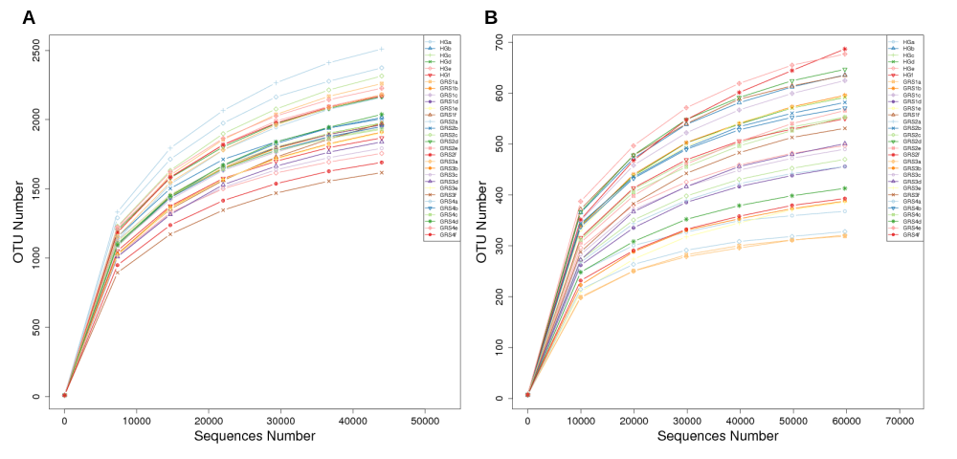
Figure S1. The rarefaction curves of observed OTUs at OTU level across all samples. A) bacteria; B) fungi.

Figure S2. MetaStat analysis of bacterial abundance from phylum level to species level. HG (healthy ginseng), GRS1 (red skin area 0 to 25%), GRS2 (red skin area 25 to 50%), GRS3 (red skin area 50 to 75%) and GRS4 (red skin area 75 to 100%).

Figure S3. MetaStat analysis of fungi abundance from phylum level to species level. HG (healthy ginseng), GRS1 (red skin area 0 to 25%), GRS2 (red skin area 25 to 50%), GRS3 (red skin area 50 to 75%) and GRS4 (red skin area 75 to 100%).

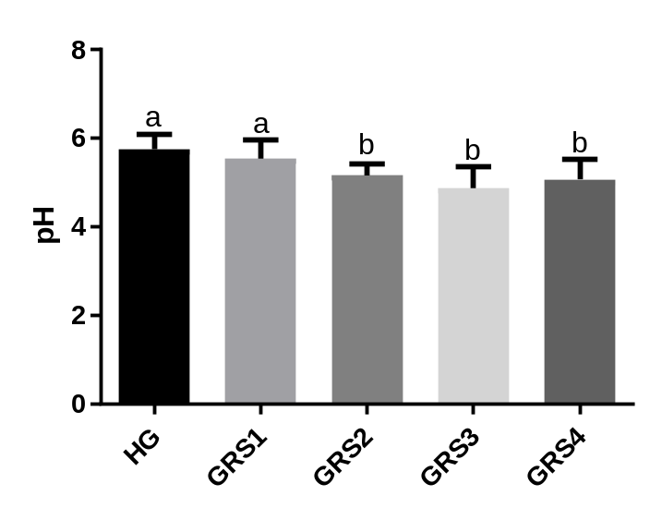
Figure S4. PH of rhizosphere soil. Different letters in the same row mean significant difference at P <0.05 among the five treatments. HG (healthy ginseng), GRS1 (red skin area 0 to 25%), GRS2 (red skin area 25 to 50%), GRS3 (red skin area 50 to 75%) and GRS4 (red skin area 75 to 100%).

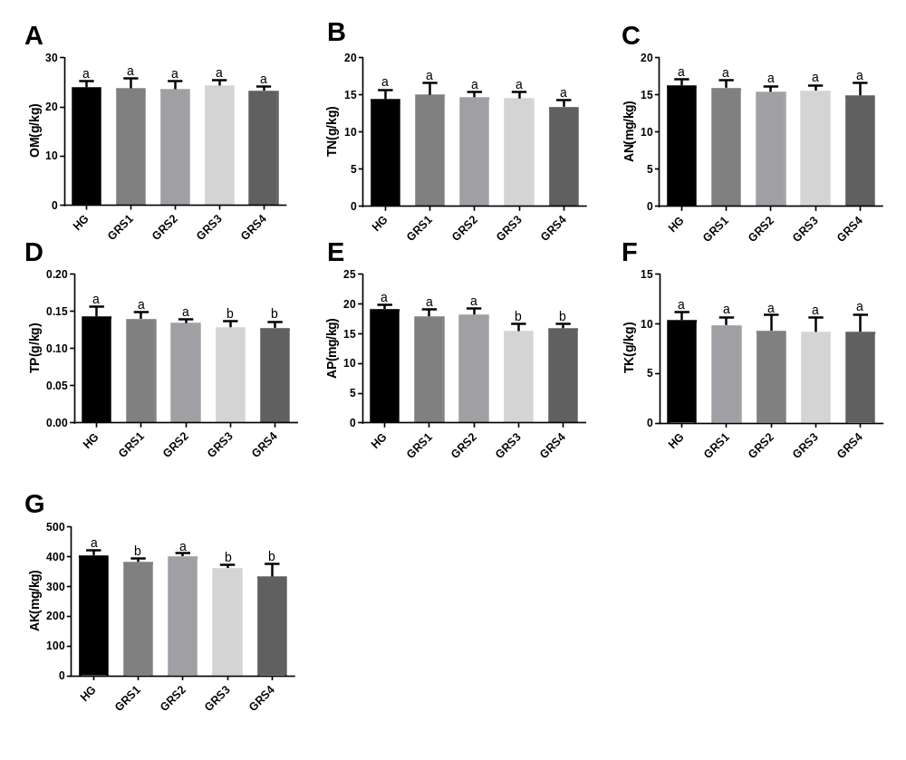
Figure S5. Nutrients of rhizosphere soil. Different letters in the same row mean significant difference at P <0.05 among the five treatments. HG (healthy ginseng), GRS1 (red skin area 0 to 25%), GRS2 (red skin area 25 to 50%), GRS3 (red skin area 50 to 75%) and GRS4 (red skin area 75 to 100%).

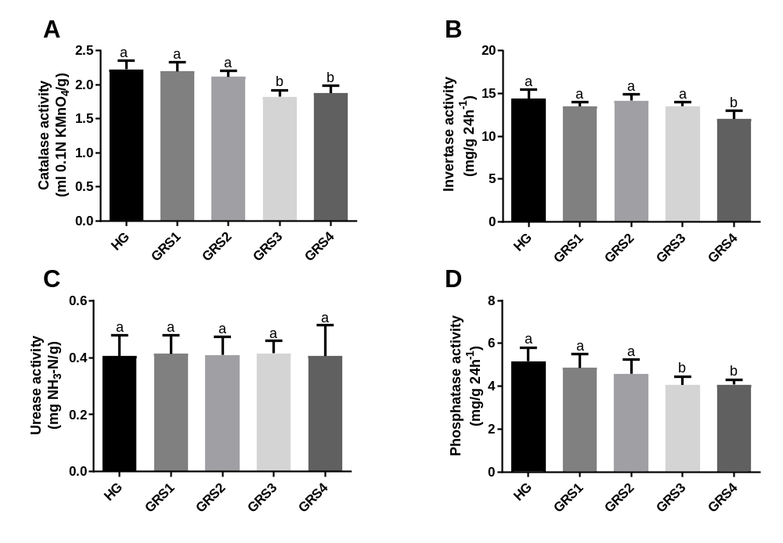
Figure S6. Enzyme activities of rhizosphere soil. Different letters in the same row mean significant difference at P <0.05 among the five treatments. HG (healthy ginseng), GRS1 (red skin area 0 to 25%), GRS2 (red skin area 25 to 50%), GRS3 (red skin area 50 to 75%) and GRS4 (red skin area 75 to 100%).

