Supplementary Materials
Achieving over 70 kg m⁻² h⁻¹ evaporation rate by a 3D polyacrylamide-based hydrogel
Yuying Chen, Jixiang Yang, Jinsong Guo, Fang Fang, Ruilin Bao, Linji, Xu

Figure S1. Evaporation rate of 2D CAH with different CNTs under 1 kW m⁻²

Figure S2. Infrared images of 3D CAH under sun and dark at room temperature (10 ℃).

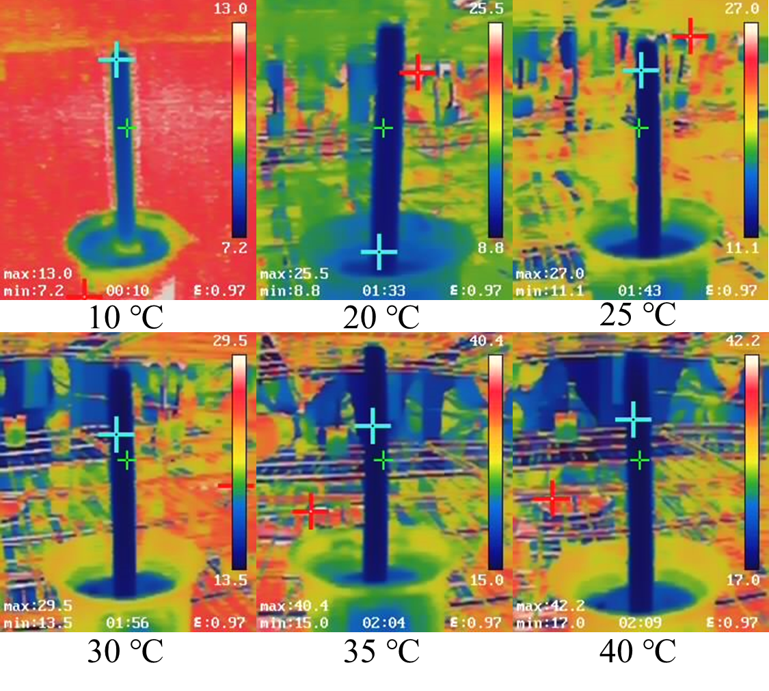
Figure S3. Dark evaporation infrared images of 3D CAH at different temperatures.

Figure S4. 24-hour long-term evaporation of 3D CAH. The effective evaporation length was 35 cm (EAI=176) under 25 ℃.

Table S1. Ion charge density.
Ionic species | Charge (Q, C) | Ionic radius (r, m) | Charge density (ρ, C m⁻³)
Cl⁻ | 1.6×10⁻¹⁹ | 1.81×10⁻¹⁰ | 6.44×10¹²
SO₄²⁻ | 3.2×10⁻¹⁹ | 2.18×10⁻¹⁰ | 7.38×10¹²
PO₄³⁻ | 4.8×10⁻¹⁹ | 2.30×10⁻¹⁰ | 9.43×10¹²
Na⁺ | 1.6×10⁻¹⁹ | 9.5×10⁻¹¹ | 4.46×10¹³
Ca²⁺ | 3.2×10⁻¹⁹ | 9.9×10⁻¹¹ | 7.88×10¹³
Mg²⁺ | 3.2×10⁻¹⁹ | 6.5×10⁻¹¹ | 2.78×10¹⁴

Table S2. Comparison of cost-effectiveness over previous reported 3D solar evaporators.
Ref | Raw Materials | Estimated  single item cost ($/m²) | Total cost ($/m²) | Evaporation rate (kg m⁻² h⁻¹) | Cost-effectiveness  (Rate/Price,  g h⁻¹ $⁻¹)
¹ | NaOH | 0.0005 | 5022.20 | 34.7 | 6.91
¹ | Graphene oxide (GO) | 4669.38 | 5022.20 | 34.7 | 6.91
¹ | 1,4-butanediol diglycidyl ether | 343.61 | 5022.20 | 34.7 | 6.91
¹ | Triethylenetetramine | 1.04 | 5022.20 | 34.7 | 6.91
¹ | Cotton core | 8.16 | 5022.20 | 34.7 | 6.91
² | Sucrose | 712.44 | 712.44 | 10.9 | 15.30
² | H₂SO₄ | 33.75 | 712.44 | 10.9 | 15.30
³ | NiCl₂·6H₂O | 47.45 | 154260.17 | 2.42 | 0.016
³ | CoCl₂·6H₂O | 457.86 | 154260.17 | 2.42 | 0.016
³ | NaBH₄ | 137.34 | 154260.17 | 2.42 | 0.016
³ | Dopamine hydrochloride | 153607.40 | 154260.17 | 2.42 | 0.016
³ | Salicylic acid | 10.12 | 154260.17 | 2.42 | 0.016
⁴ | Reduced graphene oxide (RGO) | 2029.82 | 2039.08 | 2.25 | 1.10
⁴ | Sodium alginate | 9.26 | 2039.08 | 2.25 | 1.10
⁵ | Cu(NO₃)₂·3H₂O | 1219.86 | 1706.84 | 2.04 | 1.20
⁵ | Mn(NO₃)₂·4H₂O | 456.52 | 1706.84 | 2.04 | 1.20
⁵ | Fe(NO₃)₃·9H₂O | 30.46 | 1706.84 | 2.04 | 1.20
⁶ | Pyrrole | 631.81 | 1955.21 | 3.72 | 1.90
⁶ | FeCl₃·6H₂O | 1265.81 | 1955.21 | 3.72 | 1.90
⁶ | HCl | 57.59 | 1955.21 | 3.72 | 1.90
⁷ | Polyacrylonitrile (PAN) | 30397.26 | 653274.54 | 2.27 | 0.003
⁷ | Dimethyl sulfoxide | 5039.55 | 653274.54 | 2.27 | 0.003
⁷ | Graphene oxide (GO) | 1906.50 | 653274.54 | 2.27 | 0.003
⁸ | Reduced graphene oxide (RGO) | 10354.10 | 10450.24 | 4 | 0.38
⁸ | Agarose | 961.45 | 10450.24 | 4 | 0.38
⁸ | Urea | 96.15 | 10450.24 | 4 | 0.38
⁹ | Carbon black | 98.79 | 294572.29 | 2.31 | 0.008
⁹ | Dopamine hydrochloride | 294473.50 | 294572.29 | 2.31 | 0.008
¹⁰ | CoCl₂·6H₂O | 43.39 | 14601.25 | 3.71 | 0.25
¹⁰ | Dopamine hydrochloride | 14557.86 | 14601.25 | 3.71 | 0.25
¹⁰ | Reduced graphene oxide (RGO) | 828.33 | 14601.25 | 3.71 | 0.25
¹⁰ | Agarose | 192.29 | 14601.25 | 3.71 | 0.25
¹⁰ | Urea | 0.02 | 14601.25 | 3.71 | 0.25
¹¹ | Polyvinylidene fluoride | 47 | 58.3 | 1.93 | 0.481
¹¹ | Pyrrole | 4.4 | 58.3 | 1.93 | 0.481
¹¹ | FeCl₃ | 3.2 | 58.3 | 1.93 | 0.481
¹¹ | Deionized water | 2.9 | 58.3 | 1.93 | 0.481
¹¹ | Energy consumption | 0.8 | 58.3 | 1.93 | 0.481
¹² | Reduced graphene oxide (RGO) | 17855.54 | 18042.28 | 7.6 | 0.42
¹² | Sodium alginate | 81.42 | 18042.28 | 7.6 | 0.42
¹² | Ethanol | 105.32 | 18042.28 | 7.6 | 0.42
¹³ | Nano-diamonds | 97.77 | 100.61 | 1.324 | 13.16
¹³ | Ethanol | 2.84 | 100.61 | 1.324 | 13.16
This work | Acrylamide (AM) | 1545.69 | 2553.73 | 72.3 | 28.31
This work | Carbon nanotubes (CNTs) | 246.07 | 2553.73 | 72.3 | 28.31
This work | Bis-polyacrylamide | 14.96 | 2553.73 | 72.3 | 28.31
This work | Ammonium persulfate (APS) | 16.62 | 2553.73 | 72.3 | 28.31
This work | N,N,N′,N′-tetramethyl ethylenediamine (TEMED) | 183.55 | 2553.73 | 72.3 | 28.31
This work | Cotton core | 546.83 | 2553.73 | 72.3 | 28.31

Reference

1. Finnerty CTK, et al. Interfacial Solar Evaporation by a 3D Graphene Oxide Stalk for Highly Concentrated Brine Treatment. Environmental Science & Technology 55, 15435-15445 (2021).

2. Li J, et al. Over 10 kg m(-2) h(-1) Evaporation Rate Enabled by a 3D Interconnected Porous Carbon Foam. Joule 4, 928-937 (2020).

3. Shao B, et al. Stackable nickel-cobalt@polydopamine nanosheet based photothermal sponges for highly efficient solar steam generation. Journal of Materials Chemistry A 8, 11665-11673 (2020).

4. Storer DP, Phelps JL, Wu X, Owens G, Khan NI, Xu H. Graphene and Rice-Straw-Fiber-Based 3D Photothermal Aerogels for Highly Efficient Solar Evaporation. Acs Applied Materials & Interfaces 12, 15279-15287 (2020).

5. Shi Y, et al. A 3D Photothermal Structure toward Improved Energy Efficiency in Solar Steam Generation. Joule 2, 1171-1186 (2018).

6. Xie Z, Zhu J, Zhang L. Three-Dimensionally Structured Polypyrrole-Coated Setaria viridis Spike Composites for Efficient Solar Steam Generation. Acs Applied Materials & Interfaces 13, 9027-9035 (2021).

7. Wang L, et al. Three-Dimensional Wood-Inspired Bilayer Membrane Device Containing Microchannels for Highly Efficient Solar Steam Generation. Acs Applied Materials & Interfaces 12, 24328-24338 (2020).

8. Wu X, Gao T, Han C, Xu J, Owens G, Xu H. A photothermal reservoir for highly efficient solar steam generation without bulk water. Science Bulletin 64, 1625-1633 (2019).

9. Sui Y, Hao D, Guo Y, Cai Z, Xu B. A flowerlike sponge coated with carbon black nanoparticles for enhanced solar vapor generation. Journal of Materials Science 55, 298-308 (2020).

10. Gao T, Wu X, Owens G, Xu H-L. A cobalt oxide@polydopamine-reduced graphene oxide-based 3D photothermal evaporator for highly efficient solar steam generation. Tungsten 2, 423-432 (2020).

11. Wang Y, Sun X, Tao S. Rational 3D Coiled Morphology for Efficient Solar-Driven Desalination. Environmental Science & Technology 54, 16240-16248 (2020).

12. Gao T, Wu X, Wang Y, Owens G, Xu H. A Hollow and Compressible 3D Photothermal Evaporator for Highly Efficient Solar Steam Generation without Energy Loss. Solar Rrl 5, (2021).

13. Zhang L, Bai B, Hu N, Wang H. Efficient 3D-interfacial solar steam generation enabled by photothermal nanodiamonds paint-coat with optimized heat management. Applied Thermal Engineering 171, (2020).

