Supplementary Figure 7G.
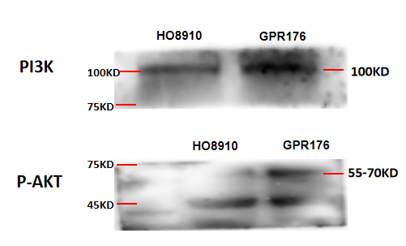
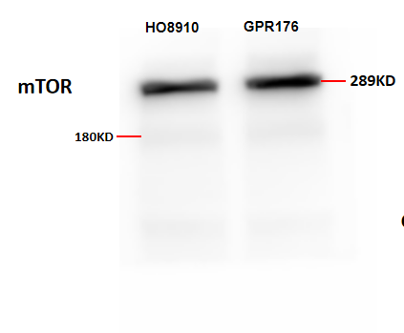
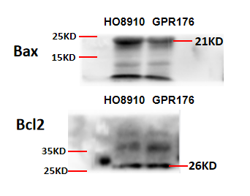
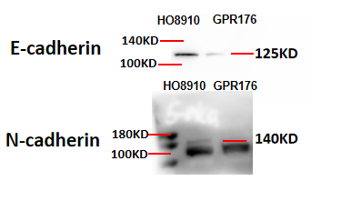
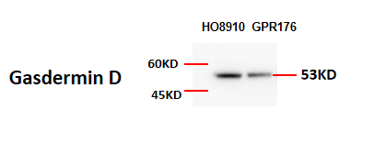

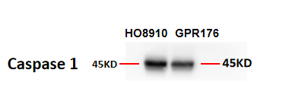
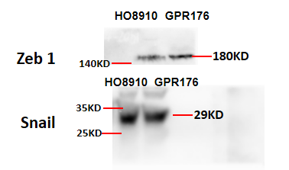
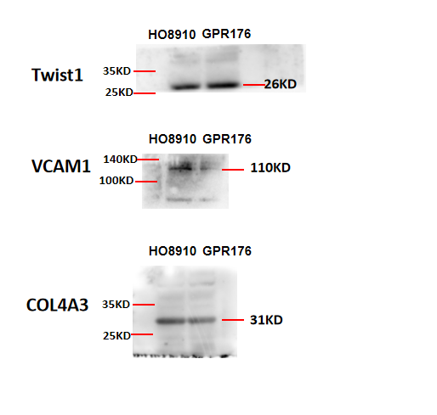
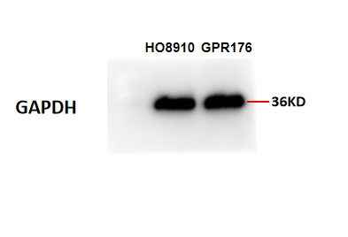
Full length original and unprocessed Western blots shown in Supplementary Figure 7G. GPR176 overexpression increased the expression levels of m-TOR, PI3K, p-Akt, Bcl-2, N-cadherin, Zeb1, Snail, and Twist1 but decreased the expression levels of Bax, gasdermin D, caspase 1, E-cadherin, vascular cell adhesion molecule 1 (VCAM-1), and COL4A3. GAPDH was used as an experimental loading control.

