Supplementary File

Article title: Identification of RP11-770J1.4-CTXN1 as an immunomodulatory axis in Low-Grade Glioma

Author: Qiyuan Zhuang^{1,9}, Chaxian Liu^{1,9}, Yihan Hu^{6,9}, Ying Liu⁷, Yingying Lyu¹, Yuheng Liao⁸, Liang Chen^{1,2,3}*, Hui Yang^{1,2,3,4,5}*, Ying Mao^{1,2,3,5}*

Affiliations:
¹ Department of Neurosurgery, Huashan Hospital, Fudan University, Shanghai, P.R. China;
² National Center for Neurological Disorders, Huashan Hospital, Fudan University, Shanghai, P.R. China;
³ Shanghai Key laboratory of Brain Function Restoration and Neural Regeneration, Huashan Hospital, Fudan University, Shanghai, P.R. China;
⁴ Institute for Translational Brain Research, Shanghai Medical College, Fudan University, Shanghai, P.R. China;
⁵ State Key Laboratory of Medical Neurobiology and MOE Frontiers Center for Brain Science, Institute for Translational Brain Research, Institutes of Brain Science, Fudan University, Shanghai, P.R. China
⁶ School of life sciences, Fudan University, Shanghai, P.R. China;
⁷ Department of Pathology, School of Basic Medical Sciences, Fudan University, Shanghai, China;
⁸ Key Laboratory of Medical Epigenetics and Metabolism and Molecular and Cell Biology Lab, Institute of Biomedical Sciences, Shanghai Medical College, Fudan University, Shanghai, P.R. China;
⁹ These authors contribute equally to this work

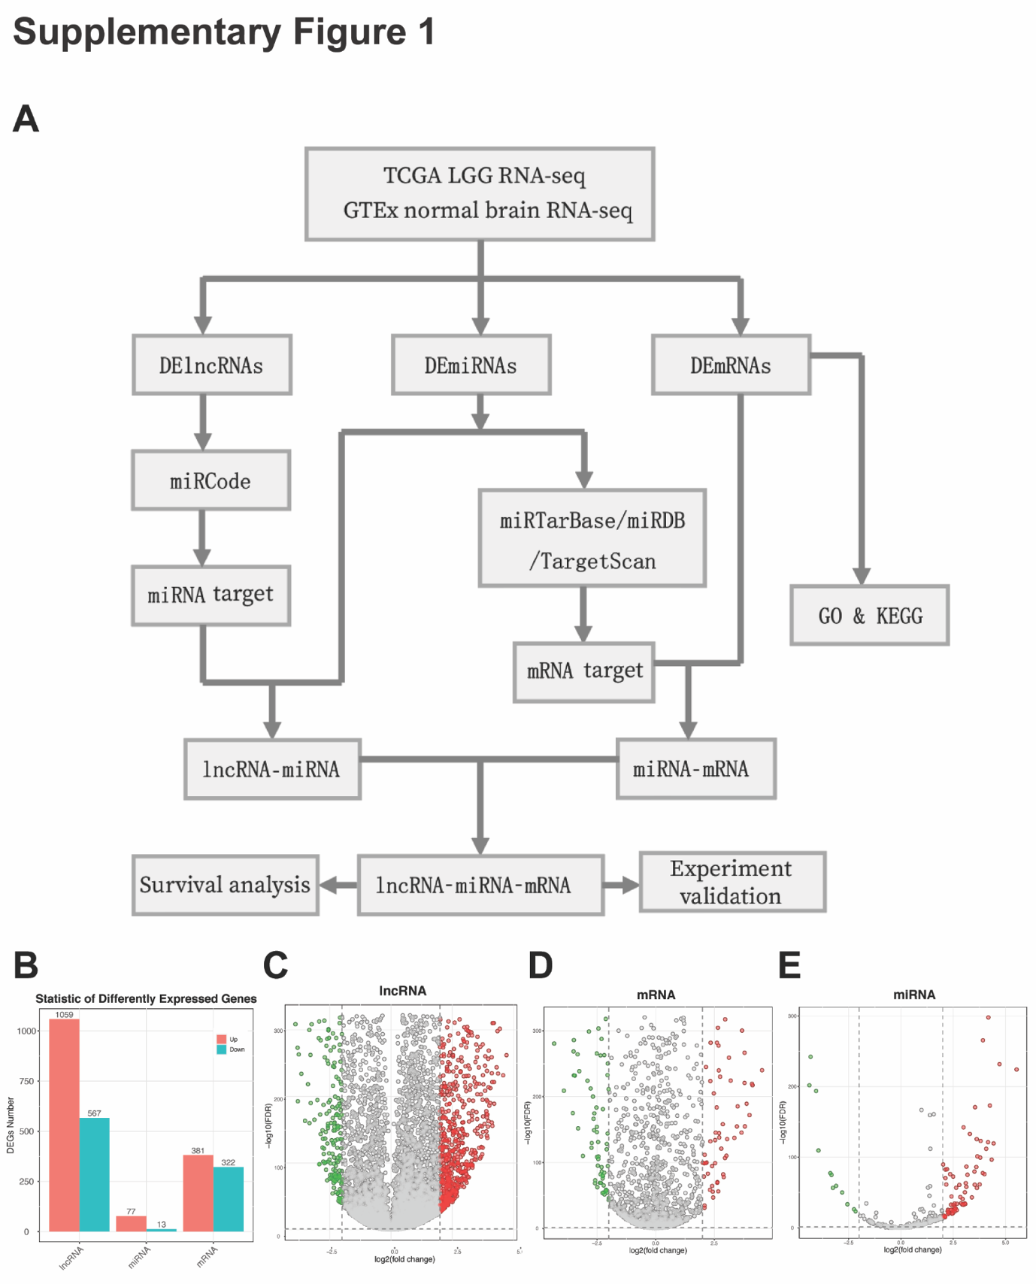
Supplementary Figure 1. Extraction of DEGs in glioma. (A) Flow chart of study design. (B) Bar plot of number of DEG genes for lncRNAs, miRNAs and mRNAs. (C-E) Volcano plot for lncRNAs, miRNAs and mRNAs. Each point in the volcano diagram represents one gene. Green represents differentially down-regulated genes, red represents differentially up-regulated genes, and grey represents non-differentially expressed genes. The vertical dashed lines represent a threshold of 4 times fold changes (down or up-regulated), and the horizontal dashed line represents the threshold of FDR < 0.05.

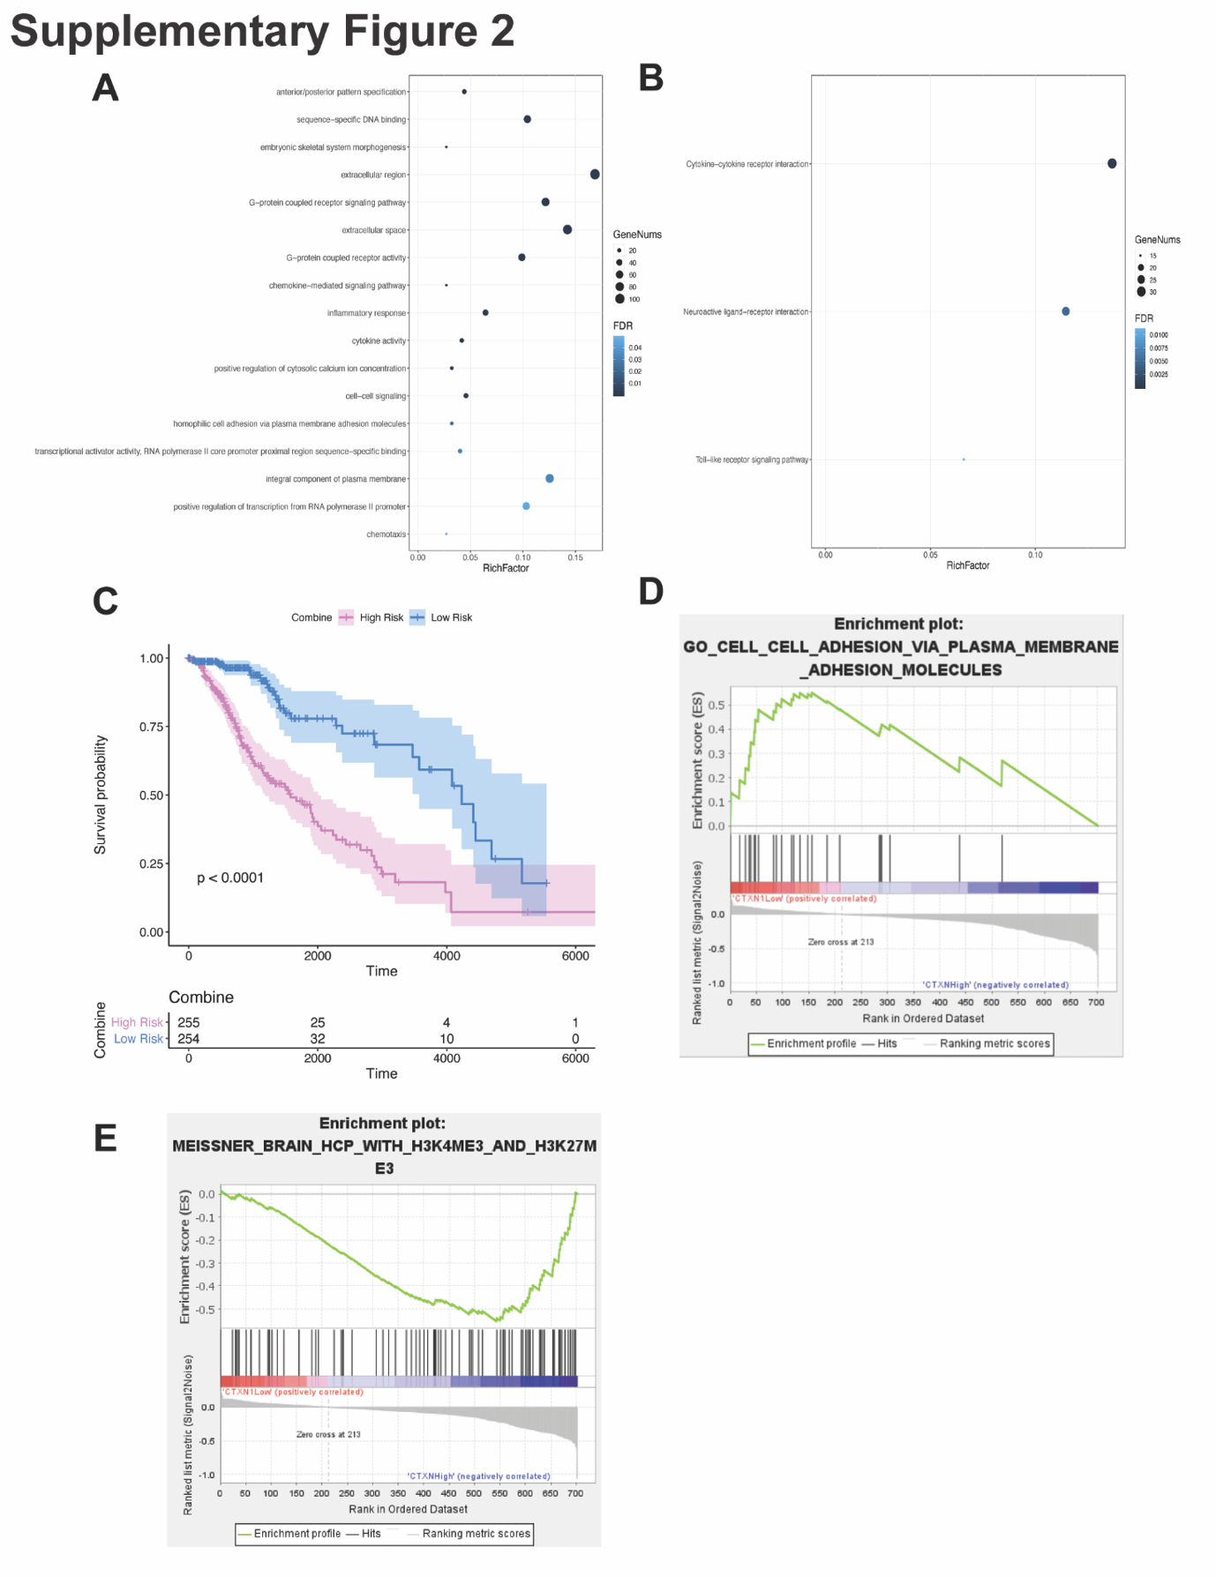
Supplementary Figure 2. Establish ceRNA network in low-grade glioma. (A-B) Rich factor calculated from the degree of enrichment and FDR of pathways was plotted. Rich factor refers to the ratio of the DEmRNA number with annotated gene number. (C) Kaplan–Meier curves for all significant genes identified in the ceRNA network and confirmed by COX analyses. (D-E) GSEA analyses of significant pathways for TCGA LGG patients in CTXN1 high-expression and low-expression groups.
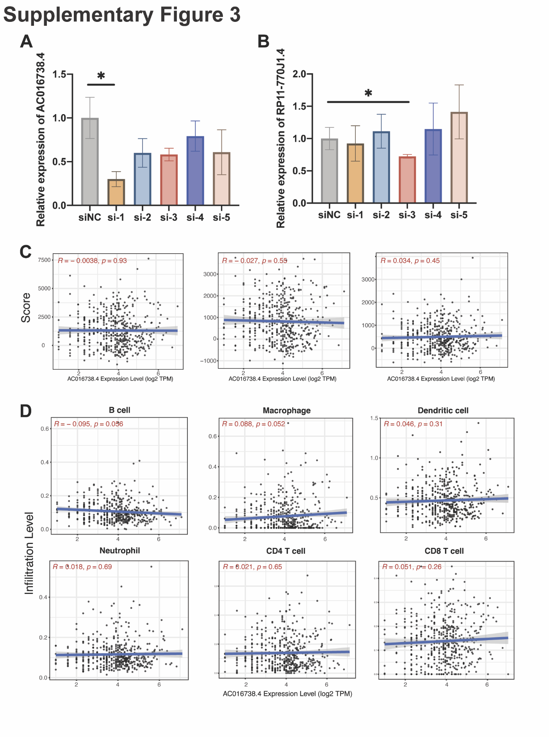
Supplementary Figure 3. AC016738.4, but not RP11-770J1.4 is immune-related lncRNA. (A-B) The expression levels of AC016738.4 and RP11-770J1.4 after treatment with siRNA. (C-D) Regression analysis based on Pearson’s test between ESTIMATE score and the expression level of AC016738.4. The horizontal axis denotes the expression levels of AC016738.4, and the vertical axis represents ESTIMATE scores. (B) Regression analysis based on Pearson’s test between TIMER-estimated immune cell infiltration level and the expression level of AC016738.4.
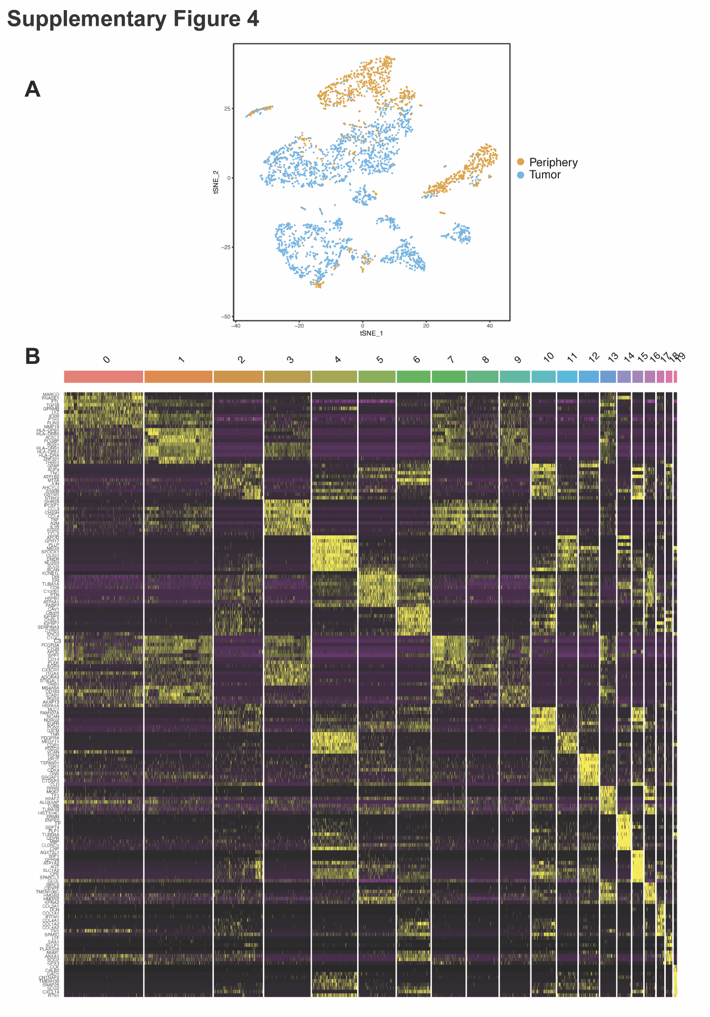
Supplementary Figure 4. t-SNE plot clustered by tumor region and the marker gene of all clusters in scRNA-seq GBM datasets. (A) GBM single cells were visualized by t-distributed stochastic neighbor embedding (t-SNE) analysis, and tumor cells derived from periphery and core were annotated by colors. (B) Heatmap of marker genes among clusters of all GBM cells.
Supplementary Figure 5. Gate strategy for examining CD4⁺ and CD8⁺ T cells among shCtrl and shCtxn1 groups. (A-B) Flow cytometry analysis of CD4 and CD8 expression on tumor infiltrating cells from GL261 on day 14 after implantation.

