Supplementary Appendix

Timeseries decomposition

For seasonal trend analysis of the time-series datasets, an additive decomposition method was applied, where the time series is modeled by a sum of three components: trend-cycle, season, and residuals, i.e., D(t) =T r(t) +S(t) +R(t). A frequency of 52 (corresponding to each week of data) was used in the decomposition and each decomposition was plotted in Supplementary Figure s5-s8.

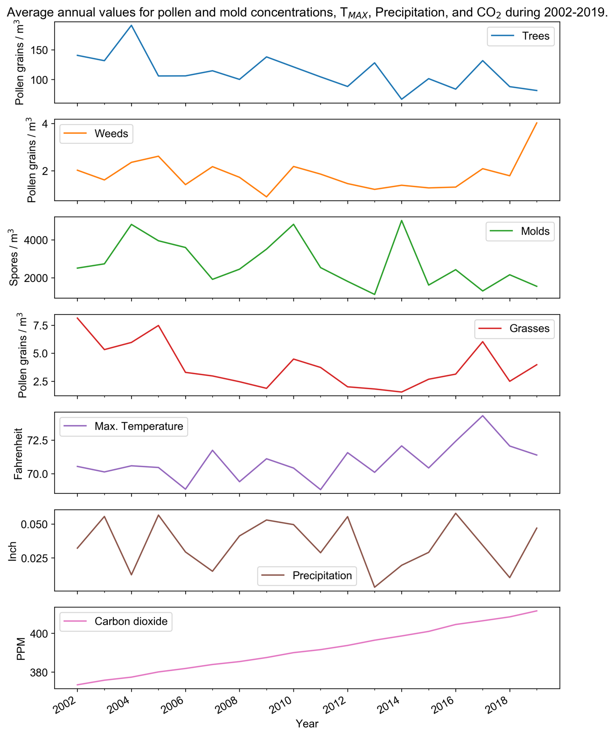

Figure s1. Average annual values for major allergens, T_{MAX}, Precipitation, and CO₂ values.

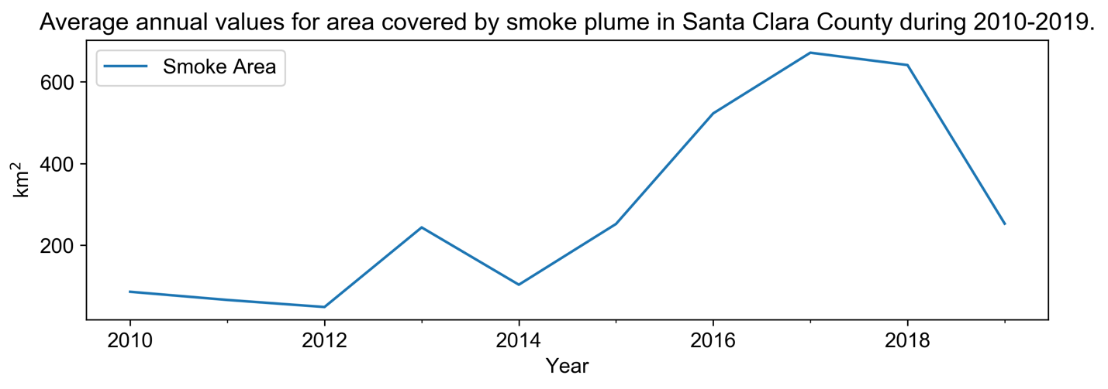

Figure s2. Average annual values for Smoke Area in Santa Clara County.

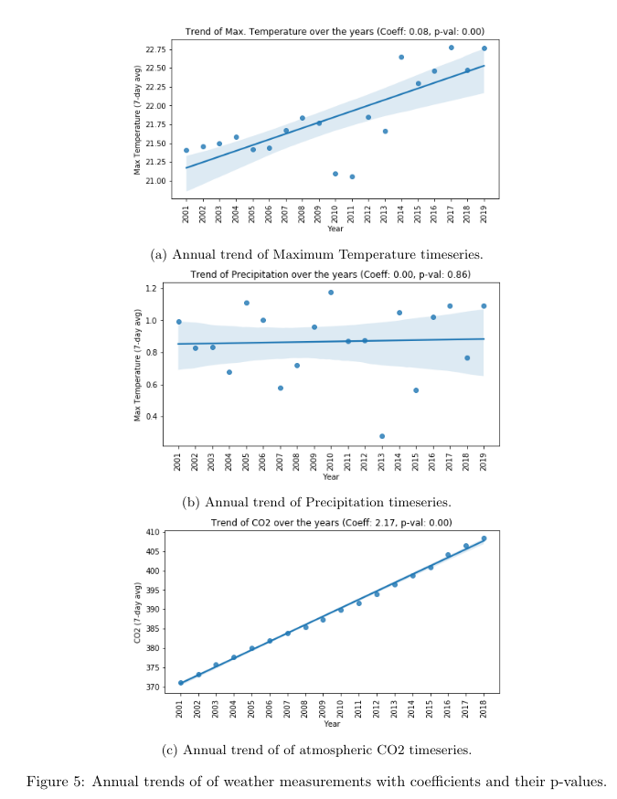
Figure s3. Annual trends of climate measurements with coefficients and their p-values.

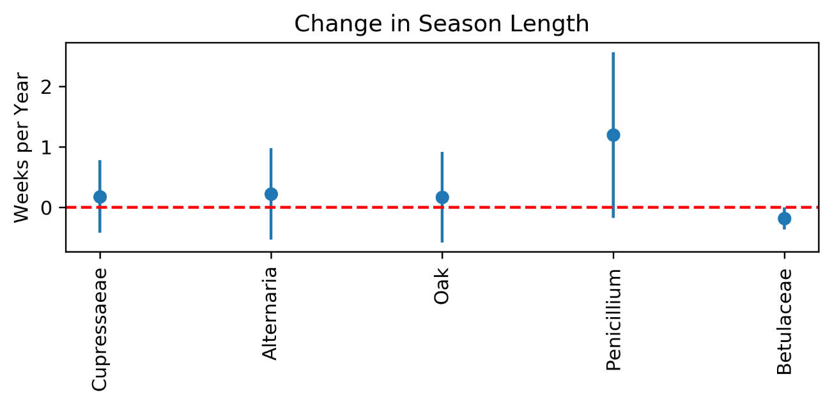

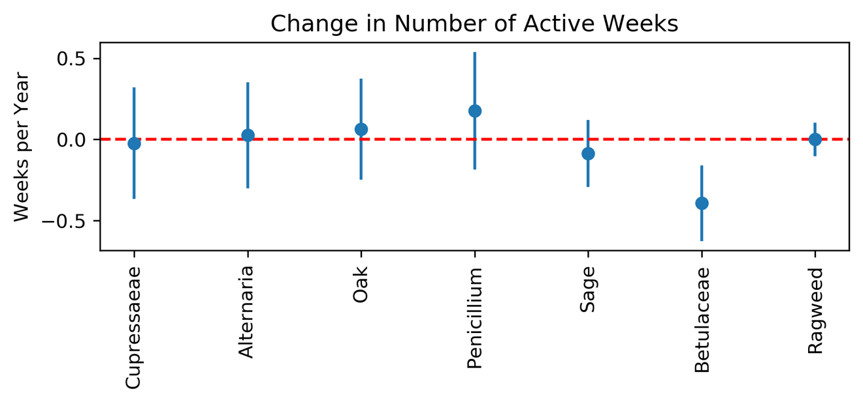

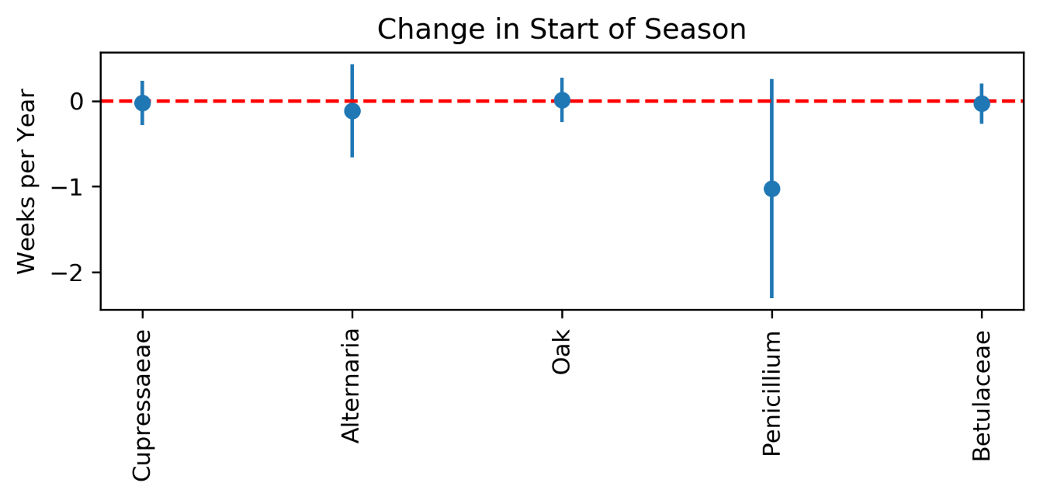

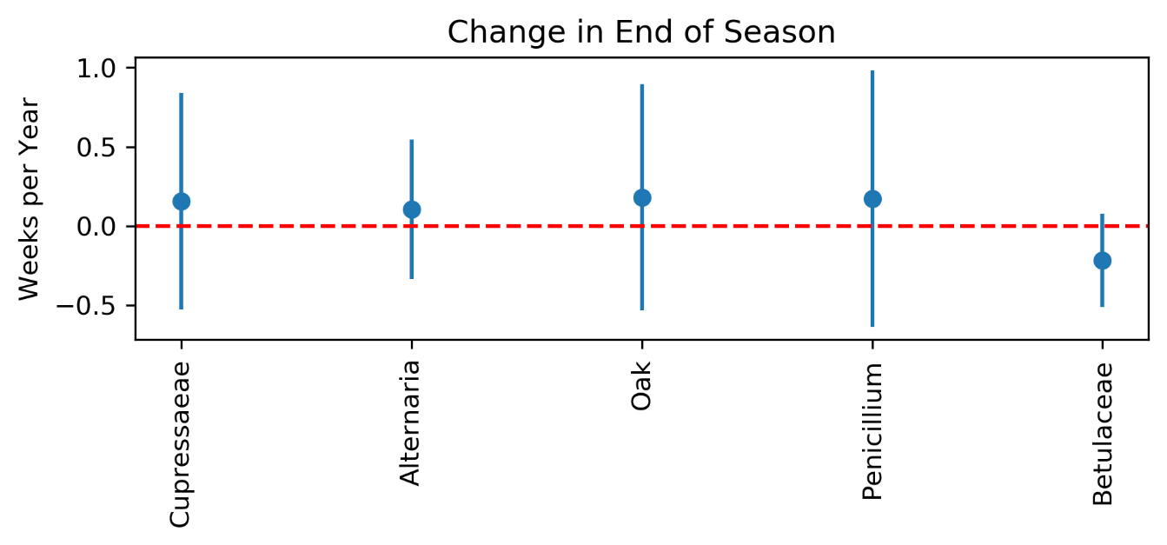

Figure s4. Coefficient estimates and 95% confidence intervals for change in season length, number of active weeks, start of season, and end of season for the selected species. Only those species for which season could be calculated for at least ten years are shown.

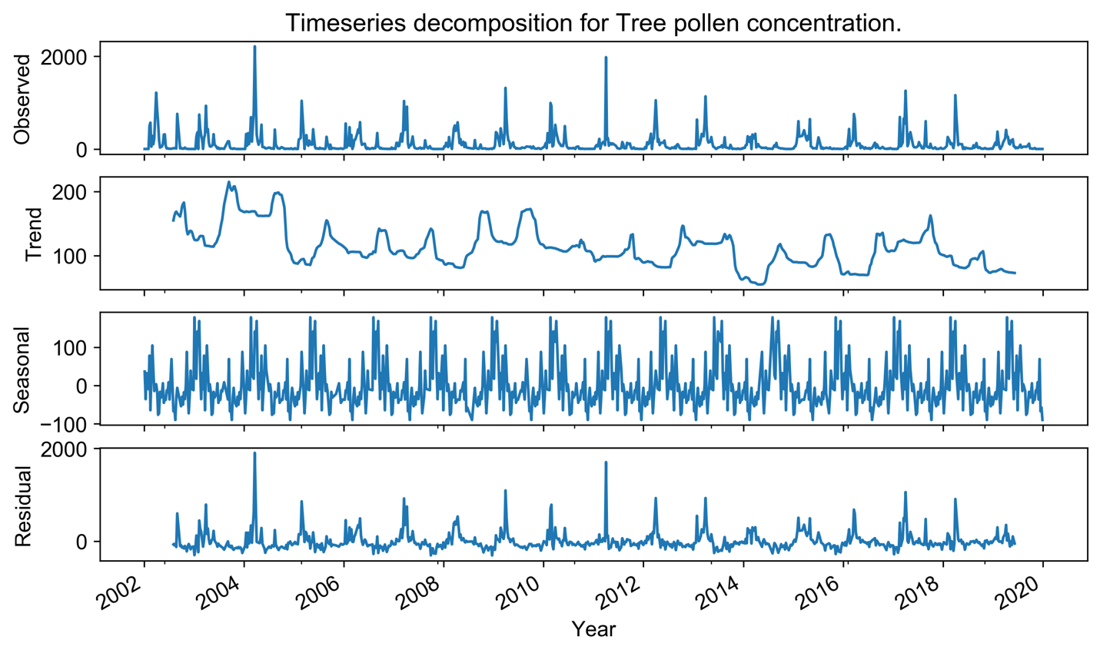
Figure s5. Seasonal decomposition of Tree pollen timeseries dataset (2002-2019).

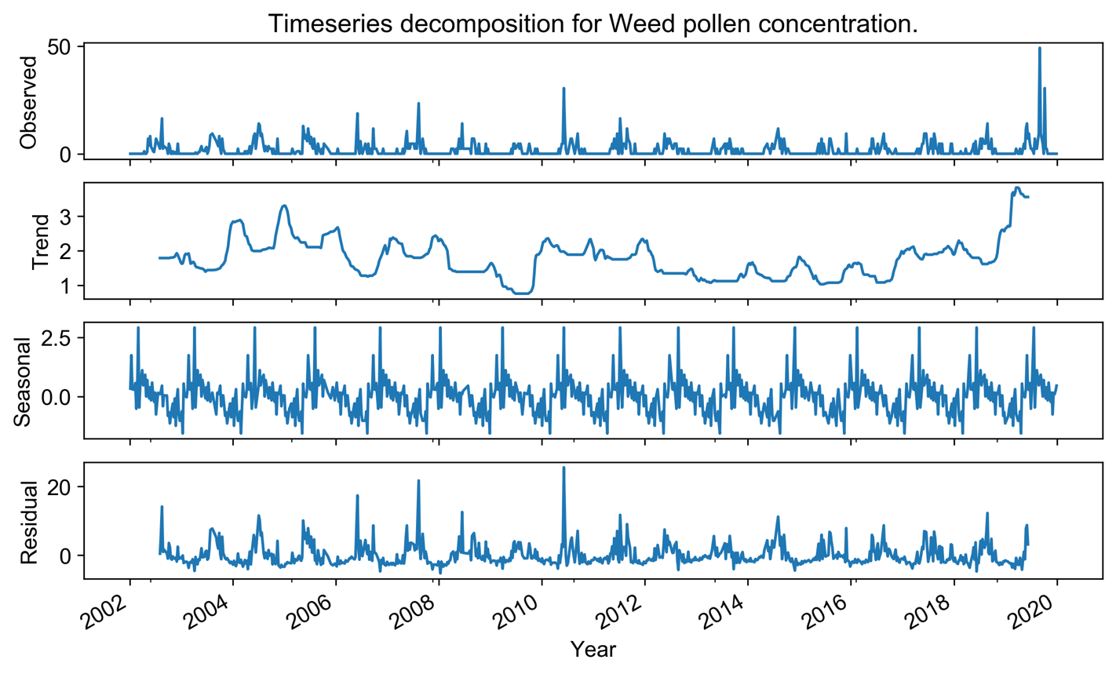
Figure s6. Seasonal decomposition of Weed pollen timeseries dataset (2002-2019).

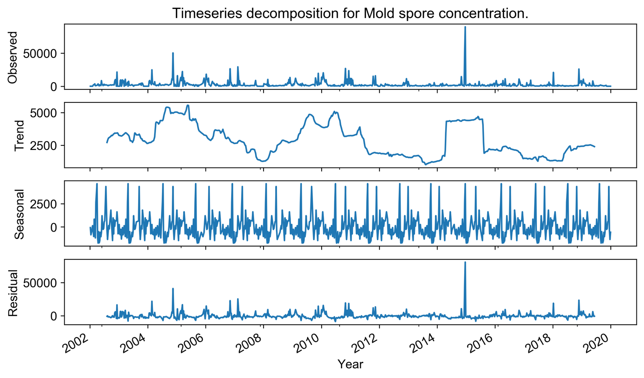
Figure s7. Seasonal decomposition of Mold spores timeseries dataset (2002-2019).

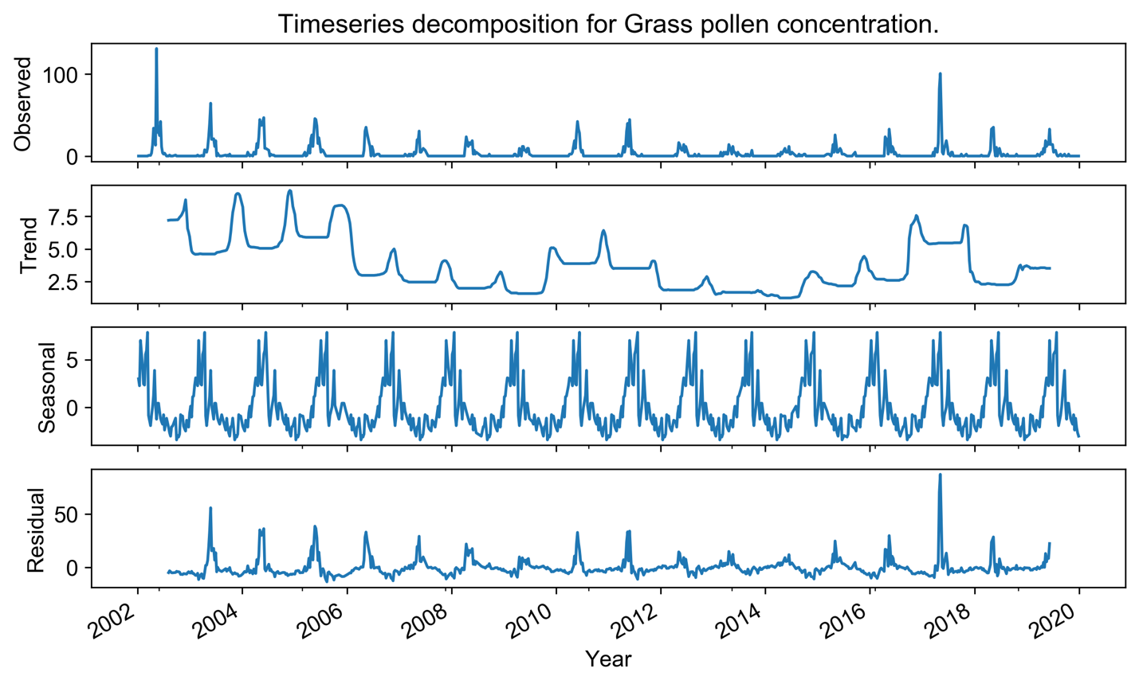
Figure s8. Seasonal decomposition of the Grass pollen timeseries dataset (2002-2019).
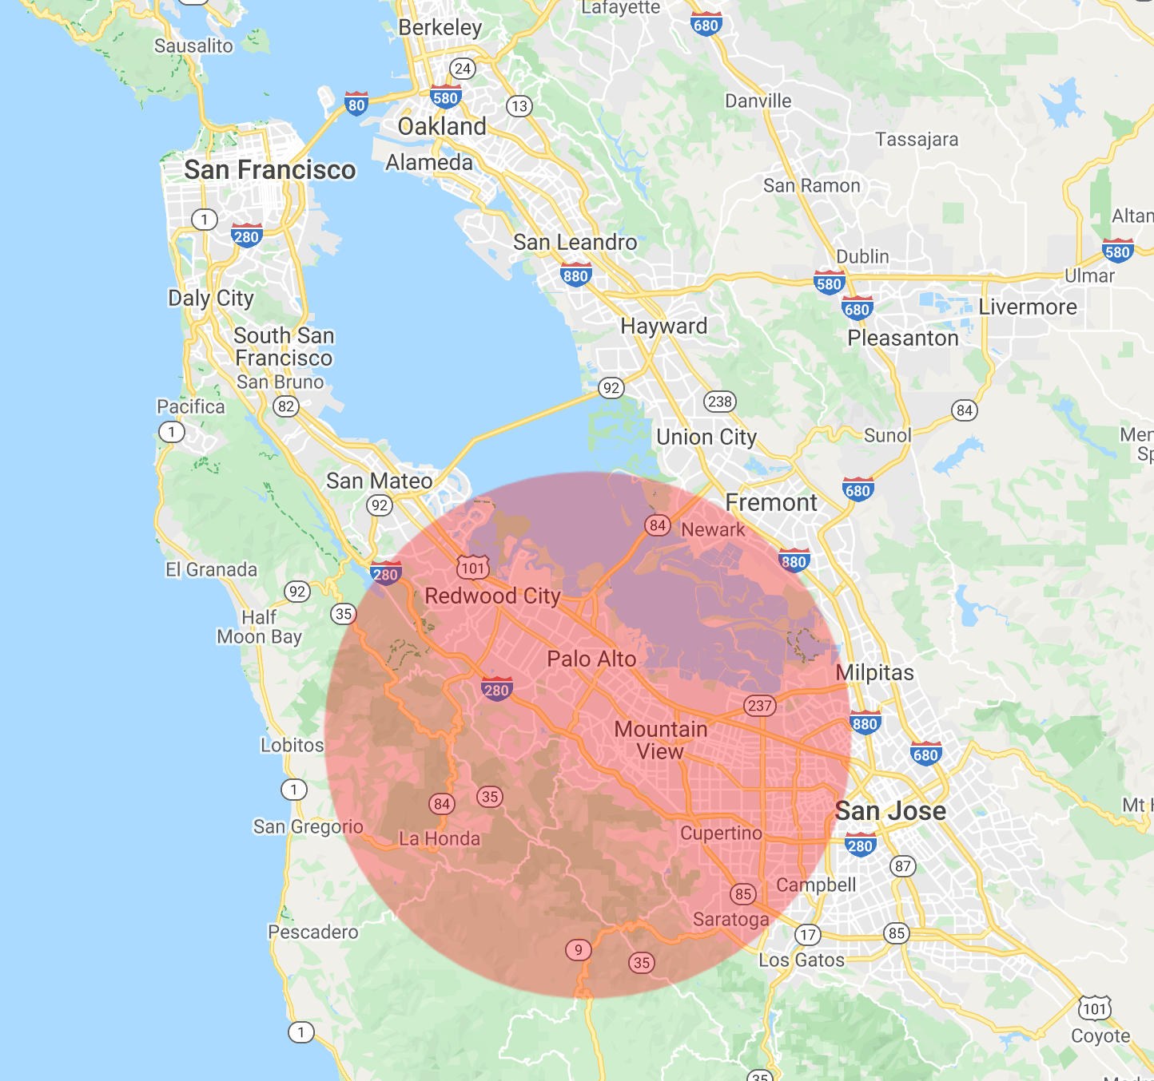
Figure s9. Spatial neighborhood (20 km radius) around the pollen data collection site. Map annotated using the Google Earth Engine Code Editor.

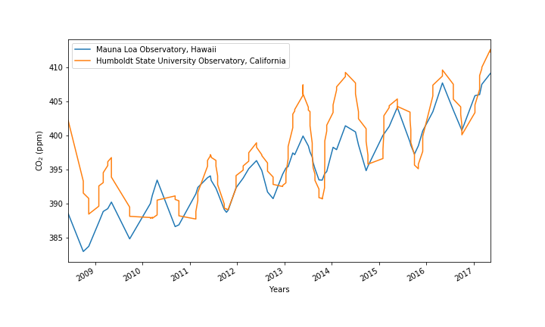

Figure s10. Comparison of the CO2 values (seven-day moving averages) at the Mauna Loa Observatory, Hawaii and Humboldt State University, California.
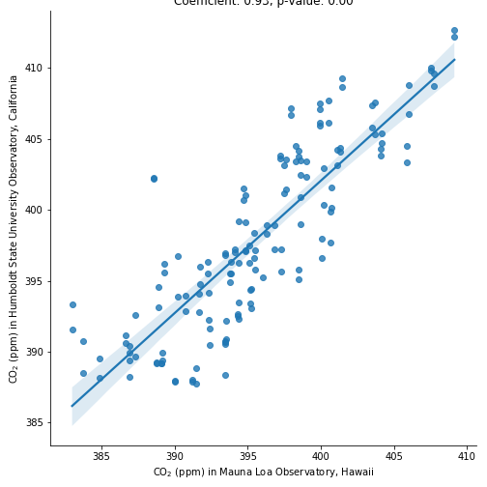
Figure s11. Linear relationship between CO2 values (seven-day moving averages) during 2008-2017 at the Mauna Loa Observatory, Hawaii and Humboldt State University, California (Correlation coefficient 0.93, p value 0.00).

Table s1. Temporal changes in the concentration and activity of major allergens (2002-2019), showing average change per year. A positive value for start of season or end of season indicates later start or end, and a negative value indicates earlier start or end. Active weeks are the weeks during which the concentrations were greater than zero for each type. Statistical significance (p value < 0.05) is denoted by an asterisk (*) and was ascertained using linear regression (see Methods section).

Type | Average rate of change of pollen/spore  concentrations per year | Average rate of change of pollen/spore season length, in weeks per year | Average rate of change of pollen/spore active weeks per year | Average rate of change of season start week  (Week  of the year) | Average rate of change of season end  (Week  of the year)
Trees | -3.16* | 0.38* | 0.47 * | -0.08 | 0.29*
Weeds | 0.01 | -0.40 | -0.30 | 0.29 | -0.11
Molds | -104.87 | 0.32 | 0.51 * | -0.08 | 0.23
Grasses | -0.19 * | -0.08 | -0.21 | 0.10 | 0.01

Table s2. Temporal changes in the concentration and activity of selected species (2002-2019), showing average change per year. A positive value for start of season or end of season indicates later start or end, and a negative value indicates earlier start or end. Active weeks are the weeks during which the concentrations were greater than zero for each type. Statistical significance (p value < 0.05) is denoted by an asterisk (*) and was ascertained using linear regression (see Methods section).
 | Species | Average rate of change of pollen/spore  concentration per year | Average rate of change of pollen/spore season length, in weeks per year | Average rate of change of pollen/spore active weeks per year | Average rate of change of season start week  (Week  of the year) | Average rate of change of season end  (Week  of the year)
Molds | Alternaria | 0.19 | 0.20 | 0.00 * | -0.01 | 0.19
Molds | Penicillium/  Aspergillus | 0.7 | 0.46 | 0.32 | -0.31 | 0.15
Trees | F Quercus (oak) | -0.39 | 0.30 | 0.02 | -0.13 | 0.17
Trees | Cupressaeae (incl. junipers/cedars) | -0.58 | 0.21 | 0.12 | -0.02 | 0.19
Trees | Betulaceae (birch  and look alikes) | -0.16 * | -0.08 | -0.43 * | -0.07 | -0.14
Weeds | A Artemesia  (sage) | 0.01 | 0.50 | -0.15 | -0.44 | 0.06
Weeds | A Ambrosia/  Franseria (ragweed) | 0.02 | 0.40 | -0.01 | -0.67 | -0.27

Table s3. Temporal changes in the concentration and activity of most commonly observed species (2002-2019), showing average change per year. A positive value for start of season or end of season indicates later start or end, and a negative value indicates earlier start or end. Active weeks are the weeks during which the concentrations were greater than zero for each type. Statistical significance (p value < 0.05) is denoted by an asterisk (*) and was ascertained using linear regression (see Methods section).
 | Species | Average rate of change of pollen/spore  concentration per year | Average rate of change of pollen/spore season length, in weeks per year | Average rate of change of pollen/spore active weeks per year | Average rate of change of season start week  (Week  of the year) | Average rate of change of season end  (Week  of the year)
Molds | Ascospores | -23.67 | 0.32 | 0.51 * | -0.08 | 0.23
Molds | Cladosporium | -24.96 * | 0.36 | 0.48 * | -0.13 | 0.23
Molds | Basidiospores | -55.54 * | 0.32 | 0.39 | -0.08 | 0.23
Molds | Unidentified Fungi | -2.70 * | -0.27 | -0.32 | 0.46 | 0.19
Molds | Periconia | 0.04 | -0.76 | 0.14 | 0.65 | -0.11
Molds | Rusts | 0.12 | 0.54 | 0.08 | 0.08 | 0.62
Molds | Alternaria | 0.19 | 0.20 | 0.00 * | -0.01 | 0.19
Molds | Algae | -1.59 * | 0.15 | -1.14 * | -0.10 | 0.04
Molds | Smuts/Myxomycetes | 0.12 | -0.31 | 0.07 | -0.33 | -0.64
Molds | Fusarium | -0.28 | 0.79 | -0.19 | -0.11 | 0.68
Molds | Epicoccum | 0.44 | -0.37 | 0.58 | 0.58 | 0.20
Molds | Oidium/Erysiphe | -0.09 | -0.07 | -0.38 * | -0.32 | -0.39
Molds | Ganoderma | 0.06 | 0.59 | 0.91 | -0.52 | 0.07
Molds | Coprinus | 1.10 | 0.28 | 0.07 | -0.17 | 0.11
Molds | Torula | -0.18 * | 0.20 | -0.51 | -0.52 | -0.29
Trees | Pinus | -0.94 * | 0.79 | 0.19 | 0.06 | 0.85
Trees | Cupressaeae (incl. juniper/cedars) | -0.58 | 0.21 | 0.12 | -0.02 | 0.19
Trees | Ulmus (elm) | -0.36 | -0.50 | 0.06 | 0.58 | 0.08
Trees | F Quercus (oak) | -0.39 | 0.30 | 0.02 | -0.13 | 0.17
 | Poaceae Graminae (Grasses) | -0.09 | 0.08 | -0.05 | -0.06 | 0.01

Table s4. Top twenty most commonly observed species ranked by the total number of active weeks in each major category. Active weeks are the weeks during which the pollen/spore concentrations were greater than zero.

 | Species | Total number of active weeks (2002-2019)
Molds | Ascospores | 1,050
Molds | Cladosporium | 1,047
Molds | Basidiospores | 1,044
Molds | Unidentified Fungi | 900
Molds | Periconia | 746
Molds | Ganoderma | 702
Molds | Coprinus | 608
Molds | Rusts | 585
Molds | Alternaria | 533
Molds | Algae | 456
Molds | Smuts/Myxomycetes | 416
Molds | Fusarium | 337
Molds | Oidium/Erysiphe | 291
Molds | Epicoccum | 289
 | Torula | 287
Trees | Pinus | 706
Trees | Cupressaeae | 604
Trees | Ulnus (elm) | 345
Trees | F Quercus (oak) | 305
Grasses | Poaceae Graminae | 366

