Table S1 Eleven microsatellite loci used in this study.
Locus | Repeat Motif | Size Range | Tm (℃)
Am116 | (CT)₂₀ | 210-268 | 56
Am118 | (CT)₁₆ | 153-169 | 52
Am340 | (AG)₂₂ | 170-202 | 52
Am607 | (AG)₁₅ | 126-162 | 56
Am258 | (CT)₁₇ | 166-184 | 56
Aca17 | (TC)₁₇(AC)₁₃ | 390-442 | 54
Aca22 | (AT)₂(AC)₁₅ | 158-174 | 51
Aca24 | (AG)₅(AC)₆ | 92-106 | 50
Map09 | (GA)₈ | 92-116 | 50
AY05 | (CA)₁₁ | 200-300 | 61
AY14 | (GT)₈(GA)₉ | 163-175 | 65

Table S2 Bayesian assignment results of 410 seeds from SEA-DHS, NEA-DHS and Hybrid-DHS maternal trees.
 | SEA-DHS maternal trees | Hybrid-DHS maternal trees | NEA-DHS maternal trees
 | N=198 | N=170 | N=42
SEA-DHS seeds | 143 (72.2%) | 30 (17.6%) | 0 (0%)
Hybrid-DHS seeds | 35 (17.7%) | 42 (24.7%) | 1 (2.4%)
NEA-DHS seeds | 20 (10.1%) | 98 (57.6%) | 41 (97.6%)

Table S3 Loadings of analysed morphology indices for PCA analysis of leaves and fruits in DHS. Bold numbers represent the first three highest contributors.

Loadings | Axis.1 | Axis.2
Leaf
Lobes# | 0.13 | 0.45
TotalArea | -0.38 | 0.56
InflectionLength | -0.53 | -0.31
InflectionWidth | -0.49 | -0.21
CentralLength | -0.51 | -0.08
CentralWidth | -0.26 | 0.58
Fruit
FruitAngle | 0.22 | 0.49
JunctionWidth | -0.37 | -0.23
SeedLength | -0.39 | -0.16
SeedWidth | -0.40 | -0.19
WingLength | -0.33 | 0.48
WingWidth | -0.38 | 0.15
FruitLength | -0.32 | 0.59
FruitWidth | -0.36 | -0.20

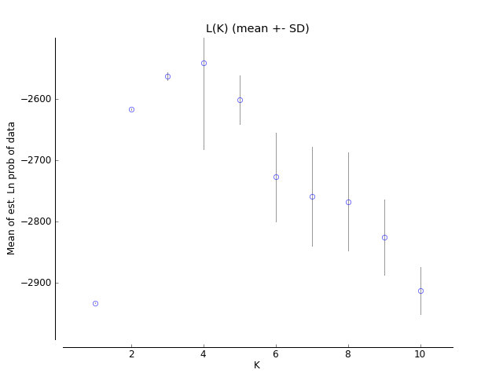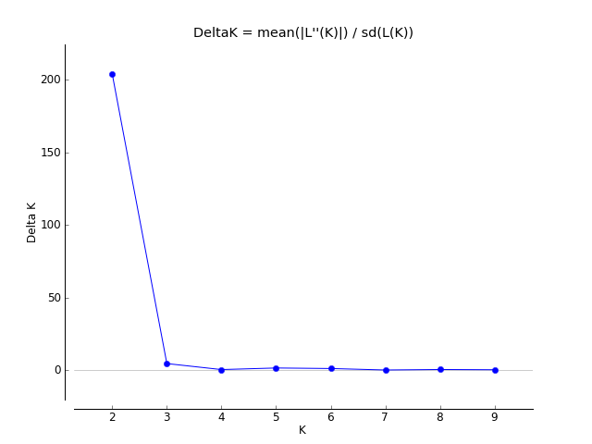
Figure S1. Summary of STRUCTURE results based on DHS-only dataset: lnPD and △K against K.

Figure S2. Ancestral proportion (q value) of each 70 individuals in DHS according to STRUCTURE analysis based on whole-range dataset. The q value is positively changed with altitude (Pearson’s r=0.63, p=0.000).

Figure S3. Principal Coordinates analysis (PCoA) result of the adult population. The colors are marked according to STRUCTURE results based on whole-range dataset.

Figure S4. Frequency distribution of Diameters at Breast Height for the 70 sampled trees in DHS.

Figure S5. Definition of morphology indices measure in this study: (a) leaf; (b) fruit.

