Table 1S Composition and nutrient levels of diets (as-fed basis)
Ingredient | g kg⁻¹ | Nutrient levels, g kg⁻¹ ^{c}
Corn | 579.0 | DE, MJ kg⁻¹ | 14.02
Soybean meal | 254.7 | Crude protein | 200.5
Fish meal | 50.0 | Ca | 6.2
Whey powder | 40.0 | Available P | 5.0
Cream powder | 45.0 | Lys | 15.9
Limestone | 3.0 | Met | 5.6
Ca (H₂PO₄)₂ | 12.0 | Met+Cys | 8.5
Moldproofant | 1.0
Acidifier | 3.0
L-Lysiine‧HCl | 2.5
Choline chloride | 1.0
DL-Methionine | 0.5
NaCl | 3.0
Trace mineral premix ª | 5.0
Vitamin premix ^{b} | 0.3
Total | 1000.0
ª Trace mineral premix provides the following per kilogram of diets: 16.5 mg of Cu as CuSO₄‧5H₂O, 100 mg of Fe as FeSO₄‧H₂O, 35 mg of Mn as MnSO₄‧H₂O, 100 mg of Zn as ZnSO₄‧H₂O, 0.3 mg of Se as Na₂SeO₃, 0.3 mg of I as KI.
^{b} Vitamin premix provides the following per kilogram of diets: 11000 IU of vitamin A, 1500 IU of vitamin D3, 16 IU of vitamin E，1 mg of vitamin K, 0.3 mg of folic acid, 15 mg of nicotinic, 10 mg of pantothenate, 2.5 mg of biotin, 1 mg of vitamin B1, 4.0 mg of vitamin B2, 0.01 mg of vitamin B12.
^{C} Nutrient levels were calculated values.

Table 2S Differential metabolites identified among BC, NC, S50, S100 and S200 groups from the data set of the feces samples
Num. | Name | P value | FC
NC vs BC
1 | L-pipecolic acid | 2.51×10⁻² | 0.34
S50 vs NC
1 | tartaric acid | 3.02×10⁻³ | 3.03
2 | N-acetylserotonin | 3.47×10⁻³ | 0.61
3 | melatonin | 1.14×10⁻² | 0.56
4 | 4-hydroxyproline | 1.17×10⁻² | 0.49
5 | 5-aminolevulinic acid | 1.17×10⁻² | 0.49
6 | 4-guanidinobutyric acid | 2.29×10⁻² | 0.61
7 | caffeine | 2.32×10⁻² | 0.52
8 | normetanephrine | 3.10×10⁻² | 0.55
9 | epinephrine | 3.10×10⁻² | 0.55
10 | dCMP | 3.94×10⁻² | 0.35
11 | 1,3-diaminopropane | 4.07×10⁻² | 2.54
12 | 3-methoxytyramine | 4.37×10⁻² | 2.58
13 | 1H-indole-3-acetamide | 4.54×10⁻² | 0.47
S100 vs NC
1 | tartaric acid | 3.65×10⁻³ | 1.98
2 | D- maltose | 3.89×10⁻³ | 2.28
3 | deoxyguanosine | 1.18×10⁻² | 0.43
4 | 4-hydroxyproline | 1.90×10⁻² | 0.38
5 | 5-aminolevulinic acid | 1.90×10⁻² | 0.38
6 | phosphorylcholine | 2.07×10⁻² | 0.31
7 | allantoin | 2.31×10⁻² | 7.25
8 | phosphonoacetate | 2.32×10⁻² | 2.47
9 | biliverdin | 3.51×10⁻² | 2.03
10 | glycolate | 4.27×10⁻² | 1.41
11 | L-pipecolic acid | 4.55×10⁻² | 4.04
12 | quinic acid | 4.62×10⁻² | 5.15
S200 vs NC
1 | tartaric acid | 1.42×10⁻³ | 2.56
2 | L-phenylalanine | 1.79×10⁻² | 0.57
3 | L-homocystine | 2.16×10⁻² | 5.21
4 | dCMP | 2.84×10⁻² | 0.36
5 | deoxyguanosine | 2.91×10⁻² | 0.52
6 | UMP (uridine 5'-monophosphate) | 3.52×10⁻² | 0.69
7 | cyclic GMP | 3.79×10⁻² | 0.49

Table 3S Differential metabolites identified among BC, NC, S50, S100 and S200 groups from the data set of the serum samples
Num. | Name | P value | FC
NC vs BC
1 | CMP (cytidine monophosphate) | 3.98×10⁻² | 0.31
2 | dUTP (deoxyuridine triphosphate) | 2.83×10⁻² | 0.33
3 | 1-methyladenosine | 3.41×10⁻² | 0.34
4 | L-allothreonine | 4.14×10⁻² | 0.47
5 | GSSG (oxidized glutathione) | 1.44×10⁻² | 0.51
6 | N, N-dimethylaniline | 4.02×10⁻² | 0.51
7 | hydroxykynurenine | 4.43×10⁻² | 0.54
8 | glucosamine 6-phosphate | 2.71×10⁻² | 0.83
9 | ITP | 2.89×10⁻² | 2.00
10 | chenodeoxycholic acid glycine conjugate | 2.44×10⁻² | 2.11
11 | L-kynurenine | 4.65×10⁻² | 2.28
12 | diaminopimelic acid | 8.46×10⁻³ | 3.64
13 | NADP | 7.22×10⁻³ | 4.89
14 | thiamine pyrophosphate | 4.25×10⁻² | 6.91
S50 vs NC
1 | desthiobiotin | 1.23×10⁻² | 0.26
2 | 2-phosphoglyceric acid | 2.12×10⁻² | 0.30
3 | pterin | 3.80×10⁻⁴ | 0.40
4 | NADP | 4.72×10⁻² | 0.49
5 | caffeine | 4.76×10⁻² | 1.85
6 | hypotaurine | 2.87×10⁻² | 1.87
7 | tryptophanamide | 4.58×10⁻² | 1.93
8 | glycerol | 1.94×10⁻² | 2.05
9 | quinic acid | 4.79×10⁻³ | 2.14
10 | 5-aminolevulinic acid | 3.39×10⁻² | 2.21
11 | N-acetyl-L-alanine | 3.39×10⁻² | 2.21
12 | 4-hydroxyproline | 3.39×10⁻² | 2.21
13 | tetrahydrofolic acid | 3.86×10⁻² | 2.88
14 | kynurenic acid | 2.54×10⁻² | 42.12
S100 vs NC
1 | phosphocreatine | 4.14×10⁻² | 0.14
2 | 2,5-dimethylpyrazine | 1.20×10⁻² | 0.18
3 | NADP | 9.85×10⁻³ | 0.19
4 | desthiobiotin | 1.81×10⁻² | 0.28
5 | uridine 5'-diphospho-N-acetylgalactosamine | 3.66×10⁻² | 0.37
6 | uridine diphosphate-N-acetylglucosamine | 3.66×10⁻² | 0.37
7 | N-acetyltryptophan | 4.09×10⁻² | 0.44
8 | L-glutamic acid | 2.97×10⁻² | 1.33
9 | N-methyl-D-aspartic acid | 2.97×10⁻² | 1.33
10 | O-acetylserine | 2.97×10⁻² | 1.33
11 | 3-sulfinoalanine | 2.74×10⁻² | 1.43
12 | L-glutamine | 5.85×10⁻³ | 1.61
13 | 5-aminolevulinic acid | 2.34×10⁻³ | 1.63
14 | N-acetyl-L-alanine | 2.34×10⁻³ | 1.63
15 | 4-hydroxyproline | 2.34×10⁻³ | 1.63
16 | glucosamine 6-phosphate | 2.49×10⁻² | 1.81
17 | salicylamide | 1.77×10⁻² | 1.89
18 | tryptophanamide | 1.03×10⁻² | 1.91
19 | L-methionine | 3.82×10⁻² | 2.23
20 | S-adenosylhomocysteine | 2.38×10⁻³ | 2.33
21 | CMP (cytidine monophosphate) | 1.34×10⁻² | 2.84
22 | glycerol | 2.35×10⁻² | 2.92
23 | ATP (adenosine triphosphate) | 1.49×10⁻² | 2.97
24 | tetrahydrofolic acid | 3.60×10⁻² | 3.39
25 | thyrotropin releasing hormone | 5.00×10⁻⁴ | 10.32
S200 vs NC
1 | thiamine pyrophosphate | 3.39×10⁻² | 0.10
2 | NADP | 6.88×10⁻³ | 0.26
3 | L-aspartic acid | 4.14×10⁻² | 0.26
4 | ciliatine | 4.53×10⁻² | 0.27
5 | taurine | 2.72×10⁻³ | 0.27
6 | indoleacetic acid | 3.18×10⁻² | 0.30
7 | guanidinosuccinic acid | 4.58×10⁻² | 0.35
8 | 5-hydroxylysine | 1.62×10⁻² | 0.38
9 | diaminopimelic acid | 2.58×10⁻² | 0.43
10 | uridine 5'-diphospho-N-acetylgalactosamine | 2.67×10⁻² | 0.43
11 | uridine diphosphate-N-acetylglucosamine | 2.67×10⁻² | 0.43
12 | 3-methylcrotonyl-CoA | 3.95×10⁻² | 0.52
13 | pyridoxamine | 4.91×10⁻² | 0.56
14 | L-methionine | 4.87×10⁻³ | 1.80
15 | N-acetylneuraminic acid | 1.48×10⁻² | 1.90
16 | L-palmitoylcarnitine | 1.15×10⁻² | 2.12
17 | ethyl 3-indoleacetate | 3.37×10⁻² | 2.15
18 | quinic acid | 6.76×10⁻³ | 2.20
19 | allantoin | 4.48×10⁻² | 2.36
20 | guanosine diphosphate mannose | 9.00×10⁻⁴ | 3.33
21 | tetrahydrofolic acid | 3.43×10⁻³ | 4.22
22 | IMP | 3.29×10⁻² | 7.18

Figure 1S TICs of the feces samples (a) and the serum samples (b) from five groups (i.e., group BC, NC, S50, S100 and S200)
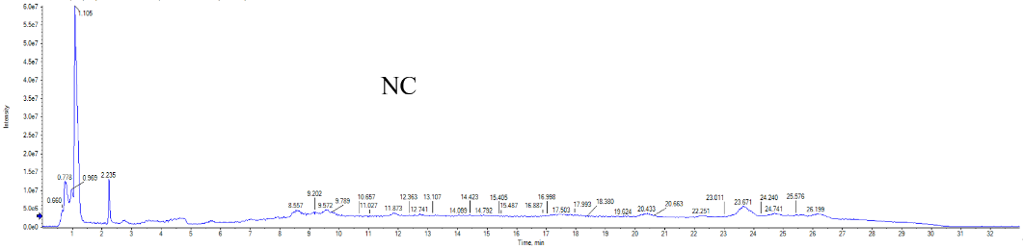
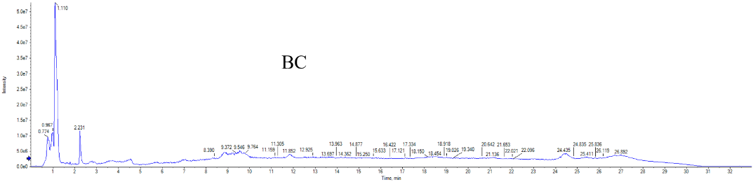
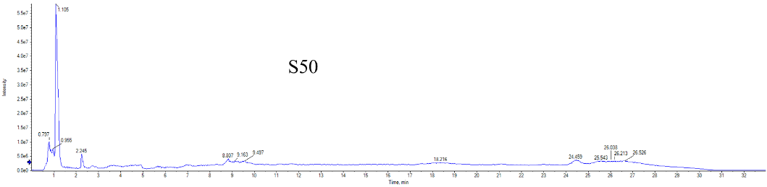
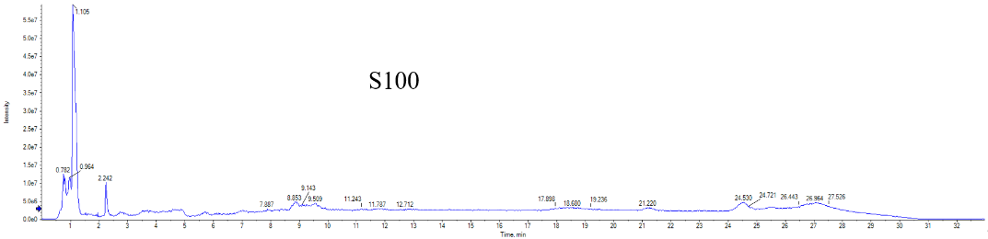
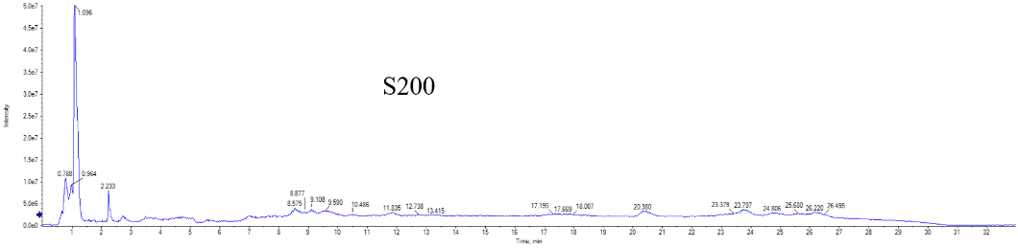
(a)

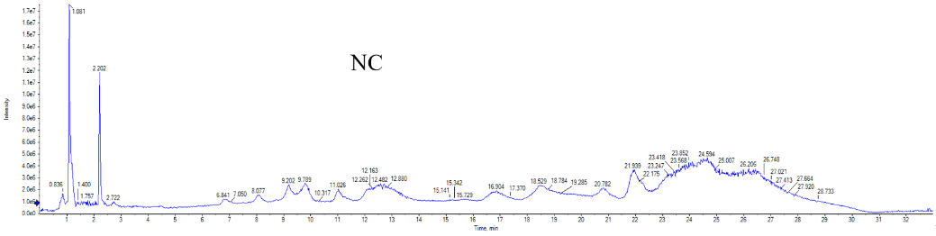
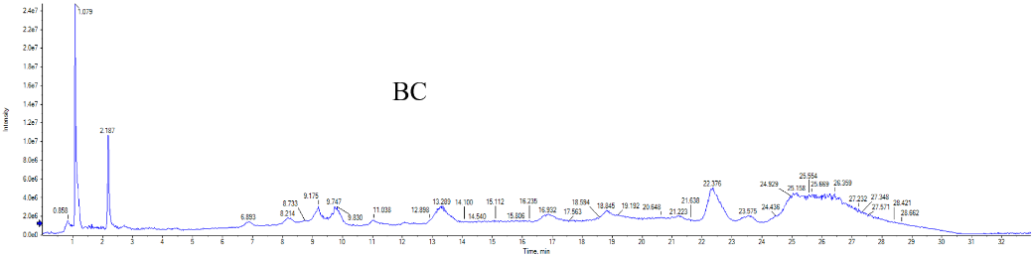
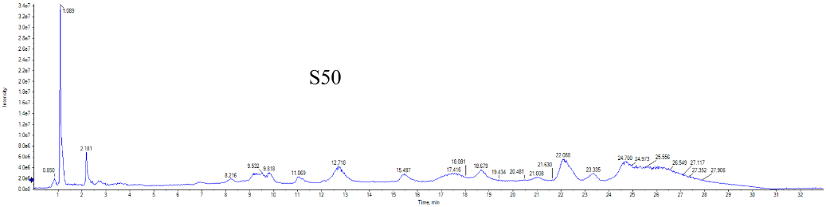
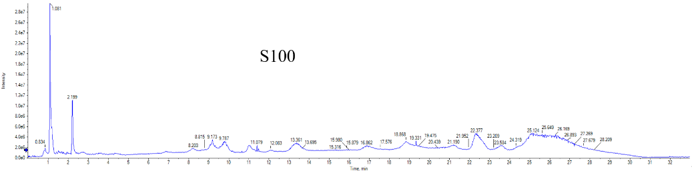
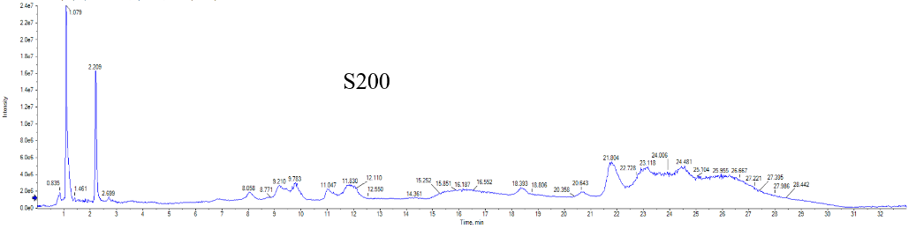
(b)

Figure 2S Overview of metabolites that were enriched on the groups of S50 vs NC, S100 vs NC and S200 vs NC based on feces intracellular metabolites of piglets, respectively.
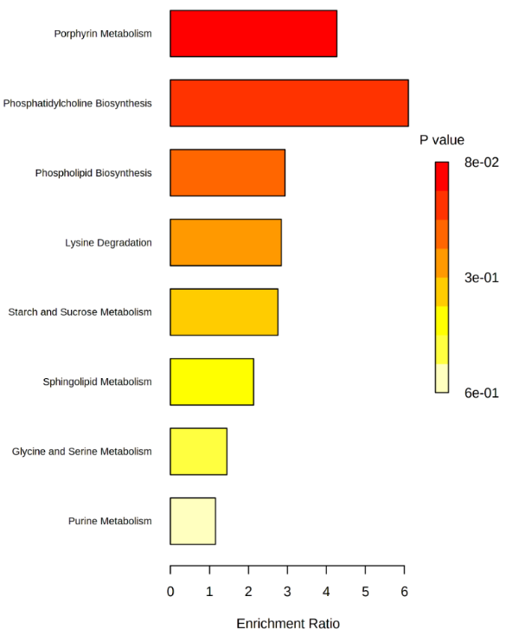
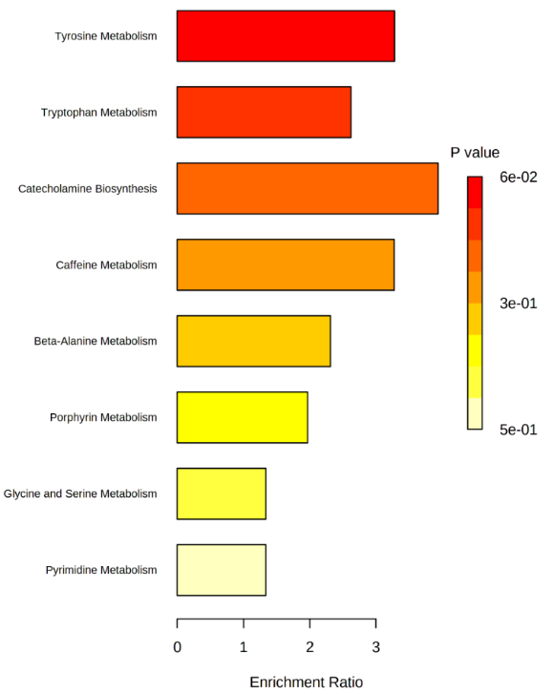
S100 vs NC
S50 vs NC

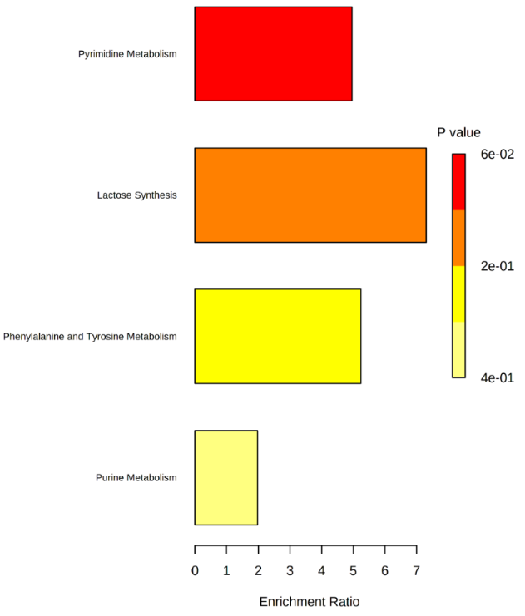
S200 vs NC

Figure 3S Overview of metabolites that were enriched on the groups of NC vs BC, S50 vs NC, S100 vs NC and S200 vs NC based on serum intracellular metabolites of piglets, respectively.
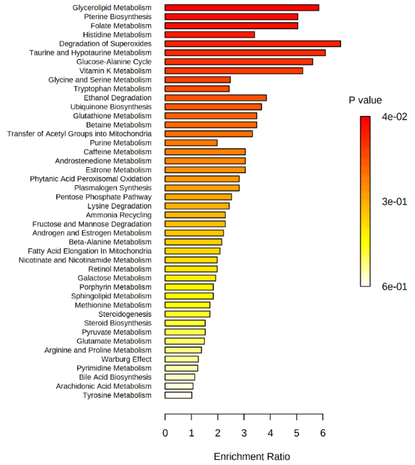
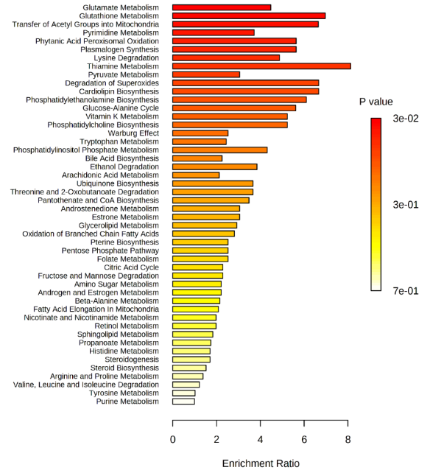
S50 vs NC
NC vs BC

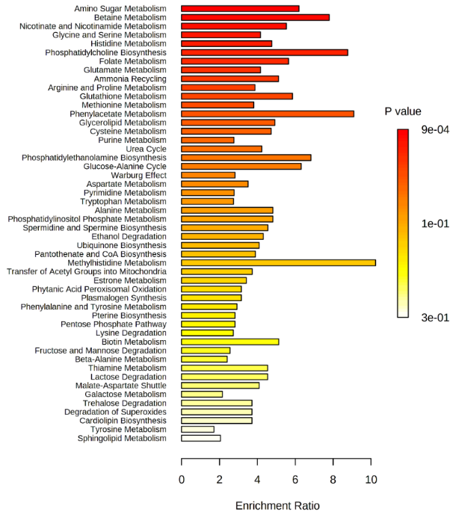
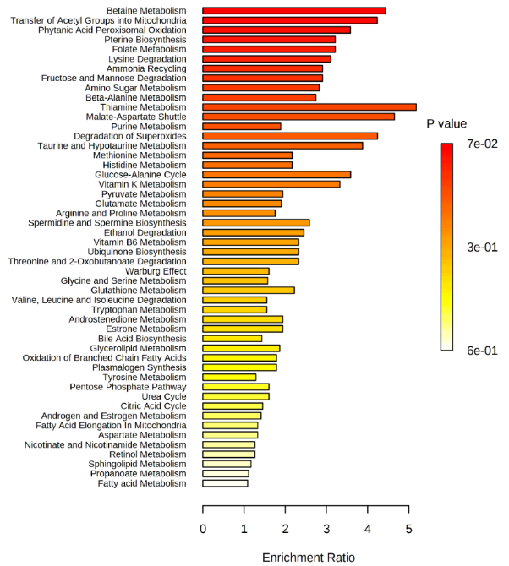
S100 vs NC
S200 vs NC

