Supporting Information

Unlocking the hidden chemical space in cubic-phase garnet solid electrolyte for long-term stable solid-state batteries
Sung-Kyun Jung^{1,2,†,}*, Hyeokjo Gwon^{1,†,}*, Hyungsub Kim³, Gabin Yoon¹, Changhoon Jung⁴, and Ju-Sik Kim¹
Affiliation
¹ Battery Material Lab, Material Research Center, Samsung Advanced Institute of Technology (SAIT), Samsung Electronics Co., Ltd., 130 Samsung-ro, Yeongtong-gu, Suwon-si, Gyeonggi-do, 16678 Republic of Korea
² School of Energy and Chemical Engineering, Ulsan National Institute of Science and Technology (UNIST), 50 UNIST‐gil, Ulsan, 44919 Republic of Korea
³ Neutron Science Center, Korea Atomic Energy Research Institute (KAERI), 111 Daedeok‐daero 989 Beon‐Gil, Yuseong‐gu, Daejeon, 34057 Republic of Korea
⁴ Analytical Engineering Group, Material Research Center, Samsung Advanced Institute of Technology (SAIT), Samsung Electronics Co., Ltd., 130 Samsung-ro, Yeongtong-gu, Suwon-si, Gyeonggi-do, 16678 Republic of Korea

* Corresponding to: skjung@unist.ac.kr, h.gwon@samsung.com
†These authors contributed equally to this work.

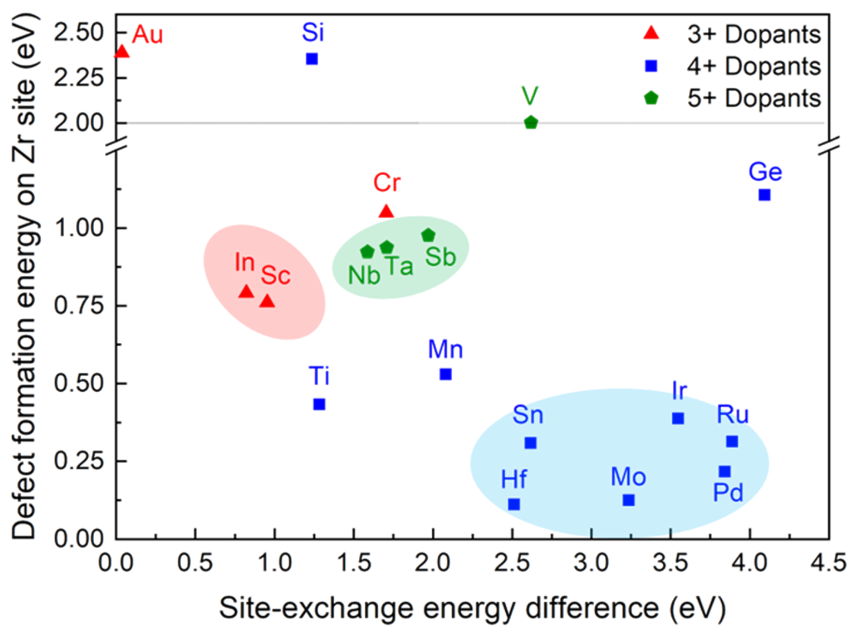

Figure S1. Dopant species with preference on Zr site in Li₇La₃Zr₂O₁₂ garnet phase. Site-exchange energy difference represents the minimum difference in defect formation energy between Zr and Li or La sites. Dopants with low defect formation energy and large difference in site-exchange energy can conveniently substitute Zr site. Shaded regions represent the most preferred dopants on Zr site with various oxidation states. (Reproduced with permission of L. J. Miara et al., Chem. Mater. 27 (2015) 4040. Copyright © 2015, American Chemical Society)

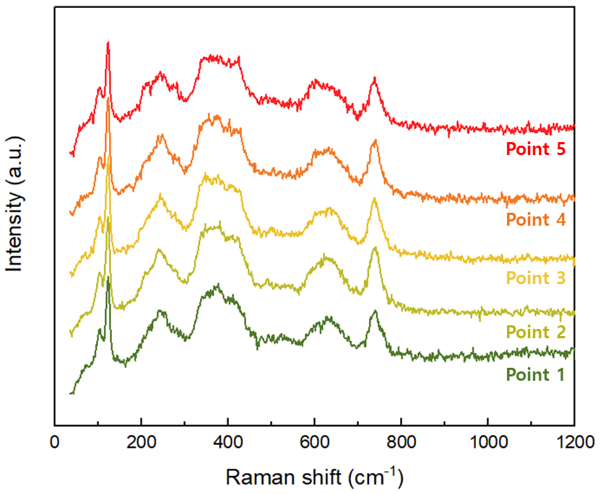

Figure S2. Raman spectra of Li₇La₃Zr_{0.4}Hf_{0.4}Sn_{0.4}Sc_{0.4}Ta_{0.4}O₁₂ at multiple points.
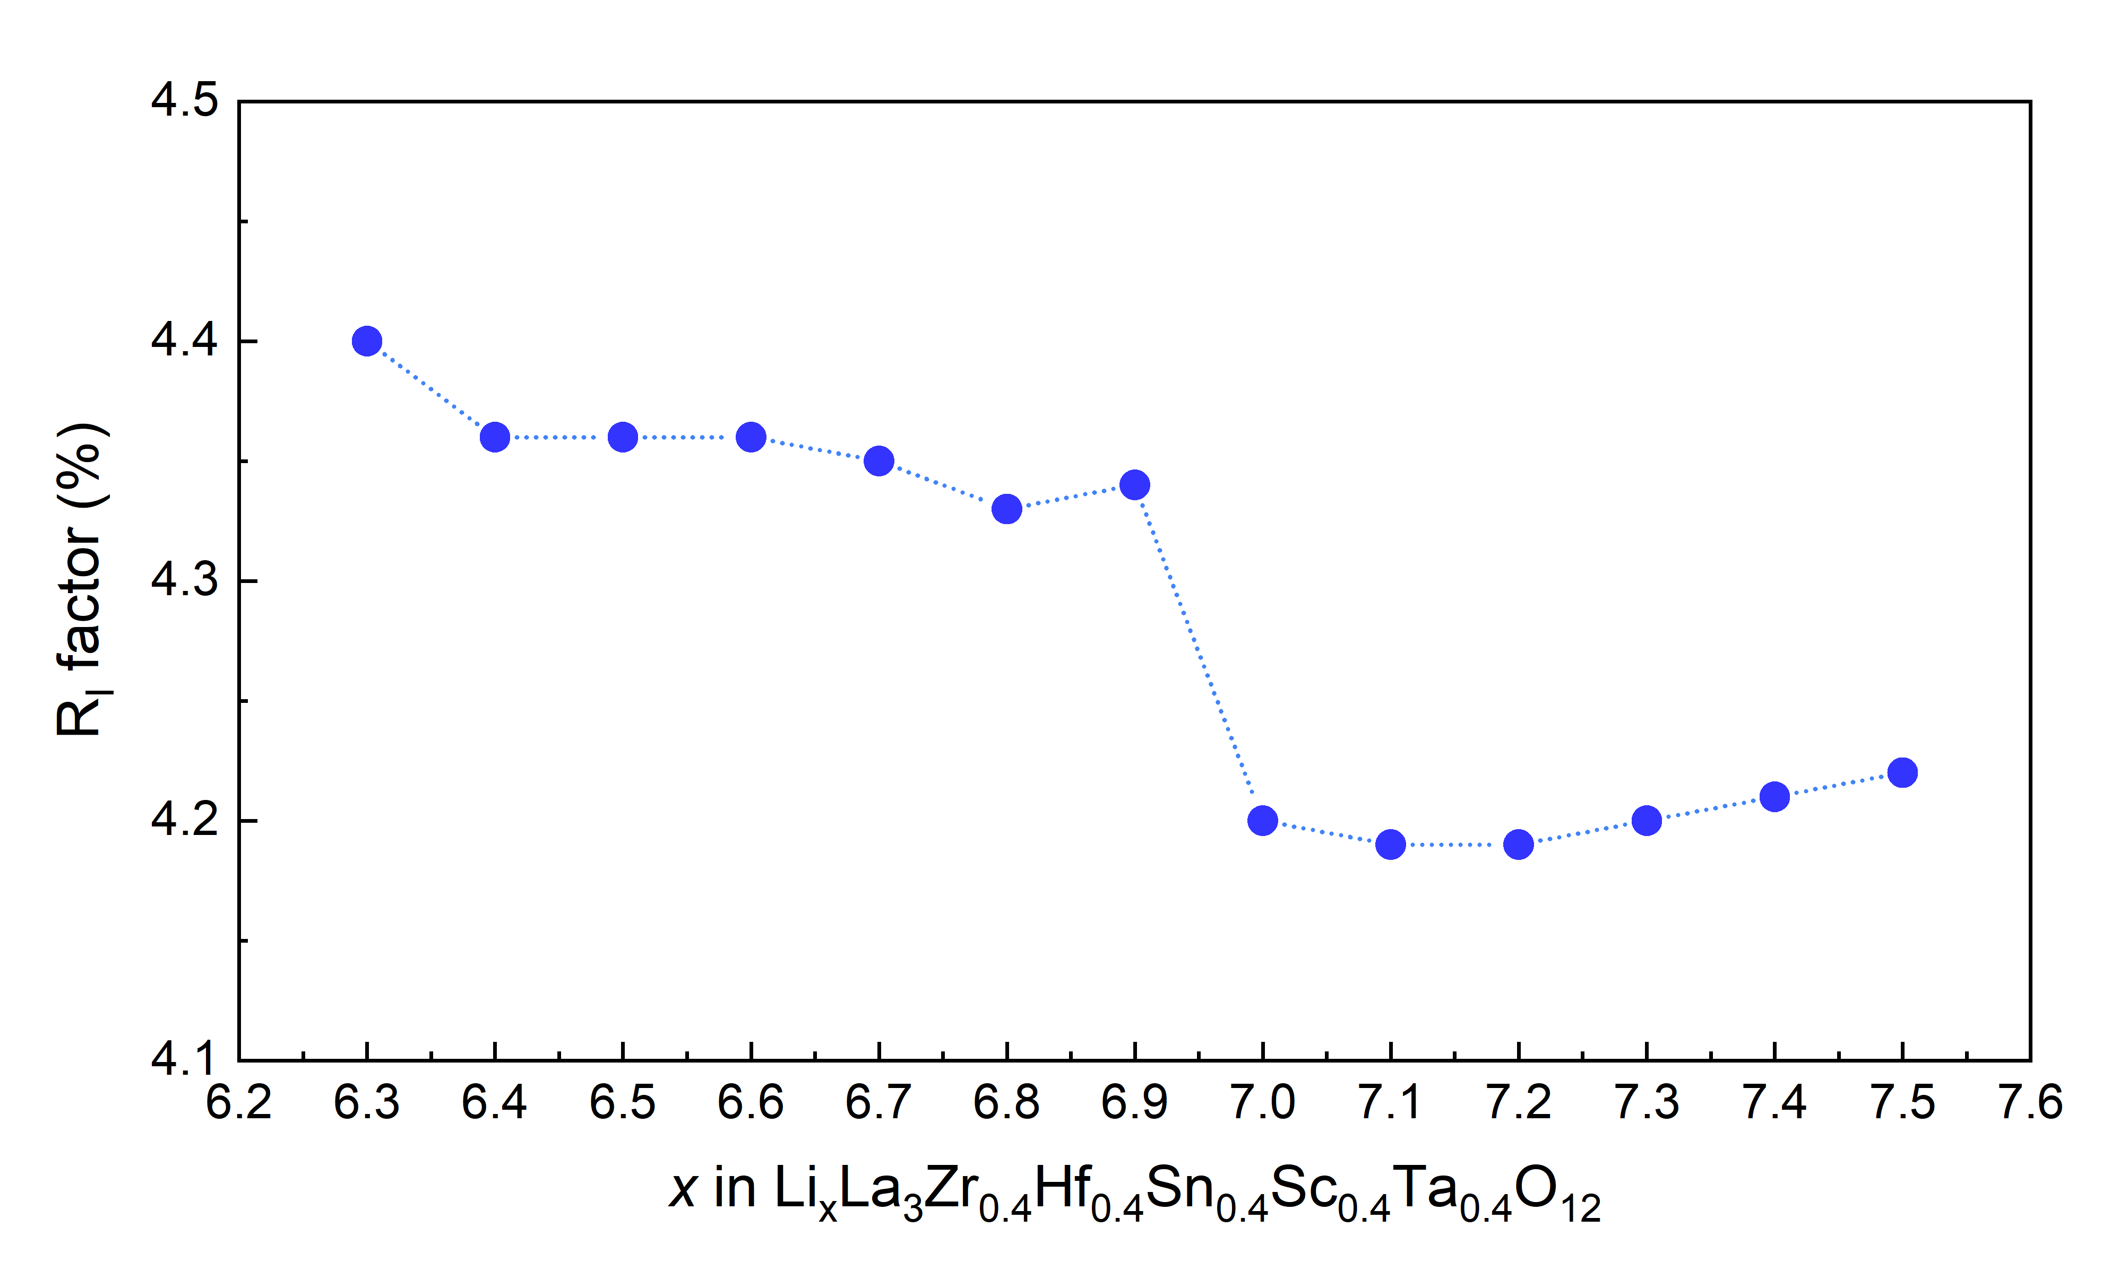

Figure S3. R_{I} factors according to lithium contents obtained from neutron diffraction Rietveld refinement result of Li = 7.0 garnet.
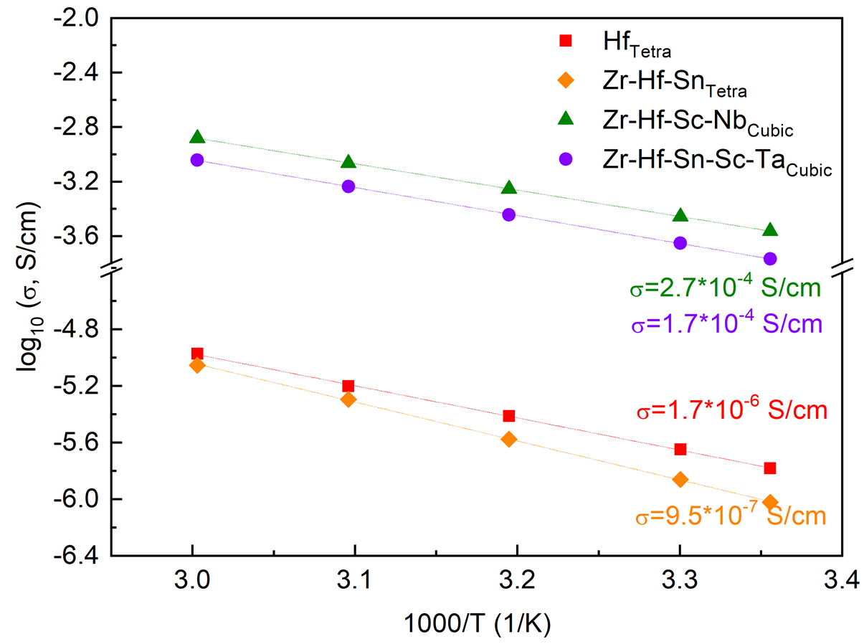

Figure S4. Arrhenius plot of tetragonal and cubic garnet phases, and their lithium ionic conductivities at room temperature.

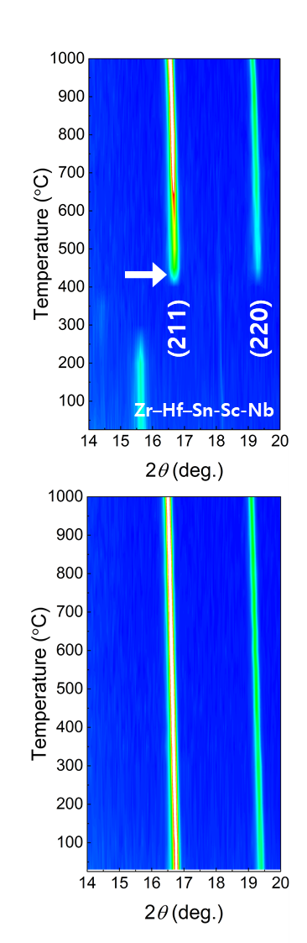

Figure S5. In-situ phase evolution during calcination of Li₇La₃Zr_{0.4}Hf_{0.4}Sn_{0.4}Sc_{0.4}Nb_{0.4}O₁₂; top: contour plot of X-ray diffraction patterns during heating process; bottom: cooling process in range of 14–20°.

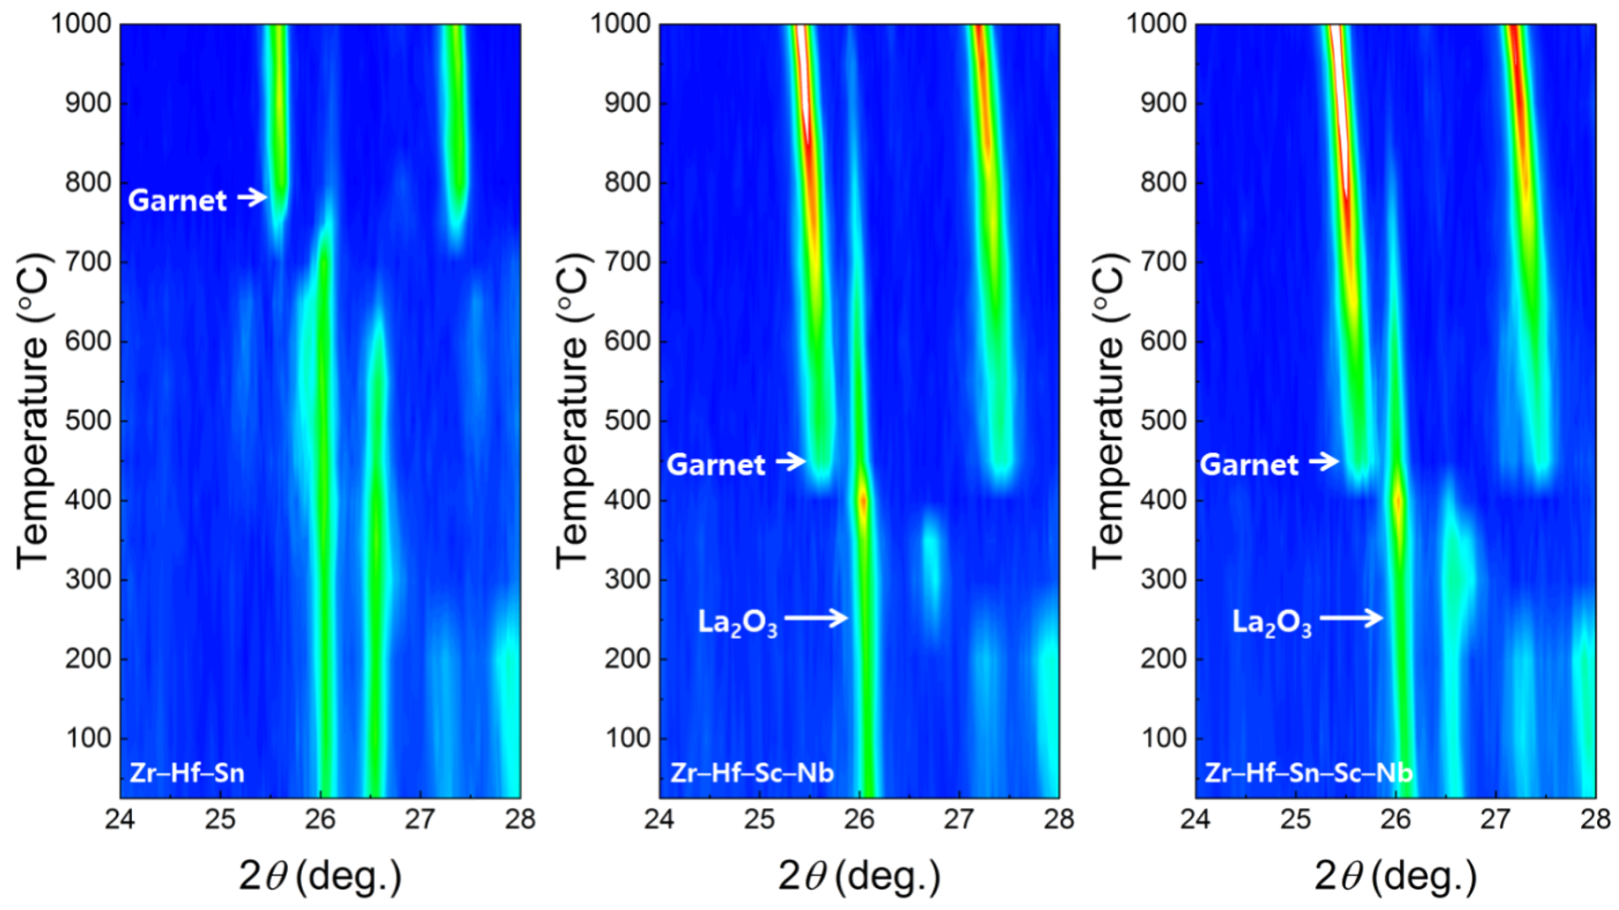

Figure S6. In-situ phase evolution during calcination and contour plot of X-ray diffraction during heating process in range of 24–28°.

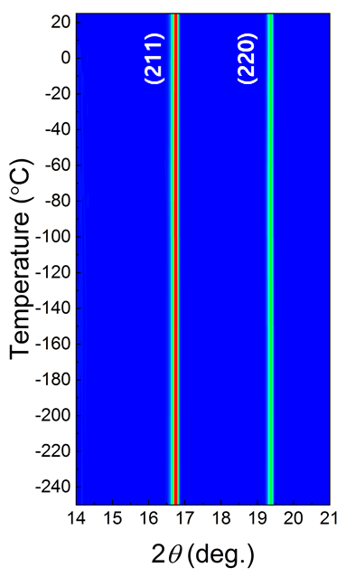

Figure S7. In-situ X-ray diffraction of Li₇La₃Zr_{0.4}Hf_{0.4}Sn_{0.4}Sc_{0.4}Ta_{0.4}O₁₂ during cooling process from 20 °C to –253 °C.
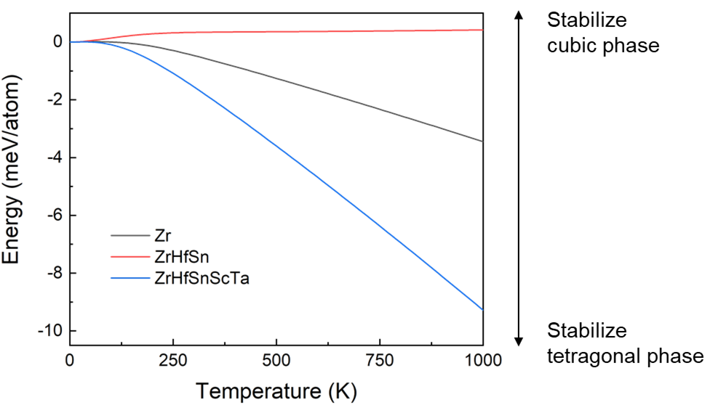

Figure S8. Difference in energy contribution from vibrational entropy obtained by DFT calculation (T × S_{vib,cubic} – T × S_{vib},_{tetra}).

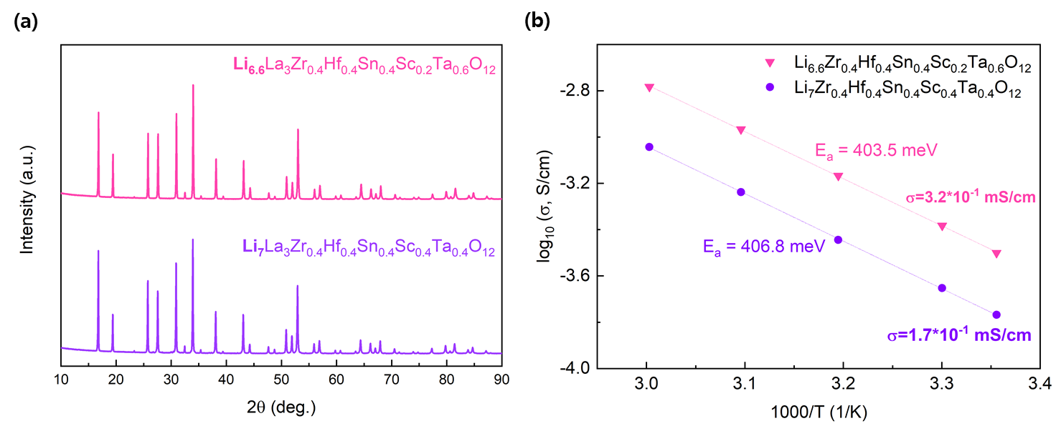

Figure S9. (a) X-ray diffraction patterns of Li_{6.6}La₃Zr_{0.4}Hf_{0.4}Sn_{0.4}Sc_{0.2}Ta_{0.6}O₁₂; (b) Arrhenius plot of ionic conductivity as a function of temperature.

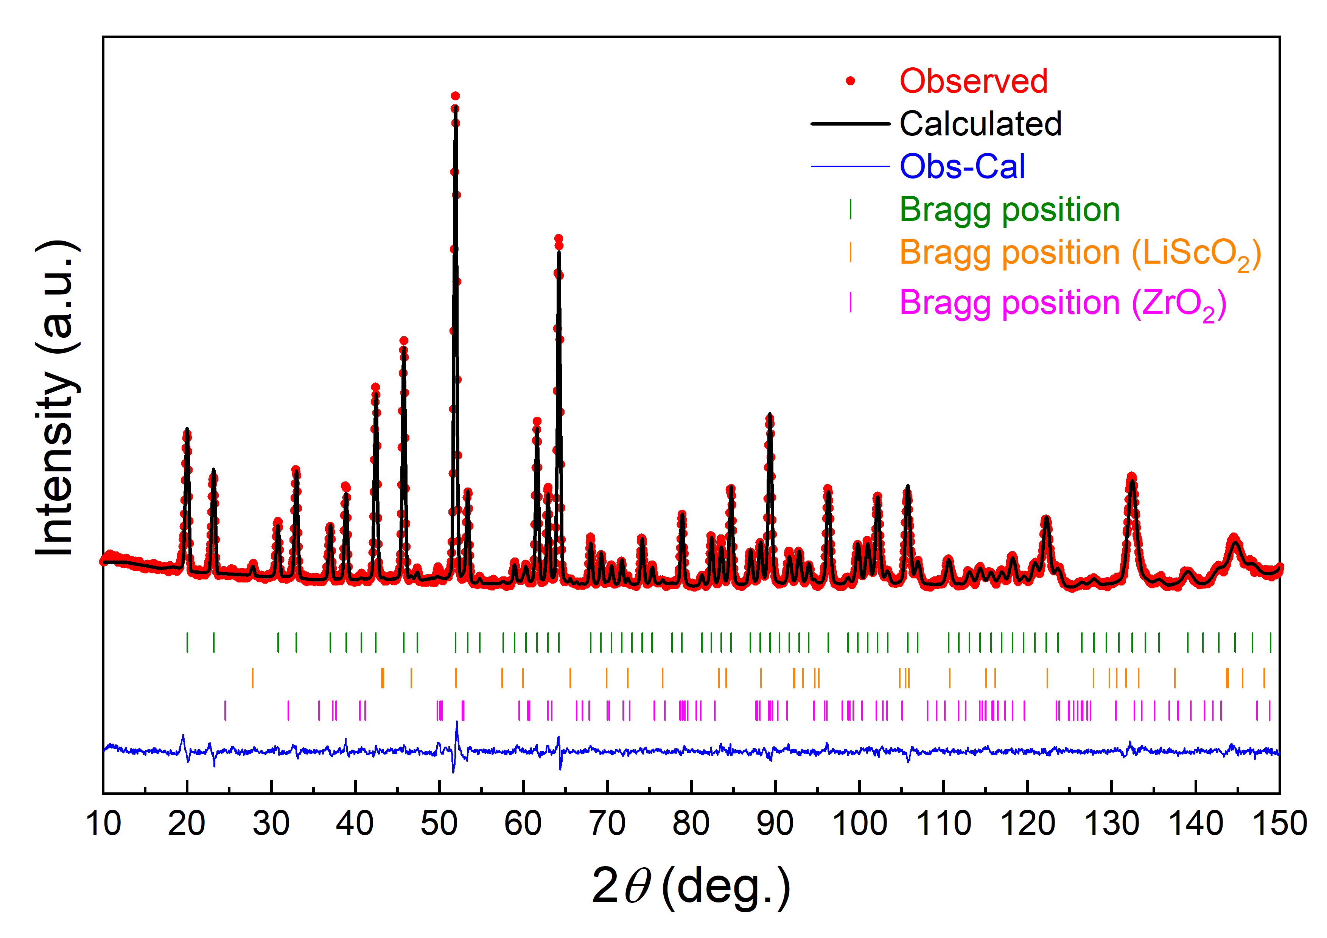

Figure S10. Neutron diffraction pattern and Rietveld refinement of Li_{6.6}La₃Zr_{0.4}Hf_{0.4}Sn_{0.4}Sc_{0.2}Ta_{0.6}O₁₂.

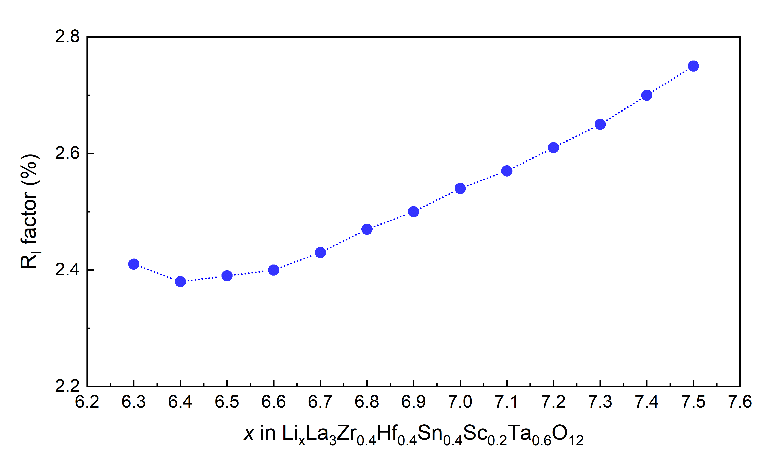

Figure S11. R_{I} factors according to lithium contents obtained from neutron diffraction Rietveld refinement result of Li = 6.6 garnet.

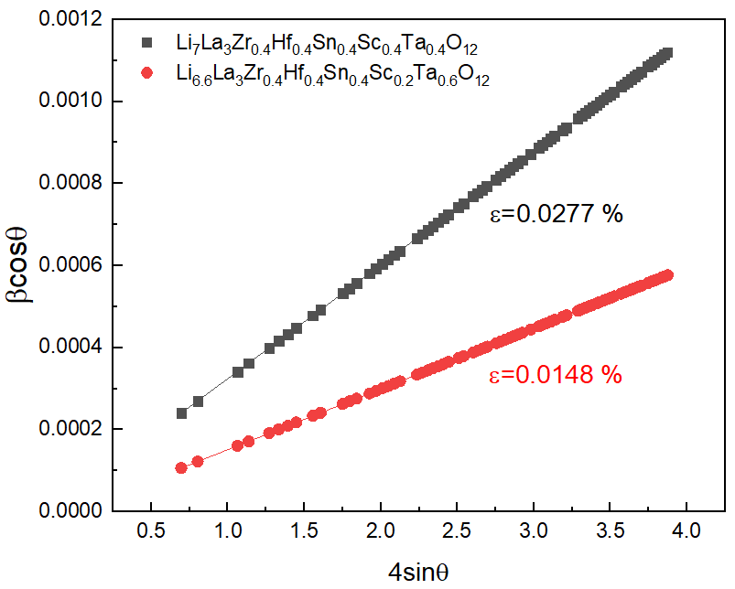

Figure S12. Williamson–Hall plots of Li₇La₃Zr_{0.4}Hf_{0.4}Sn_{0.4}Sc_{0.4}Ta_{0.4}O₁₂ and Li_{6.6}La₃Zr_{0.4}Hf_{0.4}Sn_{0.4}Sc_{0.2}Ta_{0.6}O₁₂ from neutron diffraction Rietveld refinement.

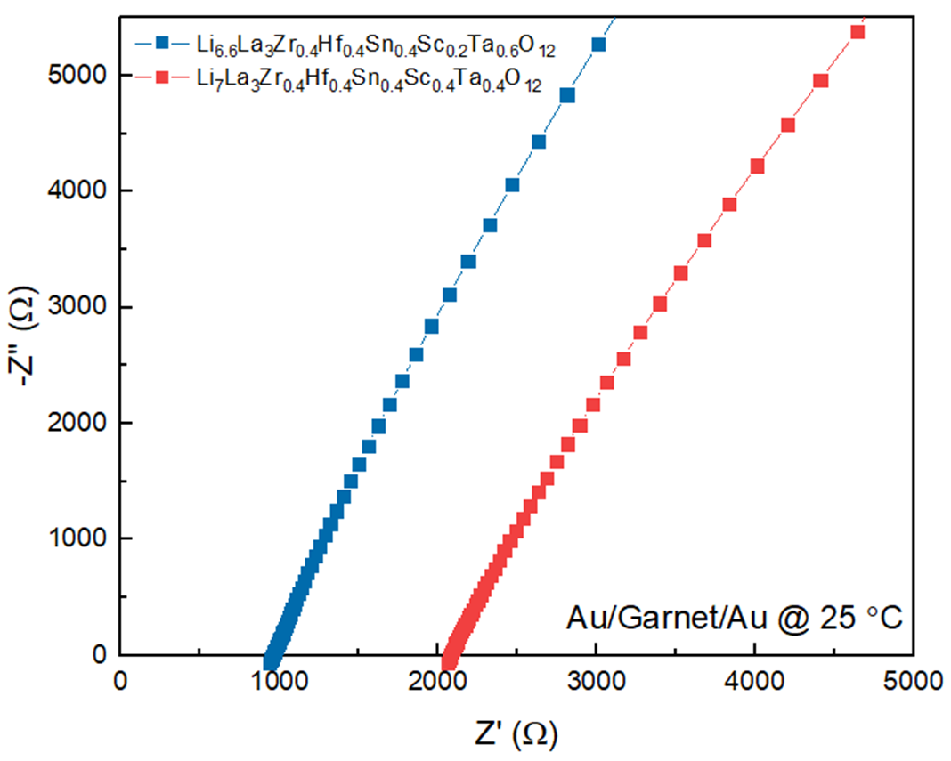

Figure S13. Impedance spectra of Li₇La₃Zr_{0.4}Hf_{0.4}Sn_{0.4}Sc_{0.4}Ta_{0.4}O₁₂ and Li_{6.6}La₃Zr_{0.4}Hf_{0.4}Sn_{0.4}Sc_{0.2}Ta_{0.6}O₁₂ in Au/Garnet/Au configuration at 25 ℃.

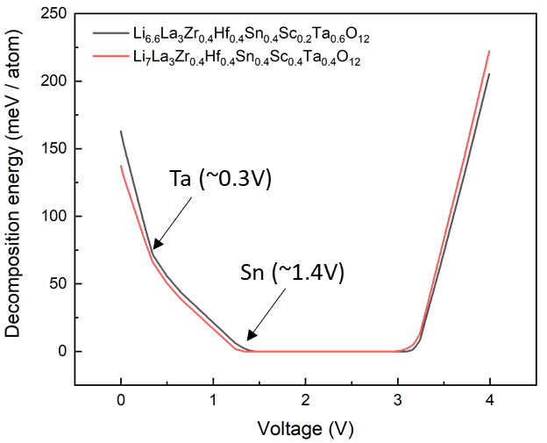

Figure S14. Thermodynamic stability window of Li = 7.0 and Li = 6.6 garnets containing multidopants in Zr site.

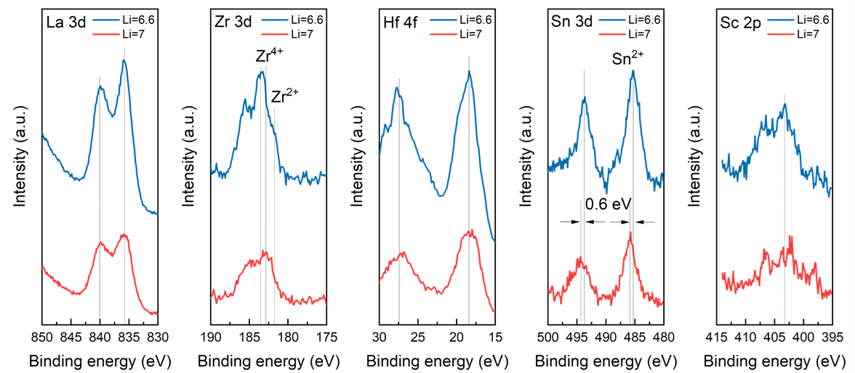

Figure S15. XPS spectra of Li = 7.0 and Li = 6.6 garnet after contacting with lithium metal.

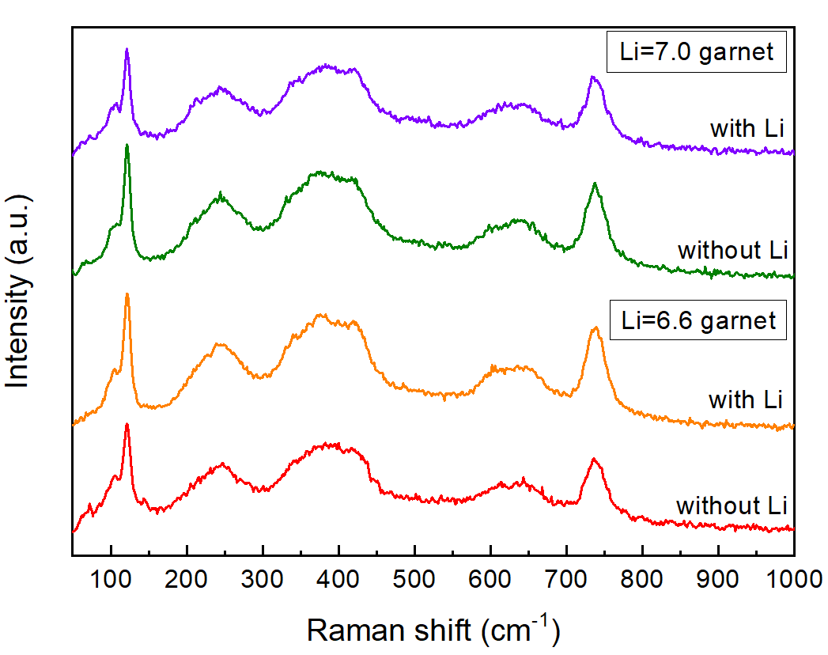

Figure S16. Raman spectra of Li = 7.0 and Li = 6.6 garnet before and after contacting with lithium metal.
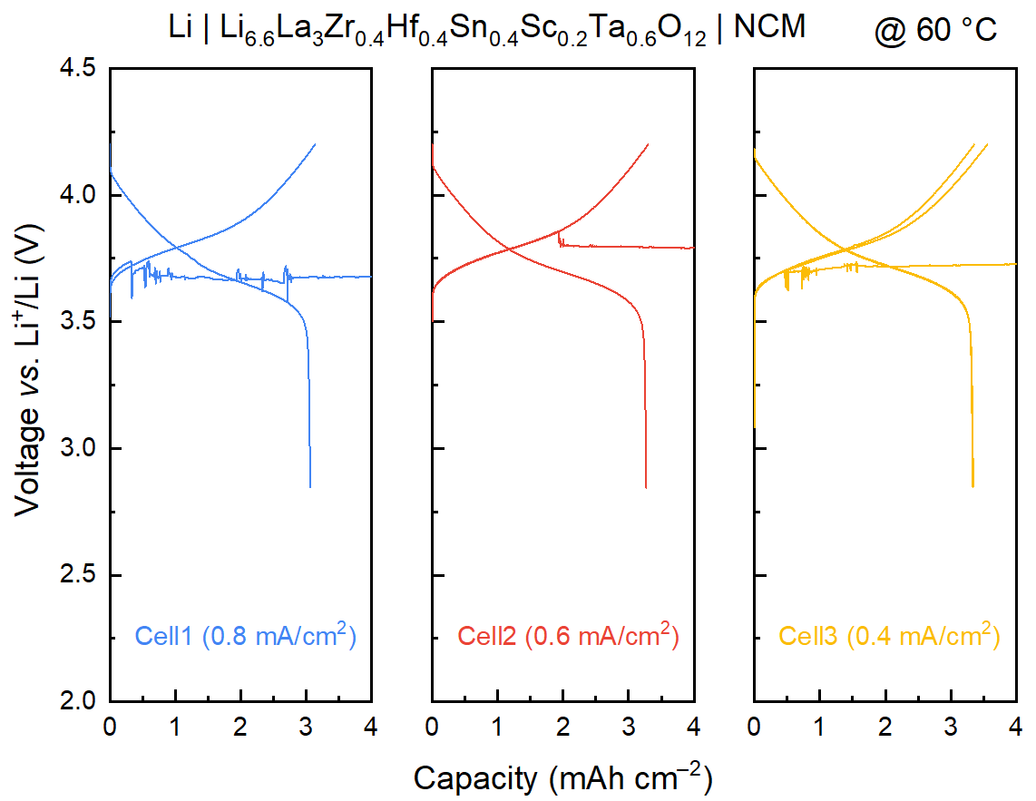

Figure S17. Charge–discharge profiles of Li = 6.6 garnet full-cells at various current densities, and their short-circuit formation at early stages of cycle.
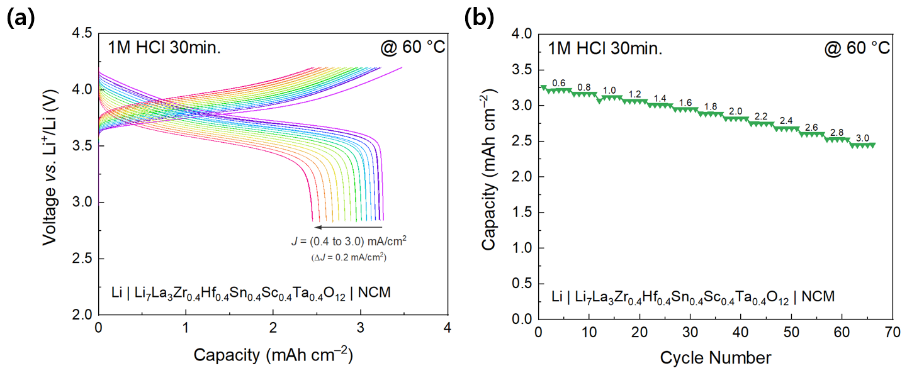

Figure S18. Rate performance of acid-treated (1M HCl for 30 min) entropy-driven Li = 7.0 cubic-phase garnet. (a) Electrochemical profiles at various current densities (0.4–3.0 mA/cm² with an interval of 0.2 mA/cm²), and (b) its capacity retention during 5 cycles at each current density.

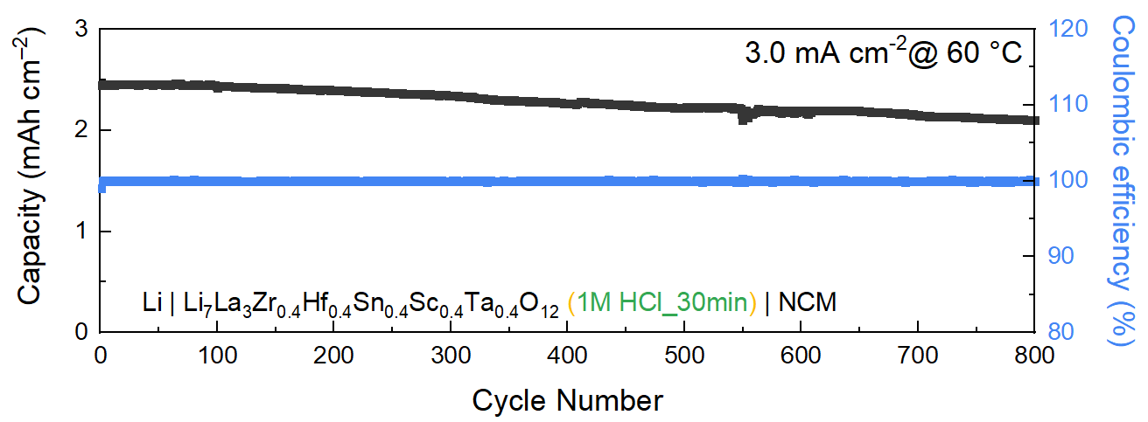

Figure S19. Long-term cycling performance of acid-treated (1M HCl for 30 min) entropy-driven Li = 7.0 cubic-phase garnet at high current density of 3.0 mA/cm² after rate test.

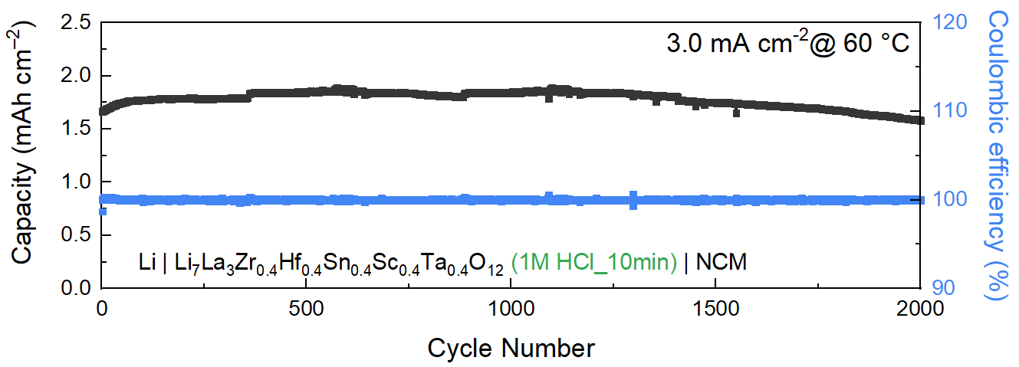

Figure S20. Long-term cycling performance of acid-treated (1M HCl for 10 min) entropy-driven Li = 7.0 cubic-phase garnet at high current density of 3.0 mA/cm².

Table S1. Composition of atomic ratio in garnets confirmed by ICP-AES measurements.
Samples | ICP-AES (atomic fraction)
Samples | Li | La | Zr | Hf | Sn | Sc | Ta | Nb
T_{Zr–Hf–Sn} | 7.173 | 3 | 0.581 | 0.677 | 0.653 | – | – | –
C_{Zr–Hf–Sc–Nb} | 7.168 | 3 | 0.566 | 0.492 | – | 0.504 | – | 0.516
C_{Zr–Hf–Sn–Sc–Ta} | 7.247 | 3 | 0.420 | 0.407 | 0.407 | 0.407 | 0.420 | –
C_{Zr–Hf–Sn–Sc–Nb} | 7.609 | 3 | 0.396 | 0.421 | 0.409 | 0.409 | – | 0.447

Table S2. X-ray diffraction Rietveld refinement results of Li₇La₃Zr_{0.4}Hf_{0.4}Sn_{0.4}Sc_{0.4}Ta_{0.4}O₁₂ based on Li-site occupancy with Neutron diffraction Rietveld refinement result.
Site | Multiplicity | x | y | z | B_{iso} | Occupancy
Li1 | 24 | 0.375 | 0 | 0.25 | 0.83228 | 0.468
Li2 | 96 | 0.69161 | 0.59754 | 0.11431 | 5.08863 | 0.466
La1 | 24 | 0.125 | 0 | 0.25 | 1.101(17) | 1
Zr1 | 16 | 0 | 0 | 0 | 0.626(19) | 0.2
Hf1 | 16 | 0 | 0 | 0 | 0.626(19) | 0.2
Sn1 | 16 | 0 | 0 | 0 | 0.626(19) | 0.2
Sc1 | 16 | 0 | 0 | 0 | 0.626(19) | 0.2
Ta1 | 16 | 0 | 0 | 0 | 0.626(19) | 0.2
O1 | 96 | 0.2823(2) | 0.1027(2) | 0.1964(3) | 1.46(10) | 1

Table S3. Phase fraction in Li₇La₃Zr_{0.4}Hf_{0.4}Sn_{0.4}Sc_{0.4}Ta_{0.4}O₁₂ based on Neutron diffraction Rietveld refinement results.
Sample | Phase | Phase fraction (wt.%) | R_{I}(%) | R_{F}(%)
Li₇La₃Zr_{0.4}Hf_{0.4}Sn_{0.4}Sc_{0.4}Ta_{0.4}O₁₂  R_{P}: 3.58 %  R_{wp}: 4.67 % | Cubic | 97.89 (1.19) | 4.20 | 3.26
 | LiScO₂ | 0.99 (0.04) | – | –
 | ZrO₂ | 1.12 (0.15) | – | –

Table S4. Neutron diffraction Rietveld refinement results of Li₇La₃Zr_{0.4}Hf_{0.4}Sn_{0.4}Sc_{0.4}Ta_{0.4}O_{12.}
Site | Multiplicity | x | y | z | B_{iso} | Occupancy
Li1 | 24 | 0.375 | 0 | 0.25 | 0.5(6) | 0.41(2)
Li2 | 96 | 0.690(1) | 0.579(1) | 0.097(1) | 1.2(3) | 0.48(1)
La1 | 24 | 0.125 | 0 | 0.25 | 0.56(5) | 1
Zr1 | 16 | 0 | 0 | 0 | 1.35(7) | 0.2
Hf1 | 16 | 0 | 0 | 0 | 1.35(7) | 0.2
Sn1 | 16 | 0 | 0 | 0 | 1.35(7) | 0.2
Sc1 | 16 | 0 | 0 | 0 | 1.35(7) | 0.2
Ta1 | 16 | 0 | 0 | 0 | 1.35(7) | 0.2
O1 | 96 | 0.2815(1) | 0.1007(2) | 0.1962(2) | 1.07(5) | 1

Table S5. Formation energy differences between cubic and tetragonal phases.
Energy (meV/atom) | Zr | Zr–Hf–Sn | Zr–Hf–Sc–Nb | Zr–Hf–Sn–Sc–Ta
H_{Cubic}–H_{Tetra} | 3.70 | 4.38 | 5.48 | 4.54

Table S6. Phase fraction in Li_{6.6}La₃Zr_{0.4}Hf_{0.4}Sn_{0.4}Sc_{0.2}Ta_{0.6}O₁₂ based on neutron diffraction Rietveld refinement results.
Sample | Phase | Phase fraction (wt.%) | R_{I}(%) | R_{F}(%)
Li_{6.6}La₃Zr_{0.4}Hf_{0.4}Sn_{0.4}Sc_{0.2}Ta_{0.6}O₁₂  R_{P}: 3.03 %  R_{wp}: 3.89 % | Cubic | 98.96 (0.69) | 2.4 | 2.02
 | LiScO₂ | 0.38 (0.02) | – | –
 | ZrO₂ | 0.66 (0.11) | – | –

Table S7. Neutron diffraction Rietveld refinement results of Li_{6.6}La₃Zr_{0.4}Hf_{0.4}Sn_{0.4}Sc_{0.2}Ta_{0.6}O_{12.}
Site | Multiplicity | x | y | z | B_{iso} | Occupancy
Li1 | 24 | 0.375 | 0 | 0.25 | 3.8(5) | 0.51(3)
Li2 | 96 | 0.6875(9) | 0.5805(8) | 0.0963(8) | 2.5(3) | 0.42(1)
La1 | 24 | 0.125 | 0 | 0.25 | 0.70(3) | 1
Zr1 | 16 | 0 | 0 | 0 | 0.81(4) | 0.2
Hf1 | 16 | 0 | 0 | 0 | 0.81(4) | 0.2
Sn1 | 16 | 0 | 0 | 0 | 0.81(4) | 0.2
Sc1 | 16 | 0 | 0 | 0 | 0.81(4) | 0.1
Ta1 | 16 | 0 | 0 | 0 | 0.81(4) | 0.3
O1 | 96 | 0.28130(8) | 0.10165(8) | 0.19725(9) | 0.99(2) | 1

