Supplementary File for: Biological network inference with GRASP: a Bayesian network structure learning method using adaptive sequential Monte Carlo

Kaixian Yu^{1,*}, Zihan Cui², Xin Sui², Xing Qiu³ and Jinfeng Zhang^{2,*}

¹Didi Chuxing, Beijing, China
²Department of Statistics, Florida State University, Tallahassee, FL, 32304
³Department of Biostatistics and Computational Biology, University of Rochester, Rochester, NY 14624, USA

Appendix

Preliminary of Bayesian Network
Let us denote the set of $p$ variables (nodes) as $X=\{X_{1},…,X_{p}\}$, and the set of edges as $E=\{X_{i}→X_{j}\}$ where $X_{i}→X_{j}$ are directed edges in the graph. $X_{i}$ is called a parent of $X_{j}$ and $X_{j}$ a child of $X_{i}$. Thus a graph can be represented as $G(X,E)$.
Definition 1: For a set of nodes $X_{i_{1}},…,X_{i_{k}}∈X$ if the edges $X_{i_{1}}→X_{i_{2}}→…→$ $X_{i_{k-1}}→X_{i_{k}}∈E$, then we say $X_{i_{1}},…,X_{i_{k}}∈X$ forms a directed path between $X_{i_{1}}$ and $X_{i_{k}}$. If $X_{i_{1}}=X_{i_{k}}$, then this directed path is called a cycle.
Definition 2: A directed acyclic graph (DAG) is a graph $G(X,E)$ such that all edges in E are directed and there is no cycles in G.
We denote P(X) as a joint probability distribution over the random variables in X, and $Pa_{G}(X_{i})$ as the set of parents of $X_{i}∈X$ given DAG G(X,E).
Property 1: P(X) can be factorized over some G as
$P\left(X\right)=\prod_{i=1}^{p}{P(X_{i}|Pa_{G}\left(X_{i}\right))}$ (1)
Now, we can define Bayesian network (BN) as follows:
Definition 3: The pair (G,P) is defined as a Bayesian network if P factorizes over G.
Remark 1: The factorization allowed the network to be locally trained, e.g. each $P(X_{i}|Pa_{G}\left(X_{i}\right))$ can be trained independently, which saves a lot of computational time.
Unfortunately, the factorization is not uniquely defined, that is, for some P there exists at least two DAGs $G_{1}$ and $G_{2}$ that P factorizes over $G_{1}$ and $G_{2}$.
Definition 4: Q(P) defines an equivalent class of P, if P factorizes over each DAG $G_{i}∈Q$.
In this work, we focusing on estimating any $G∈Q$ instead of estimating every DAGs in $Q$.
Now let us define the conditional dependencies and independencies. We denote $I{nd}_{P}(X_{i};X_{j}|Z)$ as $X_{i}$ and $X_{j}$ are conditionally independent given $Z⊂X$ with respect to P(X), and $Dep_{P}(X_{i};X_{j}|Z)$ as $X_{i}$ and $X_{j}$ are conditionally dependent given $Z$ with respect to $P(X)$.
Definition 5:
$Ind_{P}\left(X_{i};X_{j}\right|Z)⇔P\left(X_{i};X_{j} | Z\right)=P\left(X_{i} | Z\right)P(X_{j}|Z)$ (2)
$Dep_{P}\left(X_{i};X_{j}\right|Z)⇔P\left(X_{i};X_{j} | Z\right)≠P\left(X_{i} | Z\right)P(X_{j}|Z)$ (3)
One of the most important assumptions we need to include is the faithfulness. To define the faithfulness, let us first define trail:
Definition 6: A set of nodes $X_{i_{1}},…,X_{i_{k}}∈X$ forms a trail in the graph $G(X,E)$ if for every $X_{i_{j}}$ and $X_{i_{j+1}}$, either $X_{i_{j}}→X_{i_{j+1}}∈E$ or $X_{i_{j}}←X_{i_{j+1}}∈E$.
Before we can define an active trail, let us first define descendant. If $X_{j}$ is a descendant of $X_{i}$ then there is a directed path from $X_{i}$ and $X_{j}$.
Definition 7: Let $G\left(X,E\right)$ be a BN structure, $X_{i_{1}},…,X_{i_{k}}$forms a trail in $G$ and $Z⊂X$. The trail $X_{i_{1}},…,X_{i_{k}}$ is active given $Z$ if
• whenever there is a v-structure: $X_{i_{j}}→X_{i_{j+1}}←X_{i_{j+2}}$, then $X_{i_{j+1}}∈Z$ or a descendant of $X_{i_{j+1}}$ in $Z$
• other nodes are not in $Z$
We need one last definition, d-separation, before we can define faithfulness.
Definition 8: In graph $G(X,E)$, for $X_{i}, X_{j}∈X$ and $Z⊂X$, we say $X_{i}$ and $X_{j}$ are d-separated by $Z$, denoted as$Dsep_{G}(X_{i};X_{j}|Z)$, if none of the trails between $X_{i}$ and $X_{j}$ is active given $Z$.
Now let us give the definition on the faithfulness,
Definition 9: $P(X)$ is faithful to $G\left(X,E\right)$ if for any $Z∈X$:
$I{nd}_{P}\left(X_{i};X_{j} | Z\right)⇔{Dsep}_{G}(X_{i};X_{j}|Z)$ (4)
Under the faithfulness assumption, the terms conditionally independence and d-separation are equivalent; thus, they were used interchangeably through the article.
Definition 10 A score function $S(G)$ is said to have score-equivalent property if $S(G)$ do not distinguish among equivalent networks. That is, two Bayesian networks, $G_{1}$ and $G_{2}$, are equivalent if and only if $S\left(G_{1}\right)=S\left(G_{2}\right)$.

Proof of Theorem 1
Assume $\left(G\left(X,E\right),P\left(X\right)\right)$ is a Bayesian network, $X_{i}→X_{j}∈E$ and $X^{c}=X∖\left\{X_{i},X_{j}\right\}$. Since $P\left(X\right)$ factorizes on $G\left(X,E\right)$, $X_{i}→X_{j}∈E$ implies $Dep\left(X_{I};X_{j}\right)$ and $Dep\left(X_{i};X_{j} | X^{c}\right)$. Now let us assume there is an $X_{k}∈X^{c}$ such that $Ind\left(X_{I};X_{j} | X_{k}\right)$. Therefore, all path between $X_{I}$ and $X_{j}$ are blocked by $X_{k}$. Since $X_{k}∈X^{c}$, all path between $X_{i}$ and $X_{j}$ are also blocked by $X^{c}$; thus, $Ind\left(X_{I};X_{j} | X^{c}\right)$ which contradicts with the assumption. Hence, if $Dep\left(X_{I};X_{j} | X^{c}\right)$, then for any $X_{k}∈X^{c}$ we have $Dep\left(X_{I};X_{j} | X_{k}\right)$. Along with$Dep\left(X_{i};X_{j}\right)$, we conclude $X_{i}∈nbr^{C}\left(X_{j}\right)$ and $X_{j}∈nbr^{C}\left(X_{I}\right)$ for any edge in $E$.

Remark 2: $n{br}^{C}(X_{i})$ can be written as
$$nbr^{C}\left(X_{i}\right)=\left\{ X_{j}\right|dep\left(X_{i};X_{j}\right) and dep\left(X_{i};X_{j} | X_{k}\right) for any k≠i,j\}$$
In practice, a symmetric correction may be used, where if $X_{j}∈nbr^{C}\left(X_{i}\right),$but $X_{i}∉nbr^{C}\left(X_{j}\right),$ then $n{br}^{C}\left(X_{i}\right)={nbr}^{C}\left(X_{i}\right)∖\left\{X_{j}\right\}.$

Figure S1: Traditional SMC and adaptive SMC. This shows a local skeleton in some step of SMC. In a traditional SMC, it is likely the update sequence set to be $\left(x_{1},x_{2},x_{3} | X\right)→\left(x_{1},x_{4},x_{5} | X\right)→⋯$, while this might limit the later update $\left(x_{3}, x_{5} | X\right)$ to only 2 configurations instead of 3. In adSMC, by selecting sequence based on current structure, we will sample $(x_{1}, x_{3}, x_{5}|X)$ first, which gives us more options on the local sctructure for $(x_{1}, x_{3}, x_{5}|X)$, and this configuration will not affect the options for $(x_{2}, x_{3}|X)$ or $(x_{4}, x_{5}|X)$; thus, increased the diversity of samples.

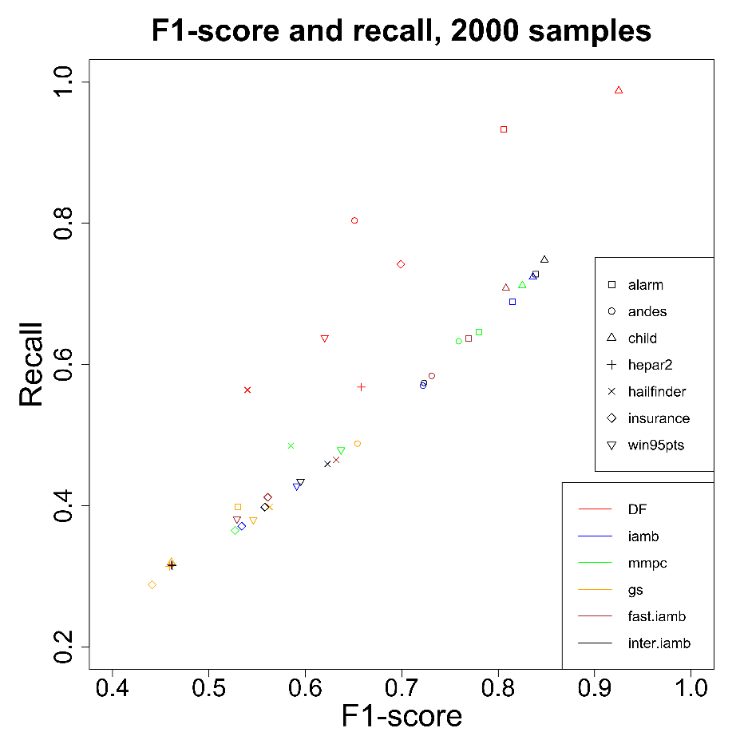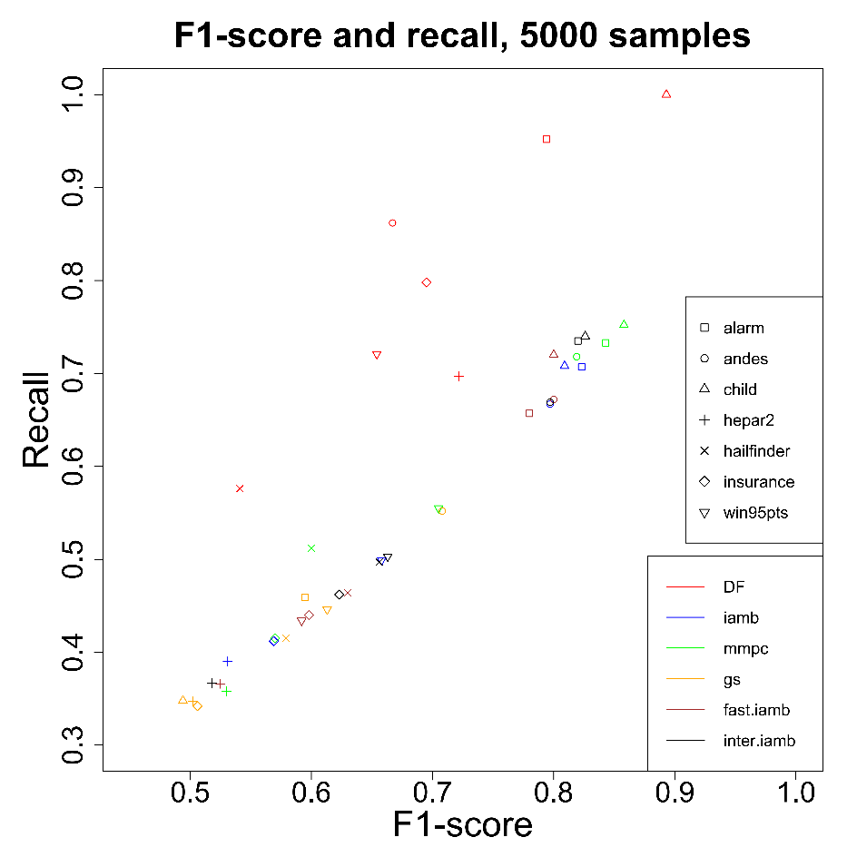
Figure S2: F1-score and recall over different methods with observation size 2000 and 5000.
Figure S3: The trend of the BIC scores of the learned networks as temperature increases. Observation sizes: (A) 1000, (B) 2000, (C) 5000
Figure S4: The comparison of adSMC and traditional SMC. (A) Andes, (B) hepar2
Figure S5: The empirical distribution of BIC scores of all SMC samples. (A) alarm network, (B) win95pts network

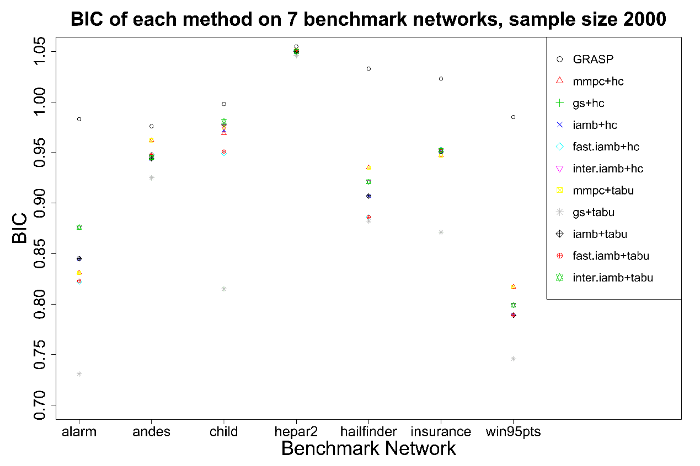
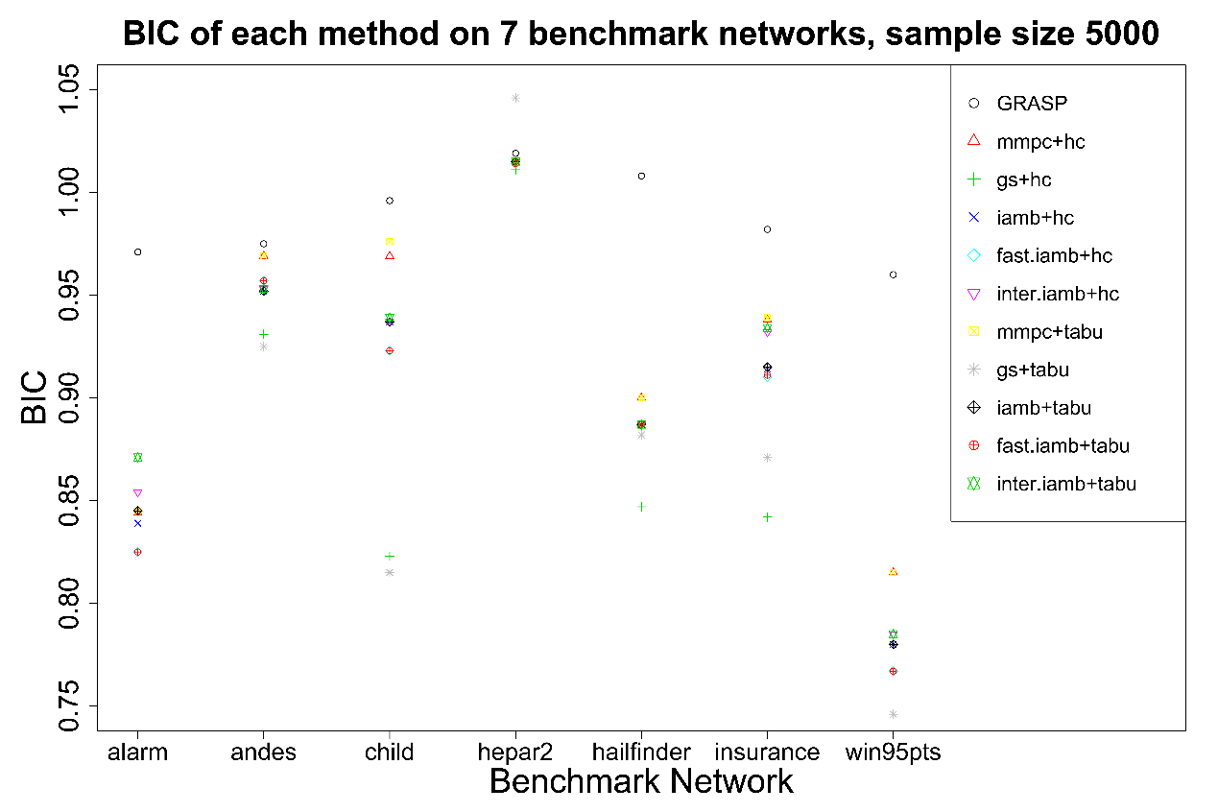
Figure S6: BIC scores of all methods on 7 benchmark networks with observation size 2000 and 5000.
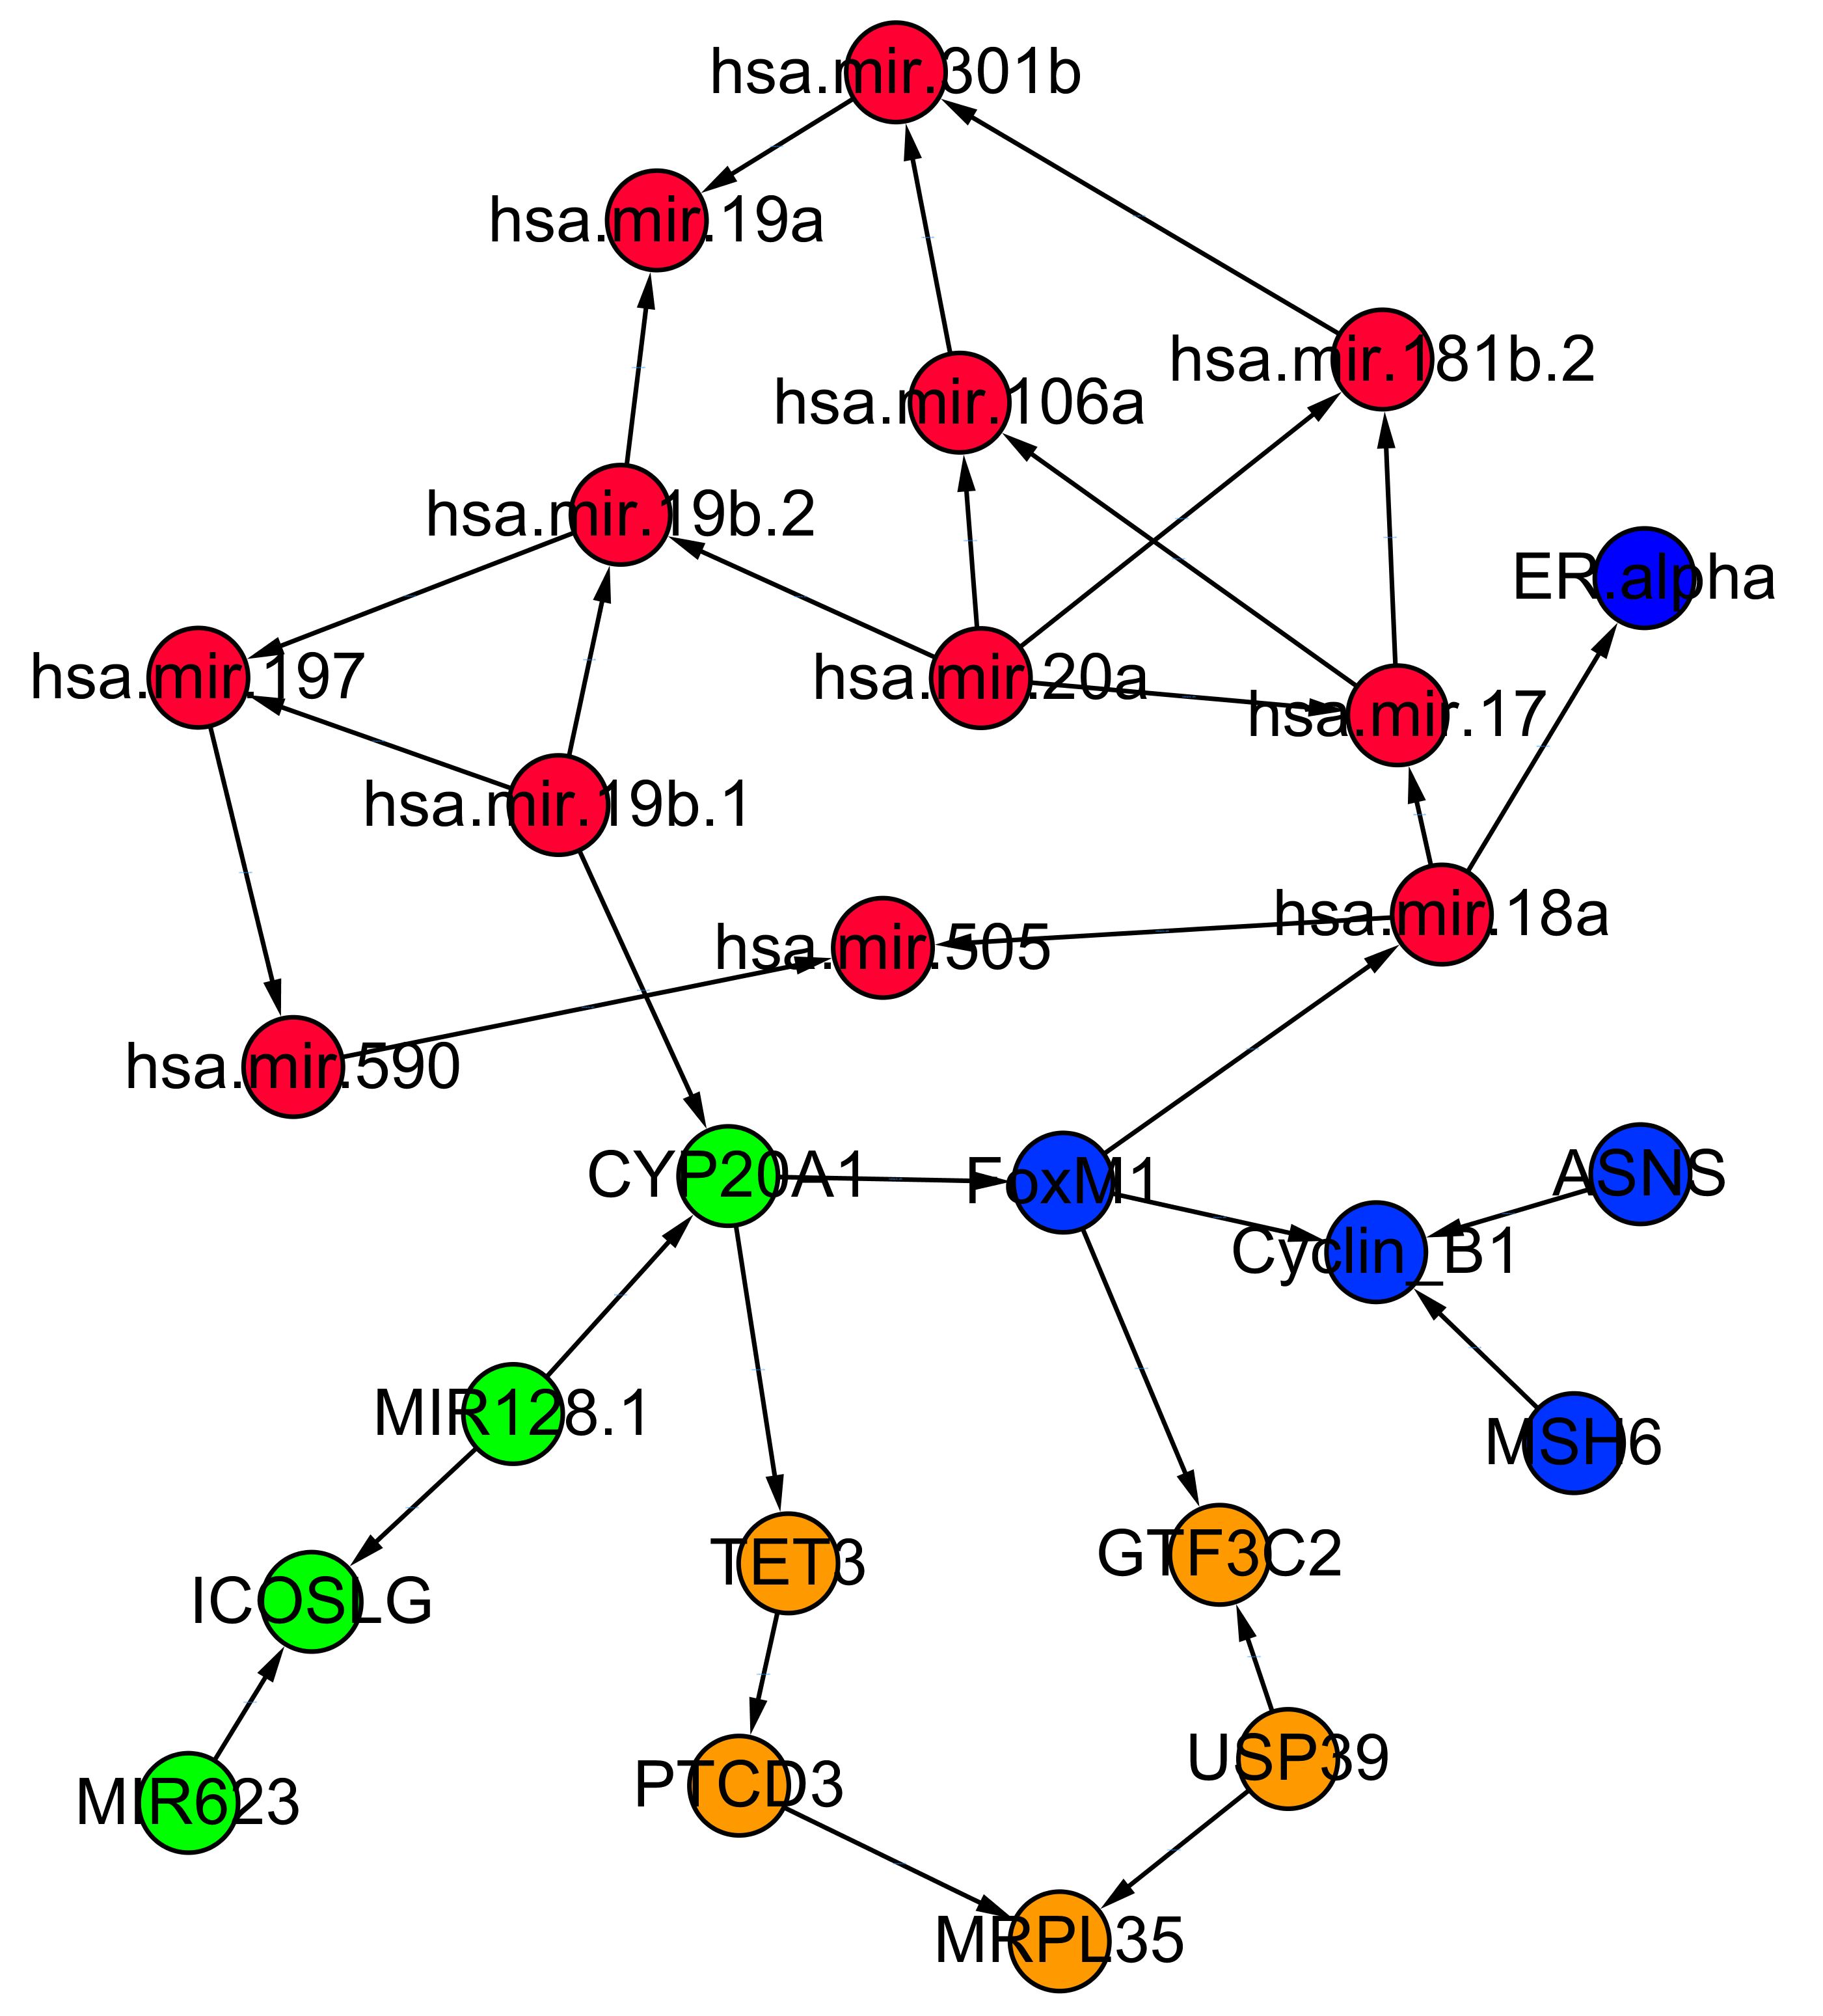

Figure S7: The BN structure learned by bnlearn using multiple different genomic features which are highly correlated with the expression of LOC90784. Orange nodes: mRNA transcripts; Red nodes: microRNAs; Blue nodes: protein expressions; Green nodes: DNA methylations.

