A fast and simple protocol to anaesthesia in chicken embryos

Mônica Horr¹, Simone Sommerfeld^{1,2}, Murilo V. Silva^{1,2}, Belchiolina B. Fonseca^{1*}

¹School of Veterinary Medicine, Federal University of Uberlandia, Uberlândia, Brazil
²Rodents Animal Facility Complex of Federal University of Uberlândia, Uberlândia, Brazil
monica.horr@ufu.br (M.H.), murilo.vieira@ufu.br (M.V.S), biafonseca@ufu.br (B.B.F), simone.sommerfeld@ufu.br (S.S)

*Corresponding author: biafonseca@ufu.br.

Supplementary Material

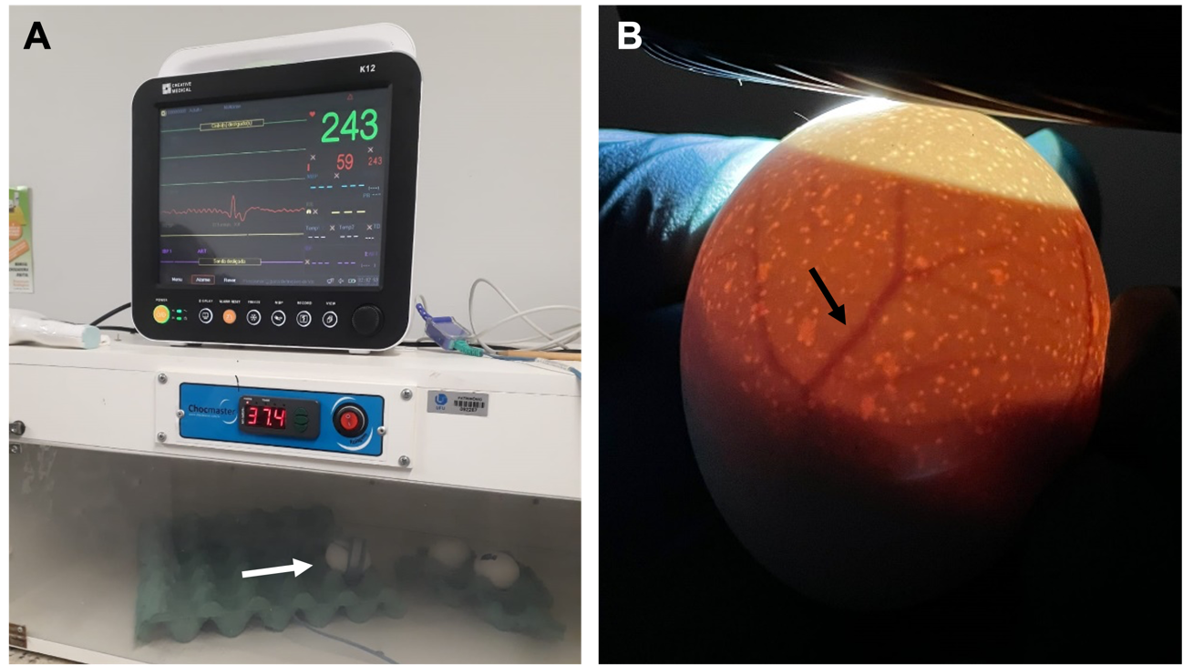
Figure S1. Experimental apparatus and access vessel. (A) The pulsation and movement of the chicken embryos was measured by a multiparameter monitor. The pulse sensor was placed at the site of identification of the large vessel after candling (arrow). (B) The large vessel of the embryo is located in the chorioallantoic membrane, found by light candling (arrow).

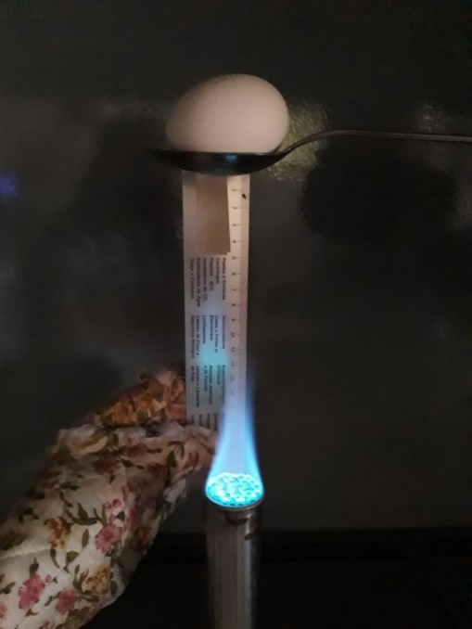
Figure S2. Embryo stimulation methodology. The stress method used to test the anaesthetic potential of the chosen drugs was heat. For high-temperature stimulation, the CEs were kept 10 cm from the fire of a Bussen nozzle for 30 seconds.

Table S1. Mean temperature (°C) of chicken embryos treated with ketamine, midazolam, and morphine; ketamine and xylazine; or xylazine and morphine inoculated at 18 days of incubation.
 |  | keta + mida + morph | keta + xyla | xyla + morph
Temperature in blunt end pole (°C) | Basal | 36.93 | 37.33 | 37.36
Temperature in blunt end pole (°C) | 5 min | 37.36 | 37.10 | 37.30
Temperature in blunt end pole (°C) | 10 min | 37.03 | 37.06 | 37.33
Temperature in blunt end pole (°C) | 15 min | 36.93 | 37.06 | 37.16
Temperature in blunt end pole (°C) | 20 min | 36.90 | 36.90 | 37.26
Temperature in blunt end pole (°C) | 25 min | 36.86 | 36.90 | 37.13
Temperature in pointed end pole (°C) | Basal | 37.23 | 37.43 | 38.10
Temperature in pointed end pole (°C) | 5 min | 37.60 | 37.10 | 37.70
Temperature in pointed end pole (°C) | 10 min | 37.10 | 37.46 | 37.76
Temperature in pointed end pole (°C) | 15 min | 36.90 | 37.13 | 37.63
Temperature in pointed end pole (°C) | 20 min | 37.00 | 37.03 | 37.20
Temperature in pointed end pole (°C) | 25 min | 37.00 | 37.00 | 37.30
Ketamine, midazolam, and morphine (keta+midad+morph); ketamine and xylazine (keta+xyla); or xylazine and morphine (xyla+morph).

