Supplementary material: Table 1 and Figure S1.

Table 1. Regional trends in the number of extreme events and their significance level (shown in bold and italics: *** - 0.001 level of significance; ** - 0.01 level of significance; * - 0.05 level of significance; + - 0.1 level of significance; no signs - trend is not significant).
Region | The region number in Figure S1 below | Population as of 01.01.2021, thousand people  (data from the Russian Statistical Agency) | Area of the region, km² | Change in the number of events per 100 th. km²/10 years over 1991-2019, soil drought over 2004-2019
 |  |  |  | Total number of meteorological extreme events | Hot extremes events | Cold extremes events | Strong wind events | Heavy rains events | Soil drought events
Altai Territory | 67 | 2296.4 | 167996 | 3.5*** | 0.0 | 0.3+ | 1.0** | 0.1 | 0.1
Amur region | 81 | 781.8 | 361908 | 0.1 | 0.0 | 0.0 | 0.0 | 0.2** | 0.0
Arkhangelsk region | 21 | 1127.1 | 413103 | -0.1 | 0.0 | 0.0 | 0.0 | 0.0 | 0.0
Astrakhan region | 40 | 997.8 | 49024 | -1.0 | 0.0 | -0.1 | -0.5* | -0.1 | 1.1
Belgorod region | 1 | 1541.3 | 27134 | 0.6 | 0.4 | 0.2 | -0.5 | 0.1 | 1.8
Bryansk region | 2 | 1182.7 | 34857 | -0.1 | -0.1 | 0.8 | -0.3 | 0.0 | 1.7
Vladimir region | 3 | 1342.1 | 29084 | -1.4 | -0.2 | 0.6 | 0.1 | 0.2 | -0.5
Volgograd region | 41 | 2474.6 | 112877 | 0.2 | -0.2 | -0.1 | 0.0 | 0.3* | 1.0
Vologda region | 23 | 1151.0 | 144527 | -0.1 | 0.0 | 0.0 | -0.1 | 0.0 | 0.0
Voronezh region | 4 | 2305.6 | 52216 | 2.1+ | -0.1 | 0.2 | -0.1 | 0.3 | 3.2*
Evreisky Autonomous region | 84 | 156.5 | 36271 | 1.1+ | 0.0 | 0.0 | -0.2 | 0.9 | -0.8
Zabaikal Territory | 75 | 1053.5 | 431892 | 0.5 | 0.1* | 0.0 | 0.2* | 0.2 | -0.1
Ivanovo region | 5 | 987.0 | 21437 | -4.8 | -0.2 | 0.6 | -1.3 | -0.7 | -0.7
Irkutsk region | 69 | 2375.0 | 774846 | 0.4*** | 0.0 | 0.1* | 0.1*** | 0.1*** | 0.0
Kabardino-Balkar Republic | 33 | 869.2 | 12470 | 24.1* | -0.8 | 0.0 | 3.4 | 12.7*** | -3.9
Kaliningrad region | 24 | 1018.6 | 15125 | 1.1 | 0.0 | 0.4 | 2.1 | -0.3 | 0.0
Kaluga region | 6 | 1001.0 | 29777 | -1.4 | -0.2 | 0.8 | -0.5 | -0.3 | 0.0
Kamchatka Territory | 78 | 311.7 | 464275 | -0.2 | 0.0 | 0.0 | 0.0 | 0.0 | 0.0
Karachayevo-Circassian Republic | 35 | 465.4 | 14277 | 1.2 | -0.7 | 0.0 | -2.6* | 2.0+ | -1.1
Kemerovo region | 71 | 2633.4 | 95725 | 2.8* | 0.0 | 0.6 | 1.1* | -0.1 | 0.2
Kirov region | 50 | 1250.2 | 120374 | 0.9* | -0.1 | 0.3 | 0.3 | 0.3 | -0.2
Kostroma region | 7 | 628.4 | 60211 | -1.1 | -0.1 | 0.1 | 0.0 | 0.0 | 0.0
Krasnodar Territory | 38 | 5683.9 | 75485 | 15.4*** | -0.2 | 0.0 | 0.7 | 7.4*** | 0.1
Krasnoyarsk Territory | 68 | 2855.9 | 2366797 | 0.1 | 0.1* | 0.1+ | 0.1* | 0.0 | 0.0
Kurgan region | 57 | 818.6 | 71488 | -1.5 | 0.0 | 0.0 | -0.4 | -0.1 | 0.5
Kursk region | 8 | 1096.5 | 29997 | 4.4+ | -0.2 | 0.6 | -0.6 | 0.8 | 1.6
Leningrad region | 25 | 1892.7 | 83908 | -1.0 | 0.0 | 0.1 | -0.1 | -0.2 | 0.0
Lipetsk region | 9 | 1128.2 | 24047 | -0.5 | 0.3 | 0.9 | -1.4 | 0.5 | -1.0
Magadan region | 82 | 139.0 | 462464 | -0.2** | 0.0 | 0.0 | -0.1** | 0.0 | 0.0
Moscow city | 18 | 12655.1 | 2561 | 0.0 | 0.0 | 0.0 | 0.0 | 0.0 | 0.0
Moscow region | 10 | 7708.5 | 44329 | -0.6 | -0.2 | 0.3 | 0.3 | -0.2 | -0.6
Murmansk region | 26 | 732.9 | 144902 | -0.1 | 0.0 | 0.0 | 0.1 | 0.0 | 0.0
Nenets Autonomous Area | 22 | 44.4 | 176810 | -0.2** | 0.0 | 0.0 | -0.1** | 0.0 | 0.0
Nizhni Novgorod Oblast | 51 | 3176.6 | 76624 | 0.1 | -0.1 | 0.2 | 0.0 | -0.1 | -0.7
Novgorod region | 27 | 592.4 | 54501 | -1.0 | 0.0 | 0.1 | -0.6+ | 0.1 | 0.0
Novosibirsk Region | 72 | 2785.8 | 177756 | 0.7 | 0.0 | 0.3 | 0.5+ | 0.0 | 0.1
Omsk Region | 73 | 1903.7 | 141140 | -0.2 | 0.0 | 0.2 | -0.3 | 0.2 | 0.6
Orenburg Oblast | 52 | 1942.9 | 123702 | 0.3 | 0.1 | 0.1 | 0.1 | 0.0 | 1.3
Orel region | 11 | 724.7 | 24652 | 0.5 | -0.2 | 0.7 | -0.6 | 0.7 | -0.2
Penza region | 53 | 1290.9 | 43352 | -1.3 | 0.2 | 0.0 | -1.1* | -0.2 | 2.0
Perm region | 49 | 2579.3 | 160236 | -0.2 | 0.0 | -0.2 | -0.2 | 0.1 | 0.1
Primorsky region | 79 | 1877.8 | 164673 | 0.4 | 0.0 | 0.0 | -0.1 | 0.3 | 0.0
Pskov region | 28 | 620.2 | 55399 | -1.8** | 0.0 | 0.1 | -0.7 | -0.2 | 0.0
The Republic of Adygeya | 30 | 463.2 | 7792 | 15.0 | -1.3 | 0.0 | 0.1 | 4.5+ | -0.5
The Republic of Altay | 63 | 221.0 | 92903 | 1.5* | 0.1 | 0.5 | 0.4 | 0.2 | 0.1
The Republic of Bashkortostan | 43 | 4013.8 | 142947 | -0.4 | 0.0 | -0.1 | -0.3 | -0.1 | 0.0
The Republic of Buryatia | 64 | 985.4 | 351334 | 1.5*** | 0.1* | 0.1 | 0.2+ | 0.1 | 0.0
The Republic of Dagestan | 31 | 3133.3 | 50270 | -1.5 | -0.2 | 0.0 | -0.4 | 0.1 | -0.3
The Republic of Ingushetia | 32 | 515.6 | 3123 | -13.8 | -2.8 | 0.0 | -5.4+ | 9.3 | 3.4*
The Republic of Kalmykia | 34 | 270.0 | 74731 | -0.3 | -0.2 | -0.1 | -0.8 | 0.3+ | 1.1
The Republic of Karelia | 19 | 609.1 | 180520 | -0.1 | 0.0 | 0.0 | -0.1+ | 0.1 | 0.0
The Republic of Komi | 20 | 813.6 | 416774 | -0.3*** | 0.0 | 0.0 | -0.1*** | 0.0 | 0.0
The Republic of Crimea | 76 | 1901.6 | 26081 | 19.4*** | 0.0 | 0.0 | 3.8*** | 8.5+ | 5.3*
The Republic of Mariy-El | 44 | 675.3 | 23375 | -3.5+ | -0.4 | -0.2 | -1.4 | -0.2 | -0.7
The Republic of Mordovia | 45 | 779.0 | 26128 | -4.0 | -0.2 | 0.5 | -1.8 | 0.0 | 2.4
The Republic of Sakha (Yakutia) | 77 | 982.0 | 3083523 | 0.0 | 0.0 | 0.0 | 0.0 | 0.0 | 0.0
Republic of North Ossetia - Alania | 36 | 693.1 | 7987 | 81.5*** | -1.3 | 0.0 | 12.2** | 31.7*** | -7.2
The Republic of Tatarstan | 46 | 3894.1 | 67847 | 2.5 | 0.0 | 0.2 | 0.4 | 0.8+ | 1.5
The Republic of Tuva | 65 | 330.4 | 168604 | 1.1*** | 0.3+ | 0.1 | 0.3* | 0.0 | 0.4+
The Republic of Khakassia | 66 | 532.0 | 61569 | 2.6* | 0.5+ | 0.6+ | 0.9 | 0.3 | 1.0+
Rostov region | 42 | 4181.5 | 100967 | 0.6 | -0.3 | 0.0 | -0.2 | 0.4* | 0.3
Ryazan region | 12 | 1098.3 | 39605 | 0.0 | -0.1 | 0.4 | 0.4 | 0.2 | 0.3
Samara region | 54 | 3154.2 | 53565 | 1.8 | 0.4 | 0.2 | 0.2 | -0.3 | 1.6
St. Petersburg | 29 | 5384.3 | 1403 | 0.0 | 0.0 | 0.0 | 0.0 | 0.0 | 0.0
Saratov region | 55 | 2395.1 | 101240 | -0.1 | 0.3* | 0.2 | -0.2 | 0.0 | 0.7
Sakhalin region | 83 | 485.6 | 87101 | 3.0+ | 0.0 | 0.0 | 0.7 | 1.2+ | 0.0
Sverdlovsk region | 58 | 4290.1 | 194307 | -0.4 | 0.0 | -0.1 | 0.2 | -0.1 | 0.1
Sevastopol | 70 | 510.0 | 864 | 0.0 | 0.0 | 0.0 | 0.0 | 0.0 | 0.0
Smolensk region | 13 | 921.1 | 49779 | -1.0 | -0.1 | 0.1 | -0.8 | -0.1 | 0.0
Stavropol Territory | 39 | 2792.8 | 66160 | 8.8*** | 0.1 | 0.2 | 1.1 | 4.0*** | 0.5
Tambov region | 14 | 994.4 | 34462 | 0.3 | -0.1 | 1.0 | -0.4 | 0.2 | 0.1
Tver region | 15 | 1245.6 | 84201 | -0.7 | -0.1 | 0.2 | -0.3 | 0.1 | 0.0
Tomsk region | 74 | 1070.3 | 314391 | -0.5 | 0.0 | 0.2 | -0.2+ | 0.0 | 0.0
Tula region | 16 | 1449.1 | 25679 | -1.4 | -0.2 | 0.7 | 0.1 | -0.6 | 0.5
Tyumen region | 59 | 3778.1 | 160122 | 0.0 | 0.0 | 0.2* | -0.1 | 0.1 | 0.5
Udmurt Republic | 47 | 1493.4 | 42061 | -0.5 | 0.0 | 0.2 | -0.6 | -0.1 | -0.3
Ulyanovsk region | 56 | 1218.3 | 37181 | 2.8+ | 0.0 | -0.1 | 1.0 | 0.8+ | 3.4*
Khabarovsk Territory | 80 | 1301.1 | 787633 | 0.1 | 0.0 | 0.0 | 0.0 | 0.1 | 0.0
Khanty-Mansi Autonomous Area | 60 | 1687.7 | 534801 | 0.1 | 0.0 | 0.0 | 0.0 | 0.0 | 0.0
Chelyabinsk region | 62 | 3442.8 | 88529 | 2.0* | 0.1 | 0.4* | 0.6 | 0.5 | 0.3
Chechen Republic | 37 | 1498.0 | 16171 | -3.1 | -0.6 | 0.0 | -0.6 | 1.8+ | 0.0
Chuvash Republic | 48 | 1207.9 | 18343 | -5.1 | -0.5 | -0.5 | -0.5 | -0.2 | 5.3*
Chukotka Autonomous Okrug | 85 | 49.5 | 721481 | 0.3** | 0.0 | 0.0 | 0.1 | 0.0 | 0.0
Yamalo-Nenets Autonomous Okrug | 61 | 547.0 | 769250 | 0.0 | 0.0 | 0.0 | 0.0 | 0.0 | 0.0
Yaroslavl region | 17 | 1241.4 | 36177 | -1.7 | -0.1 | 0.5 | -0.2 | 0.0 | 0.0

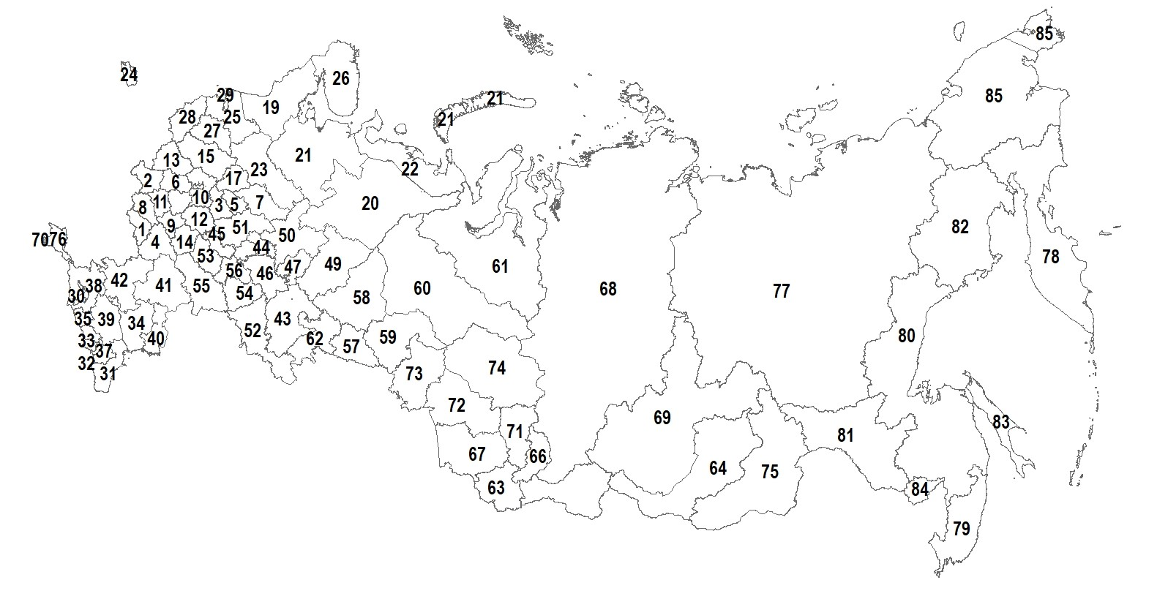
Figure S1 Region numbers according to the Table 1.

