a
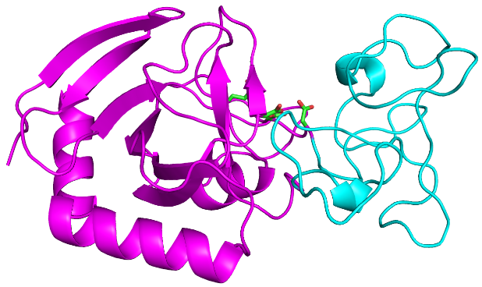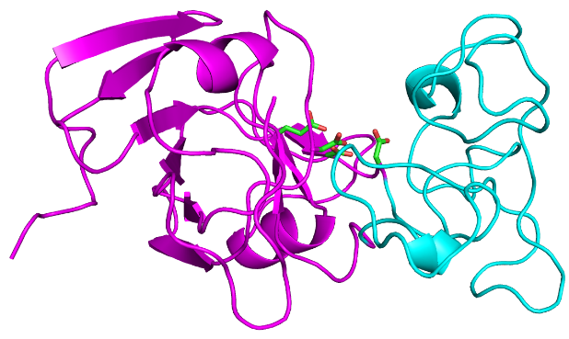
V-Csn X-ray C2 AlphaFold2
GH Domain
cov pid 1 [ . . . . : . . . 80
1 V-Csn 100.0% 100.0% ---------------------MSE-----LSEIDSVAGVTIYSVDGEPKSFVYKAGFAIDADGAPNAYAPNN--G-GTDF
2 A8 92.4% 36.3% -----------------------------------------MQLDNKPGTLFWTCKLAVDGDGDPRCYNPNGRPP-GLDF
3 B1 97.8% 46.0% ---------------------MSE-----LTKFKSVGSVMLYKDD--KNAVLWKAGLTVNADGSPHAYGPDN--S-GLDY
4 C9 86.6% 28.6% -------------------------MDNTRKIIATIANTNVY-WD--GECMEFIAGMQVDADGSPKAYHATDPHG-GLDD
5 C8 86.2% 31.1% ---------------------------------------MMD-TLKMGRSISFVAGMAIDADGAPNAYHANNI---GSDD
6 C6 83.5% 33.2% ------------------------MRIPLP-----------S-QNPDGSYTTPRAGMMIDGDGARNIYAPRGFGS-PLDF
7 C2 86.6% 32.9% ---------------------MINISIPQGSILTEIEGVEVF-WN--GTFMSYTAKMSIDGDGGYRTYHENDD--VALDY
8 C3 84.8% 31.4% -----------------------------MRVLGNISGQDIV--QKDDLSISWVAGLTVDADGAPNCYSPDPR--VGLDD
9 C4 86.6% 28.2% MWECVQKIIQSFVDKQNIESPVSNLNTPINKTLLTIDGEPVI-LDEANNILSFTAGLTIDADGCPRCYAPESSGLPTLDY
10 C5 85.7% 28.5% ----------------------------MKTLIATIQGQDVF--QNEDLTFSYMGRADVDADGSPRAYAPTKSGLPTLDY
consensus/100% ..................................................h..hsth.lsuDGs.phYt.p.....s.D.
consensus/90% ............................................p..s..h.ahuthtlDuDGs.psYtsps....shD.
consensus/80% ........................................hh..p..st.h.ahAthslDuDGuPpsYtsss....sLD.
consensus/70% ..............................p.h.plts..lh..s..spshsahAGhslDADGuPpsYsPss....uLDa

Novel Domain
cov pid 81 . 1 . . . . : . 160
1 V-Csn 100.0% 100.0% TANGGDDQGGDWWGG--P-VDAEGYPIKQK---IFDPFPGYYVSATAHFNPAYSEDSPYRYIDSNSIPFIVLPGNH---S
2 A8 92.4% 36.3% LANAGH--PGNWWGL--A-CDGEGIPFIQE---ASDPAPGFFVSTTSLEDHSLAASNPRRYVNSGQIPFVVLPSKPKF-S
3 B1 97.8% 46.0% TANAGS--AGNWWGIYAP-PDGQGVPVVQA---AYHPAPGHYISTTALVDPTYPENHPDRYVDSERYGFYVIPGGE---S
4 C9 86.6% 28.6% WSSAGY--PNGHYQDILV-CDEAGKPIVQTGLSAGDPAKGYFISATSLQRPNYSKQDVRRYVDAAVIPYAVINGALKKMV
5 C8 86.2% 31.1% LANAGY--EGHWWGLAIN--KATGKPYIQT---GTDPCPGYYVSTTSLVNPLRDDSEPARYVDSNTVPYIALGSNACTAY
6 C6 83.5% 33.2% IANAGE--PGNWYGIVTDNGKASGKPVIQK---KGDPFPGYYVSATSYEFPGFSRGDPYRYVDSATVPYIVLPSHWRAEA
7 C2 86.6% 32.9% LANAGY--PGNWWGVATDTGEGDGDPVYQK---STDPCPGYYVSPTAYEHSDYAHTDPRRYLDSESVIFSVTPPQLRQLV
8 C3 84.8% 31.4% LGNAGH--TGNWWGIVTN---DYGSPILQG---PSDPFPNFYISTTSLQNKNYARTDPRRYVNADVVPFIVVPVIIAREA
9 C4 86.6% 28.2% ISNAGN--TNNWWGIVTK----NGVPVIQG---KNDPYPGYYISTTSYIHKEFATDDPRRYLDSEKVPFVVLPSPIFKMV
10 C5 85.7% 28.5% LINAED--GDRWCGIVTD---DDGYPVIQG---ENDPAPGYYISTTTLQHKQCATSDPARYVDSENVSYVVINRAIAKAC
consensus/100% h.sut....staht.........G.PhhQt.....cPh.saalSsTsh....hsttps.RYlsut.h.a.shs.......
consensus/90% huNAG...sspWaGh..s...ttG.PhhQt.....DPhPGaalSsTuh.p.thspspPhRYlsut.lsahVlss.....s
consensus/80% huNAG...sssWaGlhhs...spGhPllQt...tsDPhPGaYlSsTuh.p.thupscPtRYlDStplsahVlssthh..s
consensus/70% luNAGp..sGsWWGlhhs..cspGhPllQt...tsDPhPGYYlSsToh.p.saucs-PtRYVDSpslPalVlPuthtt.s

GH Domain
cov pid 161 . . . 2 . . . . 240
1 V-csn 100.0% 100.0% NGAKLGDVALVYNEKTGDNCYAIYGDVGPSSKIGEGSVRLAQALKIDDNPKAGGTESRIVVTLVFPGSVGKWETPKRWF-
2 A8 92.4% 36.3% PAQMLGDLFVVFNEKSSKMTWALYADVGPANQIGEGSIALNTALGLSGDCQRGGTEEEIIAMIYFPGSAIGWPRPTDELA
3 B1 97.8% 46.0% -FCKLGDVGLALNTKTGDNFYFAMGDIGPSGQIGEGSMLLAKCLGLSHNPKTGGTAERIIACVVIPNSDPGYRDWEHKC-
4 C9 86.6% 28.6% EPKFLGCRVEVENMRLGRTYNAVCADVGPANKLGEGSIALAHFVGYPKASPRNGIDDKIFRWRFYPGQSATINNEKWAC-
5 C8 86.2% 31.1% H-MAPGAIARVE--YRDLVVLAVLADIGPSGKWGEGSIALANALGIPSSPRNGGLEEEVVRYTIFNRYYPA-SEIRTDD-
6 C6 83.5% 33.2% HGVVLGCKAQIEDTHTGNVIDSVVADFGPRGKLGEASIAAANLCGVRSSPKDGGTADLRFRYTFWPGVAAEVLGVKYAL-
7 C2 86.6% 32.9% GPVVLGCRVRMENLENGLVAWGLVGDVGPKDKLGEGSIAAAEALGIPSSPKNGGTSEHKILYVLVPGLRVPGYELKPA--
8 C3 84.8% 31.4% TGVVLGCVATVEDIRTNRKVQGVVADLGPNNHIGEASVAMARQLGLNPSPRYGGCSDPFFRYTFYPNKPAEGFQLQPL--
9 C4 86.6% 28.2% KPIVLGSKVKVTNLKNGKIAEGLVGDVGPANHLGEASMAMASLLGIGSSPKTGGMDEKMLKFEVFLGVPFDGYSLQPS--
10 C5 85.7% 28.5% KGVVLGSRCTIKDTISGILVEAVVADTGPARKLGEISIRAASLLGIDPSAKSGGSSEVRFLYSFYPNQQADGYQLQPLT-
consensus/100% ...h.Gshh.h.....s..h..hhuDhGPttphGEhShhhsp.hth..ss..sG.tp.hhhh.hh.t......t.p....
consensus/90% ..hhLGshs.h.s.hps..h.ulhuDhGPtsplGEuShthAphlGls.ssptGGht-.hhhh.hhss...th.p.p....
consensus/80% tshhLGshshl.s.csu.hh.ulhuDlGPss+lGEuSlthAphLGlssss+pGGhp-.hhhhhhaPs..sth.p.p....
consensus/70% pshhLGshsplpsh+sGphs.ulhuDlGPus+lGEuSlAhAphLGlssuP+sGGss-chhtahhaPs.sssh.php.t..

cov pid 241 : . . . ] 288
1 V-Csn 100.0% 100.0% SHANQLTKAWGGLSRLKTLSDQL-------------------------
2 A8 92.4% 36.3% KAAYDHFIAWGGYESARAALPQINWDQFPPLL----------------
3 B1 97.8% 46.0% KLAISLIDAWGGLNHLKHLAKQL-------------------------
4 C9 86.6% 28.6% V-----------------------------------------------
5 C8 86.2% 31.1% CCDLSVLSHWSSYL----------WPDLRARVGARVDNTQVLEGAATK
6 C6 83.5% 33.2% IAA---------------------------------------------
7 C2 86.6% 32.9% ------------------------------------------------
8 C3 84.8% 31.4% ------------------------------------------------
9 C4 86.6% 28.2% ------------------------------------------------
10 C5 85.7% 28.5% ------------------------------------------------
consensus/100% ................................................
consensus/90% ................................................
consensus/80% ................................................
consensus/70% ................................................

b
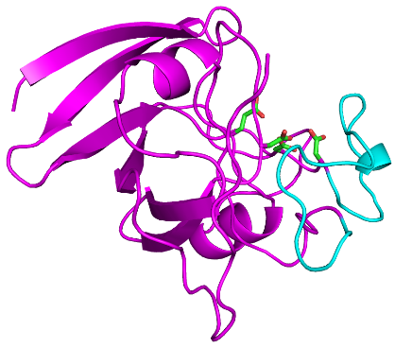
V-Csn X-ray A2 AlphaFold2
GH Domain Novel Domain
cov pid 1 [ . . . . : . . . 80
1 V-Csn 100.0% 100.0% ---------------MSELSEIDSVAGVTIYSVDGEPKSFVYKAGFAIDADGAPNAYAPNN--GGTDFTANGGDDQGGDW
2 A8 92.4% 36.3% ------------------------------MQLDNKPGTLFWTCKLAVDGDGDPRCYNPNGRPPGLDFLANAGH--PGNW
3 B1 97.8% 46.0% ---------------MSELTKFKSVGSVMLYKDD--KNAVLWKAGLTVNADGSPHAYGPDN--SGLDYTANAGS--AGNW
4 A2 64.7% 18.9% -MKKLLTIYSK---GEHYSADLI------D--N-EDGS-GQFLADADIDIDGSPDWQRDPYGQADT--------------
5 A3 67.0% 15.6% ----MATERKQQHIRAHNLEAILKIGGVEIYAD-PTGSYVCFVSDLDICNDGSGPAHGDPHHIKAT--------------
6 A4 68.3% 14.3% MT--TRAKKKAQHIKKHQLSELITIGGVIIYAS-PKGDYVCFVSDLDVCTDGTGNHHGDNTPQDET--------------
7 A5 68.3% 15.5% -MKLIYTHRSAENAQYVYYANIIRDDSRML--N-GKPC-YFWFGDADNDVDGAPYWNKDKYGQPGT--------------
8 A6 67.9% 11.7% MTKRKITAKGQAHIKAHNLEVLLEIGGAIIYTA-PKGDYVCFVSDLDVCTDGSGPSHGDPSYQPQT--------------
consensus/100% .....................................t.h.ahsths.s.DGss...ts.....th..............
consensus/90% .....................................t.h.ahsths.s.DGss...ts.....th..............
consensus/80% ...................t.h..........s..pss.hhahushslssDGss.h.tss...sth..............
consensus/70% ...............hp.httlhp.suh.lhts.scss.hhahuchslssDGus.tassst..ssT..............

Novel Domain GH Domain
cov pid 81 . 1 . . . . : . 160
1 V-Csn 100.0% 100.0% WGG--PVDAEGYPIKQKIFDPFPGYYVSATAHFNPAYSEDSPYRYIDSNSIPFIVLPGNH---SNGAKLGDVALVYNEKT
2 A8 92.4% 36.3% WGL--ACDGEGIPFIQEASDPAPGFFVSTTSLEDHSLAASNPRRYVNSGQIPFVVLPSKP-KFSPAQMLGDLFVVFNEKS
3 B1 97.8% 46.0% WGIYAPPDGQGVPVVQAAYHPAPGHYISTTALVDPTYPENHPDRYVDSERYGFYVIPGGE---S-FCKLGDVGLALNTKT
4 A2 64.7% 18.9% -------------------------------------TLHHNGKPIDSESVPFFVLPPEVIKAFKGVILGCHGTIHYE--
5 A3 67.0% 15.6% -------------------------------------AYKHNRKYLNADHDYYIVIPPQVRKLSRLKVMGCKSRLTNLTT
6 A4 68.3% 14.3% -------------------------------------AYYNGGKFLNADVDKYIVIPPQIRSMVPPVVMGCQARLTQLDT
7 A5 68.3% 15.5% -------------------------------------RWTYKGKPINGDIIPYIVVPPQMIKMTAEIVGGCVGTAEYE--
8 A6 67.9% 11.7% -------------------------------------AYYNGGKFLNADVDKYIVIPPQVRSMVAPVVMGCQGKLTRLDS
consensus/100% ...........................................+.lsut...ahVlPst........hhGs..hh.....
consensus/90% ...........................................+.lsut...ahVlPst........hhGs..hh.....
consensus/80% .....................................s..pst+.lsup...ahVlPsp....s..hhhGs.uhhh....
consensus/70% .....................................shppst+alsu-...alVlPsph.phs..hhhGshuhlhp.po

GH Domain
cov pid 161 . . . 2 . . . . 240
1 V-Csn 100.0% 100.0% GDNCYAIYGDVGPSSKIGEGSVRLAQALKIDDNP-KAGGTESRIVVTLVFPGSVGKWETPKRWF-SHANQLTKAWGGLSR
2 A8 92.4% 36.3% SKMTWALYADVGPANQIGEGSIALNTALGLSGDC-QRGGTEEEIIAMIYFPGSAIGWPRPTDELAKAAYDHFIAWGGYES
3 B1 97.8% 46.0% GDNFYFAMGDIGPSGQIGEGSMLLAKCLGLSHNP-KTGGTAERIIACVVIPNSDPGYRDWEHKC-KLAISLIDAWGGLNH
4 A2 64.7% 18.9% GKSIDAVCADVGPHSKLGEISPEAARRLGINDDP-NIGGEDEQRVLYRFWPGKPAIVD--GIAY-----QLQPFTK----
5 A3 67.0% 15.6% GGSHDAVCGEIGPPNKTGEASYCLARKVNAS--VTHNSGDKRRHYLYELWPGVPAAVN--GKHY-----NLV--------
6 A4 68.3% 14.3% QQASPAVTGEIGPDDKTGEAAYCLCKLMNKA--LTANNGDTRRIYFYELWPGKAAVVD--GKKY-----KLEAAG-----
7 A5 68.3% 15.5% DKIVGCVVGDSGPSSKIGELSPAALRELGLPAPENGNGGLDTQEILYRIWPGVAARIVRNGDVY-----QFELQHS----
8 A6 67.9% 11.7% ALQHAAVVGEIGPKDKTGEAAICLAKIMNPK--VTPKAGDERLIYFYELWPGKPAVVD--GKRY-----KLEPA------
consensus/100% t....hhhu-.GP.sphGEhu..h.p.ht........sG.tp..hhh.hhPs.s.hh...t..h.....ph.........
consensus/90% t....hhhu-.GP.sphGEhu..h.p.ht........sG.tp..hhh.hhPs.s.hh...t..h.....ph.........
consensus/80% st.h.slhu-lGPtsphGEhu.thsphhshs....ttuGpppphhhh.haPG.sshh...tchh.....ph.........
consensus/70% upth.AlhG-lGPssKhGEuShtLs+tlshs..s.tpuGsccphhhh.laPGpsuhhs..scta.....pL..th.....

cov pid 241 : ] 257
1 V-Csn 100.0% 100.0% LKTLSDQL---------
2 A8 92.4% 36.3% ARAALPQINWDQFPPLL
3 B1 97.8% 46.0% LKHLAKQL---------
4 A2 64.7% 18.9% -----------------
5 A3 67.0% 15.6% -----------------
6 A4 68.3% 14.3% -----------------
7 A5 68.3% 15.5% -----------------
8 A6 67.9% 11.7% -----------------
consensus/100% .................
consensus/90% .................
consensus/80% .................
consensus/70% .................

Supplementary Information Fig. 2. Viral chitosanase protein structure comparisons and sequence alignments
a. Viral AMG chitosanase sequences predicted to have the novel domain (cyan) and glycosyl hydrolase (GH) domain (magenta) that are similar to that of the V-Csn X-Ray structure. Alignment made with MView 1.63. The structures of V-Csn (top left) and the GH75 enzyme labeled as C2 (see Supplementary Information table 1)(top right) are shown, colored magenta (GH domain) and cyan (novel domain). Conserved active site residues shown as sticks. b. Viral AMG chitosanase sequences with and without the novel domain structure seen in V-Csn (cyan). The GH domain is in magenta. Sequences lacking the novel domain may also lack the two prominent helices in the GH domain at the C-terminus of the sequence, or a shorter C-terminal helix may be poorly predicted in the structure shown. The structures of V-Csn (top left) and the AMG enzyme A2 (top right) are shown, colored magenta (GH domain) and cyan (novel domain). Conserved active site residues shown as sticks.

