Extended data for

Structural characterization of a soil viral auxiliary metabolic gene encoding a functional chitosanase

Ruonan Wu^{1*} (ruonan.wu@pnnl.gov), Clyde A. Smith^{2*}, Garry W. Buchko^{1,3}, Ian K. Blaby⁴, David Paez-Espino⁵, Nikos C. Kyrpides⁴, Yasuo Yoshikuni⁴, Kirsten S. Hofmockel¹, John R. Cort¹, Janet K. Jansson^{1**}

¹Earth and Biological Sciences Directorate, Pacific Northwest National Laboratory, Richland, WA 99354, USA; ²Stanford Synchrotron Radiation Lightsource, Stanford University, Menlo Park, CA 94025, USA; ³School of Molecular Biosciences, Washington State University, Pullman, WA 99164, USA; ⁴Department of Energy Joint Genome Institute, Berkeley, CA 94720, USA; ⁵Mammoth Biosciences, Brisbane, CA 94005, USA.

*Co-first authors
**Senior, corresponding author

Extended Data Fig. 1. The V-Csn dimer. a. Superposition of a dimer constructed from V-Csn apo1 (molecule 1, yellow ribbon) and a crystallographic symmetry partner (molecule 2, blue ribbon), and the V-Csn apo2 homodimer (gray ribbons). The secondary structure elements which comprise the dimer interface are indicated. Secondary structure elements labeled with a prime represent the symmetry related apo1 molecule. b. The V-Csn apo2 dimer showing molecule 1 as a yellow molecular surface and molecule 2 as a blue ribbon. The contact area between the two molecules is shown in light blue on the yellow molecule 1 surface.

Extended Data Fig. 2. The DPBB motif. a. The two psi motifs (green and cyan) from the V-Csn apo1 structure, shown in approximately the same orientation so that their structural similarity is evident. b. The two psi motifs in the context of the V-Csn apo1 structure. The green psi motif is in approximately the same orientation as in panel a, and the cyan psi motif is rotated about 180º about an axis into the page. Together they make up the double-psi β-barrel (DPBB) structural motif. c. Superposition of V-Csn Domain-1 (light green) and kiwellin from Actinidia chinensis (PDB code 4PMK; orange ribbon). Loop1 and Loop2 in kiwellin coincide approximately with parts of Domain-2 (pink ribbon) of V-Csn. d. Superposition of V-Csn Domain-1 (light green) and endoglucanase V from Humicola insolens (PDB code 4ENG; yellow ribbon). Loops 1 and 2 in endoglucanase V correspond approximately with Domain-2 of V-Csn. e. Superposition of V-Csn Domain-1 (light green) and expansin from Clavibacter michiganensis (PDB code 4JCW; light purple ribbon). Loop1 of the expansin corresponds to part of V-Csn Domain-2, however, the C-terminal domain of the expansin (C-domain) bears no structural similarity to V-Csn.

Extended Data Fig. 3. Ramachandran plot for Domain-2 of V-Csn apo1. The main chain torsion angles (phi and psi) for the residues in Domain-2 are shown as light blue triangles (glycine), light blue squares (proline) and blue circles (all other residues). The three energetically-favored regions for β-sheets, α-helices and left-handed helices are colored pink. The additionally allowed regions are colored pale yellow.

Extended Data Fig. 4. V-Csn structure. a. Hydrogen bonding interactions between the two short β-strands, β4 and β5, in Domain-2. b. Hydrogen bonding interactions in the 20-aa region in Domain-1 between helix α1 (a 3₁₀ helix) and strand β5 (shown as gray sticks for main chain atoms only). This region contains four residues designated as β-bridges, G56, W63, V68 and P74 (colored magenta). These residues are involved in main chain-main chain hydrogen bonds with other β-bridge residues and residues adjacent to them. The 20-aa region is folded into two hairpin loops, with an acidic residue (D57 and D69) in each loop stabilize each hairpin through hydrogen bonding interactions with main chain amide nitrogen atoms. c. Superposition of the predicted AlphaFold2 V-Csn structure (gray ribbons) and the V-Csn apo1 crystal structure (green and pink ribbons representing Domain-1 and Domain-2, respectively).

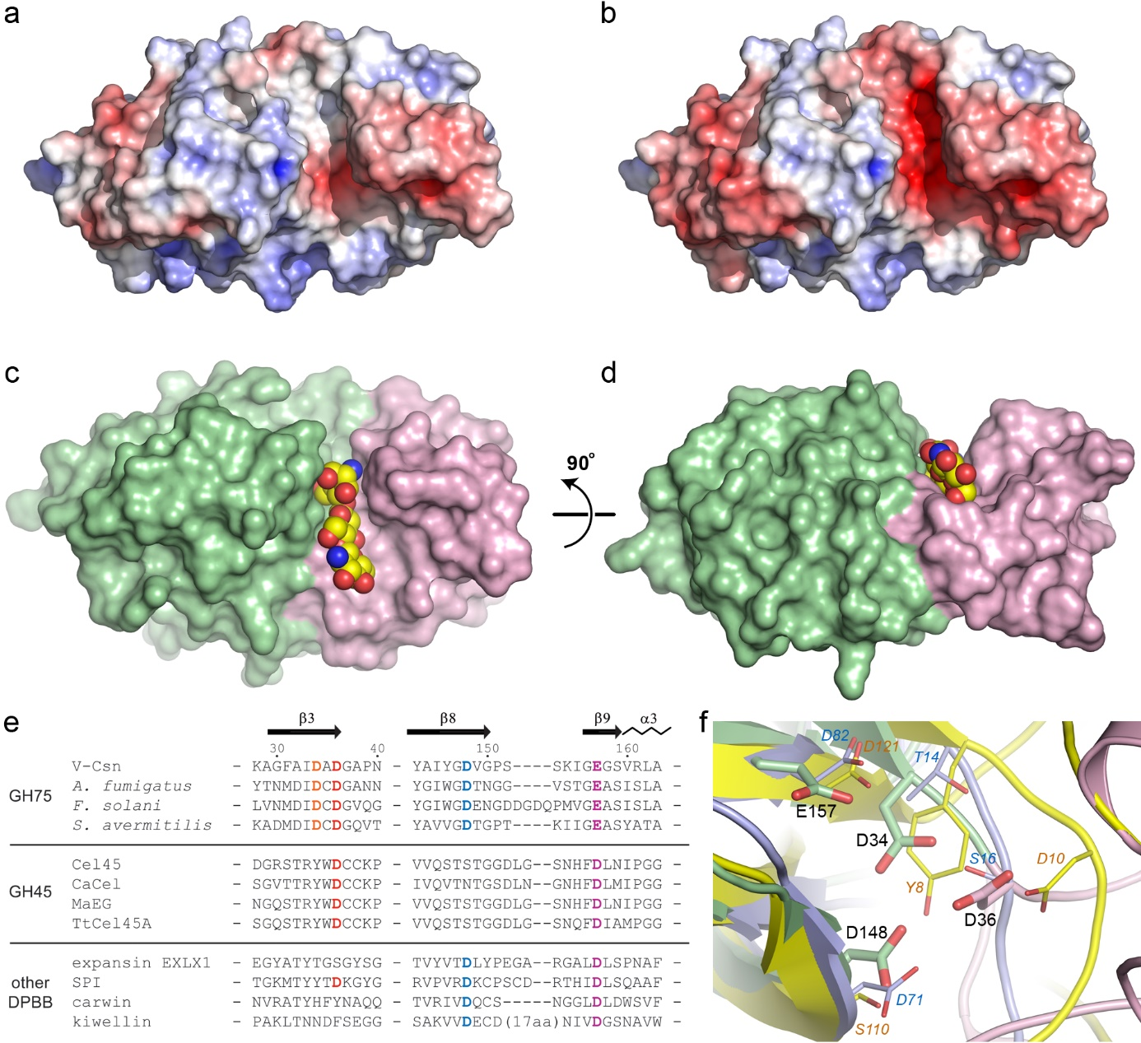
Extended Data Fig. 5. V-Csn active site identification. a. Electrostatic surface of V-Csn apo1 calculated at pH 4.6. The surface is contoured from -5 kT/e (red) to +5 kT/e (blue). b. Electrostatic surface of V-Csn apo1 calculated at pH 5.5. The surface is contoured from -5 kT/e (red) to +5 kT/e (blue). c. Solvent accessible surface representation of the chitohexaose-V-Csn complex showing the location of the modeled trisaccharide moiety (yellow, blue and red CPK spheres) in the active site cleft. d. Panel c rotated by 90º about a horizontal axis to show the CPK model of the trisaccharide deep in the active site cleft. In panels c and d, the enzyme is colored by structural domains (Domain-1, light green; Domain-2, pink). e. Partial structure-based sequence alignment of V-Csn with several enzymes containing DPBB domains. The alignment was determined from superpositions of the enzymes against V-Csn based upon their DPBB motifs. The four conserved acidic residues observed in the V-Csn active site are colored orange, red, blue and purple. Matching residues in the GH45 enzymes and other DPBB containing proteins are colored similarly when structurally equivalent. The sequences used are as follows: Cel45, endoglucanase V from Humicola isolens (Genbank P43316.1); CaCel, endoglucanase from Cryptopygus antarcticus (Genbank ACV50415.1); MaEG, endoglucanase from Melanocarpus albomyces (Genbank CAD56665.1); TtCel45A, endoglucanase from Thielavia terrestris (Genbank 1182607135); EXLX1, expansin from Bacillus subtilis (Genbank O34918); SPI, Steptomyces papain inhibitor from Streptomyces mobaraensis (Genbank WP_004951535.1); carwin from Carica papaya (Genbank 4JP6_A); kiwellin from Actinidia chinenesis (Genbank AGC39168.1). f. Superposition of V-Csn (green ribbon, green sticks and black bold labels), Cel45 (yellow ribbon, thin yellow sticks and orange italic labels, PDB code 3ENG) and expansin EXLX1 (light blue ribbon, light blue sticks and cyan italic labels, PDB code 4FFT). The structures were superimposed by matching the DPBB motifs.

Extended Data Table 1. Wild-type V-Csn data collection statistics *
 | V-Csn apo1 | V-Csn apo1 Br-SAD | V-Csn apo2
Space group | C2 | C2 | C2
Resolution range (Å) | 37.2-0.89 (0.91-0.89) | 37.2-1.60 (1.63-1.60) | 38.1-1.35 (1.37-1.35)
Unit cell - a, b, c (Å)  - β (º) | 108.84, 47.63. 45.55  97.8 | 108.66, 47.53. 45.62  97.9 | 163.30, 46.00. 73.56  92.3
Mathews coefficient | 2.45 (49.7% solvent) | 2.44 (49.6% solvent) | 2.89 (57.4% solvent)
Molecules in the A.U. | 1 | 1 | 2
Reflections (observed/unique) | 1148940 / 174574 | 400825 / 30343 | 803185 / 117982
R_{meas} # (%) | 0.093 (1.265) | 0.107 (0.597) | 0.060 (1.166)
R_{pim} # (%) | 0.036 (0.549) | 0.029 (0.192) | 0.023 (0.454)
I/σ | 11.4 (1.6) | 19.8 (4.3) | 16.1 (1.5)
Completeness (%) | 99.1 (91.3) | 99.2 (90.6) | 98.4 (95.4)
CC½ $ | 0.998 (0.609) | 0.999 (0.896) | 1.0 (0.847)
Multiplicity | 6.6 (5.0) | 13.2 (9.3) | 6.8 (6.3)
Wilson B (Å²) | 5.3 | 12.4 | 15.4
Anomalous completeness | - | 99.0 (89.5) | -
Anomalous multiplicity | - | 6.7 (4.7) | -
CC_{anom} & | - | 0.415 | -
MSAN ± | - | 1.40 | -
* Numbers in parentheses relate to the highest resolution shell. # R_{meas} is the redundancy-independent merging R factor and R_{pim} is the precision-indicating merging R factor⁶⁶. $ Percentage of correlation between intensities from random half-sets of data⁶⁷. & Correlation of ΔI_{anom} from two random half-sets⁶⁸.
± MSAN is the mid-slope of the anomalous normal probability plot. Values > 1 indicate significant anomalous signal⁶⁸.

Extended Data Table 2. Wild-type V-Csn structure refinement statistics
 | V-Csn apo1 | V-Csn apo2
PDB Code | 7TVL | 7TVM
Resolution range (Å) | 37.2 – 0.89 | 38.1 – 1.35
Reflections used, total/free | 174427 / 8555 | 117783 / 5888
Working R-factor/R_{free} * | 0.1198 / 0.1307 | 0.1429 / 0.1742
Total atoms - protein  - solvent | 1811  398 | 3442  566
B factors - protein (Å²)  - solvent (Å²) | 7.30  22.3 | 19.9  34.0
rms deviation - bonds (Å)  - angles (º) | 0.005  0.937 | 0.005  0.815
Ramachandran plot #  residues in preferred regions (%)  outliers | 99.1  0 | 99.3  0
Molprobity score # | 1.01 (96th percentile) | 0.77 (100th percentile)
* R_{free} was calculated with 5% of the reflections. # Calculated by MOLPROBITY⁶⁹.

Extended Data Table 3. V-Csn mutant data collection statistics *
 | V-Csn-D148N | V-Csn-E157Q | V-Csn-E157Q-chitohexaose
Resolution range (Å) | 37.2-1.20 (1.22-1.20) | 37.1-1.15 (1.17-1.15) | 37.1-1.30 (1.32-1.30)
Unit cell - a, b, c (Å)  - β (º) | 108.76, 47.45. 45.43  98.0 | 108.58, 47.43. 45.46  97.9 | 108.94, 47.42, 45.40  97.8
Reflections (observed/unique) | 471537 / 70261 | 546974 / 76188 | 372782 (55448)
R_{meas} (%) # | 0.071 (0.702) | 0.050 (0.361) | 0.090 (0.964)
R_{pim} (%) # | 0.027 (0.285) | 0.019 (0.135) | 0.034 (0.380)
I/σ | 16.1 (2.6) | 22.1 (5.1) | 11.7 (1.8)
Completeness (%) | 98.1 (88.4) | 94.0 (88.5) | 97.8 (87.9)
CC½ $ | 0.999 (0.970) | 1.0 (0.964) | 0.999 (0.837)
Multiplicity | 6.7 (5.7) | 7.2 (7.0) | 6.7 (6.0)
Wilson B (Å²) | 8.9 | 7.1 | 11.3
* Numbers in parentheses relate to the highest resolution shell. In all cases the crystals are isomorphous with V-Csn apo1 crystals. # R_{meas} is the redundancy-independent merging R factor and R_{pim} is the precision-indicating merging R factor⁶⁶. $ Percentage of correlation between intensities from random half-sets of data⁶⁷.

Extended Data Table 4. V-Csn mutant refinement statistics
 | V-Csn-D148N | V-Csn-E157Q | V-Csn-E157Q-chitohexaose
PDB Code | 7TVN | 7TVO | 7TVP
Resolution range (Å) | 37.2 – 1.20 | 37.1 – 1.15 | 37.1 – 1.30
Reflections used, total/free | 70244 / 3400 | 76177 / 3757 | 55326 / 2759
Working R-factor/R_{free} * | 0.1251 / 0.1489 | 0.1185 / 0.1350 | 0.1319 / 0.1640
Total atoms - protein  - solvent | 1742  310 | 1762  300 | 1731  330
B factors - protein (Å²)  - solvent (Å²) | 10.6  28.7 | 9.24  26.2 | 12.5  28.2
rms deviations - bonds (Å)  - angles (º) | 0.005  0.892 | 0.005  0.914 | 0.005  0.864
Ramachandran plot #  - preferred regions (%)  - outliers | 98.2  0 | 98.2  0 | 98.2  0
Molprobity score # | 0.97 (99th percentile) | 0.61 (100th percentile) | 1.05 (99th percentile)
* R_{free} was calculated with 5% of the reflections. # Calculated by MOLPROBITY⁶⁹.

