Supplemental Material
 | Train | Test | Total Number
Tandem + Ovoid | 33 | 5 | 38
Ovoid Only | 51 | 7 | 58
Tandem + Needles | 48 | 7 | 55
Needles Only | 37 | 5 | 42
Multi Channel Vaginal | 38 | 6 | 44
Total Fraction/Case Number | 207 | 30
Table 1. Number of cases used for training and testing.
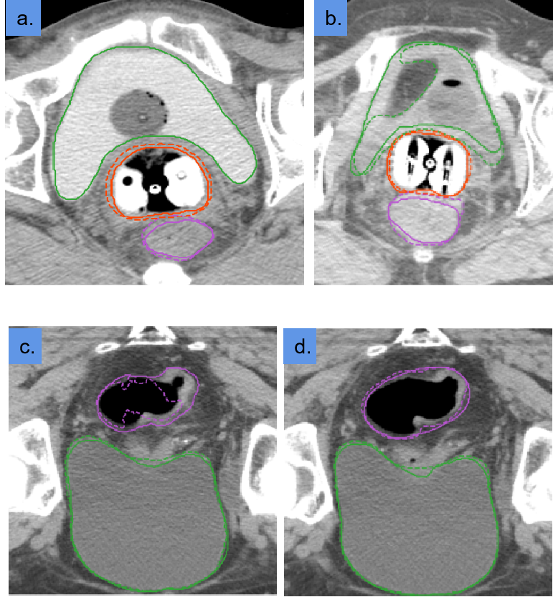
Figure 1. Visualization of segmentation demonstrated manual contouring (solid line) and auto-segmentation (dashed line): rectum (purple), bladder (green), and HRCTV (orange).
a. Failed segmentation only occurred in one case with contrast enhanced agent resided in the bladder.
b. Major segmentation errors were noticed in cases where abnormal anatomy (e.g., large air bubbles in the bladder) exists.
c & d. Minor segmentation errors were usually observed at the top slice of the rectum(c). The second to last slice has a good segmentation(d).

