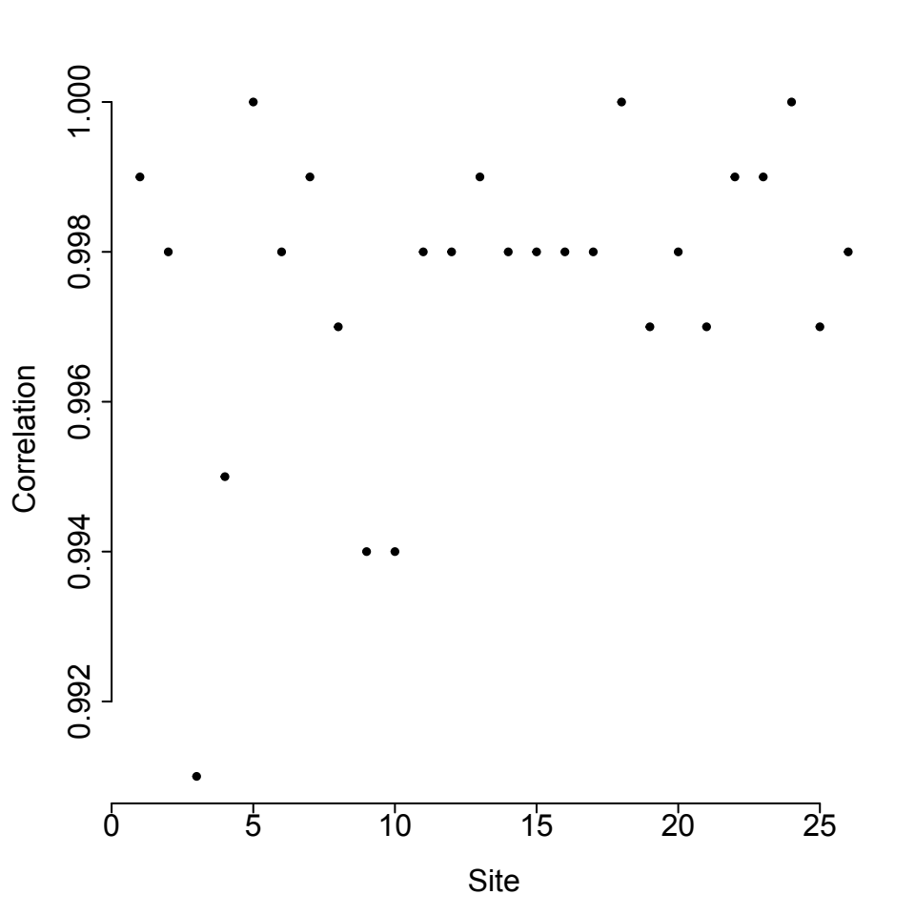Supplementary Fig 1: Correlation (Pearson correlation) between PM_{2.5} and PM₁₀ at sites

