Cellulose-based hybrid composites enabled by metal organic frameworks for CO₂ capture: The effect of cellulosic substrate
Saysam Qusai Jabbar¹, Halimeh Janani¹, Hamed Janani*¹
¹Chemical Engineering Department, Faculty of Engineering, Ferdowsi University of Mashhad
Azadi Sq., Mashhad, Iran, Postal Code: 9177948944

Supporting Information

Table S1. The parameters of kinetic models along with associated correlation functions for CO₂ adsorption onto Cotton@MOF-199.
Sample | Adsorption temperature | Kinetic Model | Supposed rate-limiting step | Model parameters | $$R^{2}$$
Cotton@MOF | RT | PFO  $$\frac{dq_{t}}{dt}=k_{1}\left(q_{e}-q_{t}\right)$$ | External diffusion | $$k_{1}=0.163$$  $$q_{e}=1.300$$ | 0.995
Cotton@MOF | RT | RNO  $$\frac{dθ}{dt}=α{(1-θ)}^{n}$$ | Active site sorption | $$α=0.165$$  $$n=0.856$$  $$q_{e}=1.24$$ | 0.993
Cotton@MOF | RT | W&M  $$q_{t}=k_{W\&M}t^{1/2}$$ | Internal diffusion | $$k_{W\&M}=0.307$$ | 0.962
Cotton@MOF | 45 $℃$ | PFO  $$\frac{dq_{t}}{dt}=k_{1}\left(q_{e}-q_{t}\right)$$ | External diffusion | $$k_{1}=0.084$$  $$q_{e}=1.434$$ | 0.969
Cotton@MOF | 45 $℃$ | RNO  $$\frac{dθ}{dt}=α{(1-θ)}^{n}$$ | Active site sorption | $$α=0.098$$  $$n=0.412$$  $$q_{e}=1.08$$ | 0.984
Cotton@MOF | 45 $℃$ | W&M  $$q_{t}=k_{W\&M}t^{1/2}$$ | Internal diffusion | $$k_{W\&M}=0.255$$ | 0.856
Cotton@MOF | 65 $℃$ | PFO  $$\frac{dq_{t}}{dt}=k_{1}\left(q_{e}-q_{t}\right)$$ | External diffusion | $$k_{1}=0.135$$  $$q_{e}=0.704$$ | 0.938
Cotton@MOF | 65 $℃$ | RNO  $$\frac{dθ}{dt}=α{(1-θ)}^{n}$$ | Active site sorption | $$α=0.130$$  $$n=0.527$$  $$q_{e}=0.62$$ | 0.964
Cotton@MOF | 65 $℃$ | W&M  $$q_{t}=k_{W\&M}t^{1/2}$$ | Internal diffusion | $$k_{W\&M}=0.155$$ | 0.847
Table S2. The parameters of kinetic models along with associated correlation functions for CO₂ adsorption onto NBC@MOF-199.
Sample | Adsorption temperature | Kinetic Model | Supposed rate-limiting step | Model parameters | $$R^{2}$$
NBC@MOF | RT | PFO  $$\frac{dq_{t}}{dt}=k_{1}\left(q_{e}-q_{t}\right)$$ | External diffusion | $$k_{1}=0.1265$$  $$q_{e}=3.2706$$ | 0.984
NBC@MOF | RT | RNO  $$\frac{dθ}{dt}=α{(1-θ)}^{n}$$ | Active site sorption | $$α=0.1215$$  $$n=0.5397$$  $$q_{e}=2.9$$ | 0.994
NBC@MOF | RT | W&M  $$q_{t}=k_{W\&M}t^{1/2}$$ | Internal diffusion | $$k_{W\&M}=0.7038$$ | 0.907
NBC@MOF | 45 $℃$ | PFO  $$\frac{dq_{t}}{dt}=k_{1}\left(q_{e}-q_{t}\right)$$ | External diffusion | $$k_{1}=0.1632$$  $$q_{e}=2.0176$$ | 0.993
NBC@MOF | 45 $℃$ | RNO  $$\frac{dθ}{dt}=α{(1-θ)}^{n}$$ | Active site sorption | $$α=0.1579$$  $$n=0.7457$$  $$q_{e}=1.9$$ | 0.995
NBC@MOF | 45 $℃$ | W&M  $$q_{t}=k_{W\&M}t^{1/2}$$ | Internal diffusion | $$k_{W\&M}=0.4754$$ | 0.928
NBC@MOF | 65 $℃$ | PFO  $$\frac{dq_{t}}{dt}=k_{1}\left(q_{e}-q_{t}\right)$$ | External diffusion | $$k_{1}=0.2377$$  $$q_{e}=1.2124$$ | 0.942
NBC@MOF | 65 $℃$ | RNO  $$\frac{dθ}{dt}=α{(1-θ)}^{n}$$ | Active site sorption | $$α=0.2409$$  $$n=1.1418$$  $$q_{e}=1.25$$ | 0.945
NBC@MOF | 65 $℃$ | W&M  $$q_{t}=k_{W\&M}t^{1/2}$$ | Internal diffusion | $$k_{W\&M}=0.3139$$ | 0.849

Figure S1. Adsorption and desorption experimental data at various temperatures fitted to the Langmuir’s kinetic equations.

Antibacterial activity of the composites:
To investigate the inhibitory effect of the cellulose@MOF-199, coagulase positive Staphylococcus aureus strain was used as an indicator of gram-positive bacteria and Escherichia coli strain was used as an indicator of gram-negative bacteria. These bacteria were inoculated in the culture medium and then the fabric with growth inhibitory properties was placed in the culture medium containing bacterial strain. After the incubation time, the tested plates were examined for growth halo and the results are as follows (Figure S2):
Diameter of non-growth halo of plate containing Escherichia coli strain (Figure S2a): 33 mm
Diameter of non-growth halo of plate containing Staphylococcus aureus coagulase (Figure S2b): 25 mm
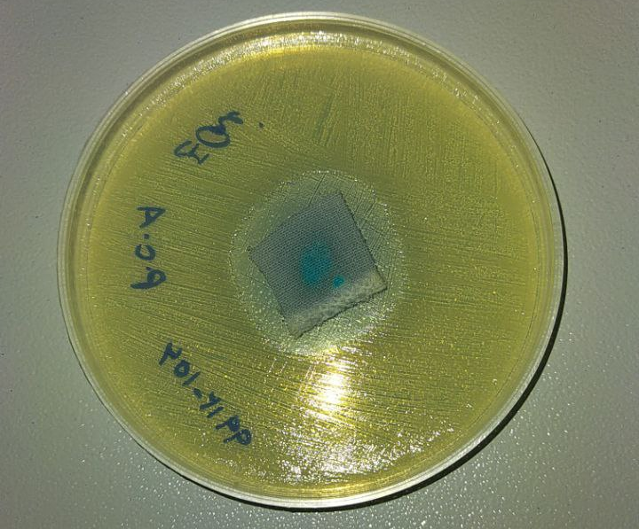  (a) | 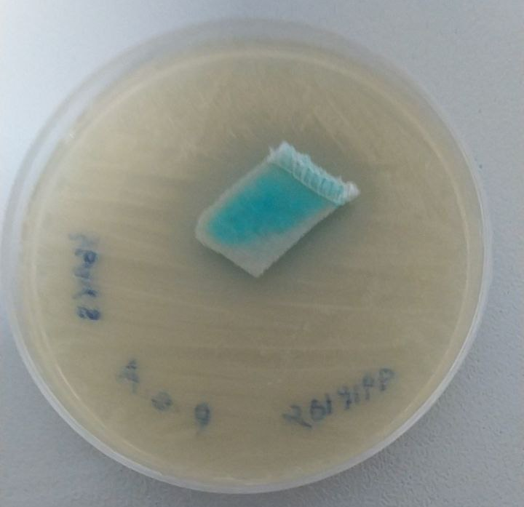  (b)
Figure S2. Antibacterial effect (growth inhibitory zone) of the cellulose@MOF-199 on (a) Escherichia coli and (b) Staphylococcus aureus coagulase

