Supporting Information (SI) for
Binding affinity and mechanisms of potential antidepressants targeting human NDMA receptors

Simin Ye^{1,2}, Yanqiang Han^{1,2}, Zhiyun Wei^{3*}, Yongli Zhang^{3*} and Jinjin Li^{1,2*}

¹National Key Laboratory of Science and Technology on Micro/Nano Fabrication, Shanghai Jiao Tong University, Shanghai, 200240, China
² Key Laboratory for Thin Film and Microfabrication of Ministry of Education, Department of Micro/Nano-electronics, Shanghai Jiao Tong University, Shanghai 200240, China
³ Shanghai Key Laboratory of Maternal Fetal Medicine, Shanghai First Maternity and Infant Hospital, School of Medicine, Tongji University, Shanghai 200092, China.

*Correspondence to: Jinjin Li (lijinjin@sjtu.edu.cn), Yongli Zhang (doctorzhang2@163.com), and Zhiyun Wei (zhiyun_wei@163.com)

Table S1 The total score and important energy terms of the selected eight drugs after docking with Rosetta3. The energy terms include binding energy, Coulombic electrostatic potential, solvation energy, sidechain-backbone hydrogen bond energy (hbond_bb_sc), attractive and repulsive energies between atoms in different residues.
Conformations | Total score | Bind  energy | electrostatic | Solvation  energy | hbond_bb_sc | attractive | repulsive
s-ketamine | -144.654 | -9.103 | -0.499 | 288.838 | -0.190 | -588.516 | 85.782
r-ketamine | -147.176 | -8.828 | -0.110 | 289.401 | -0.190 | -592.509 | 88.448
ifenprodil | -153.57 | -12.687 | -1.095 | 289.735 | -0.471 | -597.576 | 91.693
traxoprodil | -153.915 | -13.365 | -1.479 | 290.701 | -0.677 | -600.377 | 91.680
Ro 25-6981 | -152.242 | -11.568 | 0.411 | 291.098 | 0.000 | -600.546 | 91.234
Memantine | -146.729 | -7.231 | -0.406 | 288.884 | -0.190 | -588.893 | 86.600
Dextromethorphan | -150.362 | -10.635 | -0.063 | 289.428 | -0.190 | -594.154 | 87.531
Lanicemine | -147.129 | -8.365 | -0.635 | 289.476 | -0.190 | -590.556 | 86.555

Table S2 The hydrogen bond analysis of the selected eight drugs after docking using cpptraj. Acceptor, DonorH, and Donor are the residue and atom name of the atoms involved in the hydrogen bond. AvgDist is the average distance of the bond when present, and AvgAng is the average angle of the bond when present.
Conformations | Acceptor | DonorH | Donor | AvgDist | AvgAng
s-ketamine | SKE_170@O1 | ASN_160@HD22 | ASN_160@ND2 | 2.8644 | 158.146
r-ketamine | LEU_124@O | RKE_170@H9 | RKE_170@N1 | 2.8816 | 162.275
r-ketamine | RKE_170@N1 | ASN_126@HD21 | ASN_126@ND2 | 2.9043 | 152.594
ifenprodil | LEU_165@O | IF1_170@H27 | IF1_170@O2 | 2.7693 | 162.539
traxoprodil | TRA_170@O2 | TYR_69@HH | TYR_69@OH | 2.6340 | 139.755
Ro 25-6981 | VAL_42@O | RO1_170@H29 | RO1_170@O2 | 2.7397 | 162.840
Ro 25-6981 | LEU_43@O | RO1_170@H29 | RO1_170@O2 | 2.7294 | 163.301

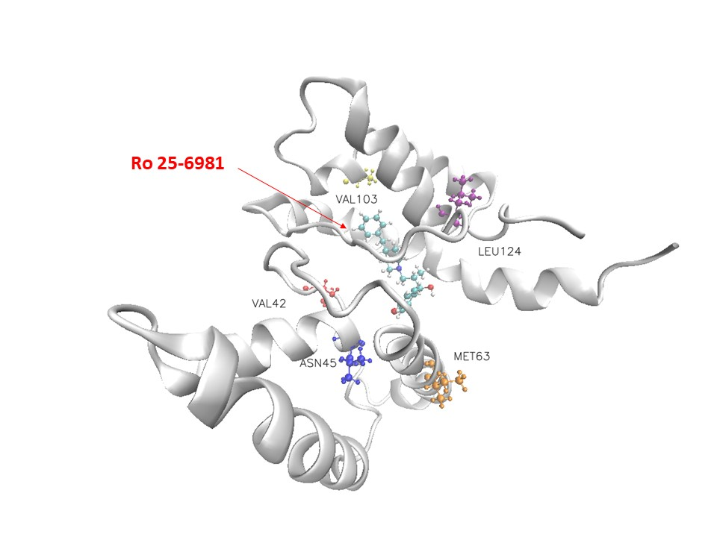
Fig S1 Visualization of the docking conformation of the NDMA receptor and Ro 25-6981. The ball-and-stick model shows the binding pocket of five residues in the NDMA receptor with dominant binding contributions to Ro 25-6981.
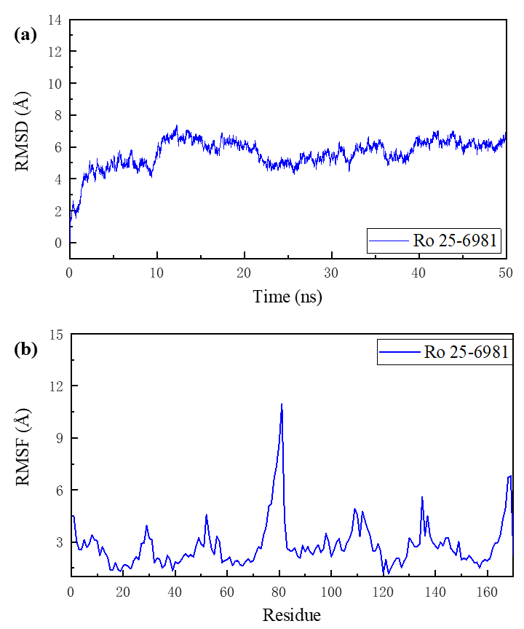
Fig. S2 Root mean square deviation (RMSD) and root mean square fluctuation (RMSF) of s-ketamine and the NDMA receptor complex in a 40-ns simulation MD. (a) The RMSD of all non-hydrogen atoms in the complex. (b) The RMSF of all non-hydrogen atoms in the NDMA receptor throughout the simulation.

Table S3 Binding energy and decomposition of top 10 residues with dominant binding contributions of the NDMA receptor to Ro 25-6981, including van der Waals energy (vdW), electrostatic energy (Ele), polar solvation energy (Polar) and non-polar solvation energy (Non-polar).
Residue | TOTAL | van der Waals | Electrostatic | Polar Solvation | Non-Polar Solv.
Leu124 | -2.23165 | -2.42877 | -0.29296 | 0.7499 | -0.25983
Met63 | -1.83398 | -1.73281 | -0.15426 | 0.195343 | -0.14226
Asn45 | -1.68813 | -2.12233 | -1.02918 | 1.864214 | -0.40083
Val103 | -1.52143 | -1.09549 | -0.17719 | -0.10878 | -0.13997
Val42 | -1.51834 | -0.0747 | -2.51597 | 1.100184 | -0.02785
Val66 | -1.41468 | -1.04118 | -0.06375 | -0.18415 | -0.12559
Val123 | -1.40648 | -1.16161 | -0.11964 | 0.01693 | -0.14216
Ala150 | -1.34849 | -0.93705 | -0.06946 | -0.23945 | -0.10253
Ala62 | -1.19032 | -0.74947 | -0.31159 | -0.09577 | -0.03349
Ala147 | -1.08407 | -1.10275 | 0.072532 | 0.076199 | -0.13005

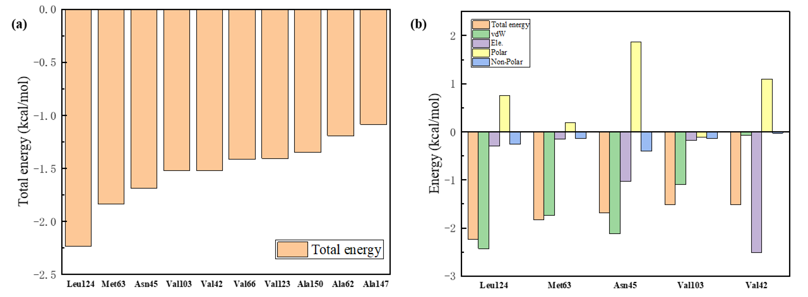
Fig. S3 Decomposition of the free energy of binding of key residues. (a) The 10 key residues with dominant binding contributions from the NDMA receptor to Ro 25-6981. (b) Decomposition of the energy of the five key residues and Ro 25-6981 pairs into four energy terms, namely van der Waals interaction (vdW), electrostatic interaction (ele), polar solvation energy (polar), and nonpolar energy (nonpolar).

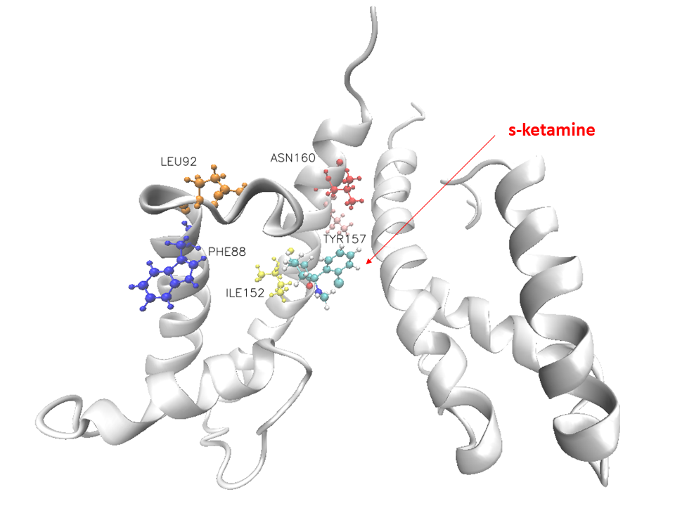
Fig. S4 Visualization of the docking conformation of the NDMA receptor and s-ketamine. The ball-and-stick model shows the binding pocket of five residues in the NDMA receptor with dominant binding contributions to ketamine.
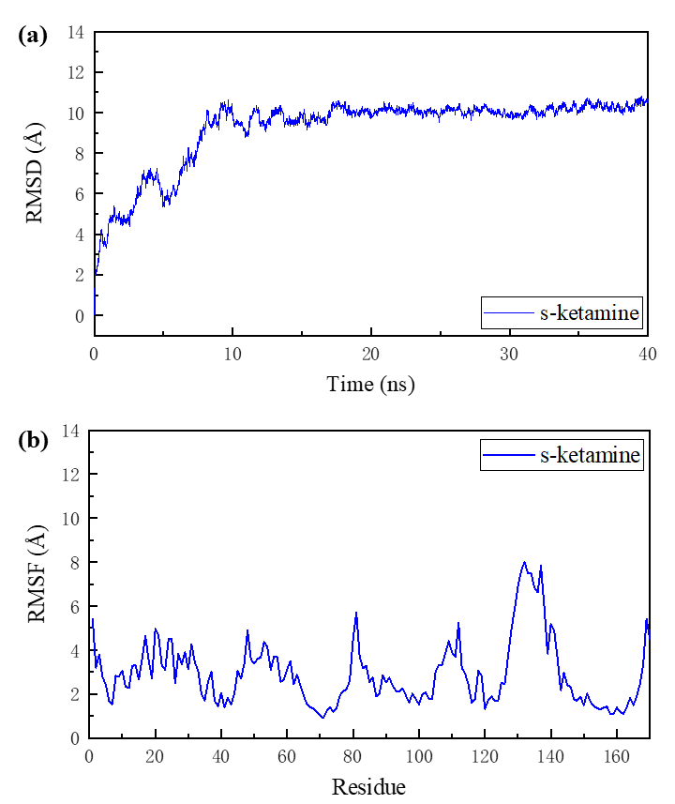
Fig. S5 Root mean square deviation (RMSD) and root mean square fluctuation (RMSF) of s-ketamine and the NDMA receptor complex in a 40-ns simulation MD. (a) The RMSD of all non-hydrogen atoms in the complex. (b) The RMSF of all non-hydrogen atoms in the NDMA receptor throughout the simulation.

Table S4 Binding energy and decomposition of top 10 residues with dominant binding contributions of the NDMA receptor to s-ketamine, including van der Waals energy (vdW), electrostatic energy (Ele), polar solvation energy (Polar) and non-polar solvation energy (Non-polar).
Residue | TOTAL | van der Waals | Electrostatic | Polar Solvation | Non-Polar Solv.
Phe88 | -2.19287 | -2.04711 | -1.12602 | 1.110792 | -0.13053
Asn160 | -2.14918 | -0.94558 | -4.3375 | 3.318178 | -0.18428
Leu92 | -1.78956 | -1.93294 | -0.47498 | 0.903851 | -0.28549
Tyr157 | -1.34733 | -1.25785 | -0.23522 | 0.212931 | -0.06719
Trp93 | -1.27813 | -1.4686 | -0.2309 | 0.501495 | -0.08012
Val96 | -0.99227 | -0.93196 | 0.324644 | -0.21474 | -0.17021
Ile153 | -0.8618 | -0.76555 | 0.223871 | -0.25334 | -0.06678
Ser156 | -0.58111 | -1.14993 | 0.636683 | 0.152842 | -0.2207
Trp121 | -0.56147 | -0.70984 | 0.034218 | 0.184792 | -0.07064
Gln89 | -0.44267 | -0.92434 | -0.57443 | 1.113663 | -0.05757

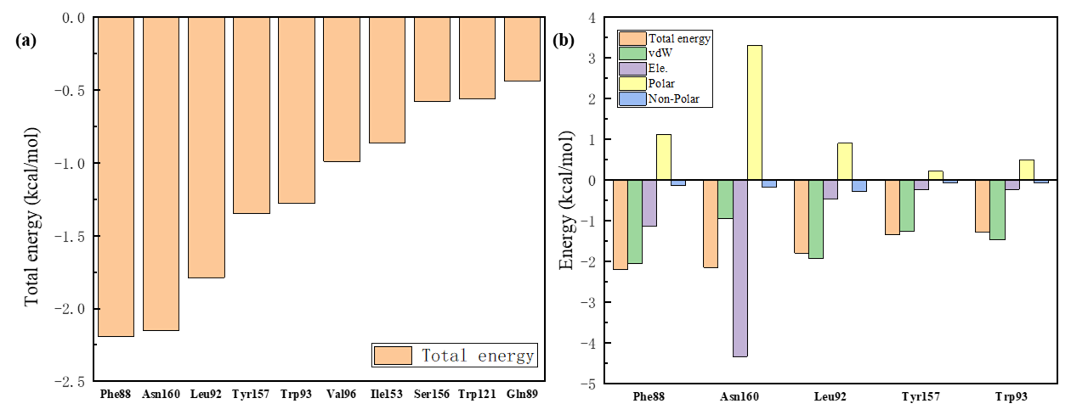
Fig. S6 Decomposition of the free energy of binding of key residues. (a) The 10 key residues with dominant binding contributions from the NDMA receptor to s-ketamine. (b) Decomposition of the energy of the five key residues and s-ketamine pairs into four energy terms, namely van der Waals interaction (vdW), electrostatic interaction (ele), polar solvation energy (polar), and nonpolar energy (nonpolar).

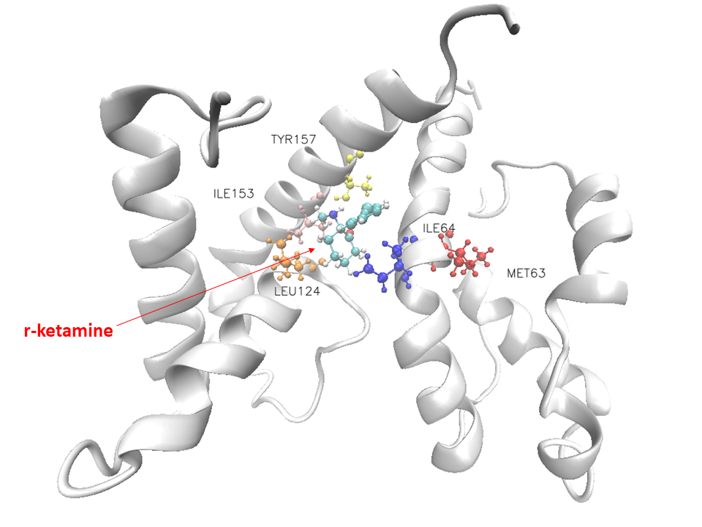
Fig S7 Visualization of the docking conformation of the NDMA receptor and r-ketamine. The ball-and-stick model shows the binding pocket of five residues in the NDMA receptor with dominant binding contributions to r-ketamine.
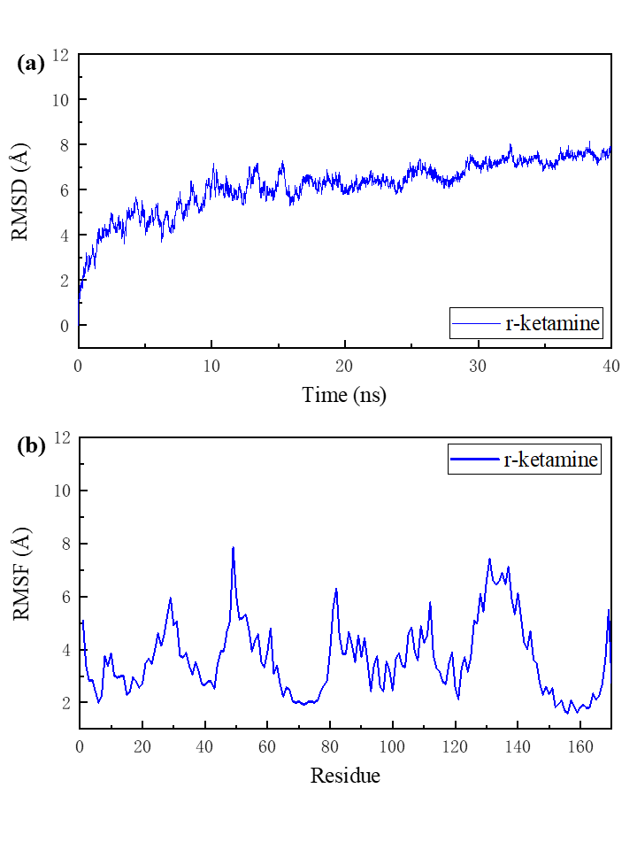
Fig. S8 Root mean square deviation (RMSD) and root mean square fluctuation (RMSF) of r-ketamine and the NDMA receptor complex in a 40-ns simulation MD. (a) The RMSD of all non-hydrogen atoms in the complex. (b) The RMSF of all non-hydrogen atoms in the NDMA receptor throughout the simulation.

Table S5 Binding energy and decomposition of top 10 residues with dominant binding contributions of the NDMA receptor to r-ketamine, including van der Waals energy (vdW), electrostatic energy (Ele), polar solvation energy (Polar) and non-polar solvation energy (Non-polar).
Residue | TOTAL | van der Waals | Electrostatic | Polar Solvation | Non-Polar Solv.
Met63 | -1.76638 | -1.28128 | -1.22127 | 0.824329 | -0.08815
Ile64 | -1.60067 | -1.51763 | -0.64395 | 0.767993 | -0.20708
Leu124 | -1.37106 | -1.48867 | -0.72941 | 1.008282 | -0.16127
Ile153 | -1.24179 | -1.20975 | -0.01193 | 0.119086 | -0.13919
Tyr157 | -1.11015 | -1.32248 | -0.07776 | 0.417628 | -0.12753
Val154 | -0.95168 | -0.93403 | -0.12226 | 0.206771 | -0.10216
Trp 146 | -0.68055 | -0.96497 | -0.23216 | 0.601987 | -0.0854
Leu125 | -0.65302 | -0.72225 | 0.042748 | 0.106176 | -0.0797
Asn126 | -0.61274 | -0.3845 | -0.82881 | 0.668924 | -0.06835
Phe88 | -0.57836 | -0.7225 | 0.032405 | 0.238734 | -0.127

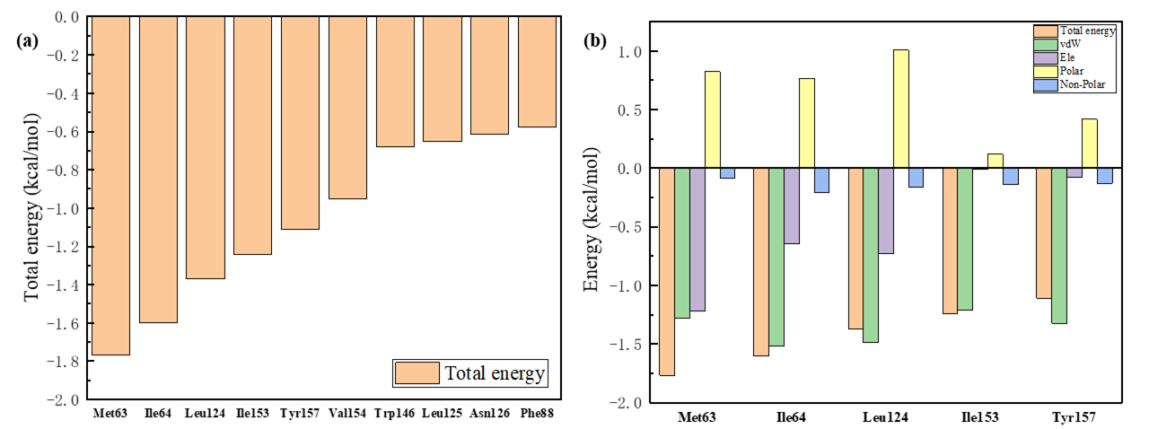
Fig. S9 Decomposition of the free energy of binding of key residues. (a) The 10 key residues with dominant binding contributions from the NDMA receptor to r-ketamine. (b) Decomposition of the energy of the five key residues and r-ketamine pairs into four energy terms, namely van der Waals interaction (vdW), electrostatic interaction (ele), polar solvation energy (polar), and nonpolar energy (nonpolar).

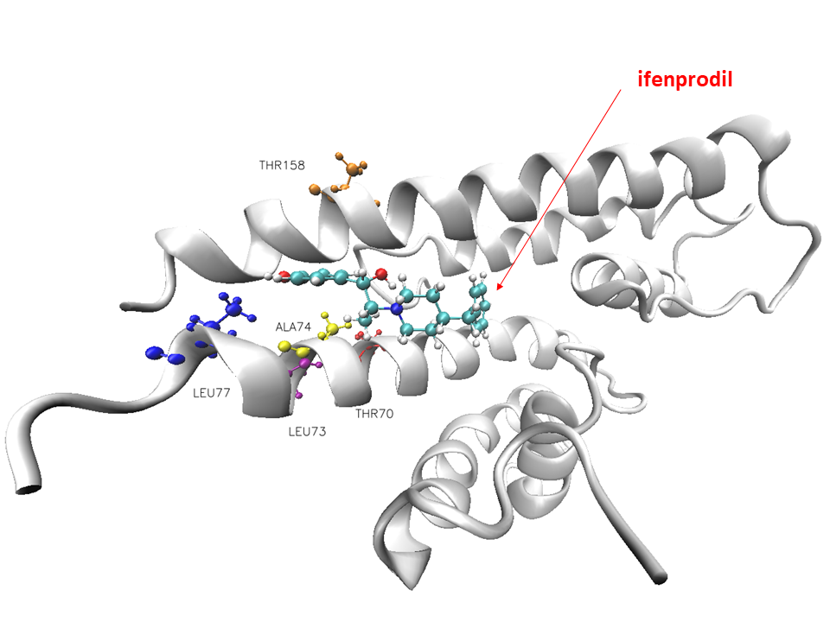
Fig. S10 Visualization of the docking conformation of the NDMA receptor and ifenprodil. The ball-and-stick model shows the binding pocket of five residues in the NDMA receptor with dominant binding contributions to ifenprodil.

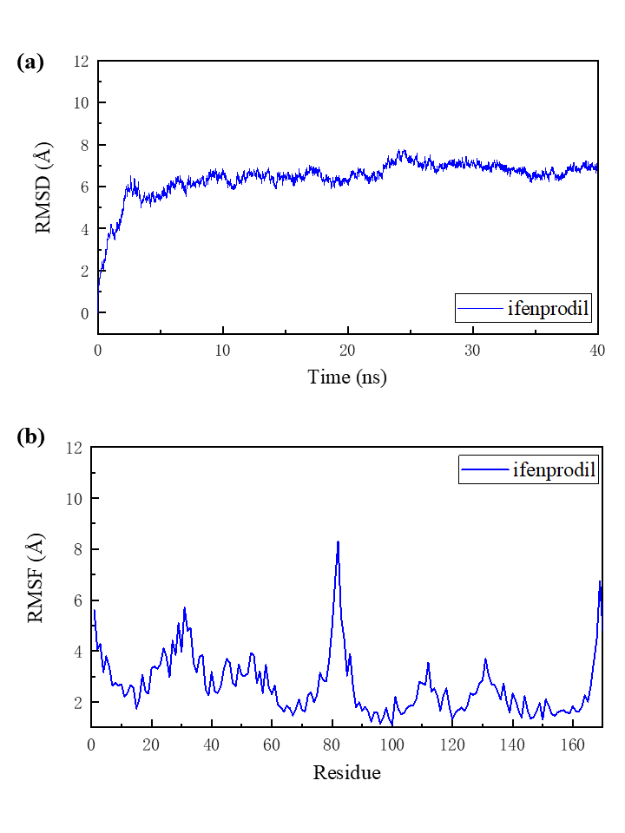
Fig. S11 Root mean square deviation (RMSD) and root mean square fluctuation (RMSF) of ifenprodil and the NDMA receptor complex in a 40-ns simulation MD. (a) The RMSD of all non-hydrogen atoms in the complex. (b) The RMSF of all non-hydrogen atoms in the NDMA receptor throughout the simulation.

Table S6 Binding energy and decomposition of top 10 residues with dominant binding contributions of the NDMA receptor to ifenprodil, including van der Waals energy (vdW), electrostatic energy (Ele), polar solvation energy (Polar) and non-polar solvation energy (Non-polar).
Residue | TOTAL | van der Waals | Electrostatic | Polar Solvation | Non-Polar Solv.
Leu77 | 1.687922 | -1.54449 | -0.2605 | 0.427807 | -0.31074
Thr70 | 1.583291 | -1.2928 | -0.07637 | -0.06165 | -0.15246
Thr158 | 1.410215 | -1.59881 | -0.00882 | 0.402392 | -0.20498
Leu 73 | 1.375455 | -1.14104 | 0.062973 | -0.14098 | -0.15641
Ala74 | 0.991262 | -1.04664 | -0.01878 | 0.163475 | -0.08931
Ala 162 | 0.933872 | -0.83479 | -0.24005 | 0.309635 | -0.16867
Val 154 | 0.717936 | -0.64291 | 0.175276 | -0.17372 | -0.07658
Leu 165 | 0.684936 | -0.39705 | -0.56417 | 0.302684 | -0.0264
Leu 161 | 0.64939 | -0.49321 | -0.06996 | -0.06838 | -0.01785
Met 151 | 0.635817 | -0.63292 | -0.11679 | 0.241465 | -0.12757

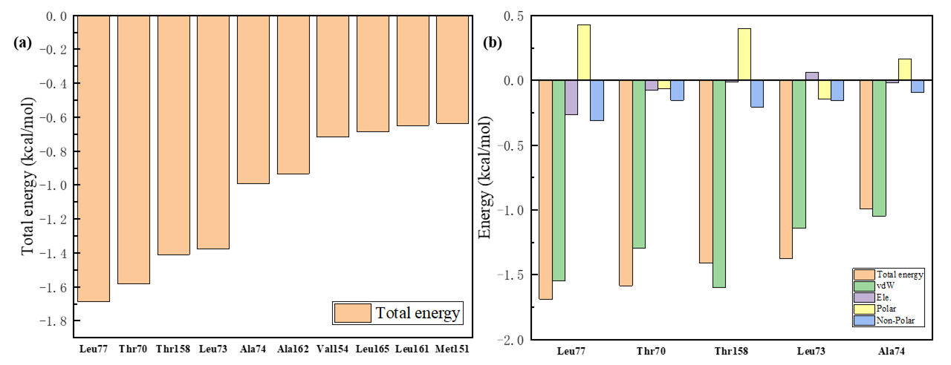
Fig. S12 Decomposition of the free energy of binding of key residues. (a) The 10 key residues with dominant binding contributions from the NDMA receptor to ifenprodil. (b) Decomposition of the energy of the five key residues and ifenprodil pairs into four energy terms, namely van der Waals interaction (vdW), electrostatic interaction (ele), polar solvation energy (polar), and nonpolar energy (nonpolar).

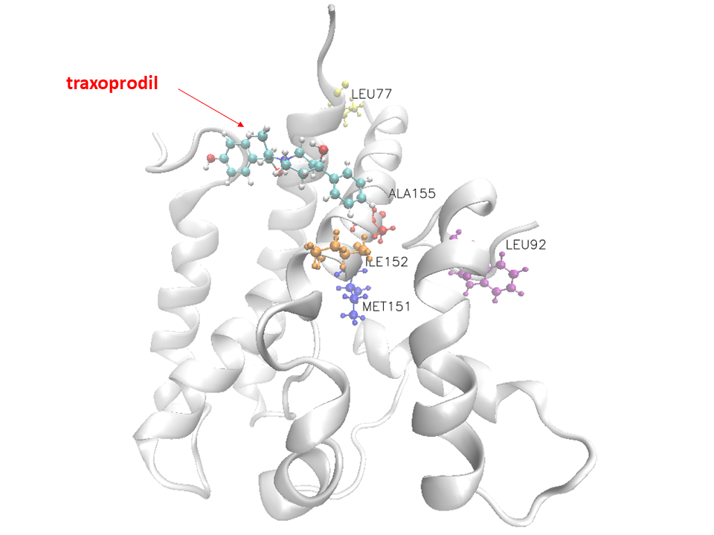
Fig. S13 Visualization of the docking conformation of the NDMA receptor and traxprodil. The ball-and-stick model shows the binding pocket of five residues in the NDMA receptor with dominant binding contributions to traxprodil.

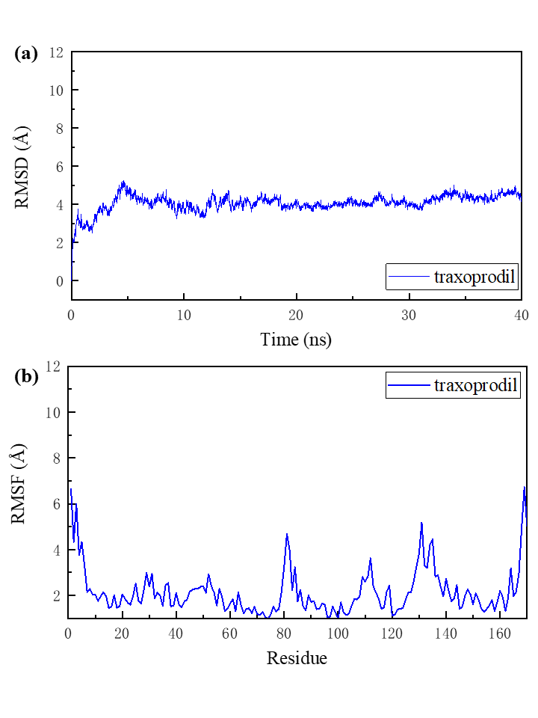
Fig. S14 Root mean square deviation (RMSD) and root mean square fluctuation (RMSF) of traxprodil and the NDMA receptor complex in a 40-ns simulation MD. (a) The RMSD of all non-hydrogen atoms in the complex. (b) The RMSF of all non-hydrogen atoms in the NDMA receptor throughout the simulation.

Table S7 Binding energy and decomposition of top 10 residues with dominant binding contributions of the NDMA receptor to traxprodil, including van der Waals energy (vdW), electrostatic energy (Ele), polar solvation energy (Polar) and non-polar solvation energy (Non-polar).
Residue | TOTAL | van der Waals | Electrostatic | Polar Solvation | Non-Polar Solv.
IleLE 152 | 1.574005 | -1.47964 | 0.002555 | 0.161645 | -0.25856
Ala 155 | 1.50332 | -1.23123 | -0.23519 | 0.128362 | -0.16526
Leu77 | 1.178284 | -1.27187 | -0.18614 | 0.51792 | -0.23819
Leu92 | 0.85404 | -0.7672 | -0.01114 | 0.096595 | -0.17229
Met 151 | 0.826756 | -0.8536 | -0.00697 | 0.186957 | -0.15314
Met4 | 0.632208 | -0.50579 | -0.28928 | 0.237581 | -0.07472
Pro6 | 0.607193 | -0.59218 | -0.30466 | 0.362017 | -0.07237
Ala 159 | 0.572672 | -0.54884 | -0.03852 | 0.099731 | -0.08504
Phe76 | 0.528461 | -0.63222 | -0.0879 | 0.311136 | -0.11948
Leu73 | 0.515525 | -0.46042 | -0.04371 | 0.037983 | -0.04938

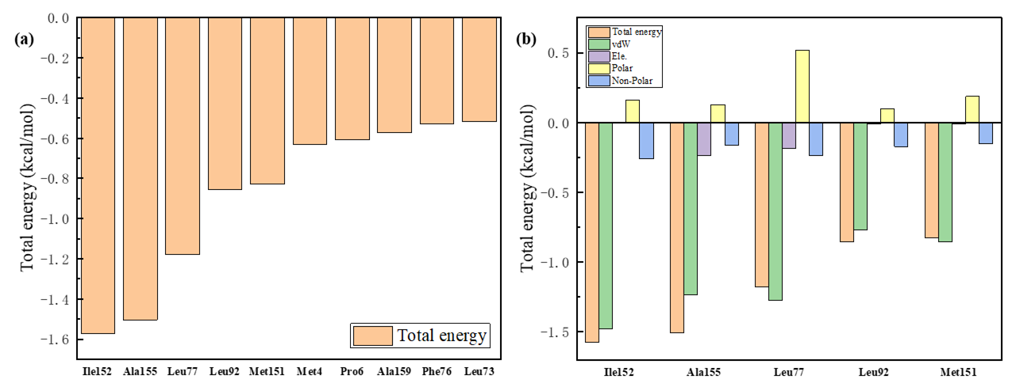
Fig. S15 Decomposition of the free energy of binding of key residues. (a) The 10 key residues with dominant binding contributions from the NDMA receptor to traxprodil. (b) Decomposition of the energy of the five key residues and traxprodil pairs into four energy terms, namely van der Waals interaction (vdW), electrostatic interaction (ele), polar solvation energy (polar), and nonpolar energy (nonpolar).

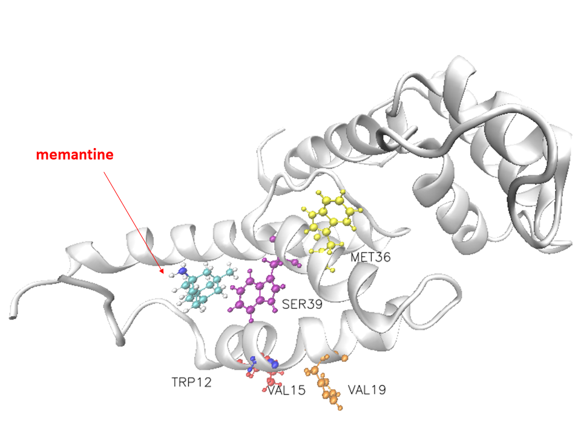
Fig. S16 Visualization of the docking conformation of the NDMA receptor and memantine. The ball-and-stick model shows the binding pocket of five residues in the NDMA receptor with dominant binding contributions to memantine.

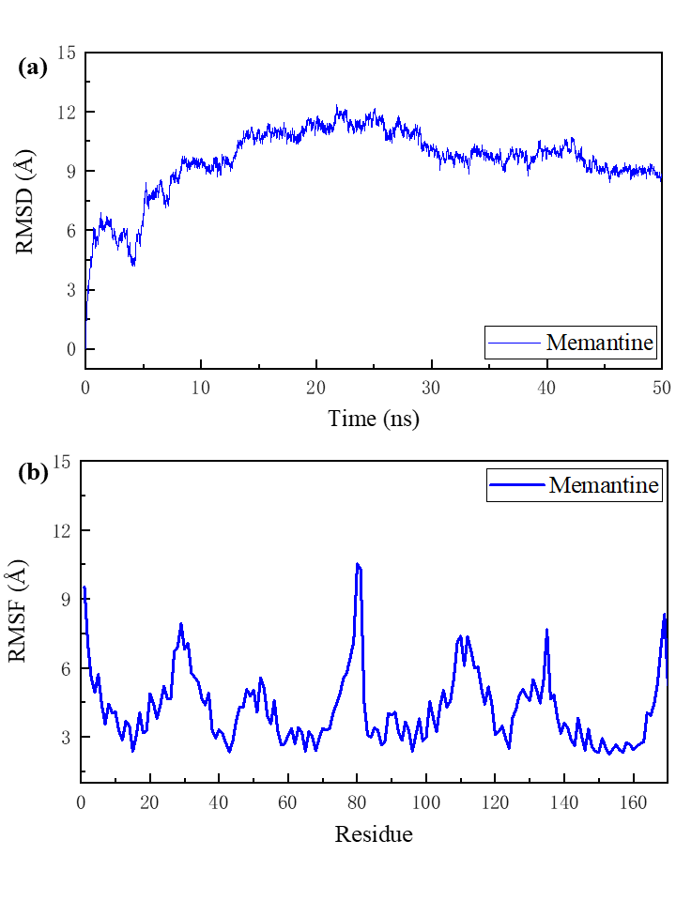
Fig. S17 Root mean square deviation (RMSD) and root mean square fluctuation (RMSF) of memantine and the NDMA receptor complex in a 50-ns simulation MD. (a) The RMSD of all non-hydrogen atoms in the complex. (b) The RMSF of all non-hydrogen atoms in the NDMA receptor throughout the simulation.

Table S8 Binding energy and decomposition of top 10 residues with dominant binding contributions of the NDMA receptor to memantine, including van der Waals energy (vdW), electrostatic energy (Ele), polar solvation energy (Polar) and non-polar solvation energy (Non-polar)
Residue | TOTAL | van der Waals | Electrostatic | Polar Solvation | Non-Polar Solv.
Met36 | -1.22973 | -1.32584 | -0.12447 | 0.452622 | -0.23204
Val15 | -1.1356 | -0.98899 | 0.04405 | -0.12713 | -0.06353
Trp12 | -0.95294 | -1.6389 | -0.16025 | 1.02093 | -0.17472
Val19 | -0.93217 | -0.7985 | 0.014264 | -0.05241 | -0.09551
Trp40 | -0.91198 | -1.61507 | -0.19885 | 1.071532 | -0.16959
Gly16 | -0.67071 | -0.69202 | -0.00529 | 0.159731 | -0.13312
Met4 | -0.64472 | -0.71532 | -0.04542 | 0.267005 | -0.15098
Ser39 | -0.42161 | -0.50578 | 0.012915 | 0.114542 | -0.04329
Leu43 | -0.31954 | -0.30826 | 0.022955 | -0.00696 | -0.02728
Leu13 | -0.23787 | -0.2985 | -0.01988 | 0.110294 | -0.02979

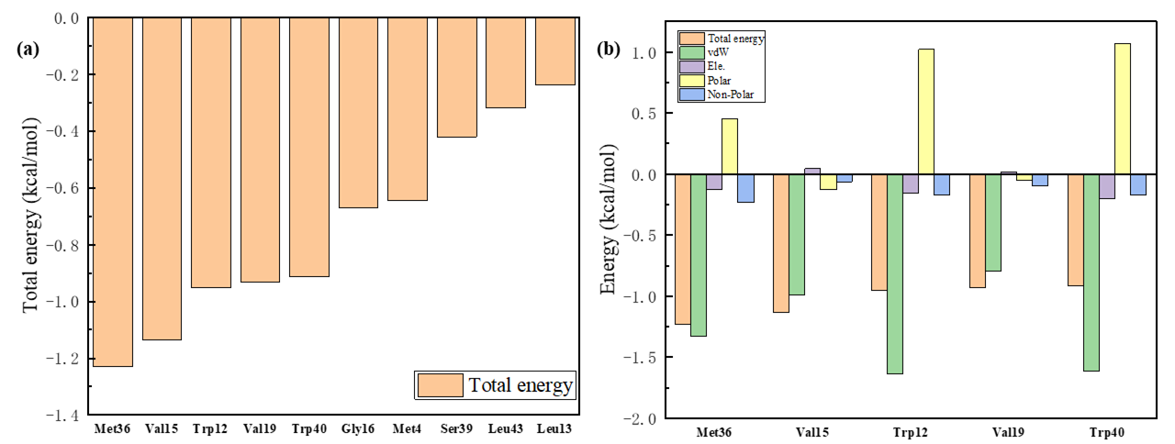
Fig. S18 Decomposition of the free energy of binding of key residues. (a) The 10 key residues with dominant binding contributions from the NDMA receptor to memantine. (b) Decomposition of the energy of the five key residues and memantine pairs into four energy terms, namely van der Waals interaction (vdW), electrostatic interaction (ele), polar solvation energy (polar), and nonpolar energy (nonpolar).

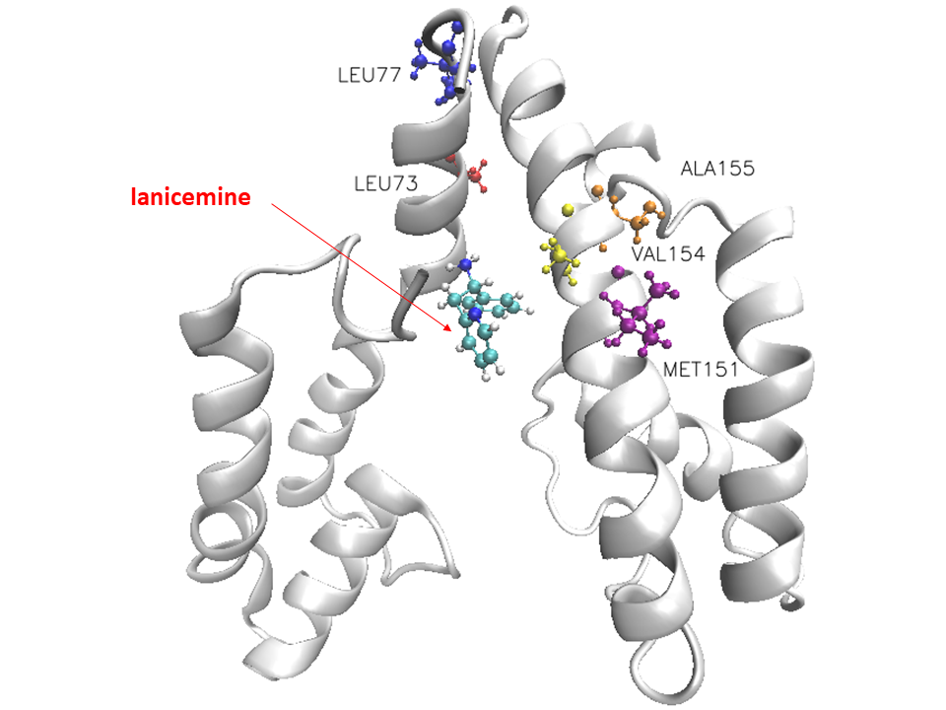
Fig. S19 Visualization of the docking conformation of the NDMA receptor and lanicemine. The ball-and-stick model shows the binding pocket of five residues in the NDMA receptor with dominant binding contributions to lanicemine.

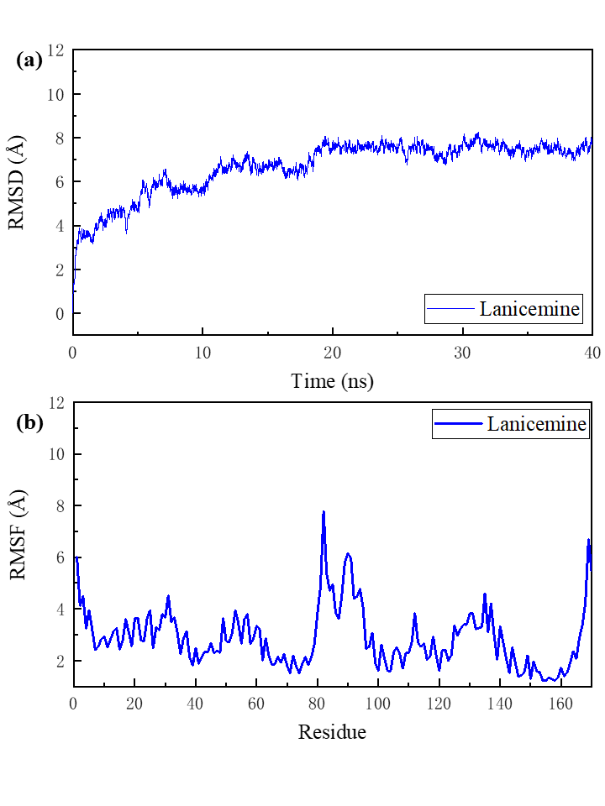
Fig. S20 Root mean square deviation (RMSD) and root mean square fluctuation (RMSF) of lanicemine and the NDMA receptor complex in a 40-ns simulation MD. (a) The RMSD of all non-hydrogen atoms in the complex. (b) The RMSF of all non-hydrogen atoms in the NDMA receptor throughout the simulation.

Table S9 Binding energy and decomposition of top 10 residues with dominant binding contributions of the NDMA receptor to lanicemine, including van der Waals energy (vdW), electrostatic energy (Ele), polar solvation energy (Polar) and non-polar solvation energy (Non-polar).
Residue | Total energy | van der Waals | Electrostatic | Polar Solvation | Non-Polar Solv.
Ala155 | -1.38505 | -1.26383 | -0.24229 | 0.345445 | -0.22439
Leu73 | -0.74935 | -0.66406 | 0.055282 | -0.01769 | -0.12289
Met151 | -0.72665 | -0.75208 | -0.01362 | 0.191402 | -0.15235
Leu77 | -0.70765 | -0.67469 | -0.00131 | 0.137066 | -0.16871
Val154 | -0.67319 | -0.57298 | -0.04368 | 0.009777 | -0.0663
Thr158 | -0.45623 | -0.5595 | -0.13422 | 0.267106 | -0.02961
Ile 152 | -0.44839 | -0.39728 | -0.03973 | 0.052193 | -0.06358
Ala159 | -0.39072 | -0.37716 | -0.01477 | 0.083784 | -0.08258
Phe3 | -0.38615 | -0.46228 | -0.09865 | 0.280917 | -0.10614
Thr70 | -0.19303 | -0.28424 | -0.07625 | 0.191146 | -0.02369

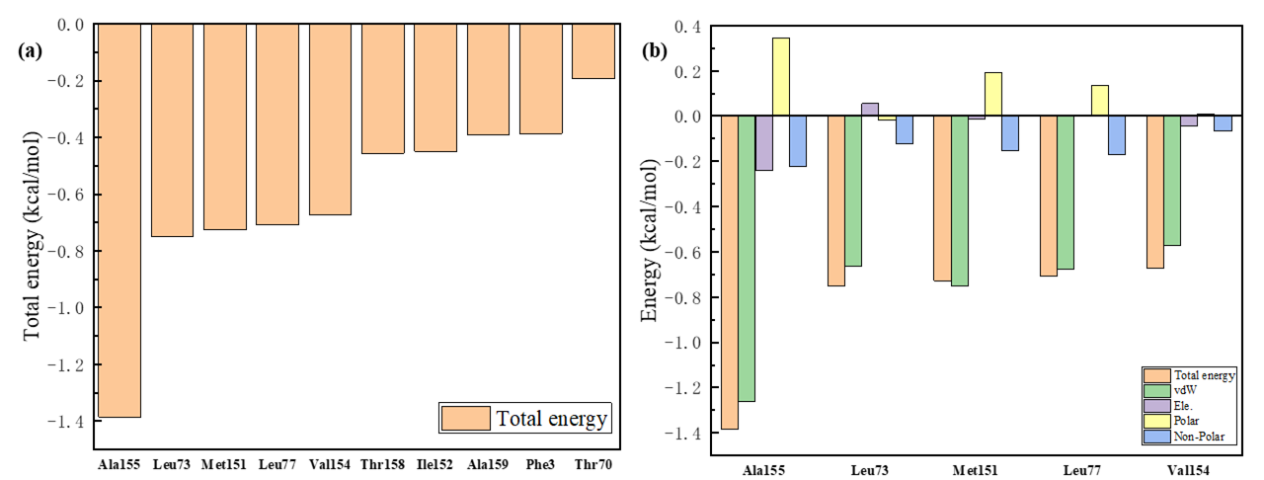
Fig. S21 Decomposition of the free energy of binding of key residues. (a) The 10 key residues with dominant binding contributions from the NDMA receptors to lanicemine. (b) Decomposition of the energy of the five key residues and lanicemine pairs into four energy terms, namely van der Waals interaction (vdW), electrostatic interaction (ele), polar solvation energy (polar), and nonpolar energy (nonpolar).

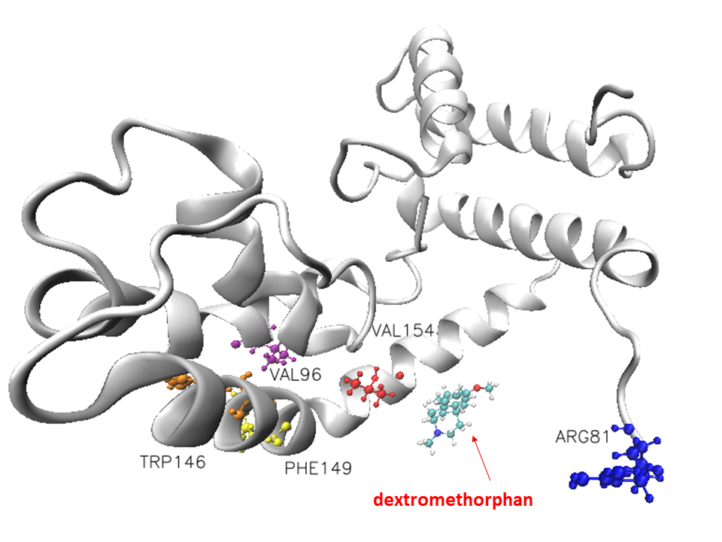
Fig. S22 Visualization of the docking conformation of the NDMA receptor and dextromethorphan. The ball-and-stick model shows the binding pocket of five residues in the NDMA receptor with dominant binding contributions to dextromethorphan.

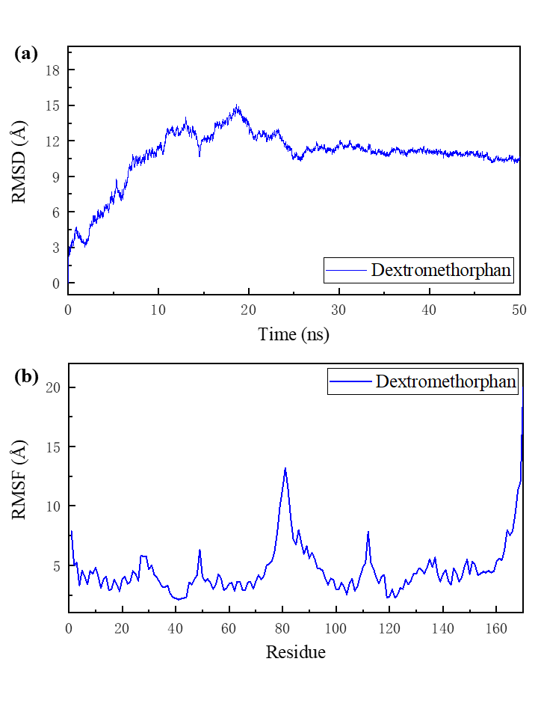
Fig. S23 Root mean square deviation (RMSD) and root mean square fluctuation (RMSF) of dextromethorphan and the NDMA receptor complex in a 50-ns simulation MD. (a) The RMSD of all non-hydrogen atoms in the complex. (b) The RMSF of all non-hydrogen atoms in the NDMA receptor throughout the simulation.

Table S10 Binding energy and decomposition of top 10 residues with dominant binding contributions of NDMA receptor to dextromethorphan, including van der Waals energy (vdW), electrostatic energy (Ele), polar solvation energy (Polar) and non-polar solvation energy (Non-polar).
Residue | TOTAL | van der Waals | Electrostatic | Polar Solvation | Non-Polar Solv.
Val96 | -0.5848 | -0.51287 | -0.01389 | 0.03004 | -0.08808
Phe149 | -0.54639 | -0.74609 | 0.029353 | 0.311368 | -0.14101
Trp146 | -0.34524 | -0.61197 | -0.03936 | 0.387806 | -0.08171
Arg81 | -0.34509 | -0.57003 | -0.23569 | 0.556045 | -0.09541
Val154 | -0.26438 | -0.24528 | -0.02877 | 0.041169 | -0.0315
Ser99 | -0.25508 | -0.31555 | -0.16573 | 0.298333 | -0.07213
Val100 | -0.20423 | -0.20154 | -0.00052 | 0.012124 | -0.0143
Ile153 | -0.17272 | -0.14407 | -0.02008 | 0.001572 | -0.01013
Val103 | -0.15839 | -0.13281 | -0.00159 | -0.00228 | -0.02172
Leu77 | -0.15532 | -0.15283 | 0.003647 | 0.022507 | -0.02864

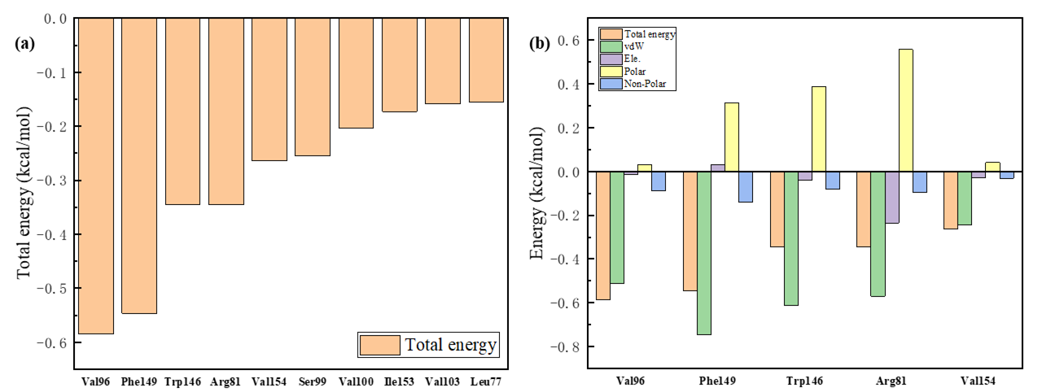
Fig. S24 Decomposition of the free energy of binding of key residues. (a) The 10 key residues with dominant binding contributions from the NDMA receptor to dextromethorphan. (b) Decomposition of the energy of the five key residues and dextromethorphan pairs into four energy terms, namely van der Waals interaction (vdW), electrostatic interaction (ele), polar solvation energy (polar), and nonpolar energy (nonpolar).

Table S11 2D structures and chemical formulas of eight selected drugs.
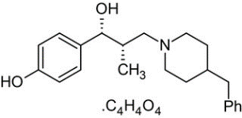 | 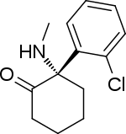 | 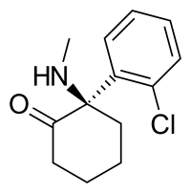 | 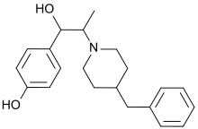
Ro 25-6981 | s-ketamine | r-ketamine | ifenprodil
C₂₂H₂₉NO₂ | C₁₃H₁₆ClNO | C₁₃H₁₇Cl₂NO | C₂₁H₂₇NO₂
CID: 6604887 | CID: 182137 | CID: 9838417 | CID: 3689
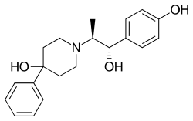 | 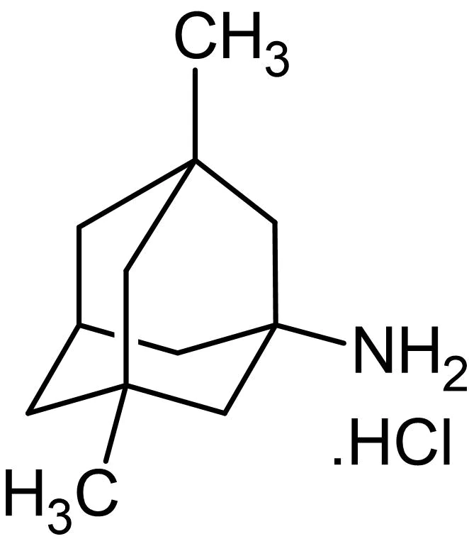 | 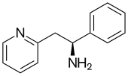 | 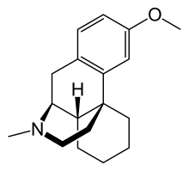
traxoprodil | memantine | lanicemine | dextromethorphan
C₂₀H₂₅NO₃ | C₁₂H₂₁N | C₁₃H₁₄N₂ | C₁₈H₂₅NO
CID: 219101 | CID:4054 | CID:9794203 | CID: 5360696

