Supplementary figure 1 the original western blot of figure 4D
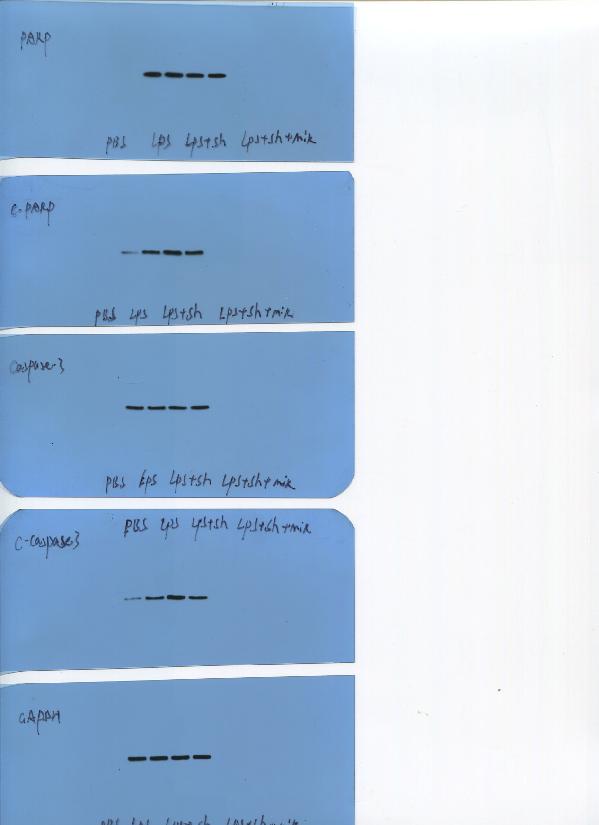

Supplementary figure 2 the original western blot of figure 5C
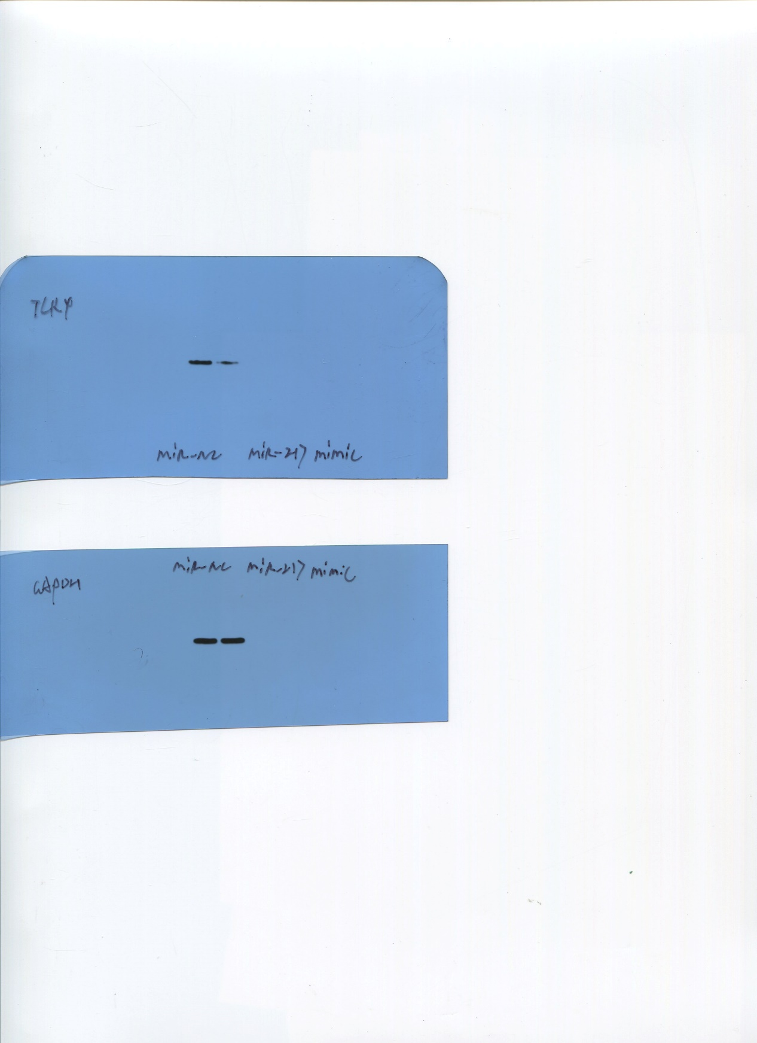

Supplementary figure 3 the original western blot of figure 5D

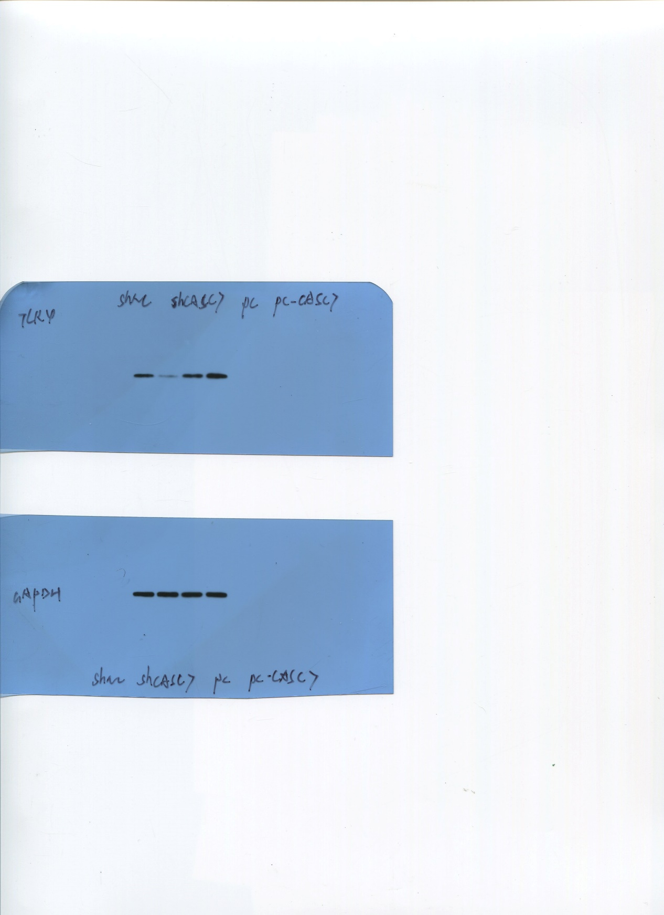

Supplementary figure 4 the original western blot of figure 5E
