Novel Fe hydrides and magnetism in the Fe-H system at high pressures
I. Kupenko^{1,*}, E. Bykova^{2,3}, D.M. Vasiukov^{4,5}, G. Aprilis⁴, V. Cerantola⁶, A.I. Chumakov⁶, J. Jacobs⁶, M. Bykov³, E. Koemets³, S. Chariton³, C. Sanchez-Valle¹ and L. Dubrovinsky³
¹Institut für Mineralogie, University of Münster, Corrensstr. 24, 48149 Münster, Germany
²Photon Science, Deutsches Elektronen-Synchrotron, Notkestrasse 85, 22607, Hamburg, Germany
³Bayerisches Geoinstitut, University of Bayreuth, D-95440, Bayreuth, Germany
⁴Material Physics and Technology at Extreme Conditions, Laboratory of Crystallography, University of Bayreuth, D-95440 Bayreuth, Germany
⁵Synchrotron Radiation Research, Lund University, Box 118, S-221 00 Lund, Sweden,
⁶ESRF-The European Synchrotron, CS 40220, 38043, Grenoble, Cedex 9, France

*Corresponding author: kupenko@uni-muenster.de

Supplementary data
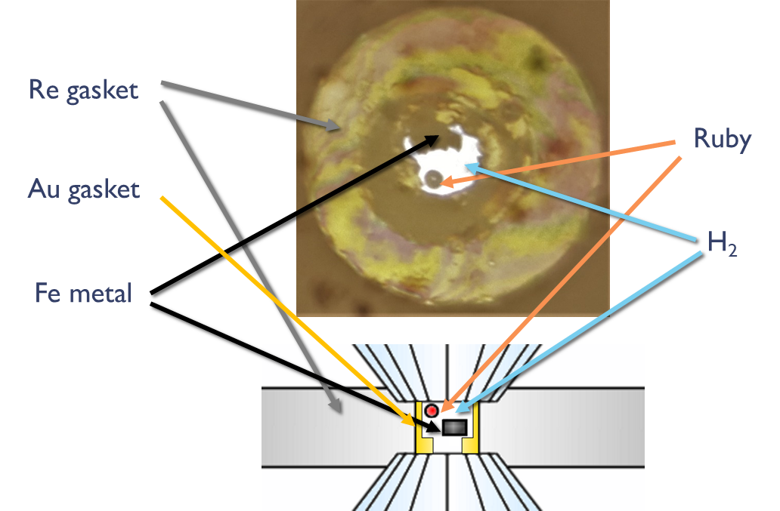
Figure S1. Photo and scheme of a typical loading.
Fig. S2. Unrolled diffraction patterns of monoclinic Fe₂H_{∼3} with C2/m space group at 65.1(2) GPa (a) and hcp-FeH at 49.0(6) GPa and room temperature. Diamond peaks and detector glitches are masked. A clear peak splitting (e.g. indicated by red ellipses) in the C2/m phase can be observed.
Fig S3. SMS spectrum of Fe₂H_{∼3} at 63.2(1.4) GPa and ca. 1000 K. Solid lines show the theoretical fit, the percentage bar indicates the relative absorptions, and the residuals of the fit are indicated below the spectrum. Light-red nonmagnetic components are from the beamline optics.
Fig S4. SMS spectrum of amorphous Fe-H at 10.2(5) GPa and room temperature. The spectrum can be fitted by the single magnetic contribution with the hyperfine parameters similar to that of dhcp-FeH (Fig. 4a, table S1). Solid lines show the theoretical fit, the percentage bar indicates the relative absorptions, and the residuals of the fit are indicated below the spectrum. Light-red nonmagnetic components are from the beamline optics. A significant decrease in the relative absorption is likely related to the decrease of the Lamb-Mössbauer factor in the amorphous material.

Supplementary Table 1. Hyperfine parameters of iron hydrides.
dhcp-FeH
P, GPa | H-site |  |  |  | C-site |  |  |  | Nonmagnetic component
P, GPa | CS | QS | Bfh | Relative weight | CS | QS | Bfh | Relative weight | CS | Relative weight
6.05(7) | 0.423(8) | -0.022(15) | 30.70(7) | 56(2) | 0.419(8) | 0.043(15) | 27.23(7) | 44(2)
12.1(4) | 0.39(1) | -0.03(2) | 29.57(10) | 50(3) | 0.386(9) | 0.036(17) | 26.03(8) | 50(3)
17.4(6) | 0.36(1) | -0.02(3) | 28.03(14) | 46(4) | 0.356(11) | 0.04(2) | 24.64(11) | 53(4) | 0.34(14) | 1(1)
23.0(1.3) | 0.353(8) | 0.00(2) | 25.62(10) | 54(5) | 0.34(2) | 0.05(4) | 22.6(3) | 40(5) | 0.26(4) | 6(2)
24.6(1.8) | 0.35(1) | -0.03(2) | 25.30(12) | 48(4) | 0.34(1) | 0.046(18) | 22.01(11) | 45(4) | 0.31(4) | 7(2)
28(4) | 0.32(1) | 0.00(2) | 23.74(16) | 53(6) | 0.311(12) | 0.02(7) | 19.4(5) | 27(7) | 0.288(12) | 20(3)
36.4(1.3) | 0.3(1) | 0.11* | 18.5(8) | 37(4) |  |  |  |  | 0.270(13) | 63(4)
40.98(11) | 0.29(4) | 0.11(7) | 18.4(3) | 32(3) |  |  |  |  | 0.244(13) | 68(3)
46.8(5) | 0.2(1) | 0.11(15) | 10.7(8) | 26(5) |  |  |  |  | 0.235(12) | 74(5)
61.2(1.4) |  |  |  |  |  |  |  |  | 0.190(5) | 100
fcc-FeH |  |  |  |  |  |  |  |  | CS | Relative weight
63.2(1.4) |  |  |  |  |  |  |  |  | 0.21(3) | 100
Fe₂H_{∼3}
P, GPa | Magnetic component |  |  |  |  |  |  |  | Nonmagnetic component
P, GPa | CS | QS | Bfh | Relative weight |  |  |  |  | CS | Relative weight
63.2(5) | 0.32(3) | 0.03(5) | 21.1(2) | 68(2) |  |  |  |  | 0.16(2) | 32(2)
63.2(5)  1000(100) K | 0.17(9) | -0.25(17) | 22.6(7) | 65(inf) |  |  |  |  | 0.23(inf) | 35(inf)
hcp-FeH
P, GPa | Magnetic component |  |  |  |  |  |  |  | Nonmagnetic component
P, GPa | CS | QS | Bfh | Relative weight |  |  |  |  | CS | Relative weight
52.3(5) | 0.22(5) | 0.02(9) | 13.3(4) | 56(5) |  |  |  |  | 0.22(3) | 44(5)
43.7(7) | 0.229(18) | 0.00(3) | 16.64(14) | 68(2) |  |  |  |  | 0.26(2) | 32(2)
31.2(5) | 0.33(4) | 0* | 22.2(4) | 76(5) |  |  |  |  | 0.24(8) | 24(5)
Amorphous
P, GPa | Magnetic component
P, GPa | CS | QS | Bfh | Relative weight
10.2(5) | 0.39(7) | 0* | 26.5(6) | 100

Supplementary Table 2. Unit cell parameters of the hcp-FeH and Fe₂H_{∼3}.
Fe₂H_{∼3}
P, GPa | a, Å | b, Å | c, Å | β, ° | c/b
65.1(2) | 4.4995(5) | 2.5574(3) | 4.0819(7) | 90.956(11) | 1.596
62.7(2) | 4.5070(4) | 2.5598(2) | 4.0870(6) | 90.960(10) | 1.596
56.3(3) | 4.4564(7) | 2.5412(3) | 4.095(3) | 90.392(10) | 1.611
hcp-FeH
P, GPa | a, Å |  | c, Å |  | c/a
56.7(3) | 2.51165(16) |  | 4.0472(3) |  | 1.611
47.7(6) | 2.52557(13) |  | 4.0781(4) |  | 1.615
49.0(6) | 2.52616(11) |  | 4.0772(5) |  | 1.614
33.1(1) | 2.56507(11) |  | 4.1460(6) |  | 1.616
24.7 (1) | 2.59536(17) |  | 4.1987(7) |  | 1.618

Supplementary Table 3. Parameters of the equation of state obtained by the fit of the experimental data to the Birth-Murnaghan equation of state.
Phase | V₀, Å³ | K₀, GPa | K₀’
Fe hcpª | 11.234 | 165* | 4.97
FeH dhcp^{b} | 13.341 | 193 | 3.54
FeH fcc^{c} | 13.45 | 99 | 11.7
FeH-hcp | 13.74 | 166 | 4*
FeH₂ tetragonal^{b} | 17.177 | 111 | 5.17
a: taken from ref. [50]; b: fitted data from ref. [14]; c: taken from ref. [21].The values marked by the asterisk symbol (*) were fixed during the refinement.

