Additional information
Additional file
Additional file 1: Fig. S1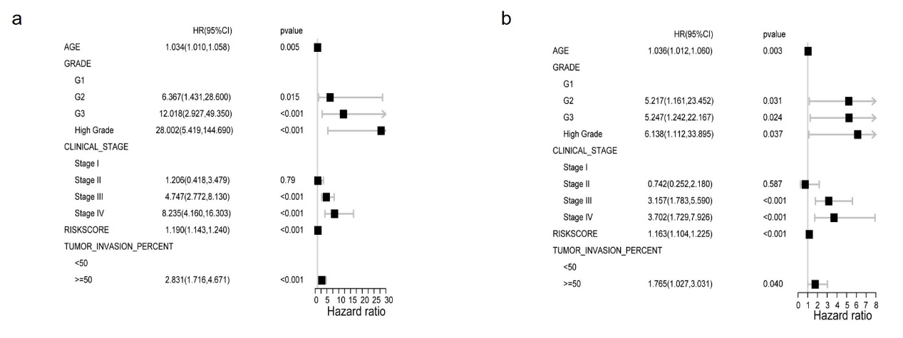
Univariate (a) and multivariate (b) Cox regression analysis of associations between clinical parameters (including risk score) and overall survival of UCEC patients.

