Supporting Information
Comparison of the PSMA target efficiency and in vivo biodistribution among [⁶⁸Ga]ludotadipep, [¹⁸F]DCFPyL, and [⁶⁸Ga]PSMA-11 in a tumor xenograft model

Authors
Min Hwan Kim¹, Kyongkyu Lee¹, Chul Hee Kim¹, Lee Sang Hwon¹, Chansoo Park¹, Hee Seup Kil¹, Yong Jin Lee², Kyo Chul Lee², Dae Yoon Chi*1

Affiliations
1 Research Institute of Radiopharmaceuticals, FutureChem Co., Ltd., Seoul 04793, Republic of Korea
2 Division of Applied RI, Korea Institute of Radiological & Medical Sciences, Seoul 01812, Republic of Korea

*Corresponding author. Email: dychi001@gmail.com

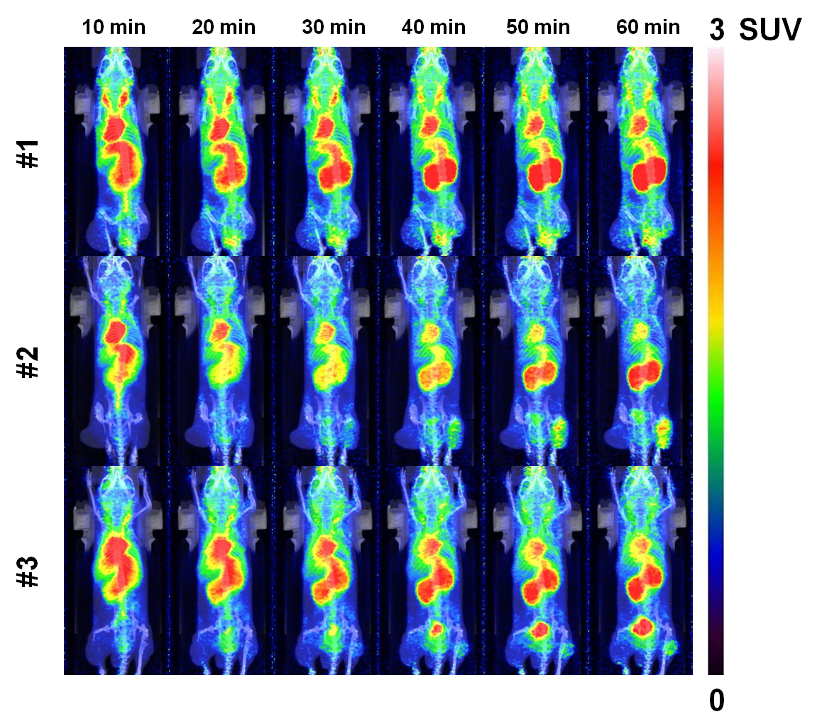
Figure S1. MicroPET/CT imaging of [⁶⁸Ga]ludotadipep in mouse #1~#3

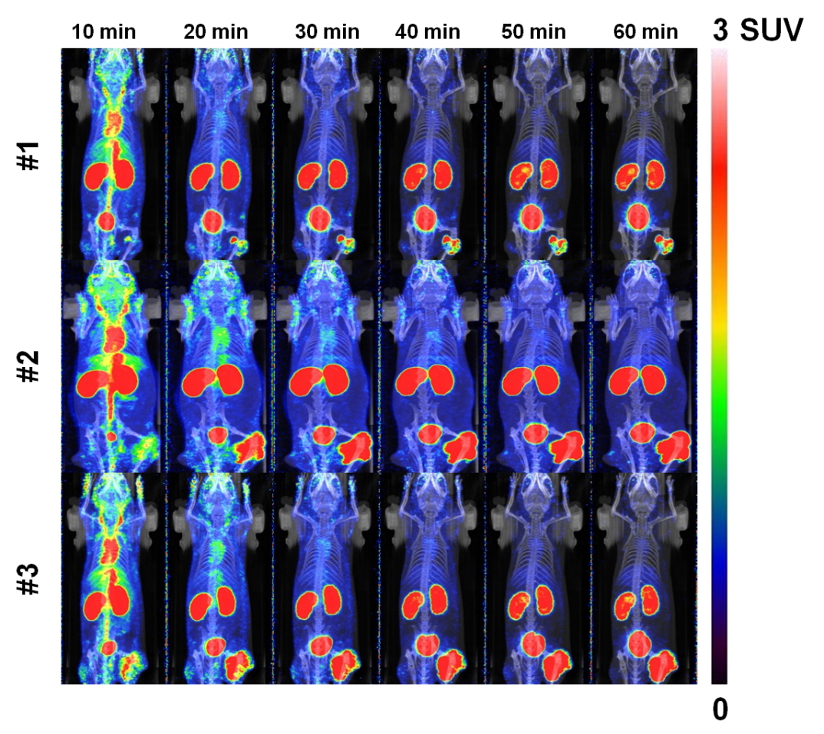
Figure S2. MicroPET/CT imaging of [¹⁸F]DCFPyL in mouse #1~#3

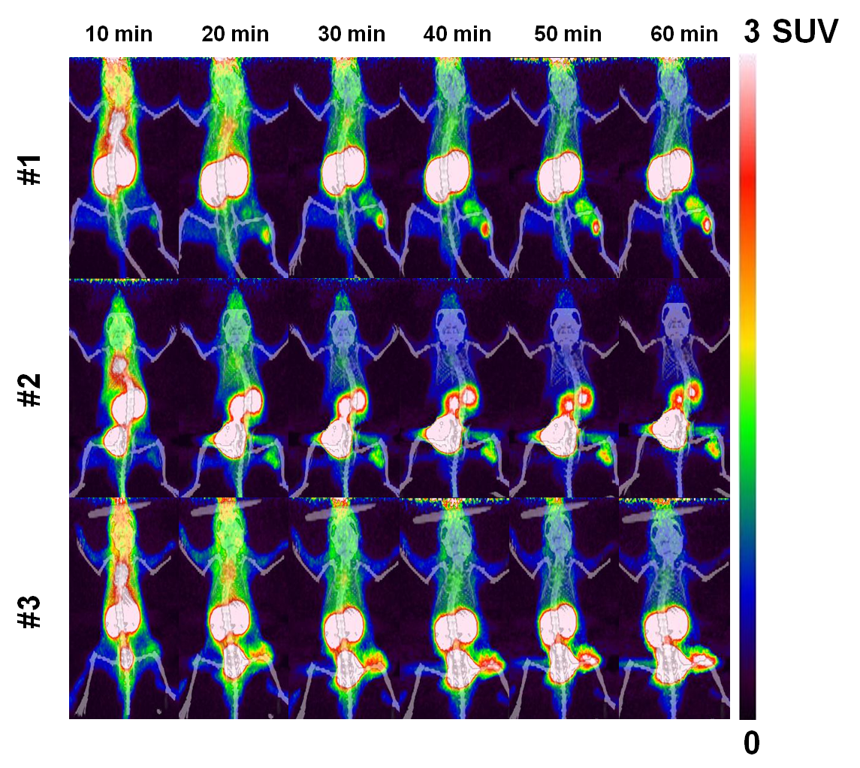
Figure S3. MicroPET/CT imaging of [⁶⁸Ga]PSMA-11 in mouse #1~#3

Table S1. Standard uptake value (SUV) of [⁶⁸Ga]ludotadipep in each organ for 60 min by dynamic microPET/CT imaging (#1-#3)

[⁶⁸Ga]Ludotadipep #1
Time (min) | PIP | flu | Kidney | Liver | Muscle | Heart
10 | 0.57 | 0.27 | 1.58 | 1.44 | 0.43 | 2.23
20 | 0.73 | 0.35 | 1.66 | 1.19 | 0.55 | 1.86
30 | 0.78 | 0.40 | 1.79 | 1.04 | 0.54 | 1.63
40 | 0.82 | 0.46 | 1.96 | 0.97 | 0.51 | 1.55
50 | 0.91 | 0.46 | 2.18 | 0.91 | 0.52 | 1.47
60 | 0.87 | 0.44 | 2.39 | 0.86 | 0.49 | 1.44

[⁶⁸Ga]Ludotadipep #2
Time (min) | PIP | flu | Kidney | Liver | Muscle | Heart
10 | 0.24 | 0.21 | 1.92 | 2.10 | 0.32 | 3.14
20 | 0.53 | 0.34 | 1.71 | 1.75 | 0.46 | 2.29
30 | 0.76 | 0.40 | 1.81 | 1.50 | 0.50 | 2.01
40 | 0.95 | 0.42 | 1.98 | 1.38 | 0.45 | 1.86
50 | 1.19 | 0.45 | 2.20 | 1.29 | 0.48 | 1.68
60 | 1.46 | 0.41 | 2.45 | 1.17 | 0.41 | 1.60

[⁶⁸Ga]Ludotadipep #3
Time (min) | PIP | flu | Kidney | Liver | Muscle | Heart
10 | 0.30 | 0.16 | 2.30 | 1.31 | 0.36 | 3.24
20 | 0.56 | 0.25 | 2.33 | 1.18 | 0.56 | 2.76
30 | 0.65 | 0.29 | 2.31 | 1.04 | 0.61 | 2.39
40 | 0.77 | 0.31 | 2.36 | 1.01 | 0.64 | 2.24
50 | 0.90 | 0.35 | 2.34 | 0.96 | 0.62 | 2.08
60 | 0.96 | 0.38 | 2.29 | 0.96 | 0.58 | 1.96

Table S2. Standard uptake value (SUV) of [¹⁸F]DCFPyL in each organ for 60 min by dynamic microPET/CT imaging (#1-#3)
[¹⁸F]DCFPyL #1
Time (min) | PIP | flu | Kidney | Liver | Muscle | Heart
10 | 0.72 | 0.53 | 5.06 | 1.16 | 0.33 | 1.83
20 | 1.23 | 0.47 | 2.83 | 0.54 | 0.30 | 0.67
30 | 1.47 | 0.39 | 2.26 | 0.45 | 0.21 | 0.41
40 | 1.54 | 0.29 | 1.89 | 0.37 | 0.15 | 0.29
50 | 1.59 | 0.21 | 1.64 | 0.31 | 0.12 | 0.21
60 | 1.78 | 0.13 | 1.52 | 0.31 | 0.07 | 0.14

[¹⁸F]DCFPyL #2
Time (min) | PIP | flu | Kidney | Liver | Muscle | Heart
10 | 0.87 | 0.36 | 6.47 | 1.22 | 0.50 | 2.49
20 | 1.99 | 0.40 | 6.15 | 0.64 | 0.48 | 0.99
30 | 2.83 | 0.31 | 5.60 | 0.54 | 0.40 | 0.72
40 | 3.61 | 0.23 | 4.81 | 0.50 | 0.32 | 0.52
50 | 4.00 | 0.20 | 2.97 | 0.46 | 0.25 | 0.43
60 | 4.40 | 0.20 | 2.55 | 0.41 | 0.20 | 0.34

[¹⁸F]DCFPyL #3
Time (min) | PIP | flu | Kidney | Liver | Muscle | Heart
10 | 1.07 | 0.53 | 6.65 | 1.28 | 0.46 | 2.45
20 | 1.87 | 0.47 | 4.98 | 0.69 | 0.43 | 1.07
30 | 2.37 | 0.36 | 3.71 | 0.53 | 0.31 | 0.72
40 | 2.60 | 0.24 | 3.11 | 0.42 | 0.24 | 0.49
50 | 2.91 | 0.19 | 2.55 | 0.36 | 0.16 | 0.34
60 | 2.95 | 0.14 | 2.41 | 0.31 | 0.12 | 0.24

Table S3. Standard uptake value (SUV) of [⁶⁸Ga]PSMA-11 in each organ for 60 min by dynamic microPET/CT imaging (#1-#3)
[⁶⁸Ga]PSMA-11 #1
Time (min) | PIP | flu | Kidney | Liver | Muscle | Heart
10 | 0.46 | 0.44 | 7.00 | 2.08 | 1.04 | 2.90
20 | 0.75 | 0.51 | 11.24 | 1.23 | 0.83 | 1.49
30 | 0.84 | 0.44 | 13.55 | 1.01 | 0.67 | 1.15
40 | 0.95 | 0.37 | 15.01 | 0.90 | 0.57 | 0.98
50 | 1.02 | 0.33 | 16.26 | 0.84 | 0.50 | 0.83
60 | 1.11 | 0.29 | 17.08 | 0.83 | 0.41 | 0.73

[⁶⁸Ga]PSMA-11 #2
Time (min) | PIP | flu | Kidney | Liver | Muscle | Heart
10 | 0.47 | 0.28 | 5.13 | 1.65 | 0.79 | 2.41
20 | 0.63 | 0.22 | 2.91 | 0.76 | 0.58 | 1.02
30 | 0.64 | 0.15 | 2.23 | 0.54 | 0.41 | 0.70
40 | 0.62 | 0.11 | 1.87 | 0.41 | 0.27 | 0.51
50 | 0.62 | 0.08 | 1.63 | 0.34 | 0.22 | 0.40
60 | 0.63 | 0.07 | 1.45 | 0.29 | 0.16 | 0.33

[⁶⁸Ga]PSMA-11 #3
Time (min) | PIP | flu | Kidney | Liver | Muscle | Heart
10 | 0.62 | 0.18 | 5.08 | 1.90 | 0.72 | 2.76
20 | 0.97 | 0.14 | 5.63 | 1.12 | 0.76 | 1.42
30 | 1.08 | 0.08 | 5.27 | 0.87 | 0.64 | 1.09
40 | 1.16 | 0.06 | 5.30 | 0.72 | 0.54 | 0.89
50 | 1.20 | 0.03 | 5.19 | 0.65 | 0.41 | 0.72
60 | 1.25 | 0.03 | 5.38 | 0.55 | 0.37 | 0.63

