Survival after surgery among patients with cholangiocarcinoma in northeast Thailand according to anatomical and morphological classification

Authors: Chaiwat Thawarungruang^{1,2,6}, Narong Khuntikeo^{2,3}, Nittaya Chamadol^{2,4}, Vallop Laopaiboon⁴, Jaruwan Thuanman^{2,6}, Kavin Thinkhamrop^{2,6,7}, Matthew Kelly⁸, Bandit Thinkhamrop^{2,5,6*}

Affiliations:

¹Epidemiology and Biostatistics Program, Faculty of Public Health, Khon Kaen University, Khon Kaen, Thailand.

²Cholangiocarcinoma Screening and Care Program (CASCAP), Faculty of Medicine, Khon Kaen University, Khon Kaen, Thailand.

³Department of Surgery, Faculty of Medicine, Khon Kaen University, Thailand.

⁴Department of Radiology, Faculty of Medicine, Khon Kaen University, Thailand.

⁵Epidemiology and Biostatistics Section, Faculty of Public Health, Khon Kaen University, Thailand.

⁶Data Management and Statistical Analysis Center (DAMASAC), Faculty of Public Health, Khon Kaen University, Thailand.
⁷Health and Epidemiology Geoinformatics Research (HEGER), Faculty of Public Health, Khon Kaen University, Thailand.
⁸Department of Global Health, Research School of Population Health, Australian National University, Canberra, Australia.

Correspondence and requests for materials should be addressed to B.T. (e-mail: bandit@kku.ac.th)

Supplementary Table
Table S1. Incidence rate and median survival time of cholangiocarcinoma patients according to anatomical classification, combination of anatomical and morphological classification separated by stage of cholangiocarcinoma
Stage of CCA | Number | Person-months | IR per 100 | Median time | 95% CI
Early stage
Overall | 259 | 8,118 | 1.4 | 60.1 | 49.5-70.8
Anatomical classification
ICCA | 150 | 4,789 | 1.3 | 63.4 | 51.4-75.4
PCCA | 82 | 2,560 | 1.3 | 53.3 | 38.0-68.6
DCCA | 27 | 769 | 2.0 | 32.0 | 12.5-51.4
Combination of anatomical and morphological classification
ICM | 80 | 2,438 | 1.6 | 52.6 | 35.4-69.9
ICP | 23 | 755 | 1.1 | - | -
ICI | 44 | 1,497 | 1.0 | 63.4 | 48.4-70.1
ICMIX | 3 | 98 | 0.0 | - | -
PCM | 5 | 123 | 2.4 | 42.6 | 28.5-56.6
PCP | 44 | 1,351 | 1.5 | 44.1 | 30.2-58.0
PCI | 30 | 1,008 | 1.1 | 60.1 | 55.4-64.9
PCMIX | 3 | 78 | 0.0 | - | -
DCM | 8 | 114 | 4.4 | 5.4 | 11.2-22.0
DCP | 11 | 416 | 1.2 | - | -
DCI | 8 | 238 | 2.1 | 26.7 | 00.2-53.2
Late stage
Overall | 487 | 7,526 | 5.4 | 11.4 | 09.8-12.9
Anatomical classification
ICCA | 222 | 2,925 | 6.5 | 8.4 | 06.2-10.6
PCCA | 212 | 3,505 | 5.1 | 14.1 | 11.0-17.2
DCCA | 53 | 1,096 | 3.2 | 20.6 | 11.6-29.5
Combination of anatomical and morphological classification
ICM | 158 | 1,935 | 7.3 | 8.1 | 05.7-10.4
ICP | 24 | 406 | 4.7 | 12.2 | 03.5-27.9
ICI | 26 | 388 | 5.4 | 8.9 | 00.6-18.5
ICMIX | 14 | 196 | 4.6 | 7.5 | 03.9-11.0
PCM | 53 | 867 | 5.1 | 14.8 | 07.0-22.5
PCP | 109 | 1,722 | 5.7 | 10.7 | 05.8-15.6
PCI | 21 | 389 | 3.9 | 13.9 | 06.2-21.7
PCMIX | 29 | 527 | 4.0 | 16.9 | 06.5-27.3
DCM | 24 | 561 | 2.7 | 23.4 | 19.6-27.2
DCP | 23 | 404 | 4.0 | 12.4 | 06.5-18.2
DCI | 6 | 131 | 3.0 | 11.3 | 03.6-19.1
CCA: Cholangiocarcinoma; ICCA: Intrahepatic CCA; PCCA: Perihilar CCA; DCCA: Distal CCA; ICM: ICCA+Mass-forming; ICP: ICCA+Periductal-infiltrating; ICI: ICCA+Intraductal; ICMIX: ICCA+Mix morphological; PCM: PCCA+Mass-forming; PCP: PCCA+Periductal-infiltrating; PCI: PCCA+Intraductal; PCMIX: PCCA+Mix morphological; DCM: DCCA+Mass-forming; DCP: DCCA+Periductal-infiltrating; DCI: DCCA+Intraductal; IR: Incidence rate; CI: Confidence interval.

Supplementary Figure

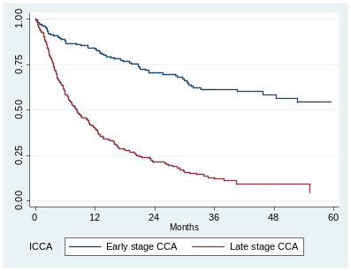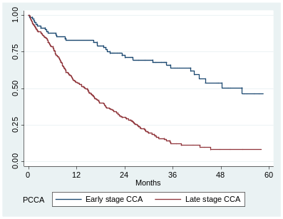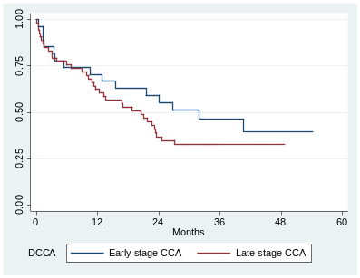
C
B
A

Figure S1. Kaplan-Meier survival estimates of cholangiocarcinoma for anatomical classification separated by stage of cholangiocarcinoma. A Intrahepatic cholangiocarcinoma. B Perihilar cholangiocarcinoma. C Distal cholangiocarcinoma. CCA: Cholangiocarcinoma; ICCA: Intrahepatic CCA; PCCA: Perihilar CCA; DCCA: Distal CCA.

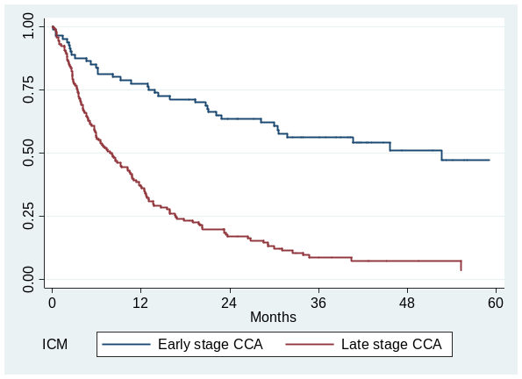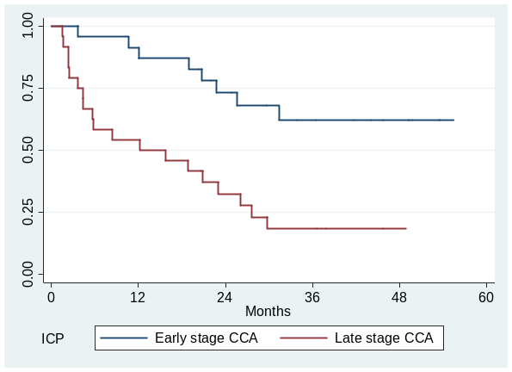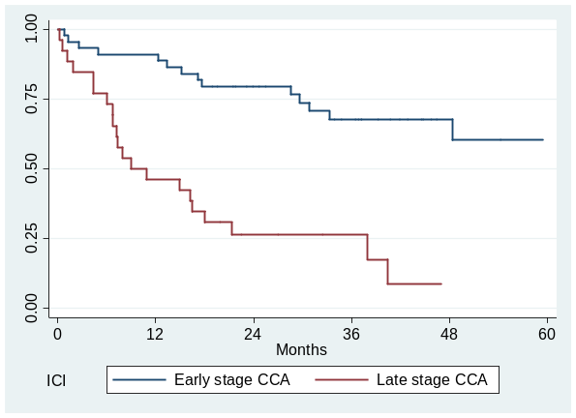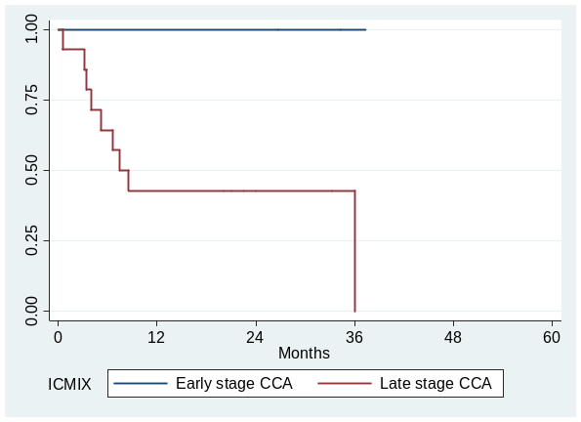
D
C
B
A

Figure S2. Kaplan-Meier survival estimates of intrahepatic cholangiocarcinoma classify by morphologically for early and late stage. A Mass-forming. B Periductal-infiltrating. C Intraductal. D Mix morphological. CCA: Cholangiocarcinoma; ICM: Intrahepatic+Mass-forming; ICP: Intrahepatic+Periductal-infiltrating; ICI: Intrahepatic+Intraductal; ICMIX: Intrahepatic+Mix morphological.
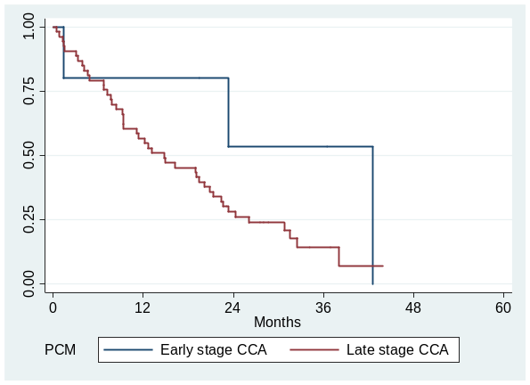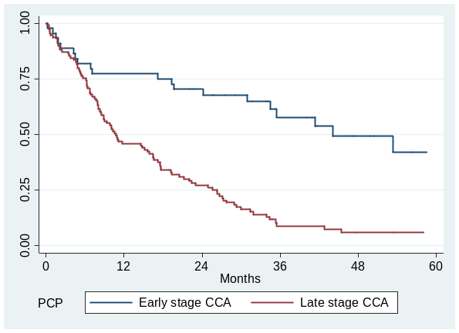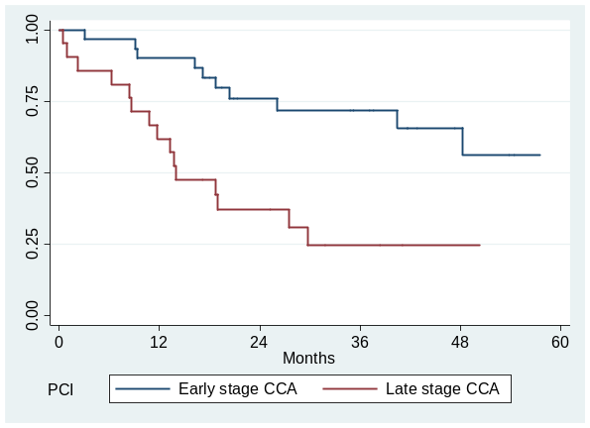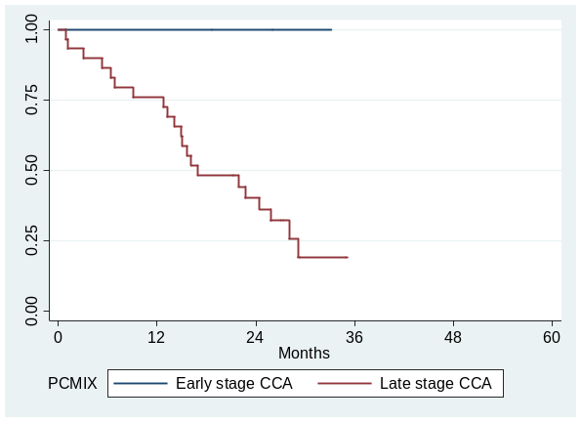
D
C
B
A

Figure S3. Kaplan-Meier survival estimates of perihilar cholangiocarcinoma classify by morphologically for early and late stage. A Mass-forming. B Periductal-infiltrating. C Intraductal. D Mix morphological. CCA: Cholangiocarcinoma; PCM: Perihilar+Mass-forming; PCP: Perihilar+Periductal-infiltrating; PCI: Perihilar+Intraductal; PCMIX: Perihilar+Mix morphological.

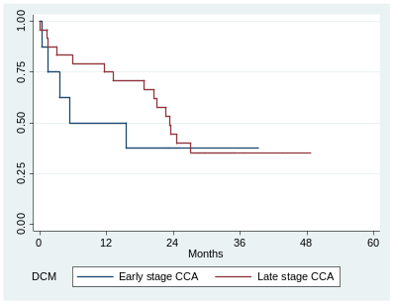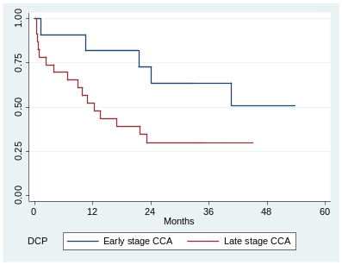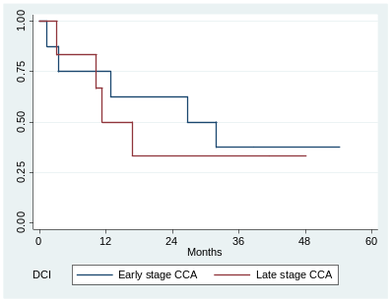
C
B
A

Figure S4. Kaplan-Meier survival estimates of distal cholangiocarcinoma classify by morphologically for early and late stage. A Mass-forming. B Periductal-infiltrating. C Intraductal. CCA: Cholangiocarcinoma; DCM: Distal+Mass-forming; DCP: Distal+Periductal-infiltrating; DCI: Distal+Intraductal.

Anatomical classification | Survival rate |  |  |  | 95% CI
Early stage
1-year
Overall | 82.2 |  |  |  |  |  | 77.0-86.4
ICCA | 84.0 |  |  |  |  |  | 77.1-89.0
PCCA | 82.9 |  |  |  |  |  | 72.9-89.5
DCCA | 70.4 |  |  |  |  |  | 49.4-83.9
3-year
Overall | 60.6 |  |  |  |  |  | 54.1-66.6
ICCA | 61.3 |  |  |  |  |  | 52.6-68.9
PCCA | 64.1 |  |  |  |  |  | 51.8-74.0
DCCA | 46.4 |  |  |  |  |  | 26.6-64.1
5-year
Overall | 50.6 |  |  |  |  |  | 42.8-58.0
ICCA | 54.2 |  |  |  |  |  | 43.9-63.4
PCCA | 46.7 |  |  |  |  |  | 31.5-60.5
DCCA | 39.8 |  |  |  |  |  | 19.9-59.1
 |  | 0 30 60 90
Late stage
1-year
Overall | 48.7 |  |  |  |  |  | 44.2-53.0
ICCA | 40.1 |  |  |  |  |  | 33.6-46.5
PCCA | 54.3 |  |  |  |  |  | 47.3-60.7
DCCA | 62.3 |  |  |  |  |  | 47.8-73.8
3-year
Overall | 14.7 |  |  |  |  |  | 11.4-18.4
ICCA | 12.2 |  |  |  |  |  | 07.9-17.5
PCCA | 12.3 |  |  |  |  |  | 07.7-18.1
DCCA | 32.7 |  |  |  |  |  | 20.4-45.6
5-year
Overall | 9.5 |  |  |  |  |  | 05.6-14.6
ICCA | 4.6 |  |  |  |  |  | 00.7-14.8
PCCA | 8.2 |  |  |  |  |  | 03.9-14.4
DCCA | 32.7 |  |  |  |  |  | 20.4-45.6
 |  | 0 30 60 90
 |  |  |  | Survival rate
Figure S5. One-year, three-year, and five-year survival rate of CCA according to anatomical classification separated by stage of CCA. CCA: Cholangiocarcinoma; CI: Confidence interval; ICCA: Intrahepatic CCA; PCCA: Perihilar CCA; DCCA: Distal CCA.

Combination of anatomical and morphological classification | Survival rate |  |  |  | 95% CI
Early stage
1-year
Overall | 82.2 |  |  |  |  |  | 77.0-86.4
ICM | 77.5 |  |  |  |  |  | 66.7-85.2
ICP | 91.3 |  |  |  |  |  | 69.5-97.8
ICI | 90.9 |  |  |  |  |  | 77.6-96.5
ICMIX | 100 |  |  |  |  |  | -
PCM | 80.0 |  |  |  |  |  | 20.4-96.9
PCP | 77.3 |  |  |  |  |  | 61.9-87.1
PCI | 90.0 |  |  |  |  |  | 72.1-96.7
PCMIX | - |  |  |  |  |  | -
DCM | 50.0 |  |  |  |  |  | 15.2-77.5
DCP | 81.8 |  |  |  |  |  | 44.7-95.1
DCI | 75.0 |  |  |  |  |  | 31.5-93.1
3-year
Overall | 60.6 |  |  |  |  |  | 54.1-66.6
ICM | 56.2 |  |  |  |  |  | 44.3-66.4
ICP | 62.3 |  |  |  |  |  | 38.1-79.3
ICI | 67.8 |  |  |  |  |  | 50.7-80.0
ICMIX | - |  |  |  |  |  | -
PCM | 53.3 |  |  |  |  |  | 06.8-86.3
PCP | 57.8 |  |  |  |  |  | 40.5-71.7
PCI | 71.7 |  |  |  |  |  | 51.0-84.8
PCMIX | - |  |  |  |  |  | -
DCM | 37.5 |  |  |  |  |  | 08.7-67.4
DCP | 63.6 |  |  |  |  |  | 29.7-84.5
DCI | 37.5 |  |  |  |  |  | 08.7-67.4
5-year
Overall | 50.6 |  |  |  |  |  | 42.8-58.0
ICM | 47.3 |  |  |  |  |  | 33.5-59.8
ICP | 62.3 |  |  |  |  |  | 38.1-79.3
ICI | 60.2 |  |  |  |  |  | 38.8-76.2
ICMIX | - |  |  |  |  |  | -
PCM | 53.3 |  |  |  |  |  | 06.8-86.3
PCP | 42.2 |  |  |  |  |  | 22.7-60.4
PCI | 56.3 |  |  |  |  |  | 30.4-75.8
PCMIX | - |  |  |  |  |  | -
DCM | 37.5 |  |  |  |  |  | 08.7-67.4
DCP | 50.9 |  |  |  |  |  | 18.2-76.6
DCI | 37.5 |  |  |  |  |  | 08.7-67.4
 |  | 0 30 60 90
 |  |  |  | Survival rate
Figure S6. One-year, three-year, and five-year survival rate according to anatomical and morphological classifications for early stage of cholangiocarcinoma patients. CCA: Cholangiocarcinoma; CI: Confidence interval; ICM: Intrahepatic+Mass-forming; ICP: Intrahepatic+Periductal-infiltrating; ICI: Intrahepatic+Intraductal; ICMIX: Intrahepatic+Mix morphological; PCM: Perihilar+Mass-forming; PCP: Perihilar+Periductal-infiltrating; PCI: Perihilar+Intraductal; PCMIX: Perihilar+Mix morphological; DCM: Distal+Mass-forming; DCP: Distal+Periductal-infiltrating; DCI: Distal+Intraductal.
Combination of anatomical and morphological classification | Survival rate |  |  |  | 95% CI
Late stage
1-year
Overall | 48.7 |  |  |  |  |  | 44.2-53.0
ICM | 36.7 |  |  |  |  |  | 29.3-44.2
ICP | 54.2 |  |  |  |  |  | 32.7-71.4
ICI | 46.2 |  |  |  |  |  | 26.6-63.6
ICMIX | 42.9 |  |  |  |  |  | 17.7-66.0
PCM | 56.6 |  |  |  |  |  | 42.3-68.7
PCP | 45.9 |  |  |  |  |  | 36.3-55.0
PCI | 61.9 |  |  |  |  |  | 38.1-78.8
PCMIX | 75.9 |  |  |  |  |  | 55.9-87.7
DCM | 75.0 |  |  |  |  |  | 52.6-87.9
DCP | 52.2 |  |  |  |  |  | 30.5-70.0
DCI | 50.0 |  |  |  |  |  | 11.1-80.4
3-year
Overall | 14.7 |  |  |  |  |  | 11.4-18.4
ICM | 8.7 |  |  |  |  |  | 04.6-14.3
ICP | 18.5 |  |  |  |  |  | 05.9-36.5
ICI | 26.4 |  |  |  |  |  | 11.4-44.1
ICMIX | 42.9 |  |  |  |  |  | 17.7-66.0
PCM | 14.3 |  |  |  |  |  | 05.6-27.0
PCP | 08.8 |  |  |  |  |  | 04.1-15.9
PCI | 24.7 |  |  |  |  |  | 08.4-45.5
PCMIX | 75.9 |  |  |  |  |  | 55.9-87.7
DCM | 35.4 |  |  |  |  |  | 17.1-54.4
DCP | 29.8 |  |  |  |  |  | 12.9-48.9
DCI | 33.3 |  |  |  |  |  | 04.6-67.6
5-year
Overall | 9.5 |  |  |  |  |  | 05.6-14.6
ICM | 3.7 |  |  |  |  |  | 00.5-12.6
ICP | 18.5 |  |  |  |  |  | 05.9-36.5
ICI | 26.4 |  |  |  |  |  | 11.4-44.1
ICMIX | 42.9 |  |  |  |  |  | 17.7-66.0
PCM | 14.3 |  |  |  |  |  | 05.6-27.0
PCP | 5.9 |  |  |  |  |  | 02.1-12.5
PCI | 24.7 |  |  |  |  |  | 08.4-45.5
PCMIX | 75.9 |  |  |  |  |  | 55.9-87.7
DCM | 35.4 |  |  |  |  |  | 17.1-54.4
DCP | 29.8 |  |  |  |  |  | 12.9-48.9
DCI | 33.3 |  |  |  |  |  | 04.6-67.6
 |  | 0 25 50 75
 |  |  |  | Survival rate
Figure S7. One-year, three-year, and five-year survival rate according to anatomical and morphological classifications for late stage of cholangiocarcinoma patients. CCA: Cholangiocarcinoma; CI: Confidence interval; ICM: Intrahepatic+Mass-forming; ICP: Intrahepatic+Periductal-infiltrating; ICI: Intrahepatic+Intraductal; ICMIX: Intrahepatic+Mix morphological; PCM: Perihilar+Mass-forming; PCP: Perihilar+Periductal-infiltrating; PCI: Perihilar+Intraductal; PCMIX: Perihilar+Mix morphological; DCM: Distal+Mass-forming; DCP: Distal+Periductal-infiltrating; DCI: Distal+Intraductal.

