Supplemental data
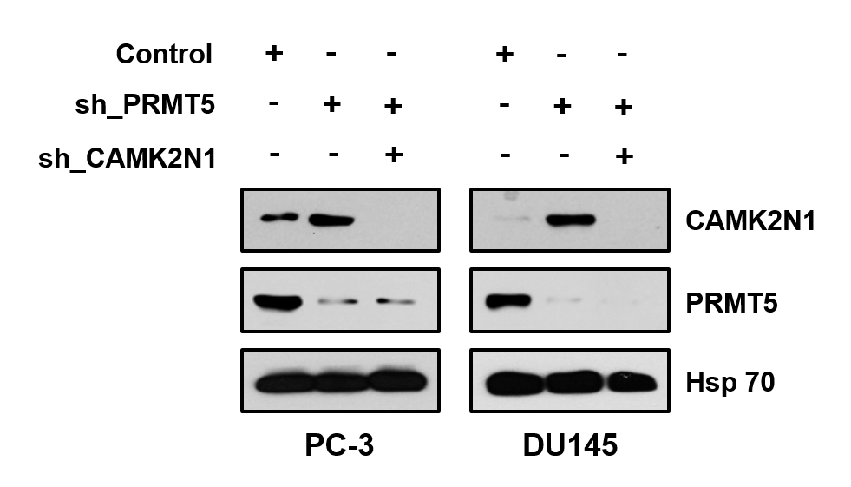
Figure S1. shRNAs-mediated PRMT5 or CAMK2N1 silencing in PC-3 and DU145 cells was verified by Western blot. Hsp 70 was used as an endogenous control.

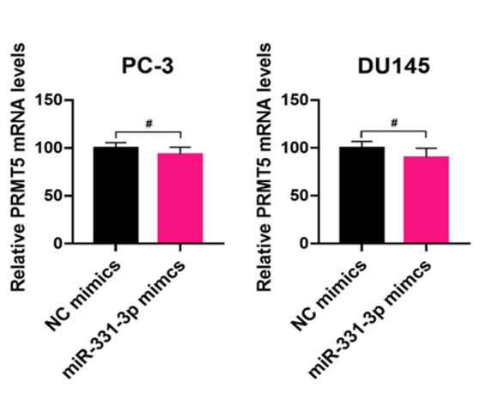
Figure S2. The mRNA levels of PRMT5 in NC or miR-331-3p-transfected PC-3 and DU145 cells were verified by qRT-PCR. Data were showed as mean ± SD. #P > 0.05.

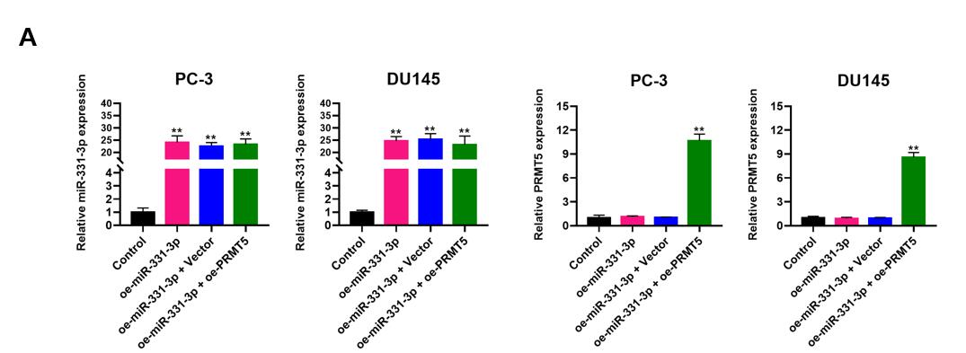
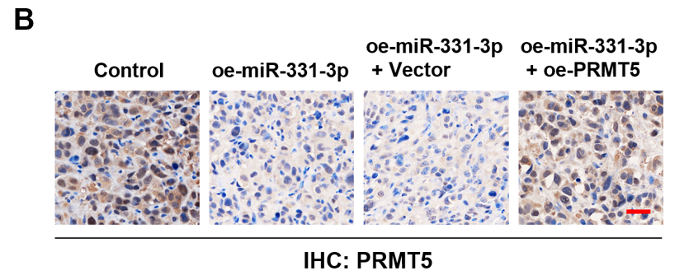
Figure S3. (A) Restoration of PRMT5 expression in miR-331-3p-overexpressed PC-3 and DU145 cells was verified by qRT-PCR. (B) The expression of PRMT5 was examined by H&E staining in control, oe-miR-331-3p, oe-miR-331-3p + vector and oe-miR-331-3p + oe-PRMT5-treated xenografts tissues. Data are showed as mean ± SD. **P < 0.01.

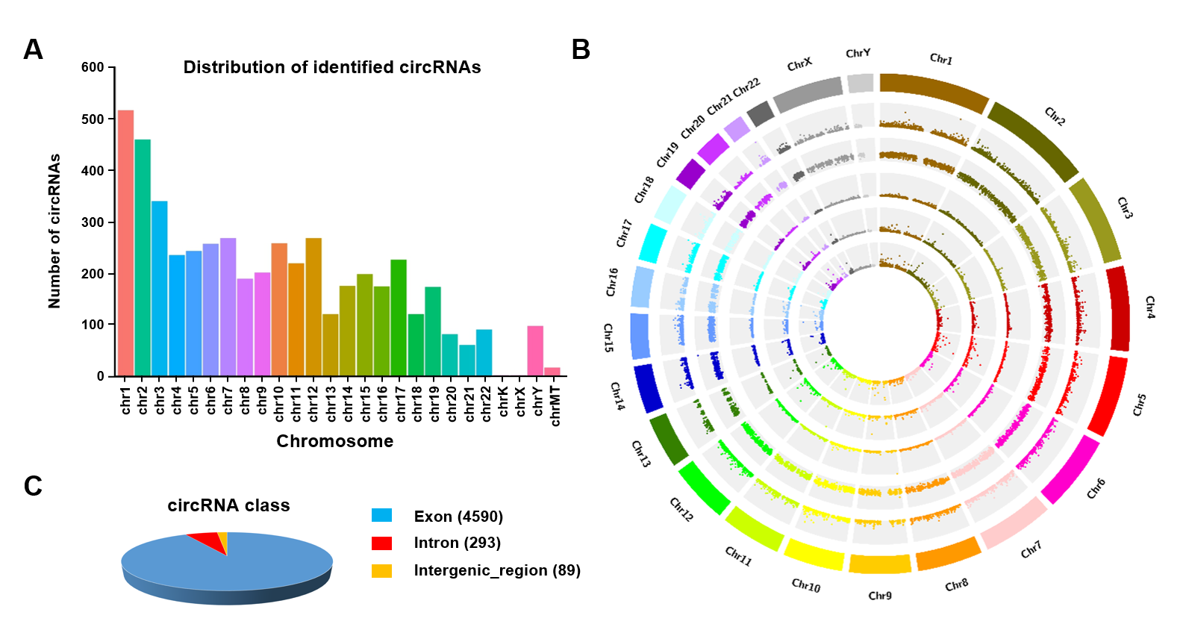
Figure S4. Expression profiles of circRNAs in human PCa. (A) Distribution of the identified circRNAs on human chromosomes. X-axis, the number of each chromosome; Y-axis, the number of circRNAs. (B) Circos plot depicting the distribution of circRNAs on human chromosomes. The outermost layer was a chromosome map of the human genome. The inner circles from outside to inside corresponded to distribution and expression of identified circRNAs on the chromosomes, distribution, and expression of significantly expressed circRNAs, respectively. (C) Composition of the identified circRNAs in terms of genomic origin.

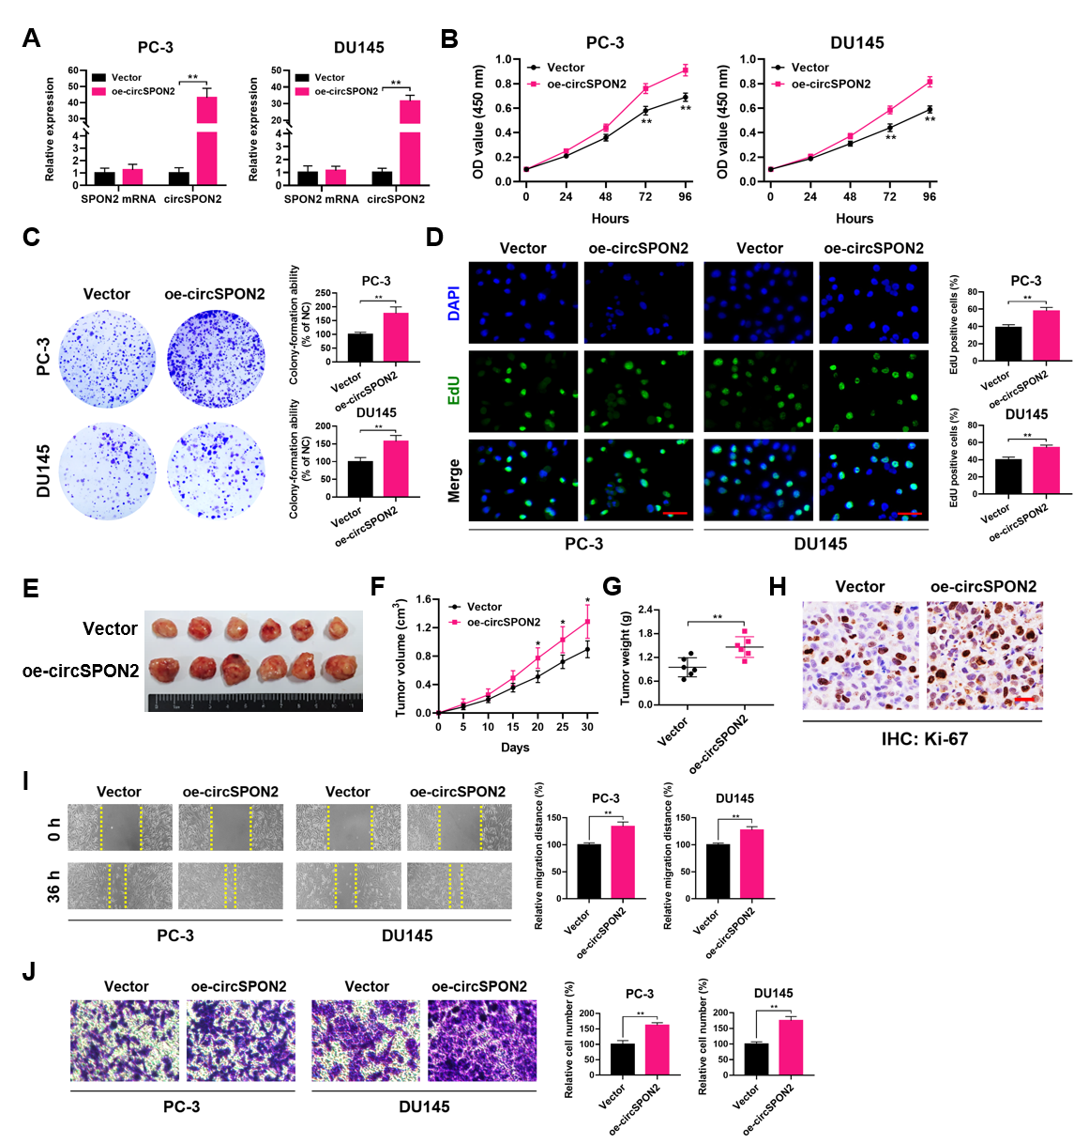
Figure S5. Overexpression of circSPON2 promotes PCa cell proliferation and migration. (A) qRT-PCR analysis of circSPON2 and SPON2 mRNA in PC-3 and DU145 cells treated with vector or oe-circSPON2. (B-D) CCK-8, plate colony-formation and EdU incorporation assays were performed to determine the proliferation abilities of PC-3 and DU145 cells treated with vector or oe-circSPON2. (E) Image of subcutaneous tumor xenografts in vector or oe-circSPON2 groups. (F) The tumor growth curves of xenografts were plotted in vector or oe-circSPON2 groups. (G) The tumor weights of xenografts were evaluated. (H) Representative IHC staining micrographs of Ki-67 in tumor xenografts were conducted. Scale bar = 20 μm. (I and J) Wound healing and transwell assays were performed to determine the migratory capabilities of PC-3 and DU145 cells treated with vector or oe-circSPON2. Data were showed as mean ± SD. *P < 0.05, **P < 0.01.

Table S1. Association between PRMT5 and clinicopathological features of PCa patients.
Characteristics | Cases (%) | PRMT5 expression | P value
Age
<70 | 110 (44.35%) | 175.36 ± 70.78 | 0.8255
≥70 | 138 (55.65%) | 173.51 ± 61.52
Gleason score
5-7 | 148 (59.68%) | 151.86 ± 58.00 | 0.000*
8-10 | 100 (40.32%) | 207.58 ± 62.37
T stage
T1-2 | 145 (58.47%) | 139.19 ± 53.20 | 0.000*
T3-4 | 103 (41.32%) | 224.72 ± 47.09
Lymph node metastasis
N0 | 87 (35.08%) | 173.40 ± 63.26 | 0.8704
N+ | 161 (64.92%) | 174.83 ± 67.11
Distant metastasis
M0 | 228 (91.94%) | 173.72 ± 65.46 | 0.6914
M1 | 18 (7.26%) | 180.11 ± 68.78
*P < 0.05 is considered significant.

Table S2. Association between miR-331-3p and clinicopathological features of PCa patients.
Characteristics | Cases (%) | miR-331-3p expression | P value
Age
<70 | 110 (44.35%) | 3.77 ± 3.25 | 0.8343
≥70 | 138 (55.65%) | 3.68 ± 3.27
Gleason score
5-7 | 148 (59.68%) | 5.23 ± 3.29 | 0.000*
8-10 | 100 (40.32%) | 1.50 ± 1.39
T stage
T1-2 | 145 (58.47%) | 4.63 ± 3.30 | 0.000*
T3-4 | 103 (41.32%) | 2.45 ± 2.74
Lymph node metastasis
N0 | 87 (35.08%) | 3.67 ± 3.20 | 0.8594
N+ | 161 (64.92%) | 3.75 ± 3.29
Distant metastasis
M0 | 228 (91.94%) | 3.75 ± 3.16 | 0.9839
M1 | 18 (7.26%) | 3.73 ± 4.41
*P < 0.05 is considered significant.

Table S3. Differentially expressed circRNAs between five paired PCa tissues by RNA-seq.
CIRI_ID | log2(Fold Change  (PC_T/PC_N)) | P value | Regulate | Gene_ID | Gene_name
CIRI_circ_10915 | 8.374155968 | 0.005707 | up | ENSG00000159674 | SPON2
CIRI_circ_13495 | 7.400645381 | 0.011066 | up | ENSG00000166743 | ACSM1
CIRI_circ_3052 | 6.234029416 | 0.001313 | up | _ | _
CIRI_circ_4991 | 6.135295273 | 0.043708 | up | ENSG00000104413 | ESRP1
CIRI_circ_2528 | 6.033600906 | 0.0474 | up | _ | _
CIRI_circ_11319 | 6.032498695 | 0.025151 | up | ENSG00000138696 | BMPR1B
CIRI_circ_7916 | 5.975397051 | 0.020315 | up | ENSG00000285837 | AC024598.1
CIRI_circ_1603 | 5.963181593 | 0.02363 | up | ENSG00000215018 | COL28A1
CIRI_circ_13932 | 5.958873385 | 0.000108 | up | ENSG00000139865 | TTC6
CIRI_circ_15267 | 5.517060347 | 0.001908 | up | ENSG00000177694 | NAALADL2
CIRI_circ_7037 | 5.512599931 | 0.002107 | up | ENSG00000169410 | PTPN9
CIRI_circ_11801 | 5.45306033 | 0.029659 | up | ENSG00000242110 | AMACR
CIRI_circ_5536 | 5.400462839 | 0.002825 | up | ENSG00000163694 | RBM47
CIRI_circ_5210 | 5.274651531 | 0.005129 | up | _ | _
CIRI_circ_13584 | 5.267603629 | 0.000815 | up | ENSG00000080493 | SLC4A4
CIRI_circ_13368 | 5.252360055 | 0.01987 | up | ENSG00000149639 | SOGA1
CIRI_circ_13390 | 5.252360055 | 0.01987 | up | ENSG00000172915 | NBEA
CIRI_circ_14494 | 5.252360055 | 0.01987 | up | ENSG00000152818 | UTRN
CIRI_circ_5257 | 5.252360055 | 0.01987 | up | ENSG00000109586 | GALNT7
CIRI_circ_7417 | 5.236367148 | 0.005336 | up | ENSG00000183077 | AFMID
CIRI_circ_14160 | 5.232460939 | 0.011056 | up | _ | _
CIRI_circ_5578 | 5.215973818 | 0.02889 | up | _ | _
CIRI_circ_14072 | 5.197395701 | 0.012096 | up | ENSG00000127663 | KDM4B
CIRI_circ_11639 | 5.163546984 | 0.024401 | up | ENSG00000105186 | ANKRD27
CIRI_circ_5322 | 5.131705283 | 8.34E-05 | up | ENSG00000169710 | FASN
CIRI_circ_9893 | 5.11751672 | 0.015295 | up | ENSG00000038382 | TRIO
CIRI_circ_13053 | 5.113577997 | 0.00767 | up | _ | _
CIRI_circ_12648 | 5.05597995 | 0.029825 | up | ENSG00000196353 | CPNE4
CIRI_circ_13362 | 5.05597995 | 0.029825 | up | ENSG00000154914 | USP43
CIRI_circ_8733 | 5.05597995 | 0.029825 | up | ENSG00000004534 | RBM6
CIRI_circ_13363 | 5.052875322 | 0.018068 | up | ENSG00000136205 | TNS3
CIRI_circ_11194 | 5.048807299 | 0.017282 | up | ENSG00000172765 | TMCC1
CIRI_circ_3770 | 5.01468539 | 0.033534 | up | _ | _
CIRI_circ_7823 | 4.998319394 | 0.019822 | up | ENSG00000021776 | AQR
CIRI_circ_2139 | 4.992020465 | 0.034517 | up | ENSG00000103534 | TMC5
CIRI_circ_3256 | 4.992020465 | 0.034517 | up | ENSG00000105983 | LMBR1
CIRI_circ_16105 | 4.959916685 | 0.011098 | up | ENSG00000188372 | ZP3
CIRI_circ_6476 | 4.924136501 | 0.023359 | up | ENSG00000138696 | BMPR1B
CIRI_circ_12502 | 4.91791556 | 0.023635 | up | ENSG00000172954 | LCLAT1
CIRI_circ_10302 | 4.911322112 | 0.041348 | up | ENSG00000242715 | CCDC169
CIRI_circ_605 | 4.880294884 | 0.025924 | up | ENSG00000196730 | DAPK1
CIRI_circ_11936 | 4.865122464 | 0.027186 | up | ENSG00000102900 | NUP93
CIRI_circ_11846 | 4.862566552 | 0.044925 | up | ENSG00000251192 | ZNF674
CIRI_circ_9090 | 4.862566552 | 0.044925 | up | ENSG00000137802 | MAPKBP1
CIRI_circ_7244 | 4.84689774 | 0.026184 | up | ENSG00000166169 | POLL
CIRI_circ_585 | 4.82956363 | 0.028571 | up | ENSG00000142515 | KLK3
CIRI_circ_1864 | 4.829367885 | 0.045982 | up | ENSG00000287460 | AL442636.1
CIRI_circ_1965 | 4.829367885 | 0.045982 | up | _ | _
CIRI_circ_4560 | 4.829367885 | 0.045982 | up | ENSG00000185621 | LMLN
CIRI_circ_5228 | 4.829367885 | 0.045982 | up | ENSG00000021574 | SPAST
CIRI_circ_6880 | 4.829367885 | 0.045982 | up | ENSG00000080493 | SLC4A4
CIRI_circ_8280 | 4.829367885 | 0.045982 | up | ENSG00000144445 | KANSL1L
CIRI_circ_9847 | 4.829367885 | 0.045982 | up | ENSG00000137075 | RNF38
CIRI_circ_14696 | 4.820875055 | 0.016044 | up | ENSG00000067208 | EVI5
CIRI_circ_7796 | 4.806401304 | 0.029782 | up | ENSG00000224078 | SNHG14
CIRI_circ_10381 | 4.797601361 | 0.049745 | up | ENSG00000215472 | RPL17-C18orf32
CIRI_circ_11725 | 4.797601361 | 0.049745 | up | ENSG00000009694 | TENM1
CIRI_circ_15711 | 4.797601361 | 0.049745 | up | ENSG00000197818 | SLC9A8
CIRI_circ_1582 | 4.797601361 | 0.049745 | up | ENSG00000163539 | CLASP2
CIRI_circ_3646 | 4.797601361 | 0.049745 | up | _ | _
CIRI_circ_4171 | 4.797601361 | 0.049745 | up | ENSG00000119772 | DNMT3A
CIRI_circ_11716 | 4.777337238 | 0.030931 | up | ENSG00000033011 | ALG1
CIRI_circ_12716 | 4.762036766 | 0.033425 | up | ENSG00000096060 | FKBP5
CIRI_circ_13745 | 4.760730702 | 0.019413 | up | ENSG00000165097 | KDM1B
CIRI_circ_186 | 4.701930349 | 0.001942 | up | ENSG00000288591 | AC078815.1
CIRI_circ_10837 | 4.680470446 | 0.004559 | up | ENSG00000139865 | TTC6
CIRI_circ_5226 | 4.672898104 | 0.040684 | up | ENSG00000188959 | C9orf152
CIRI_circ_9836 | 4.672898104 | 0.040684 | up | ENSG00000103126 | AXIN1
CIRI_circ_10495 | 4.65524319 | 0.040031 | up | ENSG00000165102 | HGSNAT
CIRI_circ_13525 | 4.636529747 | 0.044578 | up | ENSG00000105738 | SIPA1L3
CIRI_circ_12891 | 4.628121778 | 0.001215 | up | ENSG00000049759 | NEDD4L
CIRI_circ_11377 | 4.608245828 | 0.046193 | up | ENSG00000145349 | CAMK2D
CIRI_circ_456 | 4.598759855 | 0.045484 | up | ENSG00000085719 | CPNE3
CIRI_circ_5547 | 4.595753181 | 0.046524 | up | ENSG00000140527 | WDR93
CIRI_circ_1617 | 4.193963926 | 0.018173 | up | _ | _
CIRI_circ_8277 | 4.14821985 | 0.009858 | up | ENSG00000127663 | KDM4B
CIRI_circ_9021 | 4.126032751 | 0.008613 | up | ENSG00000138346 | DNA2
CIRI_circ_8207 | 4.112657483 | 0.03944 | up | _ | _
CIRI_circ_5849 | 4.106321125 | 0.02177 | up | ENSG00000059758 | CDK17
CIRI_circ_7854 | 3.936007078 | 0.003617 | up | ENSG00000271254 | AC240274.1
CIRI_circ_3625 | 3.852053896 | 0.004009 | up | ENSG00000172081 | MOB3A
CIRI_circ_3572 | 3.798647852 | 0.037967 | up | ENSG00000168137 | SETD5
CIRI_circ_15007 | 3.666396834 | 0.007163 | up | ENSG00000106617 | PRKAG2
CIRI_circ_367 | 3.654586144 | 0.013498 | up | ENSG00000065485 | PDIA5
CIRI_circ_11029 | 3.634789667 | 0.003711 | up | ENSG00000165325 | DEUP1
CIRI_circ_8476 | 3.614803845 | 0.03764 | up | ENSG00000278540 | ACACA
CIRI_circ_15896 | 3.51848132 | 2.59E-08 | up | ENSG00000182795 | C1orf116
CIRI_circ_4314 | 3.428585511 | 0.012328 | up | ENSG00000145734 | BDP1
CIRI_circ_10551 | 3.218262006 | 0.003453 | up | ENSG00000204385 | SLC44A4
CIRI_circ_3687 | 3.156916584 | 1.78E-08 | up | ENSG00000184012 | TMPRSS2
CIRI_circ_9879 | 3.143073414 | 0.011649 | up | ENSG00000179832 | MROH1
CIRI_circ_6583 | 3.104102917 | 0.039258 | up | ENSG00000127663 | KDM4B
CIRI_circ_11540 | 3.10122101 | 0.008607 | up | ENSG00000184012 | TMPRSS2
CIRI_circ_11350 | 2.948686869 | 0.016425 | up | ENSG00000140526 | ABHD2
CIRI_circ_5896 | 2.890242552 | 0.000768 | up | ENSG00000168743 | NPNT
CIRI_circ_4509 | 2.886186535 | 0.007772 | up | ENSG00000080493 | SLC4A4
CIRI_circ_2978 | 2.86840825 | 0.000111 | up | ENSG00000143797 | MBOAT2
CIRI_circ_8363 | 2.800061188 | 0.007059 | up | ENSG00000130529 | TRPM4
CIRI_circ_7293 | 2.641326105 | 0.003584 | up | _ | _
CIRI_circ_9277 | 2.612691229 | 0.001941 | up | ENSG00000146555 | SDK1
CIRI_circ_10681 | 2.584717146 | 0.001476 | up | ENSG00000137571 | SLCO5A1
CIRI_circ_7700 | 2.519653352 | 0.00802 | up | ENSG00000086991 | NOX4
CIRI_circ_244 | 2.511126096 | 0.032193 | up | ENSG00000009694 | TENM1
CIRI_circ_7176 | 2.472397788 | 0.025857 | up | ENSG00000237438 | CECR7
CIRI_circ_12406 | 2.456874192 | 0.007556 | up | ENSG00000110931 | CAMKK2
CIRI_circ_4332 | 2.385090439 | 0.006212 | up | ENSG00000138696 | BMPR1B
CIRI_circ_13985 | 2.360869503 | 0.002241 | up | ENSG00000143797 | MBOAT2
CIRI_circ_6798 | 2.351263506 | 0.0008 | up | ENSG00000162105 | SHANK2
CIRI_circ_11883 | 2.314285463 | 3.79E-05 | up | ENSG00000049759 | NEDD4L
CIRI_circ_15486 | 2.310513379 | 0.003118 | up | ENSG00000083223 | TUT7
CIRI_circ_13125 | 2.241908239 | 0.008945 | up | ENSG00000146067 | FAM193B
CIRI_circ_1764 | 2.22370136 | 0.001024 | up | ENSG00000105514 | RAB3D
CIRI_circ_919 | 2.213096139 | 0.045067 | up | ENSG00000108239 | TBC1D12
CIRI_circ_4227 | 2.211677575 | 0.006885 | up | ENSG00000173715 | C11orf80
CIRI_circ_7869 | 2.165035689 | 0.020881 | up | _ | _
CIRI_circ_13705 | 2.153520536 | 0.000599 | up | ENSG00000143797 | MBOAT2
CIRI_circ_9915 | 2.118619795 | 0.001214 | up | ENSG00000143797 | MBOAT2
CIRI_circ_8349 | 2.092233268 | 0.023714 | up | ENSG00000181789 | COPG1
CIRI_circ_15001 | 2.064873265 | 0.038481 | up | ENSG00000188554 | NBR1
CIRI_circ_4104 | 1.978689745 | 0.037404 | up | ENSG00000185359 | HGS
CIRI_circ_1880 | 1.978387715 | 0.026648 | up | ENSG00000124406 | ATP8A1
CIRI_circ_4291 | 1.926204586 | 0.00792 | up | ENSG00000144036 | EXOC6B
CIRI_circ_11614 | 1.913458621 | 0.024483 | up | ENSG00000131844 | MCCC2
CIRI_circ_9676 | 1.8753438 | 0.020822 | up | ENSG00000017260 | ATP2C1
CIRI_circ_1007 | 1.85857129 | 0.019335 | up | ENSG00000155660 | PDIA4
CIRI_circ_9239 | 1.777544754 | 0.021361 | up | ENSG00000152217 | SETBP1
CIRI_circ_13122 | 1.775581885 | 0.014603 | up | ENSG00000008382 | MPND
CIRI_circ_1291 | 1.669337392 | 0.013006 | up | ENSG00000137073 | UBAP2
CIRI_circ_9723 | 1.643574219 | 0.004345 | up | ENSG00000100116 | GCAT
CIRI_circ_10228 | 1.575945986 | 0.000713 | up | ENSG00000140526 | ABHD2
CIRI_circ_7526 | 1.540307349 | 0.001816 | up | ENSG00000113384 | GOLPH3
CIRI_circ_7160 | 1.525597752 | 0.033196 | up | ENSG00000132874 | SLC14A2
CIRI_circ_2063 | 1.438698864 | 0.030874 | up | ENSG00000113719 | ERGIC1
CIRI_circ_8715 | 1.417911396 | 0.019399 | up | ENSG00000185624 | P4HB
CIRI_circ_11086 | 1.37437982 | 0.010355 | up | ENSG00000127663 | KDM4B
CIRI_circ_15193 | 1.332391198 | 0.019751 | up | ENSG00000263001 | GTF2I
CIRI_circ_12903 | 1.259552155 | 0.00408 | up | ENSG00000142197 | DOP1B
CIRI_circ_11059 | 1.212800818 | 0.013341 | up | ENSG00000083223 | TUT7
CIRI_circ_13221 | 1.184763614 | 0.028936 | up | ENSG00000152818 | UTRN
CIRI_circ_11839 | 1.078350543 | 0.024701 | up | ENSG00000131149 | GSE1
CIRI_circ_2587 | -1.121536519 | 0.022324 | down | ENSG00000140718 | FTO
CIRI_circ_642 | -1.143594535 | 0.044437 | down | ENSG00000109381 | ELF2
CIRI_circ_14023 | -1.177188064 | 0.004421 | down | ENSG00000117868 | ESYT2
CIRI_circ_16042 | -1.194226359 | 0.017677 | down | ENSG00000110422 | HIPK3
CIRI_circ_2900 | -1.216736743 | 0.013768 | down | ENSG00000198121 | LPAR1
CIRI_circ_13453 | -1.252604416 | 0.011376 | down | ENSG00000134744 | TUT4
CIRI_circ_280 | -1.271455965 | 0.034726 | down | ENSG00000165322 | ARHGAP12
CIRI_circ_2331 | -1.308837868 | 0.034827 | down | ENSG00000141627 | DYM
CIRI_circ_408 | -1.331034583 | 0.040549 | down | ENSG00000057608 | GDI2
CIRI_circ_5603 | -1.339942323 | 0.038878 | down | ENSG00000113658 | SMAD5
CIRI_circ_15223 | -1.366277881 | 0.020415 | down | ENSG00000137478 | FCHSD2
CIRI_circ_16295 | -1.370353641 | 0.033029 | down | ENSG00000157110 | RBPMS
CIRI_circ_1293 | -1.414926945 | 0.049569 | down | ENSG00000136104 | RNASEH2B
CIRI_circ_5233 | -1.428727007 | 0.011783 | down | ENSG00000169193 | CCDC126
CIRI_circ_6687 | -1.458787139 | 0.024694 | down | ENSG00000102893 | PHKB
CIRI_circ_12979 | -1.462069124 | 0.028644 | down | ENSG00000169398 | PTK2
CIRI_circ_14964 | -1.473377667 | 0.001857 | down | ENSG00000276087 | AC008073.3
CIRI_circ_6106 | -1.509983423 | 0.016421 | down | ENSG00000112992 | NNT
CIRI_circ_52 | -1.544543377 | 0.046451 | down | ENSG00000101019 | UQCC1
CIRI_circ_7639 | -1.559971461 | 0.026581 | down | ENSG00000146247 | PHIP
CIRI_circ_3422 | -1.56066024 | 0.03189 | down | ENSG00000122507 | BBS9
CIRI_circ_10197 | -1.561447031 | 0.038814 | down | ENSG00000132383 | RPA1
CIRI_circ_8307 | -1.616101905 | 0.031511 | down | ENSG00000071205 | ARHGAP10
CIRI_circ_5503 | -1.638780795 | 0.041421 | down | ENSG00000116489 | CAPZA1
CIRI_circ_10590 | -1.656372241 | 0.013469 | down | ENSG00000112320 | SOBP
CIRI_circ_5952 | -1.65756809 | 0.007085 | down | ENSG00000197442 | MAP3K5
CIRI_circ_14990 | -1.658810759 | 0.029578 | down | ENSG00000103351 | CLUAP1
CIRI_circ_8489 | -1.660070796 | 0.002293 | down | ENSG00000103591 | AAGAB
CIRI_circ_14526 | -1.679013696 | 0.03119 | down | ENSG00000022567 | SLC45A4
CIRI_circ_16039 | -1.698306824 | 0.037929 | down | ENSG00000172292 | CERS6
CIRI_circ_11536 | -1.711136425 | 0.023153 | down | ENSG00000147854 | UHRF2
CIRI_circ_530 | -1.713831449 | 0.024522 | down | ENSG00000136169 | SETDB2
CIRI_circ_2869 | -1.753400979 | 0.021653 | down | ENSG00000075945 | KIFAP3
CIRI_circ_3950 | -1.757909372 | 0.049997 | down | ENSG00000240038 | AMY2B
CIRI_circ_15154 | -1.784428428 | 0.009978 | down | ENSG00000196418 | ZNF124
CIRI_circ_16083 | -1.794929209 | 0.045858 | down | ENSG00000122557 | HERPUD2
CIRI_circ_10748 | -1.798300734 | 0.047455 | down | ENSG00000178971 | CTC1
CIRI_circ_8025 | -1.823666559 | 0.018666 | down | ENSG00000151322 | NPAS3
CIRI_circ_6173 | -1.830994927 | 0.007712 | down | ENSG00000130638 | ATXN10
CIRI_circ_7870 | -1.831062273 | 0.021798 | down | ENSG00000169398 | PTK2
CIRI_circ_13722 | -1.856481495 | 0.036328 | down | ENSG00000197386 | HTT
CIRI_circ_4413 | -1.867485475 | 0.024335 | down | ENSG00000084676 | NCOA1
CIRI_circ_6317 | -1.871952215 | 0.019702 | down | ENSG00000131873 | CHSY1
CIRI_circ_10927 | -1.879809451 | 0.019683 | down | ENSG00000173258 | ZNF483
CIRI_circ_15175 | -1.948262126 | 0.03023 | down | ENSG00000126216 | TUBGCP3
CIRI_circ_13980 | -1.95433499 | 0.020677 | down | ENSG00000248643 | RBM14-RBM4
CIRI_circ_14589 | -1.976374206 | 0.046577 | down | ENSG00000103319 | EEF2K
CIRI_circ_4855 | -1.979397432 | 0.007193 | down | ENSG00000160321 | ZNF208
CIRI_circ_4034 | -1.989104511 | 0.005219 | down | ENSG00000196323 | ZBTB44
CIRI_circ_10193 | -1.995193778 | 0.045691 | down | ENSG00000114107 | CEP70
CIRI_circ_12058 | -2.04583883 | 0.016524 | down | ENSG00000113319 | RASGRF2
CIRI_circ_5570 | -2.056872588 | 0.047291 | down | ENSG00000110090 | CPT1A
CIRI_circ_12705 | -2.05881088 | 0.017536 | down | ENSG00000135749 | PCNX2
CIRI_circ_8245 | -2.106676637 | 0.010808 | down | _ | _
CIRI_circ_12190 | -2.163229993 | 0.026731 | down | ENSG00000100722 | ZC3H14
CIRI_circ_3022 | -2.216838764 | 0.003214 | down | ENSG00000005889 | ZFX
CIRI_circ_12625 | -2.218487871 | 0.007971 | down | ENSG00000131508 | UBE2D2
CIRI_circ_4676 | -2.248953081 | 0.033354 | down | ENSG00000138134 | STAMBPL1
CIRI_circ_13802 | -2.24984618 | 0.048604 | down | ENSG00000145687 | SSBP2
CIRI_circ_10582 | -2.256947325 | 0.017104 | down | ENSG00000120071 | KANSL1
CIRI_circ_1367 | -2.340887284 | 0.041313 | down | ENSG00000066382 | MPPED2
CIRI_circ_15698 | -2.355092929 | 0.001479 | down | ENSG00000107518 | ATRNL1
CIRI_circ_8165 | -2.397415352 | 0.049161 | down | ENSG00000065154 | OAT
CIRI_circ_8893 | -2.400096934 | 0.016609 | down | ENSG00000137776 | SLTM
CIRI_circ_12361 | -2.415718866 | 0.044192 | down | ENSG00000137513 | NARS2
CIRI_circ_1934 | -2.430954641 | 0.035975 | down | ENSG00000166889 | PATL1
CIRI_circ_9483 | -2.476269912 | 0.035404 | down | ENSG00000146909 | NOM1
CIRI_circ_12595 | -2.479960016 | 0.005924 | down | ENSG00000100154 | TTC28
CIRI_circ_6794 | -2.503970459 | 0.002687 | down | ENSG00000112851 | ERBIN
CIRI_circ_1572 | -2.540915037 | 0.043161 | down | ENSG00000146151 | HMGCLL1
CIRI_circ_3877 | -2.542796902 | 0.000207 | down | ENSG00000135424 | ITGA7
CIRI_circ_3551 | -2.574342255 | 0.026583 | down | ENSG00000272980 | Z94721.2
CIRI_circ_5515 | -2.606095438 | 0.034636 | down | ENSG00000186001 | LRCH3
CIRI_circ_16377 | -2.614164104 | 0.046542 | down | ENSG00000237877 | LINC01473
CIRI_circ_16120 | -2.667417055 | 0.009607 | down | ENSG00000132964 | CDK8
CIRI_circ_15353 | -2.67925478 | 0.012052 | down | ENSG00000149289 | ZC3H12C
CIRI_circ_6572 | -2.715288768 | 0.048504 | down | ENSG00000144559 | TAMM41
CIRI_circ_1653 | -2.72866052 | 0.034023 | down | ENSG00000185483 | ROR1
CIRI_circ_1140 | -2.737064969 | 0.044781 | down | ENSG00000213047 | DENND1B
CIRI_circ_5384 | -2.767472453 | 0.030097 | down | ENSG00000198780 | FAM169A
CIRI_circ_12197 | -2.787464523 | 0.034116 | down | ENSG00000257923 | CUX1
CIRI_circ_4415 | -2.790358592 | 0.031486 | down | ENSG00000115970 | THADA
CIRI_circ_7259 | -2.796843407 | 0.041634 | down | ENSG00000147649 | MTDH
CIRI_circ_9541 | -2.810372077 | 0.010713 | down | ENSG00000065833 | ME1
CIRI_circ_12874 | -2.83308905 | 0.042484 | down | ENSG00000169902 | TPST1
CIRI_circ_3905 | -2.841448427 | 0.042003 | down | ENSG00000073921 | PICALM
CIRI_circ_12684 | -2.84763569 | 0.044804 | down | ENSG00000135775 | COG2
CIRI_circ_5087 | -2.851417982 | 0.021537 | down | ENSG00000057663 | ATG5
CIRI_circ_9731 | -2.869700455 | 0.040064 | down | ENSG00000082701 | GSK3B
CIRI_circ_2235 | -2.872530653 | 0.042935 | down | ENSG00000177119 | ANO6
CIRI_circ_15642 | -2.902922045 | 0.035523 | down | ENSG00000088179 | PTPN4
CIRI_circ_924 | -2.908619881 | 0.007036 | down | ENSG00000161813 | LARP4
CIRI_circ_15042 | -2.917887356 | 0.033719 | down | ENSG00000169398 | PTK2
CIRI_circ_15198 | -2.918608508 | 0.036561 | down | ENSG00000138674 | SEC31A
CIRI_circ_13720 | -2.924026932 | 0.031961 | down | ENSG00000162415 | ZSWIM5
CIRI_circ_16330 | -2.927688713 | 0.049425 | down | ENSG00000148516 | ZEB1
CIRI_circ_1232 | -2.954160269 | 0.049834 | down | ENSG00000085511 | MAP3K4
CIRI_circ_4863 | -2.965975772 | 6.03E-06 | down | ENSG00000184588 | PDE4B
CIRI_circ_13228 | -2.981719115 | 0.014826 | down | ENSG00000151466 | SCLT1
CIRI_circ_3913 | -2.985085136 | 0.048696 | down | ENSG00000088179 | PTPN4
CIRI_circ_681 | -3.010037676 | 0.016557 | down | ENSG00000136169 | SETDB2
CIRI_circ_2798 | -3.037863366 | 0.025201 | down | ENSG00000175356 | SCUBE2
CIRI_circ_11596 | -3.038009301 | 0.001362 | down | ENSG00000114796 | KLHL24
CIRI_circ_3972 | -3.038731487 | 0.008222 | down | ENSG00000232855 | AF165147.1
CIRI_circ_12721 | -3.065255983 | 0.022492 | down | ENSG00000168852 | TPTE2P5
CIRI_circ_8106 | -3.066678917 | 0.040687 | down | ENSG00000270316 | BORCS7-ASMT
CIRI_circ_2072 | -3.074882696 | 0.017283 | down | ENSG00000064115 | TM7SF3
CIRI_circ_4871 | -3.075773999 | 0.010573 | down | ENSG00000005700 | IBTK
CIRI_circ_13879 | -3.090775166 | 0.039547 | down | ENSG00000187240 | DYNC2H1
CIRI_circ_596 | -3.141871405 | 0.011923 | down | ENSG00000031003 | FAM13B
CIRI_circ_2521 | -3.143638505 | 0.017562 | down | ENSG00000283563 | AC098650.1
CIRI_circ_5501 | -3.147056419 | 0.026098 | down | ENSG00000197603 | CPLANE1
CIRI_circ_10321 | -3.148511857 | 0.02442 | down | ENSG00000146072 | TNFRSF21
CIRI_circ_10049 | -3.201033261 | 0.009521 | down | ENSG00000143842 | SOX13
CIRI_circ_1568 | -3.216755146 | 0.025657 | down | ENSG00000163935 | SFMBT1
CIRI_circ_13991 | -3.247002521 | 0.016057 | down | ENSG00000133106 | EPSTI1
CIRI_circ_12810 | -3.252650375 | 0.015417 | down | ENSG00000284741 | PDE11A
CIRI_circ_1529 | -3.281195759 | 0.007327 | down | ENSG00000285943 | AC112128.1
CIRI_circ_5640 | -3.281804296 | 0.042801 | down | ENSG00000197702 | PARVA
CIRI_circ_4830 | -3.320304921 | 0.033457 | down | ENSG00000135333 | EPHA7
CIRI_circ_1469 | -3.366732107 | 0.047455 | down | ENSG00000080815 | PSEN1
CIRI_circ_5475 | -3.367860763 | 0.046517 | down | ENSG00000078747 | ITCH
CIRI_circ_454 | -3.406669693 | 0.041446 | down | ENSG00000012983 | MAP4K5
CIRI_circ_16143 | -3.41433076 | 0.041419 | down | ENSG00000159322 | ADPGK
CIRI_circ_4472 | -3.423767552 | 0.044103 | down | ENSG00000179912 | R3HDM2
CIRI_circ_11305 | -3.427781438 | 0.007193 | down | ENSG00000135775 | COG2
CIRI_circ_3507 | -3.431504647 | 0.040524 | down | ENSG00000118961 | LDAH
CIRI_circ_4930 | -3.439164504 | 0.00216 | down | ENSG00000154655 | L3MBTL4
CIRI_circ_3370 | -3.445040043 | 0.037593 | down | ENSG00000140694 | PARN
CIRI_circ_2177 | -3.45130383 | 0.002388 | down | ENSG00000019995 | ZRANB1
CIRI_circ_10170 | -3.473089816 | 0.034688 | down | ENSG00000111058 | ACSS3
CIRI_circ_2040 | -3.48340927 | 0.038098 | down | ENSG00000101596 | SMCHD1
CIRI_circ_4860 | -3.494958786 | 0.036843 | down | ENSG00000171953 | ATPAF2
CIRI_circ_12313 | -3.496465072 | 0.034418 | down | ENSG00000101596 | SMCHD1
CIRI_circ_13479 | -3.506092059 | 0.00533 | down | ENSG00000084676 | NCOA1
CIRI_circ_5674 | -3.507399803 | 0.032941 | down | ENSG00000169398 | PTK2
CIRI_circ_3306 | -3.511219205 | 0.005585 | down | ENSG00000066468 | FGFR2
CIRI_circ_11011 | -3.513566648 | 0.04985 | down | ENSG00000072736 | NFATC3
CIRI_circ_13096 | -3.515510076 | 0.000508 | down | ENSG00000232855 | AF165147.1
CIRI_circ_2626 | -3.520626087 | 0.048294 | down | ENSG00000117020 | AKT3
CIRI_circ_15770 | -3.521238339 | 0.033954 | down | ENSG00000092148 | HECTD1
CIRI_circ_2612 | -3.538719805 | 0.016782 | down | ENSG00000150760 | DOCK1
CIRI_circ_12923 | -3.542798478 | 0.048505 | down | ENSG00000156502 | SUPV3L1
CIRI_circ_6847 | -3.542854617 | 0.029962 | down | ENSG00000122545 | SEPTIN7
CIRI_circ_7530 | -3.551416375 | 0.048258 | down | ENSG00000146463 | ZMYM4
CIRI_circ_4123 | -3.553053677 | 0.031885 | down | ENSG00000135040 | NAA35
CIRI_circ_9000 | -3.553811436 | 0.048459 | down | ENSG00000144357 | UBR3
CIRI_circ_6248 | -3.55441689 | 0.02905 | down | ENSG00000115419 | GLS
CIRI_circ_8538 | -3.570663911 | 0.045574 | down | ENSG00000152894 | PTPRK
CIRI_circ_14164 | -3.573318916 | 0.047972 | down | ENSG00000008311 | AASS
CIRI_circ_15999 | -3.583626921 | 0.014688 | down | ENSG00000114796 | KLHL24
CIRI_circ_15212 | -3.584493384 | 0.044126 | down | ENSG00000197548 | ATG7
CIRI_circ_15032 | -3.586544929 | 0.044491 | down | ENSG00000052126 | PLEKHA5
CIRI_circ_1391 | -3.601243119 | 0.030838 | down | ENSG00000166377 | ATP9B
CIRI_circ_11191 | -3.613057544 | 0.040649 | down | ENSG00000075420 | FNDC3B
CIRI_circ_2342 | -3.613561116 | 0.040512 | down | ENSG00000131375 | CAPN7
CIRI_circ_8509 | -3.616960323 | 0.024588 | down | ENSG00000099956 | SMARCB1
CIRI_circ_7965 | -3.618866443 | 0.043724 | down | ENSG00000157540 | DYRK1A
CIRI_circ_12334 | -3.621057773 | 0.041793 | down | ENSG00000078124 | ACER3
CIRI_circ_4107 | -3.643897722 | 0.0431 | down | ENSG00000011114 | BTBD7
CIRI_circ_11106 | -3.655352362 | 0.038836 | down | ENSG00000066468 | FGFR2
CIRI_circ_14968 | -3.655583886 | 0.041906 | down | ENSG00000135597 | REPS1
CIRI_circ_11769 | -3.660309275 | 0.004804 | down | ENSG00000133424 | LARGE1
CIRI_circ_7677 | -3.674078019 | 0.00895 | down | ENSG00000133392 | MYH11
CIRI_circ_4520 | -3.675959867 | 9.35E-05 | down | ENSG00000100473 | COCH
CIRI_circ_15312 | -3.67607313 | 0.020754 | down | ENSG00000124535 | WRNIP1
CIRI_circ_155 | -3.683393981 | 0.019723 | down | ENSG00000164253 | WDR41
CIRI_circ_10384 | -3.68915119 | 0.038915 | down | ENSG00000115841 | RMDN2
CIRI_circ_8246 | -3.689290926 | 0.034146 | down | ENSG00000071205 | ARHGAP10
CIRI_circ_14263 | -3.69614817 | 0.036138 | down | ENSG00000237975 | FLG-AS1
CIRI_circ_9816 | -3.710609719 | 0.019098 | down | ENSG00000104218 | CSPP1
CIRI_circ_6033 | -3.713280754 | 0.022574 | down | ENSG00000125354 | SEPTIN6
CIRI_circ_3675 | -3.715573382 | 0.037919 | down | ENSG00000236532 | LINC01695
CIRI_circ_2096 | -3.721382059 | 0.03541 | down | ENSG00000171466 | ZNF562
CIRI_circ_13015 | -3.724128006 | 0.021998 | down | ENSG00000152527 | PLEKHH2
CIRI_circ_5094 | -3.7288856 | 0.017604 | down | ENSG00000169375 | SIN3A
CIRI_circ_15371 | -3.753463185 | 0.01776 | down | ENSG00000241962 | AC079447.1
CIRI_circ_3659 | -3.754173857 | 0.034873 | down | ENSG00000169398 | PTK2
CIRI_circ_10064 | -3.774736529 | 0.015338 | down | ENSG00000086200 | IPO11
CIRI_circ_5025 | -3.777660172 | 0.033594 | down | ENSG00000109381 | ELF2
CIRI_circ_13838 | -3.781138412 | 0.002033 | down | ENSG00000154655 | L3MBTL4
CIRI_circ_14498 | -3.792417908 | 0.028594 | down | ENSG00000165338 | HECTD2
CIRI_circ_3614 | -3.801372185 | 0.01597 | down | ENSG00000122507 | BBS9
CIRI_circ_8845 | -3.802649743 | 0.027387 | down | ENSG00000172915 | NBEA
CIRI_circ_5052 | -3.827361671 | 0.013389 | down | ENSG00000140153 | WDR20
CIRI_circ_11188 | -3.837110922 | 0.008238 | down | ENSG00000242441 | GTF2A1L
CIRI_circ_2329 | -3.84922584 | 0.027329 | down | ENSG00000175029 | CTBP2
CIRI_circ_8851 | -3.854838125 | 0.011908 | down | ENSG00000118454 | ANKRD13C
CIRI_circ_1223 | -3.856516678 | 0.026119 | down | ENSG00000106443 | PHF14
CIRI_circ_2559 | -3.85794528 | 0.022323 | down | ENSG00000067141 | NEO1
CIRI_circ_5559 | -3.860332927 | 0.00148 | down | ENSG00000123106 | CCDC91
CIRI_circ_11213 | -3.866846004 | 0.024052 | down | ENSG00000141627 | DYM
CIRI_circ_5757 | -3.881400494 | 0.02076 | down | ENSG00000197121 | PGAP1
CIRI_circ_7206 | -3.882852502 | 0.0117 | down | ENSG00000105855 | ITGB8
CIRI_circ_4153 | -3.891412866 | 0.020177 | down | ENSG00000049618 | ARID1B
CIRI_circ_6371 | -3.892267885 | 0.001055 | down | ENSG00000025796 | SEC63
CIRI_circ_11674 | -3.899737067 | 0.010233 | down | ENSG00000142453 | CARM1
CIRI_circ_10500 | -3.900554027 | 0.011191 | down | ENSG00000183346 | CABCOCO1
CIRI_circ_1048 | -3.901600649 | 0.010121 | down | ENSG00000165521 | EML5
CIRI_circ_11355 | -3.908254432 | 0.021253 | down | ENSG00000100934 | SEC23A
CIRI_circ_8158 | -3.915677822 | 0.019348 | down | _ | _
CIRI_circ_3029 | -3.916658671 | 0.027934 | down | ENSG00000231887 | PRH1
CIRI_circ_3405 | -3.91702681 | 0.019414 | down | ENSG00000197121 | PGAP1
CIRI_circ_1385 | -3.919500809 | 0.009142 | down | ENSG00000145293 | ENOPH1
CIRI_circ_3000 | -3.923103123 | 0.009472 | down | ENSG00000137710 | RDX
CIRI_circ_1733 | -3.925159495 | 0.009345 | down | ENSG00000172795 | DCP2
CIRI_circ_1244 | -3.943630402 | 0.018707 | down | ENSG00000101639 | CEP192
CIRI_circ_114 | -3.945039228 | 0.033603 | down | ENSG00000204644 | ZFP57
CIRI_circ_1961 | -3.947313076 | 0.010085 | down | ENSG00000111880 | RNGTT
CIRI_circ_13062 | -3.95315503 | 0.032704 | down | ENSG00000114796 | KLHL24
CIRI_circ_11655 | -3.955778723 | 0.010631 | down | ENSG00000124789 | NUP153
CIRI_circ_6793 | -3.956263732 | 0.034122 | down | _ | _
CIRI_circ_9137 | -3.956982363 | 0.00913 | down | ENSG00000108055 | SMC3
CIRI_circ_14673 | -3.9636304 | 0.033764 | down | ENSG00000197776 | KLHDC1
CIRI_circ_15058 | -3.964269841 | 0.01776 | down | ENSG00000144857 | BOC
CIRI_circ_9790 | -3.983378671 | 0.00887 | down | ENSG00000064933 | PMS1
CIRI_circ_14248 | -3.984804451 | 0.016601 | down | ENSG00000153993 | SEMA3D
CIRI_circ_11207 | -3.991865345 | 0.01566 | down | ENSG00000118420 | UBE3D
CIRI_circ_26 | -3.992797964 | 0.031471 | down | ENSG00000087206 | UIMC1
CIRI_circ_9312 | -3.995755061 | 0.017126 | down | ENSG00000138398 | PPIG
CIRI_circ_11646 | -3.998453855 | 0.016498 | down | ENSG00000104375 | STK3
CIRI_circ_14067 | -4.006472871 | 0.017354 | down | ENSG00000068878 | PSME4
CIRI_circ_11648 | -4.008402102 | 0.018056 | down | ENSG00000225689 | AL008633.1
CIRI_circ_9841 | -4.011535166 | 0.007157 | down | ENSG00000110422 | HIPK3
CIRI_circ_3482 | -4.012617775 | 0.00773 | down | ENSG00000257103 | LSM14A
CIRI_circ_2972 | -4.025677664 | 0.017942 | down | ENSG00000158966 | CACHD1
CIRI_circ_1986 | -4.03139897 | 0.006529 | down | ENSG00000061987 | MON2
CIRI_circ_3759 | -4.038303857 | 0.018046 | down | ENSG00000010803 | SCMH1
CIRI_circ_11706 | -4.062938926 | 0.015452 | down | ENSG00000115556 | PLCD4
CIRI_circ_12135 | -4.066840503 | 0.012315 | down | ENSG00000205339 | IPO7
CIRI_circ_8769 | -4.077097678 | 0.0172 | down | ENSG00000116962 | NID1
CIRI_circ_9118 | -4.082126186 | 0.013735 | down | ENSG00000198947 | DMD
CIRI_circ_3930 | -4.102675365 | 0.011397 | down | ENSG00000103404 | USP31
CIRI_circ_2433 | -4.113327565 | 0.005319 | down | ENSG00000148634 | HERC4
CIRI_circ_13022 | -4.149282707 | 0.010714 | down | ENSG00000163655 | GMPS
CIRI_circ_2273 | -4.152884406 | 0.010809 | down | ENSG00000171100 | MTM1
CIRI_circ_9383 | -4.186090755 | 0.020164 | down | ENSG00000185760 | KCNQ5
CIRI_circ_1006 | -4.190367838 | 0.018967 | down | ENSG00000168487 | BMP1
CIRI_circ_12078 | -4.19123386 | 0.004074 | down | ENSG00000111728 | ST8SIA1
CIRI_circ_9863 | -4.211298746 | 0.00472 | down | ENSG00000213079 | SCAF8
CIRI_circ_5338 | -4.223857232 | 0.00369 | down | ENSG00000167306 | MYO5B
CIRI_circ_1619 | -4.224305832 | 0.008344 | down | ENSG00000071205 | ARHGAP10
CIRI_circ_2939 | -4.230836176 | 0.008191 | down | ENSG00000127720 | METTL25
CIRI_circ_2257 | -4.235125122 | 0.008412 | down | ENSG00000109339 | MAPK10
CIRI_circ_11338 | -4.297218133 | 0.003631 | down | ENSG00000114439 | BBX
CIRI_circ_5123 | -4.302327538 | 0.006892 | down | ENSG00000122507 | BBS9
CIRI_circ_1574 | -4.316482225 | 0.01457 | down | ENSG00000145012 | LPP
CIRI_circ_5925 | -4.321077701 | 0.005882 | down | ENSG00000166979 | EVA1C
CIRI_circ_5709 | -4.342391414 | 0.002926 | down | ENSG00000165487 | MICU2
CIRI_circ_10031 | -4.360871466 | 0.003188 | down | ENSG00000183666 | GUSBP1
CIRI_circ_10791 | -4.365178286 | 0.002259 | down | ENSG00000152683 | SLC30A6
CIRI_circ_7818 | -4.371033427 | 0.00502 | down | ENSG00000153827 | TRIP12
CIRI_circ_3907 | -4.373489144 | 0.002101 | down | ENSG00000123684 | LPGAT1
CIRI_circ_8054 | -4.377456391 | 0.001853 | down | ENSG00000185842 | DNAH14
CIRI_circ_14439 | -4.397100475 | 0.001728 | down | ENSG00000111666 | CHPT1
CIRI_circ_1712 | -4.411822495 | 0.005008 | down | ENSG00000154310 | TNIK
CIRI_circ_11602 | -4.417276131 | 0.001569 | down | ENSG00000074657 | ZNF532
CIRI_circ_3656 | -4.4559119 | 0.004268 | down | ENSG00000151572 | ANO4
CIRI_circ_12548 | -4.500859132 | 0.005056 | down | ENSG00000146151 | HMGCLL1
CIRI_circ_9821 | -4.509137378 | 0.003194 | down | ENSG00000179397 | CATSPERE
CIRI_circ_14484 | -4.52348647 | 0.003541 | down | ENSG00000173175 | ADCY5
CIRI_circ_6528 | -4.560349712 | 0.001067 | down | ENSG00000265354 | TIMM23
CIRI_circ_15931 | -4.569269771 | 0.00262 | down | ENSG00000140563 | MCTP2
CIRI_circ_12106 | -4.590904121 | 0.00245 | down | ENSG00000124440 | HIF3A
CIRI_circ_10552 | -4.597425979 | 0.002579 | down | ENSG00000071205 | ARHGAP10
CIRI_circ_15859 | -4.641027706 | 0.002574 | down | ENSG00000288637 | AC013477.2
CIRI_circ_15060 | -4.646189051 | 0.001203 | down | ENSG00000180488 | MIGA1
CIRI_circ_224 | -4.65437092 | 0.002155 | down | ENSG00000133392 | MYH11
CIRI_circ_12305 | -4.772913682 | 0.001365 | down | ENSG00000071205 | ARHGAP10
CIRI_circ_9642 | -4.820706899 | 0.000208 | down | ENSG00000242086 | MUC20-OT1
CIRI_circ_9880 | -4.851191389 | 0.000193 | down | ENSG00000119906 | SLF2
CIRI_circ_5268 | -4.851674214 | 0.001003 | down | ENSG00000175662 | TOM1L2
CIRI_circ_6764 | -4.855734548 | 0.001012 | down | ENSG00000119787 | ATL2
CIRI_circ_9213 | -5.019116673 | 0.000191 | down | ENSG00000153993 | SEMA3D
CIRI_circ_1785 | -5.089190109 | 0.000555 | down | ENSG00000107518 | ATRNL1
CIRI_circ_9133 | -5.257128916 | 6.49E-05 | down | ENSG00000138119 | MYOF
CIRI_circ_10071 | -5.593717786 | 0.000133 | down | _ | _
CIRI_circ_2008 | -5.819757158 | 1.07E-05 | down | ENSG00000107518 | ATRNL1
CIRI_circ_1701 | -7.501155938 | 0.013208 | down | ENSG00000107077 | KDM4C

Table S4. Association between circSPON2 and clinicopathological features of PCa patients.
Characteristics | Cases (%) | CircSPON2 expression | P value
Age
<70 | 110 (44.35%) | 8.76 ± 4.95 | 0.7134
≥70 | 138 (55.65%) | 8.99 ± 4.84
Gleason score
5-7 | 148 (59.68%) | 6.28 ± 3.37 | 0.000*
8-10 | 100 (40.32%) | 12.77 ± 4.15
T stage
T1-2 | 145 (58.47%) | 6.53 ± 3.51 | 0.000*
T3-4 | 103 (41.32%) | 12.22 ± 4.60
Lymph node metastasis
N0 | 87 (35.08%) | 8.45 ± 4.84 | 0.2928
N+ | 161 (64.92%) | 9.13 ± 4.90
Distant metastasis
M0 | 228 (91.94%) | 8.77 ± 4.87 | 0.3024
M1 | 18 (7.26%) | 9.99 ± 4.33
*P < 0.05 is considered significant.

Table S5. Clinicopathological characteristics of 248 PCa patients.
Parameters | Number of cases（%）
Age  <70  ≥70 | 110 (44.35%)  138 (55.65%)
Gleason score  5/6  7  8  9/10 | 50 (20.16%)  98 (39.52%)  52 (20.97%)  48 (19.35%)
T Stage  T1  T2  T3  T4 | 0 (0%)  145 (58.47%)  68 (27.42%)  35 (14.11%)
Lymph node metastasis  N0  N+ | 87 (35.08%)  161 (64.92%)
Distant metastasis  M0  M1 | 228 (91.94%)  18 (7.26%)

Table S6. The sequences of shRNAs used in this study.
shRNA | Sequence (5’-3’)
circSPON2 shRNA-1 | GCGGCCCTTGTGAGCAACA
circSPON2 shRNA-2 | TGCGCGGCCCTTGTGAGCA
PRMT5 shRNA-1 | GCACCAGTCTGTTCTGCTA
PRMT5 shRNA-2 | GGACCTGAGAGATGATATA
sh_CAMK2N1 | GGTTGTTATTGAAGATGAT

Table S7. The sequences of primers used for real-time PCR.
Primers | Sequence (5’-3’)
circSPON2 (forward) | TTTCGGAAGCGTCAGTGTTT
circSPON2 (reverse) | CATGCTGTAGTCGGAGCTATGC
PRMT5 (forward) | CTAGACCGAGTACCAGAAGAGG
PRMT5 (reverse) | CAGCATACAGCTTTATCCGCCG
CAMK2N1 (forward) | GGACACCAACAACTTCTTCGGC
CAMK2N1 (reverse) | GTCGGTCATATTTTTCAGCACGTC

Table S8. The sequences of primers used for ChIP-qPCR.
Primers | Sequence (5’-3’)
CAMK2N1 promoter P1 (forward) | CCCACCCCACCTTTTCTTCT
CAMK2N1 promoter P1 (reverse) | ACAGGGACTGAAAGACAGGGAG
CAMK2N1 promoter P2 (forward) | CCCGTAAACACCCGTGAGCG
CAMK2N1 promoter P2 (reverse) | GCGAGCTGCGAGGAGAAATGC
CAMK2N1 promoter P3 (forward) | GCCGGAGTCCAGCGCAGTT
CAMK2N1 promoter P3 (reverse) | GAGCCCTTCCTCCCCACCAC
CAMK2N1 promoter P4 (forward) | CACCTGGGCCACCTGGATGT
CAMK2N1 promoter P4 (reverse) | CGCTGGAGACCGTCTTTGCT
CAMK2N1 promoter P5 (forward) | AGTGCTACCGTTCTTTCTCA
CAMK2N1 promoter P5 (reverse) | CCCGTGGTTTGCTGACTG
CAMK2N1 promoter P6 (forward) | TTATCATCCTGCTTGTTACGC
CAMK2N1 promoter P6 (reverse) | CTGGCTCATTCATTAGGACTTT
CAMK2N1 promoter P7 (forward) | GGAACAAGGCAAGGTAAACA
CAMK2N1 promoter P7 (reverse) | GAAAGACCCAGCGAGGAC

