Supporting information
Resveratrol alleviates the KCl salinity stress of Malus hupenensis Rhed. seedlings by regulating K⁺/Na⁺ homeostasis, osmotic adjustment, and Reactive Oxygen Species scavenging

Authors: Tingting Li^{a,b,1}, Yuqi Li^{a,b,1}, Zhijuan Sun^{c}, Xiangli Xi^{a,b}, Guangli Sha^{d}, Changqing Ma^{a,b}, Yike Tian^{a,b}, Caihong Wang^{a,b}, Xiaodong Zheng^{a,b,*}

ªCollege of Horticulture, Qingdao Agricultural University, Qingdao 266109, China
^{b}Qingdao Key Laboratory of Genetic Improvement and Breeding in Horticulture Plants, Qingdao 266109, China
^{c}College of Life Science, Qingdao Agricultural University, Qingdao 266109, China
^{d}Qingdao Academy of Agricultrual Science, Qingdao 266109, China
¹ These authors contributed equally to this work.

*Corresponding author
Name: Xiaodong Zheng
Address: No. 700 Changcheng Road, Qingdao Agricultural University, Qingdao 266109, China
Email: zheng.xiao.d@163.com
Tel/Fax: +86 0532 58950740 Mobile: +86-13305429068

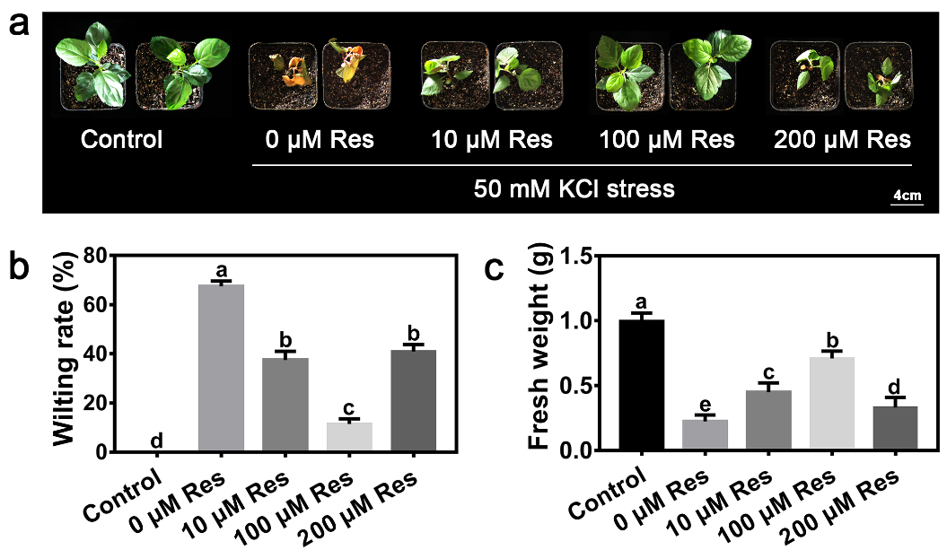

Figure S1 Phenotypes of M. hupehensis seedlings treated with 50 mM KCl stress and exogenous different concentrations of Res (0 μM, 10 μM, 100 μM, and 200 μM) after KCl stress for 15 days. Effect of different concentrations of Res on wilting rate (b) and fresh weight (c) of apple seedlings after KCl stress for 15 days. The data represent the mean ± SD of biological replicates. Different lowercase letters indicate significant differences, according to Fisher’s LSD (P <0.05).

Table S1 The primers used for qRT-PCR
Primer name | Forward primer | Reverse primer
qMhSKOR | CATCCTGACAACTGGTGGTATCG | AAGTACCTCAGAGCAATCCGTTT
qMhHAK5 | TTAATTTGAGTGTGTGAGAAGTGGCT | CTGTGAAATGGCGTGACTCG
qMhKAT1 | CTTTACCTCTCCTTTTGTTCCCTAC | GCAACAGTGTCCATTTGGTATTC
qMhTPK1 | GTCCACCGCAAATCCAGACTA | GAAGAGGCATGTCGTCGTAAAC
qMhNHX1 | TTCTGCGTGAACTTTAGACCCT | AAGACTGAGATTTCCTTTCAAGC
qMhNHX2 | CCACATTGATTCCAGTATTGCTT | CTCTTGAACTCTCCGTCACATTG
qMhCAX5 | AATGTAGACCAAATAACAGGGAGG | CTGCTCTTGTTGTCGTCGTTGT
qMhCHX15 | ATGGTTCAATAGTATGTTACGCTCC | GAATTTATCACTCTTTCCAAGCACC
qMhSOS1 | TACACTGTCGCTCTGCTCATCC | CCAGTCGTAAGGGAAAGTGAGC
qMhGPX6 | TTCCGAGAGTAAATCAATCCACG | AGGCAAACTCTACAATCTCGTCA
qMhPER65 | GGCATTCTATTCCCATTCCCTT | GAGTTGGAAGCGATGAGGAGG
qMhpoxN1 | GCTCCTCCAAATCATTGTTACTG | AAGAAGGACAGAAGCATCACAAC
qMhERF017 | ATGTCAAACCACTTCTCCAAAATCT | GGAAATTAAACTTGGCGGTGC
qMhMYB39 | AATGGGAATTGATCCTGTCACC | TGAGGTTGGATTTGGGGGTT
qMhWRKY28 | ATCAGGAACCGAAAGACCTTTACTA | ATCGCCTTCAATAGACGAAAATAGT
qMhMAPK3 | GCTACATGGGACATGACATTACTA | CCAAGATGTTCCTGCCTTTTAT
qMhANP2 | AGCATTTAGCCATTCAGGCATAC | GCAAAAAAGACGAGCTGGAGAG
qMhGK | ACTCTGTTTGTGAAGGTTCGGTCTA | ACAAGATTACTGAGCTTTCCAGTGT
ACTIN1 | CTTCAATGTGCCTGCCATGTAT | AATTTCCCGTTCAGCAGTAGTG

