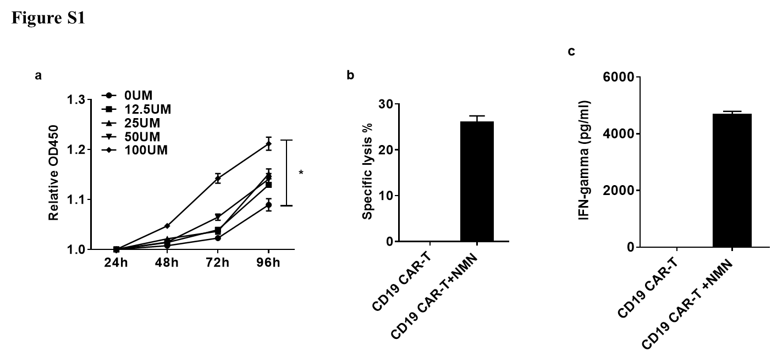
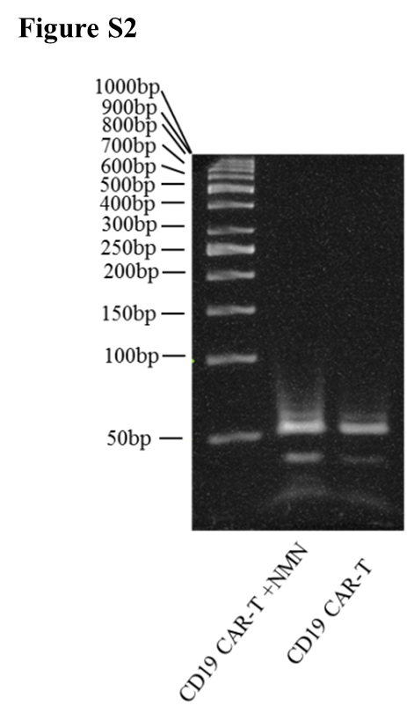
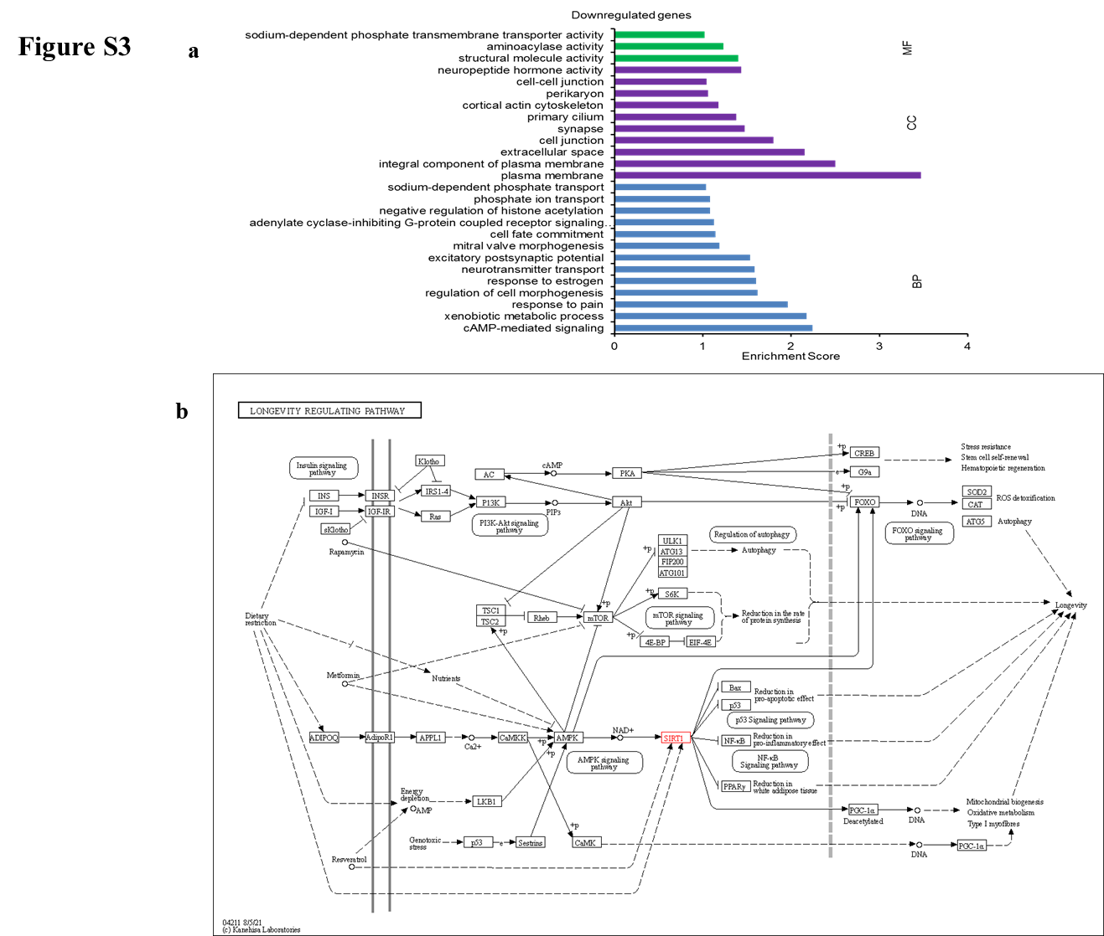

Supplementary Material
Figure S1. (a) Proliferation of CD19-CAR T cells under different concentrations of NMN CCK8 results showed that NMN (100UM) increased CD19 CAR-T cell proliferation at 72 and 96 h. *p < 0.01. (b) After co-culture with NALM-6 third times. the NMN-treated CD19 CAR-T cells still showed high specificlysis. (c) CD19 CAR-T cells still had higher INF-γ secretion after co-culture with NALM-6 third times.
Figure S2. The telomerase activity was analyzed using denaturing polyacrylamide gel electrophoresis. The gel-based TRAP assay of samples from the CD19 CAR-T cells and CD19 CAR-T cells treated with 100 UM NMN after co-culture with NALM-6 third times. The bottom bands (IC) represent the internal PCR control.
Figure S3. (a) The downregulated genes between the NMN treated CD19 CAR-T and untreated. (b) The pathway of Sirt1 on the KEGG website.

