Additional file 1
Figure S1.
The frequency of antibiotic. 62 glioma patients were allergic to Cephalosorin, 12 glioma patients were allergic to Cephalosporin and penicillin, 8 glioma patients were allergic to penicillin; only 2 glioama patients allergic to.

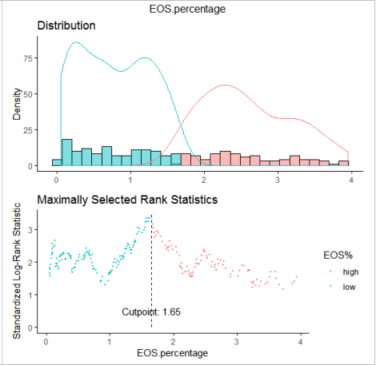
Figure S2.
The distribution of Eosinophil percentage (EOS%).

