Supplementary Material
Title: PREPRINT – Alcohol consumption during the COVID-19 pandemic in Europe: a large-scale cross-sectional study in 21 countries
Running head: Alcohol use during the COVID-19 pandemic
Authors: Carolin Kilian MSc, Jürgen Rehm PhD, Peter Allebeck PhD, Fleur Braddick MA, Antoni Gual PhD, Miroslav Barták PhD, Kim Bloomfield Dr.P.H., Artyom Gil PhD, Maria Neufeld Dipl.-Psych., Amy O’Donnell PhD, Benjamin Petruželka Mgr, Vladimir Rogalewicz PhD, Bernd Schulte PhD & Jakob Manthey PhD; with the European Study group on Alcohol use and COVID-19

Table of contents
Supplementary material S1: GATHER checklist 2
Supplementary material S2: Sensitivity analysis on the assumptions underlying the consumption- change score 4
Supplementary material S3: In-depth description of research methods 10
Supplementary material S4: Weight calculations 12
Supplementary material S5: Respondents with missing information 14
Supplementary material S6: Comparison of the study population with the actual population distribution 16
Supplementary material S7: Sample characteristics 21
Supplementary material S8: Change in alcohol consumption by country 22
Supplementary material S9: Sensitivity analyses for the association of changes in alcohol consumption and income 23
Supplementary material S10: Sensitivity analyses for the association of changes in alcohol consumption and distress experiences 24

Supplementary material S1: GATHER checklist
Item # | Checklist item | Reported on page #
Objectives and funding
1 | Define the indicator(s), populations (including age, sex, and geographic entities), and time period(s) for which estimates were made. | M6-M7
2 | List the funding sources for the work. | M2
Data Inputs
For all data inputs from multiple sources that are synthesized as part of the study:
3 | Describe how the data were identified and how the data were accessed. | M6-M7
4 | Specify the inclusion and exclusion criteria. Identify all ad-hoc exclusions. | M6-M7
5 | Provide information on all included data sources and their main characteristics. For each data source used, report reference information or contact name/institution, population represented, data collection method, year(s) of data collection, sex and age range, diagnostic criteria or measurement method, and sample size, as relevant. | M7-M9, S7
6 | Identify and describe any categories of input data that have potentially important biases (e.g., based on characteristics listed in item 5). | M9, S8-S14
For data inputs that contribute to the analysis but were not synthesized as part of the study:
7 | Describe and give sources for any other data inputs. | S9-S10, S12-S15
For all data inputs:
8 | Provide all data inputs in a file format from which data can be efficiently extracted (e.g., a spreadsheet rather than a PDF), including all relevant meta-data listed in item 5. For any data inputs that cannot be shared because of ethical or legal reasons, such as third-party ownership, provide a contact name or the name of the institution that retains the right to the data. | *
Data analysis
9 | Provide a conceptual overview of the data analysis method. A diagram may be helpful. | M7-M8, S8
10 | Provide a detailed description of all steps of the analysis, including mathematical formulae. This description should cover, as relevant, data cleaning, data pre-processing, data adjustments and weighting of data sources, and mathematical or statistical model(s). | M7-M8, S8-S10
11 | Describe how candidate models were evaluated and how the final model(s) were selected. | M7-M8, S8
12 | Provide the results of an evaluation of model performance, if done, as well as the results of any relevant sensitivity analysis. | S8, S12-S15, S18-S21
13 | Describe methods for calculating uncertainty of the estimates. State which sources of uncertainty were, and were not, accounted for in the uncertainty analysis. | M7-M8, S7
14 | State how analytic or statistical source code used to generate estimates can be accessed. | M8-M9
Results and Discussion
15 | Provide published estimates in a file format from which data can be efficiently extracted. | M20-M21, S16-S21
16 | Report a quantitative measure of the uncertainty of the estimates (e.g. uncertainty intervals). | M20-M21, S16-S21
17 | Interpret results in light of existing evidence. If updating a previous set of estimates, describe the reasons for changes in estimates. | M11-M15
18 | Discuss limitations of the estimates. Include a discussion of any modelling assumptions or data limitations that affect interpretation of the estimates. | M12-M13
Note. M = Manuscript, S = Supplementary Material. *All input data are publicly available
Table S1. Checklist of information (GATHER) that should be included in new reports of global health estimates

Supplementary material S2: Sensitivity analysis on the assumptions underlying the consumption- change score
In the main analyses, the individual categorical consumption-change indicators were combined to a single continuous scale. To test the underlying assumptions, several plots were created which allowed to compare the distribution of the original categorical scales against the mean calculated from the continuous scale.
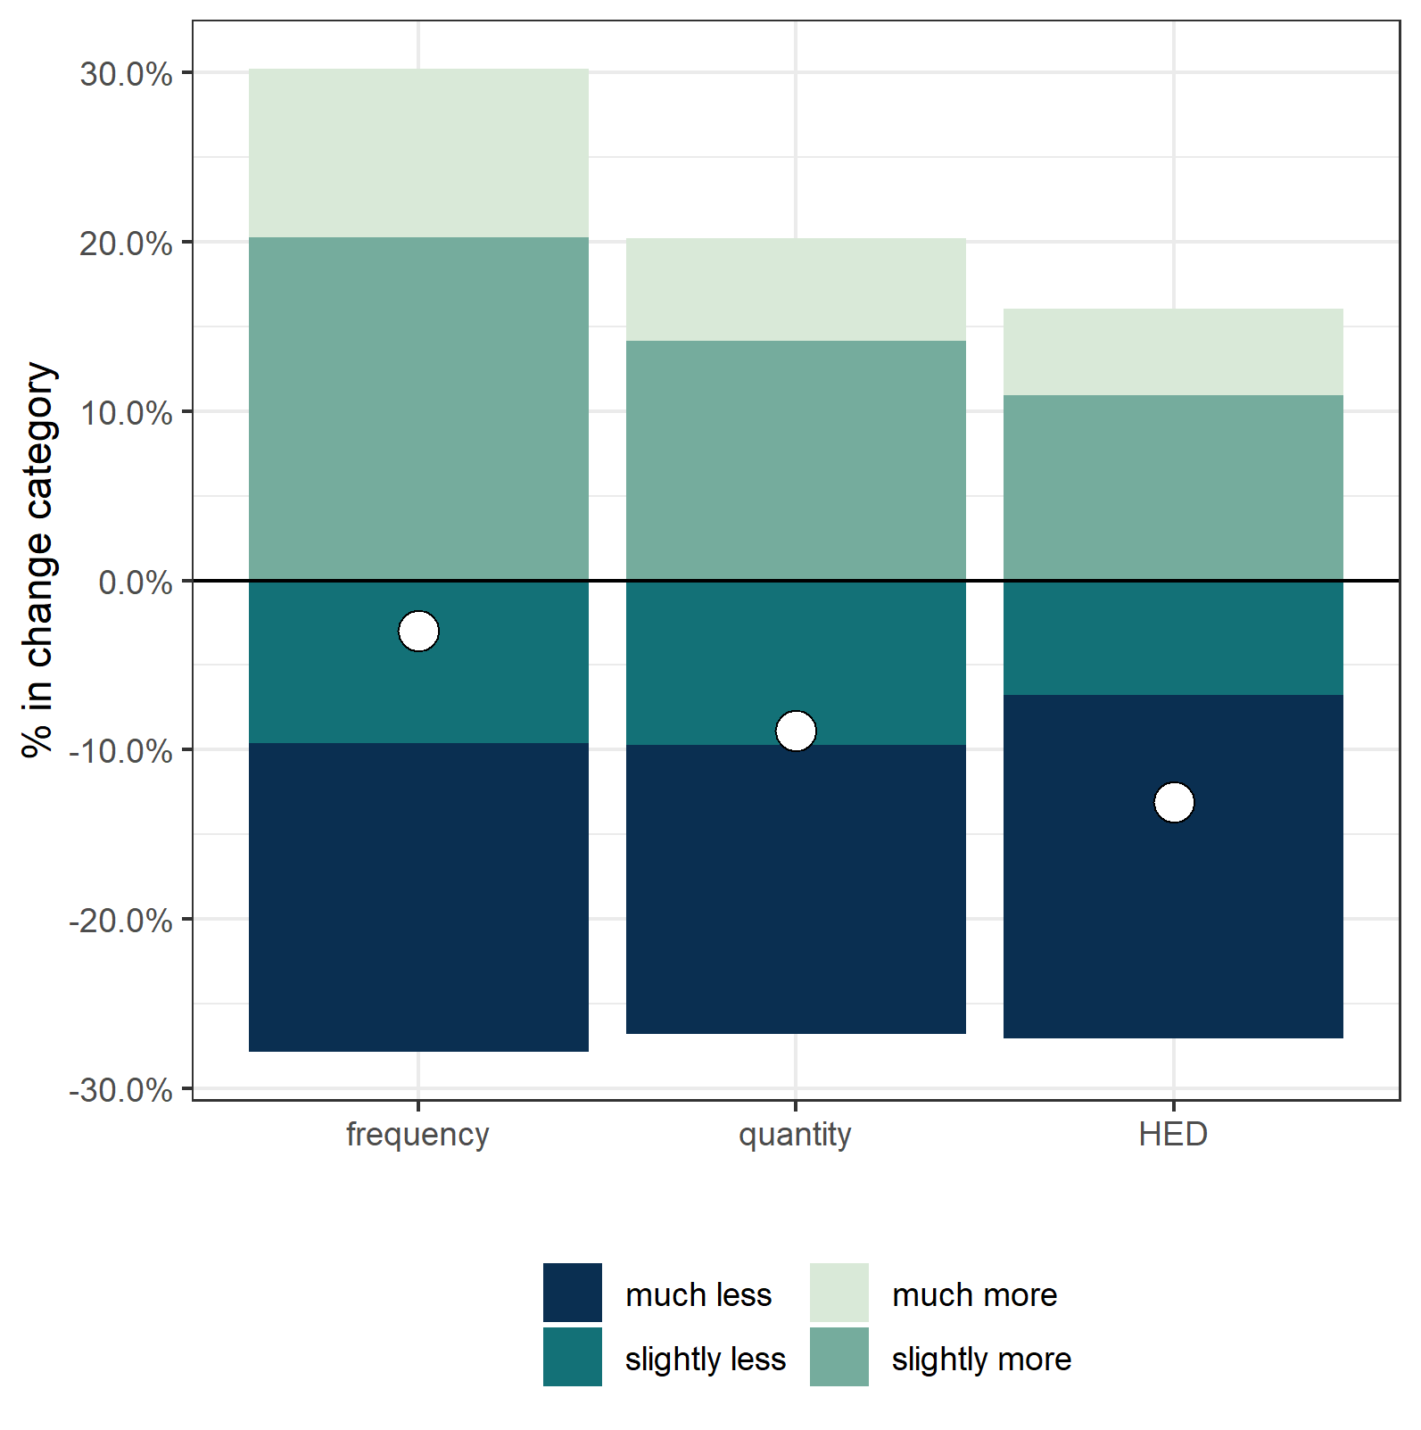
Figure S1. Distribution of the individual change indicators (drinking frequency, quantity of alcohol per occasion, frequency of HED events) and the mean change based on the calculated continuous variable (white circle).
In Figure S1, the distribution of each change category in each single indicator’s frequency, quantity and HED are plotted against the mean change calculated from the continuous variable (white circle). For demonstration purposes, consumption increases illustrated as positive values, while consumption decreases are illustrated as negative values–analogously to the mean change. Persons not changing their alcohol consumption are not represented in this plot.
For changes in frequency, more people indicated increases than decreases. However, consumption increases were mostly reported to be “slightly”, whereas the majority of decreases were of the more pronounced category (“much”). Thus, a slight decrease as the overall effect appears reasonable.
Comparing changes in quantity to changes in the frequency of HED evens, a smaller total size of these two bars can be observed. This indicates that both quantity of drinks per occasion and frequency of HED events were less prone to change during the pandemic than frequency of any drinking. Further, a considerably smaller proportion of respondents reported increases in alcohol quantity and even less so for HED, while the proportion of respondents reducing their use remained largely stable. Taken together, the mean estimates of more pronounced reductions for these indicators are consistent with the categorical distributions.

In the following Figures S2, S3, and S4, the individual change indicators frequency of drinking, quantities of alcohol per occasion, and frequency of HED events are illustrated for all countries in the same fashion as in Figure S1. Levels of decrease and increase in consumption are presented as well as the weighted mean change. Means were further adjusted for the baseline alcohol consumption as measured by the AUDIT-C sum score.
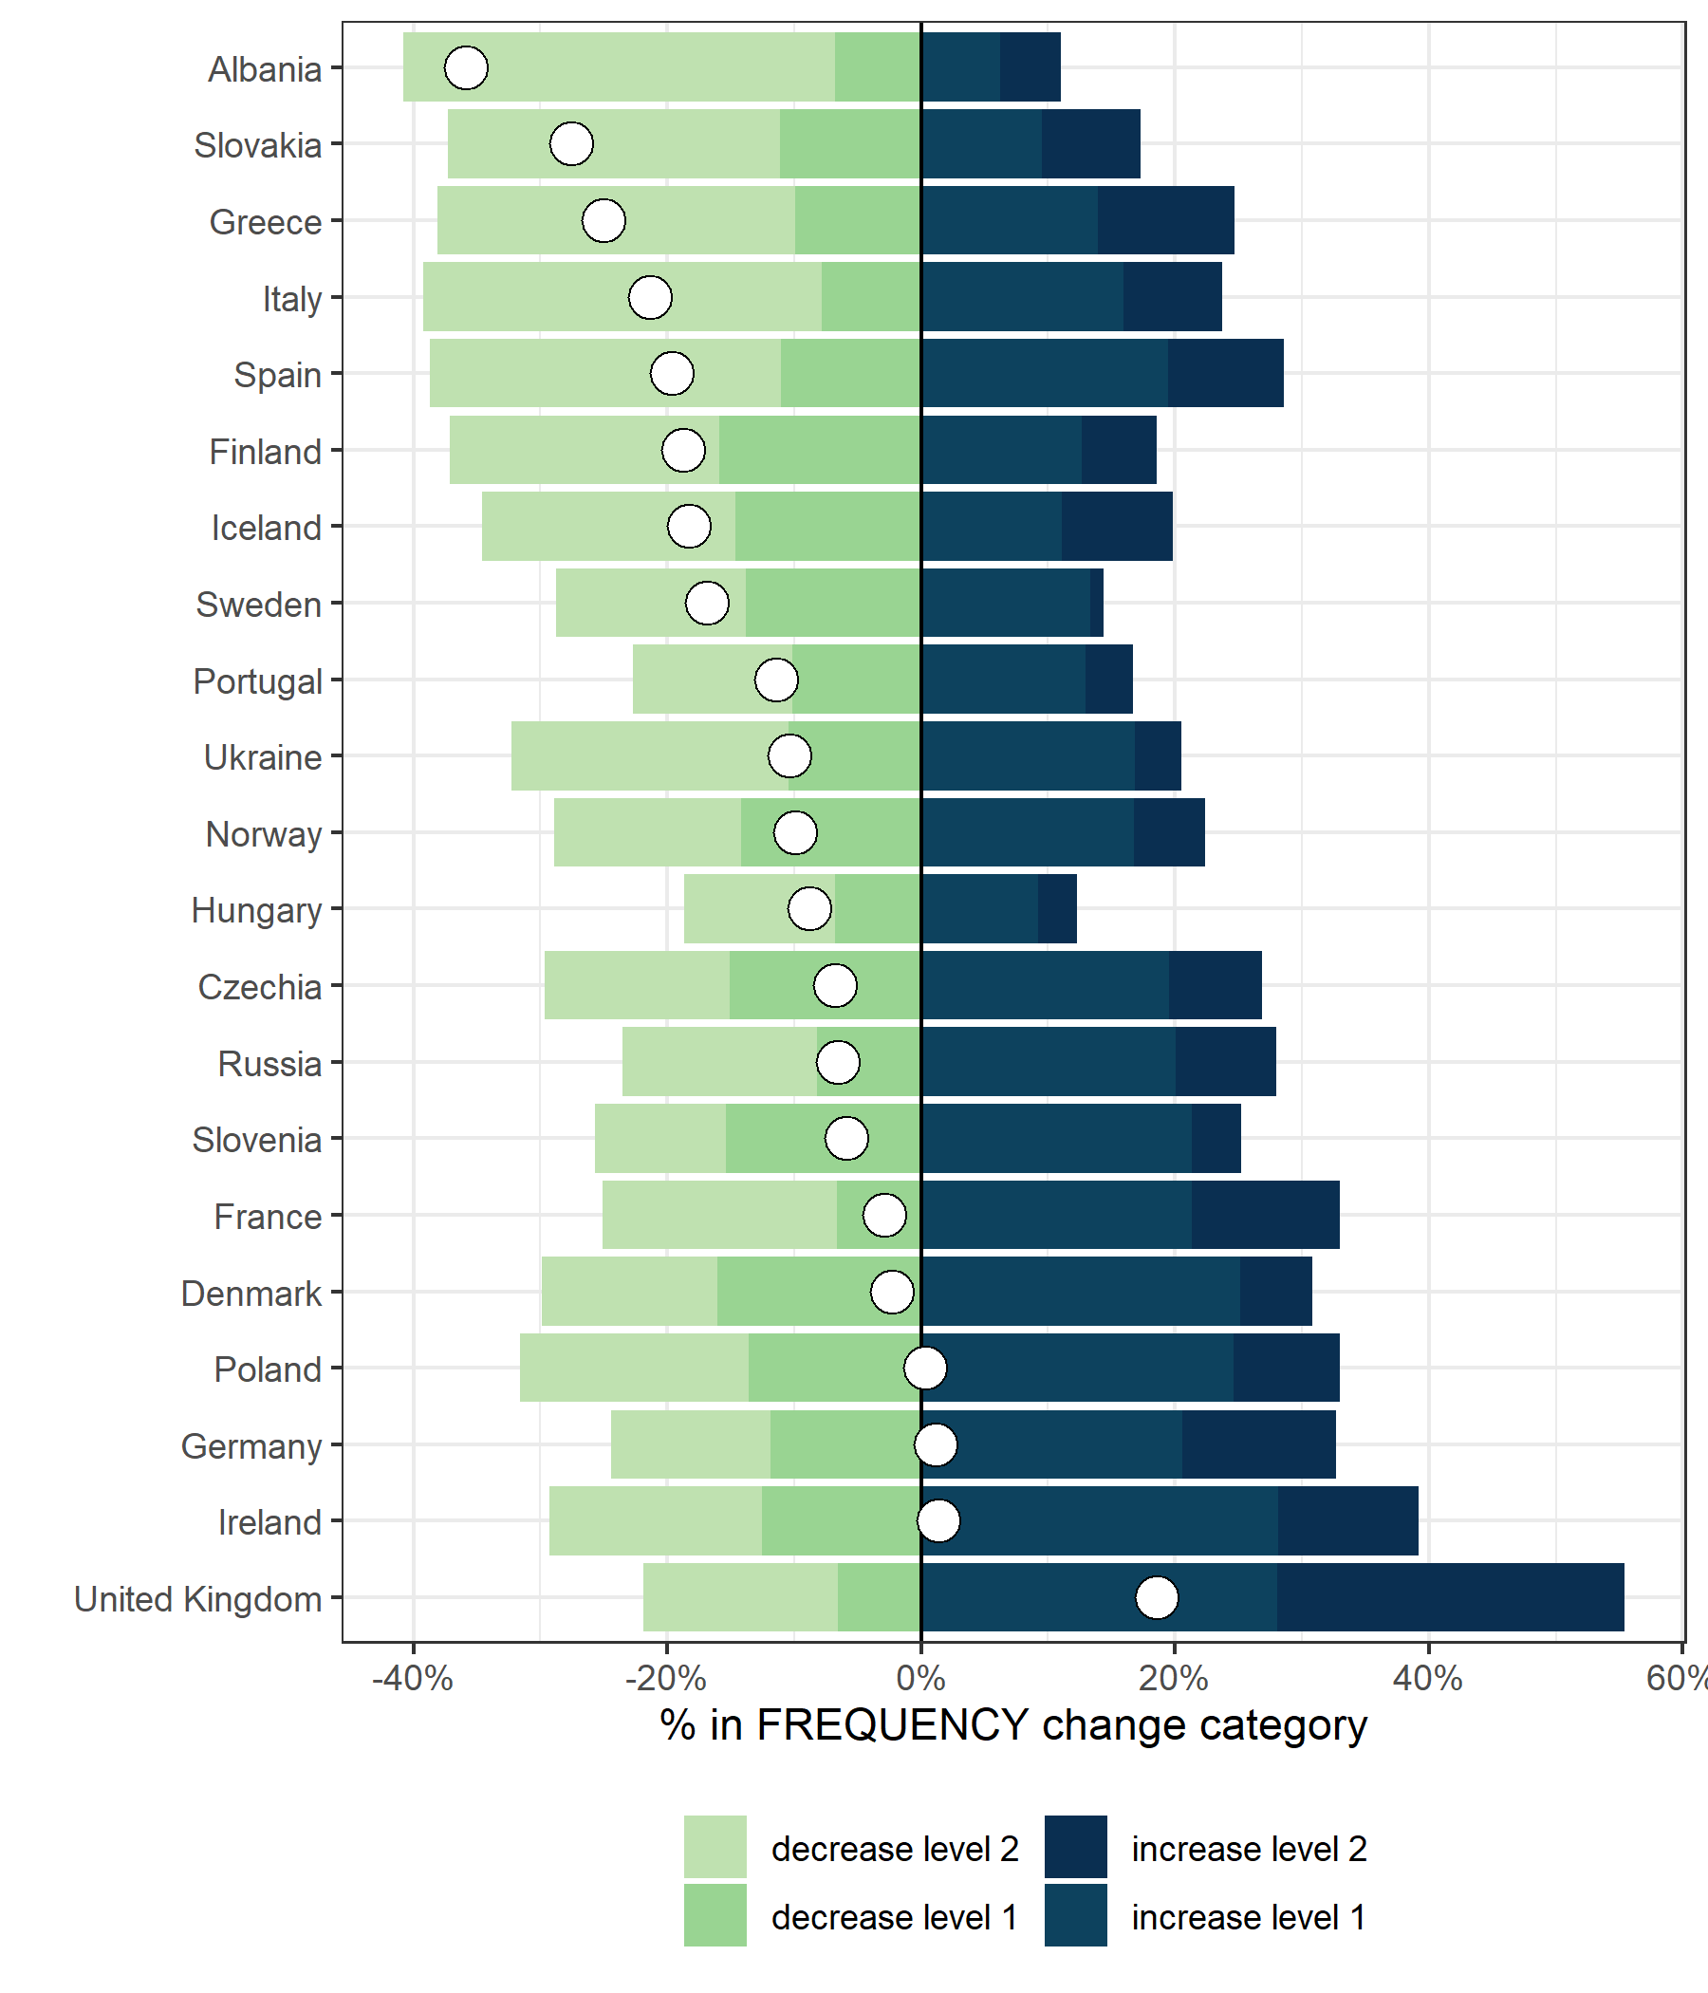
Figure S2. Distribution of the change indicator for frequency of drinking and the weighted mean change (white circle) by country.
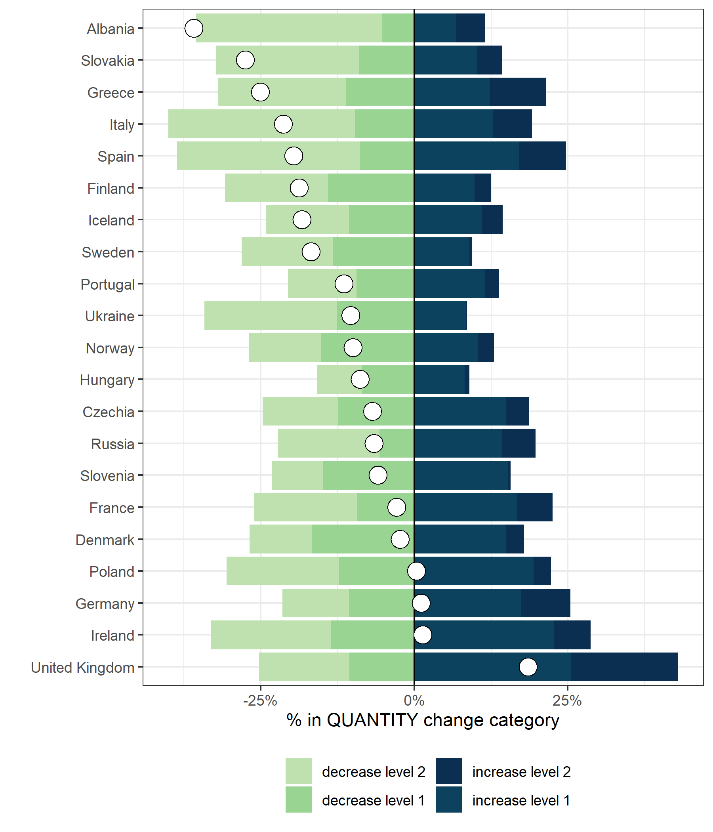
Figure S3. Distribution of the change indicator for quantities of alcohol per occasion and the weighted mean change (white circle) by country.

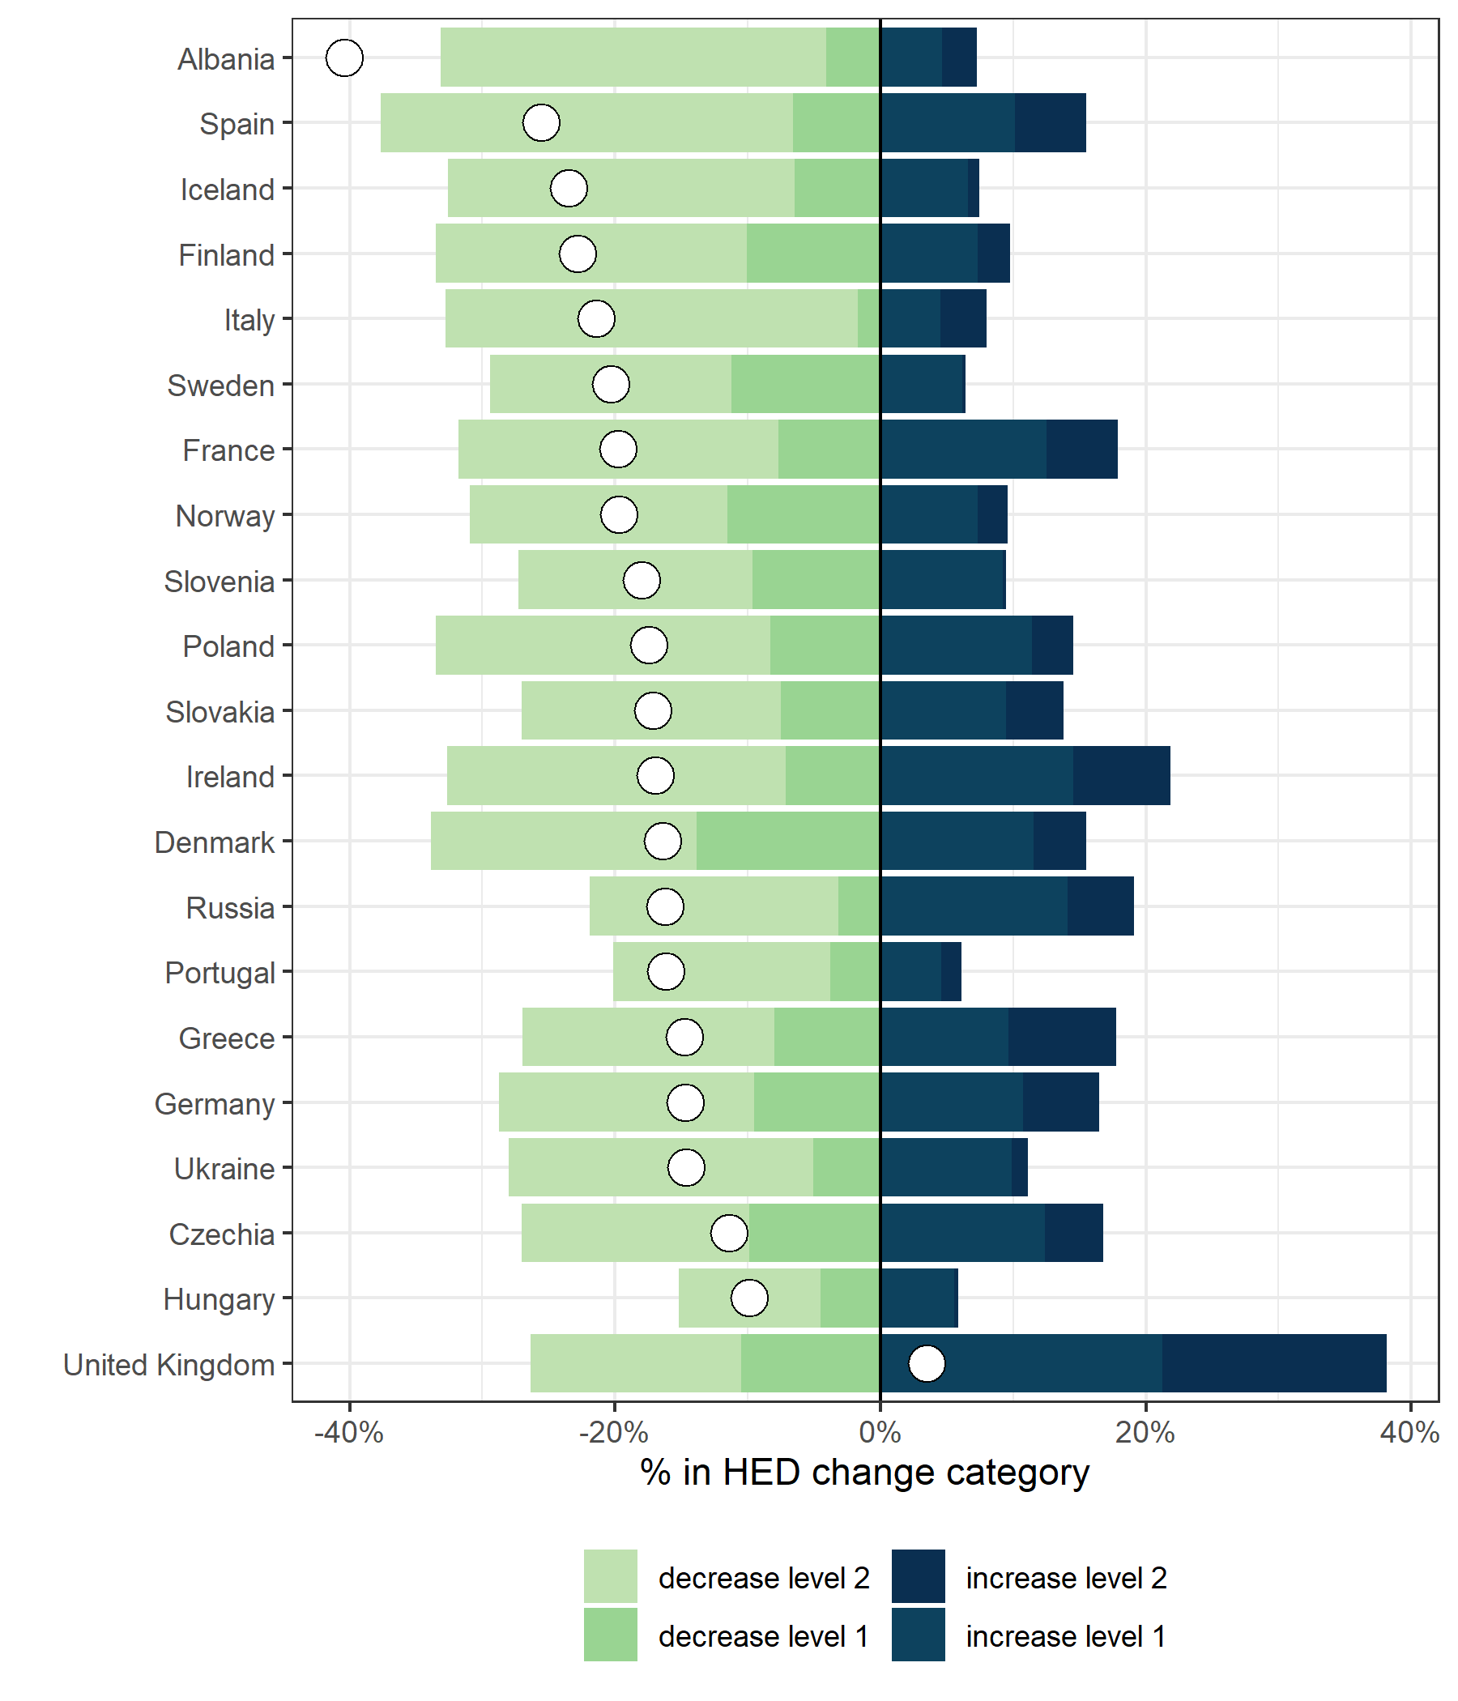
Figure S4. Distribution of the change indicator for frequency of heavy episodic drinking events and the weighted mean change (white circle) by country.

The plot shows that for the countries with largest estimated mean reductions, a substantially larger share of respondents reported any decreases in consumption as compared to any increases, corroborating the mean estimate. However, it should be noted that more people reported drinking much less (decrease level 2) than slightly less (decrease level 1), while the proportion of respondents reporting an increase were higher for increase level 1 (drinking slightly more) than increase level 2 (drinking much more).
An exception to the general pattern was observed in the UK, where a greater proportion of respondents reported increases rather than decreases. These figures are consistent with the mean estimates: all three consumption indicators indicated an increase in the United Kingdom. In Ireland decreases and increases in the frequency and quantity indicators were balanced (non-significant result, i.e. on average no change in alcohol consumption).
Overall, the categorical distribution of changes seems to be roughly consistent with the distribution of changes in the continuous variable, allowing for support of the assumptions for the main analyses.

Supplementary material S3: In-depth description of research methods
Measures
Monthly net household income before the spread of COVID-19 consisted of ten response categories ranging from ‘500€ or less’ to ‘4,500€ or more’, with income categories being adapted to national income distributions if the mean income within a country was clearly in the borderline categories of this standard distribution (see country-specific questionnaires [1]). Personal income was calculated by dividing the household income by the number of persons living in the same household. Both variables were first combined and then z-standardized for each country to account for differences in income distribution across countries.
Financial distress was assessed using two questions (i) ‘In the past month, have you experienced any negative consequences concerning your occupational or financial situation in relation to the spread of SARS-CoV-2 (i.e., coronavirus)?’, and (ii) ‘In the past month, did you perceive the ongoing situation related to the spread of SARS-CoV-2 (i.e., coronavirus) as stressful?’ The former used a four-level Likert scale (‘not at all’, ‘to some degree’, ‘to a substantial degree’, ‘to a very high degree’), while the second item recorded agreement (‘yes’) or not (‘no’). Both items were combined and financial distress was indicated by (i) reporting financial or occupational distress to at least a substantial degree and simultaneously (ii) reporting feeling distressed by the ongoing impacts on their daily lives related to the pandemic.
Experiences at least substantial distress due to changes in everyday life was considered to be a second distress indicator (‘In the past month, did you experience any restrictions of your everyday life as a result of measures implemented to contain the spread of SARS-CoV-2 (i.e., coronavirus)?’).
Statistical analysis
In the first multilevel regression model (hypothesis 2; model 1), the logarithmized and country-specific z-standardised monthly net household income was weighted according to the number of persons living in the household and was included as independent variable at three levels (low income: less than or equal to one standard deviation below the mean; average income: mean +/- one standard deviation; high income: more than or equal to one standard deviation above the mean).

In the second group of multilevel models (hypothesis 3), the two indicators of distress (financial distress, model 2; distress due to changes in everyday life, model 3) were examined as binary independent variables.
Regression models (hypothesis 2 and 3) were adjusted for gender, age, educational attainment, baseline alcohol consumption, and the week in which the respondent took the survey. For regression models addressing distress experiences (hypothesis 3), income group was included as an additional control variable. In order to account for cross-national differences in policies implemented to contain the spread of COVID-19, the country was included as a random intercept in the regression models.

Supplementary material S4: Weight calculations
- Survey weights
Survey weights were calculated as the inverse probability for taking the survey, calculated for 18 strata per country. These 18 strata were defined by the variables gender (male, female), age (18–34, 35–54, ≥55) and education (lower, middle, higher). The actual population distribution of these strata was obtained from EURSTAT [2]. For the Russian Federation, data were taken from the Russian census in 2010 [3] which was adapted to the total population estimate from 2019. The same procedure was applied to the Ukraine considering the most recent census data from 2001 [4] and population estimates from 2020 [5]. In the case of Albania, the average population distribution in strata of gender, age and education of the four neighbouring countries (Greece, Montenegro, North Macedonia and Serbia) was applied to the country's total population in 2019 [6].
As no population statistics were available on individuals with “other” gender, persons of “other” gender were randomly assigned to another gender within the same age- and education-strata for calculating the weights.
Strata were collapsed within each gender if the resulting weight exceeded 10. Out of all 38 country–gender combinations, no stratum was collapsed in 7 cases due to weights in all strata not exceeding 10. For the other country–gender combinations, the best fitting solution in collapsing strata was selected from the following options:
First–order: collapsing concerned stratum with 1 direct stratum neighbour; e.g. A with B or D
Second–order: collapsing concerned stratum with 3 stratum neighbours; e.g. A with B, D and E
Third–order: collapsing concerned stratum with 6 stratum neighbours; e.g. A with B, D, E, G and H

 | Education 1 | Education 2 | Education 3
Age 1 | A | B | C
Age 2 | D | E | F
Age 3 | G | H | I

For country–gender combinations for which only 1 stratum had to be collapsed, the best fitting solution was a first–order collapse with the resulting weight being lower than 10. If multiple first–order collapses had a weight below 10, the lowest was chosen. If no first–order collapse had a weight lower 10, a second–order and subsequently a third–order solution was considered. The same criteria (a weight lower 10 and choosing the solution with the lowest weight for multiple collapses) were applied in determining the best fitting solution.
For country–gender combinations for which more than 1 stratum had to be collapsed, the overlap of best fitting strata collapses was considered. The most economical solution was chosen, i.e. order 2 was preferred over order 3 combinations. In addition, collapsing 2 (or 3) age groups was preferred over collapsing 2 (or 3) education groups. If this allowed several options, the smaller weight was chosen. Third order solutions were applied in 9 country–gender combinations (Albania – Females, Denmark – Males, France – Males, Greece – Females, Poland – Females, Portugal – Males, Slovakia – Males, Ukraine – Males and Ukraine – Females).

- Population weights
Population weights were calculated using the same procedure as described for survey weights. There are two differences:
- Population weights were calculated as the inverse probability for taking the survey, taking into account the respective country population. In other words, the weights were calculated to arrive at estimates representing the population of the 21 European countries.
- The weight selection procedure was slightly adapted: The weight threshold was elevated to 30 to enable weights to be applied taking into account the total population. For strata in which population weights exceeded the prior threshold 10, at least 10 observations have to exist. This procedure allowed to provide weights below 30 for all strata with the exception of Russian Men (population weight: 34.78). Third order solutions have to be applied in 8 country–gender combinations (France – Males, France – Females, Poland – Females, Russia – Males, Russia – Females, Slovakia – Males, Ukraine – Males and Ukraine – Females).

Supplementary material S5: Respondents with missing information

Table S2. Number and proportion of respondents with missing information by country.
Country | Number of respondents with missing information | Number of participants within the country | % missings
Czechia | 217 | 1,555 | 14.0
Albania | 87 | 577 | 15.1
Denmark | 264 | 2,566 | 10.3
Finland | 261 | 3,800 | 6.9
France | 29 | 391 | 7.4
Germany | 159 | 1,659 | 9.6
Greece | 93 | 555 | 16.8
Hungary | 47 | 545 | 8.6
Iceland | 52 | 602 | 8.6
Ireland | 52 | 544 | 9.6
Italy | 129 | 991 | 13.0
Norway | 1,358 | 17,092 | 7.9
Poland | 129 | 1,148 | 11.2
Portugal | 45 | 704 | 6.4
Russia | 120 | 819 | 14.7
Slovakia | 85 | 506 | 16.8
Slovenia | 57 | 563 | 10.1
Spain | 335 | 3,139 | 10.7
Sweden | 36 | 808 | 4.5
Ukraine | 101 | 538 | 18.8
United Kingdom | 133 | 962 | 13.8
Total | 3,789 | 40,064 | 9.5

Table S3. Comparison of key demographic characteristics of the respondents excluded because of missing information versus the final sample.
 | Respondents with missing information (n = 3,789) | Final sample (n = 31,964)
% Women (95% CI) | 59.0 (53.9 – 63.9) | 47.5 (46.6 – 48.4)
% Other (95% CI) | 1.0 (0.4 – 2.5) | 0.4 (0.3 – 0.6)
Mean age (95% CI) | 39.4 (37.7 – 41.0) | 43.1 (42.8 – 43.4)
% Primary education (95% CI) | 11.0 (8.2 – 14.6) | 11.5 (10.8 – 12.3)
% Secondary education (95% CI) | 49.7 (44.7 – 54.7) | 50.2 (49.2 – 51.1)
% High education (95% CI) | 39.3 (34.8 – 44.0) | 38.4 (37.6 – 39.1)
Mean AUDIT Score (95% CI) | 4.0 (3.6 – 4.3) | 4.5 (4.5 – 4.6)
Note. CI = Confidence interval. Weighted Means and Proportions.

Supplementary material S6: Comparison of the study population with the actual population distribution

- Comparison of sociodemographic characteristics for the overall sample

Table S4. Demographic characteristics of the survey population and the actual European population.
 |  | European population* | Survey population
 |  | European population* | Unweighted | Weighted | n
Gender (%) | Women | 51.9 | 69.0 | 50.7 | 22,064
 | Men | 48.1 | 30.7 | 48.6 | 9,808
 | Other | NA | 0.3 | 0.7 | 92
Age groups (%) | 18-34 years | 30.6 | 34.4 | 32.4 | 11,008
 | 35-54 years | 38.4 | 48.8 | 45.3 | 15,587
 | ≥ 55 years | 30.9 | 16.8 | 22.3 | 5,369
Educational attainment (%) | Primary | 27.9 | 3.4 | 8.8 | 1,088
Educational attainment (%) | Secondary | 42.2 | 25.7 | 43.0 | 8,208
 | Higher | 29.9 | 70.9 | 48.2 | 22,668
Note. NA = Not available. *Population data based on EUROSTAT 2018 [2].

Brief summary
Compared to the actual European population of the participating countries, our sample included a higher proportion of women, middle-aged adults (35-54 years), and individuals with higher educational attainment, while people with only a primary education were underrepresented (for details, see Supplementary Material S5). After weighting the data, the gender distribution matched the actual European population, with approximate patterns for age. A comparison of the median per capita income per country between an external data source [27] and the present data showed that the median income in the survey population was above the median per capita income in most countries. Further analyses showed that the distribution of drinking patterns in our sample was mostly similar to distributions reported in representative general population surveys, with a slight tendency of heavy drinkers to be overrepresented in our sample.

- Comparison of median per capita income by country

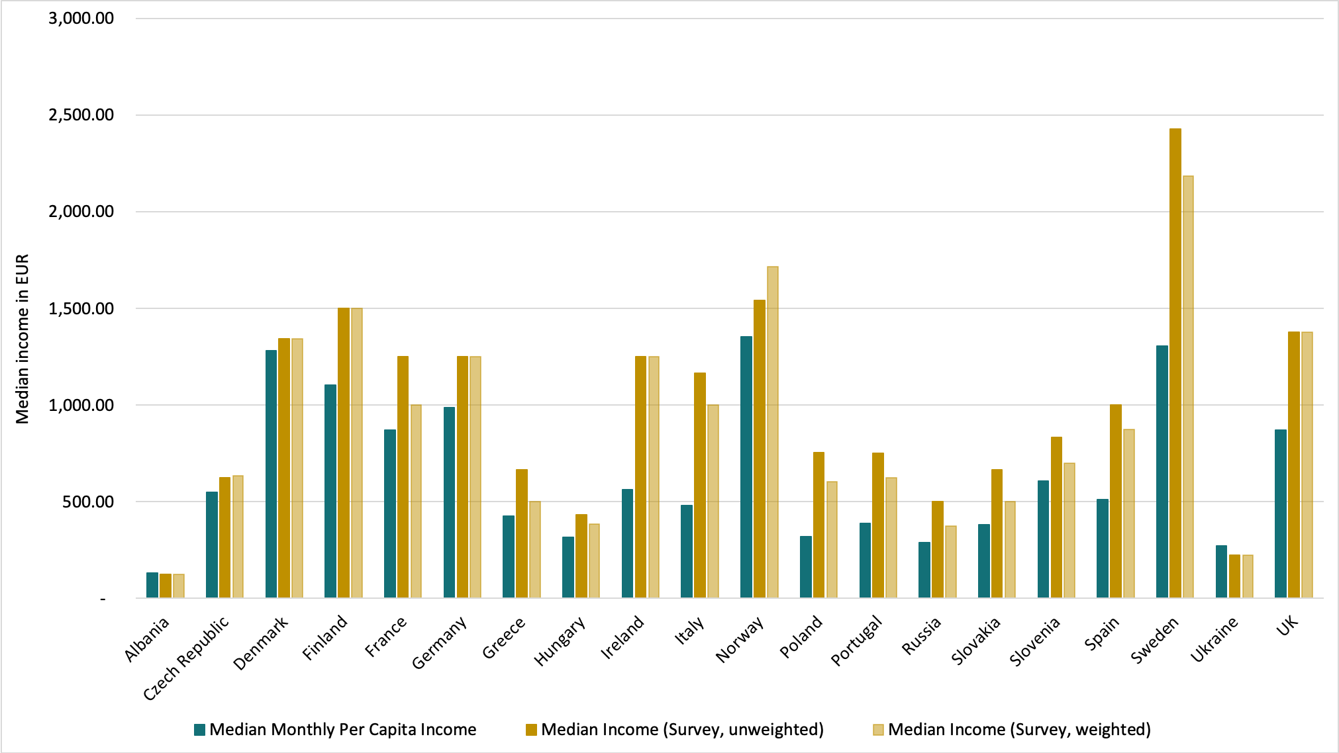
Median per capita income by country were available at World population review website [7]. Annual median per capita income was recalculated into monthly into monthly income in EUR to allow comparison with the data collected. Currencies other than EUR were converted into EUR to allow comparison (see Table 1 in the manuscript for national median incomes).
Figure S5. Median per capita income by country based on external data (World Population Review)[7], unweighted survey data and weighted survey data. Data were not available for Iceland.

- Comparison of the AUDIT-C estimates

To assess a possible sample bias in drinking patterns, results of this survey were compared to other studies.
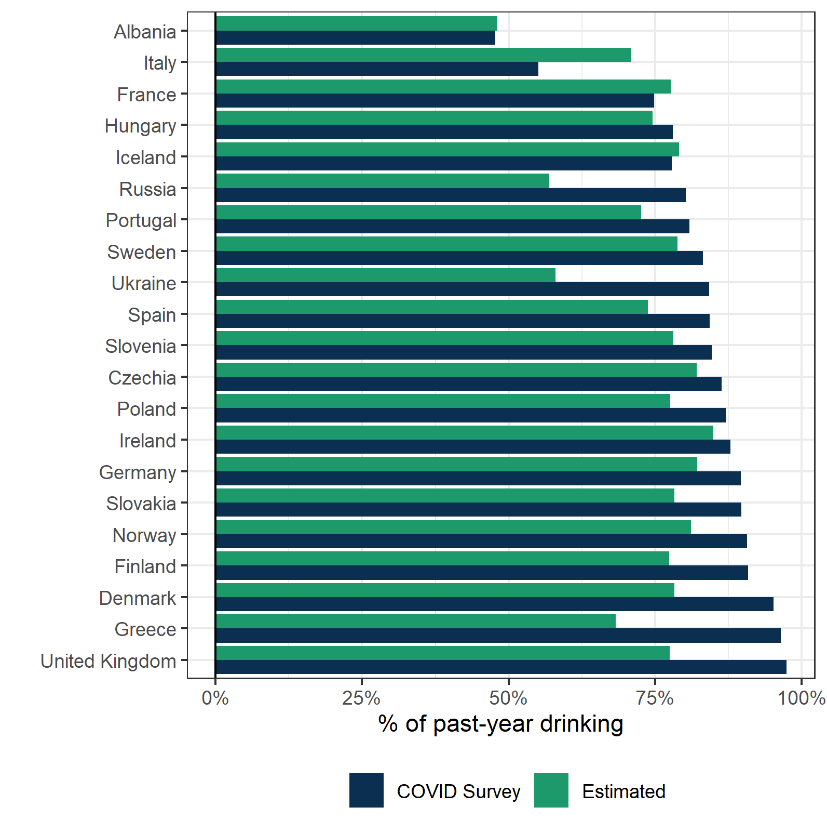
In Figure S4, the prevalence of past-year drinking as obtained from this study and a global modelling study is contrasted [8]. While the present survey did not intend to assess the prevalence of any drinking in the population, there was a considerable overlap with the estimated figures. Except for Italy, the prevalence of past-year drinking was on average higher in the present survey. This gap may be due to the relatively rarely drinking elderly persons being underrepresented in the current sample–a common problem in general population surveys.
Figure S6. Prevalence of past-year drinkers assessed in the survey and prevalence estimates based on a global modelling study by country.

Further, we compared the distribution of the AUDIT-C responses in this survey to findings from other general population samples, as available.
Norway:
The distribution of responses for each single AUDIT-C item from a general population survey conducted in 2012 and 2013 in Norway is contrasted against the distribution of the present survey in Figure S5. Overall, the distribution of responses in all three AUDIT-C items in both the present and the other survey is very similar for the Norwegian sample and less so for the other European countries. Compared to the 2012/2013, drinkers reported higher frequencies of any and heavy episodic drinking in the present survey.
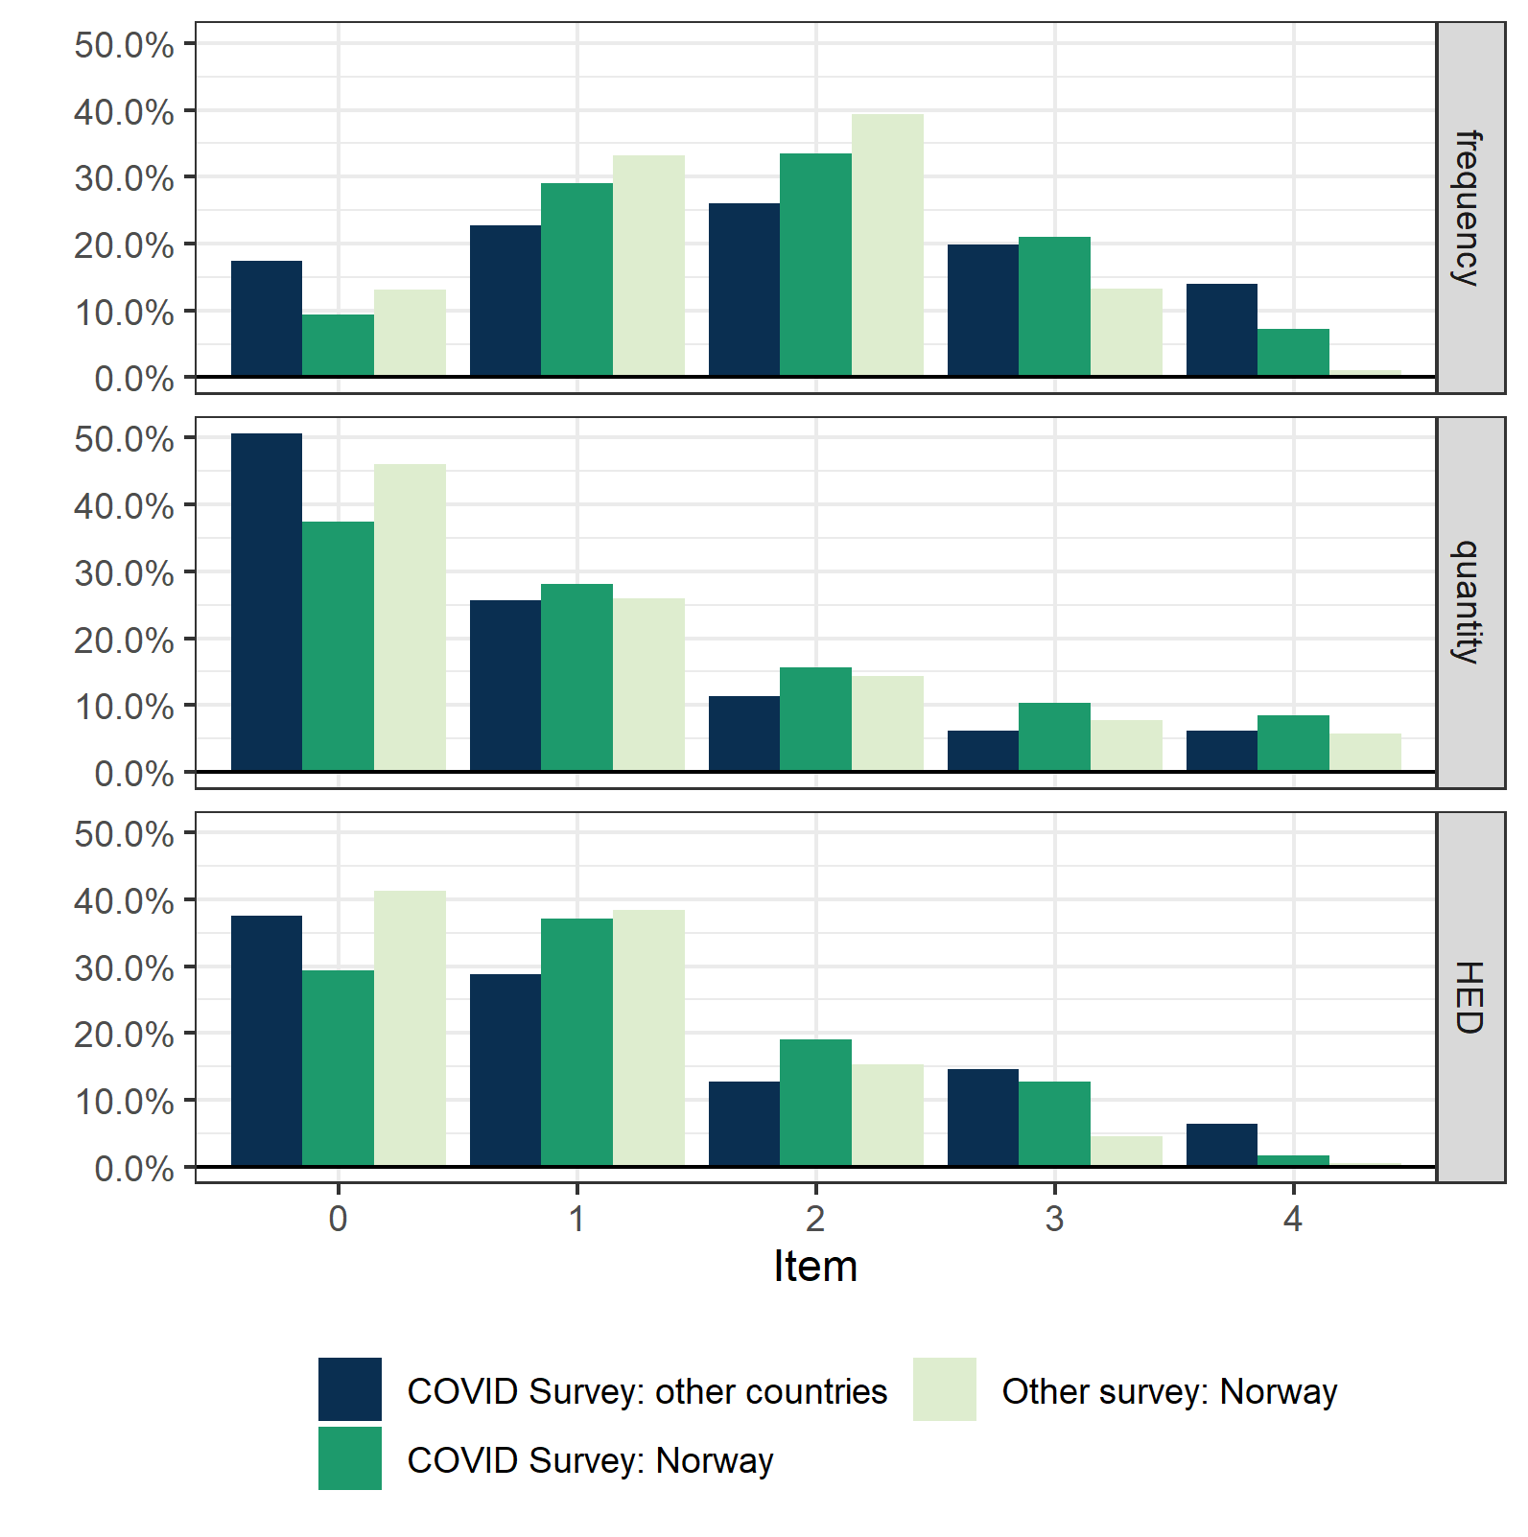
Figure S7. The distribution of responses for each AUDIT-C item from the present survey (Norway, total sample excluding Norway) and a general population survey from 2012/2013 (Norway).

Germany
For Germany, no recent study reporting AUDIT-C findings of the general population was available. In 1996/1997, the AUDIT-C was administered in a general population sample [9], resulting in a mean score of 3.15, which was considerably lower than the mean score found in the present survey for Germany (4.6) and all other countries (4.4). This discrepancy might be due to changes in drinking patterns that have occurred since the mid 90s (more abstainers but more heavy drinking among drinkers) [8].
Ireland
For Ireland, data from the National Alcohol Survey is available for the year 2013 [10]. As compared to the 2013 survey (54.3%), slightly more people from Ireland met the threshold of harmful drinking (AUDIT-C sum score ≥ 5) in our survey (59.1%). In contrast, in all other countries only 40.6% met this threshold.
With regards to at least monthly heavy episodic drinking, both the 2013 (37.3%) and the present survey (42.1%) reported similar prevalence.
Portugal
In Portugal, available data from 2016/2017 [11] suggest that 17.8% of males and 12.6% of females who report past-year drinking were drinking excessively (cut-off: males ≥ 5; females ≥ 4). In contrast, considerably higher proportions were reported in the present survey among respondents from Portugal (males: 31.5%; females: 21.2%).

Supplementary material S7: Sample characteristics
Table S5. Descriptive statistics by country.
Country | % Women (95% CI) |  | % Other gender (95% CI) |  | Mean age (SD) |  | % Secondary education (95% CI) |  | % High education (95% CI)
Country | unweighted | weighted | unweighted | weighted | unweighted | weighted | unweighted | weighted | unweighted | weighted
Albania | 80.8 (76.2 – 84.7) | 46.9 (37.8 – 56.2) | 0.6 (0.2 – 2.4) | 1.8 (0.4 – 6.8) | 27.1 (13.7) | 43.1 (13.7) | 41.4 (36.3 – 46.8) | 41.4 (36.3 – 46.8) | 56.5 (51.1 – 61.7) | 24.7 (18.3 – 32.4)
Czechia | 68.5 (65.9 – 70.9) | 48.6 (43.6 – 53.6) | 0.2 (0.0 – 0.6) | 0.1 (0.0 – 0.3) | 38.0 (12.8) | 45.5 (12.8) | 30.6 (28.2 – 33.2) | 30.6 (28.2 – 33.2) | 67.4 (64.8 – 69.9) | 31.9 (28.1 – 35.9)
Denmark | 78.6 (76.9 – 80.3) | 49.4 (45.5 – 53.2) | 0.3 (0.2 – 0.7) | 0.7 (0.3 – 1.7) | 32.7 (13.2) | 36.2 (13.2) | 34.3 (32.4 – 36.3) | 34.3 (32.4 – 36.3) | 61.1 (59.1 – 63.1) | 34.4 (31.5 – 37.4)
Finland | 76.3 (74.8 – 77.7) | 48.6 (46.0 – 51.1) | 1.0 (0.7 – 1.4) | 1.4 (0.9 – 2.3) | 45.8 (10.5) | 45.2 (10.5) | 39.1 (37.5 – 40.7) | 39.1 (37.5 – 40.7) | 58.0 (56.4 – 59.6) | 40.0 (37.7 – 42.3)
France | 59.5 (54.3 – 64.5) | 50.4 (43.0 – 57.8) | 0.3 (0.0 – 2.0) | 0.6 (0.1 – 4.2) | 49.8 (14.9) | 47.6 (14.9) | 16.1 (12.7 – 20.4) | 16.1 (12.7 – 20.4) | 79.0 (74.5 – 83.0) | 51.3 (43.8 – 58.8)
Germany | 50.4 (47.9 – 52.9) | 47.8 (44.5 – 51.1) | 0.9 (0.5 – 1.5) | 1.0 (0.5 – 2.1) | 41.2 (13.5) | 44.7 (13.5) | 27.5 (25.2 – 29.8) | 27.5 (25.2 – 29.8) | 58.1 (55.5 – 60.6) | 27.3 (25.1 – 29.7)
Greece | 59.9 (55.4 – 64.3) | 46.4 (38.3 – 54.6) | 0.2 (0.0 – 1.5) | 0.6 (0.1 – 4.0) | 36.4 (12.1) | 38.2 (12.1) | 20.7 (17.2 – 24.6) | 20.7 (17.2 – 24.6) | 78.6 (74.7 – 82.2) | 29.4 (24.2 – 35.2)
Hungary | 66.3 (62.0 – 70.4) | 49.5 (43.6 – 55.5) | 0.2 (0.0 – 1.4) | 0.2 (0.0 – 1.1) | 42.4 (15.6) | 45.7 (15.6) | 26.6 (22.9 – 30.6) | 26.6 (22.9 – 30.6) | 49.1 (44.7 – 53.5) | 21.8 (18.5 – 25.6)
Iceland | 81.1 (77.5 – 84.2) | 48.2 (40.4 – 56.1) | 0.2 (0.0 – 1.3) | 0.3 (0.0 – 2.4) | 53.3 (12.6) | 46.3 (12.6) | 21.3 (18.1 – 25.0) | 21.3 (18.1 – 25.0) | 68.8 (64.8 – 72.6) | 36.9 (30.5 – 43.7)
Ireland | 66.9 (62.6 – 71.0) | 48.2 (39.0 – 57.5) | 0.4 (0.1 – 1.6) | 0.2 (0.0 – 0.8) | 46.9 (12.5) | 45.7 (12.5) | 7.6 (5.6 – 10.4) | 7.6 (5.6 – 10.4) | 91.1 (88.2 – 93.3) | 40.4 (32.8 – 48.4)
Italy | 64.1 (60.8 – 67.3) | 52.4 (46.7 – 58.0) | 0.0 (0.0 – 0.0) | 0.0 (0.0 – 0.0) | 50.5 (13.1) | 48.4 (13.1) | 23.7 (20.9 – 26.7) | 23.7 (20.9 – 26.7) | 65.1 (61.8 – 68.3) | 18.1 (15.8 – 20.7)
Norway | 72.9 (72.2 – 73.6) | 47.8 (46.6 – 49.0) | 0.2 (0.1 – 0.2) | 0.2 (0.1 – 0.4) | 41.3 (12.7) | 44.6 (12.7) | 28.3 (27.6 – 29.0) | 28.3 (27.6 – 29.0) | 68.4 (67.7 – 69.1) | 39.9 (38.9 – 41.0)
Poland | 37.1 (34.2 – 40.1) | 47.7 (41.2 – 54.4) | 0.3 (0.1 – 0.9) | 0.7 (0.1 – 3.6) | 34.0 (11.3) | 36.2 (11.3) | 21.7 (19.3 – 24.3) | 21.7 (19.3 – 24.3) | 76.9 (74.2 – 79.4) | 28.5 (24.5 – 32.7)
Portugal | 66.7 (63.0 – 70.2) | 50.1 (42.2 – 58.0) | 0.0 (0.0 – 0.0) | 0.0 (0.0 – 0.0) | 46.8 (11.2) | 47.4 (11.2) | 9.5 (7.5 – 12.0) | 9.5 (7.5 – 12.0) | 90.2 (87.7 – 92.2) | 45.3 (38.0 – 52.7)
Russia | 59.4 (55.6 – 63.1) | 56.4 (48.7 – 63.8) | 0.4 (0.1 – 1.4) | 0.4 (0.1 – 1.6) | 38.2 (13.4) | 40.7 (13.4) | 11.9 (9.7 – 14.6) | 11.9 (9.7 – 14.6) | 86.7 (83.9 – 89.1) | 40.5 (34.2 – 47.2)
Slovakia | 65.8 (61.0 – 70.2) | 49.6 (40.7 – 58.5) | 0.0 (0.0 – 0.0) | 0.0 (0.0 – 0.0) | 34.1 (12.5) | 35.5 (12.5) | 26.1 (22.1 – 30.6) | 26.1 (22.1 – 30.6) | 71.7 (67.1 – 75.8) | 24.9 (20.3 – 30.3)
Slovenia | 73.4 (69.4 – 77.1) | 47.4 (39.4 – 55.6) | 0.4 (0.1 – 1.6) | 0.9 (0.1 – 5.4) | 43.5 (12.0) | 46.5 (12.0) | 16.0 (13.0 – 19.5) | 16.0 (13.0 – 19.5) | 83.2 (79.7 – 86.2) | 29.6 (24.5 – 35.1)
Spain | 65.2 (63.4 – 67.0) | 50.5 (47.1 – 53.8) | 0.0 (0.0 – 0.3) | 0.0 (0.0 – 0.1) | 41.4 (11.6) | 44.1 (11.6) | 13.3 (12.1 – 14.6) | 13.3 (12.1 – 14.6) | 84.0 (82.6 – 85.3) | 34.4 (32.0 – 36.9)
Sweden | 78.9 (75.9 – 81.7) | 49.2 (42.0 – 56.4) | 0.1 (0.0 – 0.9) | 0.2 (0.0 – 1.2) | 47.8 (13.9) | 44.8 (13.9) | 16.3 (13.8 – 19.0) | 16.3 (13.8 – 19.0) | 83.0 (80.1 – 85.5) | 40.1 (34.2 – 46.4)
Ukraine | 60.7 (56.0 – 65.2) | 46.8 (37.4 – 56.3) | 0.0 (0.0 – 0.0) | 0.0 (0.0 – 0.0) | 36.8 (14.2) | 31.5 (14.2) | 15.1 (12.0 – 18.8) | 15.1 (12.0 – 18.8) | 83.5 (79.7 – 86.8) | 18.5 (14.9 – 22.8)
United Kingdom | 63.8 (60.4 – 67.0) | 49.0 (43.0 – 55.0) | 0.4 (0.1 – 1.1) | 0.6 (0.1 – 2.7) | 45.9 (13.9) | 46.1 (13.9) | 14.8 (12.6 – 17.4) | 14.8 (12.6 – 17.4) | 83.5 (80.8 – 85.9) | 43.1 (37.8 – 48.5)
TOTAL | 69.0 (68.5 – 69.5) | 50.7 (48.8 – 52.7) | 0.3 (0.2 – 0.4) | 0.6 (0.4 – 1.1) | 41.1 (13.1) | 42 (13.1) | 25.7 (25.2 – 26.2) | 25.7 (25.2 – 26.2) | 70.9 (70.4 – 71.4) | 48.2 (46.3 – 50.2)
Note: CI = Confidence Interval, SD = Standard deviation.

Supplementary material S8: Change in alcohol consumption by country
Table S6. Weighted average of the consumption-change score and individual consumption change variables by country.
Country | Consumption-change score |  | Change in drinking frequency |  | Change in the quantity of alcohol being consumed per drinking occasion |  |  | Change in HED frequency
Country | Mean (95% CI) | p–value | Mean (95% CI) | p–value | Mean (95% CI) | p–value |  | Mean (95% CI) | p–value
Albania | -0.37 (-0.52 to -0.22) | < .001 | -0.36 (-0.53 to -0.19) | < .001 | -0.34 (-0.52 to -0.17) | < .001 |  | -0.40 (-0.57 to -0.24) | < .001
Czechia | -0.09 (-0.13 to -0.04) | < .001 | -0.07 (-0.12 to -0.01) | .014 | -0.08 (-0.12 to -0.03) | .001 |  | -0.11 (-0.16 to -0.06) | < .001
Denmark | -0.09 (-0.12 to -0.06) | < .001 | -0.02 (-0.06 to 0.02) | .261 | -0.08 (-0.11 to -0.05) | < .001 |  | -0.16 (-0.20 to -0.12) | < .001
Finland | -0.19 (-0.22 to -0.17) | < .001 | -0.19 (-0.21 to -0.16) | < .001 | -0.17 (-0.19 to -0.14) | < .001 |  | -0.23 (-0.25 to -0.20) | < .001
France | -0.11 (-0.19 to -0.04) | .003 | -0.03 (-0.12 to 0.06) | .512 | -0.11 (-0.19 to -0.03) | .005 |  | -0.20 (-0.28 to -0.11) | < .001
Germany | -0.05 (-0.08 to -0.02) | .001 | 0.01 (-0.03 to 0.05) | .553 | -0.02 (-0.06 to 0.01) | .191 |  | -0.15 (-0.18 to -0.11) | < .001
Greece | -0.20 (-0.28 to -0.13) | < .001 | -0.25 (-0.35 to -0.15) | < .001 | -0.21 (-0.30 to -0.12) | < .001 |  | -0.15 (-0.23 to -0.07) | < .001
Hungary | -0.09 (-0.13 to -0.05) | < .001 | -0.09 (-0.14 to -0.03) | .002 | -0.08 (-0.13 to -0.03) | .001 |  | -0.10 (-0.15 to -0.05) | < .001
Iceland | -0.17 (-0.25 to -0.09) | < .001 | -0.18 (-0.30 to -0.06) | .003 | -0.10 (-0.19 to -0.02) | .022 |  | -0.24 (-0.31 to -0.16) | < .001
Ireland | -0.08 (-0.17 to 0.01) | .084 | 0.01 (-0.09 to 0.12) | .793 | -0.09 (-0.19 to 0.01) | .075 |  | -0.17 (-0.27 to -0.07) | .001
Italy | -0.22 (-0.29 to -0.15) | < .001 | -0.21 (-0.30 to -0.13) | < .001 | -0.23 (-0.32 to -0.15) | < .001 |  | -0.21 (-0.29 to -0.14) | < .001
Norway | -0.14 (-0.15 to -0.13) | < .001 | -0.10 (-0.11 to -0.09) | < .001 | -0.12 (-0.13 to -0.11) | < .001 |  | -0.20 (-0.21 to -0.19) | < .001
Poland | -0.08 (-0.15 to -0.02) | .014 | 0.00 (-0.07 to 0.08) | .936 | -0.08 (-0.15 to -0.01) | .022 |  | -0.17 (-0.25 to -0.10) | < .001
Portugal | -0.13 (-0.19 to -0.07) | < .001 | -0.11 (-0.18 to -0.04) | .002 | -0.12 (-0.18 to -0.05) | .001 |  | -0.16 (-0.23 to -0.09) | < .001
Russia | -0.12 (-0.20 to -0.05) | .002 | -0.07 (-0.13 to 0.00) | .048 | -0.14 (-0.22 to -0.05) | .002 |  | -0.16 (-0.25 to -0.07) | .001
Slovakia | -0.23 (-0.32 to -0.14) | < .001 | -0.28 (-0.38 to -0.17) | < .001 | -0.24 (-0.34 to -0.14) | < .001 |  | -0.17 (-0.26 to -0.09) | < .001
Slovenia | -0.10 (-0.16 to -0.05) | < .001 | -0.06 (-0.12 to 0.00) | .066 | -0.08 (-0.13 to -0.02) | .004 |  | -0.18 (-0.26 to -0.10) | < .001
Spain | -0.23 (-0.27 to -0.18) | < .001 | -0.2 (-0.24 to -0.15) | < .001 | -0.22 (-0.27 to -0.18) | < .001 |  | -0.26 (-0.30 to -0.22) | < .001
Sweden | -0.19 (-0.25 to -0.13) | < .001 | -0.17 (-0.24 to -0.10) | < .001 | -0.19 (-0.26 to -0.12) | < .001 |  | -0.20 (-0.27 to -0.14) | < .001
Ukraine | -0.16 (-0.24 to -0.07) | < .001 | -0.10 (-0.21 to 0.01) | .063 | -0.22 (-0.31 to -0.12) | < .001 |  | -0.15 (-0.24 to -0.05) | .003
United Kingdom | 0.10 (0.03 to 0.17) | .004 | 0.19 (0.11 to 0.27) | < .001 | 0.08 (0.01 to 0.15) |  | .034 | 0.03 (-0.03 to 0.10) | .319
Overall countries | -0.14 (-0.18 to -0.10) | < .001 | -0.11 (-0.16 to -0.05) | < .001 | -0.14 (-0.18 to -0.10) |  | < .001 | -0.17 (-0.20 to -0.14) | < .001
Note. Consumption-change score combines responses of the change in drinking frequency, drinking quantity and frequency of HED events. HED = Heavy episodic drinking. All indicators range between –1 (decrease in consumption) to +1 (increase in consumption), 0 indicate no change.

Supplementary material S9: Sensitivity analyses for the association of changes in alcohol consumption and income
A similar picture emerges when analysing changes in the single drinking indicators separately (Table S7): decreases in drinking frequency, quantities per occasion, and the frequency of HED events were most pronounced in the high-income group. In contrast to these respondents, the reduction in the quantities of alcohol consumed and the HED frequency was less pronounced in individuals with low and average incomes, but did not significantly differ between those with low incomes compared to the high-income group with regard to the drinking frequency (p = .539).
Table S7. Sensitivity analyses of changes in alcohol consumption (outcome variable) for income (model 1).
 | Coef. | 95% Confidence interval | p–value
Model 1A: Excluding respondents from Norway (n = 17,802)
Income group (reference: high income)
Low income | 0.02 | -0.01 to 0.04 | .253
Average income | 0.04 | 0.01 to 0.06 | .001
Model 1B-1: Changes in drinking frequency
Income group (reference: high income)
Low income | 0.01 | -0.02 to 0.03 | .539
Average income | 0.05 | 0.03 to 0.07 | < .001
Model 1B-2: Changes in the quantities per drinking occasion
Income group (reference: high income)
Low income | 0.03 | 0.01 to 0.05 | .006
Average income | 0.05 | 0.03 to 0.07 | < .001
Model 1B-3: Changes in the frequency of heavy episodic drinking
Income group (reference: high income)
Low income | 0.04 | 0.02 to 0.06 | < .001
Average income | 0.05 | 0.03 to 0.07 | <.001
Notes. Consumption-change score (outcome) ranged between -1 to +1, with values higher than 0 indicating an increase in consumption and lower than 0 a reduction. Models adjusted for sex, age, education, baseline alcohol consumption, and week of survey response. Random intercept: country (A: 20 countries, B: 21 countries). Sample size: 31,964.

Supplementary material S10: Sensitivity analyses for the association of changes in alcohol consumption and distress experiences
Analyses of the association between distress experiences and the individual indicators of consumption change yielded similar results as the overall effect: Experiencing financial distress or distress due to changes in everyday life was associated with an attenuated decline in drinking frequency and quantity (Table S8, Table S9). However, changes in the frequency of HED events were only associated with experiences of financial distress but not with distress due to changes in everyday life (p = .780).
Table S8. Sensitivity analyses of changes in alcohol consumption (outcome variable) for experiencing financial distress (model 2).
 | Coef. | 95% Confidence interval | p–value
Model 2A: Excluding respondents from Norway (n = 17,802)
Financial distress (reference: no financial distress)
Substantial financial distress | 0.07 | 0.05 to 0.09 | < 0.001
Model 2B-1: Changes in drinking frequency
Financial distress (reference: no financial distress)
Substantial financial distress | 0.07 | 0.05 to 0.08 | < 0.001
Model 2B-2: Changes in the quantities per drinking occasion
Financial distress (reference: no financial distress)
Substantial financial distress | 0.05 | 0.04 to 0.07 | < 0.001
Model 2B-3: Changes in the frequency of heavy episodic drinking
Financial distress (reference: no financial distress)
Substantial financial distress | 0.06 | 0.05 to 0.08 | < 0.001
Notes. Consumption-change score (outcome) ranged between -1 to +1, with values higher than 0 indicating an increase in consumption and lower than 0 a reduction. Model adjusted for sex, age, education, baseline alcohol consumption, income group, and week of survey response. Random intercept: country (A: 20 countries, B: 21 countries). Sample size: 31,964.

Table S9. Sensitivity analyses of changes in alcohol consumption for distress due to changes in everyday life (model 3).
 | Coef. | 95% Confidence interval | p–value
Model 3A: Excluding respondents from Norway (n = 17,802)
Distress due to changes in everyday life (reference: no distress)
Substantial distress due to changes in everyday life | 0.03 | 0.02 to 0.04 | < .001
Model 3B-1: Changes in drinking frequency
Distress due to changes in everyday life (reference: no distress)
Substantial distress due to changes in everyday life | 0.03 | 0.02 to 0.04 | < .001
Model 3B-1: Changes in the quantities per drinking occasion
Distress due to changes in everyday life (reference: no distress)
Substantial distress due to changes in everyday life | 0.01 | 0.00 to 0.03 | .006
Model 3B-3: Changes in the frequency of heavy episodic drinking
Distress due to changes in everyday life (reference: no distress)
Substantial distress due to changes in everyday life | 0.00 | -0.01 to 0.01 | .780
Notes. Consumption-change score (outcome) ranged between -1 to +1, with values higher than 0 indicating an increase in consumption and lower than 0 a reduction. Model adjusted for sex, age, education, baseline alcohol consumption, income group, and week of survey response. Random intercept: country (A: 20 countries, B: 21 countries). Sample size: 31,964.

Table S10. Multilevel linear regression for the interaction effect of financial distress and income group on changes in overall alcohol consumption (outcome, model 4).
 | Coef. | 95% Confidence interval | p–value
Financial distress
(reference: no financial distress)
Financial distress | 0.15 | 0.11 to 0.19 | < .001
Income groups
(reference: high income)
Low income | 0.04 | 0.02 to 0.06 | < .001
Average income | 0.06 | 0.05 to 0.08 | < .001
Financial distress-income groups
(reference: no financial distress – high income)
Financial distress – low income | -0.12 | -0.17 to -0.07 | < .001
Financial distress – average income | -0.09 | -0.14 to -0.05 | < .001
Notes. Consumption-change score (outcome) ranged between -1 to +1, with values higher than 0 indicating an increase in consumption and lower than 0 a reduction. Model adjusted for sex, age, education, baseline alcohol consumption, and week of survey response. Random intercept: country. Sample size: 31,964.

References
[1] Kilian C. Surveys., https://doi.org/10.6084/m9.figshare.12738734.v1 (2020).
[2] EUROSTAT. DATASET: Population by educational attainment level, sex and age (1 000) (edat_lfs_9901), https://appsso.eurostat.ec.europa.eu/nui/show.do?dataset=edat_lfs_9901&lang=en (2020, accessed 30 April 2020).
[3] Russian Fertility and Mortality Database., http://demogr.nes.ru/index.php/ru/demogr_indicat/data (2020, accessed 20 July 2020).
[4] State Statistics Committee of Ukraine. All-Ukranian Population Census 2001., http://2001.ukrcensus.gov.ua/eng/results/ (2001, accessed 25 July 2020).
[5] The World Factbook 2020., https://www.cia.gov/library/publications/resources/the-world-factbook/index.htm (2020, accessed 20 July 2020).
[6] Instituti i Statistikave. Population of Albania 2019., http://www.instat.gov.al/en/ (2019, accessed 20 July 2020).
[7] World Population Review. Median Income by Country 2020, https://worldpopulationreview.com/country-rankings/median-income-by-country (2020, accessed 31 July 2020).
[8] Manthey J, Shield K, Rylett M, et al. Alcohol exposure between 1990 and 2017 and forecasts until 2030: A global modelling study. The Lancet 2019; 393: 2493–2502.
[9] Halkjelsvik T, Storvoll EE. Andel av befolkningen i Norge med et risikofylt alkoholkonsum målt gjennom Alcohol Use Disorders Identification Test (AUDIT) [Proportion of the Norwegian population with risky alcohol consumption as measured by the Alcohol Use Disorders Identification Test (AUDIT)]. Nordic Studies on Alcohol and Drugs; 0. Epub ahead of print 16 January 2014. DOI: 10.2478/nsad-2014-0035.
[10] Long J, Mongan D. Alcohol consumption in ireland 2013: Analysis of a national alcohol diary survey. Dublin, Ireland: Health Research Board, https://alcoholireland.ie/download/reports/how_much_do_we_drink/Alcohol_Consumption_in_Ireland_2013_web_version.pdf (2014, accessed 8 November 2020).
[11] Balsa C, Vital C, Urbano C. IV Inquérito Nacional ao Consumo de Substâncias Psicoativas na População Geral, Portugal 2016/17. Lisboa, Portugal, http://www.sicad.pt/BK/EstatisticaInvestigacao/EstudosConcluidos/Lists/SICAD_ESTUDOS/Attachments/181/IV%20INPG%202016_17_PT.pdf (2018, accessed 8 November 2020).

