Supplementary information
Genomic and TCR Repertoire Intratumor Heterogeneity of Small-cell Lung Cancer and its Impact on Survival
Chen et al.

Supplementary Figure 1
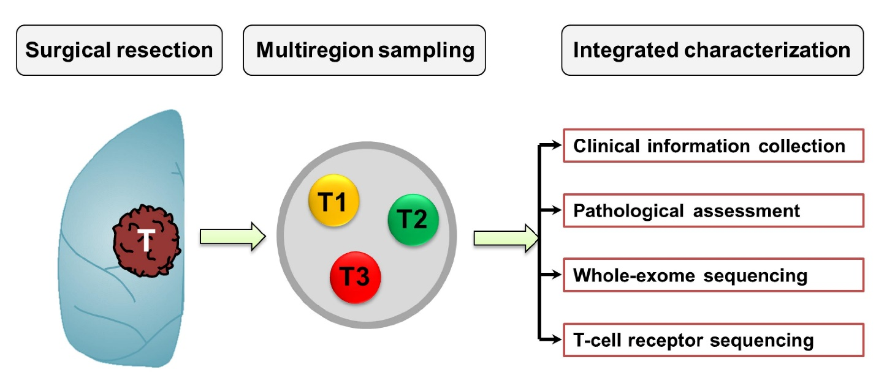
Supplementary Fig. 1 Study scheme of genomic and T cell receptor (TCR) intratumor heterogeneity (ITH) of small-cell lung cancer (SCLC) by multi-region sequencing.

Supplementary Figure 2
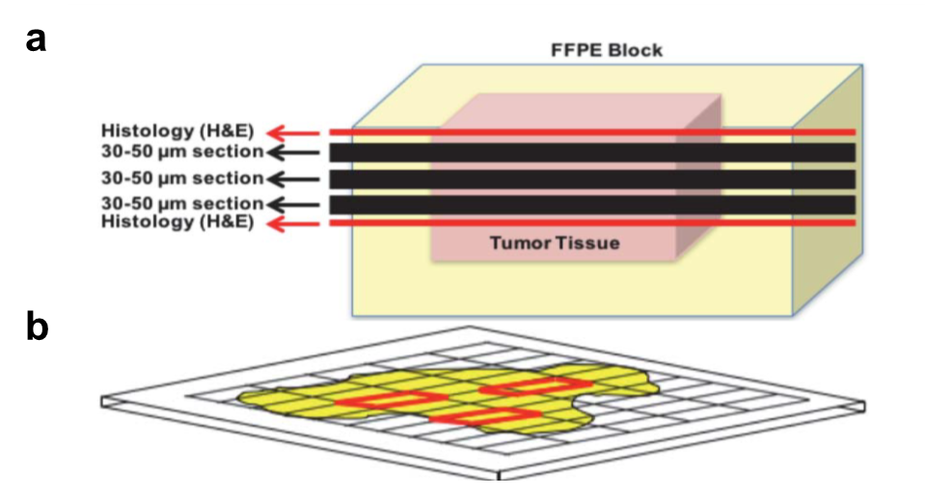
Supplementary Fig. 2 Schema of tissue “grid” methodology for multi-region sampling. (a) Tissue is consecutively sectioned for histology evaluation (H&E), 30-50 µm section, followed by 5 µm histology sections for H&E assessment. (b) A 50µm thick section from a large lesion like surgically resected lung adenocarcinoma. A grid is superimposed between H&E and thick sections to identify and select multiple spatially separated 3 x 3 mm regions (red squares) to be dissected for DNA extraction using Biobank Card system.

Supplementary Figure 3
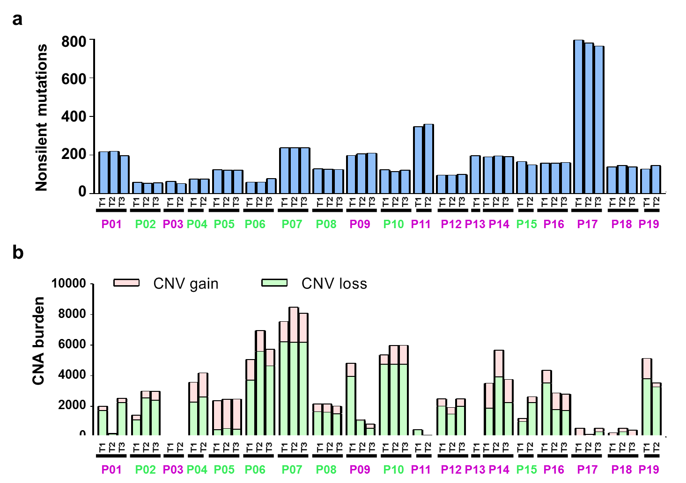
Supplementary Fig. 3 Non-silent mutations and copy number aberration (CNA) burden identified in 50 small-cell lung cancer (SCLC) specimens. (a) Total number of non-silent mutations and (b) Copy number gain burden (number of genes in the chromosomal segments with tumor/normal log2 ratio ≥ 0.6, peach) and loss burden (number of genes in the chromosomal segments with tumor/normal log2 ratio ≤ -0.6, green) in 50 SCLC tumors. Purple patient IDs = patients who were alive; Green patient IDs = patients who were deceased.

Supplementary Figure 4
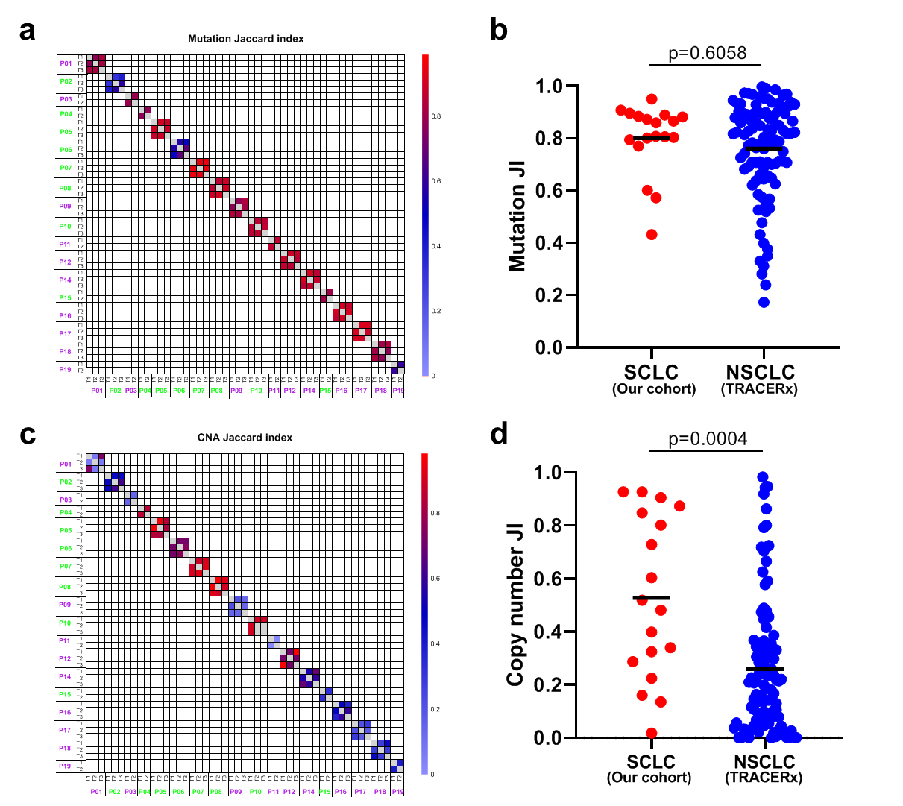
Supplementary Fig. 4 Genomic intratumor heterogeneity (ITH) in small-cell lung cancer (SCLC) and comparison with non-small cell lung cancer (NSCLC) tumors from TRACERx cohort. (a) Quantification of mutation ITH by Jaccard index (JI), a metric representing the proportion of shared somatic mutations between two samples. (b) Average mutation JI, a metric representing the proportion of shared mutations between two samples in 18 SCLC (blue) versus 100 NSCLC tumors (red) from TRACERx with multi-region genomic data. (c) Quantification of copy number ITH by Jaccard index (JI), a metric representing the proportion of shared copy number aberrations (CNA) between two samples. (d) Average copy number JI, a metric representing the proportion of shared CNAs between two samples in 18 SCLC (red) versus 100 NSCLC tumors (blue) from TRACERx with multi-region genomic data.

Supplementary Figure 5
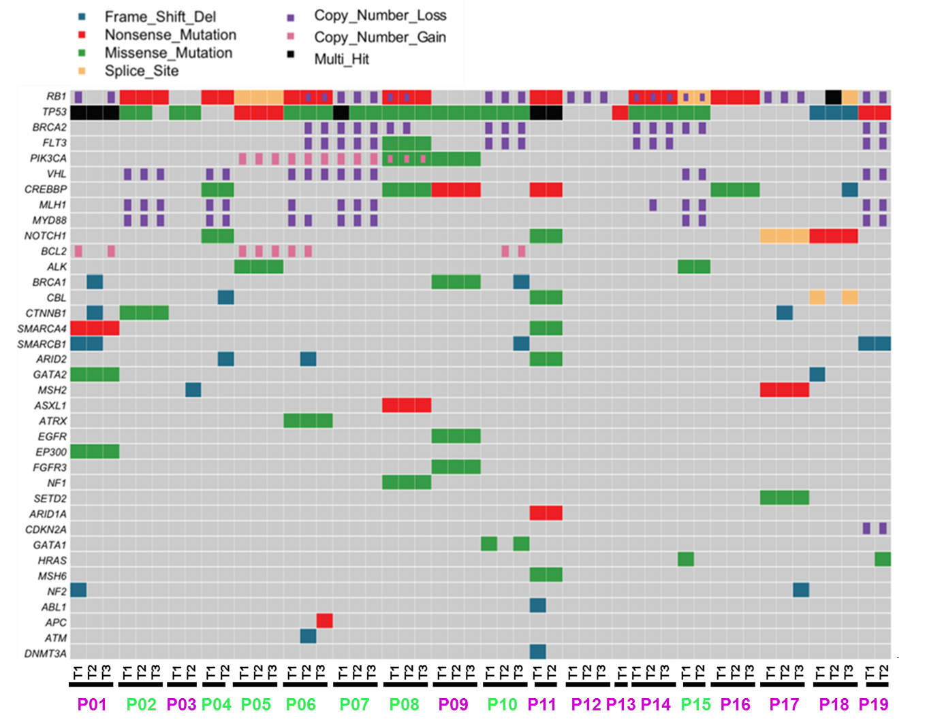Supplementary Fig. 5 Cancer gene alterations in small-cell lung cancer (SCLC) specimens. Cancer gene mutations were defined as identical mutations previously reported in oncogene, stop-gain or frameshift mutations in tumor suppressor genes and other non-silent mutations with Combined Annotation Dependent Depletion (ACDD) score>20. Copy number alternations were defined as log2 ratio of tumor DNA > 1.6 for gains or < -0.4 for losses. Multi-hit is defined as presence of different unique mutations of the same cancer genes. Purple patient IDs = patients who were alive; Green patient IDs = patients who were deceased.

Supplementary Figure 6
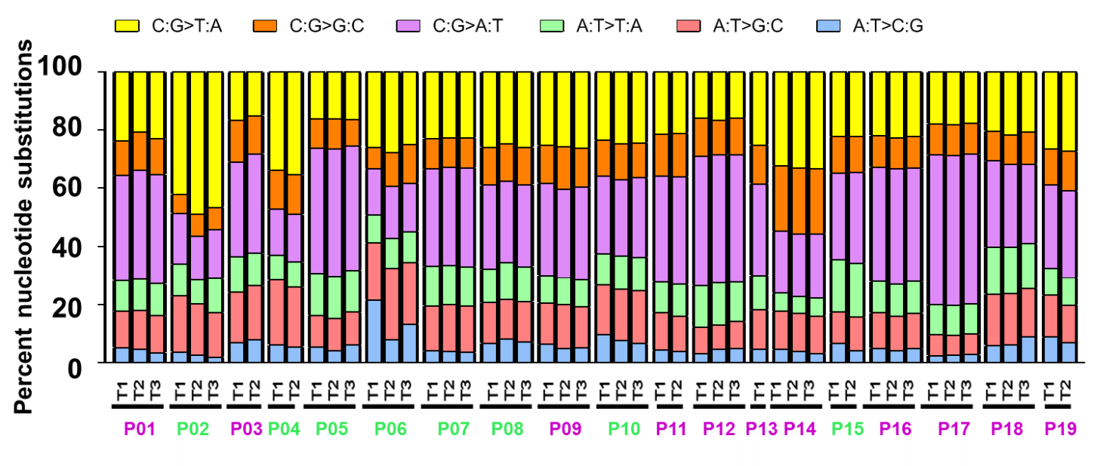
Supplementary Fig. 6 Mutational spectrum in 50 small-cell lung cancer (SCLC) specimens. Purple patient IDs = patients who were alive; Green patient IDs = patients who were deceased.

Supplementary Figure 7
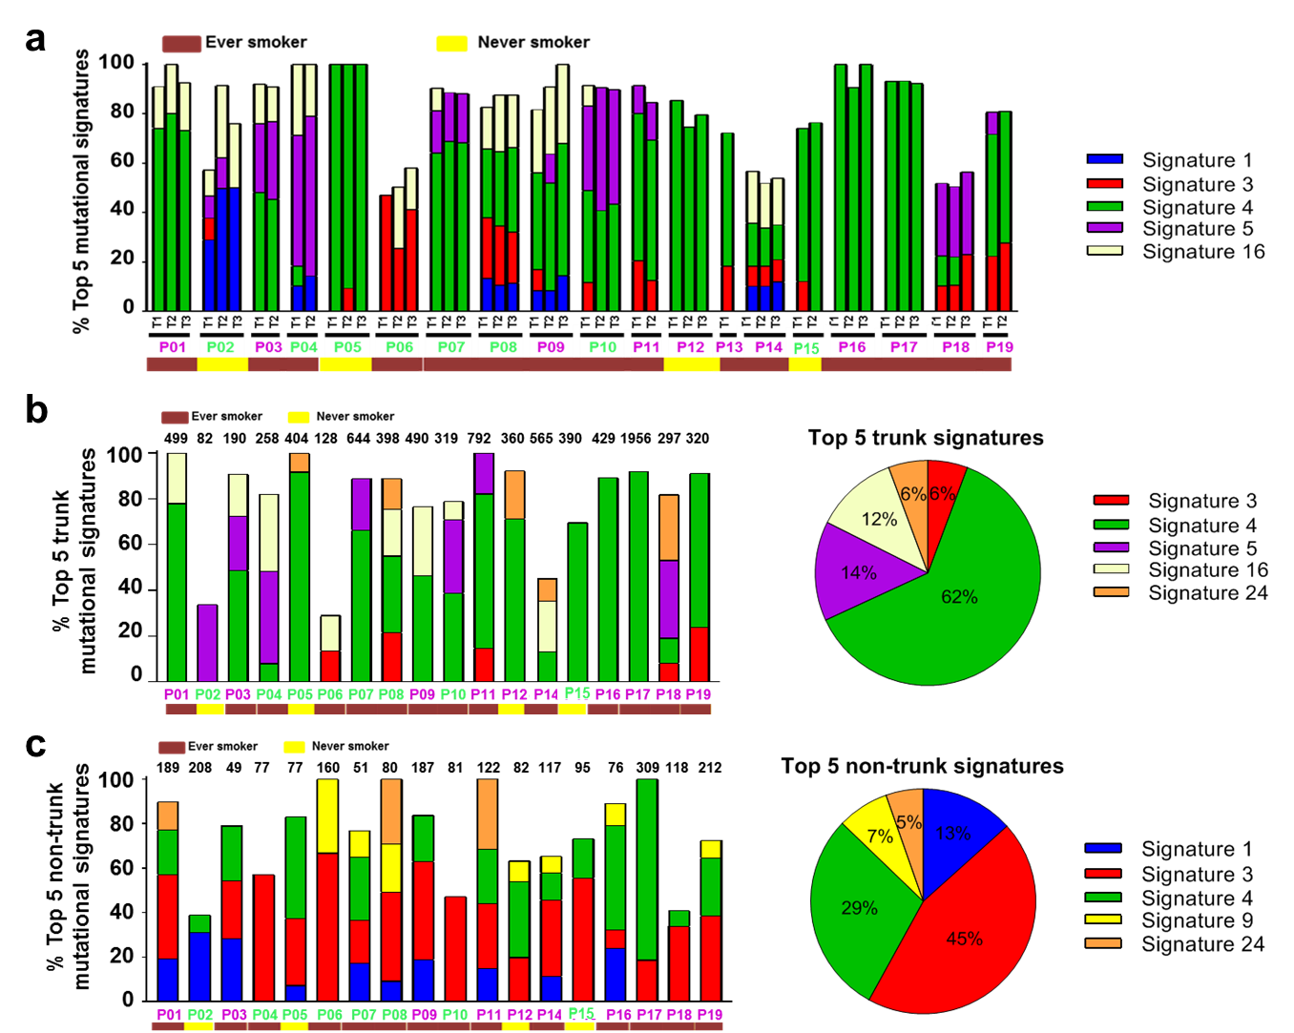
Supplementary Fig. 7 The mutational processes during clonal expansion versus subclonal diversification of small-cell lung cancer (SCLC). (a) The top 5 COSMIC mutational signatures in 50 SCLC specimens. (b) The top 5 COSMIC mutational signatures associated with trunk mutations. Bar chart on the left: top signatures associated with trunk mutations in each patient. Pie chart on the right: the average of contribution of each signature across the 18 patients. (c) The top 5 COSMIC mutational signatures associated with non-trunk mutations. Bar chart on the left: top signatures associated with non-trunk mutations in each patient. Pie chart on the right: the average of contribution of top signatures across the 18 patients. Purple patient IDs = patients who were alive; Green patient IDs = patients who were deceased.

Supplementary Figure 8
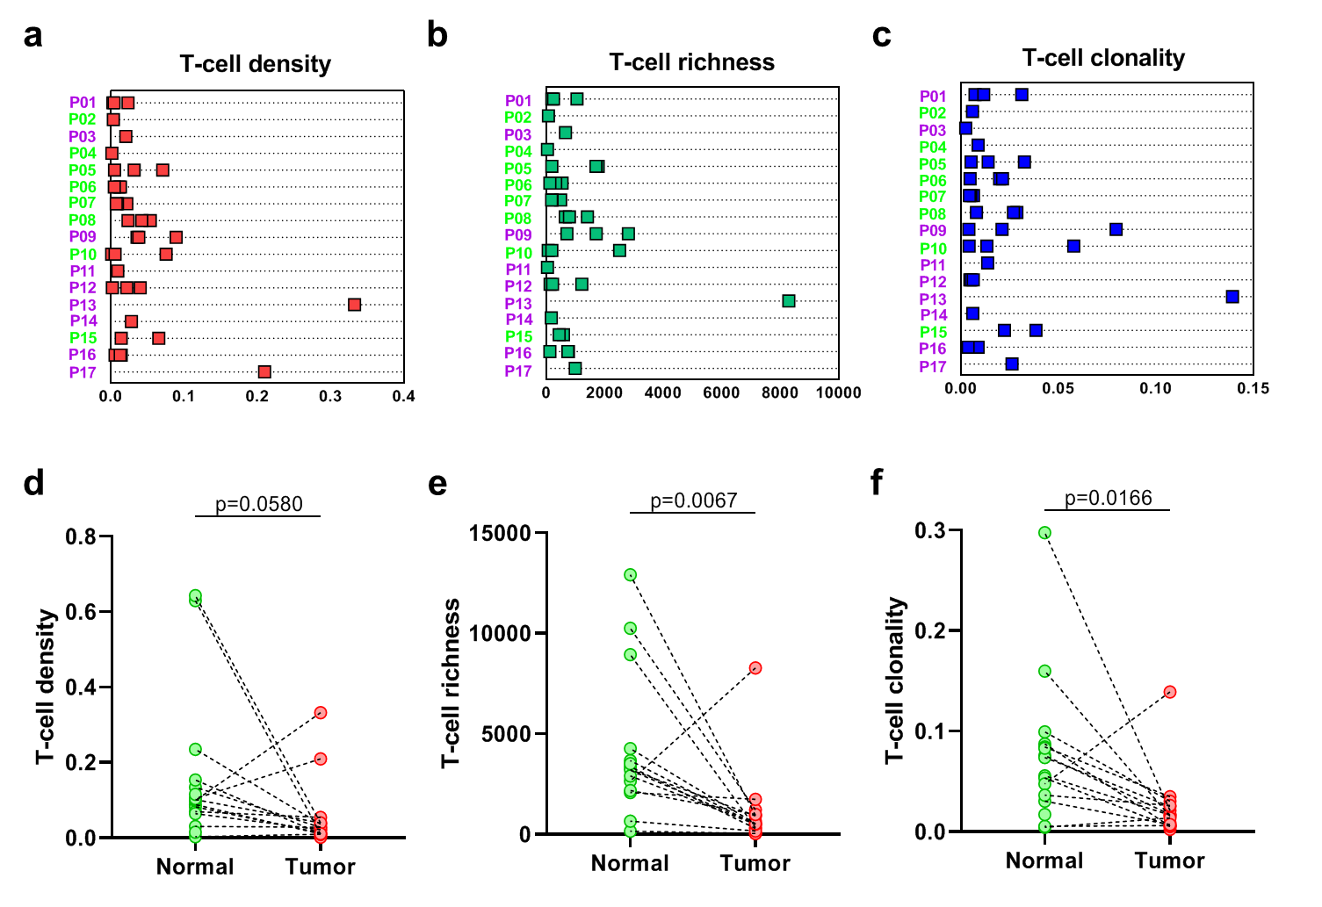
Supplementary Fig. 8 T cell receptor (TCR) repertoire landscape of small-cell lung cancer (SCLC). (a) T-cell density (red) – an estimate of the proportion of T cells in a tumor specimen. (b) T-cell richness (green) - a measure of T-cell diversity in a tumor specimen. (c) T-cell clonality (blue) - a metric indicating T-cell expansion and reactivity a tumor specimen. Purple patient IDs = patients who were alive; Green patient IDs = patients who were deceased; median follow up time: 53 months. T-cell (d) density, (e) richness and (f) clonality in tumors (red) versus normal tissues (green).

Supplementary Figure 9
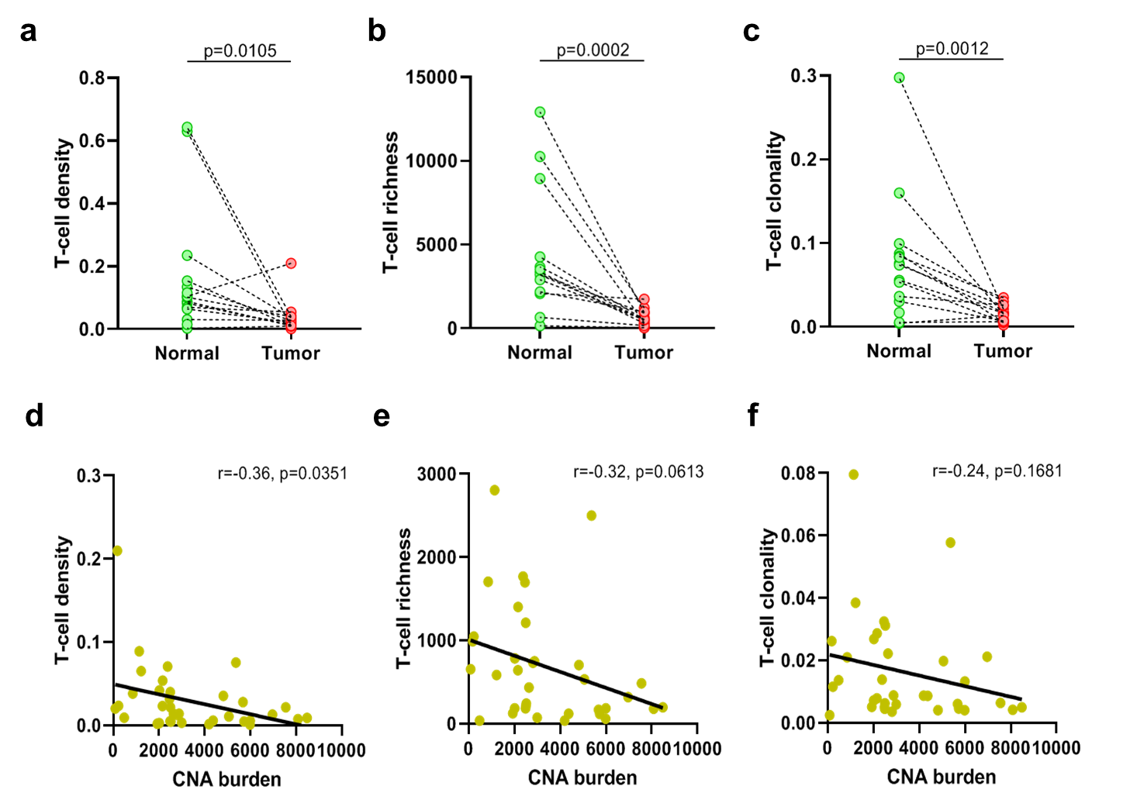
Supplementary Fig. 9 Comparison of TCR metrics between SCLCs tumors and normal lung tissues and correlations between CNA burden with TCR metrics in SCLCs without the outlier P13. T-cell (a) density, (b) richness and (c) clonality in tumors (red) versus normal tissues (green) with P13 excluded. Correlations of CNA burden with (d) T-cell density, (e) T-cell richness and (f) T-cell clonality with P13 excluded.

Supplementary Figure 10
Supplementary Fig. 10 Comparison of TCR templates between SCLCs and NSCLC tumors from PROSPECT cohort. T-cell templates were derived from 19 SCLCs (red) versus 236 NSCLCs (blue) from PROSPECT cohort.

Supplementary Figure 11
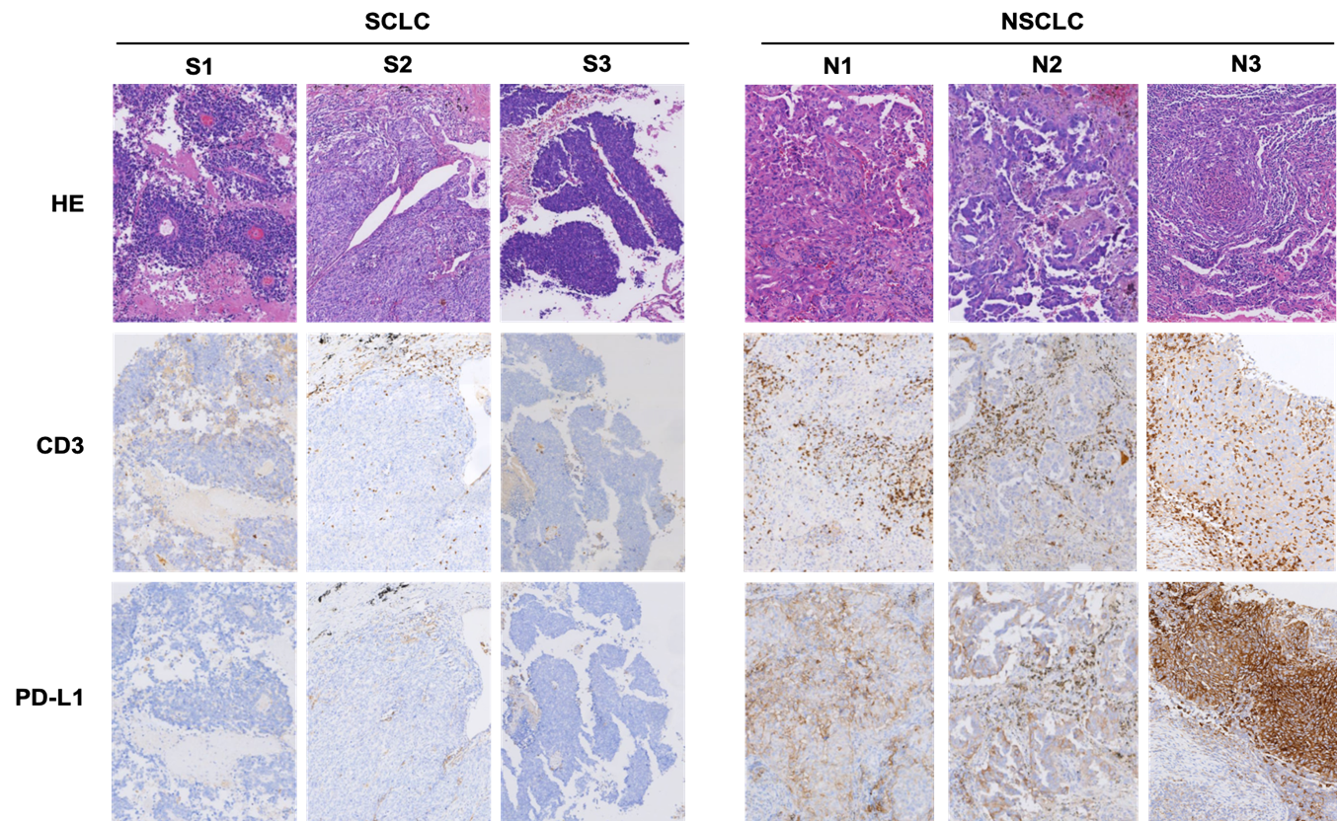
Supplementary Fig. 11 Expression of CD3 in tumor infiltrated lymphocytes (TILs) and PD-L1 in small cell lung cancer (SCLC) and non-small cell lung cancer (NSCLC) respectively. S1~3 and N1~3 indicates for three independent cases for SCLC and NSCLC. All the pictures were taken under 100× power phase.

Supplementary Figure 12
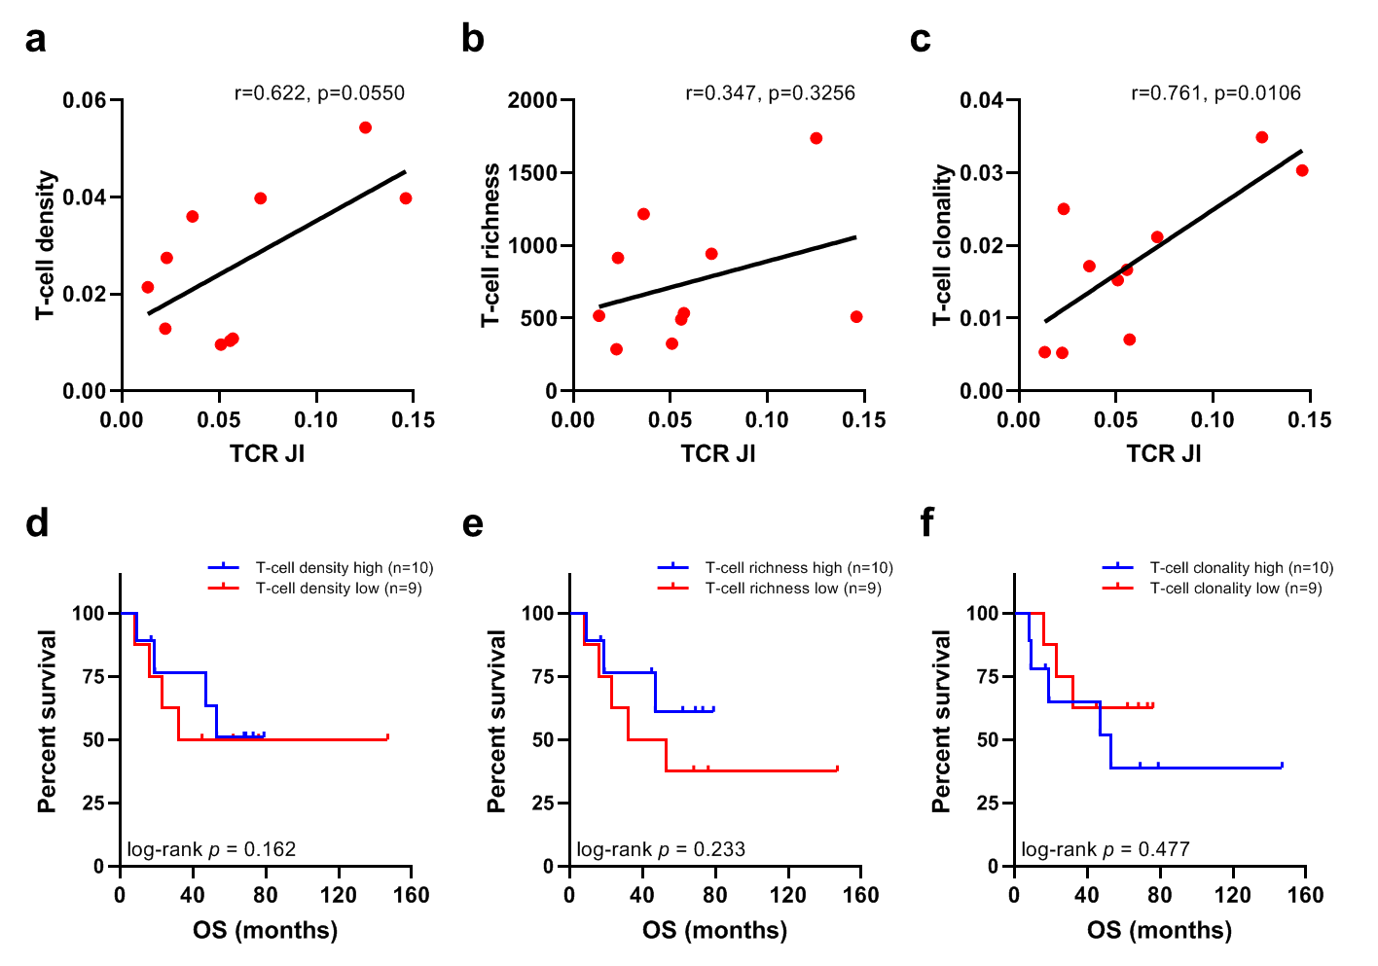
Supplementary Fig. 12 Correlations of TCR metrics with TCR Jaccard index (JI) and their associations with overall survival (OS). Positive correlations of TCR JI with T-cell (a) density, (b) richness and (c) clonality. Associations of OS with T-cell (d) density, (e) richness and (f) clonality.

Supplementary Figure 13
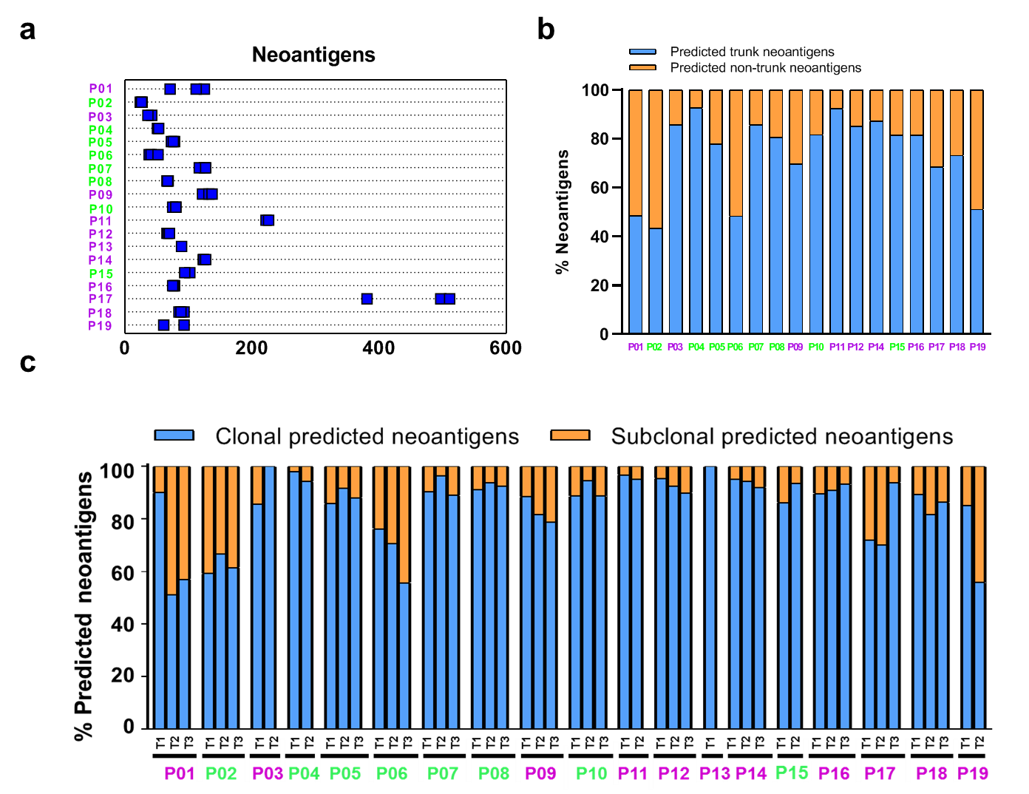
Supplementary Fig. 13 Predicted neoantigen in small-cell lung cancers (SCLCs). (a) Predicted neoantigens in SCLCs. (b) Proportion of predicted neoantigens associated with trunk mutations detected in all tumor regions of a given tumor (blue) versus non-trunk mutations (orange) mutations in 18 SCLCs with multiregional exome sequencing data available. (c) Proportion of predicted neoantigens associated with clonal (blue) versus subclonal (orange) mutations in SCLCs using PyClone. Mutations as clonal, defined as estimated cancer cell fraction (CCF) =1 (indicating mutations present in all cancer cells) or subclonal, defined as estimated CCF<1 (indicating mutations only present in a subset of cancer cells) in each tumor specimen. Purple patient IDs = patients who were alive; Green patient IDs = patients who were deceased.

Supplementary Figure 14
Supplementary Fig. 14 TCR metric features in three different regions of patient P09. T-cell density, richness and clonality were lower in P09-T1 than those of P09-T2 and P09-T3.

Supplementary Figure 15
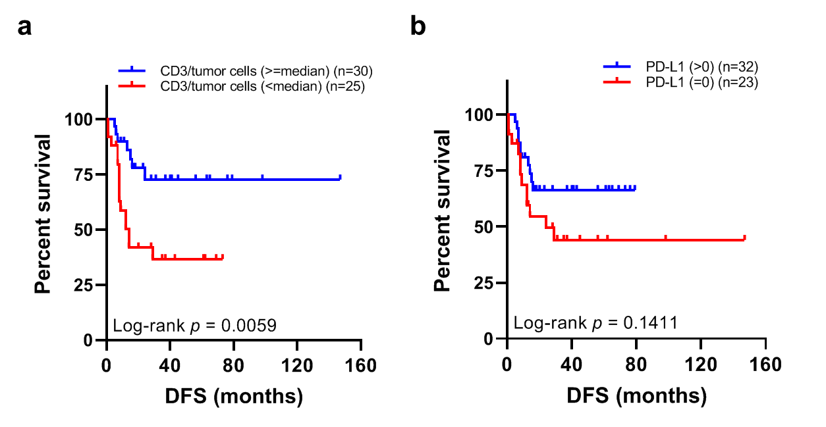Supplementary Fig. 15 Association of CD3 tumor infiltrating lymphocytes (TILs) and PD-L1 expressions with disease-free survival (DFS). (a) DFS in patients with tumors of higher (no less than median, blue) CD3+ TILs versus patients with tumors of lower (below median, red) CD3+ TILs. (b) DFS in patients with tumors of positive (above 0, blue) PD-L1 expression versus patients with tumors of negative (equal 0, red) PD-L1 expression.

Supplementary Table 1. Clinical characteristics of 67 LS-SCLC versus 68 localized NSCLC patients
 | SCLC (n=67) | NSCLC (n=68) | p value*
Age (median (range)) (yrs) | 64 (38-83) | 64 (36-79) | 0.9659
Gender |  |  | 0.155
Female | 11 | 18
Male | 56 | 50
Smoking status |  |  | 0.2025
Never smokers | 16 | 23
Smokers | 51 | 45
Tumor size (median (range)) (cm) | 2.8 (1-10) | 3 (1-8.5) | 0.6205
*The p values were calculated by Mann-Whitney test for age, Chi-squared test for gender, Chi-squared test for smoking status and Mann-Whitney test for tumor size.

Supplementary Table 2. Immunogenomic characteristics in P09
ID | Tumor* purity | T-cell density | T-cell richness | T-cell clonality | Nonsilent  TMB | Loss of predicted neoantigens
P09-T1 | 0.73 | 0.035675 | 705 | 0.004099 | 6.119075 | 6 of 115
P09-T2 | 0.59 | 0.089212 | 2805 | 0.079597 | 6.545087 | 0 of 124
P09-T3 | 0.6 | 0.038293 | 1707 | 0.021012 | 6.622543 | 0 of 129
*Tumor purity was assessed by Sequenza on whole exome sequencing data. TMB: total mutation burden.

Supplementary Data 1. Clinical characteristics and key immunogenomic features of SCLCs (n=67) and NSCLCs (n=68)
Supplementary Data 2. Somatic mutations in 50 SCLC tumor specimens

