Supplementary information:
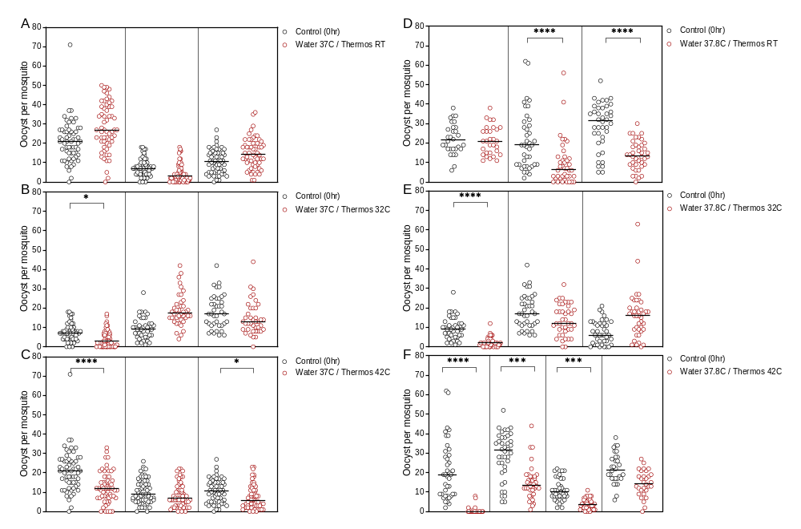

Supplementary Figure 1. Infectivity of cultured gametocytes following thermos flask storage
Mosquito infection rate (intensity of oocyst infection) was compared when a gametocyte infected blood-meal was fed to mosquitoes immediately (black circles) or stored in a thermos flask for 4 hours (red circles). Two storage condition variables were evaluated; (i) the starting water temperature in the thermos flask (37.8°C or 37°C) and, (ii) the storage temperature of the sealed thermos flask (RT, 32°C or 42°C). Lines indicate group medians and groups were compared by Kruskal-Wallis comparing each experimental condition to its own control with Dunns multiple comparison test.

