Supplementary Data for Scientific Reports

BNPs@SiO₂(CH₂)₃-TAPC-O-(CH2)2NH2-Pd (0) as a Nanocatalyst for the Coupling Reactions and Removing of Organic Dyes
Minoo Khodamorady ¹, Mohammad Jafarzadeh^{1,2} and Kiumars Bahrami^{1,2}*

¹Department of Organic Chemistry, Faculty of Chemistry, Razi University, Kermanshah 67144‐14971, Iran
² Nanoscience and Nanotechnology Research Center (NNRC), Razi University, Kermanshah 67144‐14971, Iran.
Fax +98(831)4274559; E-mail: kbahrami2@hotmail.com; k.bahrami@razi.ac.ir

Content
Experimental section | 2-4
Some ¹H NMR and ¹³C NMR of Selected products | 4-11
XPS spectra of boehmite | 11-12

Experimental
Material and physical measurements
All materials were purchased from Merck and were applied without any further purification. All reactions were screened by TLC. Melting points were measured by the Stuart Scientific SMP2 apparatus. FT‐IR spectra were recorded with a PerkinElmer 683 instrument. TGA was carried out with a STA PT- 1000 Linseis instrument (Germany) under air atmosphere at a heating rate of 10 °C min⁻¹. FESEM and EDX measurements were performed using a TESCAN‐MIRA3. TEM results were carried out with a Zeiss‐EM10C (Germany) operating at 100 kV with samples on formvar carbon‐coated grid Cu mesh 300. The elemental palladium content of nano-catalyst was determined by Perkin Elmer Optima 7300D inductively coupled plasma (ICP). XRD pattern was obtained using the STOE STADI-P diffractometer. The chemistry of the surface of the catalyst was performed using XPS a Kratos Axis Ultra DLS spectrometer with an Al Kα as a source.
General Procedure for the Suzuki–Miyaura Cross-Coupling Reaction with BNPs@SiO₂(CH₂)₃-TAPC-OCH₂CH₂NH₂-Pd (0)
A mixture of BNPs@SiO₂(CH₂)₃-TAPC-OCH₂CH₂NH₂-Pd (0) (0.015 g of catalyst contains 2.1 mol% of Pd), phenylboronic acid (1 mmol), aryl halide (1.2 mmol) and KOH (2 mmol) was stirred at 80 °C in EtOH/H₂O (1:1) for the appropriate time (Table 2). The reaction was screened by thin liquid chromatography (TLC) (n-hexane/EtOAc, 90:10). The catalyst was centrifuged, washed with ethanol, dried and applied to the subsequent run. Then, the reaction mixture was extracted with ethyl acetate (3×5) and the solvent was removed under vacuum to obtain the corresponding product. Finally, the products were recrystallized in hexane /ethyl acetate solvents.
General Procedure for the Mizoroki−Heck Cross-Coupling Reaction with BNPs@SiO₂(CH₂)₃-TAPC-OCH₂CH₂NH₂-Pd (0)
A round bottom flask was charged with styrene (1.2 mmol), Et₃N (3 mmol), aryl halide (1 mmol), and catalyst (0.015 g of catalyst equals 2.1 mol% of Pd). The mixture was heated at 100 °C under solvent-less conditions for the required time (Table 4). Raw material consumption was controlled by TLC. After consuming the raw materials, ethyl acetate (10 ml) was added to the mixture. The catalyst was centrifuged and dried. In the next step, the solvent was evaporated under vacuum and the desired product was gained. Hexane-ethyl acetate mixture was also used to recrystallize the products.
General Procedure for the Removal of MB and MO in the Presence of BNPs@SiO₂(CH₂)₃-TAPC-OCH₂CH₂NH₂-Pd (0)
To survey the efficiency of the BNPs@SiO₂(CH₂)₃-TAPC-OCH₂CH₂NH₂-Pd (0) in adsorption of MB and MO dyes, in two separate vessels, 18 ml (15 ppm) of aqueous solutions of MB and MO were poured and 0.01 g of nano-catalyst was added to them under stirring at room temperature. After that, 2 mL NaBH₄ (0.01 M) was added to the obtained mixtures under intense stirrer until the color of MB and MO turned colorless. Meanwhile, UV Visible spectra of MB and MO dyes are recorded during the color removal process in 40 s. It is noteworthy that before the recording of the UV-Visible spectrum, the catalyst is separated from solutions by centrifugation. Finally, the isolated nano-catalyst rinsed twice with water and once with ethanol, and reused for another run. Calibration curves were obtained using standard methyl orange and methylene blue solutions with specific concentrations versus the adsorption rate. Besides, NaOH (0.1 M) and HCl (0.1 M) were used to regulate the pH.
¹H- and ¹³C-NMR data of the selected products
Biphenyl (Table 2, entry 1): M.p: 66 °C. ¹HNMR (CDCl₃, 400 MHz): δ =7.52 (d, J = 8 Hz, 4H), 7.36 (t, J = 8 Hz, 4H), 7.27 (t, j = 8 Hz, 2H). ¹³CNMR (100 MHz, CDCl₃): δ = 141.27, 128.80, 137.0, 127.29, 127.21.
4-Methylbiphenyl (Table 2, entry 2): M.p: 43-44 °C. ¹HNMR (CDCl₃, 400 MHz): . δ = 7.17-7.52(m, 9H), 2.32 (s, 3H). ¹³CNMR (100 MHz, CDCl₃): δ= 21.16, 127.22, 127.30, 128.77, 129.54, 137.06, 138.40, 141.20.
3,4'-Dinitrobiphenyl (Table 2, entry 5): M.p: 183 °C. ¹HNMR (CDCl₃, 400 MHz): δ =8.55 (s,1H), 8.40 (d, J = 8 Hz, 2H), 8.42 (d, J = 8 Hz, 2H), 8.37 (d, J = 8 Hz, 1H), 8.02 (d, j = 8 Hz, 1H) 7.86 (d, j = 8 Hz, 2H). 7.76 (t, j = 8 Hz, 1H). ¹³CNMR (400 MHz, CDCl₃): δ = 148.83, 148.02, 144.91, 140.48, 133.26, 130.32, 128.16, 124.51, 123.61, 122.35.
1-(4'-methoxy-[1,1'-biphenyl]-4-yl) ethan-1-one (Table 1, entry 9): M.p: 147-148 °C. ¹H NMR (CDCl₃, 400 MHz) δ: 2.62 (s, 3H), 3.86(s. 3H), 6.98-7.01(d, j= 12 Hz, 2H), 7.56-7.59 (d, j= 12 Hz, 2H), 7.62-7.65 (d, j= 12 Hz, 2H), 7.99-8.02 (d, j= 12 Hz, 2H). ¹³CNMR (100 MHz, CDCl₃): δ= 26.64, 55.38, 114.41, 126.59, 128.37, 128.96, 132.20, 135.26, 145.34, 159.92, 197.73.
trans-Stilbene (Table 4, entry 1): M.p: 117-120 °C. ¹H NMR (CDCl₃, 400 MHz) δ: 7.60 (d, J = 8 Hz, 4H), 7.44 (t, J = 8 Hz, 4H), 7.31-7.37 (m, 2H), 7.20 (s, 2H).¹³C NMR (100 MHz, CDCl₃) δ: 137.38, 128.86, 128.76, 127.70, 126.59.
(E)-1-methyl-2-styrylbenzene (Table 4, entry 7): Oil. ¹H NMR (CDCl₃, 400 MHz) δ: 2.41 (s, 3H), 7.12-7.56 (m, 11 H). ¹³C NMR (100 MHz, CDCl₃) δ: 21.33, 126.45, 126.48, 127.45, 127.72, 128.65, 128.71, 129.45, 134.57, 137.55, 137.56.

(Table 2, entry 1)
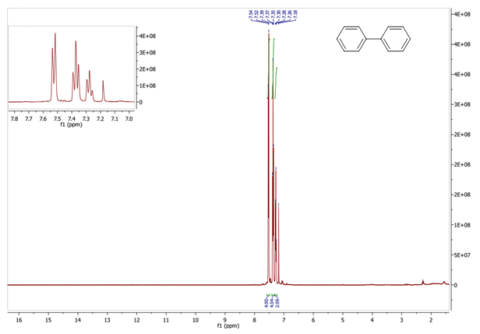
(Table 2, entry 1)
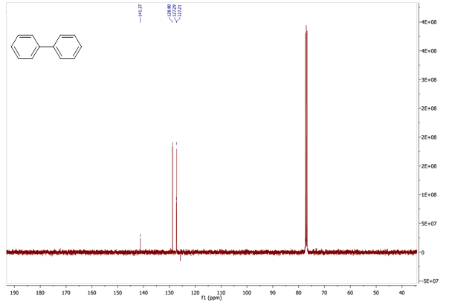

(Table 2, entry 2)
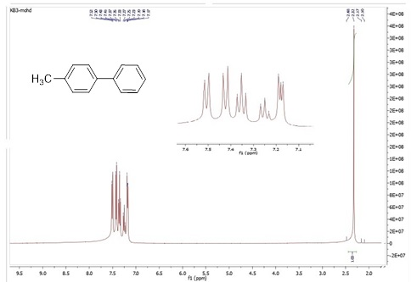

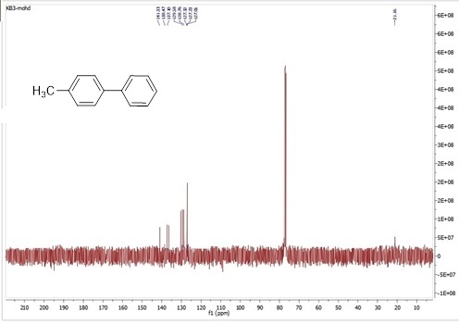

(Table 2, entry 5)
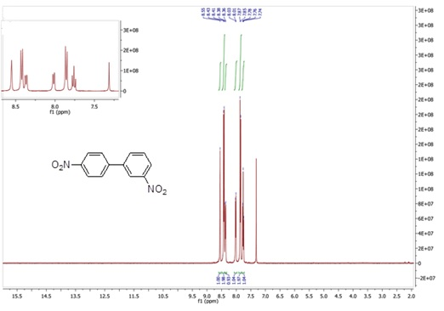
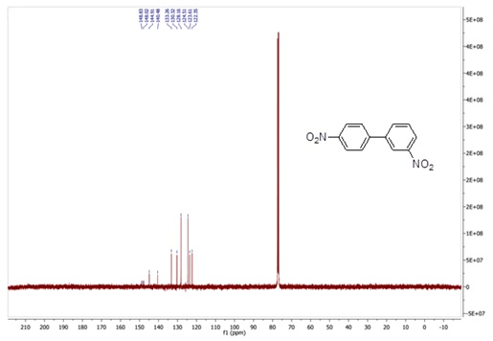

(Table 2, entry 9)
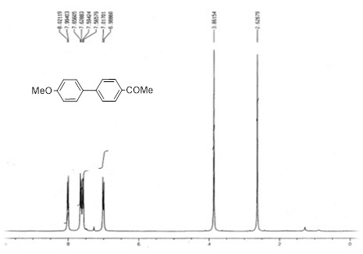

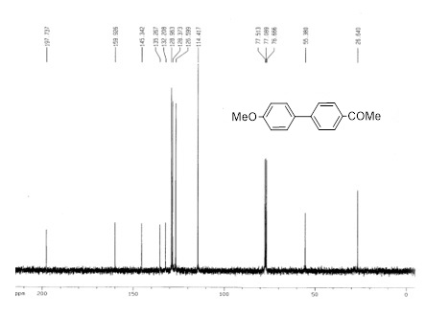

(Table 4, entry 1)

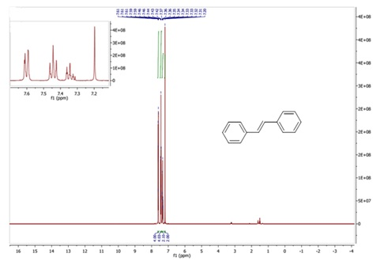

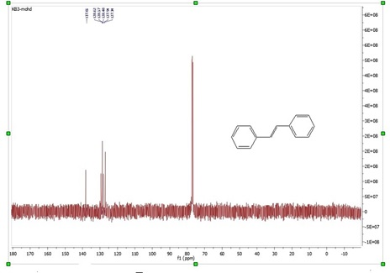

(Table 4, entry 7)
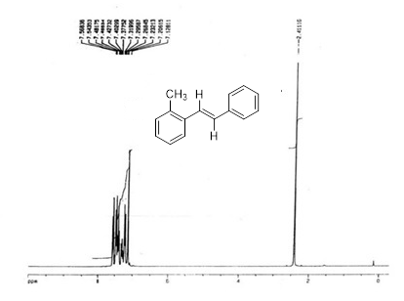

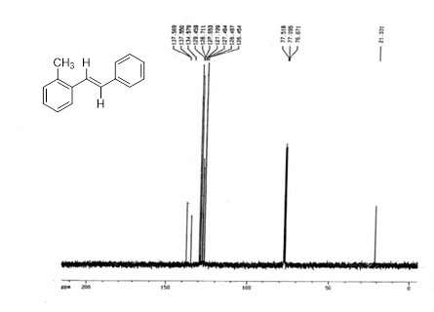

XPS surveys of a) boehmite and b) High resolution spectrum of Al 2P
