Supplementary Tables

Table S1. Toxoplasmosis, rubella, cytomegalovirus and herpes simplex (TORCH) test result of proband’s mother at 13 weeks of gestation.
Pathogen | IgM | IgG
Toxoplasmosis | Negative | Negative
Rubella | Negative | Negative
Cytomegalovirus | Negative | Positive
Herpes simplex | Negative | Positive

Table S2. Dietary nutrient intake at 14 weeks of gestation.
Nutrients | Intake | Referenceª
Nutrients | Intake | EER^{b} | RNI^{c} | AMDR^{d} | AIe
Macronutrient
Energy (kcal/d) | 1062↓ | 2400
Protein (g/d) | 31.2↓ |  | 70
Fat (%E/d) | 13.2 |  |  | 20-30
Carbohydrate (%E/d) | 75.6↑ |  |  | 50-65
Vitamin
VA (μg REA/d) | 701.3↓ |  | 770
VE (mg α-TE/d) | 24.9 |  |  |  | 14
VB1 (mg/d) | 0.63↓ |  | 1.4
VB2 (mg/d) | 0.66↓ |  | 1.4
VC (mg/d) | 288.4 |  | 115
Folic acid (μg DFE/d) | 318.2↓ |  | 600
Nicotinic acid (mg NE/d) | 9.4↓ |  | 12
Mineral
Selenium, Se (μg/d) | 25.5↓ |  | 65
Calcium, Ca (mg/d) | 454.9↓ |  | 1000
Iron, Fe (mg/d) | 15.9↓ |  | 24
Magnesium, Mg (mg/d) | 289.5↓ |  | 370
Phosphorus, P (mg/d) | 651↓ |  | 720
Potassium, K (mg/d) | 2556.4 |  |  |  | 2000
Sodium, Na (mg/d) | 2712.8 |  |  |  | 1500
Zinc, Zn (mg/d) | 6.9↓ |  | 9.5
Copper, Cu (mg/d) | 2.3 |  | 0.9
Manganese, Mn (mg/d) | 4.7 |  |  |  | 4.9
Iodine, I (μg/d) | 435.8 |  | 230

ªReference data were from Chinese Dietary Reference Intakes (DRIs), 2013.
^{b}EER: estimated energy requirement.
^{c}RNI: recommended nutrient intake.
^{d}AMDR: acceptable macronutrient distribution ranges.
^{e}AI: adequate intakes.

Table S3. Thyroid function tests and urinary iodine level at 17 weeks of gestation.
Item | Value | Reference
Serum free Triiodothyronine, fT3 (pg/mL) | 2.75 | 2.50-3.90
Free Thyroxine, fT4 (ng/dL) | 0.82 | 0.61-1.12
Thyroid-stimulating hormone, TSH (μIU/mL) | 0.12↓ | 0.34-5.10
Urinary iodine (μg/L) | 383.86↑ | 150-250

Table S4. Glucose tolerance test at 27 weeks of gestation.
Item | Value | Reference
Fasting blood glucose level (mmol/L) | 7.38↑ | 3.7-6.1
Postprandial one-hour blood glucose level (mmol/L) | 15.30↑ | <11.1
Postprandial two-hour blood glucose level (mmol/L) | 11.03↑ | <7.8

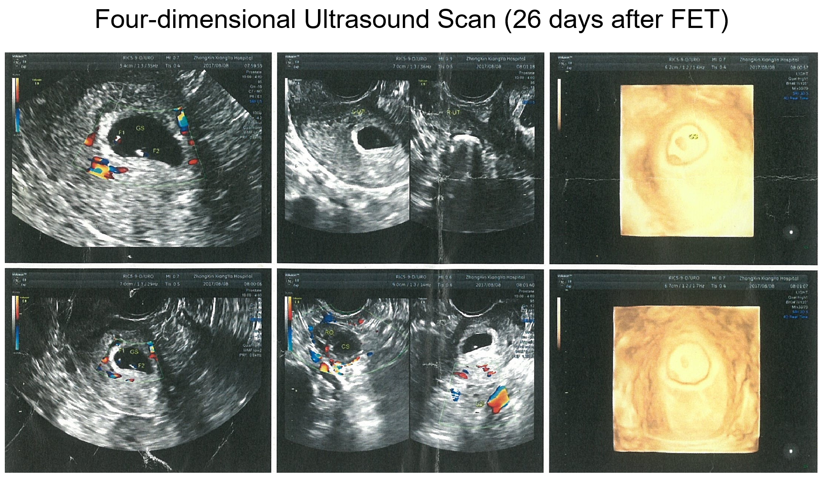
Fig. S1. Pictures of four-dimensional ultrasound scan of the infants at 26 days after FET. The monochorionic diamniotic (MCDA) twins were diagnosed.
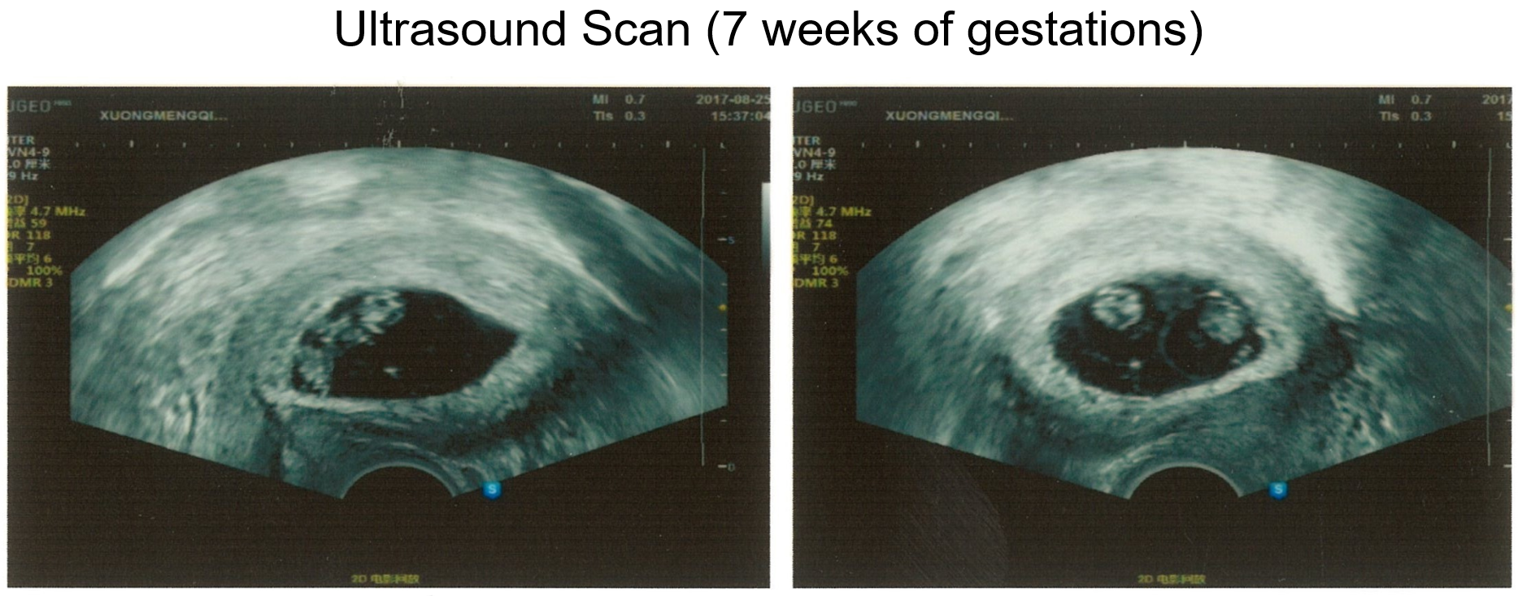
Fig. S2. Pictures of ultrasound scan of the infants at 7 weeks of gestations. Two yolk sacs and two embryos with heart beats were detected.
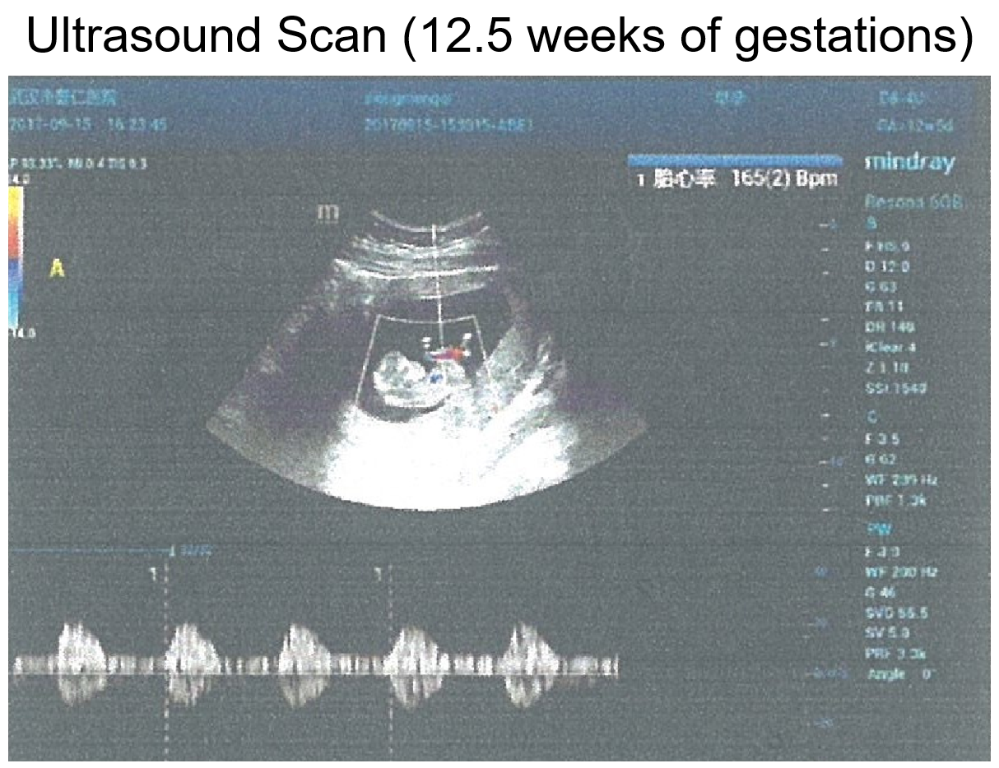
Fig. S3. Pictures of ultrasound scan of the infants at 12.5 weeks of gestations.

