Supplementary Material

Supplementary Figures

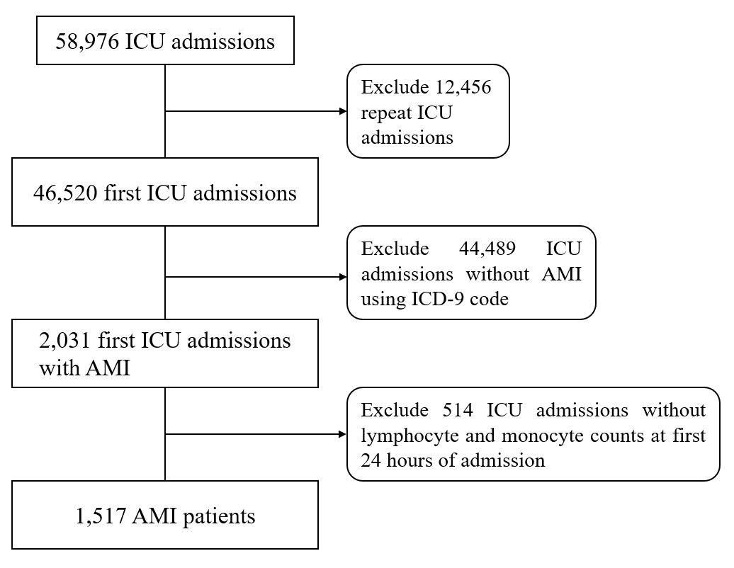
Supplementary Figure 1. Flow chart: the inclusion of the study population. Abbreviations: ICU, intensive care units; AMI, acute myocardial infarction.

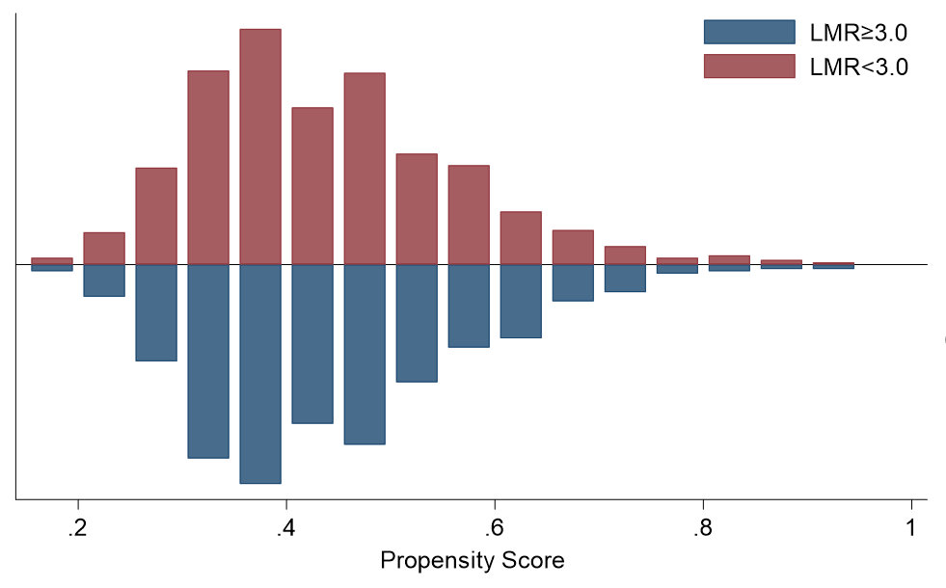
Supplementary Figure 2. Propensity score matching graph between two LMR groups. Abbreviations: LMR: lymphocyte-to-monocyte ratio.

