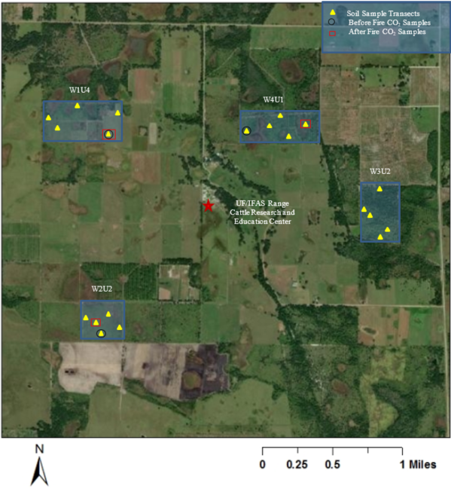
Supplementary Material
Figure S1. Experimental layout showing the USDA-LTAR network site located at the University of Florida, Range Cattle Research and Education Center Ona, FL, USA.

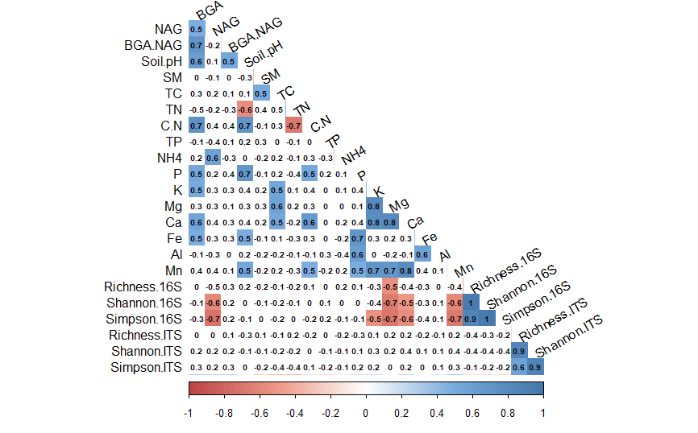

Figure S2. Pearson correlation heat map between soil enzyme activity (BGA, NAG and BGA: NAG ratio), soil properties (pH, total C, N, P, C:N ratio, extractable NH₄⁺, P, K, Ca, Mg, Mn, Fe, Al concentrations, soil moisture) and microbial diversity indices (Richness, Shannon, and Simpson indices). Numbers in the heat map represent R values: white color represent non-significant values (p>0.05), blue/red color represent significant values (p<0.05) with blue being positive correlation and red being negative correlation. (16S represents bacteria; ITS- fungi; BGA- beta glucosidase activity; NAG- N-acetyl glucosaminidase activity; SM- soil moisture)

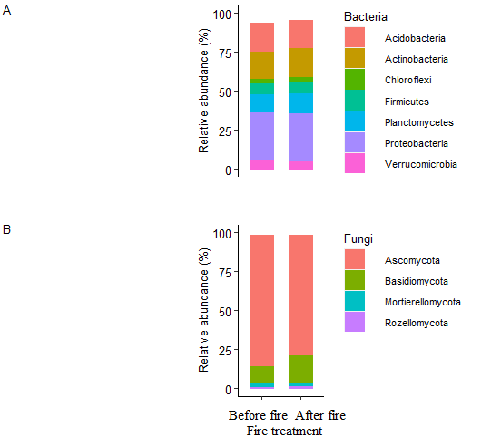
Figure S3. Relative abundance of bacterial (A) and fungal (B) phyla for 0-10 cm soil depth before fire (BF) and within 2 days after fire (AF).

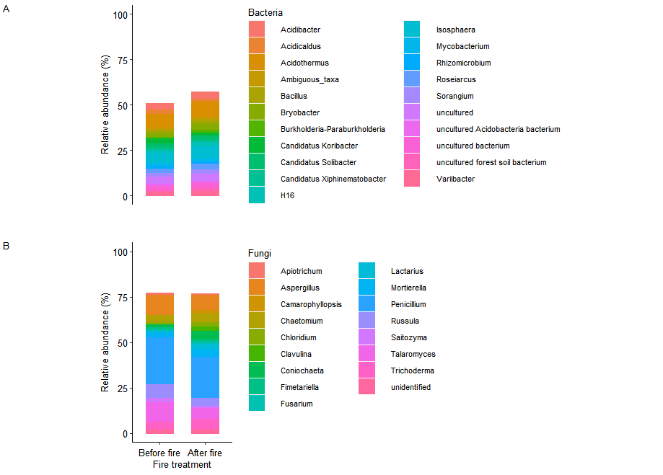

Figure S4. Relative abundance of bacterial (A) and fungal (B) genera for 0-10 cm soil depth before fire (BF) and within 2 days after fire (AF).

Table S1. Pearson correlation between bacterial genera and soil properties.
 | Acidibacter | Acidicaldus | Acidobacterium | Acidothermus | Anaeromyxobacter | Bacillus | Bradyrhizobium | Bryobacter | Burkholderia-Paraburkholderia | Candidatus Koribacter
pH | -0.31 | -0.36 | -0.30 | -0.88 | 0.20 | 0.08 | -0.65 | -0.37 | -0.31 | 0.70
Total C | -0.61 | -0.68 | -0.59 | 0.20 | 0.17 | 0.88 | 0.25 | -0.63 | -0.61 | 0.19
Total N | -0.10 | -0.12 | -0.10 | 0.10 | 0.10 | 0.12 | 0.95 | -0.12 | -0.10 | 0.05
C:N | -0.34 | -0.39 | -0.33 | -0.67 | 0.19 | 0.13 | -0.51 | -0.41 | -0.34 | 0.98
Total P | -0.61 | -0.70 | -0.59 | -0.25 | 0.99 | 0.30 | -0.24 | -0.63 | -0.61 | 0.44
NH4 | 0.94 | 0.96 | 0.98 | 0.08 | -0.56 | -0.70 | -0.14 | 0.81 | 0.88 | -0.34
P | -0.21 | -0.24 | -0.20 | -0.89 | 0.18 | 0.13 | -0.54 | -0.25 | -0.21 | 0.54
K | -0.15 | -0.17 | -0.14 | 0.15 | 0.05 | 0.08 | 0.95 | -0.18 | -0.15 | 0.12
Mg | -0.10 | -0.12 | -0.10 | 0.12 | 0.19 | 0.04 | 0.90 | -0.12 | -0.10 | 0.10
Ca | -0.28 | -0.32 | -0.27 | 0.08 | 0.20 | 0.86 | 0.39 | -0.33 | -0.28 | 0.05
Mn | 0.09 | 0.10 | 0.09 | 0.95 | -0.15 | -0.17 | 0.39 | 0.11 | 0.09 | -0.39
Fe | -0.19 | -0.22 | -0.18 | -0.89 | 0.15 | 0.10 | -0.68 | -0.23 | -0.19 | 0.21
Al | 0.15 | 0.17 | 0.14 | -0.54 | -0.21 | -0.15 | -0.90 | 0.18 | 0.15 | 0.14
SM | -0.65 | -0.68 | -0.63 | 0.05 | 0.51 | 0.54 | 0.21 | -0.68 | -0.65 | 0.30
BGA | -0.29 | -0.33 | -0.28 | -0.90 | 0.05 | 0.09 | -0.64 | -0.35 | -0.29 | 0.18
NAG | 0.21 | 0.24 | 0.20 | 0.64 | -0.14 | -0.14 | 0.35 | 0.25 | 0.21 | -0.95
BGA:NAG | -0.21 | -0.24 | -0.20 | -0.91 | 0.23 | 0.08 | -0.51 | -0.25 | -0.21 | 0.55

Table S1 continued….
Candidatus Methylomirabilis | Candidatus Solibacter | Candidatus Xiphinematobacter | Conexibacter | Dyella | Edaphobacter | Gemmata | Geobacter | H16 | Haliangium | Isosphaera
-0.38 | 0.58 | 0.09 | -0.32 | -0.29 | -0.32 | -0.30 | 0.16 | 0.10 | 0.07 | 0.08
-0.66 | 0.17 | 0.89 | -0.63 | -0.56 | -0.62 | -0.58 | 0.14 | 0.54 | 0.95 | 0.84
-0.12 | 0.05 | 0.13 | 0.00 | -0.13 | -0.11 | 0.00 | -0.14 | 0.00 | 0.11 | 0.12
-0.42 | 0.89 | 0.14 | 0.00 | -0.45 | -0.38 | 0.00 | -0.46 | 0.00 | 0.12 | 0.13
-0.66 | 0.40 | 0.33 | 0.00 | -0.69 | -0.67 | 0.00 | -0.72 | 0.00 | 0.28 | 0.31
0.91 | -0.31 | -0.77 | 0.00 | 0.89 | 0.97 | 0.00 | 1.00 | 0.00 | -0.65 | -0.72
-0.26 | 0.50 | 0.14 | 0.00 | -0.28 | -0.23 | 0.00 | -0.29 | 0.00 | 0.12 | 0.13
-0.19 | 0.11 | 0.09 | 0.00 | -0.20 | -0.17 | 0.00 | -0.20 | 0.00 | 0.07 | 0.08
-0.12 | 0.09 | 0.04 | 0.00 | -0.13 | -0.11 | 0.00 | -0.14 | 0.00 | 0.04 | 0.04
-0.35 | 0.05 | 0.90 | -0.29 | -0.26 | -0.28 | -0.27 | 0.16 | 0.32 | 0.80 | 0.94
0.11 | -0.36 | -0.18 | 0.09 | 0.08 | 0.09 | 0.09 | -0.12 | -0.21 | -0.16 | -0.17
-0.24 | 0.19 | 0.11 | -0.20 | -0.18 | -0.19 | -0.18 | 0.12 | 0.12 | 0.09 | 0.10
0.19 | 0.13 | -0.17 | 0.16 | 0.14 | 0.15 | 0.14 | -0.17 | -0.19 | -0.14 | -0.15
-0.61 | 0.28 | 0.59 | -0.68 | -0.60 | -0.66 | -0.62 | 0.42 | 0.98 | 0.50 | 0.55
-0.36 | 0.17 | 0.10 | -0.30 | -0.27 | -0.30 | -0.28 | 0.04 | 0.11 | 0.08 | 0.09
0.26 | -0.87 | -0.16 | 0.22 | 0.19 | 0.21 | 0.20 | -0.11 | -0.18 | -0.13 | -0.15
-0.26 | 0.51 | 0.09 | -0.22 | -0.19 | -0.21 | -0.20 | 0.19 | 0.10 | 0.07 | 0.08

Table S1 continued….
Jatrophihabitans | Methanobacterium | Methylocystis | Opitutus | Planctomyces | Rhodanobacter | Singulisphaera | Sorangium | Syntrophorhabdus | Tumebacillus | Variibacter
0.09 | 0.95 | 0.69 | -0.30 | -0.32 | -0.34 | -0.25 | -0.92 | 0.61 | 0.31 | -0.55
0.94 | 0.21 | 0.21 | -0.58 | -0.62 | -0.67 | -0.50 | 0.21 | 0.19 | -0.20 | 0.21
0.13 | 0.05 | 0.06 | -0.10 | -0.14 | -0.11 | -0.12 | 0.11 | 0.05 | -0.58 | 0.97
0.14 | 0.80 | 0.97 | -0.33 | -0.49 | -0.37 | -0.39 | -0.80 | 0.95 | 0.40 | -0.43
0.34 | 0.48 | 0.48 | -0.58 | -0.76 | -0.67 | -0.61 | -0.26 | 0.43 | 0.20 | -0.20
-0.79 | -0.37 | -0.37 | 0.83 | 0.98 | 0.89 | 0.85 | 0.08 | -0.33 | 0.08 | -0.12
0.14 | 0.59 | 0.59 | -0.20 | -0.30 | -0.23 | -0.24 | -0.93 | 0.53 | 0.61 | -0.45
0.09 | 0.13 | 0.13 | -0.14 | -0.22 | -0.16 | -0.17 | 0.16 | 0.12 | -0.59 | 0.95
0.04 | 0.11 | 0.11 | -0.10 | -0.14 | -0.11 | -0.12 | 0.13 | 0.10 | -0.64 | 0.90
0.80 | 0.05 | 0.06 | -0.27 | -0.28 | -0.31 | -0.23 | 0.08 | 0.05 | -0.28 | 0.33
-0.19 | -0.43 | -0.43 | 0.09 | 0.09 | 0.10 | 0.07 | 0.79 | -0.38 | -0.89 | 0.33
0.11 | 0.23 | 0.23 | -0.18 | -0.19 | -0.21 | -0.15 | -0.93 | 0.21 | 0.90 | -0.57
-0.17 | 0.15 | 0.15 | 0.14 | 0.15 | 0.16 | 0.12 | -0.57 | 0.14 | 0.64 | -0.89
0.60 | 0.33 | 0.33 | -0.62 | -0.66 | -0.71 | -0.53 | 0.05 | 0.29 | -0.15 | 0.18
0.10 | 0.20 | 0.20 | -0.28 | -0.30 | -0.32 | -0.24 | -0.95 | 0.18 | 0.91 | -0.54
-0.16 | -0.89 | -0.95 | 0.20 | 0.21 | 0.23 | 0.17 | 0.80 | -0.93 | -0.35 | 0.29
0.09 | 0.89 | 0.61 | -0.20 | -0.21 | -0.23 | -0.17 | -0.96 | 0.54 | 0.54 | -0.43
Numbers in bold represent significant values (p<0.05). BGA- beta glucosidase activity; NAG- N-acetyl glucosaminidase activity.

Table S2. Pearson correlation coefficient between fungal genera and soil properties.
 | Apiotrichum | Archaeorhizomyces | Aspergillus | Chaetomium | Cladophialophora | Clavulina | Curvularia | Fusarium | Gymnopus | Inocybe
pH | 0.35 | -0.15 | 0.10 | 0.31 | -0.90 | -0.25 | 0.15 | 0.34 | -0.17 | -0.22
Total C | 0.55 | 0.51 | -0.15 | 0.49 | 0.15 | 0.34 | -0.29 | 0.54 | 0.57 | 0.30
Total N | 0.51 | 0.59 | -0.17 | 0.45 | 0.17 | 0.29 | 0.31 | 0.50 | 0.66 | 0.26
C:N | -0.34 | -0.89 | 0.10 | -0.30 | -0.25 | -0.64 | 0.70 | -0.33 | -0.92 | -0.57
Total P | -0.30 | -0.76 | -0.19 | -0.27 | -0.33 | -0.78 | 0.89 | -0.29 | -0.85 | -0.79
NH4 | 0.85 | -0.15 | 0.28 | 0.84 | -0.21 | -0.10 | 0.05 | 0.80 | -0.17 | -0.09
P | 0.12 | -0.29 | 0.29 | 0.11 | -0.68 | -0.38 | 0.36 | 0.12 | -0.32 | -0.34
K | 0.25 | 0.74 | -0.29 | 0.22 | 0.15 | 0.58 | -0.85 | 0.24 | 0.78 | 0.52
Mg | 0.20 | 0.33 | -0.38 | 0.18 | 0.54 | 0.93 | -0.64 | 0.20 | 0.37 | 0.83
Ca | -0.12 | 0.14 | -0.94 | -0.11 | 0.95 | 0.54 | -0.34 | -0.12 | 0.16 | 0.48
Mn | 0.25 | 0.15 | -0.44 | 0.22 | 0.51 | 0.95 | -0.64 | 0.24 | 0.17 | 0.85
Fe | -0.35 | -0.85 | 0.19 | -0.31 | -0.33 | -0.49 | 0.60 | -0.34 | -0.95 | -0.44
Al | -0.31 | -0.80 | 0.25 | -0.28 | -0.34 | -0.56 | 0.84 | -0.30 | -0.90 | -0.50
SM | 0.75 | 0.49 | -0.19 | 0.76 | 0.10 | 0.44 | -0.51 | 0.78 | 0.55 | 0.39
BGA | -0.22 | -0.80 | 0.28 | -0.20 | -0.20 | -0.75 | 0.88 | -0.22 | -0.90 | -0.76
NAG | 0.58 | 0.80 | -0.29 | 0.52 | 0.25 | 0.59 | -0.65 | 0.57 | 0.89 | 0.53
BGA:NAG | -0.36 | -0.78 | 0.17 | -0.32 | -0.30 | -0.54 | 0.59 | -0.35 | -0.87 | -0.48

Table S2 continued…
Laccaria | Lophiostoma | Myrothecium | Pachyphloeus | Paraphaeosphaeria | Penicillium | Pseudeurotium | Talaromyces | Tolypocladium | Tomentella
-0.24 | 0.14 | 0.12 | -0.24 | 0.17 | 0.19 | -0.19 | 0.10 | -0.21 | -0.21
0.33 | -0.85 | -0.82 | 0.32 | -0.32 | -0.34 | 0.64 | -0.15 | 0.72 | 0.28
0.28 | -0.95 | -0.94 | 0.27 | 0.35 | -0.28 | 0.74 | -0.17 | 0.83 | 0.24
-0.63 | 0.64 | 0.78 | -0.60 | 0.69 | 0.58 | -0.91 | 0.10 | -0.94 | -0.54
-0.80 | 0.35 | 0.30 | -0.74 | 0.91 | 0.59 | -0.95 | -0.19 | -0.94 | -0.74
-0.10 | -0.54 | -0.46 | -0.09 | 0.06 | -0.34 | -0.19 | 0.28 | -0.21 | -0.08
-0.37 | 0.12 | 0.10 | -0.36 | 0.40 | 0.15 | -0.36 | 0.29 | -0.41 | -0.32
0.57 | -0.60 | -0.51 | 0.55 | -0.89 | -0.88 | 0.79 | -0.29 | 0.85 | 0.49
0.91 | -0.44 | -0.37 | 0.87 | -0.61 | -0.56 | 0.41 | -0.38 | 0.46 | 0.88
0.53 | -0.10 | -0.09 | 0.51 | -0.38 | -0.34 | 0.18 | -0.94 | 0.20 | 0.45
0.93 | -0.40 | -0.34 | 0.89 | -0.65 | -0.59 | 0.19 | -0.44 | 0.21 | 0.79
-0.48 | 0.60 | 0.51 | -0.46 | 0.68 | 0.61 | -0.94 | 0.19 | -0.95 | -0.41
-0.55 | 0.55 | 0.47 | -0.53 | 0.83 | 0.80 | -0.95 | 0.25 | -0.94 | -0.47
0.43 | -0.65 | -0.69 | 0.41 | -0.57 | -0.34 | 0.61 | -0.19 | 0.69 | 0.37
-0.84 | 0.35 | 0.30 | -0.77 | 0.90 | 0.59 | -0.88 | 0.28 | -0.89 | -0.76
0.58 | -0.85 | -0.95 | 0.55 | -0.54 | -0.27 | 0.84 | -0.29 | 0.88 | 0.49
-0.53 | -0.64 | 0.79 | -0.51 | 0.55 | 0.77 | -0.98 | 0.17 | -0.94 | -0.45
Numbers in bold represent significant values (p<0.05). BGA- beta glucosidase activity; NAG- N-acetyl glucosaminidase activity.

