Functional Assessment of AtPAP17; Encoding a Purple Acid Phosphatase Involve in Phosphate Metabolism in Arabidopsis thaliana

Arash Jamali Langeroudi¹, Mohammad Sadegh Sabet^{2*}, Mokhtar Jalali-Javaran¹, Katayoun Zamani³, Tahmineh Lohrasebi⁴, Mohammad Ali Malboobi⁴

¹ Department of Agricultural Biotechnology, Faculty of Agriculture, Tarbiat Modares University, Tehran, Iran, P.O. Box 14115-336, Tehran, Iran
² Department of Plant Genetics and Breeding, Faculty of Agriculture, Tarbiat Modares University, Tehran, Iran, P.O. Box 14115-336, Tehran, Iran
³ Department of Genetic Engineering and Biosafety, Agricultural Biotechnology Research Institute of Iran, Agricultural Research, Education, and Extension Organization, Karaj, Tehran, Iran
⁴ Department of Agricultural Biotechnology, National Institute of Genetic Engineering and Biotechnology, Tehran 14965-161, Iran.

*Corresponding author: Mohammad Sadegh Sabet
Department of Plant Genetics and Breeding, Faculty of Agriculture, Tarbiat Modares University, Tehran, Iran, P.O. Box 14115-336, Tehran, Iran
E-mail: ms.sabet@modares.ac.ir
Tel: +98-21-48292345
Fax: +98-21-48292200

Table S₁ Chi-square test for genotypes conformity from Mendelian 3:1 ratio (kanamycin resistant: sensitive)
P-value** | Expected No. |  | Observed No.* |  | Genotype No.
 | Sensitive | Resistant | Sensitive | Resistant
0.965 | 44.3 | 132.8 | 44 | 133 | 1
0.911 | 26.5 | 79.5 | 27 | 79 | 2
0.273 | 62.5 | 187.5 | 70 | 180 | 3
0.476 | 42 | 126 | 46 | 172 | 4
0.009 | 31.8 | 95.3 | 19 | 108 | 5
0.919 | 32.5 | 97.5 | 32 | 98 | 6
0.944 | 16.8 | 50.3 | 17 | 50 | 7
0.008 | 28.3 | 84.8 | 16 | 97 | 8
0.788 | 56.3 | 168.8 | 58 | 167 | 9
0.866 | 47 | 141 | 48 | 140 | 10
0.000 | 40.8 | 122.3 | 12 | 151 | 11
0.010 | 31.5 | 94.5 | 19 | 107 | 12
0.237 | 26.3 | 78.8 | 21 | 84 | 13
0.267 | 39 | 117 | 33 | 123 | 14
0.001 | 14.5 | 43.5 | 4 | 54 | 15
0.371 | 15 | 45 | 18 | 42 | 16
0.010 | 25 | 75 | 14 | 86 | 17
0.870 | 12.5 | 37.5 | 13 | 37 | 18
0.000 | 26.3 | 78.8 | 7 | 98 | 19
* All values represent the rounded average of three replicates
** All of P-value < 0.05 represented deviation from 3:1 ratio. The subsequent Chi-square tests have not shown

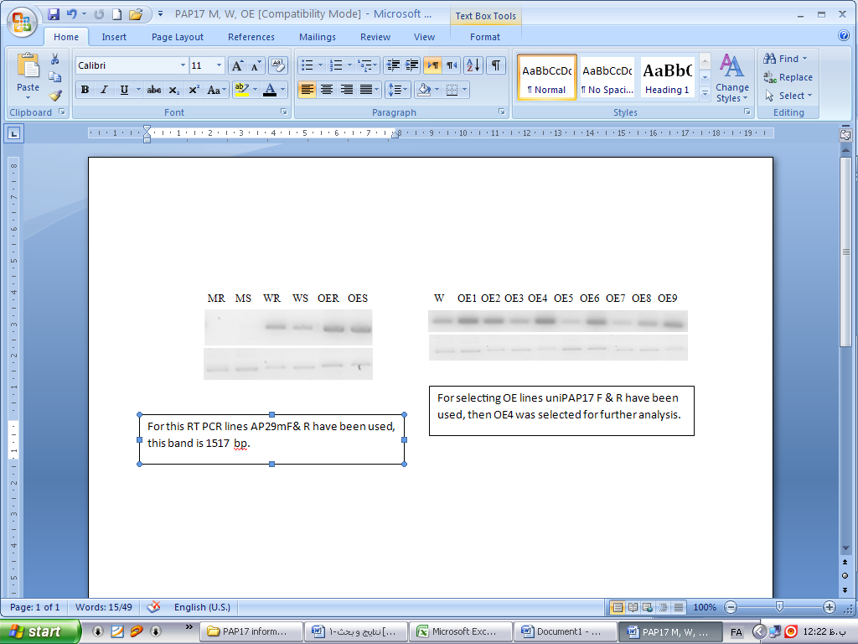
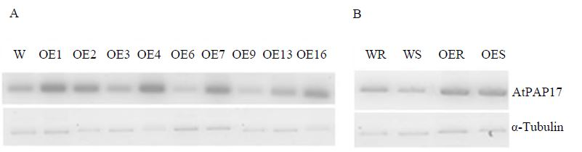
α-Tubulin
AtPAP17
Mu/root Mu/shoot WT/root WT/shoot
A
Fig. S₁ Semi-quantitative RT-PCR test. The comparison of AtPAP17 transcript levels in (A) root or shoot of Arabidopsis WT against homozygous atpap17-mutant (Mu) line, or (B) some of distinct homozygous T₃ overexpressed (OE) plants versus WT (samples prepared from whole of plant), or (C) root or shoot of WT and homozygous OE plant. RT-PCR reactions were done for 35 cycles for all experiments with the specific primers for AtPAP17 (Unique PAP17 F, R). The α-Tubulin transcript level was selected as an internal control (bottom panel). Samples were obtained by the whole of plant or shoot / root pool of WT plants, Mu line and OE plants.

WT OE1 OE2 OE3 OE4 OE6 OE7 OE9 OE13 OE16
WT/root WT/shoot OE/root OE/shoot
AtPAP17
α-tubulin
C
B

 | A | B
 | P+ | P-
WT | 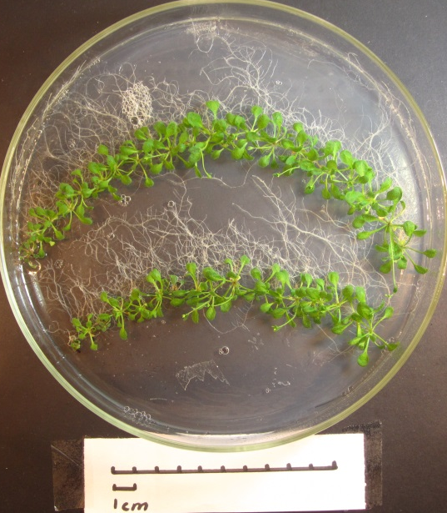 | 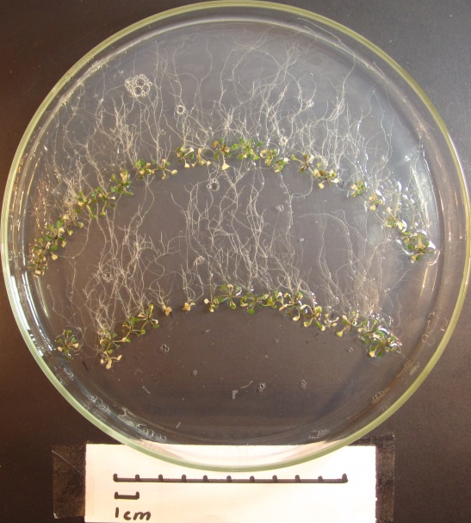
Mu | 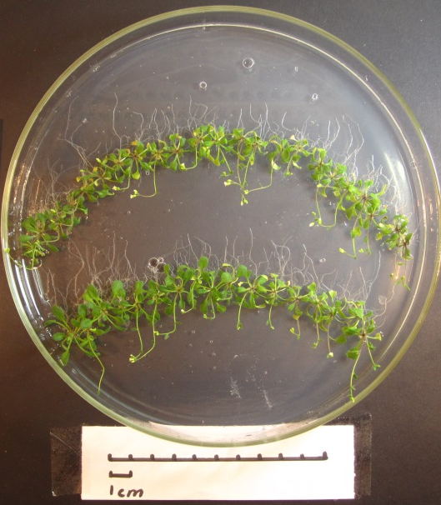 | 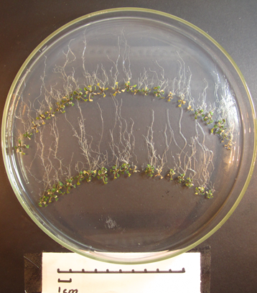
OE | 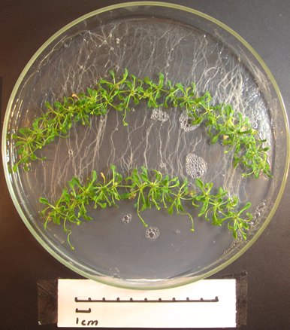 | 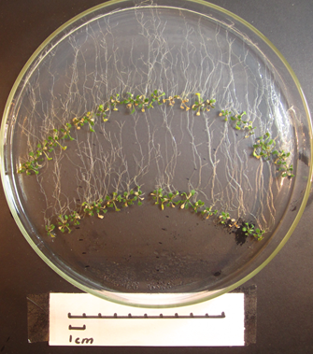
Fig. S₂ phenotypically comparison of 21-days-old seedlings. The AtPAP17-overexpressed (OE), atpap17-mutant (Mu) and WT plants have grown for 14 days on MS medium culture containing (A) 1.25 mM Pi (+P) or (B) no Pi (−P). Unit scale is 1 cm

