Supplementary Figures:
Supplementary Figure S1
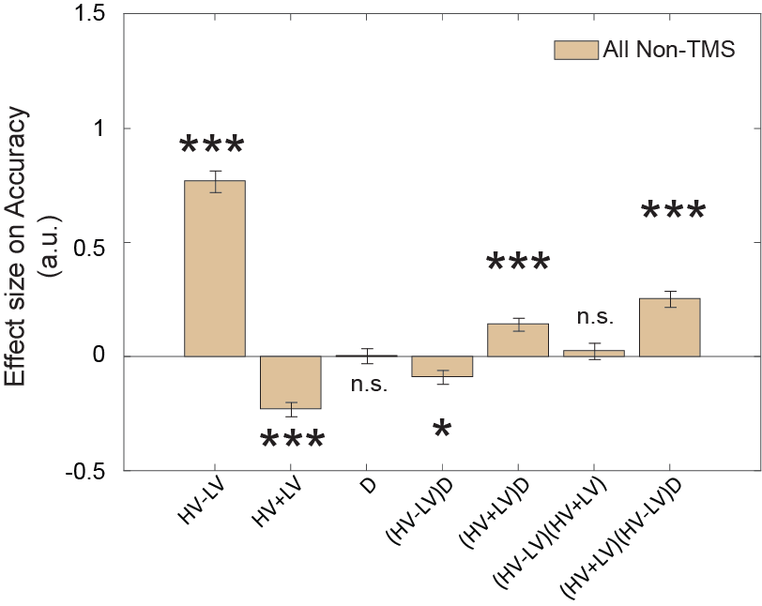
Supplementary Figure S1: Participants showed smaller negative distractor effect when HV+LV was large. Divisive normalisation models predict that the size of the negative distractor effect is smaller when HV+LV is large, since the distractor value contributes less to the overall value of HV+LV+D. To test whether this was the case in our data, we applied a GLM (which is identical to GLM5 of Chau et al., 2020) in which accuracy in all Non-TMS trials was predicted using the terms, HV-LV, HV+LV, and D, as well as all two-way and three-way interactions: β₀ + β₁ z_{(HV-LV)} + β₂ z_{(HV+LV)} + β₃ z_{(D)} + β₄ z_{(HV-LV)} z_{(D)} + β₅ z_{(HV+LV)} z_{(D)} + β₆ z_{(HV-LV)} z_{(HV+LV)} + β₇ z_{(HV-LV)} z_{(HV+LV)} z_{(D)} + ε. We found a positive effect of (HV+LV)D on accuracy (t(30) = 5.07, p < 0.001, d = 0.91, CI = [0.09, 0.2]), which was broadly consistent with the divisive normalisation prediction. In addition, as in Figure 2c, this analysis showed a significant (HV-LV)D effect, suggesting that the distractor effect reversed as a function of choice difficulty. These results are consistent with previous work (cf. Appendix 3, Chau et al., 2020). *p < 0.05, ***p < 0.001. Error bars denote standard error.

Supplementary Figure S2
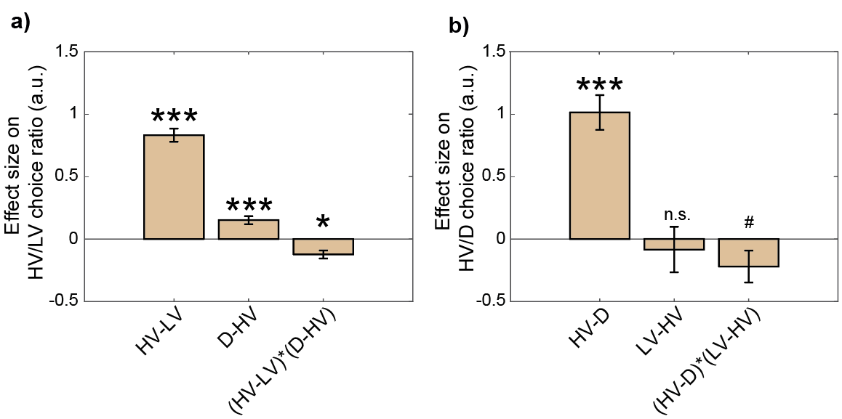
Supplementary Figure S2: A third account suggests salient distractors can capture attention and eventually be chosen. An analysis identical to that in Figure 5 of Chau et al²¹ was performed and generated similar results showing that an attentional capture effect by the distractor was present in the current study. Specifically, a multinomial logistic regression was applied to test the effects on the choice ratios (a) between HV/LV and (b) between HV/D. It involves the following GLM: β₀ + β₁ z_{(HV-LV)} + β₂ z_{(HV-D)} + β₃ z_{(HV-LV)(D-HV)} + ε. Participants with at least three trials of distractor choice were included in this analysis. The first panel (a) illustrates distractor effects on HV/LV choice ratio and so it can therefore be interpreted in a similar way to Figure 2c. Critically, the second panel (b) not only provides a way to test the attentional capture by salient distractors, but in addition it also provides a further way of testing an interesting class of distractor effects – whether the rate at which participants opt for HV or D is affected by the LV option (which should be irrelevant to the rate at which choices are made between HV and D). This analysis generated two key findings. First, as predicted by the attentional capture model, a positive HV-D effect in (b) suggested that when the value of D became larger, D was also chosen more often, t(27) = 7.30, p < 0.001, d = 1.38, CI = [0.73, 1.30]. Second, the (HV-LV)(D-HV) effect in (a), as is also the case in Figure 2c, and the (HV-D)(LV-HV) effect in (b) are all consistently negative, suggesting that the distractor effects varied as a function of choice difficulty. We note that although the (HV-D)(LV-HV) effect in (b) was marginally significant, the effect became significantly negative (t(22) = -2.56, p = 0.018, d = -0.53, CI = [-0.54, -0.06]) when the analysis included participants with at least five, instead of three, trials of distractor choice. Error bars denote standard error. # p < 0.1, * p < 0.05, *** p < 0.001.

Supplementary Figure S3
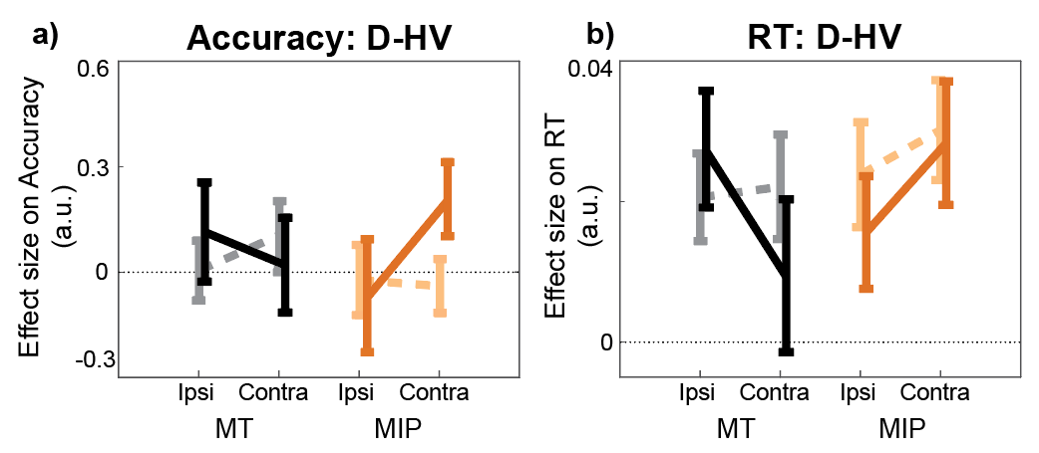
Supplementary figure S3. When TMS was applied to MIP it increased the effect of distractors (indexed by D-HV) on both accuracy and RT, although there were some differences in the precise manner in which accuracy and RT effects manifested. We ran GLM3 once (a) to obtain the effect of D-HV on accuracy, just as in Figure 3c, and (b) once again to obtain the D-HV effect on RT on accurate trials. We then re-ran a similar ANOVA to that in Figure 3c (including the factors Stimulation x Site x Distractor Location) to examine accuracy effects but added a fourth two-level factor of Behavioural Metric (Accuracy vs RT) on only the D-HV predictor and obtained the following effects. First, we found a three-way interaction between Stimulation × Site × Distractor Location (F(1,30) = 4.96, p = 0.034, η_{p}² = 0.14). This means that TMS, when applied to MIP as opposed to MT, on trials on which the distractor, D, appears contralaterally as opposed to ipsilaterally, increases both accuracy and RT as a function of D-HV. (a) As shown in Figure 3c, higher distractor values (i.e. higher D-HV) were associated with higher accuracy only when TMS was applied to MIP contralateral to the distractor, but not on any Non-TMS trials or in MT sessions. In addition, there was a trend towards a four-way interaction Stimulation × Site × Distractor Location × Behavioural Metric (F(1,30) = 3.90, p = .058, η_{p}² = 0.12) suggesting a trend for the three-way Stimulation × Site × Distractor Location interaction effect of D-HV to manifest in a slightly different way on (a) accuracy and (b) RT metrics. Nevertheless, in line with both our version of the diffusion model²¹ and standard versions of diffusion model, both RT and accuracy indices of the response selection processes are affected.

Supplementary Figure S4
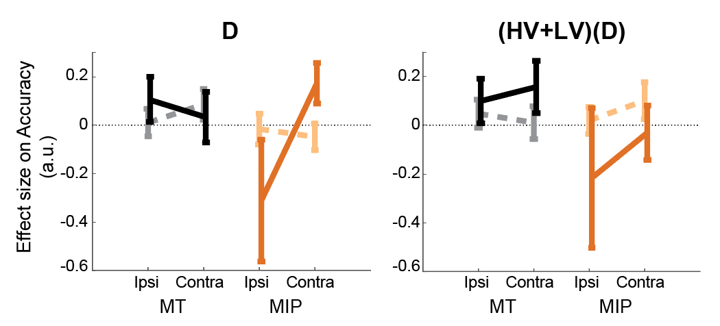
Supplementary Figure S4. Another way to look at the divisive normalization effect is to consider effects in a different GLM like that shown in Figure S1. In the context of this other GLM, two other effects are worth noting. First, the main effect of D is clearly worth considering. If this is positive, then the positive distractor effect predominates at the expense of divisive normalization while if it is negative then divisive normalization predominates at the expense of the positive distractor effect. In the baseline state, the main effect of D is near zero consistent with the existence of both divisive normalization and positive distractor effects. An ANOVA showed that the positive change in D effect was significant (Site × Stimulation × Distractor Location: F(1,30) = 4.75, p = 0.037, η_{p}² = 0.137). Second, in the same GLM the (HV+LV)D term describes how the separate divisive normalization effects caused by HV+LV and D interact with each other. This term is of particular importance when considering the divisive normalization effects caused by HV+LV and D. Divisive normalization predicts poor choice accuracy as a function of the total value of HV+LV+D. Hence, when HV+LV is small (or large), the relationship between the D value and accuracy should show a steeper (or shallower) negative slope. In other words, the negative D effect should be stronger (or weaker). Similarly, when D is small (or large), the negative HV+LV effect should also be stronger (or weaker). Had both divisive normalization effects caused by HV+LV and by D been present in our data, then this should be reflected by a positive (HV+LV)D interaction effect. This is, in fact, what is illustrated in Supplementary Figure S1. Further, it is also important to test whether TMS disrupts both types of divisive normalization effects; this should be apparent in a less positive (HV+LV)D effect. Note that in the current experimental task, however, it was not possible to have all three options, HV, LV, and D, presented on the side contralateral to the TMS on the same trial. Thus theoretically, each TMS train should only disrupt the divisive normalization component caused by the contralateral option but it should spare the divisive normalization component due to the remaining options from the ipsilateral side. Hence, we should expect only a weak TMS effect because disruption can only ever be weak. Nevertheless, the (HV+LV)D effect still became marginally less positive after MIP-TMS (F(1,30) = 3.77, p = 0.062, η_{p}² = 0.112). In summary, once again, this analysis approach confirms the existence of both positive and negative (divisive normalization) distractor effects and shows that the first effect predominates at the expense of the second effect after MIP TMS. Of course, this approach can be expanded to included analysis of the (HV-LV)(D) interaction too (already reported extensively in the main text).

Supplementary Figure S5
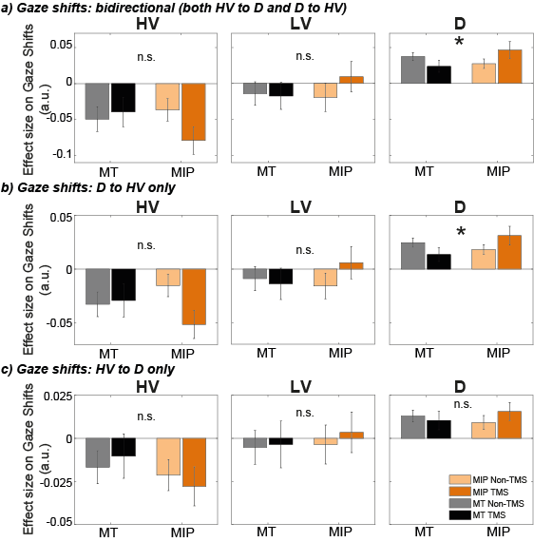
Supplementary Figure S5: Eye-movement patterns show shift under MIP stimulation:
We used the predictors HV-LV, HV+LV, and D-HV to predict gaze shifts for consistency (figure 3), since these predictors were used throughout all analyses, and since our predictions are focused on the distractor value, which is captured well by the predictor D-HV. However, to predict gaze shifts, absolute option values are arguably more interpretable. We therefore repeated the same analyses, but using the predictors HV, LV, and D, instead of HV-LV, HV+LV, and D-HV. The results do not change qualitatively. There were no effects for the predictors HV or LV on gaze shifts from D to HV, from HV to D, or both (F < 3.74, p > 0.062). When we tested the impact of D on gaze shifts, we found a Site x Stimulation interaction for bidirectional gaze shifts (both D to HV and HV to D; F(1,30) = 6.61, p = 0.015, η_{p}² = .18, and gaze shifts from D to HV (F(1,30) = 5.80, p = 0.022, η_{p}² = 0 .16), but not for gaze shifts from HV to D (F(1,30) = 0.98, p = 0.330).a-c) A GLM (predictors: HV, LV, D) was used to predict gaze shifts between different options, namely bidirectional gaze shifts between D and HV (a), directional gaze shift from D to HV (b), and directional gaze shifts from HV to D (c), for each participant and each condition. A Site x TMS ANOVA was then applied to the resulting beta values. TMS over MIP increased the number of gaze shift from D to HV (Site x Stimulation interaction, * p < 0.05), but not from HV to D.

Supplementary Figure S6
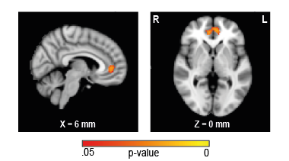
Supplementary Figure S6: VBM reveals association between MIP TMS and frontal region:
We conducted a region of interest analysis on parietal/occipital regions and identified an association between the effect of MIP stimulation on the distractor effect and MIP (Figure 4). For completeness, we also conducted a whole-brain analysis. We found an association between the TMS effect and the pregenual anterior cingulate cortex (pgACC), with larger MIP TMS effects associated with smaller pgACC GM (p = 0.018, centred around MNI X(0), Y(48), Z(4)).

