Implementing a new dose-response model for estimating infection probability of Campylobacter jejuni based on
the key events dose-response framework

Supplementary information

Hiroki Abe, Kohei Takeoka, Yuto Fuchisawa, Kento Koyama, Shigenobu Koseki*

Graduate School of Agricultural Science, Hokkaido University, Kita-9, Nishi-9, Kita-ku, Sapporo 060-8589, Japan

*Corresponding author: Phone/fax: +81 11 706 2552
E-mail address: koseki@bpe.agr.hokudai.ac.jp (S. Koseki)

Table S1. Details of components in the constructed key events dose-response model
Abbreviation | Section | Detail of components | Data source
$$N_{dose}$$ | Dose | Pathogen count intake | Describing variables
$${pH}_{0}$$ | pH change of gastric juice after meal | pH immediately after meal | Younger pH:  Dressman et al., ¹⁹  Elder pH:  Russel et al., ²⁰
$$k_{pH}$$ | pH change of gastric juice after meal | Rate of decrease in pH
$${pH}_{min}$$ | pH change of gastric juice after meal | Minimum pH value
$$σ_{pH}$$ | pH change of gastric juice after meal | S.D. of pH prediction
$$a$$ | Pathogen reduction model in gastric juice | Secondary parameter of $δ$ | Takeoka et al.,  in submission
$$b$$ | Pathogen reduction model in gastric juice | Secondary parameter of $δ$ | Takeoka et al.,  in submission
$$e$$ | Pathogen reduction model in gastric juice | Secondary parameter of $p$ | Takeoka et al.,  in submission
$$f$$ | Pathogen reduction model in gastric juice | Secondary parameter of $p$ | Takeoka et al.,  in submission
$$S_{g}$$ | Pathogen reduction model in gastric juice | Survival pathogen ratio in gastric juice | Computables
$$α$$ | Gastric retention of food | Shape parameter of gamma distribution | Hellström et al., ²¹
$$β$$ | Gastric retention of food | Rate parameter of gamma distribution | Hellström et al., ²¹
$$r_{intestine}$$ | Transit of pathogen | Survival pathogen transit ratio to intestine | Computables
$$N_{intestine}$$ | Transit of pathogen | Survival pathogen transit count to intestine | Computables
$$V$$ | Cell invasion of pathogens | Volumes of small intestine | Schiller et al., ²²
$$N_{max}$$ | Cell invasion of pathogens | Maximum invading counts to 1 cm² of cell layer | Abe et al., ⁶
$$µ$$ | Cell invasion of pathogens | Cell-invading rate | Abe et al., ⁶
$$σ_{invading}$$ | Cell invasion of pathogens | S.D. of invading pathogen count prediction | Abe et al., ⁶
$$S$$ | Cell invasion of pathogens | Surface area of intestine | Helander et al., ²³
$$α'$$ | Intestinal retention of food | Shape parameter of gamma distribution | Read et al., ²⁴
$$β'$$ | Intestinal retention of food | Rate parameter of gamma distribution | Read et al., ²⁴
$$t_{intestinal}$$ | Intestinal retention of food | Intestinal retention time | Computables
$$P_{infection}$$ | Calculation of invading probability | Infection (invading) probability | Objective variables

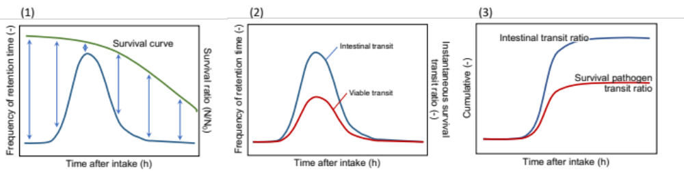
Figure S1. The scheme of the calculation for survival pathogen transit ratio from stomach to intestine (Eq. 4). (1): It is assumed that the intestinal transit rate of pathogen is equal to that of food. The survival ratio of the instantaneous pathogen transit corresponds to the instantaneous value of the survival curve. (2): Multiply the instantaneous values of survival curve and intestinal transit to calculate the instantaneous values of viable transit. (3): Integrating intestinal transit gives the ratio of all pathogens (dead or alive) that have transferred into an intestine. Similarly, the integral of viable transit represents the survival transit ratio of pathogens that have transferred into an intestine.

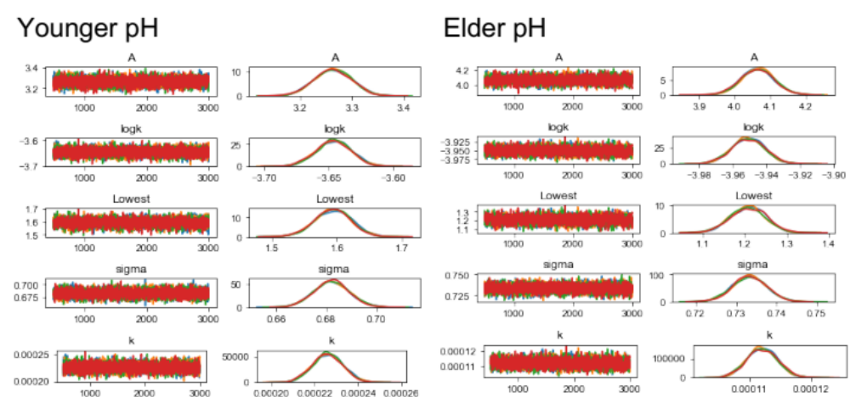
Figure S2. Trace-plots and posterior distributions for estimated parameters of younger and elderly people’s pH change by Bayesian inference. Each color indicates each trace-plot and each distribution of the MCMC chain.

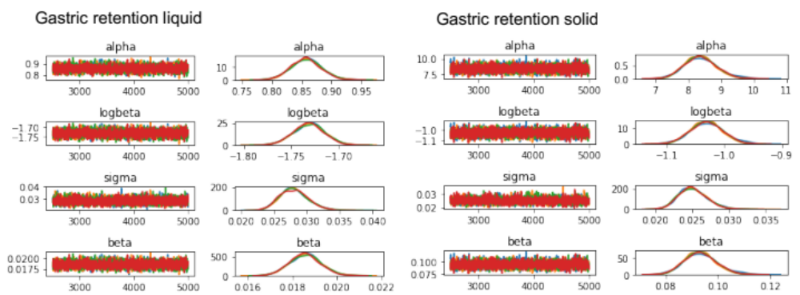
Figure S3. Trace-plots and posterior distributions for estimated parameters of gastric retention of liquid and solid by Bayesian inference. Each color indicates each trace-plot and each distribution of the MCMC chain.

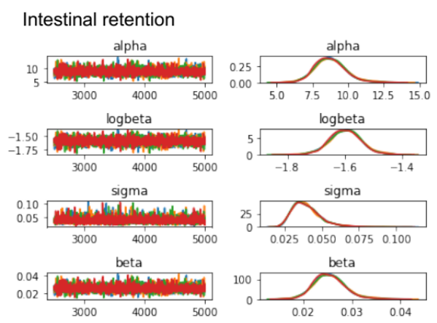
Figure S4. Trace-plots and posterior distributions for estimated parameters of gastric retention of liquid and solid by Bayesian inference. Each color indicates each trace-plot and each distribution of the MCMC chain.

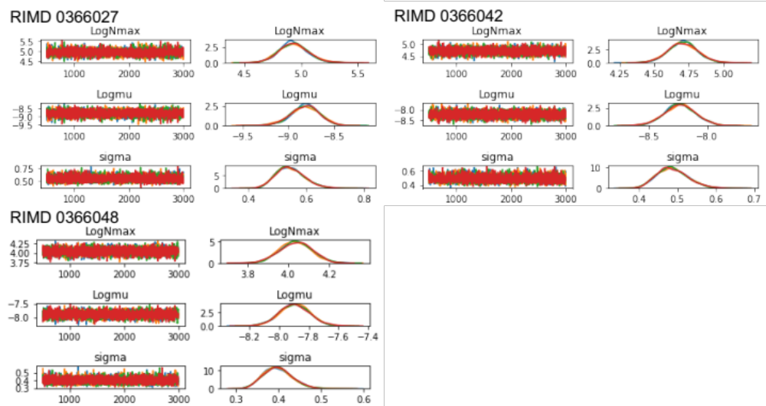
Figure S5. Trace-plots and posterior distributions for estimated parameters of the modified model from reported cell-invasion model (Abe et al., 2021) of C. jejuni (RIMD 0366027, 0366042 and 0366048) by Bayesian inference. Each color indicates each trace-plot and each distribution of the MCMC chain.

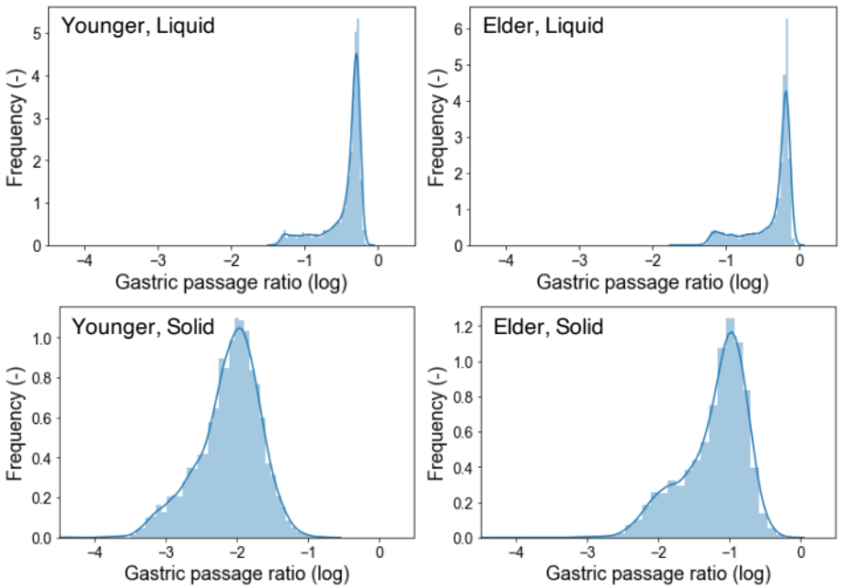
Figure S6. Histograms and kernel distributions (solid) of final survival transit ratio (12 hours after meal). Host age and food type were, from top left: Young, Liquid; Elderly, Liquid; Young, Solid and Elderly, Solid.
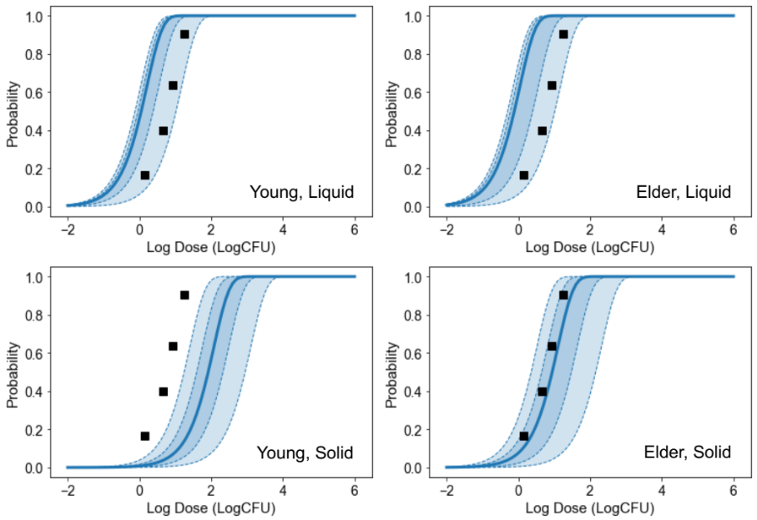
Figure S7. Cell invading probability (solid curve: median, dash curve and covered range: 60% and 95%prediction band) of C. jejuni (RIMD 0366027) under each condition (Same position as Fig. 5) & reported dose-response relationship (Teunis et al., 2005)

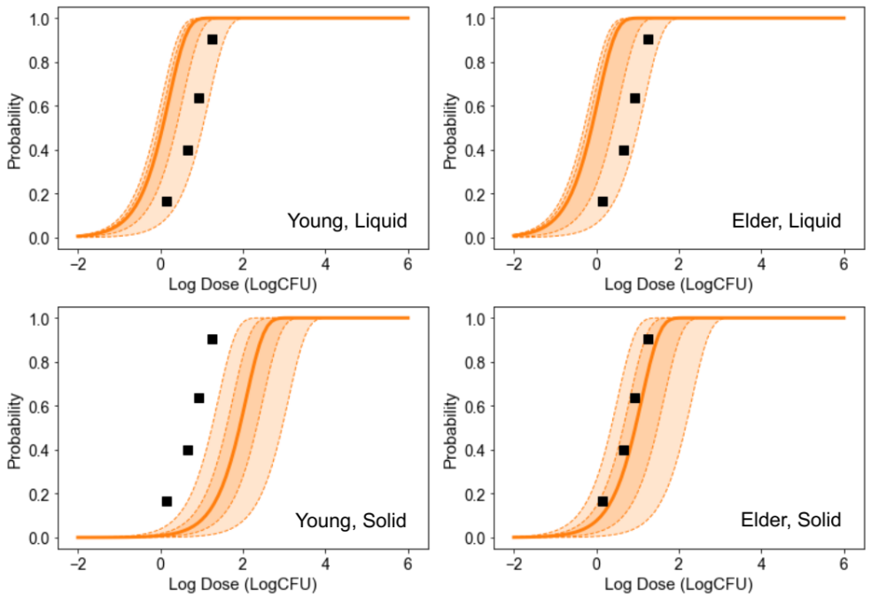
Figure S8. Cell invading probability (solid curve: median, dash curve and covered range: 60% and 95%prediction band) of C. jejuni (RIMD 0366042) under each condition (Same position as Fig. 5) & reported dose-response relationship (Teunis et al., 2005)
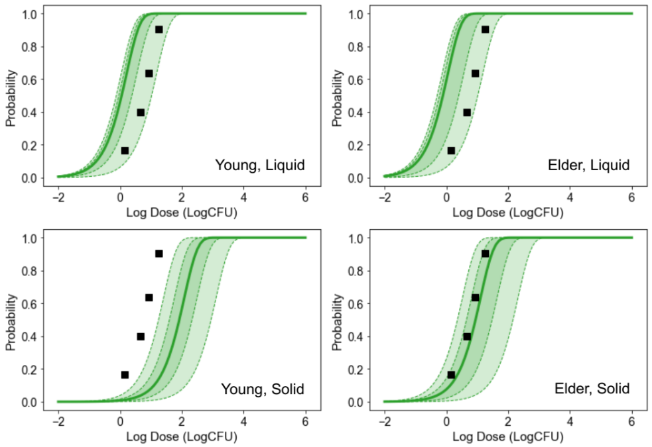
Figure S9. Cell invading probability (solid curve: median, dash curve and covered range: 60% and 95%prediction band) of C. jejuni (RIMD 0366048) under each condition (Same position as Fig. 5) & reported dose-response relationship (Teunis et al., 2005)

