SUPPLEMENTARY FIGURES 1-9

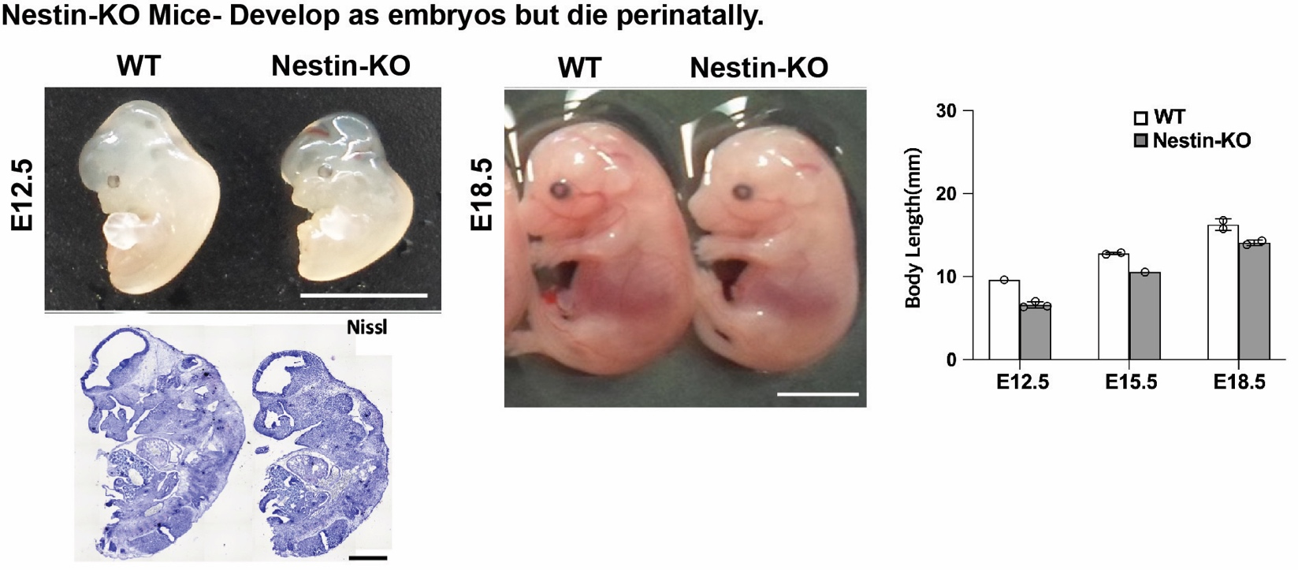
SUPPLEMENTARY FIGURE 1. Nestin-KO mice die perinatally. Brightfield and Nissl imaging of WT and developing Nestin-KO embryos showing no obvious anatomical abnormalities.

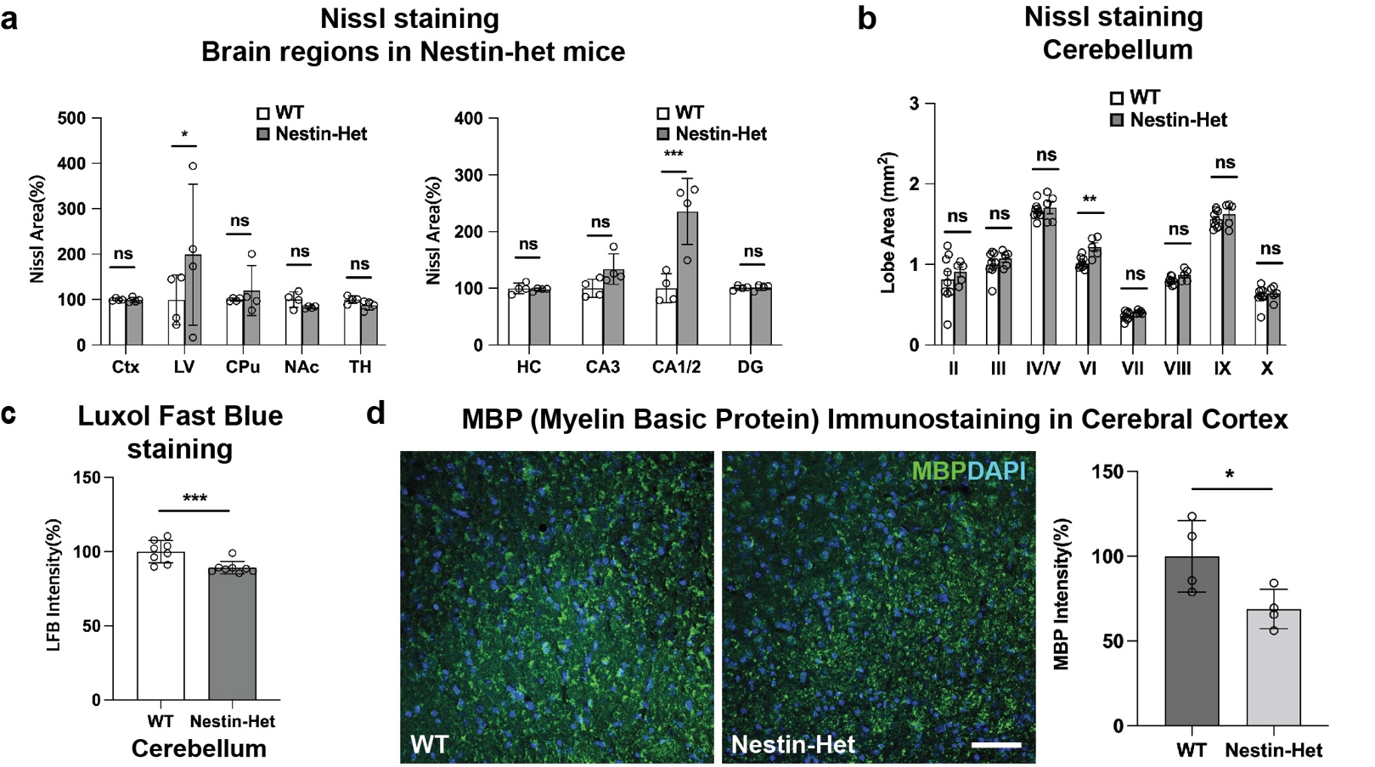

SUPPLEMENTARY FIGURE 2. Anatomical measures and MBP expression in an Anks1b haploinsufficiency mouse model. (a) Nissl staining of Nestin-Het (n=8) and WT (n=8) mice show statistically significant differences in (left) lateral ventricle (LV) and (right) CA1/2 regions of the hippocampus. 18 sections quantified from each mouse. (b) Nissl staining of cerebellar lobules in Nestin-Het (n=8) and WT (n=8) showing small but statistically significant changes in the area (mm²) of lobule VI. (c) LFB (Luxol fast blue) staining for myelin sheath components reveals decreased LFB density in cerebellum of Nestin-Het mice (n=9) compared to WT controls (n=10). (d) (Left) Immunostaining for MBP in cortex of Nestin-Het mice reveals (right) decreased myelination (Nestin-Het (n=8) and WT (n=8)). *, **, *** = p-val <0.01, <0.001, <0.0001.

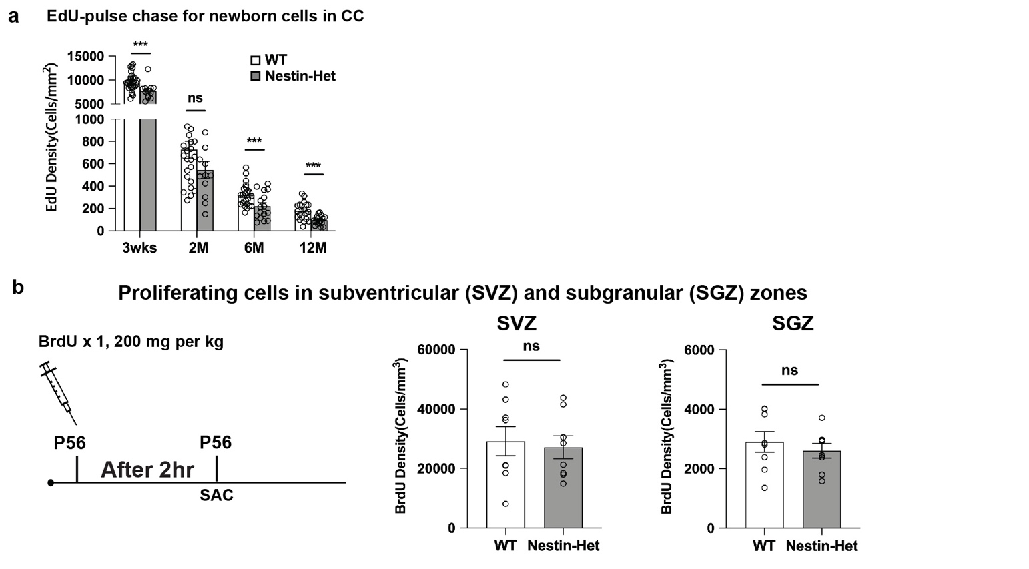

SUPPLEMENTARY FIGURE 3. No changes in overall cell birth in neurogenic zones. (a) Related to figure 3, there were significantly fewer newborn cells overall in corpus callosum at 3 weeks, 6 months, and 12 months. Number of animals tested are same as in figure 3. (b) Protocol for BrdU injections to label newborn cells: Mice 6 months of age were injected into neurogenic zones (SVZ, SGZ) with BrdU once. 2 hr after injections, mice were sacrificed, sectioned, and immunostained to identify newborn cells (BrdU+). Quantitation shows no significant differences in total number of newborn cells (Nestin-Het (n=4) and WT (n=4)).

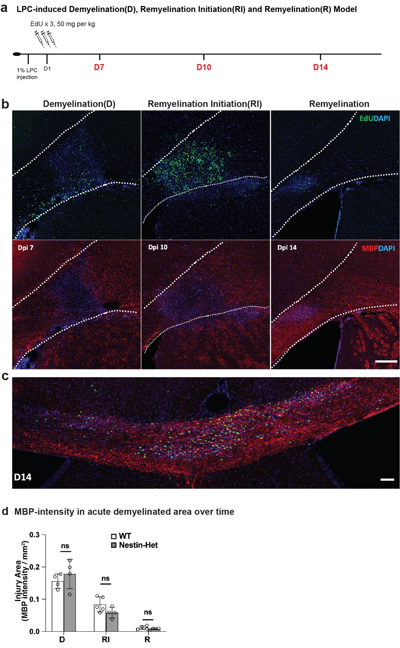
SUPPLEMENTARY FIGURE 4. Normal MBP deposition in acute myelin lesions in Anks1b haploinsufficient mice. (a) Protocol for experiment: 1% LPC (lysophosphatidylcholine) was injected into callosal regions to lesion myelin sheaths. EdU was injected IP to track newborn cells, and mice were sacrificed 7 (Demyelination-D), 10 (Remyelination Initiation-RI), and 14 days later (Remyelination-R). (b) Representative image showing (upper) newborn oligodendrocytes accumulation and (lower) MBP deposited in lesioned areas. (c) Newborn OPCs disperse throughout the corpus callosum by D14. (D) Quantitation showing no changes overall in MBP deposited in lesioned areas. Number of animals tested, same as in figure 4.
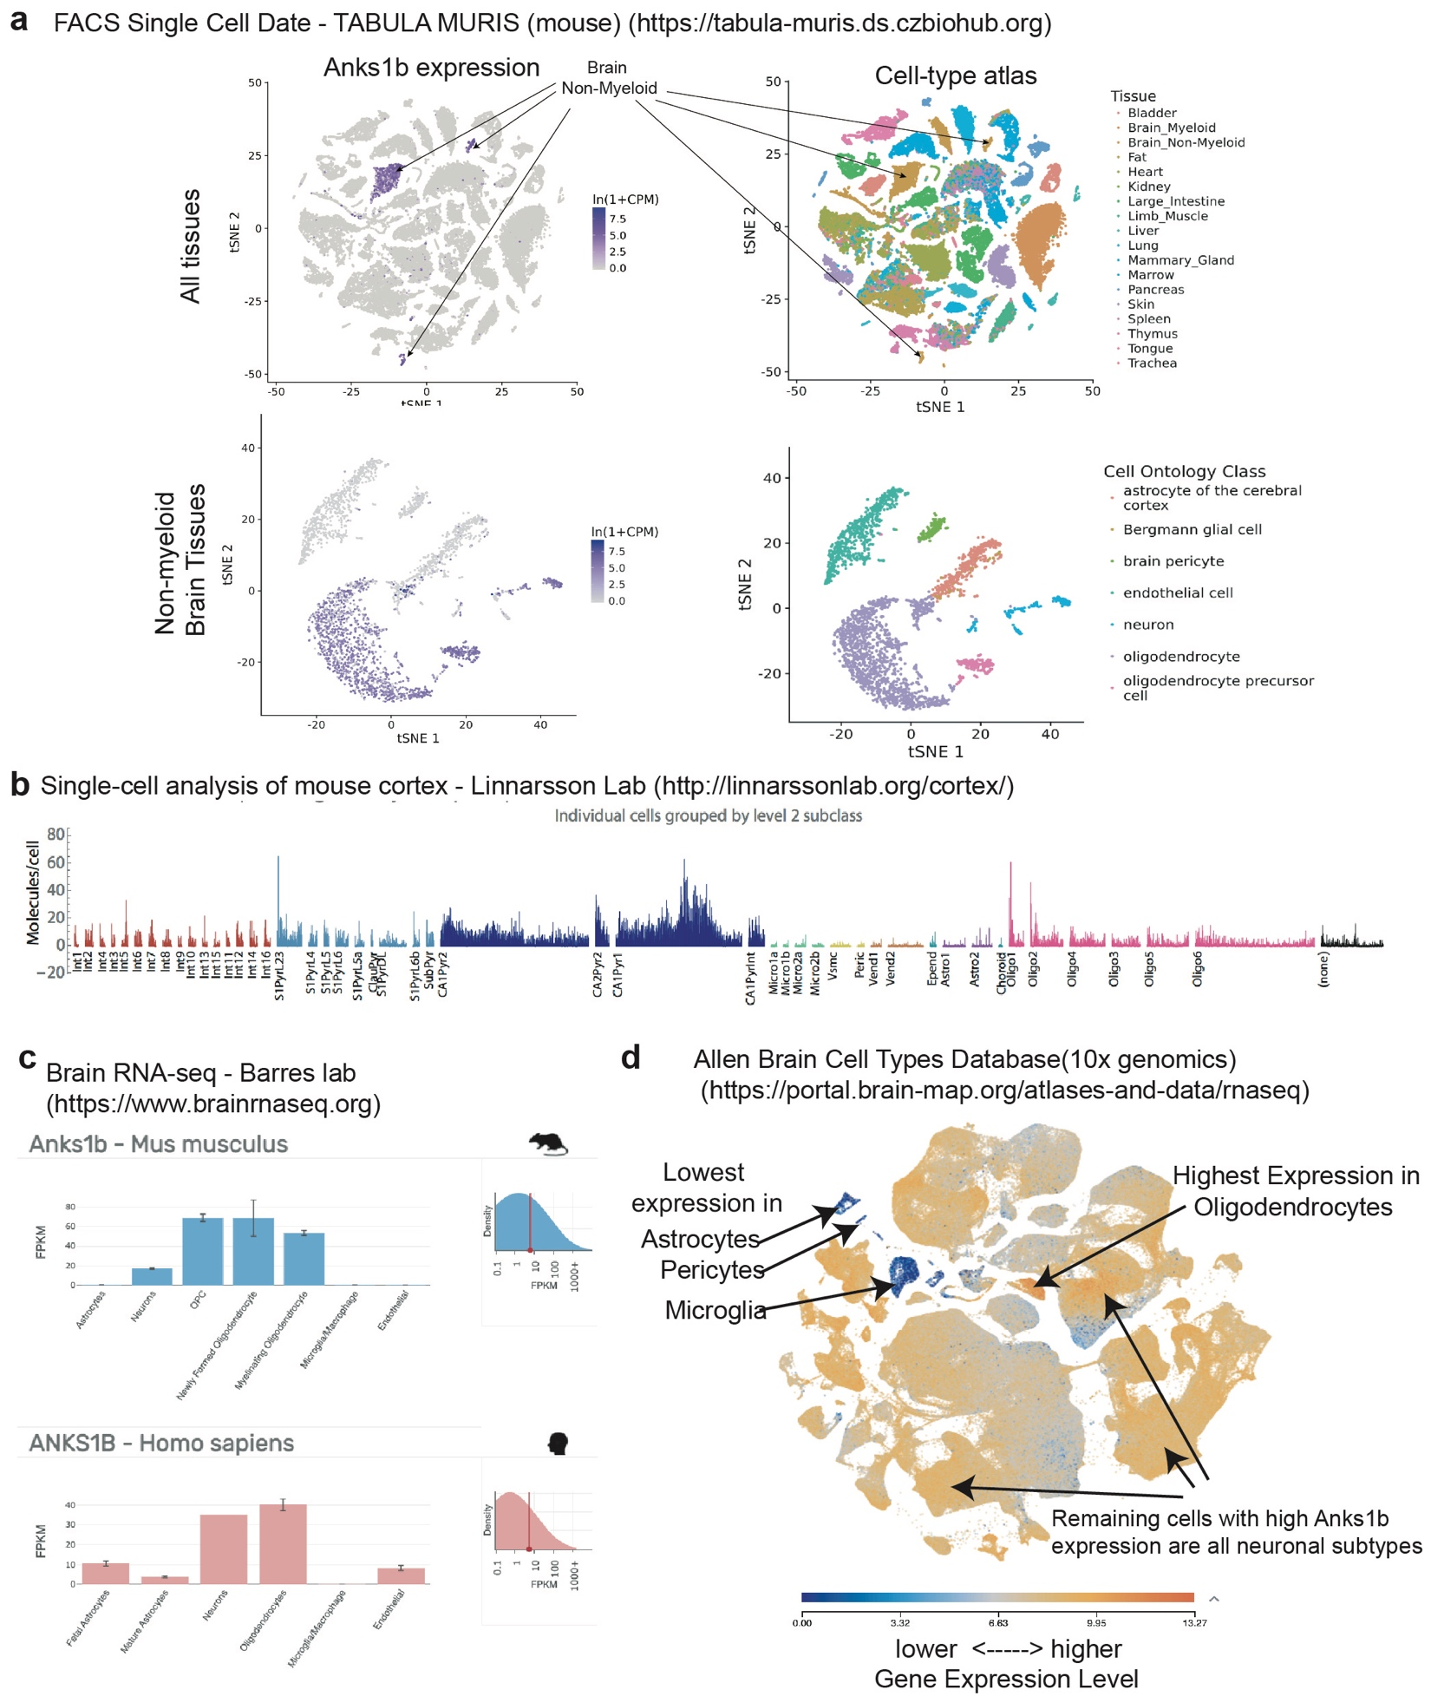
SUPPLEMENTARY FIGURE 5. AIDA-1 is expressed in oligodendrocyte lineage cells. Related to figure 5- Annotated tSNE and other single-cell transcriptomic expression charts taken from the indicated websites showing the cell-type expression of Anks1b in specific cell types.

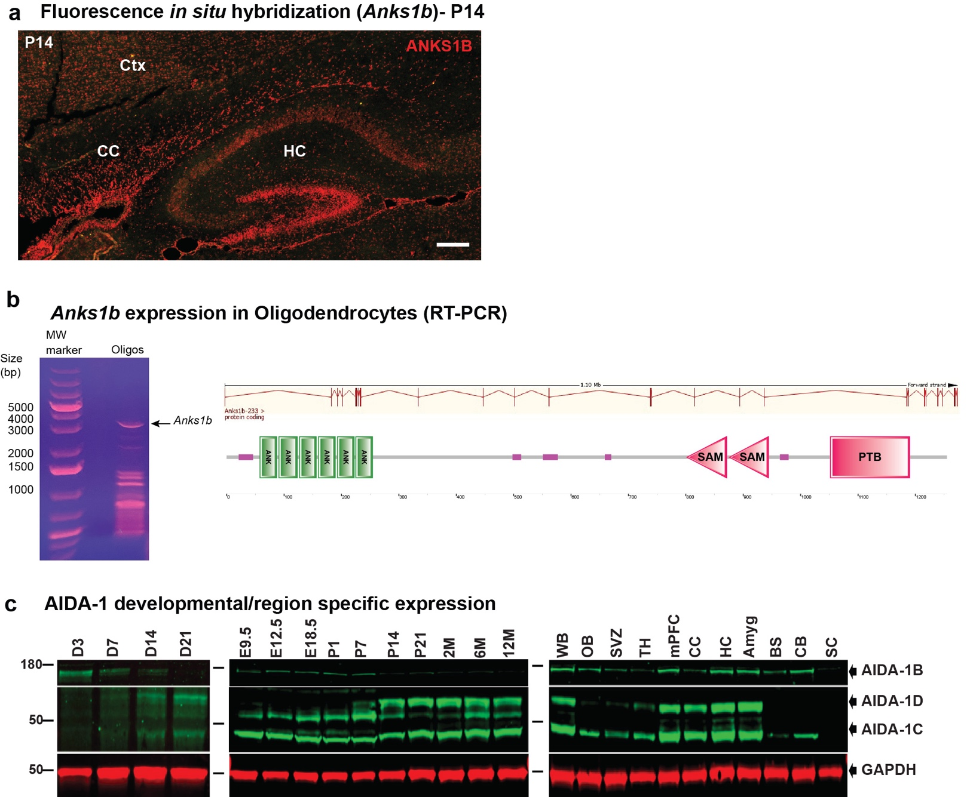SUPPLEMENTARY FIGURE 6. Large AIDA-1 splice variant is expressed in oligodendrocyte lineage cells. (a) In situ hybridization using fluorescently labelled probes targeting the 5’ region of Anks1b reveals significant expression of larger (containing the Ankyrin repeats) transcripts in hippocampal (HC) CA1 and Dentate gyrus, as well as in genu and splenium of corpus callosum (CC). (b) RT-PCR of Anks1b transcripts using gene-specific 3’ primers and degenerate oligonucleotides for 5’ priming using RNA extracted from enriched rat oligodendrocyte cultures. (left) DNA gel showing large Anks1b transcripts (~3kB) as well as smaller AIDA-1D transcripts. (right) sequencing of large 3kB transcript reveals a transcript encoding for large AIDA-1B containing 6 Ankyrin repeats. (c) Western blots using knockdown-verified AIDA-1 antibodies showing (left) AIDA-1 expression in rat primary cortical neurons at different days in culture, (middle) expression of AIDA-1 variants throughout development in total brain lysates, and (right) expression of AIDA-1 variants throughout brain regions. Representative of 3 Western blots.

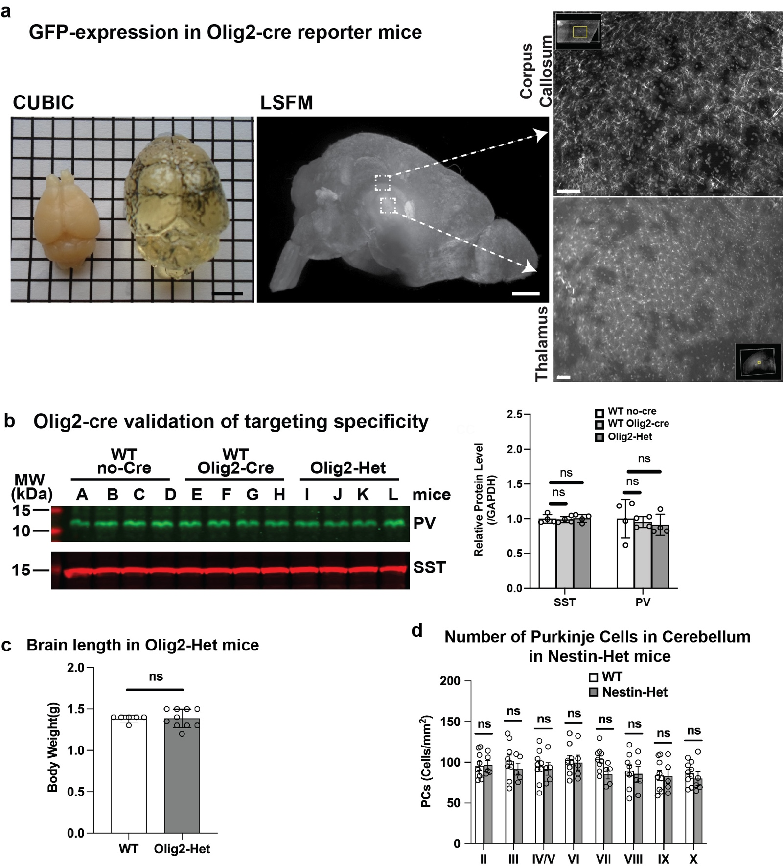SUPPLEMENTARY FIGURE 7. Validation of specific targeting in Olig2-Cre mice. Olig2-reporter mice (Olig2-Cre X Rosa26-GFP) mice were generated, sacrificed, and dissected brains were subjected to CUBIC clarifying protocols. (a) Clarified brains were analyzed by light sheet microscopy (LSFM), which confirm GFP expression in small cells with fine cloud-like processes throughout the brain, consistent with oligodendrocyte morphologies. (b) Olig2 expression was reported in a subset of interneurons early in development. However, no changes in PV or SST expression were observed in Olig2-Het mice as assessed by Western blots, suggesting normal expression of interneurons. Each letter represents an independent mouse (n=4 different mice per genotype). (c) No differences in brain length were observed in Olig2-Het mice (WT mice (n=7) and Olig2-Het (n=9). (d) No changes were observed in the number of Purkinje cells (measured using calbindin staining) in Nestin-Het mice.
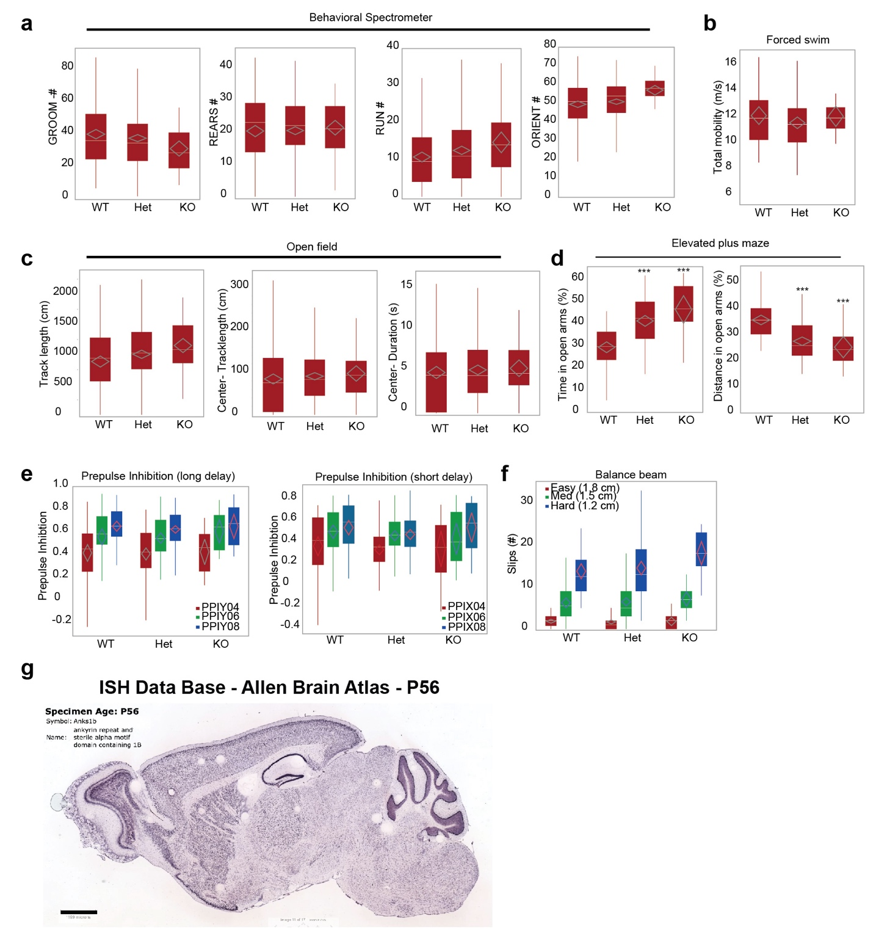SUPPLEMENTARY FIGURE 8. Additional behaviors associated with Anks1b Olig2-Cre mice. a) Results from behavioral spectrometer. No differences in grooming, rearing, number of running events, or orienting were observed in Anks1b Olig2-Het or Olig2-KO mice compared to WT controls, suggesting normal risk assessment. b) No differences were observed in the Porsolt forced swim test of learned helplessness. c) No differences were observed in total track length, or total track length or time spent in center regions in open field testing. d) In the elevated plus maze, Olig2-Het and Olig2-KO mice spent (left) significantly more time in the open arms, but (right) covered significantly less track in open arms, revealing variable anxiety-related behaviors. e) No deficits in prepulse inhibition of the acoustic startle reflex were observed at any sound level (PPI04=90db, PPI06= 100db, PPI08=115db) at short (x) or long (y) intervals. f) Olig2-Het or Olig2-KO mice do not exhibit significant deficits in gross motor coordination as measured by slips on a balance beam. Box plots show 25th-75th quantiles (box), median (black line), 95% confidence intervals (black diamond), and range (black whiskers). No significant sex differences were observed in any behaviors evaluated. For Anks1b Olig2-Het and Olig2-KO experiments, n = 53 WT, 82 Het, 12 KO. (g) Micrograph of Anks1b expression (from Allen Brain Atlas) in sagittal slices of acute rat brains at p56, showing high expression in olfactory bulb, forebrain, hippocampus, and cerebellum.
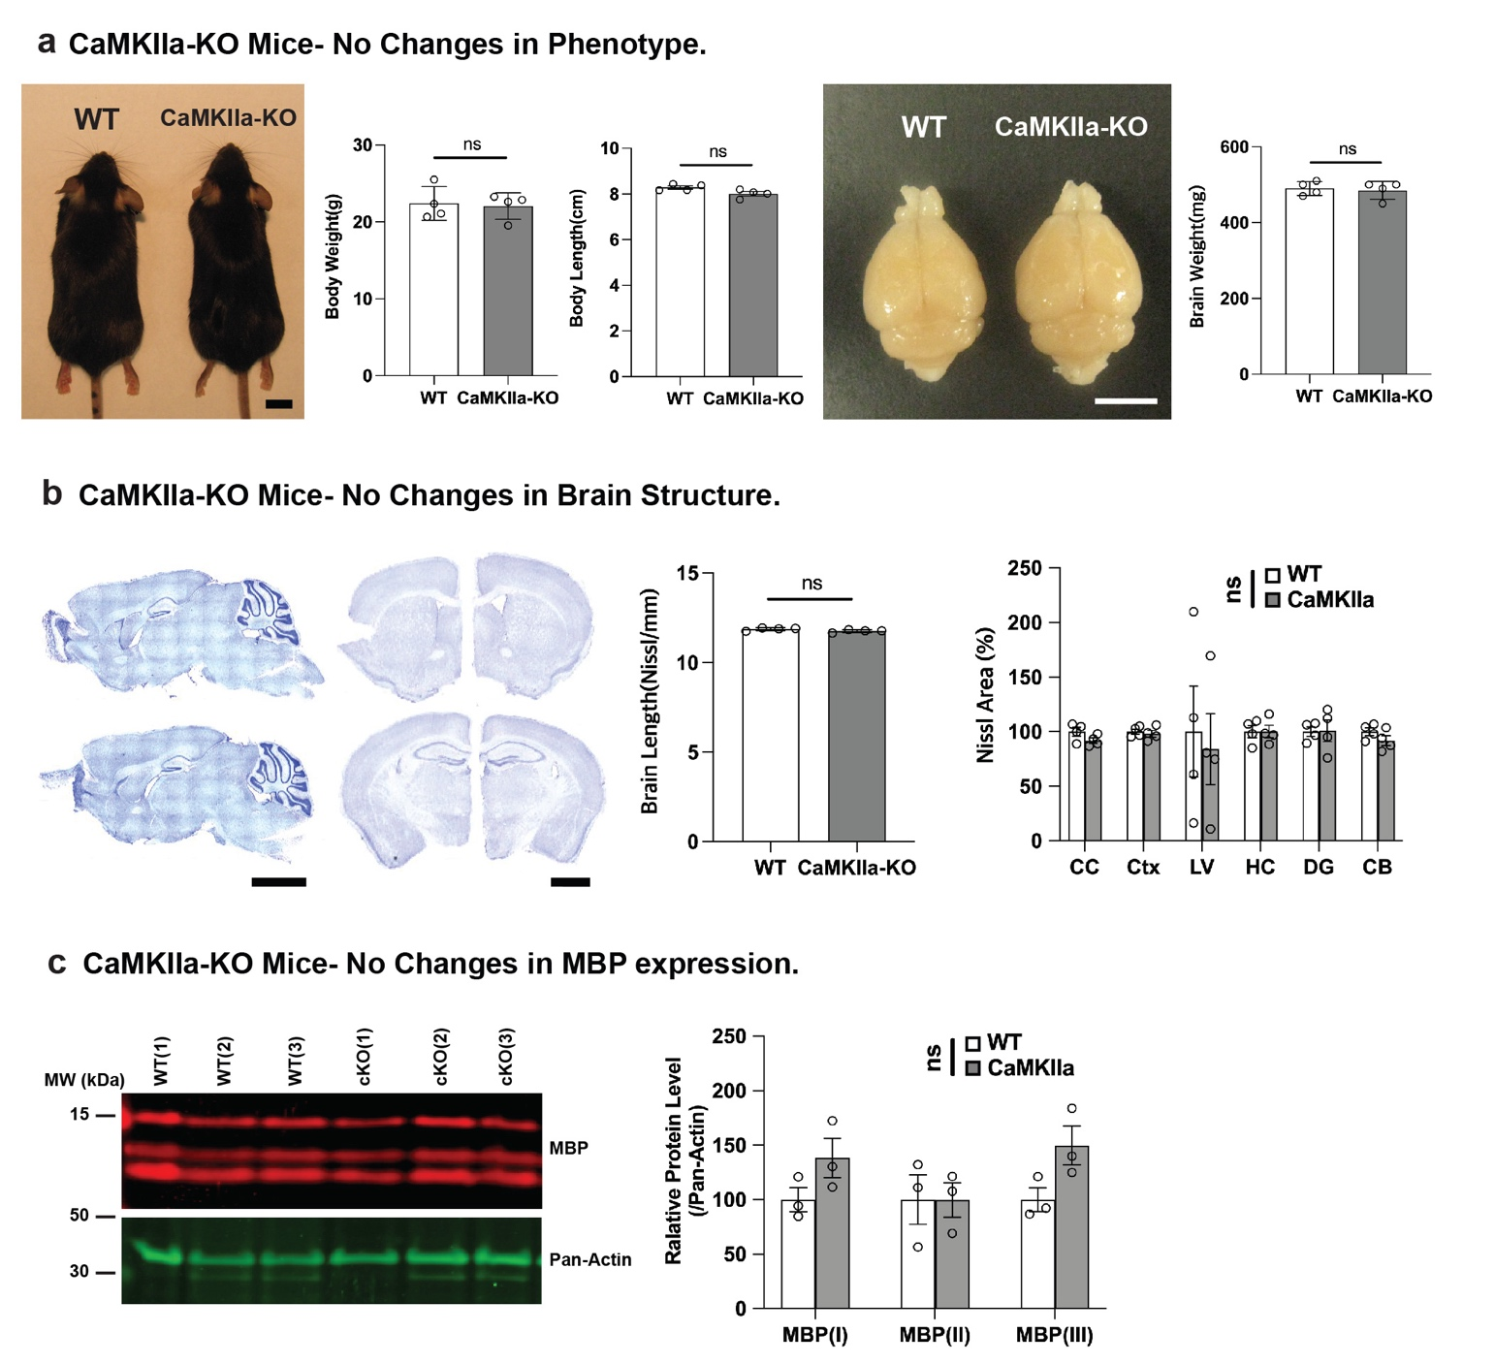SUPPLEMENTARY FIGURE 9. CaMKIIα mice do not show changes in gross anatomy or MBP expression present in Nestin-Het or Olig2-Het mice. (a) There were no changes in body measurements or brain weight between CaMKIIa-KO or WT controls. (b) Nissl staining of CaMKIIa-KO (n=8) and WT (n=8) mice shows no significant differences in different brain regions. 18 sections quantified from each mouse. (c) Western blots of total brain lysates show that there were no changes in MBP expression (in any of the three quantified splice isoforms) between genotypes.

