Supporting information
to
Versatile aliphatic polyester biosynthesis system for producing random and block copolymers composed of 2-, 3-, 4-, 5-, and 6-hydroxyalkanoates using the sequence-regulating polyhydroxyalkanoate synthase PhaC_{AR}
Keigo Satoh, Tomoya Kawakami, Nagi Isobe, Loïc Pasquier,
Hiroya Tomita, Manfred Zinn, and Ken’ichiro Matsumoto

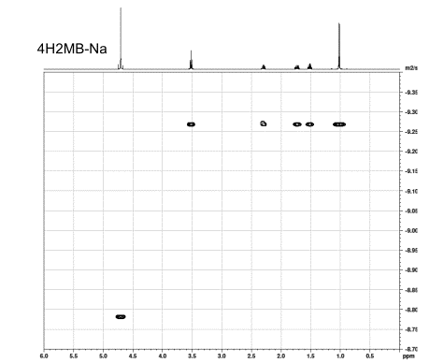
¹H [log(m²/s)]
Fig. S1A ¹H-¹H DOSY-NMR of 4H2MB-Na in D₂O

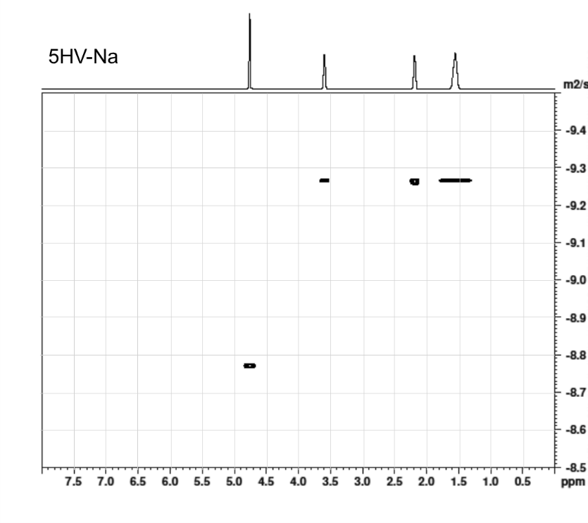
¹H [log(m²/s)]
Fig. S1B ¹H-¹H DOSY-NMR of 5HV-Na in D₂O

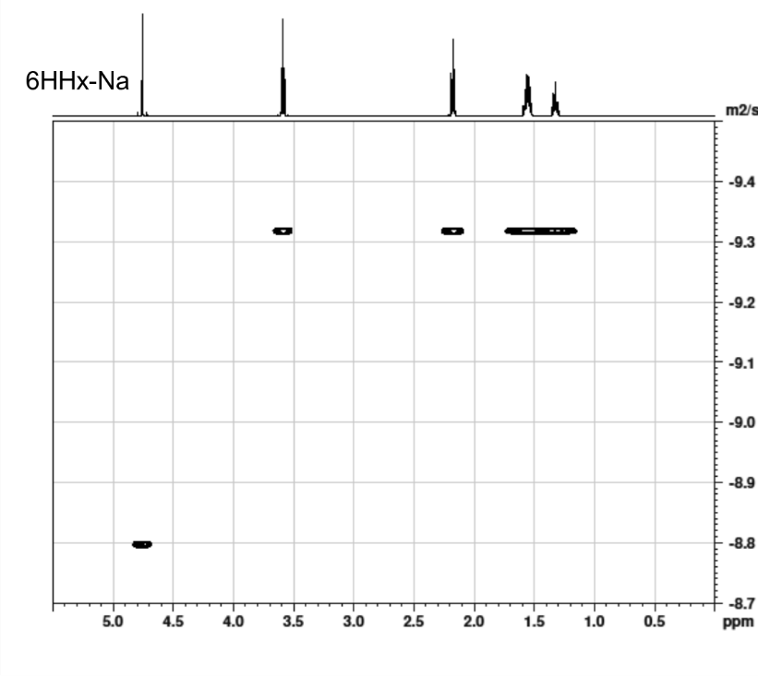
¹H [log(m²/s)]
Fig. S1C ¹H-¹H DOSY-NMR of 6HHx-Na in D₂O

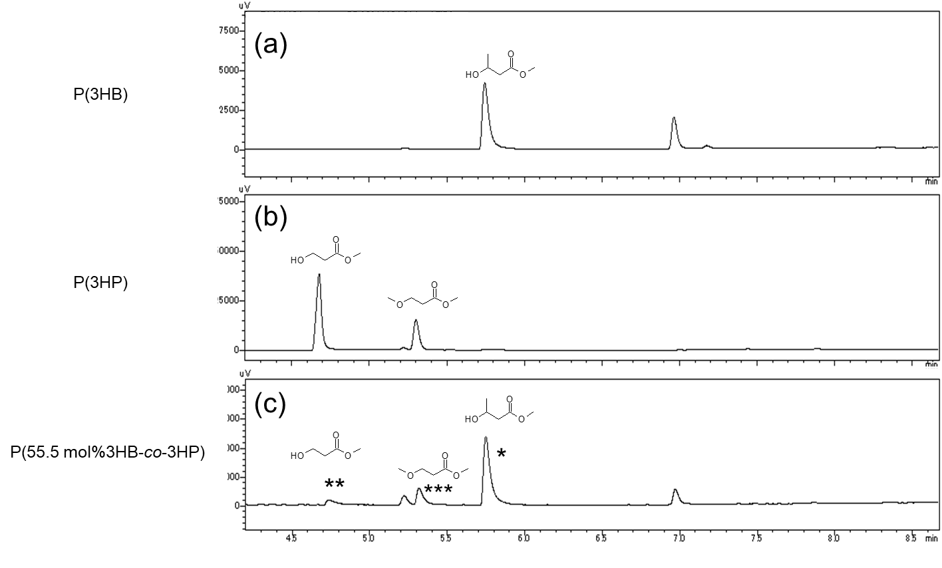
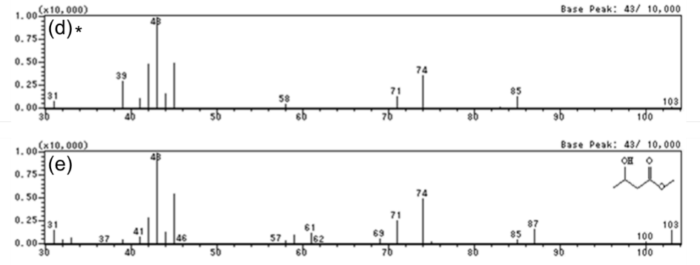
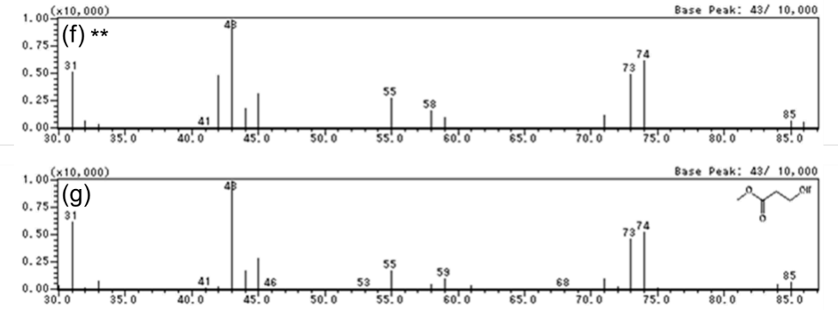
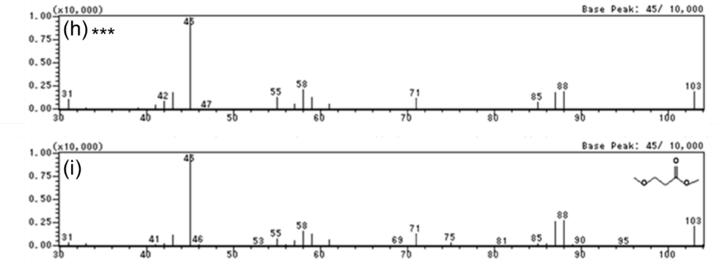
Fig. S2A GC analysis and Electron Ionization (EI) MS spectra of P(3HB), P(3HP) and P(3HB-co-3HP) synthesized by PhaC_{AR}. GC charts of P(3HB) (a), P(3HP) (b) and P(3HB-co-3HP) (c) methanolysis derivatives. MS spectra corresponding to peak * (d), methyl 3-hydroxybutyrate standard in NIST library (e), peak ** (f), methyl 3-hydroxypropionate standard (g), peak *** (h) and methyl 3-methoxypropionate standard (i).

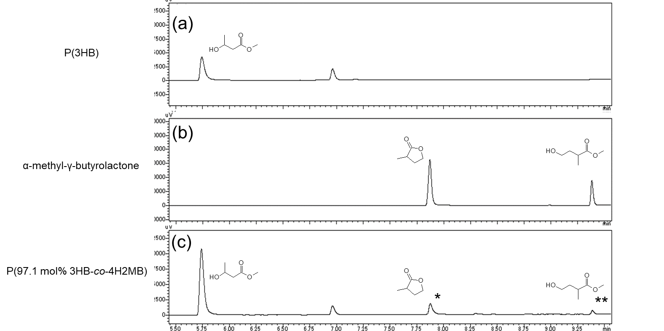
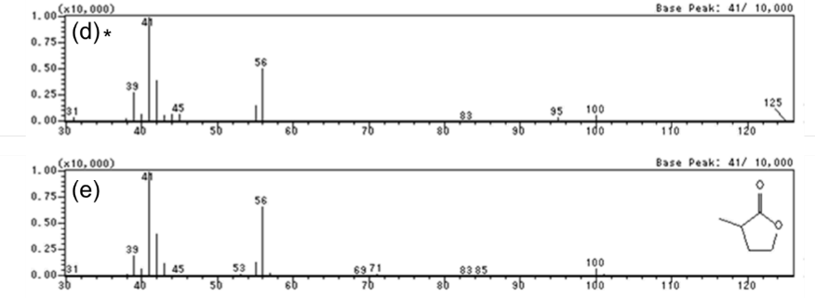
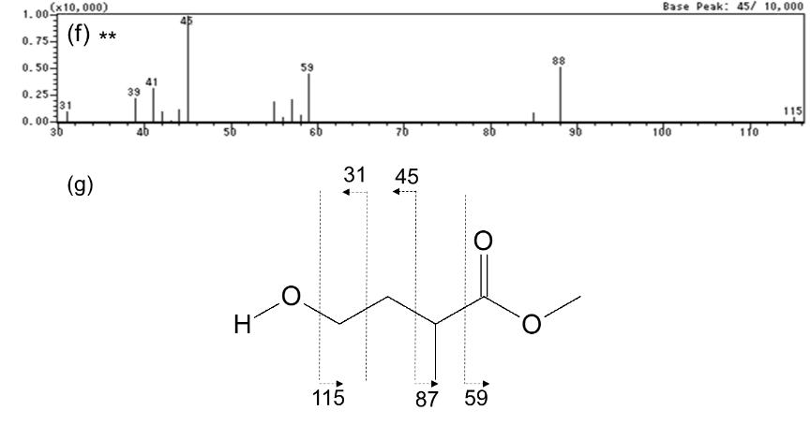
Fig. S2B GC analysis and MS spectra of P(3HB-co-4H2MB) synthesized by PhaC_{AR}. GC charts of P(3HB) (a), α-methyl-γ-butyrolactone (b) and P(3HB-co-4H2MB) (c). MS spectra of peak * (d), α-methyl-γ-butyrolactone standard (e) and peak **(f). The fragment m/z pattern generated from methyl 2-methyl-4-hydroxybutyrate (g).
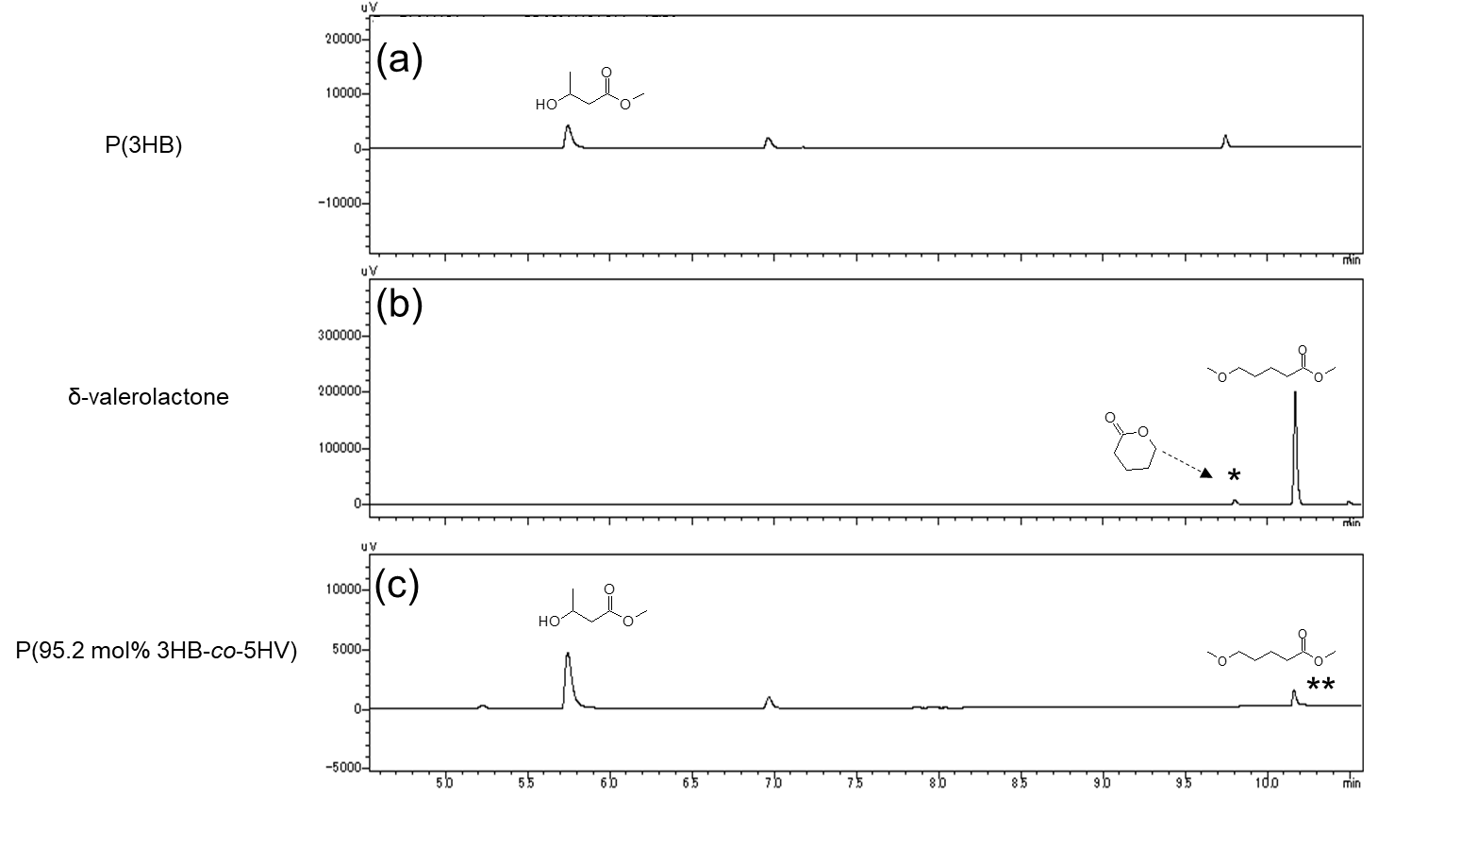
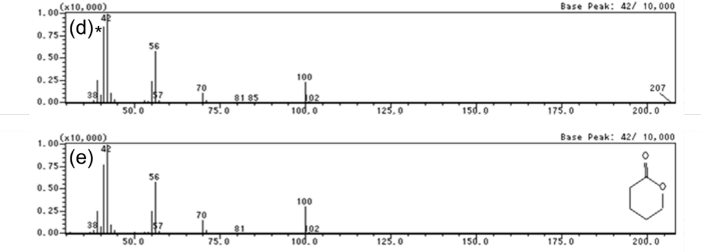
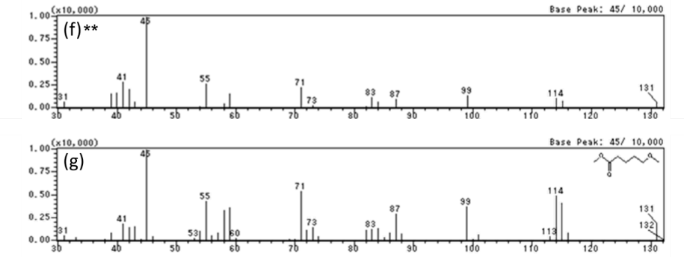
Fig. S2C GC analysis and MS spectra of P(3HB-co-5HV) synthesized by PhaC_{AR}. GC charts of P(3HB) (a), δ-valerolactone (b) and P(3HB-co-5HV) (c). MS spectra of peak * (d), δ-valerolactone standard (e), peak ** (f) and methyl 5-methoxypentanoate (g).
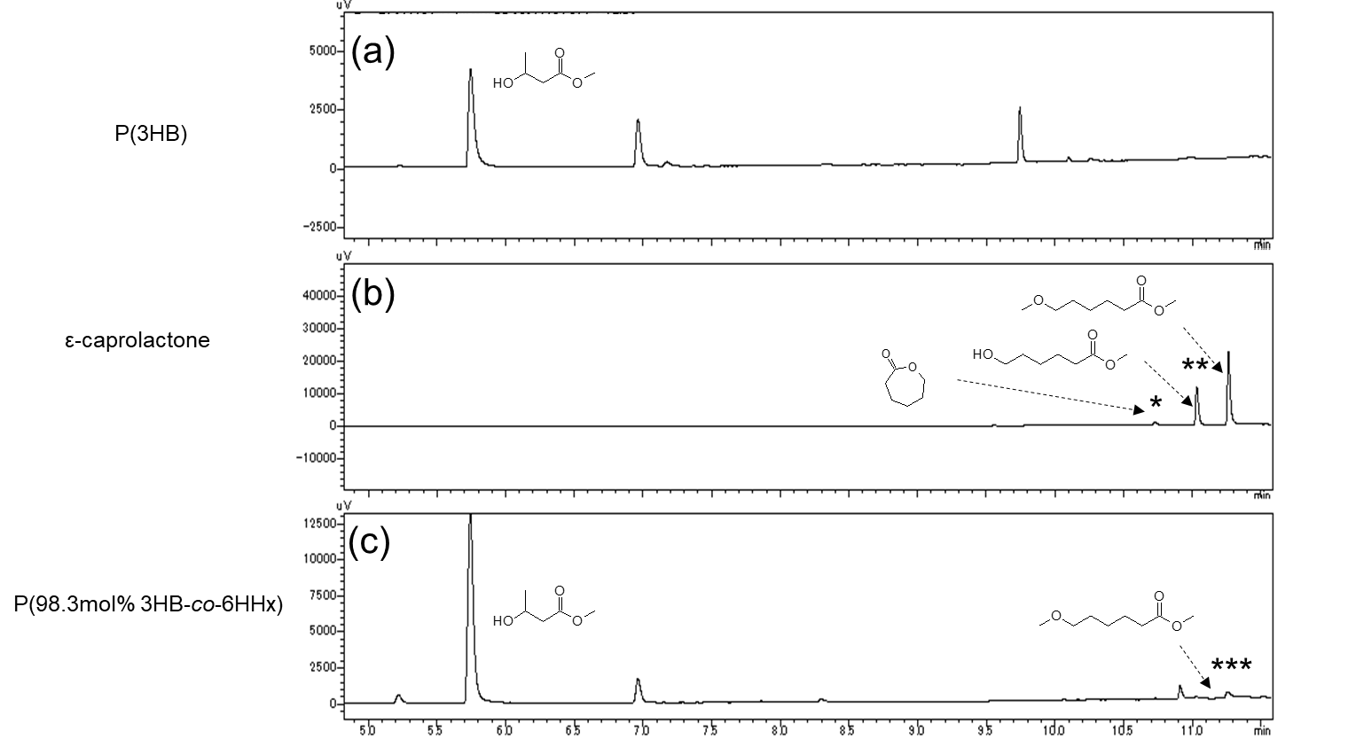
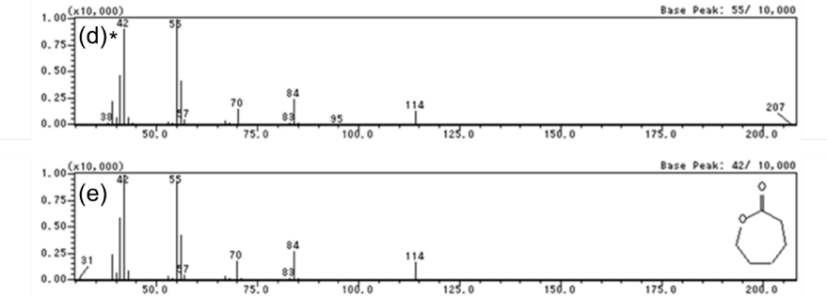
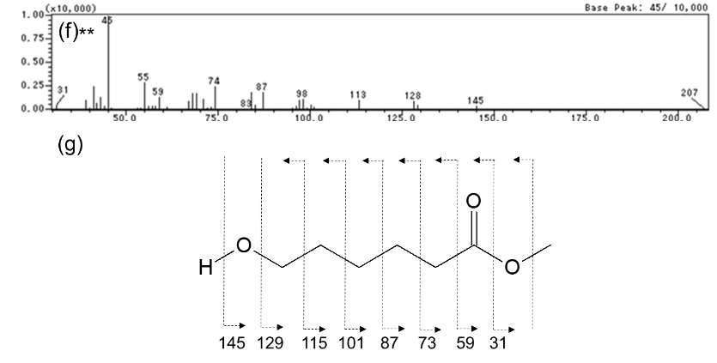
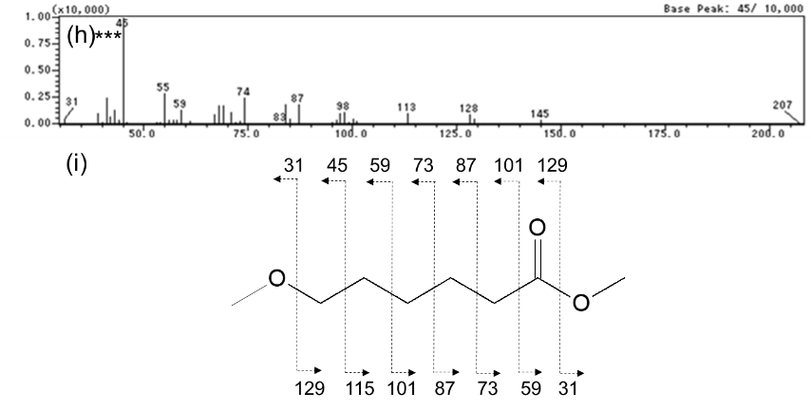
Fig. S2D GC analysis and MS spectra of P(3HB-co-6HHx) synthesized by PhaC_{AR}
GC charts of P(3HB) (a), ε-caprolactone (b) and P(3HB-co-6HHx) (c). MS spectra of peak * (d), methyl 6-methoxyhexanoate standard (e) and peak ** (f). The fragment m/z pattern generated from methyl 6-hydroxyhexanoate (g). MS spectrum of peak *** (h). The fragment m/z pattern generated from methyl 6-methoxyhexanoate (i).

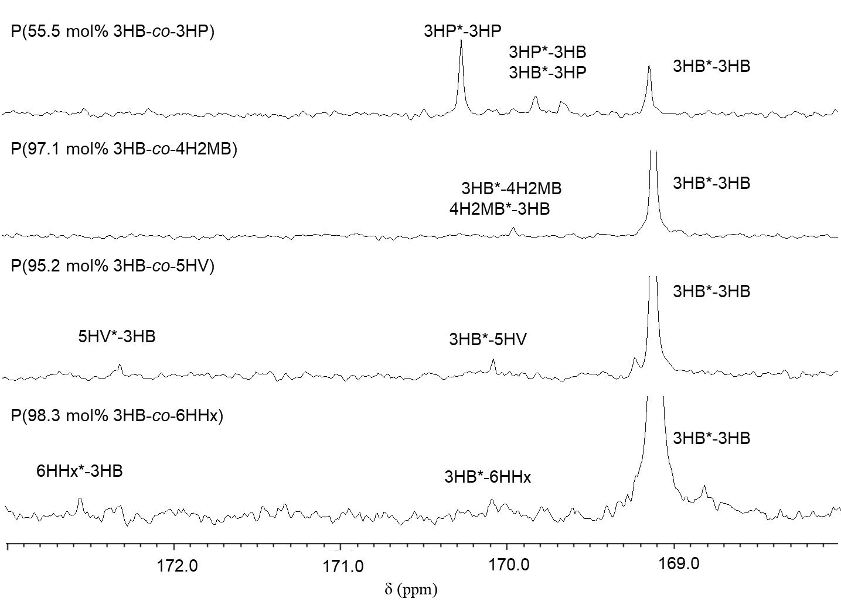
Fig. S3 ¹³C NMR analysis of P(3HB-co-LMC HA)s. Resonances of carbons of carbonyl group are magnified. The dyad sequences of P(3HB-co-6HHx) are ascribed based on the reference No. 42. The resonances of 4H2MB and 5HV containing copolymers are ascribed based on the analogy to P(3HB-co-6HHx).
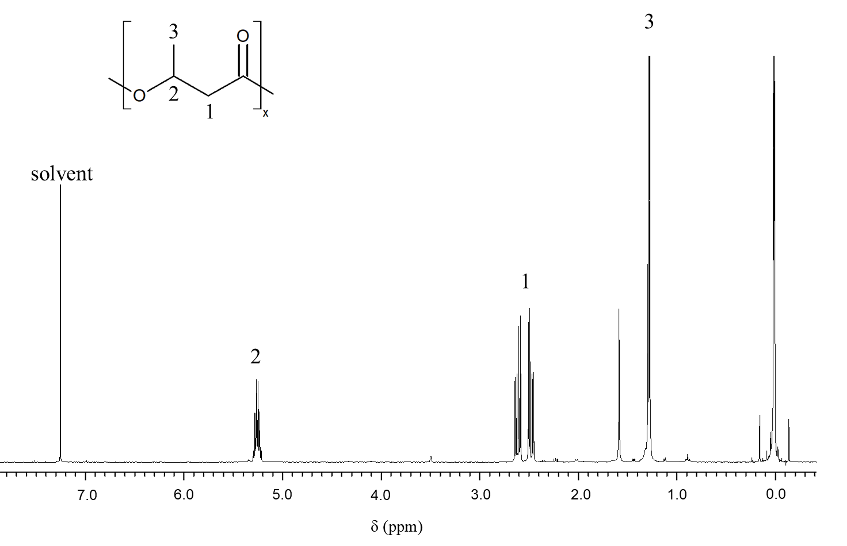
Fig. S4A ^{１}H NMR of P(3HB)
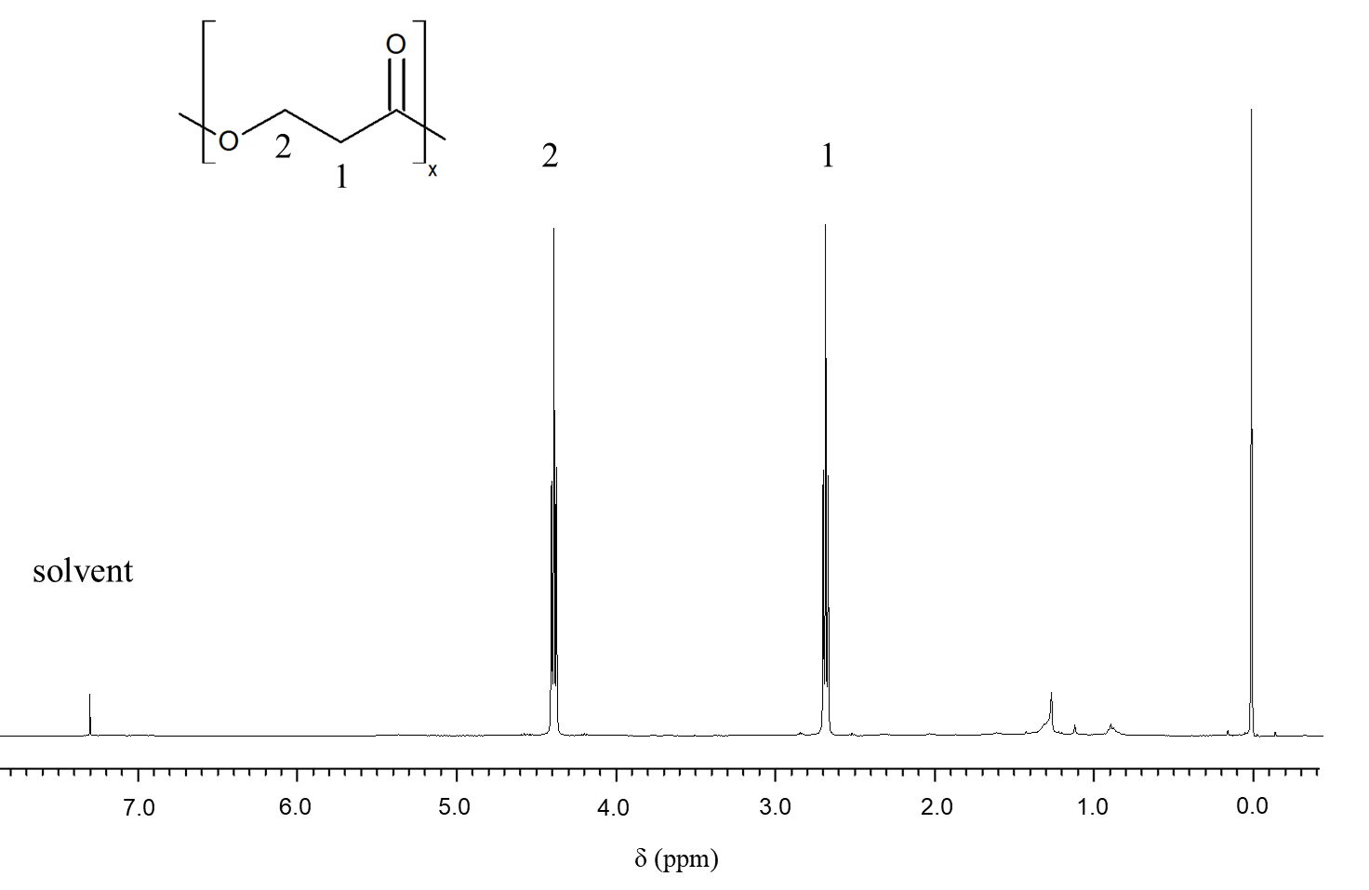

Fig. S4B ^{１}H NMR of P(3HP)

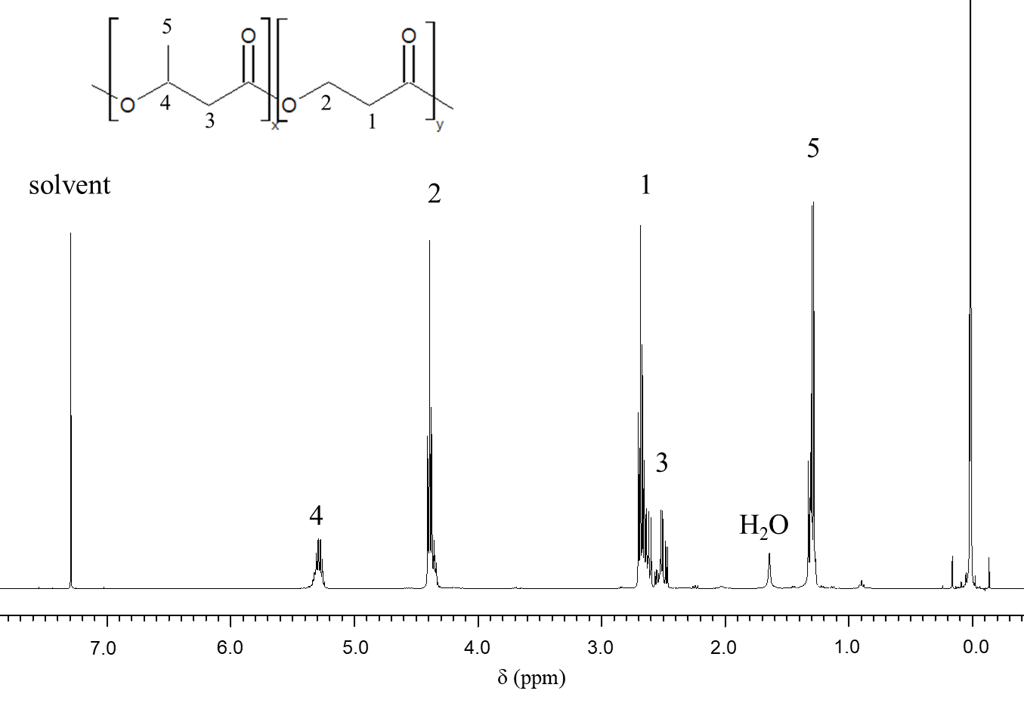
Fig. S4C ^{１}H NMR of P(3HB-co-3HP)
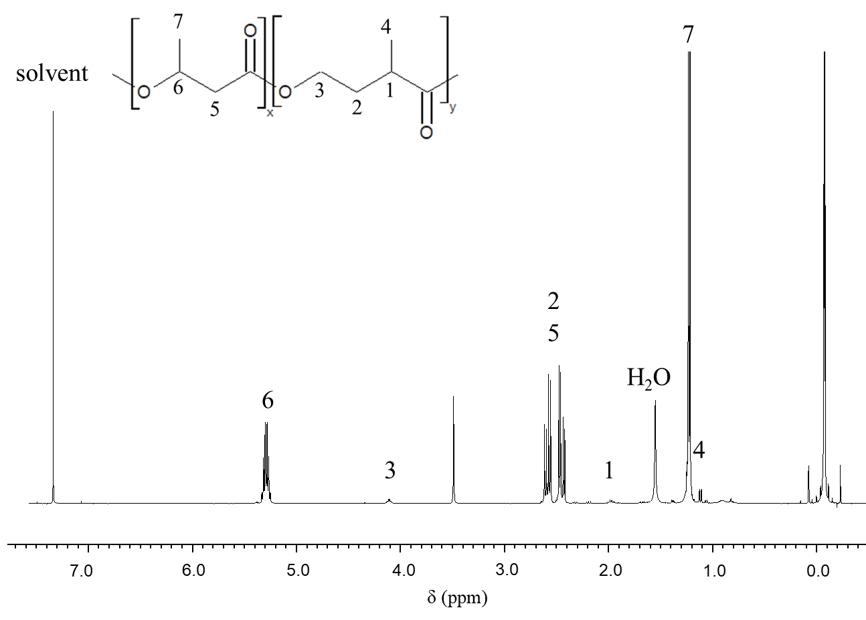
Fig. S4D ^{１}H NMR of P(3HB-co-4H2MB)

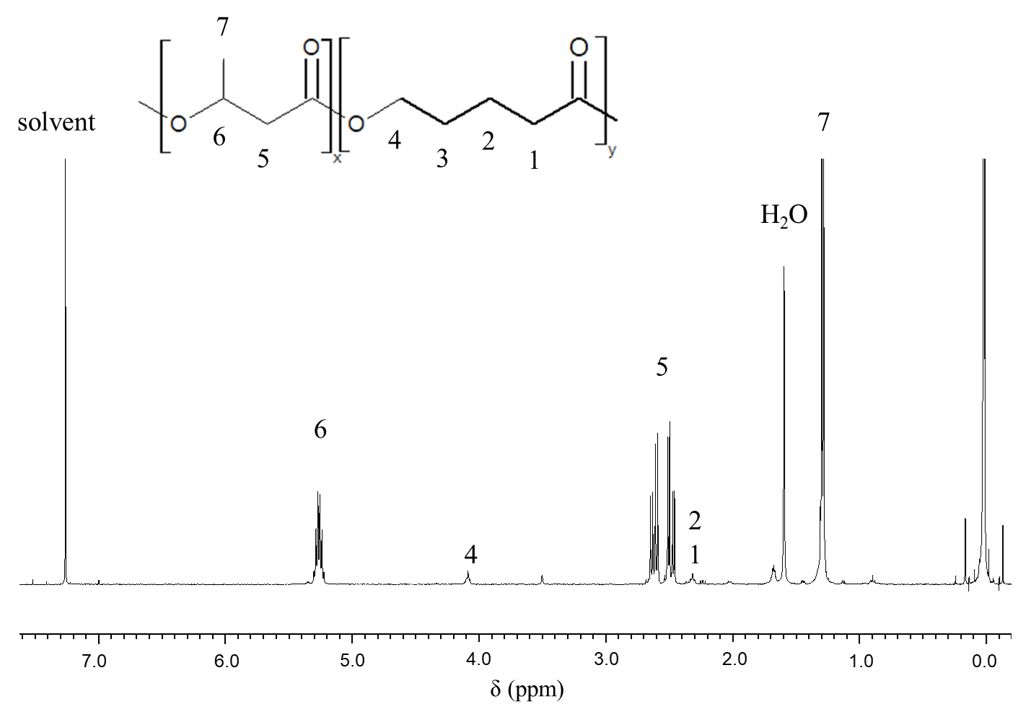
Fig. S4E ^{１}H NMR of P(3HB-co-5HV)
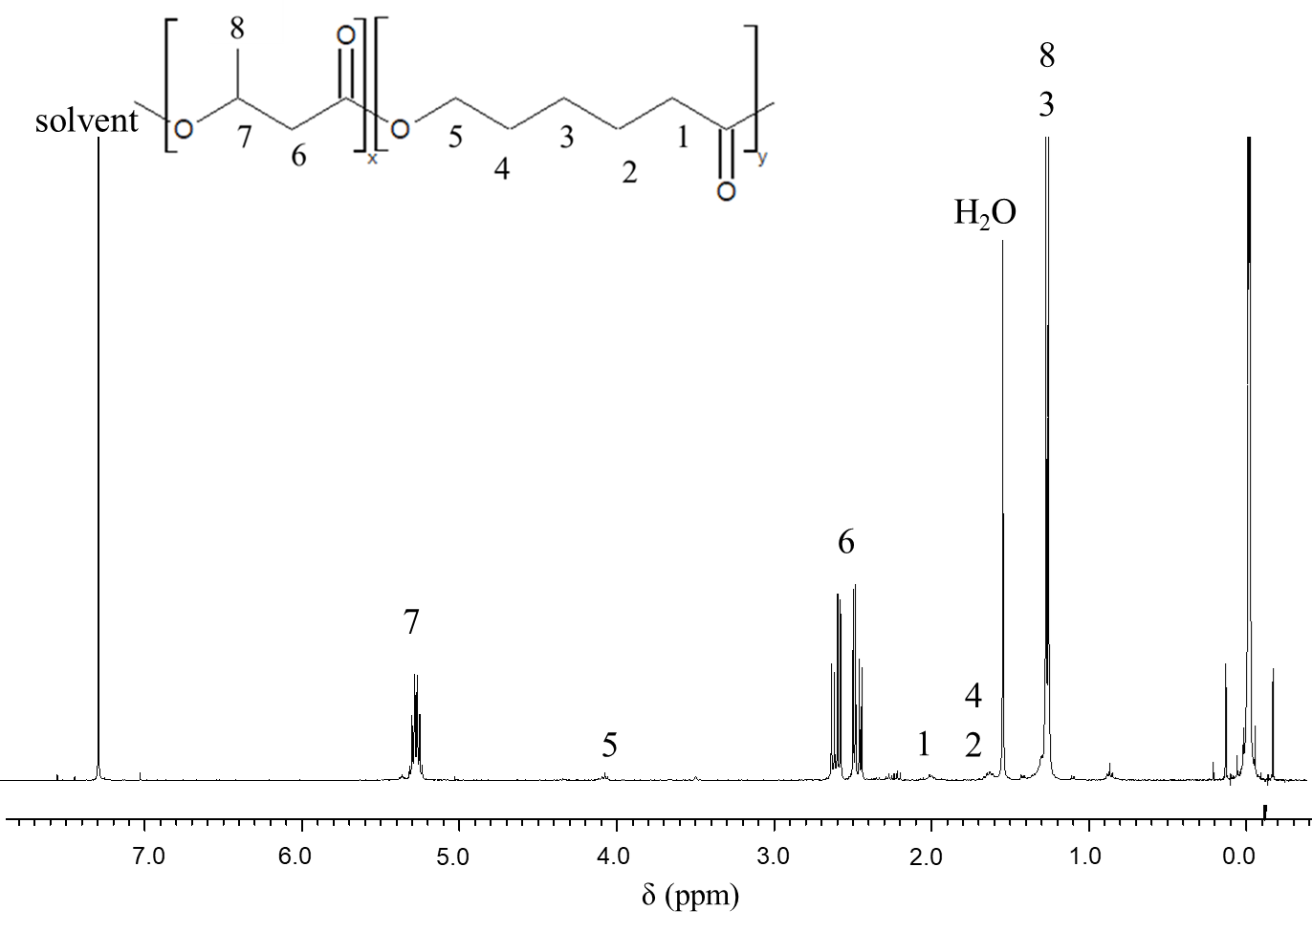
Fig. S4F ^{１}H NMR of P(3HB-co-6HHx)

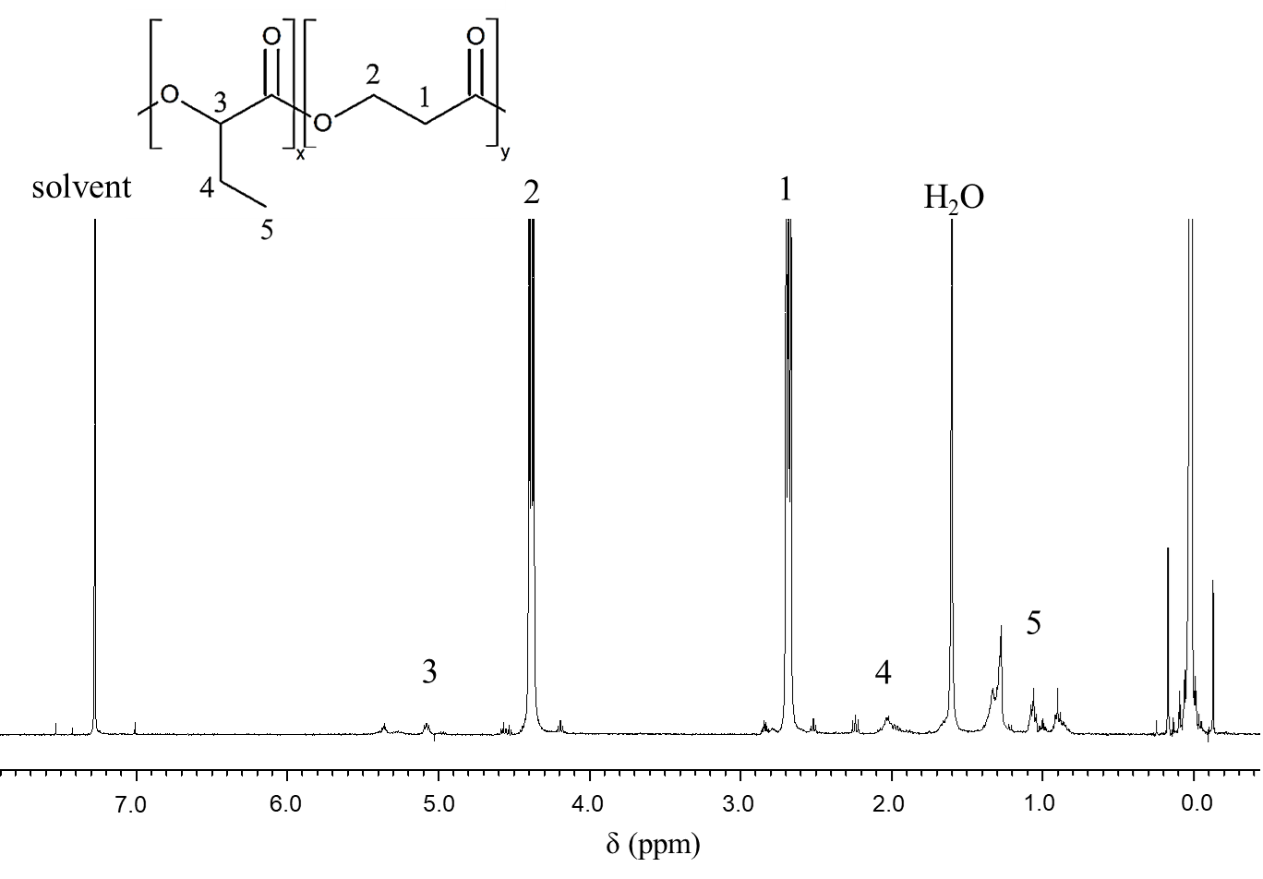
Fig. S4G ^{１}H NMR of P(2HB-co-3HP)
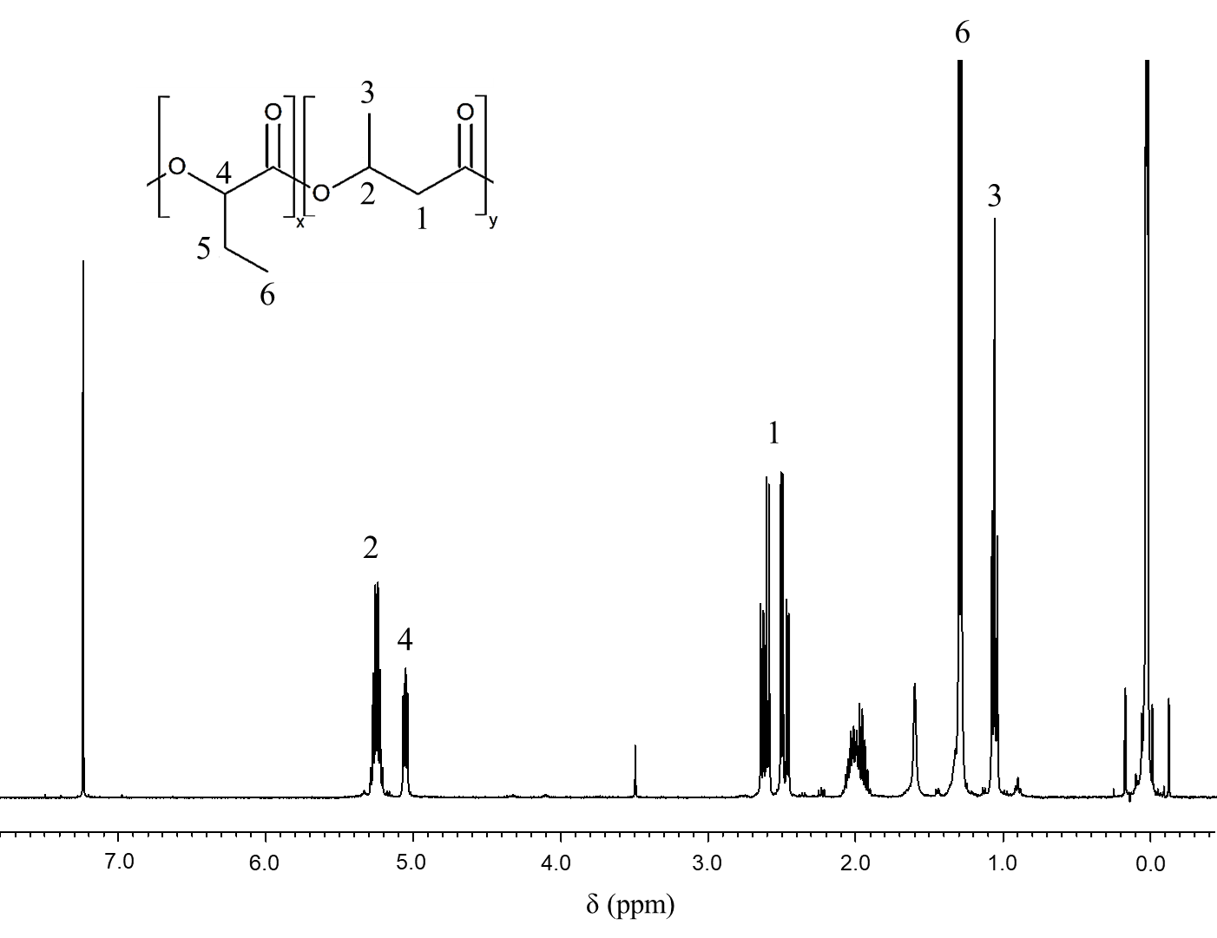
Fig. S4H ^{１}H NMR of P(2HB-co-3HB)

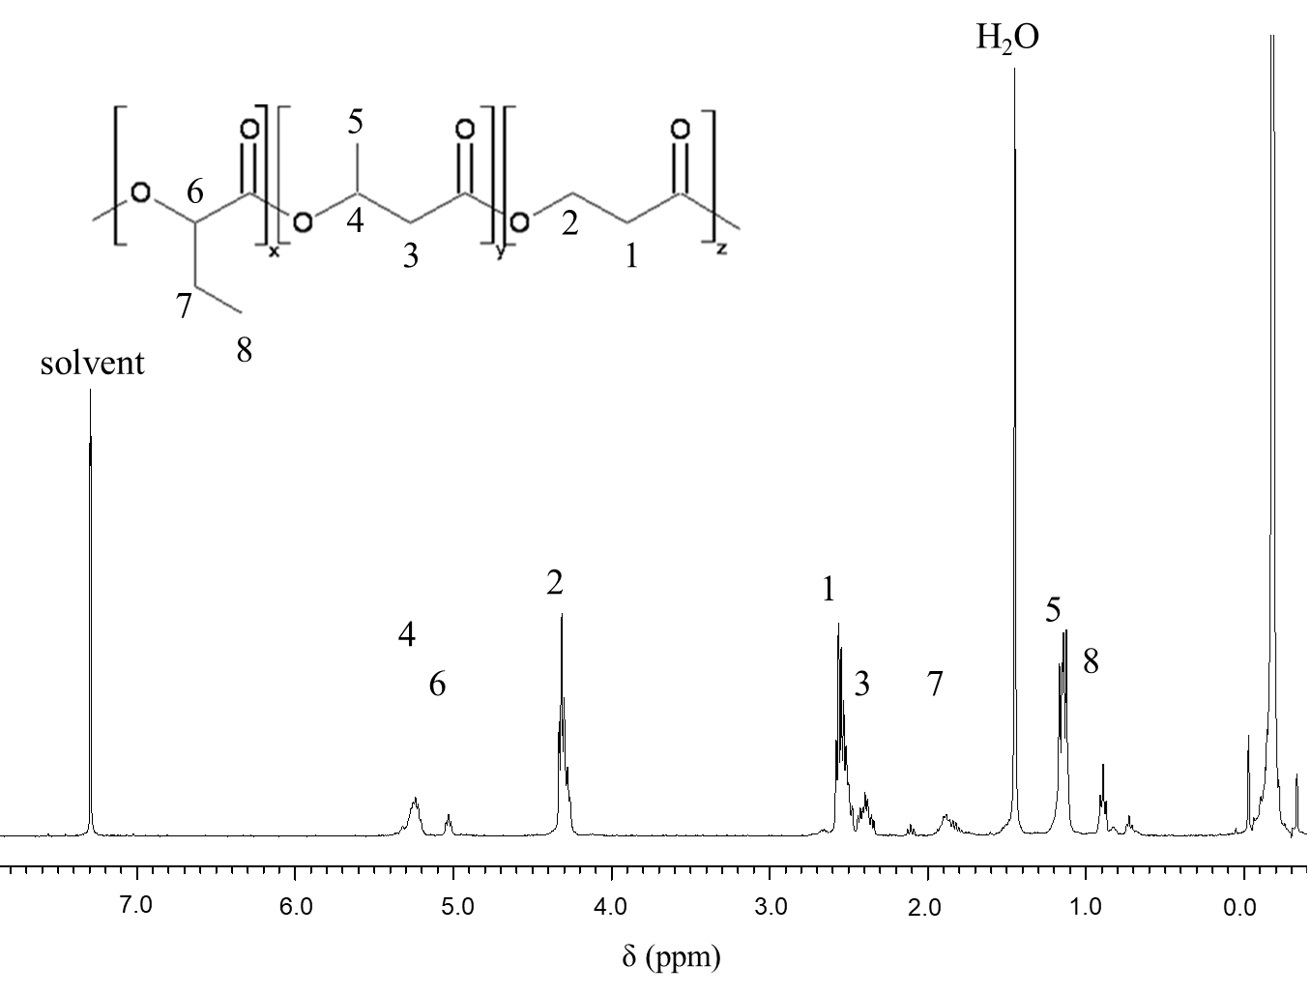
Fig. S4I ^{１}H NMR results for P(2HB-co-3HB-co-3HP)
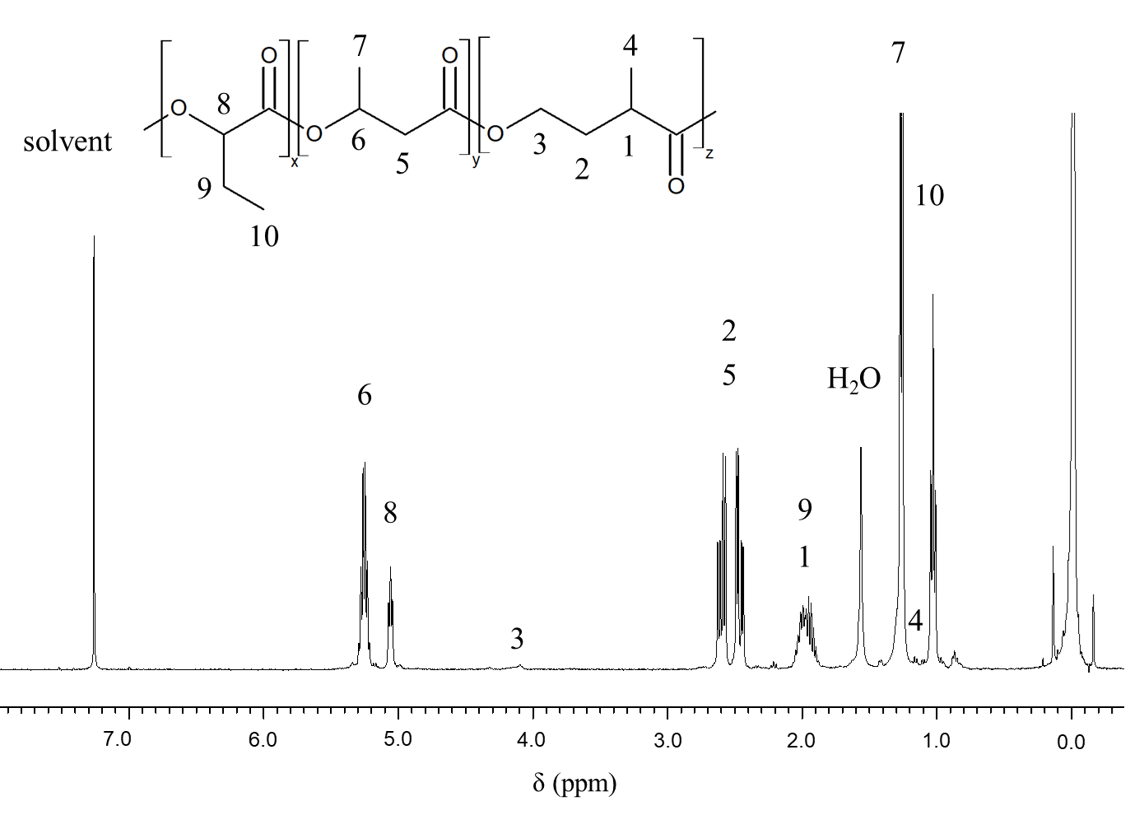
Fig. S4J ^{１}H NMR of P(2HB-co-3HB-co-4H2MB)

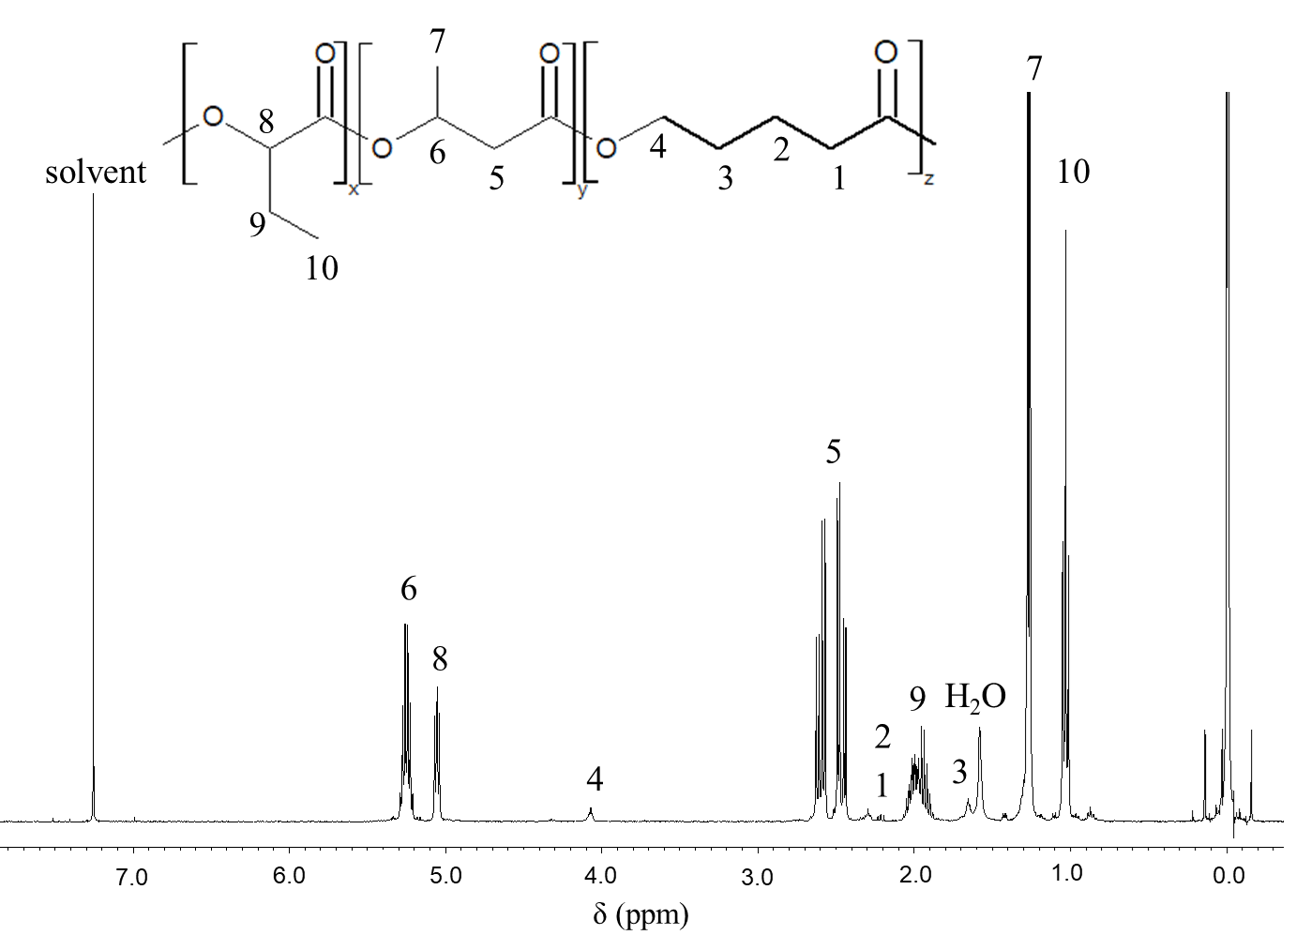
Fig. S4K ^{１}H NMR of P(2HB-co-3HB-co-5HV)
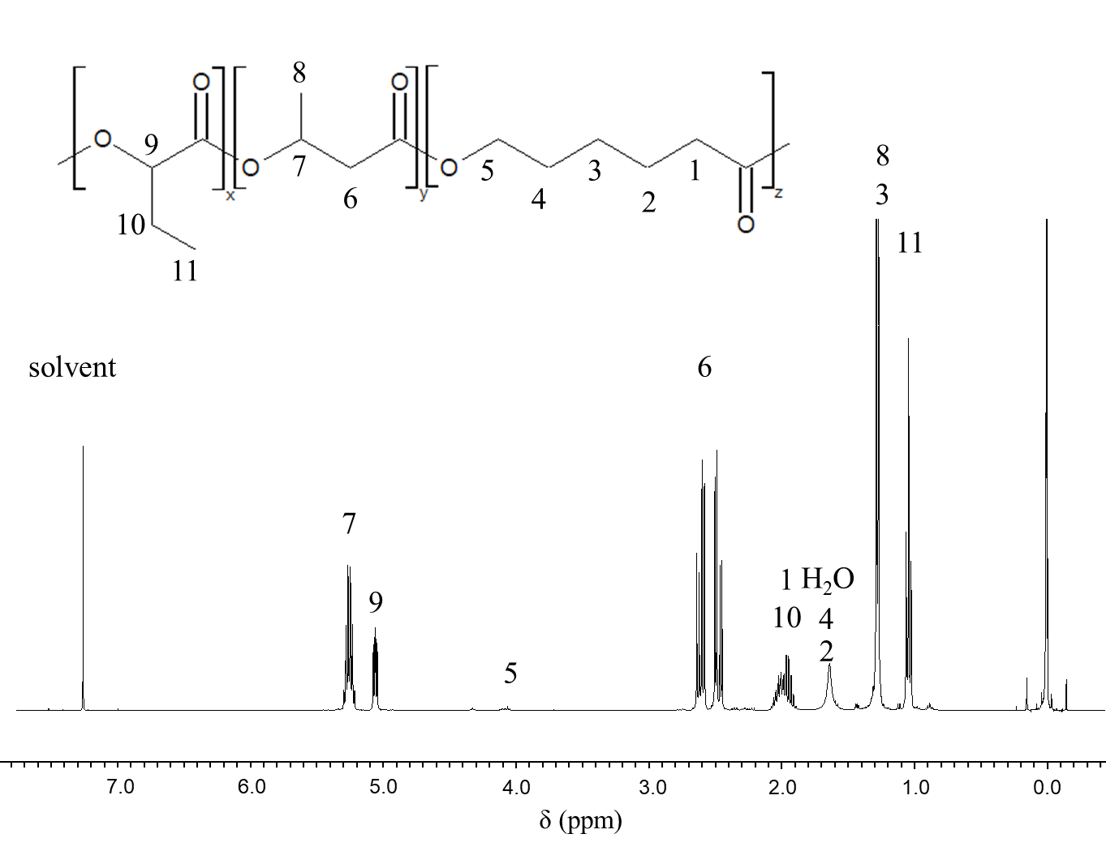
Fig. S4H ^{１}H NMR of P(2HB-co-3HB-co-6HHx)

