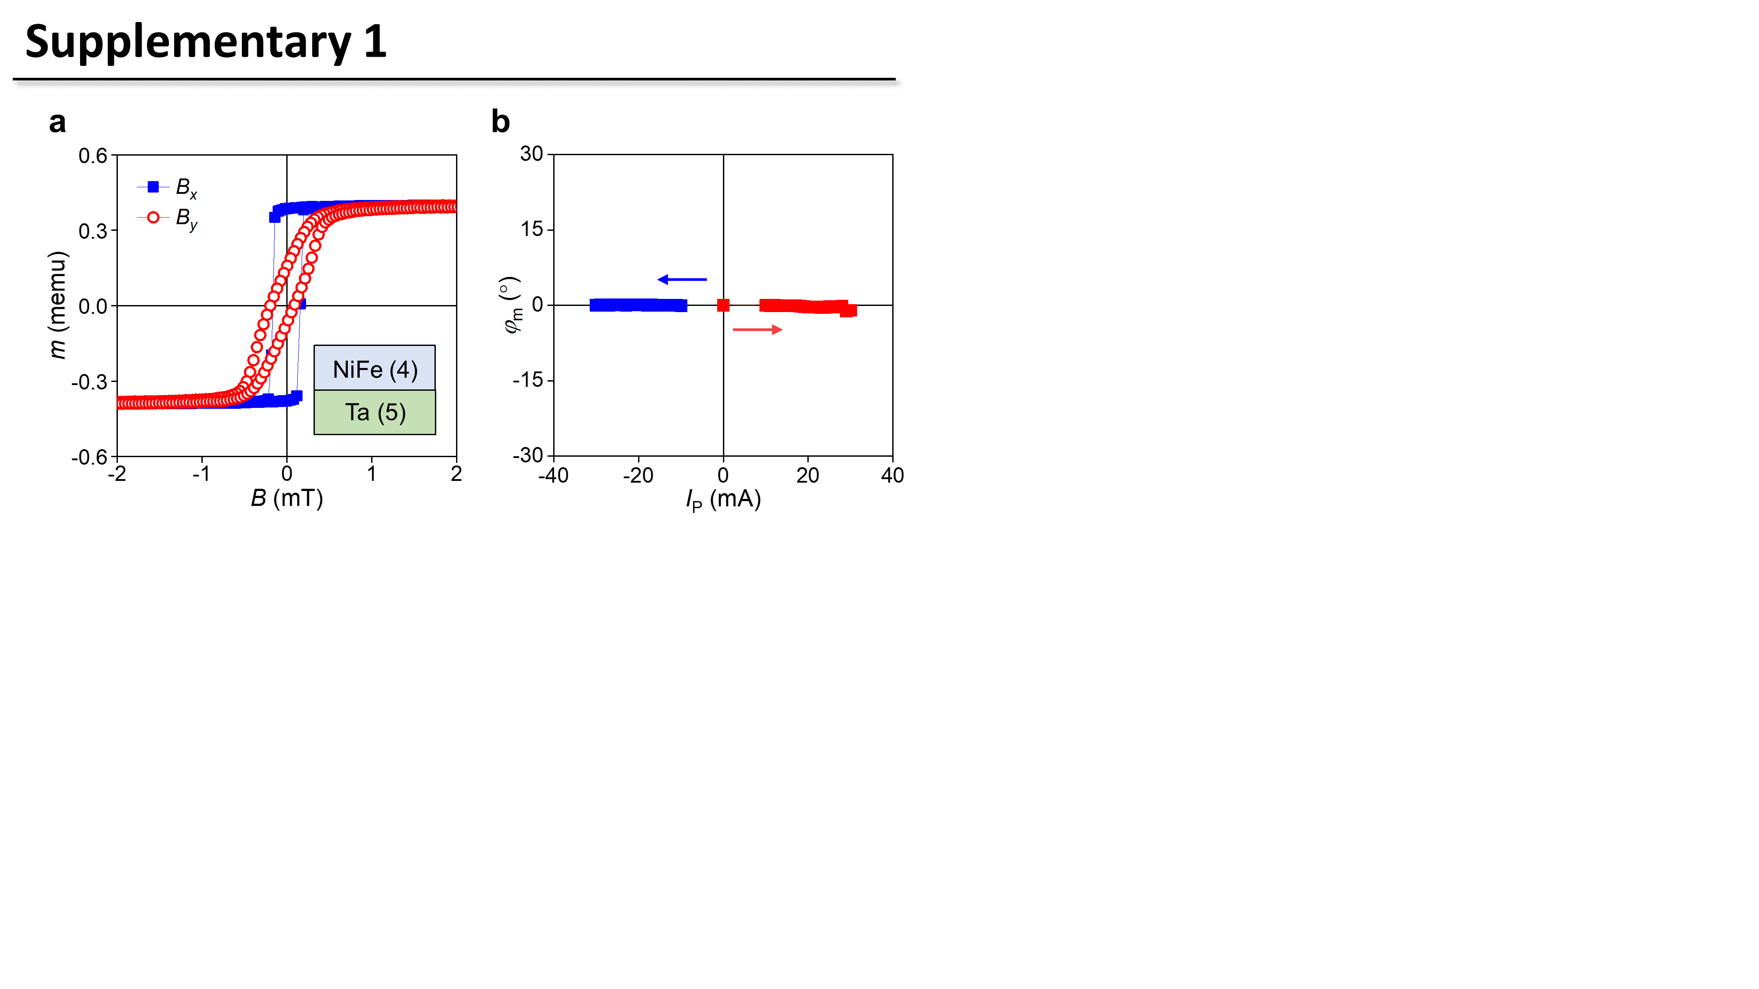SUPPLEMENTARY INFORMATION

Electrical manipulation of antiferromagnetic easy axis in IrMn/NiFe exchange-biased structures

Jaimin Kang¹, Jeongchun Ryu^{1,*}, Jong-Guk Choi¹, Taekhyeon Lee², Jaehyeon Park², Soogil Lee¹, Kab-Jin Kim², and Byong-Guk Park^{1,*}
¹ Department of Materials Science and Engineering and KI for Nanocentury, KAIST, Daejeon 34141, Korea
² Department of Physics, KAIST, Daejeon 34141, Korea

* Corresponding authors: Jeongchun Ryu (jcryu@kaist.ac.kr) & Byong-Guk Park (bgpark@kaist.ac.kr)

Figure S1 | Hysteresis loop and SOT switching in a Ta/NiFe structure. a, Hysteresis loops of the Ta (5nm)/NiFe (4 nm) structure measured with magnetic fields along the x-axis (solid blue) and y-axis (open red). b, R_{H} versus in-plane current pulse (I_{P}) of the Ta/NiFe bilayer. The arrows denote the sweeping direction of I_{P}.

Figure S2 | Thickness dependence of SOT-induced AFM switching. a-e Hysteresis loop measured using a magnetic field along the x-axis, B_{x} (a), the φ_{AFM} versus current density (J_{P}) curves of the IrMn (t_{IrMn})/NiFe (4 nm) samples with t_{IrMn} = 5 nm (b), 10 nm (c), 15 nm (d), and 20 nm (e). f-k. Hysteresis loop measured using B_{x} (f), the φ_{AFM} versus J_{P} curves of the IrMn (5 nm)/NiFe (t_{NiFe}) samples with t_{NiFe} = 3 nm (g), 4 nm (h), 5 nm (i), 7 nm (j), and 10 nm (k). The arrows denote the sweeping direction of J_{P}.

Figure S3 | Memristive behaviour of AFM switching with the opposite current sweep. Minor φ_{AFM} vs I_{P} curves for the IrMn (5 nm)/NiFe (4 nm)/Ta (1.5 nm) sample with a 4-μm-wide Hall bar, measured under the same sequence as shown in Fig. 4 of the main text with I_{P,ini} = +32 mA and I_{P(-max)} varying from -22 mA to -31 mA.

