Supplementary Information

Fabricated Hybrid Composites with Insect-Repellent Property

Hajara Babayo ^{a, b}, Haruna Musa ª, Mustapha D. Garba ^{a, c}*

ª Department of Pure and Industrial chemistry, Bayero University Kano, Nigeria P.M.B 3011
^{b} Fibre and Polymer Science Program, North Carolina State University Raleigh, NC, 27606, USA
^{c} School of Chemistry, University of Glasgow, Glasgow G12 8QQ, Scotland, UK.
e-mail: m.d.garba.11@gmail.com

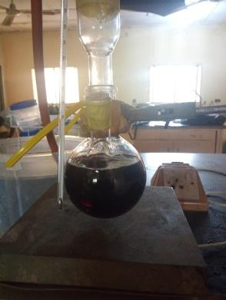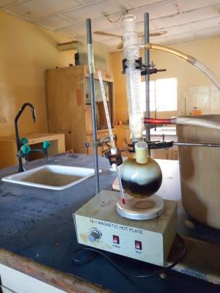
Stage 1: Start of the reaction Stage 2: Formation of homogenous solution
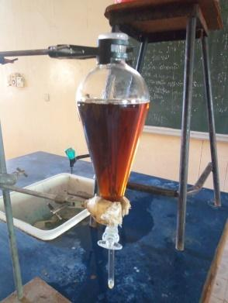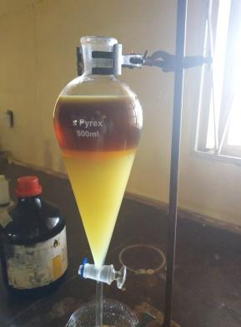
Stage 3: Dissolution of soap layer Stage 4: Formation of FFA at the top layer
Fig. S1: Extraction of free fatty acid; Stage 1 is the saponification of castor oil with a solution of sodium hydroxide, (1:1) ethanol and distilled-water. Stage 2 is the refluxing stage where a homogenous mixture is obtained. Stage 3 is the phase separation stage where the soap was obtained. At the final stage the soap was reacted with sulfuric acid to obtain free fatty acid.

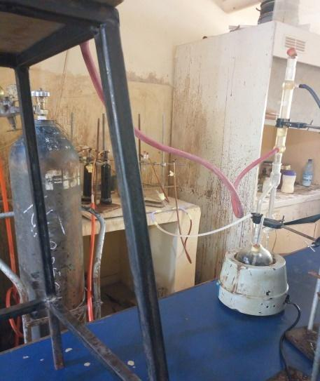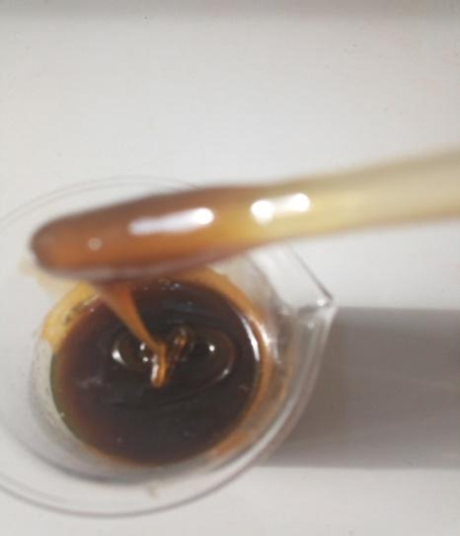
a) Set up for the preparation of alkyd resin b) Prepared alkyd resin.
Fig S2: Images for alkyd resin preparations

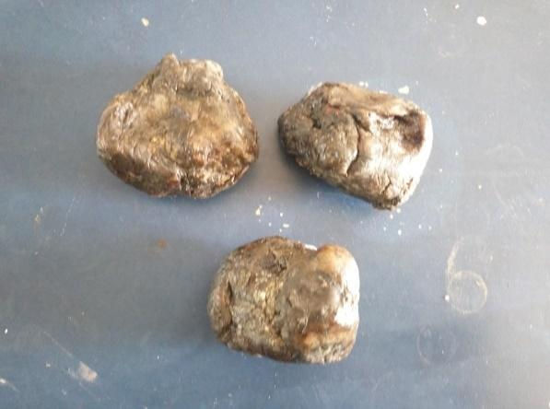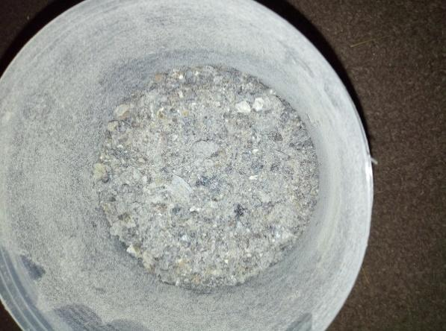
a) Raw Canarium schweinfurthii gum. b) Dried powder of Canarium schweinfurthii gum.
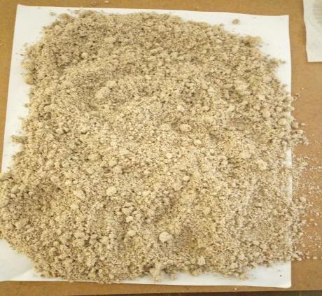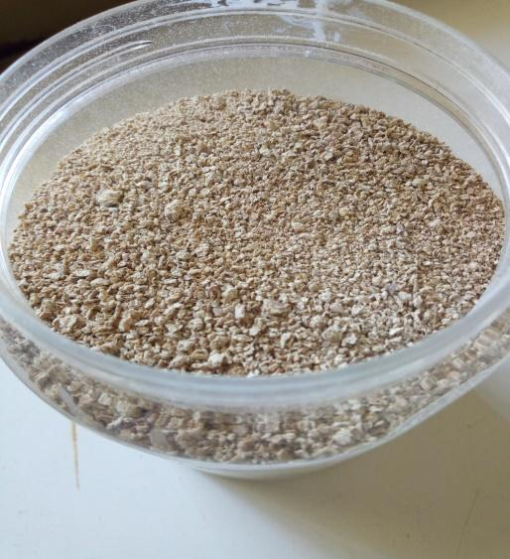
c) Dried untreated tiger nut fibre. d) Benzoyl chloride treated tiger nut fibre.
Fig S3: Tiger nut and Canarium schweinfurthii gum treatments
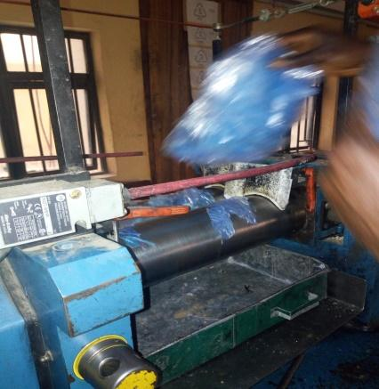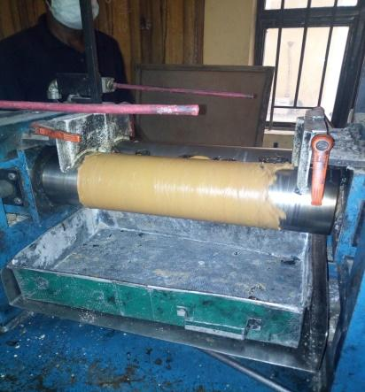
Step 1: Melting of LDPE
Step 2: Mixing of all the materials

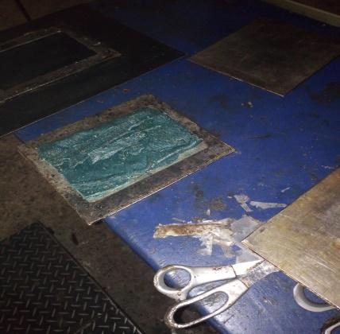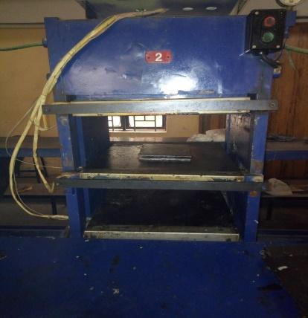
Step 4: Compression Moulding
Step 3: Semi-finished composite (Sheet Moulding Compound)
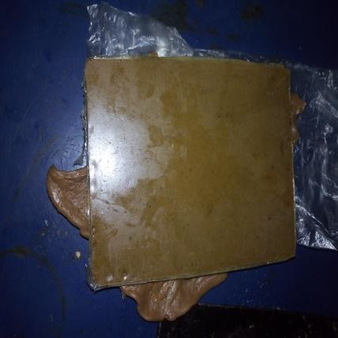
Stage 5: Molded Composite
Fig. S4: Process of composite fabrication; step 1 is where the waste LDPE was melted, all components were mixed in step 2, the semi-finished composite was prepared in a mould in the 3rd step and compressed in the 4rd step, the final step is the moulded composite obtained.

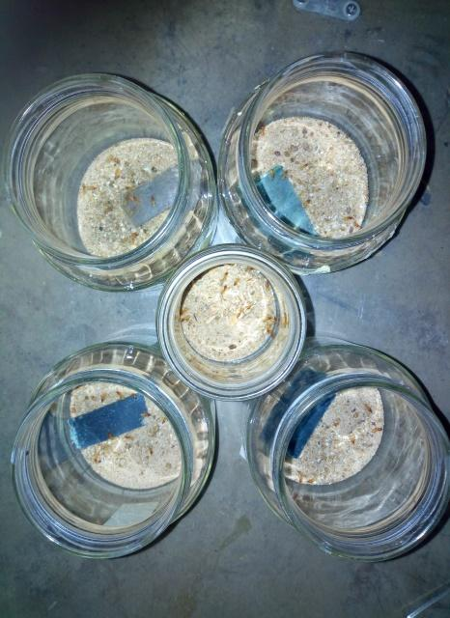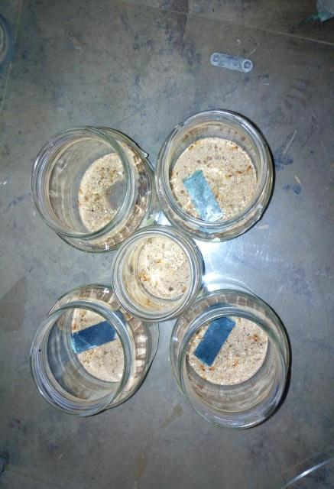
a) Termite’s repellent activity/mortality rate
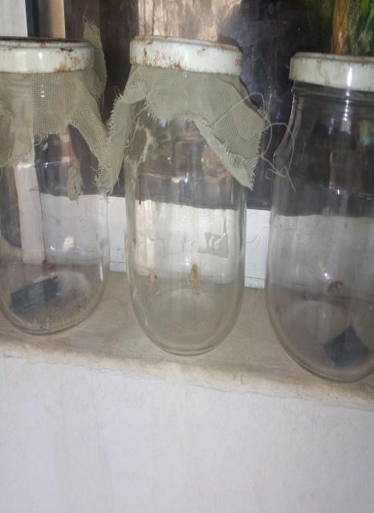
b) Cockroach repellent activity/ mortality rate
Fig. S5: Insect repellent test

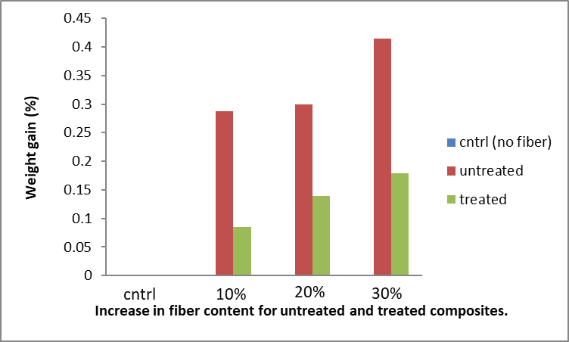
Fig. S6: Water absorption of composites

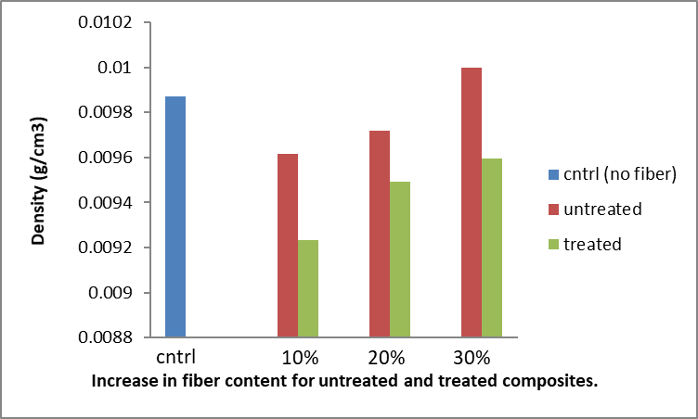
Fig.S7: Density of the composites

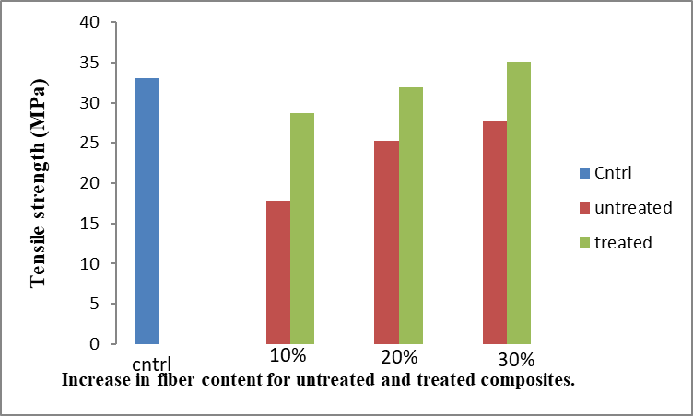
Fig. S8: Tensile Strength of Composites

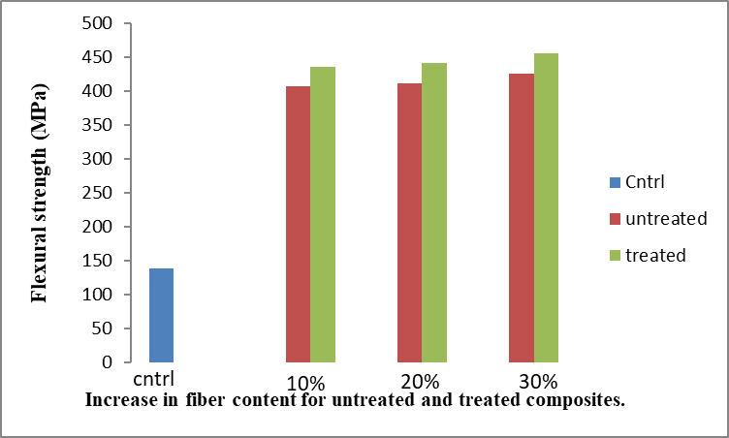
Fig. S9: Flexural strength of composites
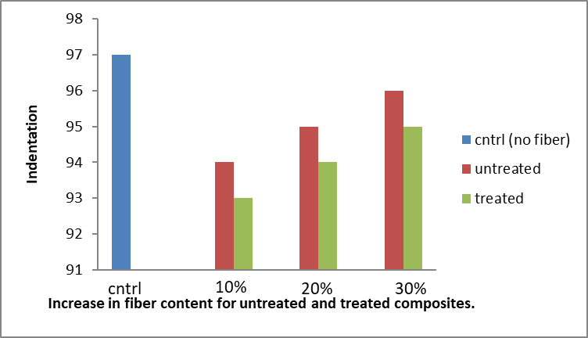
Fig. S10: Hardness of the composites

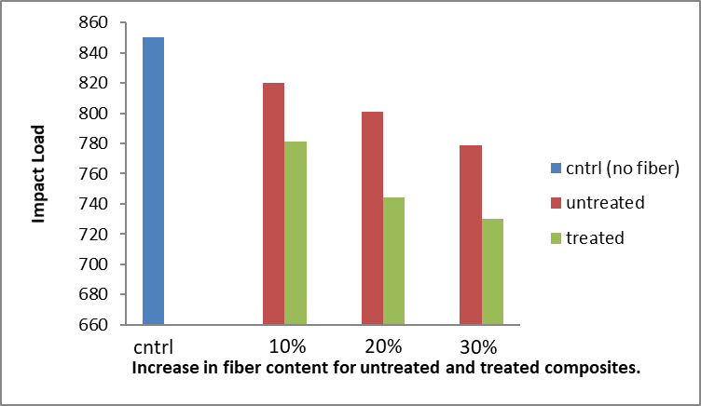
Fig. S11: Impact load of composites

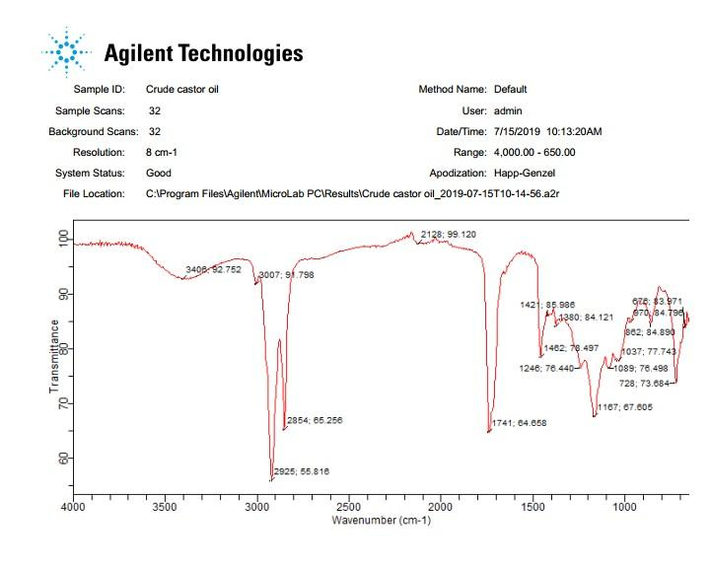
Fig. S12: FTIR of Crude castor oil
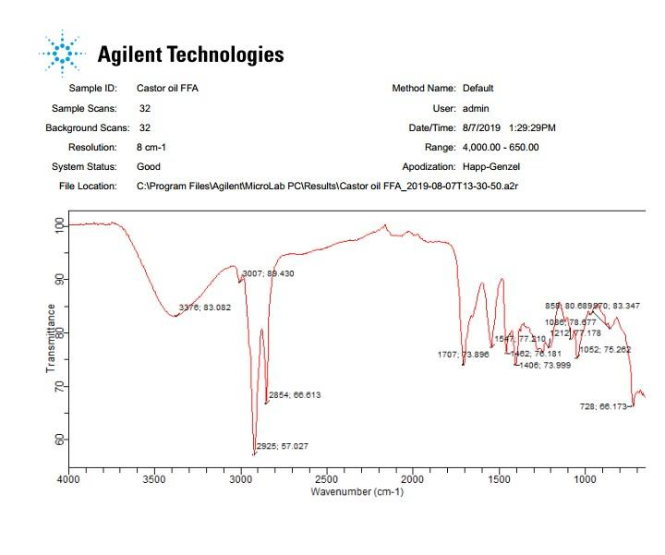
Fig. S13: FTIR of castor oil FFA
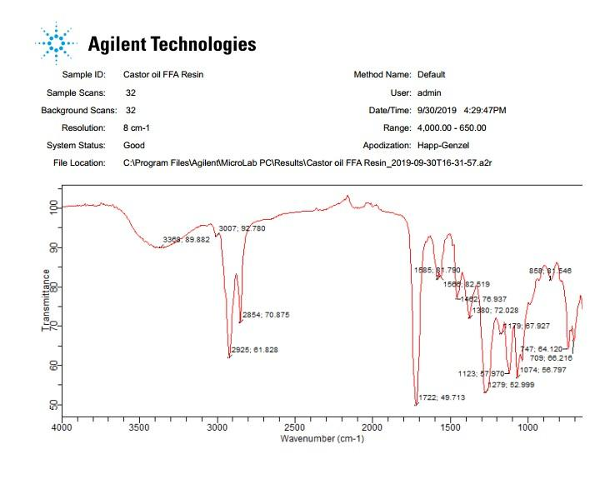Fig. S14: FTIR of castor oil FFA Resin

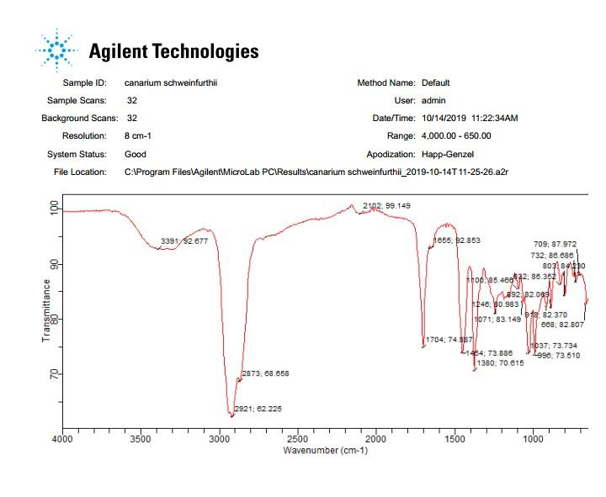Fig. S15: FTIR of canarium schweinfurthii gum resin
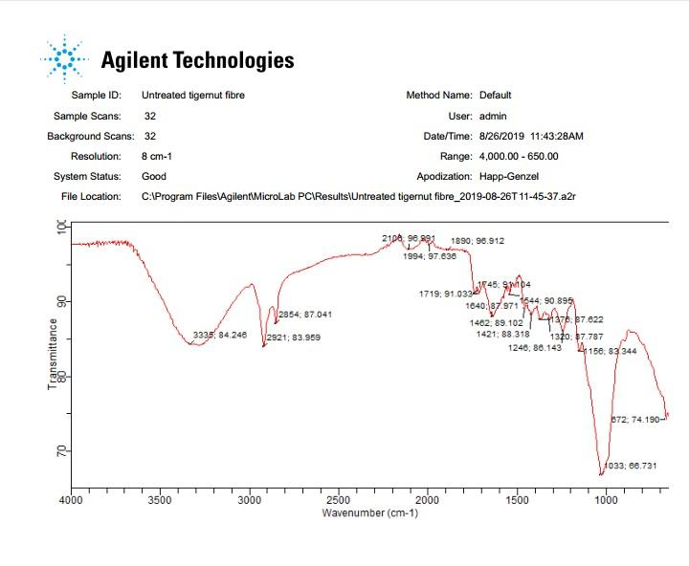
Fig. S16: FTIR of untreated tiger nut fibre

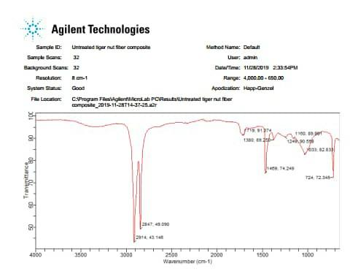
Fig. S17: FTIR of Benzoyl Chloride Treated Tiger Nut Fibre
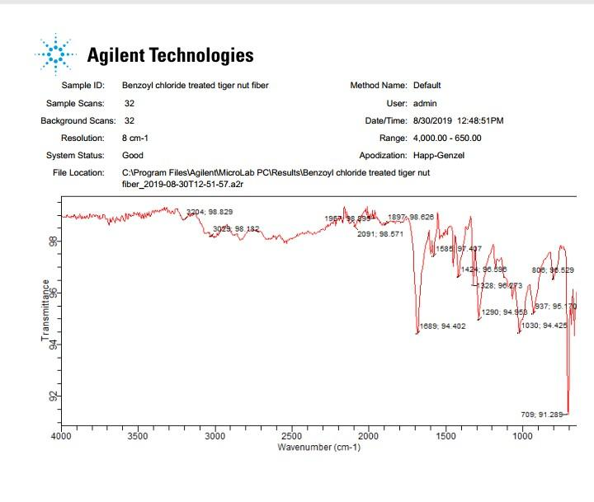Fig. S18: FTIR of untreated Tiger Nut Fibre composite
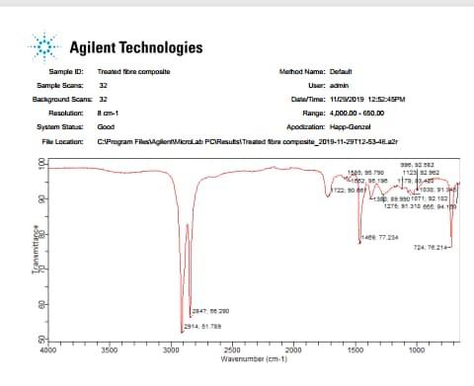 Fig. S18: FTIR of Benzoyl Chloride Treated Tiger Nut Fibre composite
Table S1: Physicochemical properties of the crude castor oil
Characteristics | Unit | Crude castor oil | Methods Used | Instrument
Acid value | mg NaOH/g | 36.91 | BinQuader et al., (2018)
Specific density at 30⁰C | g/cm³ | 0.956 | BinQuader et al., (2018)
Saponification value | mg/g | 216 | Jibrin et al., (2018)
Iodine value, Hanus | gI₂/g | 179.8 | BinQuader et al., (2018)
Viscosity | MPas | 218.3 |  | Clandom viscometer, model VT-03
pH |  | 4.71 | BinQuader et al., (2018)
Moisture Content | % | 1.33 | Abdulkadir and Jimoh., (2013) | Denver moisture analyzer (model IR-35)
FTIR | cm⁻¹ |  |  | Car 630;Agilent Technology

Table S2: Physical and Chemical Properties of Alkyd Resin.

Properties | Specific value | Alkyd resin from castor oil
Colour |  | Brown
Viscosity (absolute) | MPas | 419.63
Solubility in; | Xylene  Acetone  Toluene  Ethanol  Cyclohexanol | Completely soluble  Completely soluble  Completely soluble  Insoluble  Limited solubility
FTIR | cm⁻¹

Table S3: FTIR absorption bands of the crude castor oil

Experimental frequency (cm⁻¹) | Literature frequency (cm⁻¹) | Remark
3007.91 | Near 3030 | =C-H
3406.92 | 3570-3200 | O-H stretch
1167.67 | Near 1100 | C-O stretch
2925.55  2854.65 | 2926-2850 | C-H
1462.78  1421.85 | 1485-1415 | C-H
1741.64 | 1750-1735 | C=O
1246.76  1167.67  1089.76 | 1245-1089 | C-O

Table S4: FTIR absorption bands of the castor oil FFA
Experimental frequency (cm⁻¹) | Literature frequency (cm⁻¹) |  | Remark
3007.91 | 3010 – 3030 | =C-H Olefinic C-H stretching, this is a clear indication of the unsaturated fatty acids.
3378.83 | 3570-3200 | O-H Broad peak around 3400 cm⁻¹ corresponds to the hydroxyl group of high concentrated carboxylic acids.
1707.73 | 1710 | C=O carbonyl stretching of carboxylic acids
2925.55  2854.65 | 2926-2850 | C-H
1482.78 | 1485-1440 | C=C
1406.73 | 1410 | COO⁻ Cis group
1212.77  1086.78  1052.75 | 1245-1030 | C-O
970.83 | 936-980 | Dimer of carboxylic acid
728.66 |  | The rocking of multiple (>4) methylene groups

Table S5: FTIR absorption bands of the castor oil FFA Resin (Hlaing and Oo., 2008: Sharif 2015)
Experimental frequency (cm⁻¹) | Literature frequency (cm⁻¹) | Remark
3368.89 | 3200-2700 | O-H stretching
3007.82 | 3030-3000 | C-H olefinic stretching due to fatty acid.
2925.61  2854.70 | 2926-2850 | C-H
1722.49 | 1730-1730 | C=O due to ester
1585.81  1566.82 | 1600-1550 | Aromatic C=O stretching of the phthalate system.
1462.76 | 1480-1460 | -CH₂ bending vibration.
1380.72 | 1343-1385 | -CH₃ bending
1279.52  1179.67  1123.57 |  | C-O stretching
1074.56 | 1074-1000 | -C-O stretching of ether.
747.64 | 750-730 | Rocking of multiple (>4) methylene groups of the fatty acids.

Table S6: FTIR absorption bands of Canarium Schweinfurthii
Experimental frequency (cm⁻¹) | Literature frequency (cm-¹) | Remark
3391.92 | 3400-3200 | O-H stretching
2873.68  2921.62 | 2926-2880 | C-H
1704.74 | 1725-1705 | C=O
1454.73 | 1485-1440 | C=C stretching
1380.70 | 1380-1370 | -C-H bending bend.
1246.80  1100.85  1071.83 | 1245-1030  1150-1050 | C-H bends.  C-O stretching
918.82  996.73 | 900-600 | C-H out of plane
892.82 | 900-600 | C-H out of plane
709.87 | 900-600 | Rocking of multiple (<4) methylene group
668.82 | 900-600 | C-H out of plane

Table S7: FTIR absorption bands of the untreated tiger nut particulate fibre
Experimental frequency (cm-¹) | Literature frequency (cm-¹) | Remark
3335.84 | 3570-3200 | O-H Broad peak around 3400 cm⁻¹corresponds to the hydroxyl group.
2921.83  2854.87 | 2926-2850 | C-H
1719.91  1745.91 | 1760-1720 | C=O carbonyl of lignin in cellulose
1462.89 | 1485-1440 | C=C
1640.87 | 1680-1640 | C=O
1376.87 | Near 1380 | C-H hemicellulose
1156.83 | 1200-1100 | C-O
672.74 | 700-670 | C-H

Table S8: FTIR absorption bands of Benzoyl Chloride Treated Tiger Nut Particulate Fibre
Experimental frequency (cm-¹) | Literature frequency (cm-¹) | Remark
3204.98 | 3200-2700 | O-H weak peak corresponds to the hydroxyl group present in cellulose.
3029.98 | 3070-3020 | =C-H stretching of aromatic due to phenyl nucleus
1689.94 | 1770-1640 | C=O due to benzoyl carbonyl.
1424.96 | 1424-1415 | Conjugated C-H bending vibrations.
1328.96 | 1343-1319 | C-H in plane bending of hemicellulose.
1290.94 | 1290-1266 | C-O syringyl ring breathing and C-O stretching in lignin and Xylan.
1030.94 | 1043-1028 | C-O, C=C, symmetric glycosidic stretching.
937.95 | 980-936 | Dimer of carboxylic acid
808.96 | 860-800 | C-H

Table S9: FTIR absorption bands of untreated and benzoyl chloride treated tiger nut particulate fibre composites

Experimental frequency  (cm-¹)Untreated Composite | Experimental frequency (cm-¹)Treated Composite | Literature frequency (cm-¹) | Remark
2847.49 | 2847.56  2914.51 | 2926-2850 | C-H
_ | 1722.90 | 1725-1700 | C=O due to benzoyl carbonyl.
1469.74 | 1469.77 | 1470-1415 | C-H symmetrical bending vibration.
1380.89 | 1380.89 | 1380-1319 | C-H in plane bending of hemicellulose.

Table S10: Analysis of the composites
Analysis | Instruments used | Unit | Composites
Analysis | Instruments used | Unit | Untreated | Treated
Water absorption ASTM D-3010 |  | Wt% | 0.288 | 0.085
Thickness swelling ASTM D-570 |  | Wt% | No effect | No effect
Chemical resistance (Acids) ASTM D1693-05 |  | Wt% | 2.734 (H₂SO₄)  5.146 (HCL) | 0.331  0.450
Chemical resistance (Bases) ASTM D1693-05 |  | Wt% | 1.016 (KOH)  2.113 (NaOH) | 0.728  0.982
Density ASTM D2395-17 |  | g/cm³ | 0.0096 | 0.0092
Tensile strength ASTM D-1037 | Tensile test (Universal material testing machine, Shimadzu, model AG-1) | Mpa | 27.78 | 35.08
Flexural strength ASTM D-792 | flexural test (Universal material testing machine, Shimadzu, model AG-1) | Mpa | 426.4 | 456.3
Hardness | hardness tester (Muver Franscisco, munoz Ireles, model 5019) | HV | 95 | 93
Impact ASTM D-156 | Impact tester (Ceast Resil impactor, model P/N 6957 IZOD) | J/m | 779 | 730
SEM (Favaro et al., 2010) | Scanning Electron Microscope (Prox: Phenom World 800-07334)
FTIR | Fourier Transform Infrared spectrophotometer (Car 630; Agilent Technology) | cm⁻¹

