Supplementary Material S1

Impact of testing strategies on the transmission of SARS-CoV-2 variants including antigen target failure effects

Claudia Del Vecchio^{1^}, Bethan Cracknell Daniels^{2^}, Giuseppina Brancaccio¹, Alessandra Rosalba Brazzale³, Enrico Lavezzo¹, Constanze Ciavarella², Francesco Onelia⁴, Elisa Franchin⁴, Laura Manuto¹, Federico Bianca¹, Vito Cianci⁵, Annamaria Cattelan⁶, Ilaria Dorigatti^{2,§,*}, Stefano Toppo^{1,7,§,*}, Andrea Crisanti ^{1,4,8,§,*}

¹Department of Molecular Medicine, University of Padua, Via Gabelli, 63, Padua 35121 Italy
²MRC Centre for Global Infectious Disease Analysis and the Abdul Latif Jameel Institute for Disease and Emergency Analytics, School of Public Health, Imperial College London, London, UK
³Department of Statistical Sciences, University of Padua, Via C. Battisti 241, Padua 35121, Italy
⁴Microbiology and Virology Diagnostic Unit, Padua University Hospital, Via Giustiniani 2, Padua 35128 Italy
⁵ER Unit, Emergency-Urgency Department, Padua University Hospital, Via Giustiniani 2, Padua 35128 Italy
⁶Department of Internal Medicine, Infectious and Tropical Diseases, Padua University Hospital, Via Giustiniani 2, Padua 35128 Italy
⁷CRIBI Biotech Center, University of Padua, V.le G. Colombo,3, Padua 35131 Italy
⁸Department of Life Science Imperial College London, South Kensington Campus, Imperial College Road, SW7 AZ London, United Kingdom

^ equal contributions, joint first authors
§ joint senior authors

* Corresponding authors:
Andrea Crisanti: a.drcrisanti@imperial.ac.uk
Stefano Toppo: stefano.toppo@unipd.it
Ilaria Dorigatti: i.dorigatti@imperial.ac.uk

Supplementary Material S1

Evaluation of sample selection bias 3
Stratification of test performance 3
Figures 4
Figure S1 | Distribution of tests by age 4
Figure S2 | Distribution of test type by age 5
Figure S3 | Sensitivity estimates of ANCOV test according to Ct values 5
Figure S4 | Distribution of Ct values 6
Figure S5 | Monthly prevalence of the detected variants obtained from the GISAID database. 7
Figure S6| Flow diagram of the transmission model used to reproduce the dynamics of the discordant variant M234I-A376T, the concordant variant A220V, the alpha variant and other variants, in Veneto and Italy. 8
Figure S7| R₀ of SARS-CoV-2 variants (A220V, M234I-A376T, alpha and other) estimated in Veneto and the rest of Italy during the study period, as a function of the 9
Figure S8 | Transmission dynamics of SARS-CoV-2 variants (A220V, M234I-A376T, alpha and other) observed in Veneto and the rest of Italy assuming antigen test sensitivity is 87.5% against the concordant variants. 9
Figure S9 | Distribution of Ct values according to days from symptom onset 10
Figure S10 | Distribution of Ct values above and below 33 according to time intervals 10
Tables 11
Table S1 | Estimates of ANCOV test sensitivity according to Ct values. 11
Table S2 | Distribution of Ct values of samples. 11
Table S3| ANCOV sensitivity against variants with and without the amino-acid substitutions M234I and A376T, mapping to regions of the SARS-CoV-2 N protein containing epitopes that function as the target of capture antibodies in antigen tests. 12
Table S4 | ANCOV sensitivity against variants with and without any mutation mapping to regions of the SARS-CoV-2 N protein containing epitopes that function as the target of capture antibodies in antigen tests. 12
Table S5 | Description of the concordant and discordant variants. 12
Table S6| Mean and 95% CrI parameter estimates for Veneto and Italy, obtained from the 2.5% and 97.5% percentiles of 100 samples of the posterior distributions. 13
Table S7 | ANCOV test sensitivity according to days intervals from symptom onset. Test sensitivity at increasing time interval from symptom onset with 95% confidence intervals. P-value = 0.22 for equality of proportions. 13
References 13

Evaluation of sample selection bias

Of the 3,290 patients examined from the 15th of September to the 16th of October in the A&E and the Infectious Diseases wards, 1,441 (44%) were tested twice with both DNCOV and ANCOV tests, while 1849 patients (56%) were only tested once, with either DNCOV or ANCOV test. Individuals from 0-19 years old were predominantly tested with only one test (Figure S1) and mainly DNCOV (Figure S2), in line with the current school regulations which require a negative molecular test outcome for school re-admission. These individuals were, consequently, omitted from the analysis to avoid sampling biases. This reduced the analysis on 1,387 subjects who underwent both tests and 1,254 subjects who underwent only one test.

The 1,387 patients of our main study were compared to the 1,254 patients who, in the same observation period, were only given either a DNCOV or an ANCOV test. We did not find any clinically relevant difference with respect to sex (47% vs 53% females, P-value = 0.004), hospital ward of admission (80% vs 76% emergencies, P-value = 0.02) and, for the patients who tested positive, severity of the disease (P-value=0.77).

The majority of patients in age groups 20-49 underwent only one test; from age 50 onwards this trend reverses (Figure S1). ANCOV is the preferred test type for patients who were only tested once except for age group 30-39 (Figure S2). Further stratification by pneumonia did not show any significant difference (P-value = 0.37) although pneumonia was present in 48% of the ANCOV testing positives vs 17% of the DNCOV testing positives.

The monthly incidence of true positives, as benchmarked by a positive DNCOV test outcome, is 4.4% for those who received both DNCOV and ANCOV tests. The incidence lowers to 1.2% for patients who were only tested with DNCOV and 2.6% for those who were tested with ANCOV only. For patients with only the ANCOV test, the monthly incidence was estimated to be 3.8% using the overall specificity of 99.9% and sensitivity of 68.9% for the antigen test¹.

Stratification of test performance

We found no statistically significant association between the outcome of testing (i.e., discordance or concordance between antigen and molecular testing) with age, sex, and the presence of severe disease (pneumonia) at the time of testing. Moreover, there was no difference in the distribution of the Ct values for the S and ORF1 genes when comparing samples stratified by age, sex and disease severity The time interval between the date of symptom onset (known for all 51 symptomatic patients) and the date of testing ranges from 0 to 20 days, with a median of 2 and a mean of 4 days. The sensitivity of the antigen assay decreased from 75% (95% CI, 55-89%) to 60% (95% CI, 17-93%) to 50% (95% CI, 29 -71%) when the test was performed within 3 days, on days 4 or 5 and after 5 days after the development of symptoms (Supplementary Table S7). However, this trend is not statistically significant, possibly due the small sample size of each group (28, 5 and 18 patients). We found evidence that the Ct values of both genes increases in time from symptom onset to day of testing (Supplementary Figure S9 and Supplementary Figure S10, Pearson’s correlation coefficient of the S gene: 0.34 with p-value = 0.016; Pearson’s correlation coefficient of the ORF1 gene: 0.48 with p-value < 0.001). The sensitivity of the 10 asymptomatic patients is 90% (95% CI, 54-99%) with a Ct value for both S gene and ORF 1 gene below 33. Notably, these patients performed the test shortly after the diagnosis of infected relatives as part of the implemented surveillance measures.

Figures
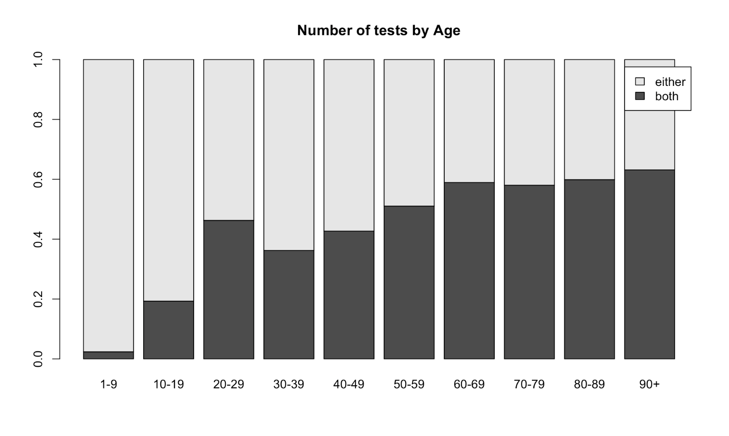
Figure S1 | Distribution of tests by age: Percent stacked bar plot of the number of tests that were delivered in each age group. Individuals who performed only one test “either” DNCOV or ANCOV is reported in light gray. Subjects who performed both tests (DNCOV and ANCOV) are reported in dark gray.

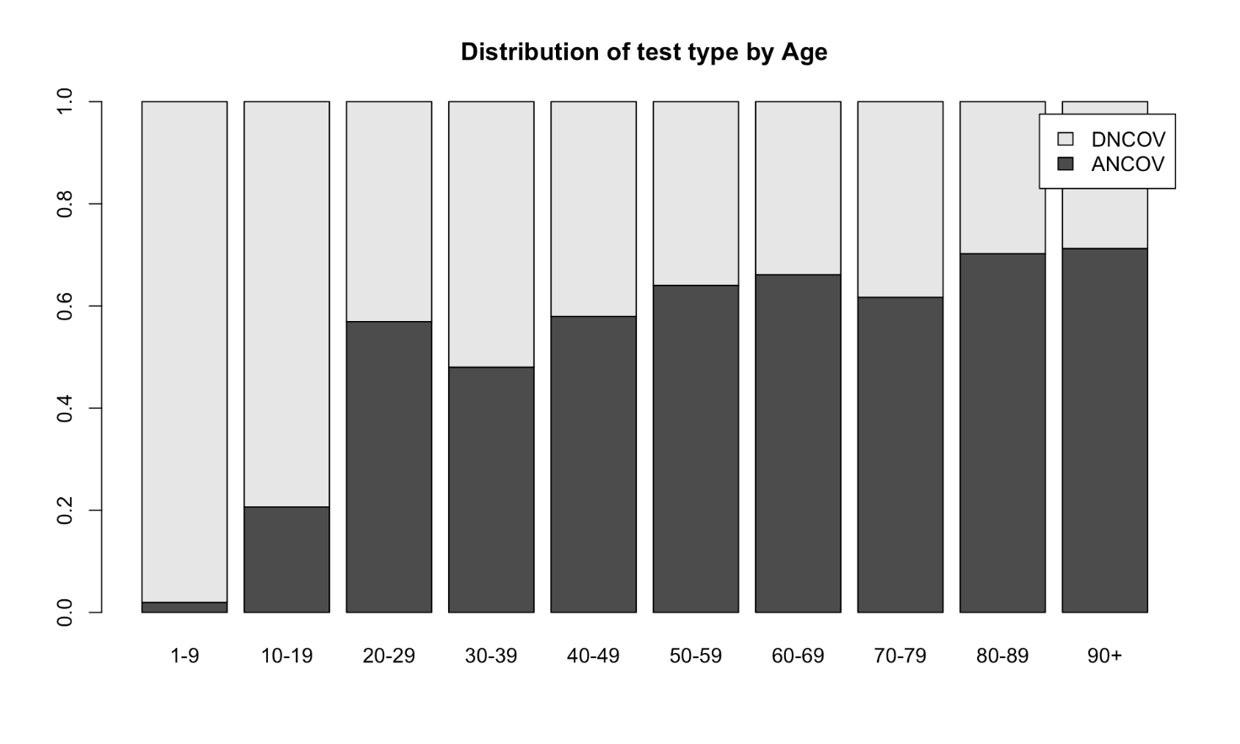
Figure S2 | Distribution of test type by age: Percent stacked bar plot of the type of tests that were delivered in each age group. Individuals who performed only DNCOV are reported in light gray. Subjects who performed only ANCOV are reported in dark gray.
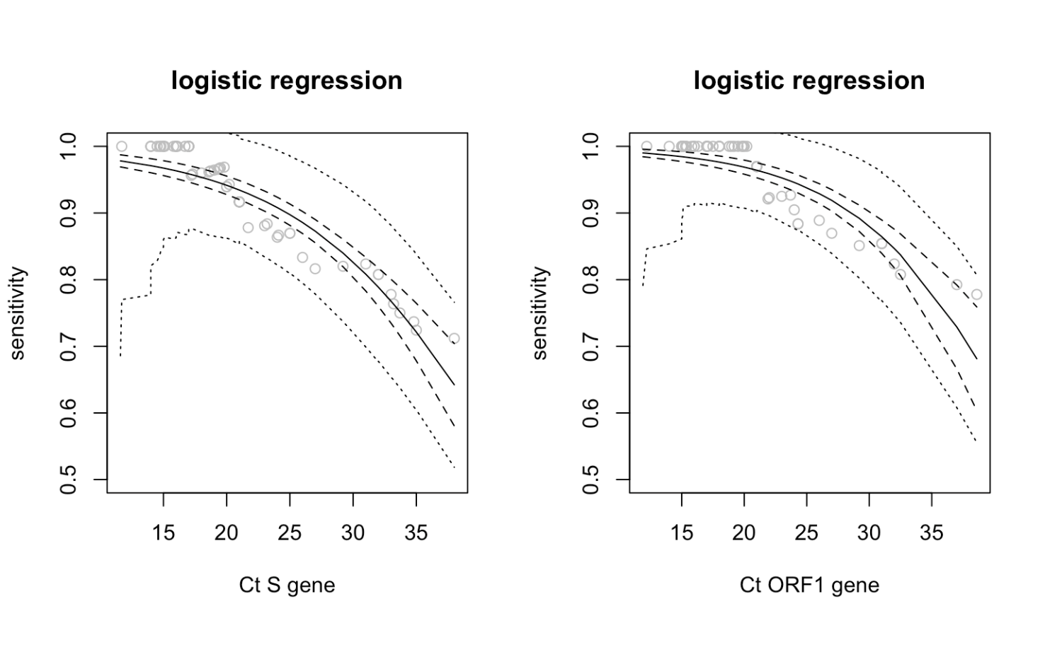
Figure S3 | Sensitivity estimates of ANCOV test according to Ct values: Sensitivity estimates (solid line) of ANCOV test for increasing Ct values of the S gene (left panel) and Ct ORF1 (right panel) gene as obtained from a logistic regression model. The dashed lines give the 95% confidence band for the fitted regression line. The dotted lines represent the 95% band for the fitted sensitivities.

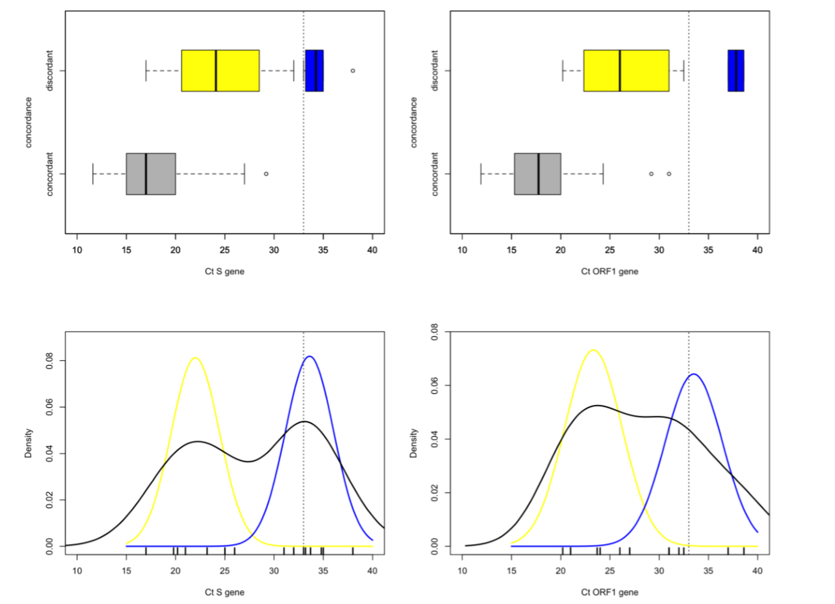

Figure S4 | Distribution of Ct values: Distribution of Ct values for concordant DNCOV+/ANCOV+ and discordant DNCOV+ / ANCOV- test results. Top row: Boxplots of Ct values for the S (left) and ORF1 (right) gene. Dotted line at Ct = 33 shows the critical value of sensitivity (95%) declared for the antigen test above which there is an expected drop and an unreliable result. DNCOV+/ANCOV+ (grey box), DNCOV+/ANCOV- below sensitive threshold (yellow box) DNCOV+/ANCOV- above sensitive threshold (blue box). Bottom row: Nonparametric density estimation for Ct values of the S (left) and ORF1(right) gene, with superimposed the two densities fitted using a two-component Gaussian mixture model. DNCOV+/ANCOV- below sensitive threshold (yellow line) DNCOV+/ANCOV- above sensitive threshold (blue line).

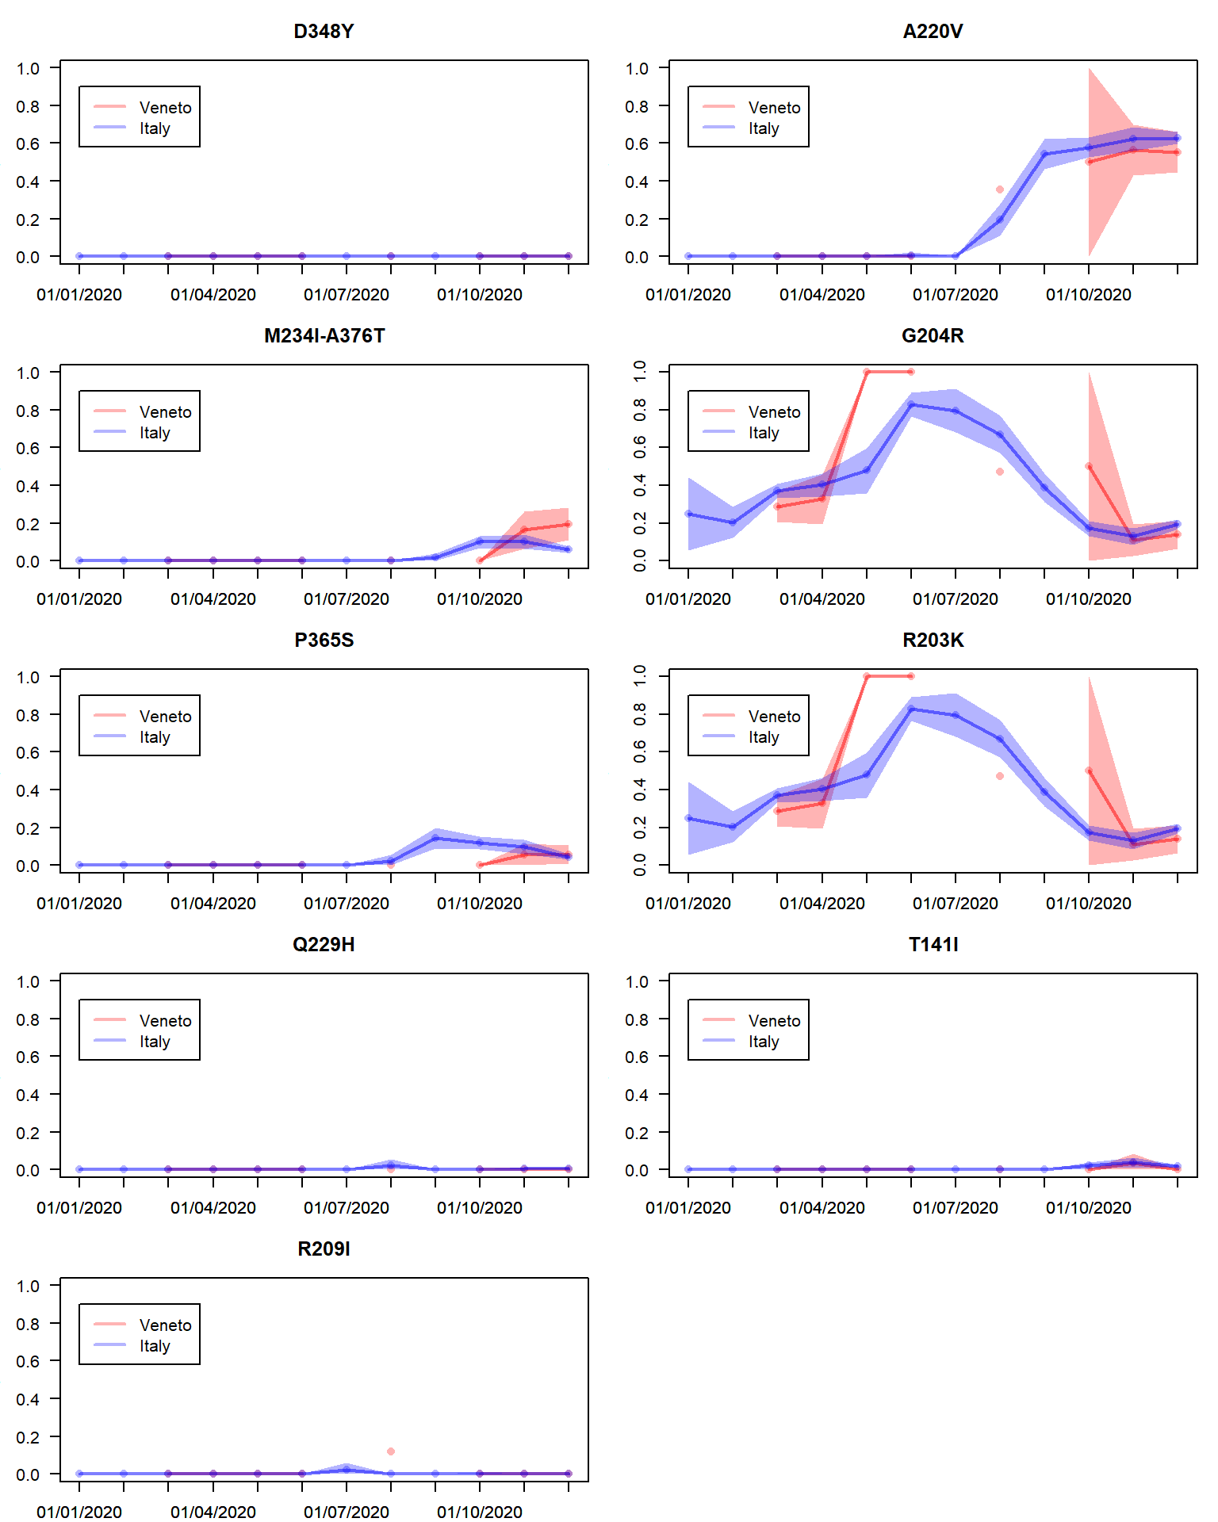

Figure S5 | Monthly prevalence of the detected variants obtained from the GISAID database. Monthly prevalence (percentage over total sequences) of N variants generating discordant DNCOV+ / ANCOV- (left panels) and concordant DNCOV+ / ANCOV+ (right panels) result in molecular and antigen swab. Shaded areas show the 95% confidence bands for each different region. No sequence data are available for Veneto region in the months of January, February, July, and September.

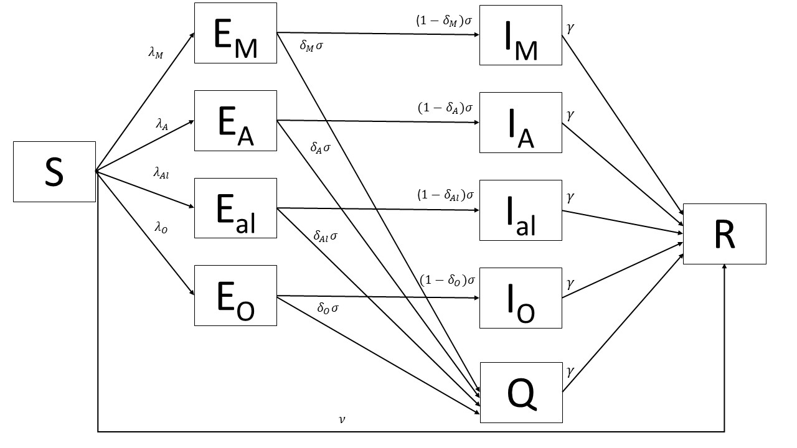

Figure S6| Flow diagram of the transmission model used to reproduce the dynamics of the discordant variant M234I-A376T, the concordant variant A220V, the alpha variant and other variants, in Veneto and Italy. Susceptible individuals are denoted S and are infected at rate $λ_{Y}$. Upon infection, individuals incubate the virus (E compartment) for an average of 1/ $σ$ days. After incubating the virus, a proportion ($1-δ_{Y}$) of individuals become infectious (I compartment), whilst the remaining $δ_{Y}$ proportion are detected, reported and isolate (Q compartment). The infectious period lasts on average $1/γ$ days, and then individuals recover and test negative (R compartment). Susceptible individuals are vaccinated and enter the R compartment at rate $ν$. Subscript Y refers to the virus variant (M = M234I-A376T, A= A220V, Al = Alpha, O other variants).

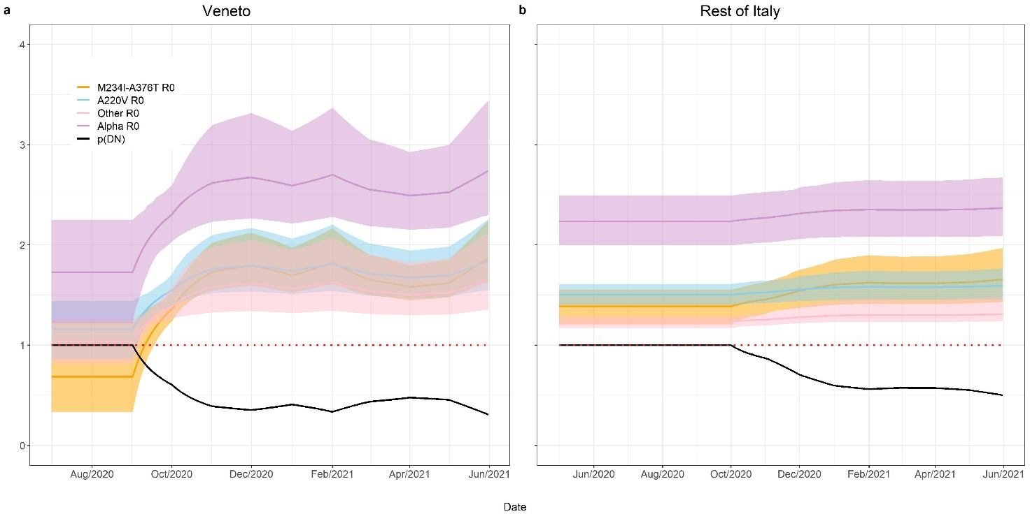

Figure S7| R₀ of SARS-CoV-2 variants (A220V, M234I-A376T, alpha and other) estimated in Veneto and the rest of Italy during the study period, as a function of the proportion of DNCOV tests that were conducted for diagnostic purposes p(DN). Estimates are the mean and 95% CrI (solid line and shaded region), obtained from the 2.5% and 97.5% percentiles of 100 samples of the posterior distributions.

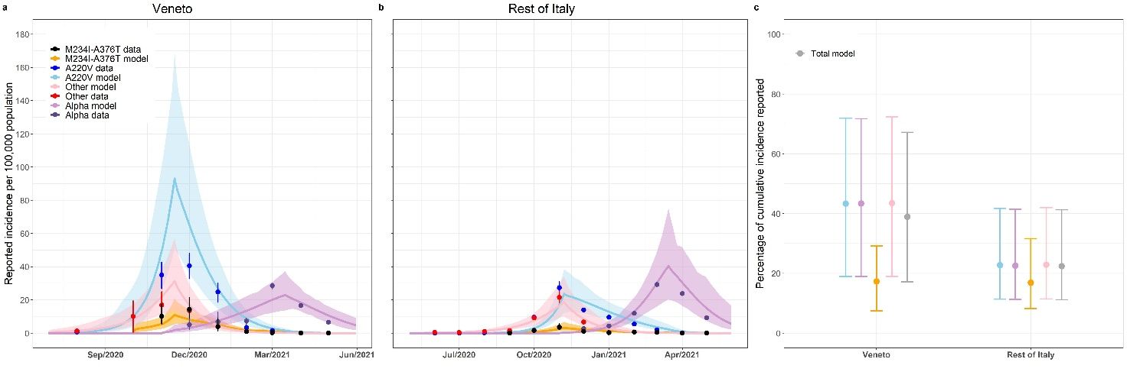

Figure S8 | Transmission dynamics of SARS-CoV-2 variants (A220V, M234I-A376T, alpha and other) observed in Veneto and the rest of Italy assuming antigen test sensitivity is 87.5% against the concordant variants. a) Veneto and b) Italy estimated daily reported incidences per 100,000 population of A220V, M234I-A376T, alpha and other virus variants, fitted from observed incidence data assuming a Negative Binomial likelihood (point and 95% binomial CI). Estimates are the mean and 95% CrI (solid line and shaded region), obtained from the 2.5% and 97.5% percentiles of 100 samples of the posterior distributions. c) Percentage of A220V, M234I-A376T, alpha, other virus variants and total cumulative incidence reported in Veneto and the rest of Italy. Point and error bar are the mean and 95% CrI obtained from the 2.5% and 97.5% percentiles of 100 samples of the posterior distributions.
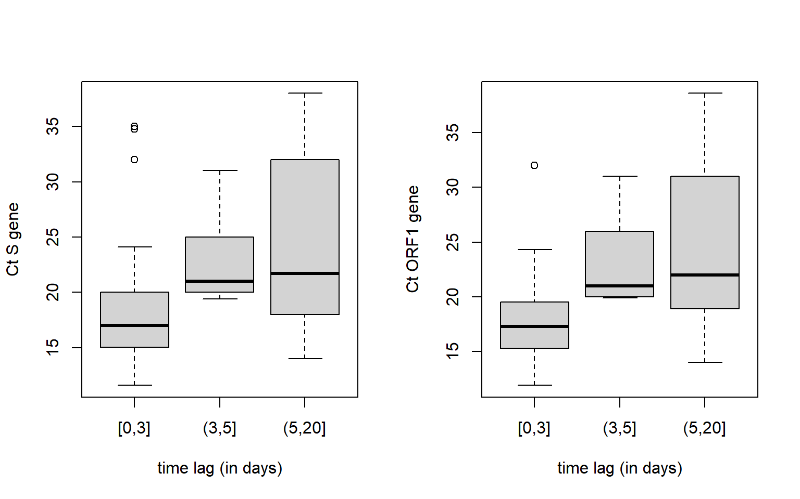

Figure S9 | Distribution of Ct values according to days from symptom onset: Boxplots of Ct values of S (left panel) and ORF1 (right panel) gene recorded at increasing time intervals (in days) from symptoms onset to day of testing 0-3 days, 4-5 days and above 5 days. P-value for Kruskall-Wallis test is 0.004 for Ct of ORF1 gene and 0.018 for Ct of S gene.
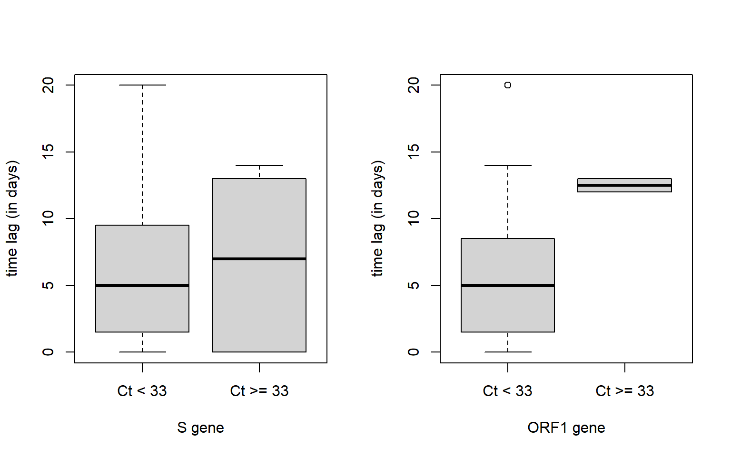
Figure S10 | Distribution of Ct values above and below 33 according to time intervals: Boxplots of time interval (in days) between time of testing and day of symptom onset against different levels of Ct values Ct < 33 and Ct >= 33 for S (left panel) and Ct ORF1 (right panel) gene. P-value for two-sided Wilcoxon-Mann-Whitney test is 1.0 for Ct S gene and 0.2 for ORF1 gene.

Tables

Table S1 | Estimates of ANCOV test sensitivity according to Ct values. Sensitivity estimates of ANCOV test at increasing Ct value for the S and ORF1 gene generated by a logistic regression model, with 95% confidence intervals.

Ct S gene |  |  |  | Ct ORF1 gene
< value | sensitivity | Lower 95% confidence bound | upper 95% confidence bound | < value | sensitivity | Lower 95% confidence bound | upper 95% confidence bound
20 | 94.2 | 86.2 | 100.0 | 20 | 96.9 | 90.7 | 100.0
21 | 93.4 | 85.5 | 100.0 | 21 | 96.4 | 90.2 | 100.0
22 | 92.7 | 84.6 | 100.0 | 22 | 95.9 | 89.6 | 100.0
23 | 91.8 | 83.5 | 100.0 | 23 | 95.3 | 88.6 | 100.0
24 | 90.8 | 82.3 | 99.4 | 24 | 94.6 | 87.7 | 100.0
25 | 89.7 | 80.9 | 98.6 | 25 | 93.8 | 86.7 | 100.0
26 | 88.6 | 79.4 | 97.7 | 26 | 92.9 | 85.3 | 100.0
27 | 87.3 | 77.8 | 96.7 | 27 | 91.9 | 83.9 | 99.9
28 | 85.9 | 76.0 | 95.7 | 28 | 90.8 | 82.4 | 99.2
29 | 84.3 | 74.1 | 94.5 | 29 | 89.5 | 80.6 | 98.3
30 | 82.6 | 72.1 | 93.2 | 30 | 88.0 | 78.7 | 97.3
31 | 80.8 | 70.0 | 91.7 | 31 | 86.4 | 76.8 | 96.1
32 | 78.9 | 67.7 | 90.0 | 32 | 84.7 | 74.7 | 94.7
33 | 76.8 | 65.4 | 88.1 | 33 | 82.7 | 72.4 | 93.0
34 | 74.5 | 62.9 | 86.0 | 34 | 80.6 | 69.8 | 91.3
35 | 72.1 | 60.3 | 83.8 | 35 | 78.2 | 67.0 | 89.4
36 | 69.6 | 57.6 | 81.5 | 36 | 75.7 | 64.0 | 87.4
37 | 66.9 | 54.8 | 79.2 | 37 | 72.9 | 60.8 | 85.0
38 | 64.2 | 52.0 | 76.7 | 38 | 70.0 | 57.5 | 82.4

Table S2 | Distribution of Ct values of samples. Wilcoxon-Mann-Whitney two-sample test of the distribution of Ct values of samples with concordant and discordant DNCOV/ANCOV test result. The hypothesis that the distributions of Ct values from DNCOV+ / ANCOV+ and discordant DNCOV+ / ANCOV- test results are equal is rejected at the 5% significance level.
 | Mean of Concordant | Mean of Discordant | p-value
Ct S gene all | 17.9 | 27.8 | < 0.001
Ct S gene < 33 | 17.9 | 24.4 | <0.001
Ct ORF1 gene all | 18.3 | 28.1 | < 0.001
Ct ORF1 gene < 33 | 18.3 | 26.3 | < 0.001

Table S3| ANCOV sensitivity against variants with and without the amino-acid substitutions M234I and A376T, mapping to regions of the SARS-CoV-2 N protein containing epitopes that function as the target of capture antibodies in antigen tests.

 | Variants M234I and A376T mutations (N = 3) | Variants without M234I and A376T mutations (N = 14)
Discordant variant (N = 8) | 3 | 5
Concordant variant (N = 9) | 0 | 9
ANCOV test sensitivity | 0% | 64.3%

Table S4 | ANCOV sensitivity against variants with and without any mutation mapping to regions of the SARS-CoV-2 N protein containing epitopes that function as the target of capture antibodies in antigen tests.

 | With mutations mapping to B cell epitopes (N = 9) | Without mutations mapping to B cell epitopes (N = 8)
Discordant variant (N = 8) | 7 | 1
Concordant variant (N = 9) | 2 | 7
ANCOV test sensitivity | 22.2% | 87.5%

Table S5 | Description of the concordant and discordant variants.

Name | Description
Variants without M234I and A376T mutations (Concordant)
A220V | Genetic sequences obtained from GISAID containing the conservative A220V mutation.
Alpha | Genetic sequences obtained from GISAID from the B.1.1.7 pango lineage, against which antigen test sensitivity has been shown ².
Other | All other genetic sequences obtained from GISAID.
Variants with M234I and A376T mutations (Discordant)
M234I-A376T | Genetic sequences obtained from GISAID containing the M234I-A376T mutations.

Table S6| Mean and 95% CrI parameter estimates for Veneto and Italy, obtained from the 2.5% and 97.5% percentiles of 100 samples of the posterior distributions. Antigen test sensitivity is assumed to be 87.5% against concordant variants.
Parameter | Veneto | Italy | Parameter description
$$β_{M}$$ | 0.9 (0.8 -1.1) | 0.9 (0.7-1.0) | Transmission rate of M234I-A376T variant
$$β_{A}$$ | 1.4 (0.9-2.4) | 0.9 (0.8-1.3) | Transmission rate of A220V variant
$$β_{O}$$ | 1.2 (0.8-2.2) | 0.8 (0.7-1.0) | Transmission rate of other variants
$$β_{Al}$$ | 2.1 (1.4-3.9) | 1.4 (1.2-1.9) | Transmission rate of alpha variant
$$ρ$$ | 48.6% (21.2-80.3%) | 25.1% (12.5-46.0%) | Probability of performing a diagnostic test
$$ω_{1}$$ | 32.0% (14.1-43.9%) | 29.7% (18.1-40.1%) | Percent reduction in transmission after control measures (second wave)
$$ω_{2}$$ | 39.1% (14.3-54.9%) | 41.6% (17.9-57.6%) | Percent reduction in transmission after control measures (third wave)
$${I0}_{M}$$ | 1772 (797-3266) | 620 (72-2138) | Initial number of M234I-A376T variant infections
$${I0}_{A}$$ | 34 (3-152) | 3 (0-12) | Initial number of A220V variant infections
$${I0}_{O}$$ | 201 (20-681) | 1015 (210-2305) | Initial number of infections due to other variants
$${I0}_{Al}$$ | 105 (13-332) | 1210 (275-2350) | Initial number of alpha variant infections
$$κ$$ | 0.2 (0.1-0.6) | 0.4 (0.2-0.8) | Overdispersion parameter

Table S7 | ANCOV test sensitivity according to days intervals from symptom onset. Test sensitivity at increasing time interval from symptom onset with 95% confidence intervals. P-value = 0.22 for equality of proportions.

Days interval from symptom onset | Number of observations | Sensitivity (95% CI)
0-3 days: | 29 | 75% (55 - 89)
4-5 days: | 5 | 60% (17 - 93)
6-20 days: | 18 | 50% (29 - 71)

References
1. Sempos, C.T. & Tian, L. Adjusting Coronavirus Prevalence Estimates for Laboratory Test Kit Error. Am J Epidemiol 190, 109-115 (2021).

2. Rodgers, M.A. et al. Detection of SARS-CoV-2 variants by Abbott molecular, antigen, and serological tests. J Clin Virol 147, 105080 (2022).

