Supplementary

Supplementary Fig 1. Plasma cortisol concentrations in response to ACTH-challenge of postpartum dairy cows under n-3 based nutrition treatments (21 DIM). The cows were divided into two nutritional groups from -21- 60 days PP; 1) Control group (CTL) - a standard lactating diet, 2) Flaxseed (FLX) - a standard diet supplemented with encapsulated flaxseed oil enriched with C18:3n-3.Synacthen- an analog to ACTH.
Supplementary Fig 2. Distribution of adipocytes according to adipocyte area. Adipose tissue of PP dairy cows supplemented with n-3 fatty acids or control diet. Dairy cows were divided into two nutritional groups from 21 d before expected calving to 60 days PP; 1) Control group (CTL) - a standard lactating diet, 2) FLX - a standard lactating diet supplemented with flaxseed oil containing n-3. ⁺P = 0.07.
Supplementary table 1. List of primers used to determine gene expression.
Gene | Description | GenBank accession no. | Sequence 5`→3` (Forward, Reverse
GAPDH | Glyceraldehyde-3-Phosphate Dehydrogenase | NM_001034034.2 | F:GATTGTCAGCAATGCCTCCT  R:GGTCATAAGTCCCTCCACGA
B- ACTIN | Beta- Actin | AY_141970.1 | F: CTCTTCCAGCCTTCCTTCCT  R: AGAGGTCCTTGCGGATGTC
YWHAZ | Tyrosine 3-Monooxygenase | NM_174814.2 | F:GGAGGGTCGTCTCCAGTATTGA  R:CGAGCCATCTGCTGTTTTTTC
HPRT1 | Hypoxanthine Phosphoribosyltransferase 1 | NM_001034035.2 | F:CACTGGGAAGACATGCAGA  R: ACACTTCGAGGGGTCCTTTT
CNR1 | Cannabinoid Receptor 1 | NM_001242341.2 | F:AAGCCCGCATGGACATTAGGTTAG  R: AGCAGAGGGCCCCAGCAGAT
CNR2 | Cannabinoid Receptor 2 | NM_001192303.1 | F: TCTTCGCCGGCATCATCTAC  R: CATCCGGGCTATTCCAGACA
MGLL | Monoglyceride Lipase | NM_001206681.1 | F: GCAACCAGCTGCTCAACAC  R: AGCGTCTTGTCCTGGCTCTT
FAAH | Fatty Acid Amide Hydrolase | NM_001099102.2 | F: TTCCTGCCAAGCAACATACCT  R: CACGAAATCACCTTTGAAGTTCTG
NAPEPLD | N-Acyl Phosphatidylethanolamine Phospholipase D | NM_001015680.1 | F: AGAGATCACAGCAGCGTTCCAT  R: ACTCCAGCTTCTTCAGGGTCATC
DAGLA | Diacylglycerol Lipase Alpha | NM_001192583.3 | F: GGCTCAAAGTGTTCCTCTGC  R: TGTCCAGGTCTCGGAAAAAC
PPARA | Peroxisome Proliferator Activated Receptor Alpha | NM_001034036.1 | F: CCCTCTTTGTGGCTGCTATC  R: GCACAATACCCTCCTGCATT
PPARG | Peroxisome Proliferator Activated Receptor Gamma | NM_181024.2 | F: TGCTGTGGGGATGTCTCATA  R: GGTCAGCAGACTCTGGGTTC
ChREBP | Carbohydrate-Responsive Element-Binding Protein | NM 001205408.1 | F: ATCCGCCTCAACAACGC  R: TCCCTCCAAGACGACG
ACO | Acyl-CoA oxidase | NC 015500.1 | F: TAAGCCTTTGCCAGGTATT  R: ATGGTCCCGTAGGTCAG
ACSL | Acyl-CoA Synthetase Long Chain Family Member 1 | NM 001076085.1 | F: CAAGCCTCCAGTACCTGAAGATC  R: AACGTGTTCTCTGTCATTTTCACAA
LFABP | Fatty Acid Binding Protein 1 | NC 007309.4 | F: AAGTACCAAGTCCAGACCCAG  R: CACGATTTCCGACACCC
CPT1 | Carnitine Palmitoyltransferase 1A | NC 007330.4 | F: GGTCAACAGCAACTACTACG  R: TGAACATCCTCTCCATCTGG
CPT2 | Carnitine Palmitoyltransferase 2 | NM 001045889.1 | F: ACGCCGTGAAGTATAACCCT  R: CCAAAAATCGCTTGTCCCTT
TNF-A | Tumor Necrosis Factor α | NM_173966.3 | F: CCATCAACAGCCCTCTGGTT  R:GGGCTACCGGCTTGTTACTT
IL-6 | Interleukin 6 | NM_173923.2 | F:GCCCAAGGTTAACGCTACAG  R:TGATCTCTCTGGGGTTCAGG
NFkB | Nuclear Factor Kappa B | NM_001076409.1 | F:CACGTATGGCGGAATTACCT  R:GCCACAACTTTCAGGGTCAT
IL-1B | Interleukin 1-beta | NM_174093.1 | F:CCATGGAGAAGCTGAGGAAC  R:GGAGGACGTTTCGAAGATGA
TLR4 | Tall like receptor 4 | NM_174198.6 | F:AGGCAGCATACTTCTCCA  R:GCCCTGAAATGTGTCGTCTT
CD14 | CD14 Molecule | NM_174008.1 | F:CCGACAACCAGAGAGAGG  R:CAGACACACGCAGCAGTGAC
SAA2 | Serum Amyloid A2 | NM_001075260.2 | F: CAGCCAGTGGATGTCCTTCT  R: GCACCCTTGTAGTTGGCTTC
HP | Haptoglobin | NM_001040470.2 | F: CCTATTACACACTGCGCACCT  R: GCACACTGCCTCACATTCAG
PTGS2 | Prostaglandin-Endoperoxide Synthase 2 | NM_174445.2 | F: CCAGACAAGCAGGCTAATCC  R: GCAGCTCTGGGTCAAACTTC
PLA2 | Phospholipase A2 Group IIA | NM_001075820.2 | F: AGATGAAGACCCTCCTGCTG  R: CTTTCCTGTCGTGTGCTTGA
HSL | Hormone Sensitive Lipase | NM_001080220.1 | F: TCGTGGCTCAACTCCTTCTT  R: AGGGCTGCTTCAGACACACT
FABP4 | Fatty acid binding protein4 | NM_174313.2 | F: TTCAAGCTGGGAGTCGAGTT  R: TGTCCATTCCACTTCTGCAC
FASN | Fatty Acid Synthase | NM_001012669.1 | F: ACCTCGTGAAGGCTGTGACTCA  R: TGAGTCGAGGCCAAGGTCTGAA
IL-10 | Interleukin 10 | NM_174088.1 | F: CTGTATCCACTTGCCAACCA  R:AAGCTGTGCAGTTGGTCCTT
Amplicon size was 90-120bp in all primers. The primers were all used in a final concentration of 1µM. The thermal profile was composed of 15min in 95ºc followed by 40 cycles of 15 sec in 95ºc and 1min in 60ºc.

Supplementary table 2. List of Immunoblot Ab's used to measure protein abundance.
Antigen | Abbreviation | Host | Dilution | Source
Cannabinoid Receptor1 | CB1 | Rabbit | 1:200 | Abcam biotech, Cambridge, UK, ab23703
Cannabinoid Receptor2 | CB2 | Rabbit | 1µg/ml | Enzo, NY, USA, ADI-905-820-100
Monoglyceride Lipase | MGLL | Rabbit | 1:200 | Abcam biotech, Cambridge, UK, ab24701
Fatty Acid Amide Hydrolase | FAAH | Rabbit | 1µg/ml | Aviva systems biology, CA, USA, ARP33121_P050
Diacylglycerol Lipase Alpha | DAGLA | Goat | 0.3µg/ml | Aviva systems biology, CA, USA, OAEB01139
Tumor Necrosis Factor α | TNF-α | Rabbit | 1:1000 | Aviva systems biology, CA, USA, OACA04183
Nuclear Factor Kappa B | NFκB | Rabbit | 1:1000 | Cell signaling, MA, USA, 4717
Interleukin 10 | IL-10 | Rabbit | 1µg/ml | Aviva systems biology, CA, USA, OACD04543
Hormone Sensitive Lipase | HSL | Rabbit | 1:1000 | Cell signaling, MA, USA, 4107P
Fatty Acid Synthase | FASN | Rabbit | 1:2000 | Abcam biotech, Cambridge, UK, ab99359

Supplementary Table 3. Adipose tissue relative protein abundance of ECS-related, lipid metabolism and inflammatory proteins of PP dairy cows supplemented with n-3 fatty acids.
 |  |  |  |  | Treatment¹
 |  | Control |  |  |  | FLX |  |  | SEM |  |  |  | P-value
Protein Abundance, AU
 | CB1² |  |  | 1.0 |  |  |  | 0.8 |  | 0.14 |  |  |  | 0.37
 | DAGLA³ |  |  | 1.0 |  |  |  | 1.5 |  | 0.40 |  |  |  | 0.41
 | FAAH⁴ |  |  | 0.7 |  |  |  | 0.9 |  | 0.22 |  |  |  | 0.72
 | HSL⁵ |  |  | 1.4 |  |  |  | 0.7 |  | 0.31 |  |  |  | 0.16
 | FASN⁶ |  |  | 1.5 |  |  |  | 0.8 |  | 0.40 |  |  |  | 0.28
 | TNF-α⁷ |  |  | 1.1 |  |  |  | 1.3 |  | 0.26 |  |  |  | 0.50
 | NFkB⁸ |  |  | 1.3 |  |  |  | 1.8 |  | 0.40 |  |  |  | 0.37
 | IL-10⁹ |  |  | 1.0 |  |  |  | 1.6 |  | 0.27 |  |  |  | 0.19
¹Dairy cows were divided into two nutritional regiment groups from -21- 60 days PP; 1) Control group (CTL) - a standard Israeli diet, 2) FLX - a standard diet supplemented with flaxseed oil containing n-3. ²Cannabinoid receptor 1; ³Diacylglycerol Lipase Alpha; ⁴Fatty Acid Amide Hydrolase ; ⁵Hormone Sensitive Lipase; ⁶Fatty Acid Synthase; ⁷Tumor necrosis factor α; ⁸Nuclear Factor Kappa-Light-Chain-Enhancer of activated B cells; ⁹Interleukin 10. Full blots are presented in supplementary figure 4.

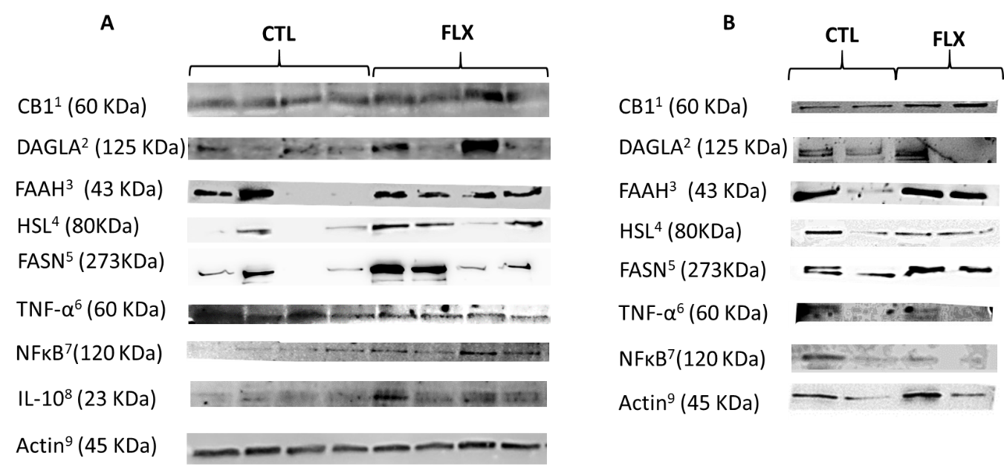
Supplementary Fig. 3. Western blot images of Adipose tissue average protein expression of ECS-related, lipid metabolism and inflammatory proteins of PP dairy cows supplemented with n-3 fatty acids. Dairy cows were divided into two nutritional regiment groups from -21- 60 days PP; 1) Control group (CTL) - a standard Israeli diet, 2) FLX - a standard diet supplemented with flaxseed oil containing n-3. A- 1st set of samples n=4 per treatment; B-2nd set of samples n=2 per treatment.¹Cannabinoid receptor 1; ²Diacylglycerol Lipase Alpha; ³Fatty Acid Amide Hydrolase; ⁴Hormone Sensitive Lipase; ⁵Fatty Acid Synthase; ⁶Tumor necrosis factor α; ⁷Nuclear Factor Kappa-Light-Chain-Enhancer of activated B cells; ⁸Interleukin 10; ⁹All samples were corrected by the β-Actin protein expression levels.

Supplement Table 4. Liver tissue relative protein abundance of ECS-related, lipid metabolism and inflammatory proteins of PP dairy cows supplemented with n-3 fatty acids.
 |  |  |  |  | Treatment¹
 |  | Control |  |  |  | FLX |  | SEM |  |  |  | P-value
Protein Abundance, AU
 | FAAH² |  |  | 2.8 |  | 2.1 |  |  | 0.58 |  |  |  | 0.43
 | TNF-α³ |  |  | 1.2 |  | 1.4 |  |  | 0.27 |  |  |  | 0.67
 | IL-10⁴ |  |  | 3.3 |  | 3.9 |  |  | 0.86 |  |  |  | 0.68
¹Dairy cows were divided into two nutritional regiment groups from -21- 60 days PP; 1) Control group (CTL) - a standard Israeli diet, 2) FLX - a standard diet supplemented with flaxseed oil containing n-3. ²Fatty Acid Amide Hydrolase ; ³Tumor necrosis factor α ; ⁴Interleukin 10. Full blots are presented in supplementary figure 5.

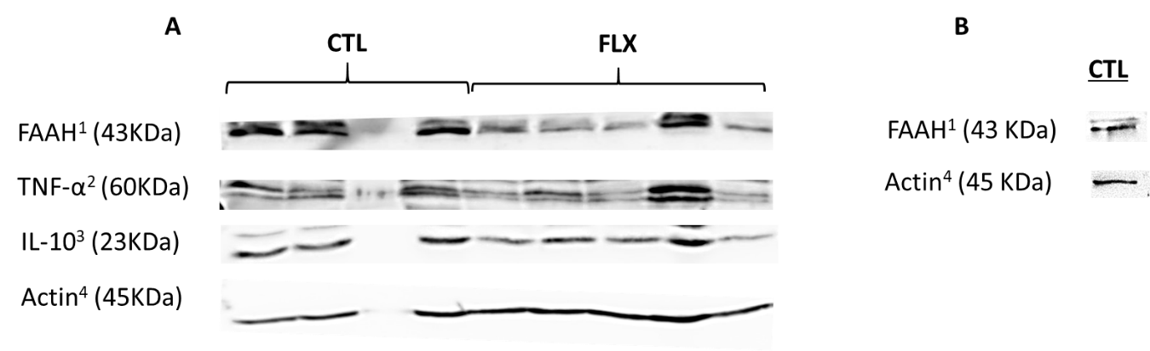
Supplementary Fig. 4. Western blot images of Liver average protein expression of ECS-related, lipid metabolism and inflammatory proteins of PP dairy cows supplemented with n-3 fatty acids. Dairy cows were divided into two nutritional regiment groups from -21- 60 days PP; 1) Control group (CTL) - a standard Israeli diet, 2) FLX - a standard diet supplemented with flaxseed oil containing n-3. A- 1st set of samples n=4 for CTL and n=5 for FLX treatment; B-2nd set of samples n=1 of CTL treatment.¹Fatty Acid Amide Hydrolase; ²Tumor necrosis factor α; ³Interleukin 10; ⁴All samples were corrected by the β-Actin protein expression levels.

