S.Table 1 showing the sampling details Latitude and Longitude of fixed point on the north and south side of MAPS.
S.no | Sample location | Latitude | Longitude
1 | Mahabalipuram beach | 12⁰ 62.093’ N | 80⁰19.878’ E
2 | Kokkilamedu kuppam | 12⁰ 59.342’ N | 80⁰18.944’ E
3 | Meyyar kuppam | 12⁰ 52.965’ N | 80⁰16.752’ E
4 | Sadras kuppam | 120 52.363’ N | 80⁰16.557’ E
5 | Wyalli kuppam | 120 48.979’ N | 80⁰15.876’ E

S. Table 2 showing distribution of the age group at kalpakkam zone.
S.no | Sample location | Variable age | Percent (%)
1 | Mahabalipuram beach | Young (15-30 years) | 10
1 | Mahabalipuram beach | Middle (31-50 years) | 38
1 | Mahabalipuram beach | Old (above 50 years) | 52
2 | Kokkilamedu kuppam | Young (15-30 years) | 25
2 | Kokkilamedu kuppam | Middle (31-50 years) | 45
2 | Kokkilamedu kuppam | Old (above 50 years) | 30
3 | Meyyar kuppam | Young (15-30 years) | 42
3 | Meyyar kuppam | Middle (31-50 years) | 35
3 | Meyyar kuppam | Old (above 50 years) | 27
4 | Sadras kuppam | Young (15-30 years) | 35
4 | Sadras kuppam | Middle (31-50 years) | 40
4 | Sadras kuppam | Old (above 50 years) | 25
5 | Wyalli kuppam | Young (15-30 years) | 48
5 | Wyalli kuppam | Middle (31-50 years) | 32
5 | Wyalli kuppam | Old (above 50 years) | 20

S. Table 3 showing distribution of the Religious status at kalpakkam zone.
S.no | Sample location | Religion Categories | Percent (%)
1 | Mahabalipuram beach | Hindu | 45
1 | Mahabalipuram beach | Muslim | 15
1 | Mahabalipuram beach | Christian | 38
1 | Mahabalipuram beach | Others | 2
2 | Kokkilamedu kuppam | Hindu | 55
2 | Kokkilamedu kuppam | Muslim | 10
2 | Kokkilamedu kuppam | Christian | 33
2 | Kokkilamedu kuppam | Others | 2
3 | Meyyar kuppam | Hindu | 53
3 | Meyyar kuppam | Muslim | 12
3 | Meyyar kuppam | Christian | 34
3 | Meyyar kuppam | Others | 1
4 | Sadras kuppam | Hindu | 56
 |  | Muslim | 24
 |  | Christian | 10
 |  | Others | 1
5 | Wyalli kuppam | Hindu | 49
 |  | Muslim | 21
 |  | Christian | 28
 |  | Others | 2

S. Table 4 showing distribution of the educational status at kalpakkam zone.
S.No | Sample location | Categories |  | Percent (%)
1 | Mahabalipuram beach | Educational status | Government | 48
1 | Mahabalipuram beach | Educational status | Private | 52
1 | Mahabalipuram beach | Educational level | High school | 27
1 | Mahabalipuram beach | Educational level | Middle school | 33
1 | Mahabalipuram beach | Educational level | Primary school | 16
1 | Mahabalipuram beach | Educational level | Illiterate | 24
2 | Kokkilamedu kuppam | Educational status | Government | 65
2 | Kokkilamedu kuppam | Educational status | Private | 35
2 | Kokkilamedu kuppam | Educational level | High school | 19
2 | Kokkilamedu kuppam | Educational level | Middle school | 24
2 | Kokkilamedu kuppam | Educational level | Primary school | 36
2 | Kokkilamedu kuppam | Educational level | Illiterate | 21
3 | Meyyar kuppam | Educational status | Government | 63
3 | Meyyar kuppam | Educational status | Private | 37
3 | Meyyar kuppam | Educational level | High school | 18
3 | Meyyar kuppam | Educational level | Middle school | 31
3 | Meyyar kuppam | Educational level | Primary school | 29
3 | Meyyar kuppam | Educational level | Illiterate | 22
4 | Sadras kuppam | Educational status | Government | 71
4 | Sadras kuppam | Educational status | Private | 29
4 | Sadras kuppam | Educational level | High school | 26
4 | Sadras kuppam | Educational level | Middle school | 28
4 | Sadras kuppam | Educational level | Primary school | 22
4 | Sadras kuppam | Educational level | Illiterate | 24
5 | Wyalli kuppam | Educational status | Government | 76
5 | Wyalli kuppam | Educational status | Private | 24
5 | Wyalli kuppam | Educational level | High school | 17
5 | Wyalli kuppam | Educational level | Middle school | 19
5 | Wyalli kuppam | Educational level | Primary school | 41
5 | Wyalli kuppam | Educational level | Illiterate | 23

S. Table 5 showing distribution of the Family status at kalpakkam zone.
S.No | Sample location | Family |  | Percent (%)
1 | Mahabalipuram beach | Family type | Nuclear | 88
1 | Mahabalipuram beach | Family type | Joint | 12
1 | Mahabalipuram beach | Family size | Small (2-3) | 45
1 | Mahabalipuram beach | Family size | Medium (4-5) | 38
1 | Mahabalipuram beach | Family size | Large (6 and above) | 17
2 | Kokkilamedu kuppam | Family type | Nuclear | 71
2 | Kokkilamedu kuppam | Family type | Joint | 29
2 | Kokkilamedu kuppam | Family size | Small (2-3) | 41
2 | Kokkilamedu kuppam | Family size | Medium (4-5) | 40
2 | Kokkilamedu kuppam | Family size | Large (6 and above) | 19
3 | Meyyar kuppam | Family type | Nuclear | 76
3 | Meyyar kuppam | Family type | Joint | 24
3 | Meyyar kuppam | Family size | Small (2-3) | 35
3 | Meyyar kuppam | Family size | Medium (4-5) | 41
3 | Meyyar kuppam | Family size | Large (6 and above) | 24
4 | Sadras kuppam | Family type | Nuclear | 63
4 | Sadras kuppam | Family type | Joint | 37
4 | Sadras kuppam | Family size | Small (2-3) | 41
4 | Sadras kuppam | Family size | Medium (4-5) | 39
4 | Sadras kuppam | Family size | Large (6 and above) | 20
5 | Wyalli kuppam | Family type | Nuclear | 69
5 | Wyalli kuppam | Family type | Joint | 31
5 | Wyalli kuppam | Family size | Small (2-3) | 43
5 | Wyalli kuppam | Family size | Medium (4-5) | 38
5 | Wyalli kuppam | Family size | Large (6 and above) | 19

S. Table 6 showing distribution of the occupation status at kalpakkam zone.
S.No | Sample location | Occupation categorized | Percent (%)
1 | Mahabalipuram beach | Fishing | 61
1 | Mahabalipuram beach | Agriculture | 15
1 | Mahabalipuram beach | Others | 24
2 | Kokkilamedu kuppam | Fishing | 65
2 | Kokkilamedu kuppam | Agriculture | 10
2 | Kokkilamedu kuppam | Others | 25
3 | Meyyar kuppam | Fishing | 78
3 | Meyyar kuppam | Agriculture | 8
3 | Meyyar kuppam | Others | 14
4 | Sadras kuppam | Fishing | 76
4 | Sadras kuppam | Agriculture | 5
4 | Sadras kuppam | Others | 19
5 | Wyalli kuppam | Fishing | 71
5 | Wyalli kuppam | Agriculture | 11
5 | Wyalli kuppam | Others | 18

S. Table 7 showing distribution of the housing condition status at kalpakkam zone.

S.No | Sample location | House condition | Percent (%)
1 | Mahabalipuram beach | Building | 85
1 | Mahabalipuram beach | Tin shade building | 8
1 | Mahabalipuram beach | Wood and Tin | 4
1 | Mahabalipuram beach | Others | 3
2 | Kokkilamedu kuppam | Building | 68
2 | Kokkilamedu kuppam | Tin shade building | 12
2 | Kokkilamedu kuppam | Wood and Tin | 15
2 | Kokkilamedu kuppam | Others | 5
3 | Meyyar kuppam | Building | 80
3 | Meyyar kuppam | Tin shade building | 8
3 | Meyyar kuppam | Wood and Tin | 6
3 | Meyyar kuppam | Others | 8
4 | Sadras kuppam | Building | 81
4 | Sadras kuppam | Tin shade building | 7
4 | Sadras kuppam | Wood and Tin | 6
4 | Sadras kuppam | Others | 6
5 | Wyalli kuppam | Building | 71
5 | Wyalli kuppam | Tin shade building | 18
5 | Wyalli kuppam | Wood and Tin | 7
5 | Wyalli kuppam | Others | 4

S. Table 8 showing distribution of the training exposure status at kalpakkam zone.

S.No | Sample location | Training exposure | Percent (%)
1 | Mahabalipuram beach | Received training | 80
1 | Mahabalipuram beach | Did not receive training | 20
2 | Kokkilamedu kuppam | Received training | 74
2 | Kokkilamedu kuppam | Did not receive training | 26
3 | Meyyar kuppam | Received training | 78
3 | Meyyar kuppam | Did not receive training | 22
4 | Sadras kuppam | Received training | 79
4 | Sadras kuppam | Did not receive training | 21
5 | Wyalli kuppam | Received training | 65
5 | Wyalli kuppam | Did not receive training | 35

S. Table 9 showing Graft and gear used for fishing activities at kalpakkam zone.
S.No | Sample location | fishing activities |  | Percent (%)
1 | Mahabalipuram beach | Graft | Cast net | 12
1 | Mahabalipuram beach | Graft | Gill net | 45
1 | Mahabalipuram beach | Graft | Hooks and lines | 25
1 | Mahabalipuram beach | Graft | Trawl nets | 3
1 | Mahabalipuram beach | Graft | Seine nets | 15
1 | Mahabalipuram beach | Gear | Mechanized boat | 70
1 | Mahabalipuram beach | Gear | Non Mechanized boat | 30
2 | Kokkilamedu kuppam | Graft | Cast net | 11
2 | Kokkilamedu kuppam | Graft | Gill net | 48
2 | Kokkilamedu kuppam | Graft | Hooks and lines | 31
2 | Kokkilamedu kuppam | Graft | Trawl nets | 4
2 | Kokkilamedu kuppam | Graft | Seine nets | 6
2 | Kokkilamedu kuppam | Gear | Mechanized boat | 75
2 | Kokkilamedu kuppam | Gear | Non Mechanized boat | 25
3 | Meyyar kuppam | Graft | Cast net | 15
3 | Meyyar kuppam | Graft | Gill net | 45
3 | Meyyar kuppam | Graft | Hooks and lines | 30
3 | Meyyar kuppam | Graft | Trawl nets | 5
3 | Meyyar kuppam | Graft | Seine nets | 5
3 | Meyyar kuppam | Gear | Mechanized boat | 82
3 | Meyyar kuppam | Gear | Non Mechanized boat | 18
4 | Sadras kuppam | Graft | Cast net | 16
4 | Sadras kuppam | Graft | Gill net | 44
4 | Sadras kuppam | Graft | Hooks and lines | 29
4 | Sadras kuppam | Graft | Trawl nets | 6
4 | Sadras kuppam | Graft | Seine nets | 5
4 | Sadras kuppam | Gear | Mechanized boat | 81
4 | Sadras kuppam | Gear | Non Mechanized boat | 19
5 | Wyalli kuppam | Graft | Cast net | 17
5 | Wyalli kuppam | Graft | Gill net | 43
5 | Wyalli kuppam | Graft | Hooks and lines | 30
5 | Wyalli kuppam | Graft | Trawl nets | 5
5 | Wyalli kuppam | Graft | Seine nets | 5
5 | Wyalli kuppam | Gear | Mechanized boat | 75
5 | Wyalli kuppam | Gear | Non Mechanized boat | 25

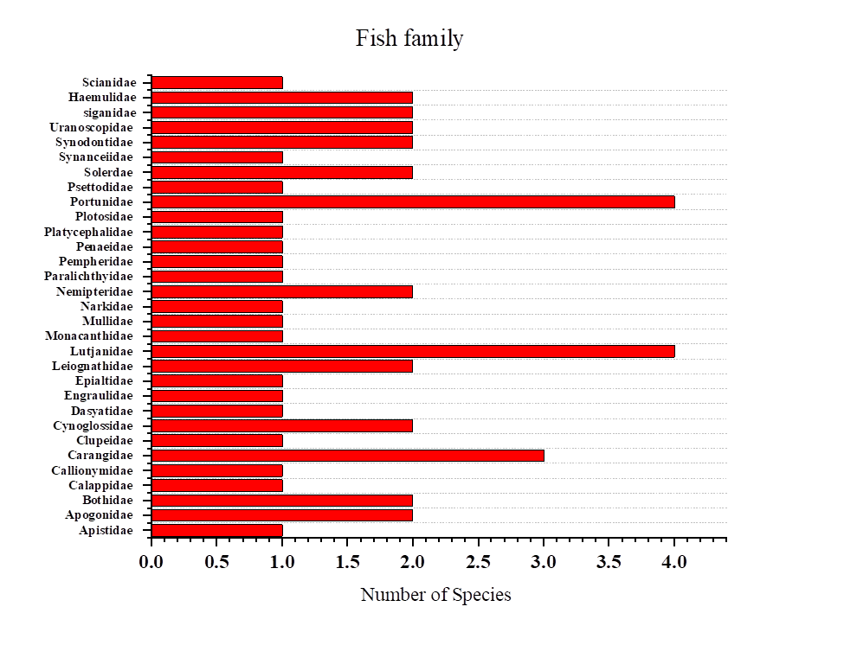

S.Figure 1 showing the distribution of the fish family.

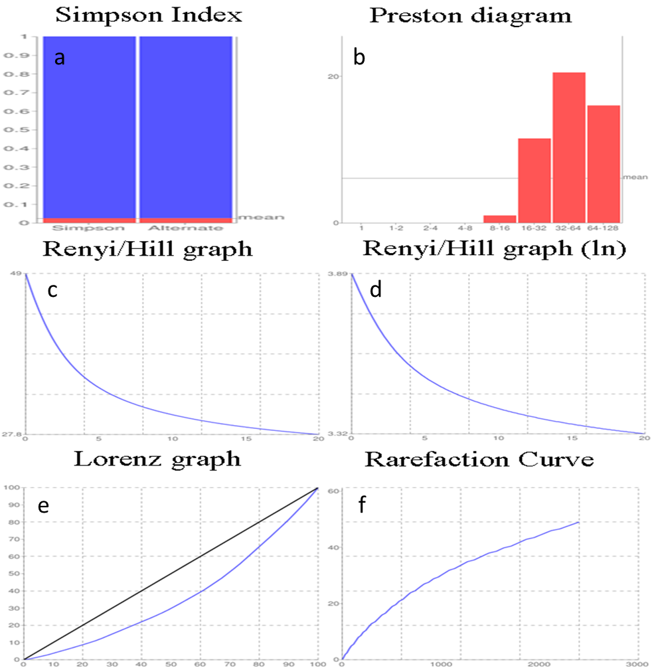
S.Figure 2 showing (a) Simpson Index, (b) Preston diagram, (c) Renyi/Hill graph, (d)Renyi/Hill graph (ln),(e) Lorenz graph, and (f) Rarefaction Curve.

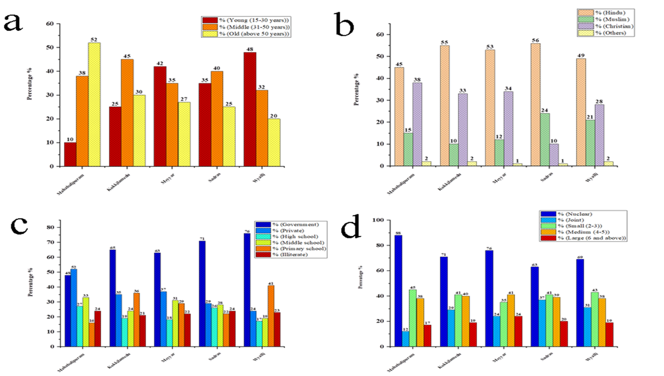

S. Figure 3 showing distribution of the (a) age group, (b) Religious status, (c) educational status, and (d) family status at kalpakkam zone.

